Table of Contents

UNITED STATES

SECURITIES AND EXCHANGE COMMISSION
WASHINGTON, D.C. 20549

FORM 10-Q

- QUARTERLY REPORT PURSUANT TO SECTION 13 OR 15(d) OF THE SECURITIES EXCHANGE ACT OF 1934.

For the quarterly period ended January 27, 2018

OR

- TRANSITION REPORT PURSUANT TO SECTION 13 OR 15(d) OF THE SECURITIES EXCHANGE ACT OF 1934

For the transition period from to

Commission File Number: 001-33261

AEROVIRONMENT, INC.

(Exact name of registrant as specified in its charter)

Delaware | 95-2705790
(State or other jurisdiction of incorporation or organization) | (I.R.S. Employer Identification No.)
800 Royal Oaks Drive, Suite 210
Monrovia, California | 91016
(Address of principal executive offices) | (Zip Code)

(626) 357-9983

(Registrant’s telephone number, including area code)

N/A

(Former name, former address and former fiscal year, if changed since last report)

Indicate by check mark whether the registrant (1) has filed all reports required to be filed by Section 13 or 15(d) of the Securities Exchange Act of 1934 during the preceding 12 months (or for such shorter period that the registrant was required to file such reports), and (2) has been subject to such filing requirements for the past 90

days. Yes ☒ No ☐

Indicate by check mark whether the registrant has submitted electronically and posted on its corporate Web site, if any, every Interactive Data File required to be submitted and posted pursuant to Rule 405 of Regulation S-T (§232.405 of this chapter) during the preceding 12 months (or for such shorter period that the registrant was

required to submit and post such files). Yes ☒ No ☐

Indicate by check mark whether the registrant is a large accelerated filer, an accelerated filer, a non-accelerated filer, a smaller reporting company, or an emerging growth company. See the definitions of “large accelerated filer,” “accelerated filer,” “smaller reporting company,” and “emerging growth company” in Rule 12b-2 of the Exchange Act.

Large accelerated filer ☐ | Accelerated filer ☒
Non-accelerated filer ☐ | Smaller reporting company ☐
(Do not check if smaller reporting company) | Emerging growth company ☐

If an emerging growth company, indicate by check mark if the registrant has elected not to use the extended transition period for complying with any new or revised financial accounting standards provided pursuant to Section 13(a) of the Exchange Act. ☐

Indicate by check mark whether the registrant is a shell company (as defined in Rule 12b-2 of the Exchange Act). Yes ☐ No ☒

As of February 27, 2018, the number of shares outstanding of the registrant’s common stock, $0.0001 par value, was 23,905,986.

Table of Contents
 |  |  |  |  |  |  |  |  |  |  |  |  |  |  | AeroVironment, Inc.
 |  |  |  |  |  |  |  |  |  |  |  |  |  |  | Table of Contents
Item 1. |  |  |  | Financial Statements:
 |  |  |  |  | Consolidated Balance Sheets as of January 27, 2018 (Unaudited) and April 30, 2017 |  |  |  |  |  |  |  |  |  |  |  |  |  |  |  |  |  |  |  |  |  | 3
 |  |  |  |  | Consolidated Statements of Operations for the three and nine months ended January 27, 2018 |  |  |  |  |  |  |  |  |  |  |  |  |  |  |  |  |  |  |  |  |  | 4
 |  |  |  |  |  | (Unaudited) and January 28, 2017 (Unaudited) |  |  |  |  |  |  |  |  |  |  |  |  |  |  |  |  |  |  |  |  | 5
 |  |  |  |  |  | Consolidated Statements of Comprehensive (Loss) |  |  |  |  |  |  |  |  |  | Income for the three and nine months ended |  |  |  |  |  |  |  |  |  |  | 5
 |  |  |  |  |  | January 27, 2018 (Unaudited) and January 28, 2017 (Unaudited) |  |  |  |  |  |  |  |  |  |  |  |  |  |  |  |  |  |  |  |  | 6
 |  |  |  |  |  | Consolidated Statements of Cash Flows for the nine months ended |  |  |  |  |  |  |  |  |  |  |  |  |  |  | January 27, |  |  |  |  |  | 6
 |  |  |  |  |  | 2018 (Unaudited) and January 28, 2017 (Unaudited)
 |  |  |  | Notes |  | to Consolidated Financial Statements (Unaudited) |  |  |  |  |  |  |  |  |  |  |  |  |  |  |  |  |  |  |  |  | 7
Item 2. |  |  |  | Management’s Discussion and Analysis of Financial Condition and Results of Operations |  |  |  |  |  |  |  |  |  |  |  |  |  |  |  |  |  |  |  |  |  |  | 21
Item 3. |  |  |  | Quantitative and Qualitative Disclosures About Market Risk |  |  |  |  |  |  |  |  |  |  |  |  |  |  |  |  |  |  |  |  |  |  | 28
Item 4. |  |  |  | Controls and Procedures |  |  |  |  |  |  |  |  |  |  |  |  |  |  |  |  |  |  |  |  |  |  | 29
PART II. OTHER INFORMATION
Item 1. |  |  |  | Legal Proceedings |  |  |  |  |  |  |  |  |  |  |  |  |  |  |  |  |  |  |  |  |  |  | 30
Item 1A. |  |  | Risk Factors |  |  |  |  |  |  |  |  |  |  |  |  |  |  |  |  |  |  |  |  |  |  |  | 30
Item 2. |  |  |  | Unregistered Sales of Equity Securities and Use of Proceeds |  |  |  |  |  |  |  |  |  |  |  |  |  |  |  |  |  |  |  |  |  |  | 30
Item 3. |  |  |  | Defaults Upon Senior Securities |  |  |  |  |  |  |  |  |  |  |  |  |  |  |  |  |  |  |  |  |  |  | 30
Item 4. |  |  |  | Mine Safety Disclosures |  |  |  |  |  |  |  |  |  |  |  |  |  |  |  |  |  |  |  |  |  |  | 30
Item 5. |  |  |  | Other Information |  |  |  |  |  |  |  |  |  |  |  |  |  |  |  |  |  |  |  |  |  |  | 30
Item 6. |  |  |  | Exhibits |  |  |  |  |  |  |  |  |  |  |  |  |  |  |  |  |  |  |  |  |  |  | 32
Signatures |  |  |  |  |  |  |  |  |  |  |  |  |  |  |  |  |  |  |  |  |  |  |  |  |  |  | 33

2

Table of Contents

PART I. FINANCIAL INFORMATION

ITEM 1. FINANCIAL STATEMENTS

AeroVironment, Inc.

Consolidated Balance Sheets

(In thousands except share and per share data)
 |  | January 27, |  |  |  |  | April 30,
 |  |  | 2018 |  |  |  | 2017
 |  | (Unaudited)
Assets
Current assets:
Cash and cash equivalents | $ |  | 112,304 |  | $ |  | 79,904
Short-term investments |  |  | 109,543 |  |  |  | 119,971
Accounts receivable, net of allowance for doubtful accounts of $1,360 at January 27, 2018 and
$291 at April 30, 2017 |  |  | 25,690 |  |  |  | 74,361
Unbilled receivables and retentions |  |  | 24,961 |  |  |  | 14,120
Inventories, net |  |  | 77,327 |  |  |  | 60,076
Income taxes receivable |  |  | 292 |  |  |  | —
Prepaid expenses and other current assets |  |  | 5,138 |  |  |  | 5,653
Total current assets |  |  | 355,255 |  |  |  | 354,085
Long-term investments |  |  | 38,822 |  |  |  | 42,096
Property and equipment, net |  |  | 21,626 |  |  |  | 19,220
Deferred income taxes |  |  | 14,837 |  |  |  | 15,089
Other assets |  |  | 2,305 |  |  |  | 2,010
Total assets |  | $ | 432,845 |  |  | $ | 432,500
Liabilities and stockholders’ equity
Current liabilities:
Accounts payable | $ |  | 13,249 |  | $ |  | 20,283
Wages and related accruals |  |  | 15,090 |  |  |  | 12,966
Income taxes payable |  |  | — |  |  |  | 1,418
Customer advances |  |  | 3,555 |  |  |  | 3,317
Other current liabilities |  |  | 8,651 |  |  |  | 10,079
Total current liabilities |  |  | 40,545 |  |  |  | 48,063
Deferred rent |  |  | 1,589 |  |  |  | 1,719
Capital lease obligations - net of current portion |  |  | 7 |  |  |  | 161
Other non-current liabilities |  |  | 184 |  |  |  | 184
Deferred tax liability |  |  | 67 |  |  |  | 116
Liability for uncertain tax positions |  |  | 64 |  |  |  | 64
Commitments and contingencies
Stockholders’ equity:
Preferred stock, $0.0001 par value:
Authorized shares—10,000,000; none issued or outstanding at January 27, 2018 and
April 30, 2017 |  |  | — |  |  |  | —
Common stock, $0.0001 par value:
Authorized shares—100,000,000
Issued and outstanding shares—23,906,043 shares at January 27, 2018 and 23,630,419 at
April 30, 2017 |  |  | 2 |  |  |  | 2
Additional paid-in capital |  |  | 168,735 |  |  |  | 162,150
Accumulated other comprehensive loss |  |  | (25) |  |  |  | (127)
Retained earnings |  |  | 221,676 |  |  |  | 219,929
Total AeroVironment stockholders' equity |  |  | 390,388 |  |  |  | 381,954
Noncontrolling interest |  |  | 1 |  |  |  | 239
Total equity |  |  | 390,389 |  |  |  | 382,193
Total liabilities and stockholders’ equity |  | $ | 432,845 |  |  | $ | 432,500

See accompanying notes to consolidated financial statements (unaudited).

3

Table of Contents

AeroVironment, Inc.

Consolidated Statements of Operations (Unaudited)

(In thousands except share and per share data)

 |  |  | Three Months Ended |  |  |  |  |  | Nine Months Ended
 |  |  | January 27, |  |  | January 28, |  |  | January 27, |  |  | January 28,
 |  |  | 2018 |  |  | 2017 |  |  | 2018 |  |  | 2017
Revenue:
Product sales | $ |  | 49,204 | $ |  | 36,746 | $ |  | 133,228 | $ |  | 81,833
Contract services |  |  | 14,731 |  |  | 16,417 |  |  | 48,298 |  |  | 57,664
 |  |  | 63,935 |  |  | 53,163 |  |  | 181,526 |  |  | 139,497
Cost of sales:
Product sales |  |  | 31,911 |  |  | 23,641 |  |  | 86,142 |  |  | 58,060
Contract services |  |  | 11,438 |  |  | 10,171 |  |  | 32,168 |  |  | 37,986
 |  |  | 43,349 |  |  | 33,812 |  |  | 118,310 |  |  | 96,046
Gross margin:
Product sales |  |  | 17,293 |  |  | 13,105 |  |  | 47,086 |  |  | 23,773
Contract services |  |  | 3,293 |  |  | 6,246 |  |  | 16,130 |  |  | 19,678
 |  |  | 20,586 |  |  | 19,351 |  |  | 63,216 |  |  | 43,451
Selling, general and administrative |  |  | 13,500 |  |  | 12,788 |  |  | 41,295 |  |  | 39,838
Research and development |  |  | 7,314 |  |  | 7,988 |  |  | 21,047 |  |  | 25,105
(Loss) income from operations |  |  | (228) |  |  | (1,425) |  |  | 874 |  |  | (21,492)
Other income (expense):
Interest income, net |  |  | 545 |  |  | 390 |  |  | 1,489 |  |  | 1,162
Other expense, net |  |  | (108) |  |  | (38) |  |  | (159) |  |  | (357)
Income (loss) before income taxes |  |  | 209 |  |  | (1,073) |  |  | 2,204 |  |  | (20,687)
Provision (benefit) for income taxes |  |  | 628 |  |  | 1,102 |  |  | 277 |  |  | (2,809)
Equity method investment activity, net of tax |  |  | (418) |  |  | (8) |  |  | (418) |  |  | (119)
Net (loss) income |  |  | (837) |  | $ | (2,183) |  |  | 1,509 |  |  | (17,997)
Net loss attributable to noncontrolling interest |  |  | 9 |  |  | — |  |  | 238 |  |  | —
Net (loss) income attributable to AeroVironment |  | $ | (828) |  | $ | (2,183) |  | $ | 1,747 |  | $ | (17,997)
Net (loss) income per share attributable to AeroVironment:
Basic | $ |  | (0.04) | $ |  | (0.09) | $ |  | 0.07 | $ |  | (0.78)
Diluted | $ |  | (0.04) | $ |  | (0.09) | $ |  | 0.07 | $ |  | (0.78)
Weighted-average shares outstanding:
Basic |  |  | 23,515,622 |  |  | 23,082,974 |  |  | 23,443,673 |  |  | 23,029,546
Diluted |  |  | 23,515,622 |  |  | 23,082,974 |  |  | 23,774,946 |  |  | 23,029,546

See accompanying notes to consolidated financial statements (unaudited).

4

Table of Contents

AeroVironment, Inc.

Consolidated Statements of Comprehensive (Loss) Income (Unaudited)

(In thousands)

 |  |  | Three Months Ended |  |  |  |  |  | Nine Months Ended
 |  | January 27, |  |  | January 28, |  |  | January 27, |  |  | January 28,
 |  |  | 2018 |  |  | 2017 |  |  | 2018 | 2017
Net (loss) income |  | $ | (837) |  | $ | (2,183) |  | $ | 1,509 |  | $ (17,997)
Other comprehensive income:
Change in foreign currency translation adjustments |  |  | 62 |  |  | — |  |  | 62 |  | —
Unrealized gain (loss) on investments, net of deferred tax expense
(benefit) of $10 and $(23) for the three months ended January 27, 2018
and January 28, 2017, respectively; and net of deferred tax expense of
$29 and $6 for the nine months ended January 27, 2018 and January
28, 2017, respectively |  |  | 13 |  |  | (11) |  |  | 42 | 32
Total comprehensive (loss) income |  |  | (762) |  | $ | (2,194) |  |  | 1,613 |  | (17,965)
Net loss attributable to noncontrolling interest |  |  | 9 |  |  | — |  |  | 238 |  | —
Comprehensive (loss) income attributable to AeroVironment |  | $ | (753) |  | $ | (2,194) |  | $ | 1,851 |  | $ (17,965)

See accompanying notes to consolidated financial statements (unaudited).

5

Table of Contents

AeroVironment, Inc.

Consolidated Statements of Cash Flows (Unaudited)

(In thousands)

 |  |  | Nine Months Ended
 |  |  | January 27, |  |  | January 28,
 |  |  | 2018 |  |  | 2017
Operating activities
Net income (loss) | $ |  | 1,509 | $ |  | (17,997)
Adjustments to reconcile net income (loss) to cash provided by (used in) operating activities:
Depreciation and amortization |  |  | 5,605 |  |  | 5,188
Loss from equity method investments |  |  | 418 |  |  | 119
Impairment of long-lived assets |  |  | 255 |  |  | —
Provision for doubtful accounts |  |  | 1,102 |  |  | 115
Impairment of intangible assets and goodwill |  |  | 1,021 |  |  | —
(Gains) losses on foreign currency transactions |  |  | (36) |  |  | 272
Deferred income taxes |  |  | 175 |  |  | (698)
Stock-based compensation |  |  | 3,899 |  |  | 2,736
Tax benefit from exercise of stock options |  |  | — |  |  | 22
Loss on disposition of property and equipment |  |  | 15 |  |  | 37
Amortization of held-to-maturity investments |  |  | 1,250 |  |  | 1,827
Changes in operating assets and liabilities:
Accounts receivable |  |  | 47,652 |  |  | 32,553
Unbilled receivables and retentions |  |  | (10,841) |  |  | 4,079
Inventories |  |  | (17,251) |  |  | (31,320)
Income tax receivable |  |  | (292) |  |  | (2,487)
Prepaid expenses and other assets |  |  | 472 |  |  | (1,190)
Accounts payable |  |  | (6,684) |  |  | (3,170)
Other liabilities |  |  | (153) |  |  | (4,510)
Net cash provided by (used in) operating activities |  |  | 28,116 |  |  | (14,424)
Investing activities
Acquisition of property and equipment |  |  | (8,450) |  |  | (7,586)
Equity method investments |  |  | (1,860) |  |  | —
Redemptions of held-to-maturity investments |  |  | 163,813 |  |  | 93,208
Purchases of held-to-maturity investments |  |  | (151,740) |  |  | (122,978)
Proceeds from the sale of property and equipment |  |  | — |  |  | 7
Redemptions of available-for-sale investments |  |  | 450 |  |  | 400
Net cash provided by (used in) investing activities |  |  | 2,213 |  |  | (36,949)
Financing activities
Principal payments of capital lease obligations |  |  | (231) |  |  | (291)
Tax withholding payment related to net settlement of equity awards |  |  | (389) |  |  | —
Exercise of stock options |  |  | 2,691 |  |  | 655
Net cash provided by financing activities |  |  | 2,071 |  |  | 364
Net increase (decrease) in cash and cash equivalents |  |  | 32,400 |  |  | (51,009)
Cash and cash equivalents at beginning of period |  |  | 79,904 |  |  | 124,287
Cash and cash equivalents at end of period |  | $ | 112,304 |  | $ | 73,278
Supplemental disclosures of cash flow information
Cash paid, net during the period for:
Income taxes | $ |  | 1,812 | $ |  | 1,786
Non-cash activities
Unrealized gain on investments, net of deferred tax expense of $29 and $6, respectively | $ |  | 42 | $ |  | 32
Reclassification from share-based liability compensation to equity | $ |  | 384 | $ |  | 307
Change in foreign currency translation adjustments | $ |  | 62 | $ |  | —
Acquisitions of property and equipment included in accounts payable | $ |  | 332 | $ |  | 408

See accompanying notes to consolidated financial statements (unaudited).

6

Table of Contents

AeroVironment, Inc.

Notes to Consolidated Financial Statements (Unaudited)

1. Organization and Significant Accounting Policies

Organization

AeroVironment, Inc., a Delaware corporation (the “Company”), is engaged in the design, development, production, support and operation of unmanned aircraft systems (“UAS”) and efficient energy systems (“EES”) for various industries and governmental agencies.

Basis of Presentation

The accompanying unaudited consolidated financial statements have been prepared in accordance with accounting principles generally accepted in the United States (“U.S. GAAP”) for interim financial information and with the instructions of Form 10-Q and Article 10 of Regulation S-X. Accordingly, they do not include all of the information and footnotes required by U.S. GAAP for complete financial statements. In the opinion of management, all adjustments, consisting only of normal recurring adjustments necessary for a fair presentation with respect to the interim financial statements have been included. The results of operations for the three and nine months ended January 27, 2018 are not necessarily indicative of the results for the full year ending April 30, 2018. For further information, refer to the consolidated financial statements and footnotes thereto for the year ended April 30, 2017, included in the Company’s Annual Report on Form 10-K.

The preparation of financial statements in conformity with U.S. GAAP requires management to make estimates and assumptions, including estimates of anticipated contract costs and revenue utilized in the revenue recognition process, that affect the reported amounts in the consolidated financial statements and accompanying notes. Actual results could differ from those estimates.

The Company’s consolidated financial statements include the assets, liabilities and operating results of wholly-owned subsidiaries. All intercompany accounts and transactions have been eliminated.

The accompanying consolidated financial statements include the balance sheet and results of operations of Altoy Savunma Sanayi ve Havacilik Anonim Sirketi (“Altoy”), in which the Company increased its ownership to a controlling interest of 85% during the fourth quarter of the fiscal year ended April 30, 2017. Prior to the increase in ownership, the Company's investment in Altoy was accounted for under the equity method.

In July 2016, the Company dissolved Charger Bicycles, LLC, the results of which were not material to the consolidated financial statements. During the three months ended January 28, 2017, the Company dissolved Skytower, LLC and Regenerative Fuel Cell Systems, LLC, the results of which were not material to the consolidated financial statements.

In December of 2017, the Company and Softbank Corp. (“Softbank”) formed a joint venture, HAPSMobile, Inc. (“HAPSMobile”). As the Company has the ability to exercise significant influence over the operating and financial policies of HAPSMobile, the Company’s investment will be accounted as an equity method investment. The Company has presented its proportion of HAPSMobile’s net loss in “Equity method investment activity, net of tax” in the consolidated statement of operations. The carrying value of the investment in HAPSMobile was recorded in “Other assets, long-term.” Refer to Note 5 – Equity Method Investments for further details.

Reclassifications

Certain prior year amounts have been reclassified to conform to the current year presentation. Equity method losses associated with the Company’s investment in Altoy for the three and nine months ended Janaury 28, 2017 have been reclassified from other expense, net to equity method investment activity, net of tax on the consolidated statement of operations.

7

Table of Contents

Recently Adopted Accounting Standards

In July 2015, the Financial Accounting Standards Board (“FASB”) issued Accounting Standards Update (“ASU”) 2015-11, Inventory (Topic 330): Simplifying the Measurement of Inventory. This ASU does not apply to inventory that is measured using last-in, first-out (LIFO) or the retail inventory method. The amendments apply to all other inventory, which includes inventory that is measured using first-in, first-out (FIFO) or average cost. This ASU eliminates from U.S. GAAP the requirement to measure inventory at the lower of cost or market. Market under the previous requirement could be replacement cost, net realizable value, or net realizable value less a normal profit margin. Entities within the scope of this update will now be required to measure inventory at the lower of cost and net realizable value. Net realizable value is the estimated selling price in the ordinary course of business, less reasonably predictable costs of completion, disposal, and transportation. Subsequent measurement is unchanged for inventory using LIFO or the retail inventory method. The Company’s adoption of ASU 2015-11 effective May 1, 2017 did not have a material impact on its consolidated financial statements.

In January 2017, the FASB issued ASU 2017-04, Intangibles - Goodwill and Other (Topic 350): Simplifying the Test for Goodwill Impairment, which simplifies the test for goodwill impairment by removing Step 2 from the goodwill impairment test. If goodwill impairment is realized, the amount recognized will be the amount by which the carrying amount exceeds the reporting unit’s fair value; however, the loss recognized cannot exceed the total amount of goodwill allocated to that reporting unit. ASU 2017-04 must be applied on a prospective basis and will become effective for public entities in the first quarter of the year ending July 31, 2020, with early adoption available. The Company elected to early adopt the standard during the three months ended October 28, 2017. The Company’s adoption of ASU 2017-04 did not have a material impact on its consolidated financial statements.

Segments

The Company’s products are sold and divided among two reportable segments to reflect the Company’s strategic goals. Operating segments are defined as components of an enterprise from which separate financial information is available that is evaluated regularly by the Chief Operating Decision Maker (“CODM”) in deciding how to allocate resources and in assessing performance. The Company’s CODM is the Chief Executive Officer, who reviews the revenue and gross margin results for each of these segments in order to make resource allocation decisions, including the focus of research and development (“R&D”) activities and performance assessment. The Company’s reportable segments are business units that offer different products and services and are managed separately.

Investments

The Company’s investments are accounted for as held-to-maturity and available-for-sale and reported at amortized cost and fair value, respectively.

Fair Values of Financial Instruments

Fair values of cash and cash equivalents, accounts receivable, unbilled receivables and retentions, and accounts payable approximate cost due to the short period of time to maturity.

Government Contracts

Payments to the Company on government cost reimbursable contracts are based on provisional, or estimated indirect rates, which are subject to an annual audit by the Defense Contract Audit Agency (“DCAA”). The cost audits result in the negotiation and determination of the final indirect cost rates that the Company may use for the period(s) audited. The final rates, if different from the provisional rates, may create an additional receivable or liability for the Company.

For example, during the course of its audits, the DCAA may question the Company’s incurred costs, and if the DCAA believes the Company has accounted for such costs in a manner inconsistent with the requirements under Federal Acquisition Regulations, the DCAA auditor may recommend to the Company’s administrative contracting officer to disallow such costs. Historically, the Company has not experienced material disallowed costs as a result of government

8

Table of Contents

audits. However, the Company can provide no assurance that the DCAA or other government audits will not result in material disallowances for incurred costs in the future.

The Company’s revenue recognition policy calls for revenue recognized on all cost reimbursable government contracts to be recorded at actual rates unless collectability is not reasonably assured. During the fiscal year ended April 30, 2017, the Company settled rates for its incurred cost claims with the DCAA for fiscal years 2011 through 2014 without payment of any consideration. At January 27, 2018, the Company had $77,000 reserved for incurred cost claim audits. At April 30, 2017, the Company had no reserves for incurred cost claim audits.

(Loss) Earnings Per Share

Basic (loss) earnings per share is computed using the weighted-average number of common shares outstanding, excluding shares of unvested restricted stock.

The reconciliation of basic to diluted shares is as follows:

 |  | Three Months Ended |  |  |  | Nine Months Ended
 |  | January 27, 2018 |  | January 28, 2017 |  | January 27, 2018 |  | January 28, 2017
 | Denominator for basic (loss) earnings per share:
 | Weighted-average common shares outstanding,
 | excluding unvested restricted stock | 23,515,622 |  | 23,082,974 |  | 23,443,673 |  | 23,029,546
 | Dilutive effect of employee stock options and
 | unvested restricted stock | — |  | — |  | 331,273 |  | —
 | Denominator for diluted (loss) earnings per share | 23,515,622 |  | 23,082,974 |  | 23,774,946 |  | 23,029,546

Due to the net loss for the three months ended January 27, 2018, no shares reserved for issuance upon exercise of stock options or shares of unvested restricted stock were included in the computation of diluted loss per share as their inclusion would have been anti-dilutive. Potentially dilutive shares not included in the computation of diluted weighted-average common shares because their effect would have been anti-dilutive were 379,749 for the three months ended January 27, 2018. Potentially dilutive shares not included in the computation of diluted weighted-average common shares because their effect would have been anti-dilutive were 27,139 for the nine months ended January 27, 2018. Due to the net loss for the three and nine months ended January 28, 2017, no shares reserved for issuance upon exercise of stock options or shares of unvested restricted stock were included in the computation of diluted loss per share as their inclusion would have been anti-dilutive. Potentially dilutive shares not included in the computation of diluted weighted-average common shares because their effect would have been anti-dilutive were 222,071 and 246,093 for the three and nine months ended January 28, 2017, respectively.

Recently Issued Accounting Standards

In January 2017, the FASB issued ASU 2017-01, Business Combinations – Clarifying the definition of a business (Topic 805). This ASU clarifies the definition of a business with the objective of providing a more robust framework to evaluate whether transactions should be accounted for as acquisitions (or disposals) of assets or businesses. The guidance will be effective for fiscal years beginning after December 15, 2017, including interim periods within that fiscal year, with early adoption permitted. The amendments are to be applied prospectively to business combinations that occur after the effective date.

In August 2016, the FASB issued ASU 2016-15, Statement of Cash Flows - Classification of Certain Cash Receipts and Cash Payments (Topic 230). This ASU adds and clarifies guidance on the classification of certain cash receipts and payments in the statement of cash flows. The guidance is effective for fiscal years beginning after December 15, 2017 and interim periods therein, with early adoption permitted. The Company is evaluating the potential impact of this adoption on its consolidated financial statements.

In February 2016, the FASB issued ASU 2016-02, Leases (Topic 842). This ASU requires the lessee to recognize the

9

Table of Contents

assets and liabilities for the rights and obligations created by leases with terms of 12 months or more. The guidance is effective for fiscal years beginning after December 15, 2018 and interim periods therein, with early adoption permitted. The Company is evaluating the potential impact of this adoption on its consolidated financial statements. The Company currently does not hold a large number of leases that are classified as operating leases under the existing lease standard, with the only significant leases being the Company’s various property leases. The Company is evaluating the potential impact of this adoption on its consolidated financial statements.

In May 2014, the FASB issued ASU 2014-09, Revenue from Contracts with Customers (Topic 606). The new standard was originally effective for reporting periods beginning after December 15, 2016 and early adoption was not permitted. In August 2015, the FASB issued ASU 2015-14, Revenue from Contracts with Customers (Topic 606)-Deferral of the Effective Date. This update approved a one-year delay of the effective date to reporting periods beginning after December 15, 2017, while permitting companies to voluntarily adopt the new standard as of the original effective date. Since the issuance of ASU 2014-09, the FASB has issued several amendments to provide additional supplemental guidance on certain aspects of the original pronouncement. The core principle of ASU 2014-09 is to recognize revenue upon the transfer of goods or services to customers at an amount that reflects the consideration expected to be received. In adopting the guidance, companies are permitted to select between two transition methods: (1) a full retrospective transition method with the application of the new guidance to each prior reporting period presented, or (2) a retrospective transition method that recognizes the cumulative effect on prior periods at the date of adoption together with additional footnote disclosures.

The Company currently expects to adopt ASU 2014-09 on May 1, 2018 using the full retrospective transition method. The Company is continuing to assess the potential impact of this guidance, including the impact on those areas currently subject to industry-specific guidance such as government contract accounting. As part of its assessment, the Company is reviewing representative samples of customer contracts to determine the impact on revenue recognition under the new guidance. The Company’s contracts with the U.S. government contain provisions that, among other things, allow the government to unilaterally terminate the contract for convenience (in whole or in part), pay the Company for costs incurred plus a reasonable profit and take control of any work in process. The Company is continuing to evaluate its contracts with the U.S. government to determine whether: (i) the Company’s performance creates or enhances an asset that the customer controls as the asset is created or enhanced, or (ii) the Company’s performance does not create an asset with an alternative use to

the Company and the Company has an enforceable right to payment for performance completed to date. Revenues for contracts meeting either of these criteria will be recognized over the performance period using an acceptable measure of progress under the new standard, which the Company anticipates to be as costs are incurred.

The Company’s contracts with international governments for the purchase of small UAS and related services generally contain provisions that, among other things, allow the international government to unilaterally terminate the contract for convenience (in whole or in part), pay the Company for costs incurred plus a reasonable profit and take control of any work in process. The Company is continuing to evaluate its contracts with its international UAS customers to determine whether the Company’s performance does not create an asset with an alternative use to the Company and the Company has an enforceable right to payment for performance completed to date. Revenues for contracts meeting this criteria will be recognized over the performance period using an acceptable measure of progress under the new standard, which the Company anticipates to be as costs are incurred.

The Company’s contracts with its EES customers are generally product purchase order, bill and ship arrangments. The Company is continuing to evaluate its contracts with these customers to determine the impact on revenue recognition under the new guidance.

10

Table of Contents

2. Investments

Investments consist of the following (in thousands):

 |  | January 27, |  |  |  |  | April 30,
Short-term investments: |  |  | 2018 |  |  |  | 2017
Held-to-maturity securities:
Municipal securities | $ |  | 53,728 |  | $ |  | 47,437
U.S. government securities |  |  | 28,607 |  |  |  | 14,515
Corporate bonds |  |  | 27,208 |  |  |  | 55,519
Certificates of deposit |  |  | — |  |  |  | 2,500
Total held-to-maturity and short-term investments |  | $ | 109,543 |  |  | $ | 119,971
Long-term investments:
Held-to-maturity securities:
Municipal securities | $ |  | 1,258 |  | $ |  | 8,942
U.S. government securities |  |  | 29,467 |  |  |  | 22,540
Corporate bonds |  |  | 5,979 |  |  |  | 8,117
Total held-to-maturity investments |  |  | 36,704 |  |  |  | 39,599
Available-for-sale securities:
Auction rate securities |  |  | 2,118 |  |  |  | 2,497
Total available-for-sale investments |  |  | 2,118 |  |  |  | 2,497
Total long-term investments |  | $ | 38,822 |  |  | $ | 42,096

Held-To-Maturity Securities

As of January 27, 2018 and April 30, 2017, the balance of held-to-maturity securities consisted of state and local government municipal securities, U.S. treasury securities, U.S. government-guaranteed agency securities, U.S. government-sponsored agency debt securities, highly rated corporate bonds, and certificates of deposit. Interest earned from these investments is recorded in interest income.

The amortized cost, gross unrealized gains, gross unrealized losses, and estimated fair value of the held-to-maturity investments as of January 27, 2018 were as follows (in thousands):

 |  |  |  |  | January 27, 2018
 | Amortized |  |  |  | Gross |  |  | Gross |  |  |  | Fair
 |  |  |  | Unrealized |  |  | Unrealized
 |  | Cost |  |  | Gains |  |  | Losses |  |  |  | Value
Municipal securities | $ | 54,986 |  | $ | 3 |  | $ | (26) |  |  | $ | 54,963
U.S. government securities |  | 58,074 |  |  | — |  |  | (285) |  |  |  | 57,789
Corporate bonds |  | 33,187 |  |  | — |  |  | (53) |  |  |  | 33,134
Total held-to-maturity investments | $ | 146,247 |  | $ | 3 |  | $ | (364) |  |  | $ | 145,886

The amortized cost, gross unrealized gains, gross unrealized losses, and estimated fair value of the held-to-maturity investments as of April 30, 2017 were as follows (in thousands):

 |  | Amortized |  |  |  | Gross |  |  | Gross |  |  | Fair
 |  |  |  |  | Unrealized |  |  | Unrealized
 |  |  | Cost |  |  | Gains |  |  | Losses |  |  | Value
Municipal securities |  | $ | 56,379 |  | $ | 30 |  | $ | (21) |  | $ | 56,388
U.S. government securities |  |  | 37,055 |  |  | 2 |  |  | (41) |  |  | 37,016
Corporate bonds |  |  | 63,636 |  |  | 9 |  |  | (85) |  |  | 63,560
Certificates of deposit |  |  | 2,500 |  |  | 1 |  |  | — |  |  | 2,501
Total held-to-maturity investments | $ |  | 159,570 | $ |  | 42 | $ |  | (147) | $ |  | 159,465
 | 11

Table of Contents

The amortized cost and fair value of the held-to-maturity securities by contractual maturity at January 27, 2018 were as follows (in thousands):

 |  | Cost |  |  | Fair Value
Due within one year | $ | 109,543 |  | $ | 109,399
Due after one year through five years |  | 36,704 |  |  | 36,487
Total | $ | 146,247 |  | $ | 145,886

Available-For-Sale Securities

Auction Rate Securities

As of January 27, 2018 and April 30, 2017, the entire balance of available-for-sale auction rate securities, consisted of two investment grade auction rate municipal bonds, with maturities of approximately 1 and 16 years, respectively. These investments have characteristics similar to short-term investments, because at pre-determined intervals, generally ranging from 30 to 35 days, there is a new auction process at which the interest rates for these securities are reset to current interest rates. At the end of such period, the Company chooses to roll-over its holdings or redeem the investments for cash. A market maker facilitates the redemption of the securities, and the underlying issuers are not required to redeem the investment within 365 days. Interest earned from these investments is recorded in interest income.

During the fourth quarter of the fiscal year ended April 30, 2008, the Company began experiencing failed auctions on some of its auction rate securities. A failed auction occurs when a buyer for the securities cannot be obtained and the market maker does not buy the security for its own account. The Company continues to earn interest on the investments that failed to settle at auction at the maximum contractual rate until the next auction occurs. In the event the Company needs to access funds invested in these auction rate securities, the Company may not be able to liquidate these securities at the fair value recorded on January 27, 2018, until a future auction of these securities is successful or a buyer is found outside of the auction process.

As a result of the failed auctions, the fair values of these securities are estimated utilizing a discounted cash flow analysis as of January 27, 2018. The analysis considers, among other items, the collateralization underlying the security investments, the creditworthiness of the counterparty, the timing of expected future cash flows, and the estimated date upon which the security is expected to have a successful auction. Based on the Company’s ability to access its cash and cash equivalents, expected operating cash flows, and other sources of cash, the Company does not anticipate that the current lack of liquidity of these investments will affect its ability to operate its business in the ordinary course. The Company believes the current lack of liquidity of these investments is temporary and expects that the securities will be redeemed or refinanced at some point in the future. The Company will continue to monitor the value of its auction rate securities at each reporting period for a possible impairment if a further decline in fair value occurs. The auction rate securities have been in an unrealized loss position for more than 12 months. The Company has the ability and the intent to hold these investments until a recovery of fair value, which may be at maturity. As of January 27, 2018, the Company did not consider these investments to be other-than-temporarily impaired.

The amortized cost, gross unrealized gains, gross unrealized losses, and estimated fair value of the auction rate securities as of January 27, 2018, were as follows (in thousands):

 |  |  |  |  | Gross |  |  | Gross
 | Amortized |  |  | Unrealized |  |  | Unrealized
 |  | Cost |  |  | Gains |  |  | Losses |  |  | Fair Value
Auction rate securities | $ | 2,250 |  | $ | — |  | $ | (132) |  |  | $ | 2,118
Total available-for-sale investments | $ | 2,250 |  | $ | — |  | $ | (132) |  |  | $ | 2,118

The amortized cost, gross unrealized gains, gross unrealized losses, and estimated fair value of the auction rate securities

12

Table of Contents

as of April 30, 2017, were as follows (in thousands):

 |  |  |  |  | Gross |  |  | Gross
 | Amortized |  |  | Unrealized |  |  | Unrealized
 |  | Cost |  |  | Gains |  |  | Losses |  |  | Fair Value
Auction rate securities | $ | 2,700 |  | $ | — |  | $ | (203) |  |  | $ | 2,497
Total available-for-sale investments | $ | 2,700 |  | $ | — |  | $ | (203) |  |  | $ | 2,497

The amortized cost and fair value of the auction rate securities by contractual maturity at January 27, 2018, were as follows (in thousands):

 |  | Cost |  | Fair Value
Due after one through five years | $ | 250 |  | $ | 252
Due after 10 years |  | 2,000 |  |  | 1,866
Total | $ | 2,250 |  | $ | 2,118

3. Fair Value Measurements

Fair value is the price that would be received to sell an asset or paid to transfer a liability (an exit price) in the principal or most advantageous market for the asset or liability in an orderly transaction between market participants on the measurement date. The fair value hierarchy contains three levels as follows:

- Level 1 — Inputs to the valuation based upon quoted prices (unadjusted) for identical assets or liabilities in active markets that are accessible as of the measurement date.

- Level 2 — Inputs to the valuation include quoted prices in either markets that are not active, or in active markets for similar assets or liabilities, inputs other than quoted prices that are observable, and inputs that are derived principally from or corroborated by observable market data.

- Level 3 — Inputs to the valuation that are unobservable inputs for the asset or liability.

The Company’s financial assets measured at fair value on a recurring basis at January 27, 2018, were as follows (in thousands):

 |  |  |  |  | Fair Value Measurement Using
 |  |  | Quoted prices in |  |  |  | Significant |  |  |  | Significant
 |  |  |  |  |  |  |  |  | other
 |  |  | active markets for |  |  |  | observable |  |  |  | unobservable
Description |  |  |  | identical assets |  |  |  |  | inputs |  |  | inputs |  |  | Total
Description |  |  |  |  | (Level 1) |  |  | (Level 2) |  |  |  | (Level 3)
Auction rate securities |  |  | $ |  | — |  | $ |  | — |  | $ | 2,118 |  | $ | 2,118
Total | $ |  |  |  | — | $ |  |  | — | $ |  | 2,118 | $ |  | 2,118
 | 13

Table of Contents

The following table provides a reconciliation between the beginning and ending balances of items measured at fair value on a recurring basis in the table above that used significant unobservable inputs (Level 3) (in thousands):

 |  |  | Fair Value
 |  | Measurements Using
 |  |  | Significant
 |  | Unobservable Inputs
Description |  |  | (Level 3)
Balance at May 1, 2017 |  | $ | 2,497
Transfers to Level 3 |  |  | —
Total gains (realized or unrealized)
Included in earnings |  |  | —
Included in other comprehensive income |  |  | 71
Purchases, issuances and settlements, net |  |  | (450)
Balance at January 27, 2018 |  | $ | 2,118
The amount of total gains or (losses) for the period included in earnings attributable to the change in
unrealized gains or losses relating to assets still held at January 27, 2018 | $ |  | —

The auction rate securities are valued using a discounted cash flow model. The analysis considers, among other items, the collateralization underlying the security investments, the creditworthiness of the counterparty, the timing of expected future cash flows and the estimated date upon which the security is expected to have a successful auction. As of January 27, 2018, the inputs used in the Company’s discounted cash flow analysis included current coupon rates of 2.33% and 1.88%, estimated redemption periods of 1 and 16 years and discount rates of 2.97% and 9.59%. The discount rates were based on market rates for municipal bond securities, as adjusted for a risk premium to reflect the lack of liquidity of these investments.

4. Inventories, net

Inventories consist of the following (in thousands):

 |  |  |  | January 27, |  |  | April 30,
 |  |  |  | 2018 |  |  | 2017
 | Raw materials | $ |  | 21,381 | $ |  | 18,365
 | Work in process |  |  | 29,743 |  |  | 16,168
 | Finished goods |  |  | 31,958 |  |  | 30,793
 | Inventories, gross |  |  | 83,082 |  |  | 65,326
 | Reserve for inventory excess and obsolescence |  |  | (5,755) |  |  | (5,250)
Inventories, net |  |  | $ | 77,327 |  | $ | 60,076
 |  | 14

Table of Contents

5. Equity Method Investments

In December of 2017, the Company and Softbank formed a joint venture, HAPSMobile. HAPSMobile is a Japanese corporation that is 5% owned by the Company and 95% owned by SoftBank and is governed by a Joint Venture Agreement (the “JVA”). The Company purchased its 5% stake in HAPSMobile for 210,000,000 yen ($1,860,000) effective as of December 27, 2017. Under the JVA, the Company committed to make additional capital contributions of 150,000,000 yen (approximately $1,400,000) and 209,500,000 yen (approximately $1,900,000) in or around April 2018 and January 2019, respectively, to maintain its 5% ownership stake. Additionally under the JVA, the Company may purchase additional shares of HAPSMobile, at the same per share price for the purchase of its original 5% stake, to increase its ownership percentage of HAPSMobile up to 19% prior to the first flight test of the prototype aircraft produced under a design and development agreement between HAPSMobile and the Company.

As the Company has the ability to exercise significant influence over the operating and financial policies of HAPSMobile, the Company’s investment will be accounted as an equity method investment. For the three months ended January 27, 2018, the Company recorded 5% of the net loss of HAPSMobile, or $418,000, in “Equity method investment activity, net of tax” in the consolidated statement of operations. At January 27, 2018, the carrying value of the investment in HAPSMobile was $1,503,000 and was recorded in “Other assets, long-term.”

6. Warranty Reserves

The Company accrues an estimate of its exposure to warranty claims based upon both current and historical product sales data and warranty costs incurred. The warranty reserve is included in other current liabilities. The related expense is included in cost of sales. Warranty reserve activity is summarized as follows for the three and nine months ended January 27, 2018 and January 28, 2017, respectively (in thousands):

 |  |  | Three Months Ended |  |  |  |  |  |  | Nine Months Ended
 |  |  | January 27, |  |  |  | January 28, |  |  | January 27, |  |  | January 28,
 |  |  | 2018 |  |  |  | 2017 |  |  | 2018 |  |  | 2017
Beginning balance | $ |  | 3,084 |  | $ |  | 3,688 |  | $ | 3,231 |  | $ | 4,134
Warranty expense |  |  | 1,347 |  |  |  | 245 |  |  | 2,513 |  |  | 581
Changes in estimates related to pre-existing warranties |  |  | — |  |  |  | 200 |  |  | — |  |  | 1,428
Warranty costs settled |  |  | (566) |  |  |  | (679) |  |  | (1,879) |  |  | (2,689)
Ending balance |  | $ | 3,865 |  |  | $ | 3,454 |  | $ | 3,865 |  | $ | 3,454

During the three and nine months ended January 28, 2017, the Company revised its estimates based on the results of additional engineering studies and recorded incremental warranty reserve charges totaling $328,000 and $1,735,000 related to the estimated costs to repair a component of certain small UAS that were delivered in prior periods. At January 27, 2018, there were no remaining estimated warranty costs related to the repair of the impacted UAS. As of January 27, 2018, a total of $2,198,000 of costs related to this warranty have been incurred.

7. Intangibles

Intangibles are included in other assets on the balance sheet. The components of intangibles are as follows:

 |  |  | April 30, |  |  | Impairment |  |  | January 27,
 |  |  | 2017 |  |  | Charges |  |  | 2018
 |  |  |  |  | (In thousands)
Licenses | $ |  | 818 | $ |  | - | $ |  | 818
Customer relationships |  |  | 1,600 |  |  | (867) |  |  | 733
Trademarks and tradenames |  |  | 60 |  |  | (32) |  |  | 28
Other |  |  | 3 |  |  | - |  |  | 3
Intangibles, gross |  |  | 2,481 |  | $ | (899) |  |  | 1,582
Less accumulated amortization |  |  | (658) |  |  |  |  |  | (853)
Intangibles, net |  | $ | 1,823 |  |  |  |  | $ | 729
 | 15

Table of Contents

The customer relationships, trademarks and tradenames, and other intangible assets were recognized in conjunction with the Company’s acquisition of a controlling interest in Altoy on February 1, 2017.

The Company tests identifiable intangible assets and goodwill for impairment in the fourth quarter of each fiscal year unless

there are interim indicators that suggest that it is more likely than not that either the identifiable intangible assets or goodwill

may be impaired. Due to the current political situation within Turkey and the increased uncertainty in the relations between

the U.S. and Turkey, the Company significantly lowered its cash flow expectations for its Altoy operations. As a result of the

decline in the Company’s cash flow forecast, the Company performed an interim assessment of impairment of Altoy’s long-

lived assets, excluding goodwill during the three months ended October 28, 2017. Based on the analysis, the Company

determined that the fair value of Altoy had declined below its carrying value, excluding goodwill. As a result, the Company

performed additional analysis to determine the amount of the impairment loss and recorded an impairment loss totaling

$899,000 during the three months ended October 28, 2017, which is included in selling, general and administrative expense

on the consolidated statements of operations. The fair value of the Altoy asset group was determined based on a discounted

cash flow model reflective of the revised cash flow estimates.

8. Accumulated Other Comprehensive Loss and Reclassifications Adjustments

The components of accumulated other comprehensive loss and adjustments are as follows (in thousands):

 | Available-for-Sale |  |  |  | Foreign Currency |  | Accumulated Other
 |  | Securities |  | Translation Adjustments |  |  | Comprehensive Loss
Balance, net of $76 of taxes, as of April 30, 2017 | $ | (127) |  | $ | — |  | $ | (127)
Reclassifications out of accumulated other comprehensive
loss, net of taxes |  | — |  |  | — |  |  | —
Change in foreign currency translation adjustments, net of $0
taxes |  | — |  |  | 62 |  |  | 62
Unrealized gains, net of $29 of taxes |  | 42 |  |  | — |  |  | 42
Balance, net of $47 of taxes, as of January 27, 2018 | $ | (85) |  | $ | 62 |  | $ | (23)

9. Customer-Funded Research & Development

Customer-funded R&D costs are incurred pursuant to contracts (revenue arrangements) to perform R&D activities according to customer specifications. These costs are direct contract costs and are expensed to cost of sales when the corresponding revenue is recognized, which is generally as the R&D services are performed. Revenue from customer-funded R&D was approximately $10,319,000 and $30,427,000 for the three and nine months ended January 27, 2018, respectively. Revenue from customer-funded R&D was approximately $9,089,000 and $38,367,000 for the three and nine months ended January 28, 2017, respectively.

16

Table of Contents

10. Long-Term Incentive Awards

During the three months ended July 29, 2017, the Company granted awards under its amended and restated 2006 Equity Incentive Plan (the “Restated 2006 Plan”) to key employees (“Fiscal 2018 LTIP”). Awards under the Fiscal 2018 LTIP consist of: (i) time-based restricted stock awards which vest in equal tranches in July 2018, July 2019 and July 2020, and (ii) performance-based restricted stock units (“PRSUs”) which vest based on the Company’s achievement of revenue and operating income targets for the three-year period ending April 30, 2020. At the award date, target achievement levels for each of the financial performance metrics were established for the PRSUs, at which levels the PRSUs would vest at 100% for each such metric. Threshold achievement levels for which the PRSUs would vest at 50% for each such metric and maximum achievement levels for which such awards would vest at 200% for each such metric were also established. The actual payout for the PRSUs at the end of the performance period will be calculated based upon the Company’s achievement of the established revenue and operating income targets for the performance period. Settlement of the PRSUs will be made in fully-vested shares of common stock. As of January 27, 2018, no compensation cost has been recognized for the performance-based portion of the Fiscal 2018 LTIP, as the Company concluded that it was not probable that the performance conditions will be achieved. At January 27, 2018, the maximum compensation expense that may be recorded for the performance-based portion of the Fiscal 2018 LTIP is $2,850,000.

During the three months ended July 29, 2017, the Company also granted awards under the Restated 2006 Plan to key employees (“Fiscal 2017 LTIP”). Awards under the Fiscal 2017 LTIP consist of: (i) time-based restricted stock awards which vest in equal tranches in July 2017, July 2018 and July 2019, and (ii) PRSUs which vest based on the Company’s achievement of revenue and operating income targets for the three-year period ending April 30, 2019. At the award date, target achievement levels for each of the financial performance metrics were established for the PRSUs, at which levels the PRSUs would vest at 100% for each such metric. Threshold achievement levels for which the PRSUs would vest at 50% for each such metric and maximum achievement levels for which such awards would vest at 200% for each such metric were also established. The actual payout for the PRSUs at the end of the performance period will be calculated based upon the Company’s achievement of the established revenue and operating income targets for the performance period. Settlement of the PRSUs will be made in fully-vested shares of common stock. As of January 27, 2018, no compensation cost has been recognized for the performance-based portion of the Fiscal 2017 LTIP, as the Company concluded that it was not probable that the performance conditions will be achieved. At January 27, 2018, the maximum compensation expense that may be recorded for the performance-based portion of the Fiscal 2017 LTIP is $2,630,000.

During the year ended April 30, 2016, the Company granted a three-year performance award under the Restated 2006 Plan to key employees (“Fiscal 2016 LTIP”). The performance period for each three-year award is the three-year period ending April 30, 2018. A target payout was established at the award date. The actual payout at the end of the performance period will be calculated based upon the Company’s achievement of revenue and gross margin for the performance period. Payouts will be made in cash and restricted stock units. Upon vesting of the restricted stock units, the Company has the discretion to settle the restricted stock units in cash or stock. As of January 27, 2018, no compensation cost has been recognized for this award as the Company has concluded that it was not probable that the performance conditions will be achieved. At January 27, 2018, the maximum compensation expense that may be recorded for the Fiscal 2016 LTIP is $2,690,000.

At each reporting period, the Company reassesses the probability of achieving the performance targets. The estimation of whether the performance targets will be achieved requires judgment, and, to the extent actual results or updated estimates differ from the Company’s current estimates, the cumulative effect on current and prior periods of those changes will be recorded in the period estimates are revised.

11. Income Taxes

On December 22, 2017, the Tax Cuts and Jobs Act of 2017 (the “Tax Act”) was signed into law making significant changes to the Internal Revenue Code. Changes include, but are not limited to, a corporate tax rate decrease from 35% to 21% effective for tax years beginning after December 31, 2017, repeal of the corporate alternative minimum tax, repeal of the deduction for domestic production activities, and limitation on the deductibility of certain executive compensation.

17

Table of Contents

In accordance with U.S. GAAP as determined by ASC 740, Income Taxes, the Company is required to record the effects of tax law changes in the period enacted. As the Company has an April 30 fiscal year end, its U.S. federal corporate income tax rate will be blended in fiscal 2018, resulting in a statutory federal rate of approximately 30.4% (8 months at 35% and 4 months at 21%), and will be 21% for subsequent fiscal years. The Company remeasured its existing deferred tax assets and liabilities at the rate the Company expects to be in effect when those deferred taxes will be realized (30.4% if in 2018 or 21% thereafter) and recorded a one-time deferred tax expense of approximately $3,100,000 during the three months ended January 27, 2018.

The Company followed the guidance in SEC Staff Accounting Bulletin 118 (“SAB 118”), which provides additional clarification regarding the application of ASC Topic 740 in situations where the Company does not have the necessary information available, prepared, or analyzed in reasonable detail to complete the accounting for certain income tax effects of the Tax Act for the reporting period in which the Act was enacted. SAB 118 provides for a measurement period beginning in the reporting period that includes the Act’s enactment date and ending when the Company has obtained, prepared, and analyzed the information needed in order to complete the accounting requirements but in no circumstances should the measurement period extend beyond one year from the enactment date.

The $3,100,000 expense for the one-time deferred tax remeasurement is a provisional estimate of the impact of the Tax Act. In addition, the Company has estimated that it will not have an income tax payable as a result of the one-time deemed repatriation transition tax on unrepatriated foreign earnings. These amounts are considered provisional because they use estimates for which final tax computations or returns have not been completed and because estimated amounts may be impacted by future regulatory and accounting guidance if and when issued.

The Company’s financial statements do not reflect the impact of certain aspects of the Tax Act as the Company did not have the necessary information available, prepared, or analyzed (including computations), or because sufficient guidance has not been issued in order to determine an actual or provisional amount for the tax effects of the Act. To date, these aspects include the new compensation related provisions under section 162(m) and the state income tax conformity to the Tax Act.

For the three and nine months ended January 27, 2018, the Company recorded a provision for income taxes of $628,000 and $277,000, respectively, yielding an effective tax rate of 300.5% and 12.6%, respectively. For the three and nine months ended January 28, 2017, the Company recorded a provision (benefit) for income taxes of $1,102,000 and $(2,809,000), yielding an effective tax rate of (102.7)% and 13.6%, respectively. The variance from statutory rates for the three and nine months ended January 27, 2018 was primarily due to a $3,100,000 remeasurement charge of the Company’s deferred tax assets and liabilities and a reduction in the fiscal 2018 federal statutory rate to 30.4%, both of which are impacts of the Tax Act. In addition, during the three and nine months ended January 27, 2018 the Company recorded discrete excess tax benefits of $212,000 and $1,614,000, respectively, resulting from the vesting of restricted stock awards and exercises of stock options. The variance from statutory rates for the three and nine months ended January 28, 2017 was primarily due to federal legislation permanently reinstating the federal research and development tax credit retroactive to January 2015 during the third quarter of fiscal 2016 and the reversal of a $968,000 reserve, including the related interest, for uncertain tax positions due to the settlement of prior fiscal year audits recorded during the first quarter of fiscal 2017. The provision for income taxes for the three months ended January 28, 2017 was also impacted by a change in estimate to reduce the full year fiscal 2017 estimated income before income taxes, which decreased the estimated fiscal 2017 effective income tax rate.

12. Share Repurchase

In September 2015, the Company’s Board of Directors authorized a program to repurchase up to $25,000,000 of the Company’s common stock with no specified termination date for the program. No shares were repurchased under the program during the three and nine months ended January 27, 2018. As of January 27, 2018 and April 30, 2017, approximately $21.2 million remained authorized for future repurchases under this program.

18

Table of Contents

13. Related Party Transactions

Related party transactions are defined as transactions between the Company and entities either controlled by the Company or that the Company can significantly influence. Although Softbank has a controlling interest in HAPSMobile, the Company determined that it has the ability to exercise significant influence over HAPSMobile. As such, HAPSMobile and Softbank are considered related parties of the Company. Concurrent with the formation of HAPSMobile, the Company executed a Design and Development Agreement (the “DDA”) with HAPSMobile. Under the DDA, the Company will use its best efforts, up to a maximum net value of $65,011,481, to design and build prototype solar powered high altitude aircraft and ground control stations for HAPSMobile and conduct low altitude and high altitude flight tests of the prototype aircraft.

The Company recorded revenue under the DDA and preliminary design agreements between the Company and SoftBank of $5,500,000 and $15,100,000 for the three and nine months ended January 27, 2018, respectively. At January 27, 2018, the Company had unbilled related party receivables from HAPSMobile of $1,648,000 recorded in “Unbilled receivables and retentions” on the consolidated balance sheet. During the three months ended January 27, 2018, the Company purchased a 5% stake for a capital contribution of 210,000,000 yen ($1,860,000) in accordance with the JVA. Refer to Note 5 – Equtiy Method Investments for further details.

14. Segment Data

The Company’s product segments are as follows:

- Unmanned Aircraft Systems — The UAS segment focuses primarily on the design, development, production, support and operation of innovative UAS and tactical missile systems that provide situational awareness, multi-band communications, force protection and other mission effects to increase the security and effectiveness of the operations of the Company’s customers.

- Efficient Energy Systems — The EES segment focuses primarily on the design, development, production, marketing, support and operation of innovative efficient electric energy systems that address the growing demand for electric transportation solutions.

19

Table of Contents

The accounting policies of the segments are the same as those described in Note 1, “Organization and Significant Accounting Policies.” The operating segments do not make sales to each other. Depreciation and amortization related to the manufacturing of goods is included in gross margin for the segments. The Company does not discretely allocate assets to its operating segments, nor does the CODM evaluate operating segments using discrete asset information. Consequently, the Company operates its financial systems as a single segment for accounting and control purposes, maintains a single indirect rate structure across all segments, has no inter-segment sales or corporate elimination transactions, and maintains limited financial statement information by segment. The segment results are as follows (in thousands):

 |  |  | Three Months Ended |  |  |  |  |  | Nine Months Ended
 |  |  | January 27, |  |  | January 28, |  |  | January 27, |  |  |  | January 28,
 |  |  | 2018 |  |  | 2017 |  |  | 2018 |  |  |  | 2017
Revenue:
UAS | $ |  | 53,433 | $ |  | 41,894 | $ |  | 153,671 |  | $ |  | 113,220
EES |  |  | 10,502 |  |  | 11,269 |  |  | 27,855 |  |  |  | 26,277
Total |  |  | 63,935 |  |  | 53,163 |  |  | 181,526 |  |  |  | 139,497
Cost of sales:
UAS |  |  | 36,130 |  |  | 25,530 |  |  | 98,355 |  |  |  | 76,549
EES |  |  | 7,219 |  |  | 8,282 |  |  | 19,955 |  |  |  | 19,497
Total |  |  | 43,349 |  |  | 33,812 |  |  | 118,310 |  |  |  | 96,046
Gross margin:
UAS |  |  | 17,303 |  |  | 16,364 |  |  | 55,316 |  |  |  | 36,671
EES |  |  | 3,283 |  |  | 2,987 |  |  | 7,900 |  |  |  | 6,780
Total |  |  | 20,586 |  |  | 19,351 |  |  | 63,216 |  |  |  | 43,451
Selling, general and administrative |  |  | 13,500 |  |  | 12,788 |  |  | 41,295 |  |  |  | 39,838
Research and development |  |  | 7,314 |  |  | 7,988 |  |  | 21,047 |  |  |  | 25,105
(Loss) income from operations |  |  | (228) |  |  | (1,425) |  |  | 874 |  |  |  | (21,492)
Other income (expense):
Interest income, net |  |  | 545 |  |  | 390 |  |  | 1,489 |  |  |  | 1,162
Other expense, net |  |  | (108) |  |  | (38) |  |  | (159) |  |  |  | (357)
Income (loss) before income taxes |  | $ | 209 |  | $ | (1,073) |  | $ | 2,204 |  |  | $ | (20,687)

15. Subsequent Events

On February 26, 2018, a jury verdict found that former AeroVironment employees, Gabriel Torres, Justin McAllister, and

Jeff McBride engaged in fraud, and that Torres and McAllister breached their respective Patent and Confidentiality

Agreements. The jury also awarded punitive damages against all three defendants. The total verdict was more than

$2,400,000. Torres, McAllister, and McBride are founders of MicaSense, Inc., which is majority-owned by Parrot SA. No

amounts have been recorded to the Company’s consolidated financial statements as of January 27, 2018.

20

Table of Contents

ITEM 2. MANAGEMENT’S DISCUSSION AND ANALYSIS OF FINANCIAL CONDITION AND RESULTS OF OPERATIONS

The following is a discussion and analysis of our financial condition and the results of operations as of and for the periods presented below. The following discussion and analysis should be read in conjunction with the “Consolidated Financial Statements” and notes thereto included elsewhere in this Quarterly Report on Form 10-Q. This section and other parts of this Quarterly Report on Form 10-Q contain forward-looking statements that involve risks and uncertainties. In some cases, forward-looking statements can be identified by words such as “anticipates,” “believes,” “could,” “estimates,” “expects,” “intends,” “may,” “plans,” “potential,” “predicts,” “projects,” “should,” “will,” “would” or similar expressions. Such forward-looking statements are based on current expectations, estimates and projections about our industry, our management’s beliefs and assumptions made by our management. Forward-looking statements are not guarantees of future performance and our actual results may differ significantly from the results discussed in the forward-looking statements. Factors that might cause such differences include, but are not limited to, those discussed in Part I, Item 1A, “Risk Factors” in our Annual Report on Form 10-K for the fiscal year ended April 30, 2017, as updated by our subsequent filings under the Securities and Exchange Act of 1934, as amended (“the Exchange Act”).

Unless required by law, we expressly disclaim any obligation to update publicly any forward-looking statements, whether as result of new information, future events or otherwise.

Critical Accounting Policies and Estimates

Management’s Discussion and Analysis of Financial Condition and Results of Operations discusses our consolidated financial statements, which have been prepared in accordance with accounting principles generally accepted in the United States. When we prepare these consolidated financial statements, we are required to make estimates and assumptions that affect the reported amounts of assets and liabilities and the disclosure of contingent assets and liabilities at the date of the financial statements and the reported amounts of revenue and expenses during the reporting period. Some of our accounting policies require that we make subjective judgments, including estimates that involve matters that are inherently uncertain. Our most critical estimates include those related to revenue recognition, inventories and reserves for excess and obsolescence, warranty liabilities, self-insured liabilities, accounting for stock-based awards, and income taxes. We base our estimates and judgments on historical experience and on various other factors that we believe to be reasonable under the circumstances, the results of which form the basis for our judgments about the carrying values of assets and liabilities that are not readily apparent from other sources. Our actual results may differ from these estimates under different assumptions or conditions.

There have been no material changes made to the critical accounting estimates during the periods presented in the consolidated financial statements from those disclosed in our Annual Report on Form 10-K for the fiscal year ended April 30, 2017.

We review cost performance and estimates-to-complete at least quarterly and in many cases more frequently. Adjustments to original estimates for a contract’s revenue, estimated costs at completion and estimated profit or loss are often required as work progresses under a contract, as experience is gained and as more information is obtained, even though the scope of work required under the contract may not change, or if contract modifications occur. The impact of revisions in profit estimates for all types of contracts are recognized on a cumulative catch-up basis in the period in which the revisions are made. During the three and nine months ended January 27, 2018 and January 28, 2017, changes in accounting estimates on fixed-price contracts recognized using the percentage of completion method of accounting are presented below.

21

Table of Contents

For the three months ended January 27, 2018 and January 28, 2017, favorable and unfavorable cumulative catch-up adjustments included in cost of sales were as follows (in thousands):

 |  |  |  | Three Months Ended
 |  |  |  | January 27, |  |  | January 28,
 |  |  |  | 2018 |  |  | 2017
 | Gross favorable adjustments | $ |  | 424 | $ |  | 258
 | Gross unfavorable adjustments |  |  | (437) |  |  | (227)
 | Net (unfavorable) favorable adjustments |  | $ | (13) |  | $ | 31

For the three months ended January 27, 2018, favorable cumulative catch-up adjustments of $0.4 million were primarily due to final cost adjustments on 8 contracts, which individually were not material. For the same period, unfavorable cumulative catch-up adjustments of $0.4 million were primarily related to higher than expected costs on 8 contracts, which individually were not material.

For the three months ended January 28, 2017, favorable cumulative catch-up adjustments of $0.3 million were primarily due to final cost adjustments on 14 contracts, which individually were not material. For the same period, unfavorable cumulative catch-up adjustments of $0.2 million were primarily related to higher than expected costs on 6 contracts.

For the nine months ended January 27, 2018 and January 28, 2017, favorable and unfavorable cumulative catch-up adjustments included in cost of sales were as follows (in thousands):

 |  |  |  | Nine Months Ended
 |  |  |  | January 27, |  |  | January 28,
 |  |  |  | 2018 |  |  | 2017
 | Gross favorable adjustments | $ |  | 1,199 | $ |  | 2,352
 | Gross unfavorable adjustments |  |  | (708) |  |  | (271)
 | Net favorable adjustments |  | $ | 491 |  | $ | 2,081

For the nine months ended January 27, 2018, favorable cumulative catch-up adjustments of $1.2 million were primarily due to final cost adjustments on 12 contracts, which individually were not material. For the same period, unfavorable cumulative catch-up adjustments of $0.7 million were primarily related to higher than expected costs on 6 contracts, which individually were not material.

For the nine months ended January 28, 2017, favorable cumulative catch-up adjustments of $2.4 million were primarily due to final cost adjustments on 50 contracts, which individually were not material. For the same period, unfavorable cumulative catch-up adjustments of $0.3 million were primarily related to higher than expected costs on 11 contracts, which individually were not material.

Fiscal Periods

Due to our fixed year end date of April 30, our first and fourth quarters each consist of approximately 13 weeks. The second and third quarters each consist of exactly 13 weeks. Our first three quarters end on a Saturday. Our 2018 fiscal year ends on April 30, 2018 and our fiscal quarters end on July 29, 2017, October 28, 2017 and January 27, 2018, respectively.

Results of Operations

Our operating segments are Unmanned Aircraft Systems, or UAS, and Efficient Energy Systems, or EES. Our accounting policies for each of these segments are the same. In addition, a significant portion of our research and development, or R&D, selling, general and administrative, or SG&A, and general overhead resources are shared across our segments.

22

Table of Contents

The following table sets forth our revenue and gross margin generated by each operating segment for the periods indicated (in thousands):

Three Months Ended January 27, 2018 Compared to Three Months Ended January 28, 2017

 |  |  | Three Months Ended
 |  |  | January 27, |  |  | January 28,
 |  |  | 2018 |  |  | 2017
Revenue:
UAS | $ |  | 53,433 | $ |  | 41,894
EES |  |  | 10,502 |  |  | 11,269
Total |  |  | 63,935 |  |  | 53,163
Cost of sales:
UAS |  |  | 36,130 |  |  | 25,530
EES |  |  | 7,219 |  |  | 8,282
Total |  |  | 43,349 |  |  | 33,812
Gross margin:
UAS |  |  | 17,303 |  |  | 16,364
EES |  |  | 3,283 |  |  | 2,987
Total |  |  | 20,586 |  |  | 19,351
Selling, general and administrative |  |  | 13,500 |  |  | 12,788
Research and development |  |  | 7,314 |  |  | 7,988
(Loss) income from operations |  |  | (228) |  |  | (1,425)
Other income (expense):
Interest income, net |  |  | 545 |  |  | 390
Other expense, net |  |  | (108) |  |  | (38)
Income (loss) before income taxes |  | $ | 209 |  | $ | (1,073)

Revenue. Revenue for the three months ended January 27, 2018 was $63.9 million, as compared to $53.2 million for the three months ended January 28, 2017, representing an increase of $10.8 million, or 20%. The increase in revenue was due to an increase in product deliveries of $12.5 million, partially offset by a decrease in service revenue of $1.7 million. UAS revenue increased $11.5 million, or 28%, to $53.4 million for the three months ended January 27, 2018, due to an increase in product deliveries of $13.0 million and an increase in customer-funded R&D work of $1.2 million, partially offset by a decrease in service revenue of $2.7 million. The increase in product deliveries was primarily due to an increase in product deliveries of small UAS and an increase in product deliveries of tactical missile systems. During the quarter, we continued to experience expansion in small UAS product deliveries to international customers. The increase in customer-funded R&D was primarily associated with the HAPSMobile design and development agreement (“DDA”), partially offset by decreases in tactical missile systems and tactical missile system variant programs. The decrease in service revenue was primarily due to a decrease in sustainment activities in support of small UAS for our international customers. EES revenue decreased $0.8 million, or 7%, to $10.5 million for the three months ended January 27, 2018, primarily due to a decrease in product deliveries of our PosiCharge industrial electric vehicle charging systems.

Cost of Sales. Cost of sales for the three months ended January 27, 2018 was $43.3 million, as compared to $33.8 million for the three months ended January 28, 2017, representing an increase of $9.5 million, or 28%. As a percentage of revenue, cost of sales increased from 64% to 68%. The increase in cost of sales was primarily due to an increase in product costs of $8.3 million and an increase in cost of services of $1.3 million. The increase in product costs was primarily due to the increase in product deliveries. The increase in cost of services was primarily due to a lower service margin on a UAS program due to unfavorable cost adjustments and an unfavorable sales mix. UAS cost of sales increased $10.6 million, or 42%, to

$36.1 million for the three months ended January 27, 2018, primarily due to an increase in product deliveries. As a percentage of revenue, cost of sales for UAS increased from 61% to 68%, primarily due to a lower service margin on a UAS program due to unfavorable cost adjustments and an unfavorable sales mix. EES cost of sales decreased $1.1 million, or 13%, to $7.2 million for the three months ended January 27, 2018, primarily due to the decreased sales volume. As a percentage of revenue, cost of sales for EES decreased from 73% to 69%, primarily due to favorable product mix.

23

Table of Contents

Gross Margin. Gross margin for the three months ended January 27, 2018 was $20.6 million, as compared to $19.4 million for the three months ended January 28, 2017, representing an increase of $1.2 million, or 6%. The increase in gross margin was primarily due to an increase in product margins of $4.2 million, partially offset by a decrease in service margins of $3.0 million. As a percentage of revenue, gross margin decreased from 36% to 32%, primarily due to a lower service margin on a UAS program due to unfavorable cost adjustments and an unfavorable sales mix on our services contracts. UAS gross margin increased $0.9 million, or 6%, to $17.3 million for the three months ended January 27, 2018, primarily due to the increase in product sales volume, partially offset by decreases resulting from a lower service margin on a UAS program due to unfavorable cost adjustments and an unfavorable sales mix. As a percentage of revenue, gross margin for UAS decreased from 39% to 32%, primarily due to a lower service margin on a UAS program due to unfavorable cost adjustments and an unfavorable sales mix. EES gross margin increased $0.3 million, or 10%, to $3.3 million for the three months ended January 27, 2018. As a percentage of revenue, EES gross margin increased from 27% to 31%, primarily due to favorable product mix.

Selling, General and Administrative. SG&A expense for the three months ended January 27, 2018 was $13.5 million, or 21% of revenue, compared to SG&A expense of $12.8 million, or 24% of revenue, for the three months ended January 28, 2017. The increase in SG&A expense was primarily due to an increase in employee related expenses.

Research and Development. R&D expense for the three months ended January 27, 2018 was $7.3 million, or 11% of revenue, compared to R&D expense of $8.0 million, or 15% of revenue, for the three months ended January 28, 2017. R&D expense decreased by $0.7 million, or 8%, for the three months ended January 27, 2018, primarily due to a planned decrease in development activities for certain strategic initiatives.

Interest Income, net. Interest income, net for the three months ended January 27, 2018 was $0.5 million compared to interest income, net of $0.4 million for the three months ended January 28, 2017.

Other Expense, net. Other expense, net for the three months ended January 27, 2018 was $0.1 million compared to other expense, net of $38,000 for the three months ended January 28, 2017.

Provision for Income Taxes. Our effective income tax rate was 300.5% for the three months ended January 27, 2018, as compared to (102.7)% for the three months ended January 28, 2017. The provision for income taxes for the third quarter of fiscal 2018 included the impact of the Tax Cut and Jobs Act of 2017, inclusive of a reduction in the blended fiscal year 2018 federal statutory tax rate from 35% to 30.4% and an estimated $3.1 million one-time expense resulting from the remeasurement of our deferred tax assets and liabilities.

Equity method investment activity, net of tax. Equity method investment activity, net of tax for the three months ended January 27, 2018 was a loss of $0.4 million compared to equity method investment activity, net of tax loss of $8,000 for the third quarter of fiscal 2017. The increase was due to the equity method loss associated with our investment in the HAPSMobile joint venture formed in December 2017. Equity method investment activity, net of tax for the three months ended January 28, 2017 related to our investment in Altoy prior to obtaining a controlling interest in February 2017.

24

Table of Contents

Nine Months Ended January 27, 2018 Compared to Nine Months Ended January 28, 2017

 |  |  | Nine Months Ended
 |  |  | January 27, |  |  | January 28,
 |  |  | 2018 |  |  | 2017
Revenue:
UAS | $ |  | 153,671 | $ |  | 113,220
EES |  |  | 27,855 |  |  | 26,277
Total |  |  | 181,526 |  |  | 139,497
Cost of sales:
UAS |  |  | 98,355 |  |  | 76,549
EES |  |  | 19,955 |  |  | 19,497
Total |  |  | 118,310 |  |  | 96,046
Gross margin:
UAS |  |  | 55,316 |  |  | 36,671
EES |  |  | 7,900 |  |  | 6,780
Total |  |  | 63,216 |  |  | 43,451
Selling, general and administrative |  |  | 41,295 |  |  | 39,838
Research and development |  |  | 21,047 |  |  | 25,105
Income (loss) from operations |  |  | 874 |  |  | (21,492)
Other income (expense):
Interest income, net |  |  | 1,489 |  |  | 1,162
Other expense, net |  |  | (159) |  |  | (357)
Income (loss) before income taxes |  | $ | 2,204 |  | $ | (20,687)

Revenue. Revenue for the nine months ended January 27, 2018 was $181.5 million, as compared to $139.5 million for the nine months ended January 28, 2017, representing an increase of $42.0 million, or 30%. The increase in revenue was due to an increase in product deliveries of $51.4 million, partially offset by a decrease in service revenue of $9.4 million. UAS revenue increased $40.5 million, or 36%, to $153.7 million for the nine months ended January 27, 2018, due to an increase in product deliveries of $49.6 million, partially offset by a decrease in customer-funded R&D work of $8.0 million and a decrease in service revenue of $1.2 million. The increase in product deliveries was primarily due to an increase in small UAS product deliveries to international customers and product deliveries of small UAS and tactical missile systems to customers within the U.S. government. The decrease in customer-funded R&D was primarily associated with tactical missile systems and tactical missile system variant programs, partially offset by an increase in revenue associated with our DDA with HAPSMobile. The decrease in service revenue was primarily due to a decrease in sustainment activities in support of tactical missile system product deliveries. EES revenue increased $1.6 million, or 6%, to $27.9 million for the nine months ended January 27, 2018, primarily due to an increase in product deliveries of passenger electric vehicle charging systems.

Cost of Sales. Cost of sales for the nine months ended January 27, 2018 was $118.3 million, as compared to $96.0 million for the nine months ended January 28, 2017, representing an increase of $22.3 million, or 23%. As a percentage of revenue, cost of sales decreased from 69% to 65%. The increase in cost of sales was primarily due to an increase in product costs of $28.1 million, partially offset by a decrease in cost of services of $5.8 million. The increase in product costs was primarily due to the increase in product deliveries. The decrease in cost of services was primarily due to the decrease in service revenue. UAS cost of sales increased $21.8 million, or 28%, to $98.4 million for the nine months ended January 27, 2018, primarily due to an increase in product deliveries. As a percentage of revenue, cost of sales for UAS decreased from 68% to 64%, primarily due to an increase in sales volume and an increase in the proportion of product sales to total revenue. EES cost of sales increased $0.5 million, or 2%, to $20.0 million for the nine months ended January 27, 2018, primarily due to the increased sales volume. As a percentage of revenue, cost of sales for EES decreased from 74% to 72%, primarily due to the increased sales volume and a decrease in sustaining engineering activities in support of our existing products.

Gross Margin. Gross margin for the nine months ended January 27, 2018 was $63.2 million, as compared to $43.5 million for the nine months ended January 28, 2017, representing an increase of $19.8 million, or 45%. The

25

Table of Contents

increase in gross margin was primarily due to an increase in product margins of $23.3 million, partially offset by a decrease

in service margins of $3.5 million. As a percentage of revenue, gross margin increased from 31% to 35%, primarily due to an

increase in sales volume and an increase in the proportion of product sales to total revenue. UAS gross margin increased

$18.6 million, or 51%, to $55.3 million for the nine months ended January 27, 2018, primarily due to the increase in product

deliveries and an increase in the proportion of product sales to total revenue. As a percentage of revenue, gross margin for

UAS increased from 32% to 36%, primarily due to an increase in sales volume and an increase in the proportion of product

sales to total revenue. EES gross margin increased $1.1 million, or 17%, to $7.9 million for the nine months ended January

27, 2018, primarily due to the increased sales volume. As a percentage of revenue, EES gross margin increased from 26% to

28%, primarily due to the increased sales volume and a decrease in sustaining engineering activities in support of our

existing products.

Selling, General and Administrative. SG&A expense for the nine months ended January 27, 2018 was $41.3 million, or 23% of revenue, compared to SG&A expense of $39.8 million, or 29% of revenue, for the nine months ended January 28, 2017. The increase in SG&A expense was primarily due to the recording of impairment charges totaling $1.0 million related to the identifiable intangible assets and goodwill of Altoy during the three months ended October 28, 2017.

Research and Development. R&D expense for the nine months ended January 27, 2018 was $21.0 million, or 12% of revenue, compared to R&D expense of $25.1 million, or 18% of revenue, for the nine months ended January 28, 2017. R&D expense decreased by $4.1 million, or 16%, for the nine months ended January 27, 2018, primarily due to a planned decrease in development activities for certain strategic initiatives.

Interest Income, net. Interest income, net for the nine months ended January 27, 2018 was $1.5 million compared to interest income, net of $1.2 million for the nine months ended January 28, 2017.

Other Expense, net. Other expense, net for the nine months ended January 27, 2018 was $0.2 million compared to other expense, net of $0.4 million for the nine months ended January 28, 2017.

Provision (Benefit) for Income Taxes. Our effective income tax rate was 12.6% for the nine months ended January 27, 2018, as compared to 13.6% for the nine months ended January 28, 2017. The provision for income taxes for the first nine months of fiscal 2018 included the impact of the Tax Cut and Jobs Act of 2017, inclusive of a reduction in the blended fiscal year 2018 federal statutory tax rate from 35% to 30.4% and an estimated $3.1 million one-time expense resulting from the remeasurement of our deferred tax assets and liabilities.

Equity method investment activity, net of tax. Equity method investment activity, net of tax, for the first nine months of fiscal 2018 was a loss of $0.4 million compared to equity method investment activity, net of tax loss of $0.1 million for the first nine months of fiscal 2017. The increase was due to the equity method loss associated with our investment in
the HAPSMobile joint venture formed in December 2017. Equity method investment activity, net of tax for the nine months ended January 28, 2017 related to our investment in Altoy prior to obtaining a controlling interest in February 2017.

Backlog

We define funded backlog as unfilled firm orders for products and services for which funding currently is appropriated to us under the contract by the customer. As of January 27, 2018 and April 30, 2017, our funded backlog was approximately $123.5 million and $78.0 million, respectively.

In addition to our funded backlog, we also had unfunded backlog of $21.2 million and $24.6 million as of January 27, 2018 and April 30, 2017, respectively. We define unfunded backlog as the total remaining potential order amounts under cost reimbursable and fixed price contracts with multiple one-year options, and indefinite delivery, indefinite quantity, or IDIQ contracts. Unfunded backlog does not obligate the U.S. government to purchase goods or services. There can be no assurance that unfunded backlog will result in any orders in any particular period, if at all. Management believes that unfunded backlog does not provide a reliable measure of future estimated revenue under our contracts. Unfunded backlog does not include the remaining potential value associated with a U.S. Army IDIQ-type contract for small UAS because the contract was awarded to five companies in 2012, including AeroVironment, and we cannot be certain that we will receive task orders issued against the contract.

26

Table of Contents

Because of possible future changes in delivery schedules and/or cancellations of orders, backlog at any particular date is not necessarily representative of actual sales to be expected for any succeeding period, and actual sales for the year may not meet or exceed the backlog represented. Our backlog is typically subject to large variations from quarter to quarter as existing contracts expire or are renewed or new contracts are awarded. A majority of our contracts, specifically our IDIQ contracts, do not currently obligate the U.S. government to purchase any goods or services. Additionally, all U.S. government contracts included in backlog, whether or not they are funded, may be terminated at the convenience of the U.S. government.

Liquidity and Capital Resources

We currently have no material cash commitments, except for normal recurring trade payables, accrued expenses and ongoing R&D costs, all of which we anticipate funding through our existing working capital and funds provided by operating activities. The majority of our purchase obligations are pursuant to funded contractual arrangements with our customers. In addition, we believe that our existing cash, cash equivalents, cash provided by operating activities and other financing sources will be sufficient to meet our anticipated working capital and capital expenditure requirements during the next twelve months. There can be no assurance, however, that our business will continue to generate cash flow at current levels. If we are unable to generate sufficient cash flow from operations, then we may be required to sell assets, reduce capital expenditures or obtain financing. We anticipate that existing sources of liquidity and cash flows from operations will be sufficient to satisfy our cash needs for the foreseeable future.

Our primary liquidity needs are for financing working capital, investing in capital expenditures, supporting product development efforts, introducing new products, enhancing existing products and marketing to stimulate acceptance and adoption of our products and services. Our future capital requirements, to a certain extent, are also subject to general conditions in or affecting the defense, commercial and electric vehicle industries and are subject to general economic, political, financial, competitive, legislative and regulatory factors that are beyond our control. To the extent that existing cash, cash equivalents, and cash from operations are insufficient to fund our future activities, we may need to raise additional funds through public or private equity or debt financing. We may also need to seek additional equity funding or debt financing if we become a party to any agreement or letter of intent for potential investments in, or acquisitions of, businesses, services or technologies.

Our working capital requirements vary by contract type. On cost-plus-fee programs, we typically bill our incurred costs and fees monthly as work progresses, and therefore working capital investment is minimal. On fixed-price contracts, we typically are paid as we deliver products, and working capital is needed to fund labor and other expenses incurred during the lead time from contract award until contract deliveries begin.

Cash Flows

The following table provides our cash flow data for the nine months ended January 27, 2018 and January 28, 2017 (in thousands):

 |  |  | Nine Months Ended
 |  |  | January 27, |  | January 28,
 |  |  | 2018 |  | 2017
 |  |  | (Unaudited)
Net cash provided by (used in) operating activities | $ |  | 28,116 | $ | (14,424)
Net cash provided by (used in) investing activities | $ |  | 2,213 | $ | (36,949)
Net cash provided by financing activities | $ |  | 2,071 | $ | 364

Cash Provided by (Used in) Operating Activities. Net cash provided by operating activities for the nine months ended January 27, 2018 increased by $42.5 million to $28.1 million, compared to net cash used in operating activities of $14.4 million for the nine months ended January 28, 2017. The increase in net cash provided by operating activities was primarily due to an increase in net income of $19.6 million, an increase in cash as a result of changes in operating assets and liabilities of $18.9 million, largely resulting from decreases in accounts receivable due to the year over year timing of revenue and related cash collections and decreases in cash paid for inventory purchases, and non-cash expenses of

27

Table of Contents

$4.1 million, primarily due to stock-compensation expense and the impairment of the identifiable intangible assets and goodwill of Altoy.

Cash Provided by (Used in) Investing Activities. Net cash provided by investing activities increased by $39.2 million to $2.2 million for the nine months ended January 27, 2018, compared to net cash used in investing activities of $36.9 million for the nine months ended January 28, 2017. The increase in net cash provided by investing activities was primarily due to an increase in net redemptions and purchases of investments of $41.8 million, partially offset by $1.9 million investment in our HAPSMobile joint venture.

Cash Provided by Financing Activities. Net cash provided by financing activities increased by $1.7 million to $2.1 million for the nine months ended January 27, 2018, compared to net cash provided by financing activities of $0.4 million for the nine months ended January 28, 2017. The increase in cash provided by financing activities was primarily due an increase in cash provided from the exercise of employee stock options of $2.0 million.

Contractual Obligations

During the three and nine months ended January 27, 2018, there were no material changes in our contractual obligations and commercial commitments from those disclosed in our Annual Report on Form 10-K for the fiscal year ended April 30, 2017 with the exception of our commitment under the HAPSMobile, Inc. JVA to make additional capital contributions of 150,000,000 yen (approximately $1,400,000) and 209,500,000 yen (approximately $1,900,000) in or around April 2018 and January 2019, respectively, to maintain our 5% ownership stake.

Off-Balance Sheet Arrangements

As of January 27, 2018, we had no off‑balance sheet arrangements as defined in Item 303(a)(4) of the SEC’s Regulation S‑K.

Inflation

Our operations have not been, and we do not expect them to be, materially affected by inflation. Historically, we have been successful in adjusting prices to our customers to reflect changes in our material and labor costs.

New Accounting Standards

Please refer to Note 1 “Organization and Significant Accounting Policies” to our unaudited consolidated financial statements in Part I, Item 1 of this Quarterly Report on Form 10-Q for a discussion of new accounting pronouncements and accounting pronouncements adopted during the three and nine months ended January 27, 2018.

ITEM 3. QUANTITATIVE AND QUALITATIVE DISCLOSURES ABOUT MARKET RISK

In the ordinary course of business, we are exposed to various market risk factors, including fluctuations in interest rates, changes in general economic conditions, domestic and foreign competition, and foreign currency exchange rates.

Interest Rate Risk

It is our policy not to enter into interest rate derivative financial instruments. We do not currently have any significant interest rate exposure.

Foreign Currency Exchange Rate Risk

Since a significant part of our sales and expenses are denominated in U.S. dollars, we have not experienced significant foreign exchange gains or losses to date, and do not expect to incur significant foreign exchange gains or losses in the future.

28

Table of Contents

ITEM 4. CONTROLS AND PROCEDURES

Controls and Procedures

We maintain disclosure controls and procedures (as defined in Rules 13a-15I and 15d-15(e) under the Exchange Act) that are designed to ensure that information required to be disclosed in our Exchange Act reports is recorded, processed, summarized and reported within the time periods specified in the SEC’s rules and forms, and that such information is accumulated and communicated to our management, including our Chief Executive Officer and Chief Financial Officer, as appropriate, to allow for timely decisions regarding required disclosure.

In designing and evaluating the disclosure controls and procedures, management recognizes that any controls and procedures, no matter how well designed and operated, can provide only reasonable assurance of achieving the desired control objectives, and management is required to apply its judgment in evaluating the cost-benefit relationship of possible controls and procedures.

As required by Rule 13a-15(b) under the Exchange Act, we carried out an evaluation, under the supervision and with the participation of our management, including our Chief Executive Officer and Chief Financial Officer, of the effectiveness of the design and operation of our disclosure controls and procedures, as of January 27, 2018, the end of the period covered by this Quarterly Report on Form 10-Q.

Based on the foregoing, our Chief Executive Officer and Chief Financial Officer concluded that, as of January 27, 2018, the end of the period covered by this Quarterly Report on Form 10-Q, our disclosure controls and procedures were effective and were operating at a reasonable assurance level.

Changes in Internal Control over Financial Reporting

There were no changes in our internal control over financial reporting or in other factors identified in connection with the evaluation required by paragraph (d) of Rules 13a-15 or 15d-15 under the Exchange Act that occurred during the quarter ended January 27, 2018 that have materially affected, or are reasonably likely to materially affect, our internal control over financial reporting (as defined in Rules 13a-15(f) and 15d-15(f) under the Exchange Act).

29

Table of Contents

PART II. OTHER INFORMATION

ITEM 1. LEGAL PROCEEDINGS

We are not currently a party to any material legal proceedings. We are, however, subject to lawsuits, government investigations, audits and other legal proceedings from time to time in the ordinary course of our business. It is not possible to predict the outcome of any legal proceeding with certainty. The outcome or costs we incur in connection with a legal proceeding could adversely impact our operating results and financial position.

ITEM 1A. RISK FACTORS

There have been no material changes to the risk factors disclosed under Part I, Item 1A, “Risk Factors,” of our Annual Report on Form 10-K for the fiscal year ended April 30, 2017. Please refer to that section for disclosures regarding the risks and uncertainties related to our business.

ITEM 2. UNREGISTERED SALES OF EQUITY SECURITIES AND USE OF PROCEEDS

Issuer Purchases of Equity Securities

On September 24, 2015, we announced that on September 23, 2015 our Board of Directors authorized a share repurchase program (the “Share Repurchase Program”), pursuant to which we may repurchase up to $25 million of our common stock from time to time, in amounts and at prices we deem appropriate, subject to market conditions and other considerations. Share repurchases may be executed through open market transactions or negotiated purchases and may be made under a Rule 10b5-1 plan. There is no expiration date for the program. The Share Repurchase Program does not obligate us to acquire any particular amount of common stock and may be suspended at any time by our Board of Directors. No shares were repurchased in the three and nine months ended January 27, 2018. As of January 27, 2018, approximately $21.2 million remained authorized for future repurchases under this program.

ITEM 3. DEFAULTS UPON SENIOR SECURITIES

None.

ITEM 4. MINE SAFETY DISCLOSURES

Not applicable.

ITEM 5. OTHER INFORMATION

On March 5, 2018, we entered into an Amended and Restated Severance Protection Agreement (the “Severance Agreement”) with Melissa Brown, our Vice President, General Counsel and corporate secretary. The material terms of the Severance Agreement are as follows:

- The Severance Agreement expires on December 31, 2018, provided, however, that if a change in control (as that term is defined in the Severance Agreement) occurs during the term of the Severance Agreement, the term will be extended to the date that is 18 months after the date of the occurrence of such change in control.

- Upon termination of her employment by us without cause or by her for good reason (as those terms are defined in the Severance Agreement) within 18 months following a change in control, Ms. Brown is entitled to receive (i) her prorated bonus target for the year in which the termination occurs, (ii) a lump sum cash payment equal to 1.0x the sum of her base salary at the rate in effect on the termination date (or, if higher, the highest base salary rate in effect at any time during the 180-day period prior to a change in control), her annual target bonus for the year in which the termination occurs and 100% of her target payout under all outstanding long-term incentive plan awards, (iii) acceleration of vesting and exercisability of equity awards, (iv) the continuation of certain employee welfare plan benefits for her and her

30

Table of Contents

dependents and beneficiaries for a period of 12 months and (v) outplacement services for a period of 12 months, or if earlier, until the first acceptance by her of an offer of employment.

- If her employment is terminated by us without cause or by her for good reason, and a change in control occurs prior to the earlier of the date which is three (3) months following the termination date or February 14th of the calendar year following the year in which the termination date occurs, Ms. Brown is entitled to receive the benefits described in (b) above.

- Ms. Brown will receive the following severance benefits if her employment is terminated by us for any reason other than cause in a context that does not involve a change in control, or upon any termination by reason of her death or disability: (i) her prorated bonus target for the year in which the termination occurs, (ii) a lump sum payment in an amount equal to her base salary at the rate in effect on the termination date, and (iii) the continuation of certain employee welfare plan benefits for her and her dependents and beneficiaries for a period of 12 months.

To receive the severance benefits described above, Ms. Brown must execute a full release of any and all claims against us and comply with certain obligations specified in the agreement for 12 months following the termination date, including non-solicitation and non-disparagement obligations and continued compliance with the obligations under her patent and confidentiality agreement with us. Any waiver of any breach of such obligations must be approved by us.

The description of the Severance Agreement set forth in this Item 5 is is not complete and is qualified in its entirety by reference to the full text of the Severance Agreement which is filed as Exhibit 10.4 to this Quarterly Report on Form 10-Q and is incorporated herein by reference.

31

Table of Contents

ITEM 6. EXHIBITS

Exhibit
Number |  |  |  |  |  |  |  | Description
 | 3.1(1) |  |  | Amended and Restated Certificate of Incorporation of AeroVironment, Inc.
3.2(2) |  |  | Third Amended and Restated Bylaws of AeroVironment, Inc.
 | 10.1†
 | 10.1† |  | Joint Venture Agreement by and between AeroVironment, Inc. and SoftBank Corp. effective as of December
 | 10.2† |  | 27, 2017.
 | 10.2† |  | Design and Development Agreement by and between AeroVironment, Inc. and HAPSMobile, Inc. dated as of
 | 10.3† |  | December 27, 2017.
 | 10.3† |  | Intellectual Property |  |  | License Agreement by and among AeroVironment, Inc., SoftBank Corp. and
10.4 |  |  | HAPSMobile, Inc. dated as of December 27, 2017.
 |  |  | Amended and Restated Severance Protection Agreement dated as of March 5, 2018 by and between
31.1 |  |  | AeroVironment, Inc. and Melissa Brown.
 |  |  | Certification of Chief Executive Officer |  |  |  |  | pursuant to Rule 13a-14(a) and Rule 15d-14(a) of the Securities
31.2 |  |  | Exchange Act of 1934, as amended.
 |  |  | Certification of Chief Financial Officer pursuant to Rule 13a-14(a) and Rule 15d-14(a) of the Securities
32# |  |  | Exchange Act of 1934, as amended.
 |  |  | Certification of Chief Executive Officer and Chief Financial Officer Pursuant to 18 U.S.C. Section 1350, as
 | 101.INS |  | adopted pursuant to Section 906 of the Sarbanes-Oxley Act of 2002.
 | 101.INS |  | XBRL Instance Document.
 | 101.SCH |  | XBRL Taxonomy Extension Schema Document.
 | 101.CAL |  | XBRL Taxonomy Extension Calculation Linkbase Document.
 | 101.DEF |  | XBRL Taxonomy Extension Definition Linkbase Document.
 | 101.LAB |  | XBRL Taxonomy Extension Label Linkbase Document.
 | 101.PRE |  | XBRL Taxonomy Extension Presentation Linkbase Document.

- Incorporated by reference herein to Exhibit 3.1 to the Company’s Quarterly Report on Form 10‑Q filed March 9, 2007 (File No. 001‑33261).

- Incorporated by reference herein to Exhibit 3.3 to the Company’s Annual Report on Form 10-K filed July 1, 2015 (File No. 001-33261).

†Confidential treatment has been requested for portions of this

exhibit.

- The information in Exhibit 32 shall not be deemed “filed” for purposes of Section 18 of the Securities Exchange Act of 1934, as amended, or the Exchange Act, or otherwise subject to the liabilities of that section, nor shall it be deemed incorporated by reference in any filing under the Securities Act of 1933, as amended, or the Exchange Act (including this report), unless the Company specifically incorporates the foregoing information into those documents by reference.

32

Table of Contents

SIGNATURES

Pursuant to the requirements of the Securities Exchange Act of 1934, the registrant has duly caused this report to be signed on its behalf by the undersigned, thereunto duly authorized.

Date: March 6, 2018 AEROVIRONMENT, INC.

By: /s/ Wahid Nawabi

Wahid Nawabi
President and Chief Executive Officer

(Principal Executive Officer)

/s/ Teresa P. Covington

Teresa P. Covington
Senior Vice President and Chief Financial Officer

(Principal Financial and Accounting Officer)

33

Exhibit 10.1

CERTAIN MATERIAL (INDICATED BY AN ASTERISK [***]) HAS BEEN OMITTED FROM THIS DOCUMENT PURSUANT TO A REQUEST FOR CONFIDENTIAL TREATMENT. THE OMITTED MATERIAL HAS BEEN FILED SEPARATELY WITH THE SECURITIES AND EXCHANGE COMMISSION.

JOINT VENTURE AGREEMENT

This JOINT VENTURE AGREEMENT (this “Agreement”) is made and entered into with effect as of December 1, 2017 (the “Effective Date”), by and between SoftBank Corp., a company incorporated under the laws of Japan and having its principal place of business at 1-9-1 Higashi-shimbashi, Minato-ku, Tokyo, Japan (“SoftBank”) and AeroVironment, Inc., a company incorporated under the laws of the State of Delaware and having its principal place of business at 800 Royal Oaks Drive, Suite 210, Monrovia, CA 91016, U.S.A. (“AV”). SoftBank and AV are hereinafter referred to collectively as the “Parties” and individually as a “Party”.

RECITALS

WHEREAS:

- AV is engaged in the business of designing and manufacturing unmanned, solar-powered high altitude aircraft, along with providing associated operational and logistics services;

- SoftBank is engaged in the business of, among other things, providing fixed-line and mobile telecommunications services and products and associated internet broadband services;

- SoftBank and AV desire to establish a joint venture company (the “Company”) in the form of a Japanese kabushiki kaisha to engage in the business of Solar HAPS (as such term is hereinafter defined);

- SoftBank and AV desire that the establishment of the Company, their relationships with the Company as Shareholders thereof, and their relationships with each other in connection therewith to be governed by the terms, and subject to the conditions, hereinafter set forth.

NOW, THEREFORE, in consideration of the mutual covenants and agreements set forth herein and for other good and valuable consideration, the receipt and sufficiency of which is hereby acknowledged, the Parties agree as follows:

- DEFINITIONS

1.1 Definitions. Capitalized terms used herein shall have the meanings ascribed to such terms in Exhibit

A.

- THE COMPANY

2.1 Establishment of the Company. Promptly after the execution of this Agreement, the Parties will establish the Company as a Japanese kabushiki kaisha, targeting December 1, 2017 as the date of incorporation. The Company’s initial articles of incorporation will be substantially in the form of that set forth in Exhibit B to this Agreement. The Parties will discuss and agree in good faith on any details necessary in order to effect the incorporation of the Company. The costs of incorporating and registering the Company (i.e., the fees of any judicial scrivener retained to complete the registration and any official filing or registration fees) will be reimbursed by the Company to the Party(ies) that incurred such costs, as may be agreed by the Parties.

- Information has been omitted and filed separately with the Securities and Exchange Commission. Confidential treatment has been requested with respect to the omitted portions.

-1-

2.2 Issuance of Shares. Promptly after incorporation of the Company, the Parties will cause the Company to issue to each Shareholder the number of shares specified in Section 2.7.

2.3 Name. The name of the Company shall be HAPSMobile Inc.

2.4 Head Office. The head office of the Company will be initially located in Minato-ku, Tokyo.

2.5 Business Purpose. [***] of the Company’s business, the purpose and intended business of the Company shall be to research, develop and manufacture Solar HAPS and to research, and develop the payload as a potential solution for the Company’s next generation businesses. [***].

2.6 Initial Capital Contributions. The Parties shall make initial cash capital contributions to establish the Company. SoftBank’s initial contribution shall be 3,990,000,000 JPY in cash in exchange for ninety-five percent (95%) of the issued common stock of the Company and AV’s initial contribution shall be 210,000,000 JPY in cash in exchange for five percent (5%) of the issued common stock of the Company. Following the initial capital contributions, the Parties shall make cash capital contributions in accordance with the Capital Plan attached hereto as Exhibit D. Any costs in making the capital contribution shall be incurred by the respective Parties.

2.7 Share Capital.

- Shareholdings. The Company shall initially be authorized to issue shares of capital stock consisting of 336,000 shares of common stock (the “Shares”). All of the capital of the Company will be composed of voting common shares of a single class. Upon completion of the initial capital contributions described in Section 2.6 above, each Shareholder’s percentage of total share capital of the Company will be as follows. For the avoidance of doubt, such percentage and the total number of authorized shares of the Company may change from time to time as the result of Transfers or new issuances of Shares by the Company pursuant to the terms of this Agreement and applicable Laws.

Shareholders | Number of Shares | Percentage of Share Capital
SoftBank | 79,800 | 95%
AV | 4,200 | 5%

2.8 Independent Operation of the Company. Without prejudice to the rights and obligations of the Shareholders set forth in this Agreement, the Company (including its Subsidiaries) shall operate as an independent entity separate and apart from the Shareholders.

- CAPITAL AND FUNDING AND PROVISION OF SERVICES, ETC.

3.1 Additional Capitalization or Financing. The Parties will consider the use of debt, as appropriate and as a complement to funding in share capital. In the event the Company requires any additional funding for its operations and other activities, the Company may (a) seek such additional financing in the form of debt financing from banks and other financial institutions on

- Information has been omitted and filed separately with the Securities and Exchange Commission. Confidential treatment has been requested with respect to the omitted portions.

-2-

commercially reasonable terms without requiring any credit support provided by any Shareholder (unless otherwise agreed in writing by the Shareholders) or (b) seek such additional financing from the Shareholders in debt or equity as agreed to by the Shareholders, which, subject to Section 5.3 and unless otherwise agreed to in writing by the Shareholders, shall be on a pro rata basis based on each Shareholder’s Pro Rata Portion at the time of such financing.

3.2 Provision of Services, etc. By means of secondment, separate service agreement(s) or otherwise, the Parties will support the Company through the provision of services and office space as necessary.

  - The Company may have staff members seconded from both Parties. It is anticipated that the Company shall initially have secondees from SoftBank for the purpose of [***].

- GOVERNANCE OF THE COMPANY

4.1General. To the extent permitted by applicable Law, each Shareholder shall at all times exercise its

voting rights, and each Shareholder shall cause the Director(s) appointed by such Shareholder to exercise his/her/their voting rights, to give effect to the terms of this Section 4.

4.2 Organization. The Company shall have a board of directors (torishimariyaku-kai) and audit & supervisory board member(s) (kansa-yaku).

4.3 General Meetings of Shareholders.

  - General.

    - Annual General Meeting and Extraordinary General Meeting. The annual general meeting of Shareholders shall be convened by the Board once every year no later than three (3) months from the end of the preceding Fiscal Year. Any Shareholder may request to convene an extraordinary general meeting by giving the Board and the other Shareholders written notice of the proposed meeting and time thereof. In the event that the Board receives such request, the Board shall convene an extraordinary general meeting without delay pursuant to the provisions of the Companies Act. Written notice of all meetings of Shareholders of the Company shall be given not less than one (1) week in advance of each meeting (which notice period may be shortened by the written waiver of or actual attendance without objection by each Shareholder at such meeting). Representatives of Shareholders (or their proxies) may attend a meeting of Shareholders (A) in person, or (B) by means of telephone or video conference or other communication device that permits all representatives participating in the meeting to hear each other or any other means unanimously approved by the Shareholders and permitted under applicable Law, and participation in a meeting by any such means shall constitute presence in person at such meeting.

    - Quorum of General Meeting. Subject to the requirements of the Companies Act, the quorum for any shareholders’ meeting shall require the attendance of Shareholders holding at least a majority of the issued and outstanding Shares; provided, that if a quorum is not present at the time appointed for a duly convened meeting, such meeting shall be adjourned to the same place and time on the date which is fifteen (15) calendar days after the original meeting date (with notice to all Shareholders) and, if at such adjourned meeting on the

- Information has been omitted and filed separately with the Securities and Exchange Commission. Confidential treatment has been requested with respect to the omitted portions.

-3-

same subject and with the same agenda, such quorum is still not present, the attendance of the other Shareholders (or their proxies), so long as they hold at least a majority of the issued and outstanding Shares, shall be deemed a quorum.

- Resolutions of General Meeting. Any matters requiring the approval of the Shareholders under the Companies Act and Articles of Incorporation shall be submitted to the Shareholders’ meeting. Subject to the requirements of the Companies Act and Articles of Incorporation, any action, determination or resolution of the Shareholders of the Company shall require the affirmative vote of Shareholders holding a majority of the issued and outstanding Shares present at a meeting at which a valid quorum is present. Any action which may be taken at a meeting of the shareholders of the Company may be taken by a written resolution of the Shareholders if such resolution is executed by all the Shareholders.

- Language. General meetings of Shareholders shall be conducted in the Japanese and

English language.

- Minutes. Official written minutes of general meetings of Shareholders shall be prepared by the Company in English; provided that where registration of the minutes is required, the minutes will be prepared in Japanese and English; provided further that in the event where both Japanese and English versions exist, the Japanese version shall be the original and the English translation thereof shall be certified by the chairman of the Board to be an accurate translation, in all material aspects, of the Japanese version. The minutes shall be distributed to each Shareholder promptly following each meeting.

4.4 Directors and the Board.

  - General.

    - Composition of the Board of Directors. The board of directors of the Company (the “Board”) shall, from and after the establishment of the Company, consist of five (5) Directors, of which three (3) shall be nominated by SoftBank (collectively, the “SoftBank Directors”) and two (2) shall be nominated by AV (the “AV Directors”). The initial SoftBank Directors shall be Mr. Junichi Miyakawa, Mr. Ryuji Wakikawa and Mr. Yoshihito Shimazaki. The initial AV Directors shall be Mr. Wahid Nawabi and Mr. Kirk Flittie. Each Shareholder agrees that, if at any time it is then entitled to vote for the election, removal or re-election of directors to the Board, it shall vote all of its Shares that are entitled to vote or execute proxies or written consents, as the case may be, and take all other necessary actions (including causing the Company to call a special meeting of the Shareholders) in order to ensure that the composition of the Board is as set forth in this Section 4.4(a)(i) (i.e. that the Board shall consist of three (3) SoftBank nominated Directors and two (2) AV nominated Directors).

    - Representative Director. The Company shall have one (1) representative Director (daihyou-torishimari-yaku, the “Representative Director”), who shall be nominated by SoftBank and approved by the Board. The initial Representative Director shall be Mr. Junichi Miyakawa.

- Information has been omitted and filed separately with the Securities and Exchange Commission. Confidential treatment has been requested with respect to the omitted portions.

-4-

    - Removal. Each Shareholder agrees that, if at any time it is then entitled to vote for the removal of Directors from the Board, it shall not vote any of its Shares or execute proxies or written consents, as the case may be, in favor of the removal of any Director who shall have been nominated pursuant to Section 4.4(a)

- or Section 4.4(a)(iv), unless removal is for Cause or the Shareholder entitled to designate or nominate such Director pursuant to Section 4.4(a)(i) has consented to such removal in writing or is no longer entitled to designate or nominate such Director pursuant to Section 4.4(a)(i); provided that, if a Shareholder requests in writing the removal, with or without Cause, of a Director nominated by such Shareholder, each Shareholder shall vote all of its Shares that are entitled to vote or execute proxies or written consents, as the case may be, in favor of such removal.

    - Vacancies. If, as a result of death, disability, retirement, resignation, removal or otherwise, there shall exist or occur any vacancy on the Board, the Shareholder entitled under Section 4.4(a)(i) to nominate such Director whose death, disability, retirement, resignation or removal resulted in such vacancy, subject to the provision of Section 4.4(a)(i), shall have the exclusive right to nominate another individual to fill such vacancy and serve as a Director on the Board.

  - Board Meetings.

    - Regular and Special Board Meetings. The Board shall hold a regularly scheduled meeting at least once every calendar quarter, and extraordinary meetings as necessary for any matters requiring the urgent attention of the Board. Any Director may convene a special Board meeting by giving the other Directors written notice of the proposed meeting and time thereof. Written notice of all Board meetings shall be given not less than one (1) week in advance of each meeting (which notice period may be shortened by the written waiver of or actual attendance without objection by each Director at such meeting). Directors may attend a Board meeting (A) in person, or (B) by means of telephone or video conference or other communication device that permits all Directors participating in the meeting to hear each other or any other means unanimously approved by all the Directors and permitted under applicable Law, and participation in a meeting by any such means shall constitute presence in person at such meeting.

    - Quorum of Board Meeting. Subject to the requirements of the Companies Act and Articles of Incorporation, the quorum for any Board meeting shall require the attendance of at least a majority of all Directors, provided, that if a quorum is not present at the time appointed for a duly convened Board meeting, such meeting shall be adjourned to the same place and time on the date which is fifteen (15) calendar days after the original Board meeting date (with notice to all Directors).

    - Resolutions of Board Meetings. Any matters requiring the approval of the Board under the Companies Act, Articles of Incorporation or Section 4.4(c) herein shall be submitted to the Board meeting. Subject to the requirements of the Companies Act, Article of Incorporation and any applicable Minority Shareholder Protections, any action, determination or resolution of the Board shall require the affirmative vote of at least a majority of all Directors attending and entitled to vote at the meeting, provided that, if there is a vacancy on the Board and an individual has been nominated to fill

- Information has been omitted and filed separately with the Securities and Exchange Commission. Confidential treatment has been requested with respect to the omitted portions.

-5-

such vacancy, the first order of business shall be to fill such vacancy. Neither the Representative Director nor any other Director shall have a casting vote. Any action which may be taken at a meeting of the Board may be taken by a written resolution of the Board if all Directors agree in writing and no audit & supervisory board member raises any objection.

- Language. Meetings of the Board shall be conducted in the Japanese and English

language.

  - Minutes. Minutes of Board meetings shall be prepared by the Company in English; provided that where registration of the minutes is required, the minutes will be prepared in Japanese and English; provided further that in the event where both Japanese and English versions exist, the Japanese version shall be the original and the English translation thereof shall be used for reference purposes only. The minutes shall be distributed to each Director promptly following each meeting.

- Board Reserved Matters. The Company agrees that it will not take any action with respect to any of the following matters without the prior consent of at least a majority of all Directors (each such matter, a “Board Reserved Matter”):

  - any amendment to the Articles of Incorporation of the Company and this Agreement;

  - any reorganization, termination, Change of Control of the Company, merger, liquidation, dissolution, consolidation, sale or any bankruptcy or similar filings or actions by the Company, or the incorporation of another company into the Company;

  - any sale or disposition of all or substantially all of the assets of the Company to any third party that is not a member of the SoftBank Group or SoftBank Vision Fund;

  - the approval of the compensation to be paid to directors and audit & supervisory

board members;

  - any change in the size or composition of the Board;

  - the establishment or acquisition of a subsidiary and/or affiliate;

  - any reclassification, share dividend, share split, share combination, reorganization, recapitalization or other similar changes in the capital structure of the Company or any Subsidiary of the Company;

  - any issuance of additional shares, notes or bonds; any issuance, purchase or redemption of any securities; and any loans to the Company;

  - granting or alteration of any options, warrants or other rights (including any subscription rights) by the Company;

- Information has been omitted and filed separately with the Securities and Exchange Commission. Confidential treatment has been requested with respect to the omitted portions.

-6-

    - the establishment of, or any change in the dividend policy of the Company, and the amount of net profits to be retained by the Company as reasonable and necessary reserves;

    - an initial public offering of the Company;

    - transfer of shares to a third party that is not a member of the SoftBank Group or

SoftBank Vision Fund;

    - any expenditure exceeding [***] Japanese yen ([***] JPY) to the extent that it is not covered by the annual budget approved in Section 4.4.(c)(xv);

    - the approval of granting AV and SoftBank the right to use the Intellectual Property owned by the Company and the determination of the royalty amount for the usage of the Intellectual Property owned by the Company;

    - approval of the Company’s Business Plan or Annual Budget, or any material deviation from the Company’s Business Plan or Annual Budget;

    - the entering into of any new business lines or markets or selling products outside

Japan; and

    - participation in any group or consortium of companies addressing the area of business

of the Company.

  - Minority Shareholder Protection.

    - At any time that AV’s percentage of total share capital of the Company is at least 5% and less than 19%, Minority Shareholder Protection shall apply with respect to the following items in Section

4.4(c):

      - items (i) and (ii);

      - item (iii) but only in cases where any sale or disposition of all or substantially all of the assets of the Company to any third party (other than members of the SoftBank Group and SoftBank Vision Fund) that is a UAV competitor of AV occurs, provided that AV shall not unreasonably withhold its consent; and

      - item (xii) but only in cases when transfer of shares to a third party (other than members of the SoftBank Group and SoftBank Vision Fund) that is a UAV competitor of AV occurs, provided that AV shall not unreasonably withhold its consent.

    - At any time if AV’s percentage of total share capital of the Company is 19% or greater, Minority Shareholder Protection shall be applied to the following items in Section 4.4(c):

- Information has been omitted and filed separately with the Securities and Exchange Commission. Confidential treatment has been requested with respect to the omitted portions.

-7-

- items (i), (ii), (iv), (v), (vi), (vii), (viii), (ix), (x), (xi), (xiii), and (xiv);

- item (iii) but only in cases where any sale or disposition of all or substantially all of the assets of the Company to any third party (other than members of the SoftBank Group and SoftBank Vision Fund) that is a UAV competitor of AV occurs, provided that AV shall not unreasonably withhold its consent; and

- item (xii) but only in cases when transfer of shares to a third party (other than members of the SoftBank Group and SoftBank Vision Fund) that is a UAV competitor of AV occurs, provided that AV shall not unreasonably withhold its consent,

provided, that any matter regarding the issuance of additional shares and transfer of shares, the consent shall not be unreasonably withheld or conditioned. For purposes of the foregoing sentence, if a Director withholds consent unless a Shareholder receives the right to purchase shares of the Company at a lower price or upon better terms than offered to third parties (or grants consent conditioned upon a Shareholder receiving the right to purchase shares of the Company at a lower price or upon better terms than offered to third parties), such withholding of consent (or conditional granting of consent) shall be deemed unreasonable.

  - Deadlock.

    - If the Board cannot reach an agreement on any resolution within fourteen (14) days of that matter being referred to them with respect to the Board Reserved Matter that is subject to Minority Shareholder Protection (a “Deadlock Matter”), the Deadlock Matter shall immediately be referred via a written notice from the Board (a “Deadlock Notice”) to a designated senior executive of each Party, who shall initially be Mr. Junichi Miyakawa with respect to SoftBank and Mr. Wahid Nawabi with respect to AV (each a “Designated Executive”). The Designated Executives, joined by a third party mediator, shall meet, confer and discuss in person or by telephone conference the Deadlock Matter in good faith attempt to resolve such issue. The Designated Executives shall refer the Deadlock Matter to commercial mediation by the Japan Commercial Arbitration Association (“JCAA”) in accordance with its International Commercial Mediation Rules. Such mediation shall take place in Tokyo, Japan and be conducted in English, and all documents shall be translated into Japanese. The mediation shall be conducted before a single mediator to be agreed upon by the Designated Executives, provided if the Designated Executives cannot agree on the mediator within ten (10) days after referral of the Deadlock Matter to commercial mediation, either Designated Executive may request the JCAA to designate a mediator in accordance with Rule 7 of the International Commercial Mediation Rules by JCAA. The Parties shall equally bear the fees and expenses of the mediator. During the continuation of any Deadlock Matter, the Company shall continue to operate in a manner consistent with its prior practices and this Agreement until such time as such Deadlock Matter is resolved.

- Information has been omitted and filed separately with the Securities and Exchange Commission. Confidential treatment has been requested with respect to the omitted portions.

-8-

  - If the Designated Executives are not able to resolve the Deadlock Matter within ninety

- days of the date of delivery of the Deadlock Notice and at least sixty (60) days after referral of the Deadlock Matter to meditation pursuant to Section 4.4(e)(i), the majority Shareholder shall then have the right to exercise the Transfer Option within thirty (30) days (the “Option Period A”) by delivering the other Shareholder a written notice including the Buy-Out Price pursuant to terms of the Transfer Option (the “Option Notice”). If at the end of the Option Period A, the majority Shareholder does not deliver an Option Notice to the other Shareholder, the other Shareholder shall then have the right to exercise the Transfer Option by delivering the majority Shareholder the Option Notice within fifteen (15) days from the end of Option Period A (the “Option Period B”). The Shareholder whose Option Notice is delivered shall be known as the “initiating Shareholder” and the Shareholder in receipt of the Option Notice shall be known as the “responding Shareholder”.

  - Within thirty (30) days after the end of either Option Period A or Option Period B (such period, the “Option Election Period”), the responding Shareholder shall deliver to the initiating Shareholder a written notice (the “Response Notice”) stating whether it elects to (a) sell all of its Shares to the initiating Shareholder for the Buy-out Price specified in the Option Notice or (b) validate the Buy-Out Price offered by obtaining an independent valuation of the fair market value of the Shares in which each initiating Shareholder and responding Shareholder shall appoint one (1) accounting firm among Deloitte Touche Tohmatsu, KPMG, Ernst & Young or PricewaterhouseCoopers or an Affiliate of such companies, excluding the accounting firm that has been retained by the Company as its Auditor at the time of the occurrence of the Deadlock Matter, and use the average of the valuations obtained from the two (2) accounting firms (a “Valuation”), with each Shareholder bearing the respective fees and expenses of obtaining such Valuation. If in the Response Notice the responding Shareholder elects to obtain a Valuation, it shall have an additional fifteen (15) days from the end of the Option Election Period (regardless of any prior date upon which the Response Notice is delivered) to obtain the Valuation and deliver it to the initiating Shareholder. If the responding Shareholder elects to obtain a Valuation, the responding Shareholder shall sell its Shares at an adjusted Buy-Out Price consistent with the Valuations. The failure of the responding Shareholder to deliver the Response Notice during the Option Election Period shall be deemed to be an election to sell all of its Shares to the initiating Shareholder at the Buy-out Price specified in the Option Notice.

  - The closing of any purchase and sale of Shares pursuant to the Transfer Option shall take place no later than thirty (30) days after the Response Notice is delivered or deemed to have been delivered or some other date mutually agreed upon by the parties. The applicable Buy-out Price shall be paid at closing by wire transfer of immediately available funds to an account designated in writing by the selling Shareholder (the “Selling Shareholder”). At the closing, the Selling Shareholder shall deliver to the purchasing Shareholder (the “Purchasing Shareholder”) good and marketable title to its Shares, free and clear of all liens and encumbrances. Each Shareholder agrees to cooperate and take all actions and execute all documents reasonably necessary or appropriate to reflect the purchase of the Selling Shareholder’s Shares by the Purchasing Shareholder. Any exercise of the Transfer Option and transfer of Shares pursuant to such exercise shall not be subject to the transfer restrictions on Shares contained in Section 5.1 hereof and each Shareholder agrees to cause the Board to approve the transfer of the Selling Shareholder’s shares to the Purchasing Shareholder . If neither Shareholder exercises the Transfer

- Information has been omitted and filed separately with the Securities and Exchange Commission. Confidential treatment has been requested with respect to the omitted portions.

-9-

Option within either Option Period A or Option Period B, the Board shall promptly proceed with the wind-up and liquidation of the Company.

4.5 Articles of Incorporation. Each Shareholder agrees to vote all of its Shares that are entitled to vote or execute proxies or written consents, as the case may be, and to take all other actions necessary, to adopt or amend the Articles of Incorporation to (a) facilitate, and ensure that they do not at any time conflict with, any provision of this Agreement, and (b) permit each Shareholder to receive the benefits to which each such Shareholder is entitled under this Agreement.

4.6 Audit & Supervisory Board Member. The Company shall have at least one (1) audit & supervisory board member, which shall be nominated by SoftBank. The initial audit & supervisory board member shall be Mr. Makoto Shindo.

4.7 Senior Executives of the Company. The Company shall have one (1) CEO which shall be appointed by SoftBank. Executives of the Company holding positions of vice president (or equivalent) or above shall be nominated by the CEO and submitted to the Board for approval.

4.8 Fiscal Year. The fiscal year of the Company shall commence on April 1 of each calendar year and end on March 31 of the immediately following calendar year (the “Fiscal Year”).

- TRANSFER OF SHARES AND PREEMPTIVE RIGHTS

5.1 Transfer Restricted. Subject to Section 4.4(c), no Shareholder may Transfer any of its Shares without the approval of the Board.

5.2 Permitted Transfer.

  - Notwithstanding Section 5.1, a Shareholder may Transfer all or part of its Shares to its Permitted Affiliate (“Permitted Transfer”). Each Shareholder agrees to cause the Board to approve the Permitted Transfer, provided that the requirements of Section 5.2(b) below are met. The Shareholders shall execute and deliver such documents in writing as may reasonably be required to implement a Permitted Transfer. Each Shareholder further agrees that it shall, and it shall cause its Permitted Affiliates, if applicable, to waive any rights they may possess under applicable Law in relation to such Permitted Transfer. For the avoidance of doubt, any Transfer of the Shares by a Permitted Affiliate shall be subject to the approval of the Board.

  - Any such Permitted Affiliate to which the Shares are fully or partially Transferred pursuant to a Permitted Transfer (the “Transferee Affiliate”) shall agree to be bound by this Agreement as a Shareholder of the Company in respect of the Transferred Shares by executing and delivering a counterpart to this Agreement. In the event of a partial Transfer of the Shares by a Shareholder to its Permitted Affiliate pursuant to a Permitted Transfer, this Agreement shall apply as if the Transferring Shareholder and the Transferee Affiliate are one and the same Shareholder in the Company. Following a Shareholder’s full or partial Transfer of Shares to its Permitted Affiliate pursuant to a Permitted Transfer, the original Transferring Shareholder shall remain a party to this Agreement and shall be jointly and severally liable with its Transferee

- Information has been omitted and filed separately with the Securities and Exchange Commission. Confidential treatment has been requested with respect to the omitted portions.

-10-

Affiliate under this Agreement as a Shareholder of the Company in respect of the Transferred Shares.

5.3 Preemptive Rights.

  - Subject to Sections 4.4(b) and 5.3(d), the Company shall give each Shareholder a notice of any proposed issuance by the Company of any Shares (an “Issuance Notice”) at least fifteen (15) Business Days prior to the proposed issuance date. The Issuance Notice shall specify the number of Shares proposed to be issued, the price at which such Shares are to be issued, the type and amount of consideration offered for the proposed issuance and the other material terms of the issuance.

  - Each Shareholder may elect to purchase any or all of the Shares specified in the Issuance Notice up to such Shareholder’s Pro Rata Portion, by delivering a written notice to the Company (an “Exercise Notice”) within ten (10) Business Days following receipt of the Issuance Notice, setting out the number of Shares to be purchased by such Shareholder. Such Exercise Notice shall constitute exercise by such Shareholder of its rights under this Section 5.3 and a binding agreement of such Shareholder to purchase, at the price and on the terms specified in the Issuance Notice, the number of Shares specified in the Exercise Notice. If, at the termination of such ten (10) Business Day-period, any Shareholder shall not have delivered an Exercise Notice to the Company, such Shareholder shall be deemed to have waived all of its rights under this Section 5.3 with respect to the purchase of such Shares.

  - The Company shall have ninety (90) calendar days from the date of the Issuance Notice to consummate the proposed issuance of Shares at the price and upon terms that are not materially less favorable to the Company than those specified in the Issuance Notice. On or before consummation of such issuance, any Person to whom Shares are issued (unless already bound hereby) shall agree in writing to be bound by the terms of this Agreement as a “Shareholder”. If the Company proposes to issue any Shares after such 90-day period, it shall again comply with the procedures set forth in this Section 5.3.

  - Notwithstanding the foregoing, no Shareholder shall be entitled to purchase any Shares as contemplated by this Section 5.3 in connection with issuances of Shares (i) to employees or directors of the Company or any of its Subsidiaries pursuant to any equity incentive plans, (ii) issued in connection with any share dividend, share split, reverse share split, reclassification or similar changes in the capital structure of the Company or any of its Subsidiaries, or (iii) in connection with any bona fide, arm’s-length direct or indirect merger, acquisition or similar transaction, in each case duly approved pursuant hereto. The Company shall not be obligated to consummate any proposed issuance of Shares, nor be liable to any Shareholder if the Company has not consummated any proposed issuance of Shares pursuant to this Section 5.3 for whatever reason, regardless of whether it shall have delivered an Issuance Notice or received any Exercise Notices in respect of such proposed issuance.

  - For the avoidance of doubt, the initial percentage of total share capital of the Company is not guaranteed in the case of an increase in capital of the Company by one Party where the other Party declines to make a capital contribution corresponding to its initial percentage of total

- Information has been omitted and filed separately with the Securities and Exchange Commission. Confidential treatment has been requested with respect to the omitted portions.

-11-

share capital of the Company. Anti-dilution protection shall be available to each Party in the event of an increase in capital or issuance of additional Shares of the Company. Each Party will have preemptive rights as set forth in this Section 5.3 to make a capital contribution or subscribe to such additional Shares so as to retain its respective initial percentage of total share capital of the Company and avoid dilution. If either Party fails to exercise its preemptive rights, such Party will not be able to retain its initial percentage of total share capital of the Company and will result in a dilution.

- Notwithstanding anything in this Agreement to the contrary, AV has the right to increase its percentage of total share capital of the Company to up to nineteen percent (19%) at the Initial Share Price by making a capital contribution in cash, up to 1,968,641,975 JPY, which is expected to occur prior to the month immediately previous to the 1st Flight Test at [***] as specified in the Initial Business Plan attached hereto as Exhibit C (such right, “AV’s Share Purchase Right”). No other Shareholder shall have any pre-emptive right to participate in any issuance of Shares to AV pursuant to AV’s exercise of AV’s Share Purchase Right. AV’s Share Purchase Right shall expire upon the commencement of the 1st Flight Test at [***] as specified in the Initial Business Plan attached hereto as Exhibit C.

- Each Shareholder will have the right to participate in future third party offerings.

5.4 Avoidance of Restrictions. The Parties agree that the transfer restrictions in this Agreement shall not be circumvented or avoided by the holding of Shares indirectly through another Person that can itself be sold in order to dispose of an interest in Shares free of such restrictions. Any Transfer or other disposal of any Shares resulting in any Change of Control of a Shareholder or of any Person having control over that Shareholder shall be treated as being a Transfer of the Shares held by that Shareholder, and the provisions of this Agreement that apply in respect of the Transfer of Shares shall thereupon apply in respect of the Shares so held.

5.5 Transfers in Violation of this Agreement. Any Transfer, purported Transfer or attempted Transfer of Shares other than in accordance with this Agreement shall be void, and no such Transfer shall be recorded or otherwise given any effect by the Company, and the relevant purported Transferee shall not (and the purported Transferor shall) be treated as the owner of such Shares for all purposes.

- DIVIDENDS AND DISTRIBUTIONS

6.1 Declaration of Dividends. Subject to applicable Law and approval of the Board of Directors, the Directors may from time to time declare dividends (including interim dividends) and distributions on Shares outstanding and authorize payment of the same out the funds of the Company lawfully available therefor and in accordance with this Section 6.

- CERTAIN COVENANTS AND AGREEMENTS

7.1 Covenants of the Company. The Parties shall assure that, after formation, the Company, for itself and each Subsidiary, covenant to and agree with the Shareholders as follows by executing this Agreement:

- Information has been omitted and filed separately with the Securities and Exchange Commission. Confidential treatment has been requested with respect to the omitted portions.

-12-

  - the Company will maintain in full force and effect its respective corporate existence, rights, and franchises, and all material licenses, permits, authorizations, trademarks, trade names, copyrights, patents, or processes owned or possessed by them and necessary to the conduct of the business of the Company;

  - the Company will timely pay and discharge, or cause to be timely paid and discharged, all taxes (including all employment and payroll taxes), assessments, and other governmental charges imposed upon them or any of their respective properties or in respect of their franchises or income; provided, however, that no such tax or charge need be paid if being contested in good faith by proceedings diligently conducted and if such reservation or other appropriate provisions, if any, as are required by Japanese GAAP or other generally accepted accounting principles and practices applicable to the Company have been made therefor;

  - the Company shall not, and shall cause its Representatives not to,

    - directly or indirectly, make or authorize any offer, gift, payment, or transfer, or promise of, any money or anything else of value, or provide any benefit, to any Government Officials, Governmental Entity or Person that would result in a breach of any Anticorruption Law, by the Company or any Shareholder, or undertake or cause to be undertaken any such act (collectively, “Corrupt Acts”),

    - request any action, inaction or service by any third party that would violate any

Anticorruption Law, or

    - receive, agree or attempt to receive the benefits of or profits from a crime or any Corrupt Act or agree to assist any person to retain the benefits of or profits from a crime or any Corrupt Act;

  - the Company shall immediately terminate the employment of any of its employees who engaged in, authorized or permitted any Corrupt Act;

  - no Government Officials will serve in any capacity within the Company, including as a director, employee or consultant;

  - the Company shall, and shall procure that each Subsidiary shall, make and keep books, records and accounts which, in reasonable detail, accurately and fairly reflect their transactions and dispositions of assets, which comply with applicable Laws in relation to such record keeping requirements and devise and maintain a system of internal accounting controls sufficient to provide reasonable assurances that transactions are executed in accordance with management’s general or specific authorization and are recorded as necessary to permit preparation of financial statements in conformity with Japanese GAAP to maintain accountability of such assets;

  - the Company shall not, and shall procure that each Subsidiary shall not, use any agent, representative or consultant to apply or procure any permits, licenses or certifications for any business or operation of the Company or such Subsidiary unless such agent, representative

- Information has been omitted and filed separately with the Securities and Exchange Commission. Confidential treatment has been requested with respect to the omitted portions.

-13-

or consultant has been subject to reasonable due diligence to ensure that it has a good business reputation and conducts its business in an ethical fashion and in compliance with applicable Laws;

- the Company shall not, directly or indirectly, use or make available any loans or contributions from the Shareholders to fund or facilitate any activities or business of or with any Person or in any country or territory that, at the time of such funding or facilitation, is the subject of any sanctions administered or enforced by the U.S. Department of the Treasury’s Office of Foreign Assets Control, the United Nations Security Council, the European Union or Her Majesty’s Treasury; and

- the Company shall, and shall procure that each Subsidiary shall, remain in full compliance with applicable Laws in all material respects.

7.2 Company’s Obligation. The Parties shall assure that the Company, after formation, shall perform and observe all its obligations under this Agreement in good faith and to the maximum extent permitted under Law or the Company’s Constitutional Documents and that the Company executes this Agreement to abide by the Company’s obligations specified in this Agreement. For the avoidance of doubt, no failure by the Company to engage in any conduct that is not permitted under Law or the Company’s Constitutional Documents shall be deemed to be a breach of the Company’s obligations hereunder.

7.3 Covenants of the Shareholders. Each Shareholder hereby agrees and undertakes to use its best efforts to cause its respective Directors on the Board to exercise their voting rights in order to ensure the Company’s compliance with Laws and with other terms and conditions of this Agreement.

7.4 Auditor. The initial accounting auditor of the Company (the “Auditor”) shall be Deloitte Touche Tohmatsu (and its affiliated national practices). Unless otherwise agreed by the Parties, the Company shall maintain one of Deloitte Touche Tohmatsu, KPMG, Ernst & Young or PricewaterhouseCoopers or an Affiliate of such companies as its Auditor throughout the Term.

7.5 Financial Statements. The Company shall prepare the financial statements based on SoftBank’s consolidated statement in accordance with Japanese GAAP and furnish the information in accordance with SoftBank’s timeline. For the avoidance of doubt, all financial statements for the Company shall be prepared in Japanese and translated into English. The Company agrees to furnish to each Shareholder the following information:

  - as soon as practicable following the end of each Fiscal Year, but in any event within seventy-five (75) days after the end of the Fiscal Year, the statement of income (loss) and statement of change in equity for such Fiscal Year and balance sheet as of the end of such Fiscal Year, of the Company on a consolidated basis, together with accompanying notes, all prepared in accordance with Japanese GAAP, all in reasonable detail, and audited by the Auditor;

  - as soon as practicable following the end of each Fiscal Year, but in any event within sixty (60) days after the end of each Fiscal Year, a preliminary draft of the statement of income (loss) for such Fiscal Year and balance sheet as of the end of such Fiscal Year, of the

- Information has been omitted and filed separately with the Securities and Exchange Commission. Confidential treatment has been requested with respect to the omitted portions.

-14-

Company on a consolidated basis, all prepared in accordance with Japanese GAAP, with the exception that no notes need be attached to such statements;

- as soon as practicable following the end of each quarter of each Fiscal Year, but in any event within forty-five (45) days after the end of each quarter, an unaudited balance sheet as of the end of such quarter, and a statement of income of the Company on a consolidated basis for such quarter and for the current Fiscal Year to date, prepared in accordance with Japanese GAAP, with the exception that no notes need be attached to such statements and year-end audit adjustments may not have been made, in each case certified by an officer of the Company;

- as soon as practicable following the end of each one month period that directly follows the end of each quarter of each Fiscal Year (each such month, a “Stub Month”), but in any event within ten (10) Business Days of the end of each Stub Month, an unaudited balance sheet as of the end of such Stub Month and a statement of income of the Company on a consolidated basis for each such Stub Month, prepared in accordance with Japanese GAAP, with the exception that no notes need be attached to such statements and year-end audit adjustments may not have been made;

- upon the request of any Shareholder (at that Shareholder’s expense), any other information (including any operating metrics) which is reasonably required by that Shareholder to keep it properly informed about the affairs of the Company and the Business or for the purposes of managing the tax affairs of such Shareholder (or any of its Affiliates), as soon as practicable after such request and in any event within five (5) Business Days of such request; and

- upon the request of AV, the Company shall provide the data reasonably necessary for AV to reconcile the financial statements to U.S. GAAP and AV shall bear any costs exceeding reasonable amounts which may occur from preparing the requested data from AV.

7.6 Business Plan; Annual Budget. The Company shall conduct its operations in accordance with the Business Plan and the Annual Budget as approved by the Board pursuant to Section 4.4(c). The Initial Business Plan and Initial Annual Budget covering the period between the establishment of the Company up to March 31, 2018 are attached hereto as Exhibit C.

7.7 Steering Committee for Progression to Commercialization. Once the research and development phase of the Solar HAPS has been completed, the Parties shall form a steering committee to decide whether to proceed to the next step which shall be [***] (the “Steering Committee”). The Steering Committee shall initially be composed of two representatives; [***] from SoftBank and [***] from AV. The following are the criteria for the research and development phase for the Steering Committee to consider:

  - [***].

  - AV has full responsibility for procurement of all materials, equipment and services to be consumed during the period of performance of the development of the [***] Aircraft.

  - The [***] Aircraft will demonstrate by a combination of flight test and analysis the capability to perform [***] operations prior to first A Check Maintenance.

- Information has been omitted and filed separately with the Securities and Exchange Commission. Confidential treatment has been requested with respect to the omitted portions.

-15-

- [***].

- [***].

- [***].

7.8 Additional Agreements. The Company and AV shall enter into an agreement for AV to continue the design and development of the Solar HAPS for the Company as begun under the Design Agreement by and between the Parties and dated 28 April 2017 (such agreement to continue design and development, the “Design and Development Agreement”) and enter into any follow-on agreements as necessary. Key personnel may be included in the Design and Development Agreement or purchase orders issued pursuant thereto.

7.9 Purchase Orders. For purchase orders issued by the Company to AV to continue the design and development of the Solar HAPS for the Company, the profit that AV may include in its prices to the Company shall be no greater than [***] ([***]%) of AV’s total cost.

7.10 Preferred Supplier. AV will have exclusive rights for future design and manufacturing work of the aircraft as long as the quality, performance and cost is competitive. AV is responsible for providing evidence of its quality and cost competitiveness to the Company by the use of transparency standards, such as preferred supplier certification process and the Company shall review the evidence presented by AV. However, in the event that AV is not capable of performing the necessary work due to unforeseen events, including but not limited to force majeure, the Company shall have the right to use a second source of supplier.

7.11 Operations. All future operations of the Solar HAPS shall be conducted by the Company, however, AV shall be considered as a preferred outsourcing partner.

7.12 Inspection Rights.

  - Each of the Shareholders (through its designee Directors and auditors) shall have the right during regular working hours following reasonable advance notice by such Shareholder to the Company and at such Shareholder’s expense, to (i) inspect all financial books of account and records of the Company, and (ii) make copies from such books and records. Any information provided under this Section 7.12 that constitutes Confidential Information shall be subject to the terms of Section 10.

  - The Company shall, and shall procure that each Subsidiary shall, cooperate with any compliance audit or investigation by any Shareholder initiated in good faith and conducted reasonably, and provide all reasonable information and assistance requested upon any investigation or inquiry by a Governmental Entity directed to the Company or any of the Subsidiaries.

- Information has been omitted and filed separately with the Securities and Exchange Commission. Confidential treatment has been requested with respect to the omitted portions.

-16-

- [Intentionally blank]

- TERM AND TERMINATION

9.1 Term. This Agreement shall be effective as of the Effective Date, and shall continue in effect until terminated pursuant to Section 9.2 (such effective period, the “Term”).

9.2 Termination. Subject to Section 4.4 (c), either Party shall be entitled to terminate this Agreement, upon the occurrence of any of the following:

- the mutual written agreement of all Parties to terminate this Agreement;

- the dissolution, voluntary or involuntary liquidation or winding-up of the Company;

- upon an initial public offering of the Company duly approved by the Shareholders in accordance with this Agreement;

- a Party filing for bankruptcy or insolvency;

- a Change of Control of the Company or the other Party;

- a Party is in material breach of this Agreement and any follow on agreements, and fails to remedy such breach after receiving sixty (60) days prior written notice from the non-breaching Party; provided that if such breach is not capable of being cured, fifteen (15) days prior written notice from the non-breaching Party; or

- a Shareholder ceases to beneficially own any Shares.

9.3 Effect. The provisions of Sections 9, 10, 13 and 14 shall survive any termination of this Agreement. If the Company is dissolved, after all liabilities are paid, the remaining equity capital of the Company is to be distributed to the Parties in the same proportion as the capital contribution. Subject to separate any Intellectual Property agreements and any other additional agreements between the Parties and the Company, distribution of all non-cash assets, including any Intellectual Property, and the valuation of Intellectual Property shall be discussed by the Board of Directors. Any liabilities or obligations incurred under this Agreement shall be fulfilled in accordance with the terms set out in this Agreement. Any liabilities or obligations incurred under the Design and Development Agreement and any follow on agreements shall be fulfilled in accordance with the terms set out in the respective agreements.

9.4 Continuing Liability. Termination of this Agreement for any reason shall not release any Party hereto from any liability or obligation which has already accrued prior to such termination, and shall not constitute a waiver or release of, or otherwise be deemed to prejudice or adversely affect, any rights, remedies or claims, whether for damages or otherwise, which a Party hereto may have hereunder, under applicable Law or otherwise or which may arise out of or in connection with such termination.

- Information has been omitted and filed separately with the Securities and Exchange Commission. Confidential treatment has been requested with respect to the omitted portions.

-17-

- CONFIDENTIALITY AND PUBLICITY

10.1 Confidential Information. The Parties recognize that, in connection with the performance of this Agreement, each Party (in such capacity, the “Disclosing Party”) may disclose Confidential Information (as defined below) to other Parties (each, in such capacity, a “Receiving Party”). For purposes of this Agreement, “Confidential Information” means information disclosed by the Disclosing Party in connection with the transactions contemplated under this Agreement that is (a) proprietary (whether owned by the Disclosing Party or a third party to whom the Disclosing Party owes a non-disclosure obligation), confidential or otherwise non-public including, but not limited to, the business, future plans, technology, Intellectual Property, financial information, projections and customer information of a Party and (b) identified as confidential at the time of disclosure to a Receiving Party or which by its nature should reasonably have been considered confidential by the Receiving Party. Confidential Information does not include information which: (i) was already known to a Receiving Party or any of its Representatives at the time of the initial disclosure by the Disclosing Party, and such previous knowledge by the Receiving Party was not under a disclosure restriction by the Disclosing Party; (ii) has become publicly known through no breach of this Section 10.1 by a Receiving Party or any of its Representatives; (iii) has been duly received by a Receiving Party or any of its Representatives from a third party which, to the knowledge of the Receiving Party, is not subject to a confidentiality obligation to the Disclosing Party; or (iv) has been independently developed by or on behalf of a Receiving Party without use of or reliance on any of the Disclosing Party’s Confidential Information.

10.2 Confidentiality Obligation. The Receiving Party agrees (a) to keep the Confidential Information confidential as it treats its own confidential information, but such treatment shall not be less than a reasonable standard of protection of confidential information, and not to use the Confidential Information for any purpose other than in the performance of its obligations under this Agreement and (b) not to disclose (including by way of interviews, responses to questions or inquiries, press releases or otherwise) any such Confidential Information, except (i) to its Permitted Affiliates and its and their respective, directors, officers and employees and agents, representatives, lawyers and other advisers (collectively, the “Representatives”) who reasonably need to know the Confidential Information in connection herewith for the Receiving Party’s performance of its obligations under this Agreement; provided, that such Representatives are subject to a confidentiality obligation and use restrictions no less restrictive than those set out in this Section 10 by such Representatives and the Receiving Party, and provided further, that the Receiving Party shall remain fully responsible for the breach of confidentiality obligations and use restrictions under this Section 10 by any such Representatives, and (ii) pursuant to, and to the extent required by, the applicable Laws (including an order of a Governmental Entity, court or a requirement of an applicable stock exchange); provided, that, to the extent permitted by applicable Laws, the Receiving Party shall, to the extent possible, promptly notify the Disclosing Party of such need to disclose Confidential Information in order to provide the Disclosing Party with a reasonable opportunity to contest such applicable disclosure and Receiving Party shall provide reasonable cooperation with the Disclosing Party to minimize disclosure or seek a grant of confidential treatment by the applicable Governmental Entity, court or stock exchange on any Confidential Information, solely at the Disclosing Party’s expense.

- Information has been omitted and filed separately with the Securities and Exchange Commission. Confidential treatment has been requested with respect to the omitted portions.

-18-

10.3 Certain Acknowledgements. Each Party acknowledges and agrees that (a) its obligations under this Section 10 are necessary and reasonable to protect the Disclosing Party’s Confidential Information, (b) any violation of these provisions could cause irreparable injury to the Disclosing Party for which money damages would be inadequate, and (c) as a result, the Disclosing Party shall be entitled to obtain injunctive relief against the threatened breach of the provisions of this Section 10 without the necessity of proving actual damages. The Parties agree that the remedies set forth in this Section 10 are in addition to and in no way preclude any other remedies or actions that may be available at law or under this Agreement.

10.4 Confidentiality of this Agreement; Publicity. Each Party agrees that the terms and conditions of this Agreement and the transactions hereunder shall be treated as Confidential Information for purposes of Section 10 (with such Party being treated as the Receiving Party and each of the other Parties being treated as the Disclosing Party, for purposes of applying Section 10 to the confidentiality of the terms and conditions of this Agreement and the transactions contemplated hereby). Unless otherwise required by the applicable Laws (including an order or regulation of a Governmental Entity, court, or a requirement of an applicable stock exchange), no Party shall make any press release, public announcement or any other public statements with respect to the transactions occurring under this Agreement without the prior agreement of each of the other Parties, which shall not be unreasonably withheld.

10.5 Residuals. This Agreement shall not be construed to limit the Disclosing Party’s, the Receiving Party’s, or any of their respective Representatives’ right to independently and separately develop or acquire products, services, or technology, provided such is done without any use, reference, and/or knowledge, in whole or part, of the other Party’s Confidential Information.

10.6 Export Restrictions. Each Party agrees, in connection with the performance of this Agreement and the exercise of any rights hereunder, to comply with all applicable export laws, regulations and restrictions and neither Party will require the other to produce or otherwise provide any information, in whatever form, that is prohibited, restricted or limited, by any relevant export law, regulation or government restriction.

- NON-SOLICITATION

During the Term, (a) neither of the Parties shall, whether directly or indirectly, solicit for employment or engage any personnel directly employed by the Company (the “Company Employees”); (b) SoftBank shall not (whether directly or indirectly) solicit for employment or engagement any personnel directly employed by AV (or its Affiliates) (the “AV Employees”); and (c) AV shall not (whether directly or indirectly) solicit for employment or engagement any personnel directly employed by SoftBank (or its Affiliates) (the “SoftBank Employees”). The restrictions under (a), (b) and (c) shall not prohibit general solicitations for employment or engagement through advertisements or other means not targeted specifically to Company Employees, SoftBank Employees or AV Employees, as the case may be. This Section 11 shall not limit the ability of any Party and its Affiliates to depute or second any employee to the Company or to any other Party.

- Information has been omitted and filed separately with the Securities and Exchange Commission. Confidential treatment has been requested with respect to the omitted portions.

-19-

- NON-COMPETE

12.1 Exclusivity. The Parties agrees that the Solar HAPS is being developed exclusively for the Company.

12.2 Non-Compete. The Parties agree that neither of the Parties will compete with the Company in the area of use of Solar HAPS in commercial [***] applications and will not engage in any similar project(s). The Company shall have the exclusive right to the Solar HAPS in any application other than Non-Commercial applications. AV shall have the exclusive rights to the Solar HAPS for Non-Commercial applications which is an extension of its now current business; provided, however, the Company shall have the exclusive rights to Non-Commercial applications for the Solar HAPs for Japan. If AV’s Non-Commercial applications of Solar HAPS impact the Company’s overall business in a materially and demonstrably negative way, then AV shall cease the activities directly causing such negative impact within a commercially reasonable time after receiving written notice from the Company providing AV with evidence of such negative impact. In the event that AV is required to cease such activities pursuant to this Article 12.2, the Steering Committee shall promptly and in good faith work to resolve the issues causing such material and demonstrable negative impact to allow AV to resume such activities in a timely manner while eliminating such negative impact to the Company’s business. In the event that AV is required to disclose to its government customers that the Solar HAPS includes technology licensed by the Company, AV shall promptly notify the Company in advance of such requirement and take steps reasonably necessary to seek to maintain the confidentiality of the information to be disclosed.

- NO USE OF NAME

13.1 Without the prior written consent of a Shareholder, and whether or not it or any Affiliate thereof is then a Shareholder, no Party hereto shall (or shall permit any Affiliate thereof to) use, publish or reproduce the name or logo of such Shareholder or any similar name, trademark or logo in any manner, context or format (including references on or links to websites, in press releases, or in other public announcement); provided, however, that this Section 13.1 shall not prevent any Party from making any public disclosures, including the disclosure of the identity of a Shareholder, that are required by applicable Laws (including an order of a Governmental Entity or a requirement of an applicable stock exchange).

- MISCELLANEOUS

14.1 Governing Law. This Agreement shall be governed in all respects including as to validity, interpretation and effect, by the laws of Japan, without giving effect to the conflict of laws rules thereof.

14.2 Dispute Resolution. The Parties hereby agree that any dispute arising out of or in relation to this Agreement, including without limitation the Design and Development Agreement and any license agreements, shall be referred to arbitration and finally settled by arbitration in accordance with the Commercial Arbitration Rules of the JCAA in force when the notice of arbitration is submitted. The place of arbitration shall be Tokyo, Japan. The number of arbitrators shall be more than one (1) which are fluent in English and appointed in accordance with the said

- Information has been omitted and filed separately with the Securities and Exchange Commission. Confidential treatment has been requested with respect to the omitted portions.

-20-

rules. The arbitration proceedings shall be conducted in English and all documents shall be translated into Japanese. The arbitrator(s) shall have the authority to grant specific performance, and to allocate among the Parties the costs of arbitration in such equitable manner as the arbitrator(s) may determine. The prevailing Party or Parties in the arbitration shall be reimbursed for its or their reasonable expenses, including reasonable attorneys’ fees, incurred in connection therewith and the enforcement of any resulting award. Judgment upon the award so rendered may be entered in any court having jurisdiction or application may be made to such court for judicial acceptance of any award and an order of enforcement, as the case may be. Notwithstanding the foregoing, any Party shall have the right to institute a legal action in a court of proper jurisdiction for injunctive relief and/or a decree for specific performance pending final settlement by arbitration.

14.3 Constitutional Documents. All Constitutional Documents in relation to the Company shall be in bilingual format providing both English and Japanese languages, provided that the Japanese versions shall be the original and the English translations thereof shall be used for reference purposes only.

14.4 Notices and Contact Information.

- Notices. Each notice, demand or other communication given or made under this Agreement shall be in writing in Japanese or English as necessary, and delivered or sent to the relevant Party(ies) hereto at its address or electronic mail address set out below (or such other address or electronic mail address as the addressee has by five days’ prior written notice specified to the other Party(ies)). Any notice, demand or other communication given or made by letter between countries shall be delivered by air mail. Any notice, demand or other communication so addressed to the relevant Party(ies) hereto shall be deemed to have been delivered, (i) if delivered in person or by messenger, when proof of delivery is obtained by the delivering Party; (ii) if sent by post within the same country, on the third day following posting, and if sent by post to another country, on the seventh day following posting; and (iii) if given or made by electronic mail, upon dispatch, provided that the delivering Party does not receive a transmission report indicating such electronic mail was not given or made.

- Addresses, Email Addresses. The initial address and email address for each Party hereto for the purposes of this Agreement are:

Notices to SoftBank:
SoftBank Corp.
Address: Tokyo Shiodome Bldg., 1-9-1 Higashi-Shimbashi, Minato-ku, Tokyo, 105-7323 Japan

Email: [***]
Attention: [***]

Notices to AV:
AeroVironment, Inc.
Address: 900 Innovators Way, Simi Valley, CA 93065, U.S.A.

- Information has been omitted and filed separately with the Securities and Exchange Commission. Confidential treatment has been requested with respect to the omitted portions.

-21-

Email: BrownM@avinc.com (or email of current General Counsel, if different)

Attention: General Counsel

14.5 Expenses. Except as otherwise noted herein, each Party hereto shall bear the expenses incurred by it in connection with the negotiation and execution of this Agreement and the performance of its obligations hereunder.

14.6 Assignment. Except as otherwise provided herein, neither this Agreement nor any of the rights, duties, obligations or entitlements hereunder may be assigned, delegated, transferred, sold, conveyed or otherwise disposed of by any Party without the express, prior written consent of the other Parties, and any purported assignment, delegation, transfer, sale, conveyance or other disposition without such consent shall be void and unenforceable ab initio; provided, however, that rights, duties or entitlements under this Agreement may be assigned, transferred and/or conveyed to a transferee of Shares pursuant to Permitted Transfer or other transfer of Shares approved by the Board without the written consent of any other Party.

14.7 Amendment and Waiver. Except as otherwise provided for in this Section 14.7, no provision of this Agreement may be waived, amended or otherwise modified except by an instrument in writing executed by all the Parties hereto. Any Party hereto may at any time irrevocably waive any or all of its rights under this Agreement by delivering a waiver of such rights, which states that such waiver is irrevocable, in writing to each of the other Parties hereto. Notwithstanding anything to the contrary in the foregoing, any amendment, waiver or modification of any provision of this Agreement that would adversely affect the rights, obligations, powers or interests of any Shareholder in a manner that is disproportionate from the manner in which it affects such matters with respect to other Shareholders may be effected only with the written consent of the Shareholder so disproportionately affected. No failure or delay by any Party in exercising any right, power or privilege hereunder shall operate as a waiver thereof nor shall any single or partial exercise thereof preclude any other or further exercise thereof or the exercise of any other right, power or privilege. Any Person that becomes a Shareholder shall provide its address and electronic mail address to the Company, which shall promptly provide such information to each other Shareholder.

14.8 Entire Agreement. The terms and conditions contained in this Agreement (including the Annexes, Exhibits and Schedules thereto) constitute the entire agreement between the Parties and supersede all previous agreements and understandings, whether oral or written, between the Parties with respect to the subject matter hereof. No agreement or understanding amending this Agreement shall be binding upon any Party unless set forth in a written document which expressly refers to this Agreement and which is signed and delivered by duly authorized representatives of each Party.

14.9 No Presumption Against Drafting Party. This Agreement has been negotiated by the Parties and their respective counsel and shall be fairly interpreted in accordance with its terms and without any strict construction in favor of or against either of the Parties. Accordingly, any rule of law or any legal decision that would require interpretation of any claimed ambiguities in this Agreement against the drafting party has no application and is expressly waived.

- Information has been omitted and filed separately with the Securities and Exchange Commission. Confidential treatment has been requested with respect to the omitted portions.

-22-

14.10 Severability.

- Each and every obligation under this Agreement shall be treated as a separate obligation and shall be severally enforceable as such.

- If a term of this Agreement is or becomes illegal, invalid or unenforceable in any respect under any jurisdiction, that will not affect (i) the legality, validity or enforceability in that jurisdiction of any other term of this Agreement or (ii) the legality, validity or enforceability in any other jurisdictions of that or any other term of this Agreement. Such term shall be replaced by a mutually acceptable provision, which being valid, legal, and enforceable comes closest to the intention of the Parties underlying such invalid, illegal or unenforceable provision.

14.11 Counterparts. This Agreement may be executed in counterparts, each of which shall be binding as of the Effective Date, and all of which shall constitute one and the same instrument. Each such counterpart shall be deemed an original, and it shall not be necessary in making proof of this Agreement to produce or account for more than one such counterpart.

14.12 Third Party Beneficiaries. Nothing herein, express or implied, is intended to nor shall be construed to confer upon or give to any Person, other than the Parties, any interests, rights, remedies or other benefits with respect to or in connection with any agreement or provision contained herein or contemplated hereby.

14.13 Obligations as a Consolidated Subsidiary. The Parties agree to cause the Company to establish any internal governance rules that might be required by either Party in which the Company is consolidated for financial accounting purposes, including any rules that might require the approval of any such Party prior to the Company taking any action including without limitation any resolution of the Board; provided, however, that such rules shall not diminish the rights of either Party under this Agreement, including any Minority Shareholder Protections.

[The remainder of this page is intentionally left blank.]

- Information has been omitted and filed separately with the Securities and Exchange Commission. Confidential treatment has been requested with respect to the omitted portions.

-23-

IN WITNESS WHEREOF, the Parties have executed this Agreement as of the date first above written.

SoftBank Corp.

By: /s/ Junichi Miyakawa

Name:Junichi Miyakawa
Title: Executive Vice President, Director & CTO
Date: [undated]

AeroVironment, Inc.

By: /s/ Wahid Nawabi

Name:Wahid Nawabi
Title: President and CEO
Date: [undated]

- Information has been omitted and filed separately with the Securities and Exchange Commission. Confidential treatment has been requested with respect to the omitted portions.

-24-

EXHIBIT A

DEFINED TERMS

- Unless the context otherwise requires, as used in this Agreement, the following terms have

the following meaning:

“A Check Maintenance” means the routine [***] of operations inspection and maintenance check of the [***] Aircraft.

“Affiliate” of any particular Person means any other Person controlling, controlled by or under common control with such particular Person, where “control” means the possession, directly or indirectly, of more than fifty

- percent of the ownership interests or voting power of a Person or the ability to appoint a majority of the board of directors of such Person whether through the ownership of voting securities, contract or otherwise. In the case such particular Person is an individual, the term “Affiliate” also includes extended family members, family trusts and holding company controlled by or for the benefit of such particular Person.

“Annual Budget”, means the Initial Annual Budget and, with respect to any given Fiscal Year thereafter, means the annual budget of the Company for such Fiscal Year duly approved by the Board pursuant to Section 4.4(c), in each case as the same may be amended from time to time pursuant hereto.

“Anticorruption Law” means laws, regulations, directives and statutes, in each case, relating to anti-bribery or anticorruption, which apply to the business and dealings of the Company, including laws that prohibit the corrupt payment, offer, promise, or authorization of the payment or transfer of anything of value (including gifts or entertainment), directly or indirectly, to any Government Official to obtain a business advantage; such as, without limitation, the U.S. Foreign Corrupt Practices Act of 1977, as amended from time to time, the UK Bribery of 2010, as amended and all national and international laws enacted to implement the OECD Convention on Combating Bribery of Foreign Officials in International Business Transactions.

“Articles of Incorporation” means the articles of incorporation of the Company, attached hereto as Exhibit B, as the same may be amended from time to time.

“Business Day” means any day other than a Saturday, a Sunday or a day on which banks in Tokyo are authorized or obligated by Laws to be closed.

“Business Plan” means the Initial Business Plan and, with respect to any given Fiscal Year thereafter, the business plan of the Company duly approved by the Board pursuant to Section 4.4(c), as the same may be amended from time to time pursuant hereto.

“Capital Plan” means the initial capital plan attached hereto as Exhibit D.

“Cause” shall be deemed to exist with respect to a director or officer of the Company (a) if there exists any petition or other proceeding seeking to find such individual bankrupt or insolvent, (b) if a Governmental Entity declares that he or she is insane, incompetent or ineligible to manage

- Information has been omitted and filed separately with the Securities and Exchange Commission. Confidential treatment has been requested with respect to the omitted portions.

his or her affairs, or (c) if he or she is prohibited from assuming such directorship or officership by applicable Law.

“CEO” means, with respect to a company, its chief executive officer or a person serving equivalent function.

“Change of Control” means (a) any third party, excluding any Permitted Affiliate, is or becomes, directly or indirectly, the owner of more than fifty percent (50%) of the ownership interests or voting power of a Person, including the Company, or the ability to appoint a majority of the board of directors of such Person whether through the ownership of voting securities, contract or otherwise or (b) the sale, disposition or transfer by a Person of all or substantially all of such Person’s assets.

“Companies Act” means the Companies Act of Japan, as amended from time to time.

“Constitutional Documents” of any Person means such Person’s articles of incorporation, by-laws, certificate of formation or equivalent governing or organizational documents.

“Director(s)” means director(s) of the Company.

“FAA” means the Federal Aviation Administration of United States.

“Government Official” means (i) any official, officer, employee, or representative of, or any Person acting in an official capacity for or on behalf of, any Governmental Entity, or (ii) any political party or party official or candidate for political office.

“Governmental Entity” means any federal, national, supranational, state, provincial, local or other governmental, administrative or regulatory authority, agency or commission, or any court, tribunal, or judicial or arbitral body or other similar entity.

“Initial Annual Budget” means the annual budget attached hereto as Exhibit C.

“Initial Business Plan” means the business plan attached hereto as Exhibit C.

“Initial Share Price” means the price per share of the common stock at the time of incorporation of the Company as specified in the Articles of Incorporation.

“Intellectual Property” means all rights of every kind and nature however denominated, throughout the world, including: (a) trade secrets, information maintained in secret whether or not designated as a trade secret, trade secrets may include: ideas, discoveries, know-how, formulae, compositions, manufacturing and production processes and techniques, data (including user data and personal data), designs, drawings, diagrams, flow charts, specifications, software (including source code, object code, and documentation), and business information;

- inventions and designs (whether patentable or unpatentable, and whether or not reduced to practice), improvements or modifications thereto, and all patents, patent applications and patent disclosures, together with all reissuances, continuations, continuations-in-part, divisionals, revisions, extensions and reexaminations thereof, whether foreign or domestic; (c) copyrightable works of expression, all copyrights (whether or not registered), all copyright applications, registrations,

- Information has been omitted and filed separately with the Securities and Exchange Commission. Confidential treatment has been requested with respect to the omitted portions.

-1

renewals in connection therewith, whether foreign or domestic, and derivative works thereof, and all database rights; (d) marks and the goodwill and activities associated therewith; (e) domain names, rights of privacy and publicity, and moral rights; (f) all rights to obtain, register, perfect and enforce these proprietary interests throughout the world, including all registrations, applications, recordings, licenses, common-law rights, statutory rights, and contractual rights; and (g) all rights to obtain renewals, continuations, divisions, or other extensions of legal protections pertaining thereto.

“Japanese GAAP” means Japanese generally accepted accounting principles and practices as in effect from time to time.

“JPY” means Japanese Yen, the lawful currency of Japan.

“Law(s)” means, with respect to any Person, any federal, national, supranational, state, provincial or local laws (statutory, common or otherwise), constitution, treaty, convention, ordinance, code, rule, regulation, order, injunction, judgment, decree, ruling or other similar requirement enacted, adopted, promulgated or adopted by any Governmental Entity that is legally binding and applicable to such Person.

“Minority Shareholder Protection” means, with respect to the Board Reserved Matters, the prior consent of at least a majority of all Directors which must include 1 Director from SoftBank and 1 Director from AV.

“Non-Commercial” means any sale, use, development, manufacture or other activity to, by or on behalf of, or substantially for the benefit of, any government, public entity and/or agency, service, entity, organization, or the like thereof, for non-weaponized military or defense applications, and in so doing does not in any manner prevent, exclude or limit creating, generating, realizing, obtaining, seeking, preparing for, and/or pursuing a profit, revenue, commercial advantage, monetary compensation and/or increased value. The definition of Non-Commercial is not to be construed to mean non-profit.

“Permitted Affiliate” means a Party’s subsidiary in which such Party holds 100% voting rights, SoftBank Group and SoftBank Vision Fund.

“Person” means any natural person, corporation, company, partnership (general or limited), limited liability company, trust or other entity.

“Pro Rata Portion” means, with respect to any Shareholder, a fraction determined by dividing the number of Shares held by such Shareholder by the number of total issued and outstanding Shares of the Company, as of the date of such calculation.

“[***] Aircraft” means the aircraft to be developed under the Design and Development Agreement to be entered between the Company and AV.

“Shareholder” means at any time, any Person (other than the Company) who shall then be a party to or bound by this Agreement, so long as such Person shall, directly or indirectly, through

- Information has been omitted and filed separately with the Securities and Exchange Commission. Confidential treatment has been requested with respect to the omitted portions.

-2

any contract, arrangement, understanding, relationship or otherwise, possess or share the voting power or investment power over any Shares.

“SoftBank Group” means SoftBank Group Corp. and its Affiliates.

“SoftBank Vision Fund” means the limited partnership named SoftBank Vision Fund L.P., whose general partner is SVF GP (Jersey) Limited, a wholly-owned subsidiary of SoftBank Group Corp.

“Solar HAPS” means a solar powered high altitude platform station that performs mission critical tasks for the next generation businesses such as [***].

“Subsidiary” means, with respect to any given Person, any other Person of which at least a majority of the securities or ownership interests having by their terms ordinary voting power to elect a majority of the board of directors or other Persons performing similar functions is directly or indirectly owned or controlled by such Person and/or by one or more of its Subsidiaries. Unless the context otherwise requires, the term “Subsidiary” shall refer to a Subsidiary of the Company.

“Technology” means all inventions, works, discoveries, innovations, know-how, information (including ideas, research and development, formulas, algorithms, compositions, processes and techniques, data, designs, drawings, specifications, customer and supplier lists, pricing and cost information, business and marketing plans and proposals, graphics, illustrations, artwork, documentation, and manuals), databases, computer software, firmware, computer hardware, integrated circuits and integrated circuit masks, electronic, electrical and mechanical equipment, and all other forms of technology, including improvements, modifications, works in process, derivatives, or changes, whether tangible or intangible, embodied in any form, whether or not protectable or protected by patent, copyright, mask work right, trade secret law, or otherwise, and all documents and other materials recording any of the foregoing.

“Third Party” means a prospective purchaser(s) of Shares in an arm’s–length transaction from a Shareholder, other than an Affiliate of such Shareholder.

“Transfer” means, with respect to any Shares, (i) when used as a verb, to sell, assign, dispose of, exchange, pledge, encumber, hypothecate or otherwise transfer such Shares or any participation or interest therein, whether directly or indirectly (including pursuant to a derivative transaction), or agree or commit to do any of the foregoing, and (ii) when used as a noun, a direct or indirect sale, assignment, disposition, exchange, pledge, encumbrance, hypothecation, or other transfer of such Shares or any participation or interest therein or any agreement or commitment to do any of the foregoing. The terms “Transferor”, “Transferring”, “Transferee” and “Transferred” shall be interpreted accordingly.

“Transfer Option" means the right granted to each Shareholder to trigger the buy-out of the Shares owned by the other Shareholder, by providing an Option Notice to the other Shareholder within Option Period A or Option Period B for a purchase price (which shall be payable exclusively in cash (unless otherwise agreed)) at which the initiating Shareholder shall purchase all of the Shares owned by the responding Shareholder (the “Buy-out Price”).

- Information has been omitted and filed separately with the Securities and Exchange Commission. Confidential treatment has been requested with respect to the omitted portions.

-3

“Transferred Shares” means the Shares that are subject to a Transfer.

“UAV” means unmanned aerial vehicle.

“USD” means U.S. Dollars, the lawful currency of United States.

“U.S. GAAP” means United States generally accepted accounting principles and practices as in effect from time to time.

- Each of the following terms is defined in the Section set forth opposite such term:

Term |  |  | Section
 | Agreement |  | Preamble
AV |  |  | Preamble
AV Director |  |  | 4.4(a)(i)
AV Employees |  |  | 11
AV’s Share Purchase Right |  |  | 5.3(f)
Auditor |  |  | 7.4
Board |  |  | 4.4(a)(i)
Board Reserved Matter |  |  | 4.4(c)
Company |  |  | Preamble
Company Employees |  |  | 11
Confidential Information |  |  | 10.1
Corrupt Acts |  |  | 7.1(c)(i)
Deadlock Matter |  |  | 4.4(e)
Deadlock Notice |  |  | 4.4(e)
Designated Executive |  |  | 4.4(e)
Design and Development Agreement |  |  | 7.8
Disclosing Party |  |  | 10.1
Exercise Notice |  |  | 5.3(b)
FAA |  |  | 7.8
Fiscal Year |  |  | 4.8
Issuance Notice |  |  | 5.3(a)
JCAA |  |  | 4.4(e)
Option Election Period |  |  | 4.4(e)
Option Notice |  |  | 4.4(e)
Option Period A |  |  | 4.4(e)
Option Period B |  |  | 4.4(e)
Party(ies) |  |  | Preamble
Permitted Transfer |  |  | 5.2(a)
Purchasing Shareholder |  |  | 4.4(e)
Receiving Party |  |  | 10.1
Representatives |  |  | 10.2
Representative Director |  |  | 4.4(a)(ii)
Response Notice |  |  | 4.4(e)

- Information has been omitted and filed separately with the Securities and Exchange Commission. Confidential treatment has been requested with respect to the omitted portions.

-4

Term |  |  | Section
 | Selling Shareholder |  | 4.4(e)
Shares |  |  | 2.5(a)
SoftBank |  |  | Preamble
SoftBank Directors |  |  | 4.4(a)(i)
SoftBank Employees |  |  | 11
Steering Committee |  |  | 7.7
Stub Month |  |  | 7.5(d)
Term |  |  | 9.1
Transferee Affiliate |  |  | 5.2(b)
Valuation |  |  | 4.4(e)

- Information has been omitted and filed separately with the Securities and Exchange Commission. Confidential treatment has been requested with respect to the omitted portions.

-5

EXHIBIT B

ARTICLES OF INCORPORATION

[see attached]

- Information has been omitted and filed separately with the Securities and Exchange Commission. Confidential treatment has been requested with respect to the omitted portions.

-6

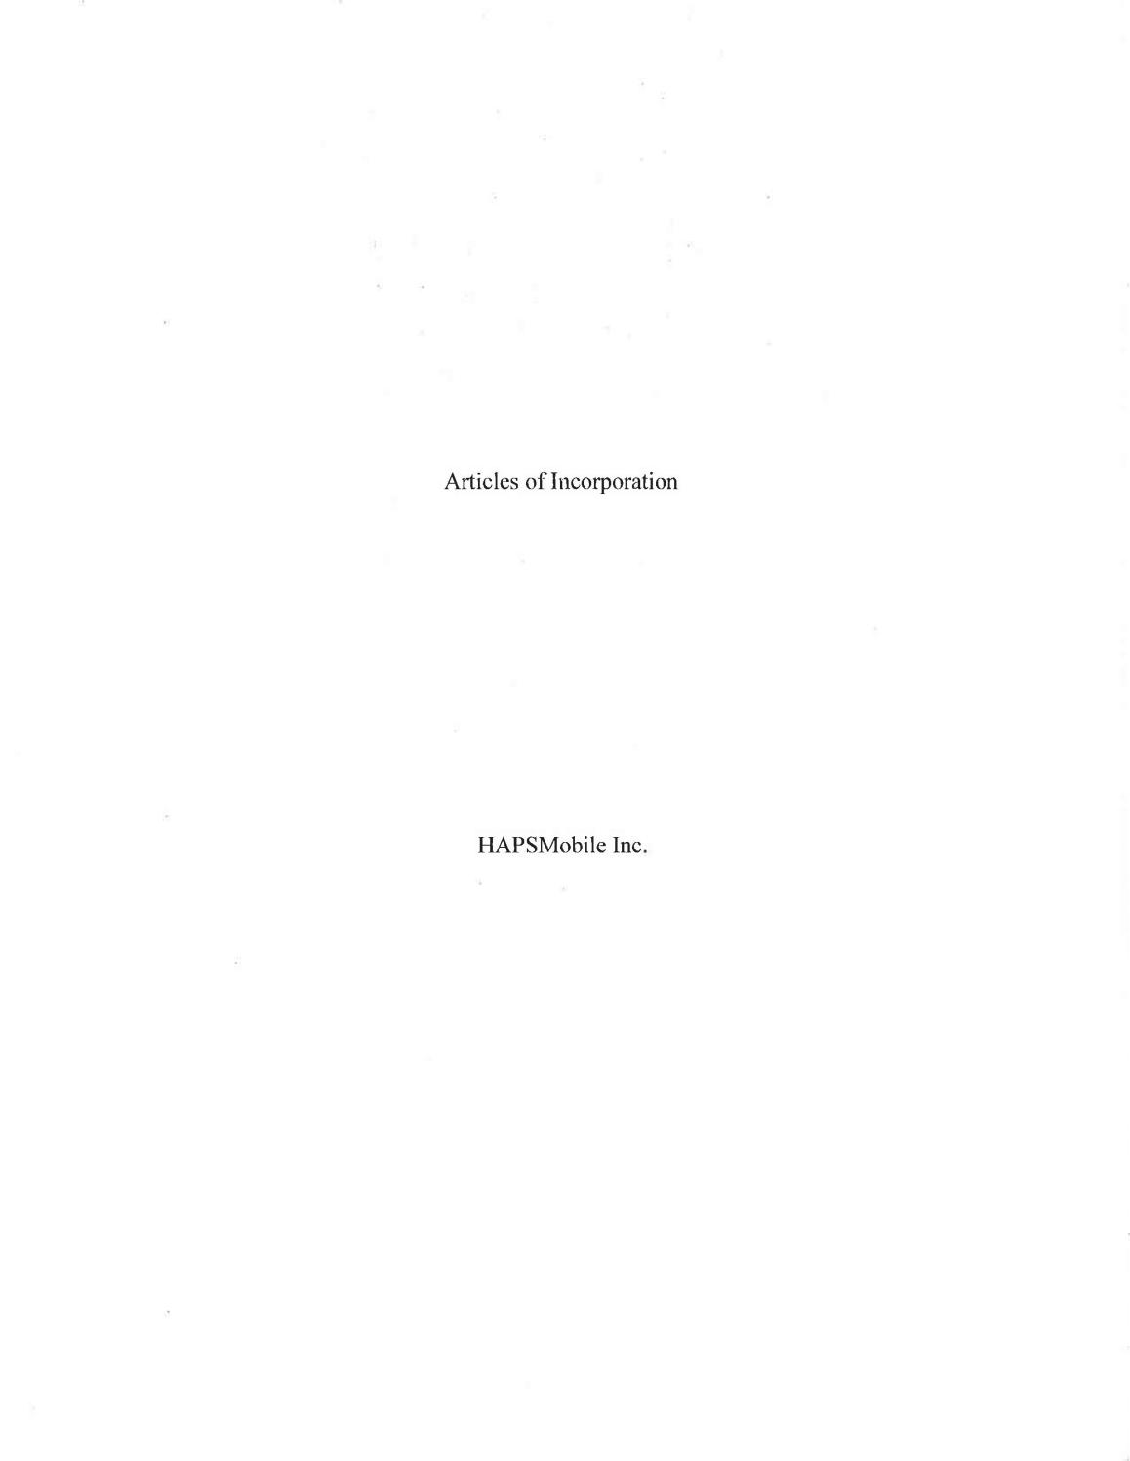

- Information has been omitted and filed separately with the Securities and Exchange Commission. Confidential treatment has been requested with respect to the omitted portions.

-7

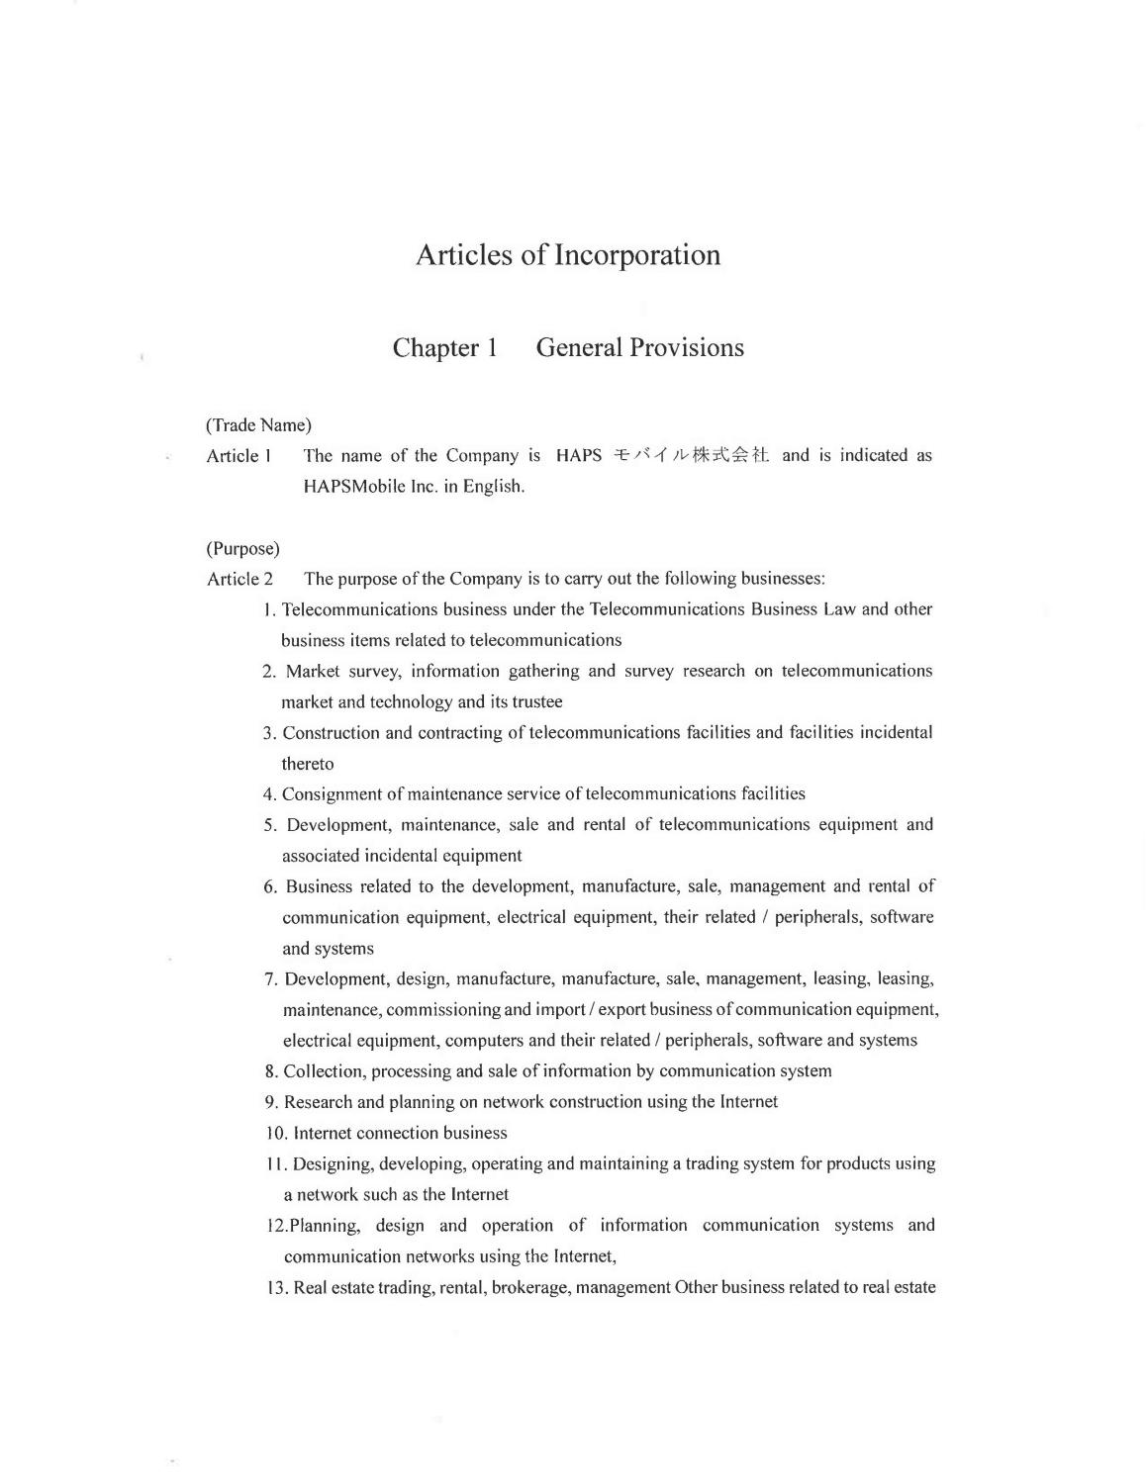

- Information has been omitted and filed separately with the Securities and Exchange Commission. Confidential treatment has been requested with respect to the omitted portions.

-8

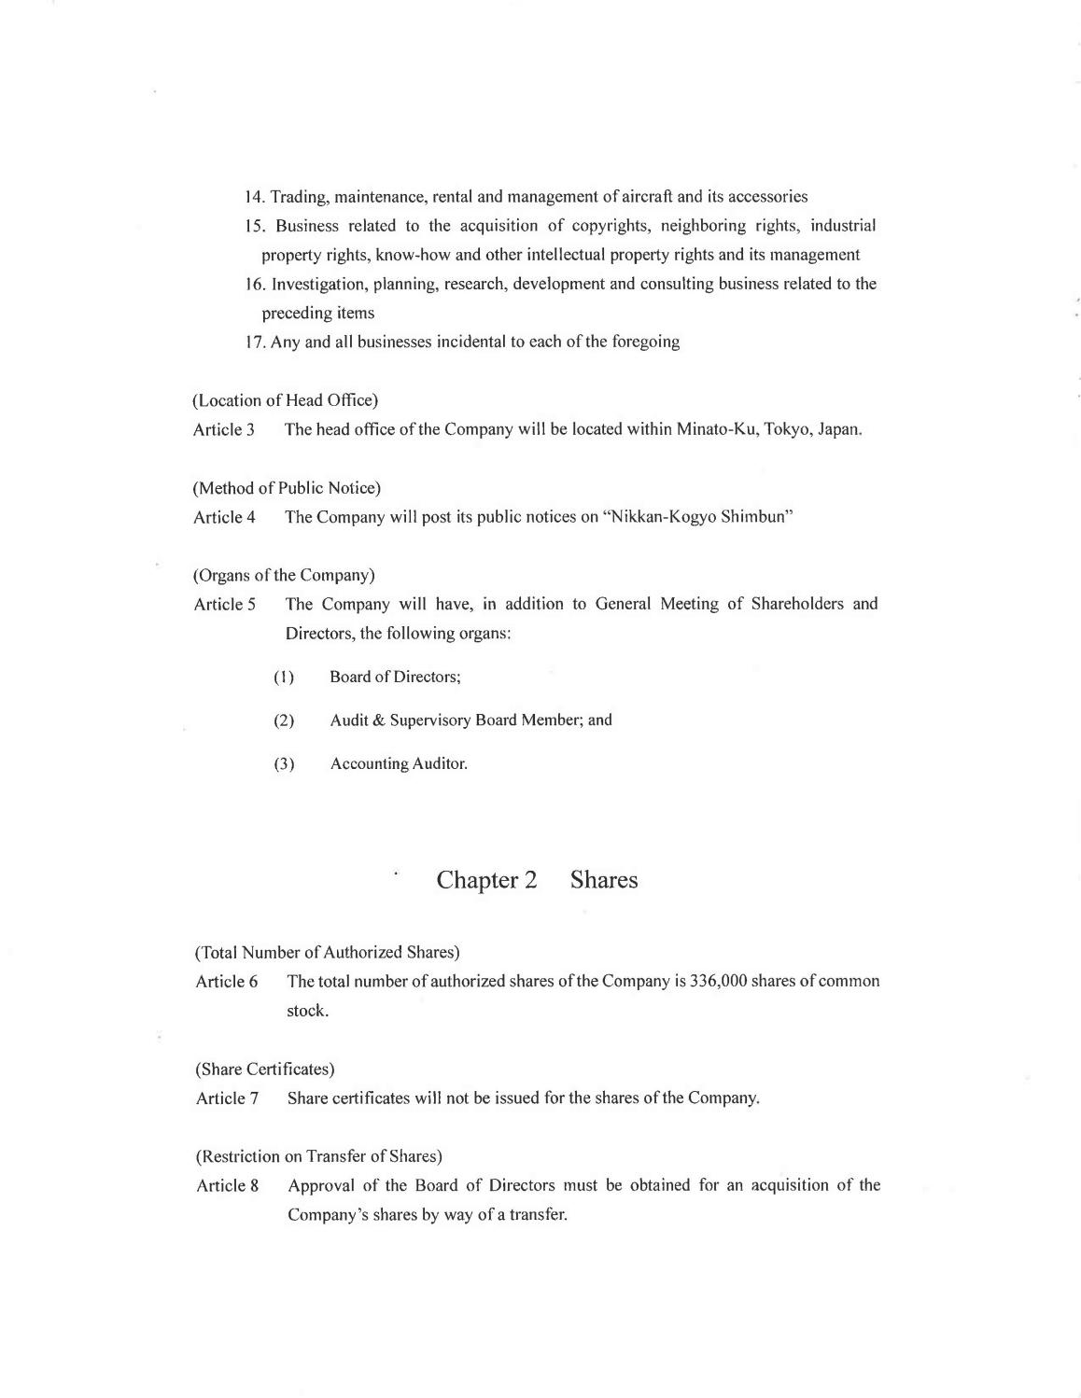

- Information has been omitted and filed separately with the Securities and Exchange Commission. Confidential treatment has been requested with respect to the omitted portions.

-9

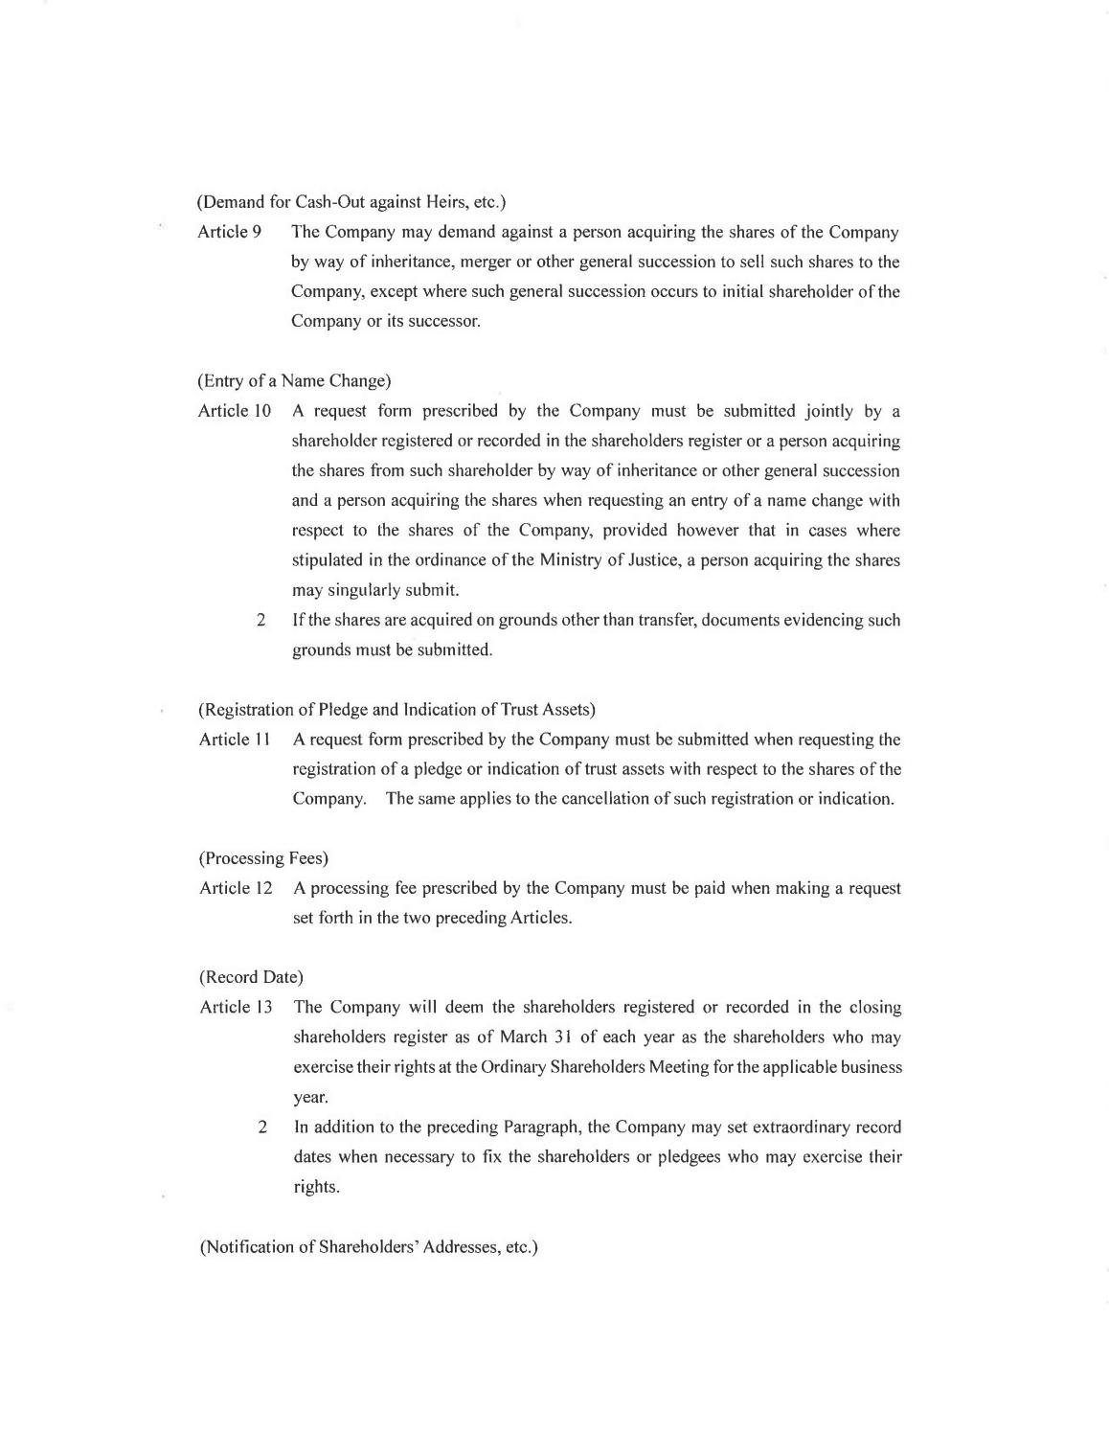

- Information has been omitted and filed separately with the Securities and Exchange Commission. Confidential treatment has been requested with respect to the omitted portions.

-10

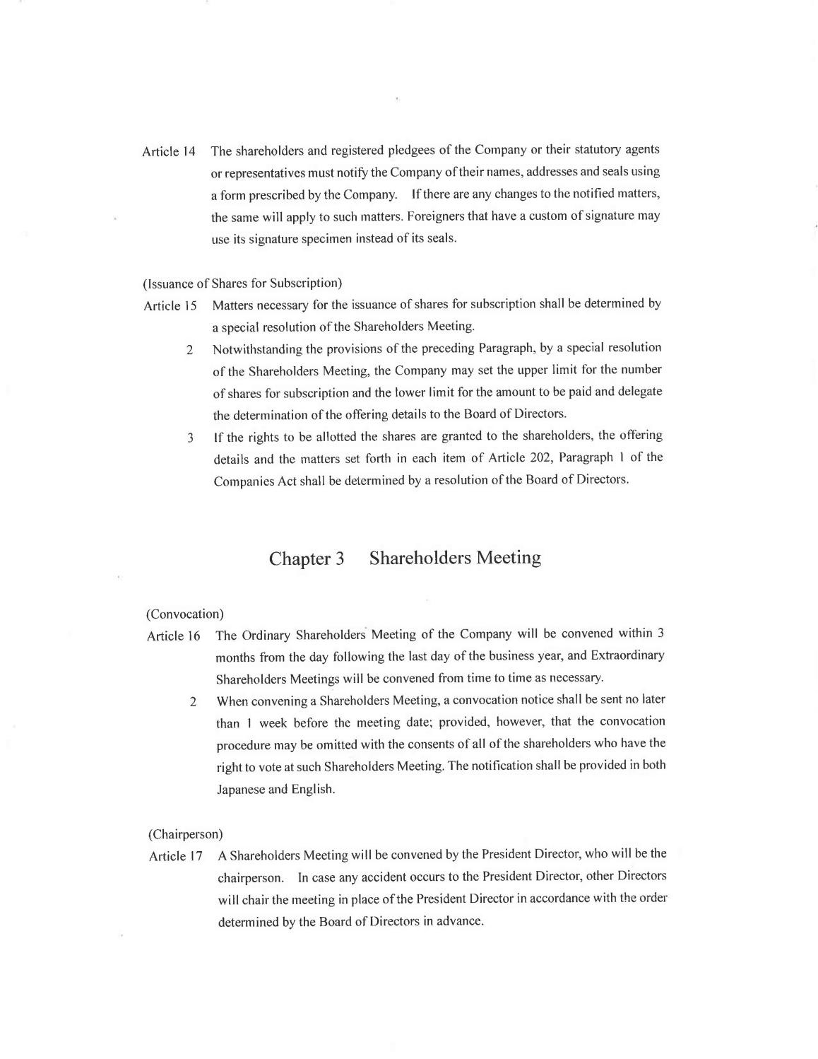

- Information has been omitted and filed separately with the Securities and Exchange Commission. Confidential treatment has been requested with respect to the omitted portions.

-11

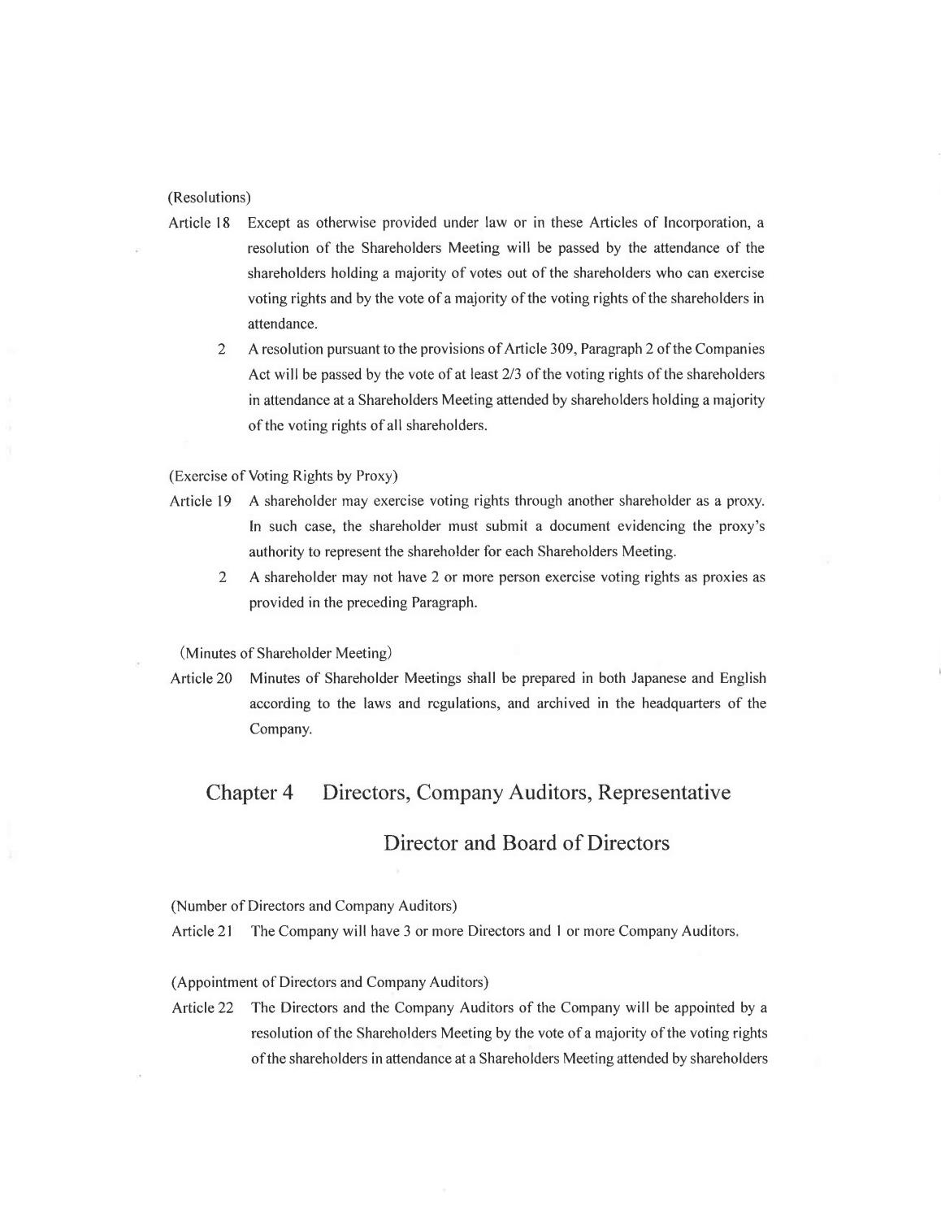

- Information has been omitted and filed separately with the Securities and Exchange Commission. Confidential treatment has been requested with respect to the omitted portions.

-12

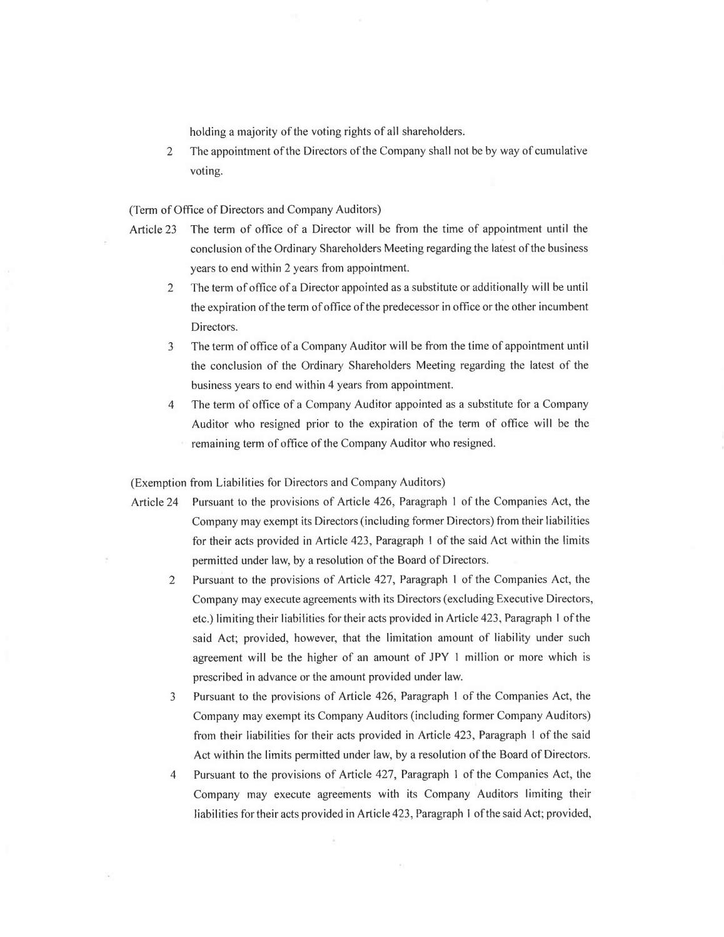

- Information has been omitted and filed separately with the Securities and Exchange Commission. Confidential treatment has been requested with respect to the omitted portions.

-13

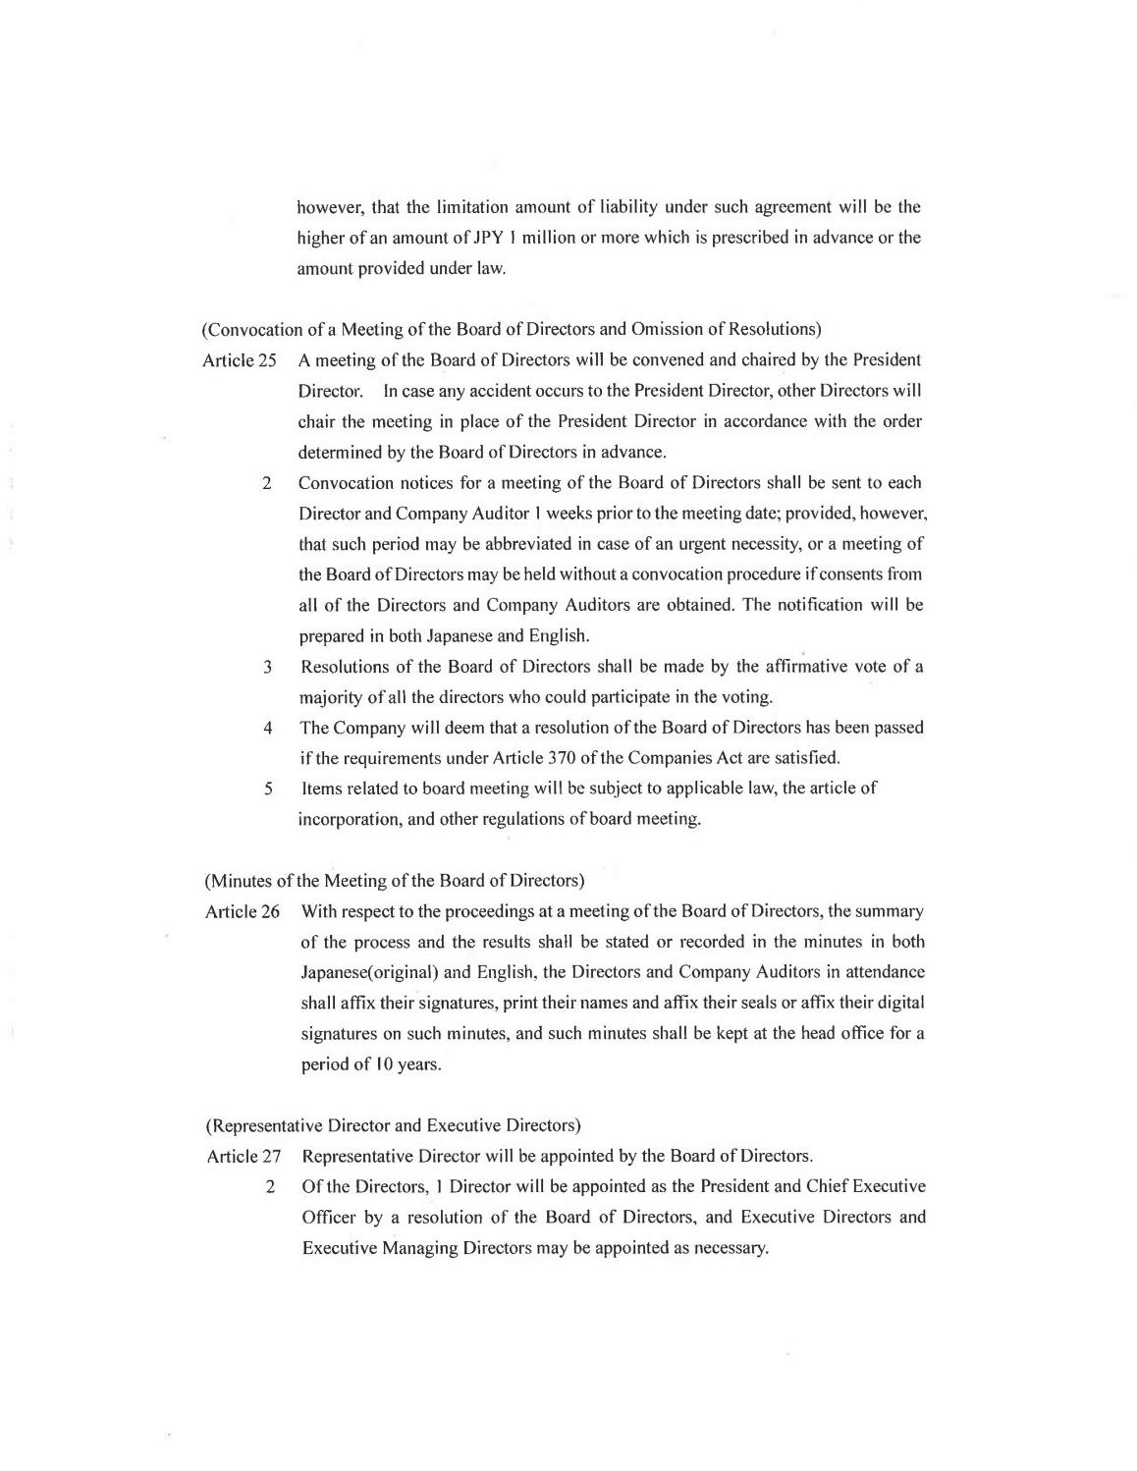

- Information has been omitted and filed separately with the Securities and Exchange Commission. Confidential treatment has been requested with respect to the omitted portions.

-14

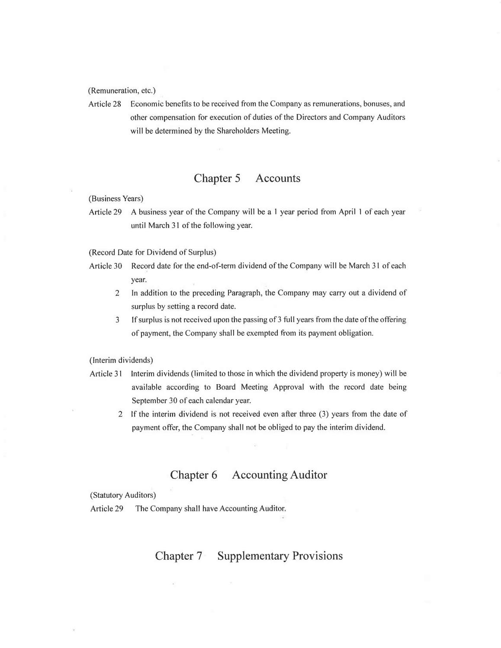

- Information has been omitted and filed separately with the Securities and Exchange Commission. Confidential treatment has been requested with respect to the omitted portions.

-15

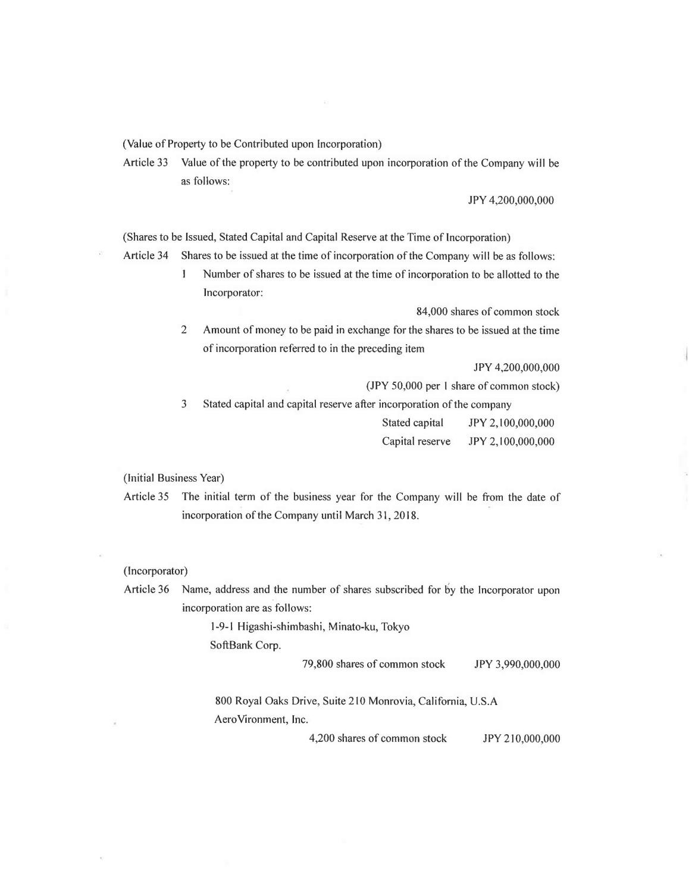

- Information has been omitted and filed separately with the Securities and Exchange Commission. Confidential treatment has been requested with respect to the omitted portions.

-16

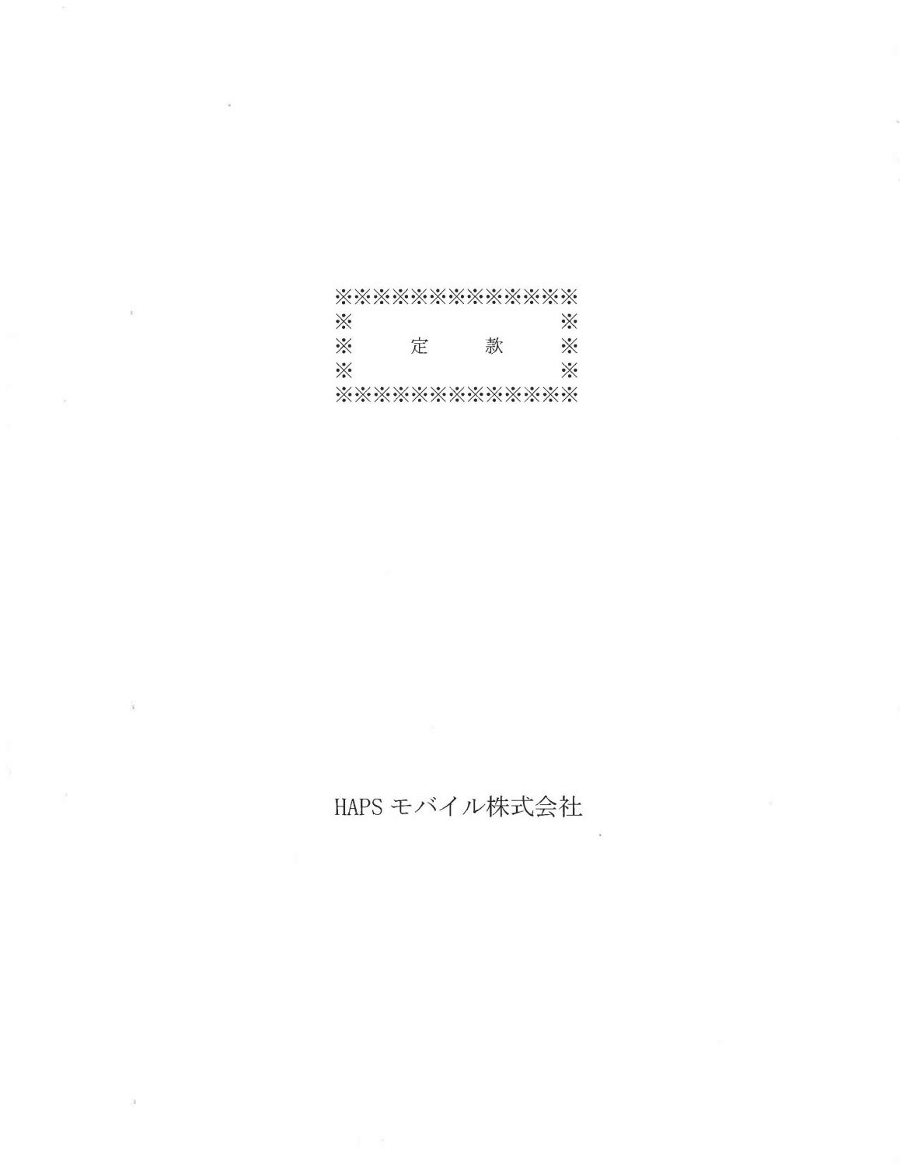

- Information has been omitted and filed separately with the Securities and Exchange Commission. Confidential treatment has been requested with respect to the omitted portions.

-17

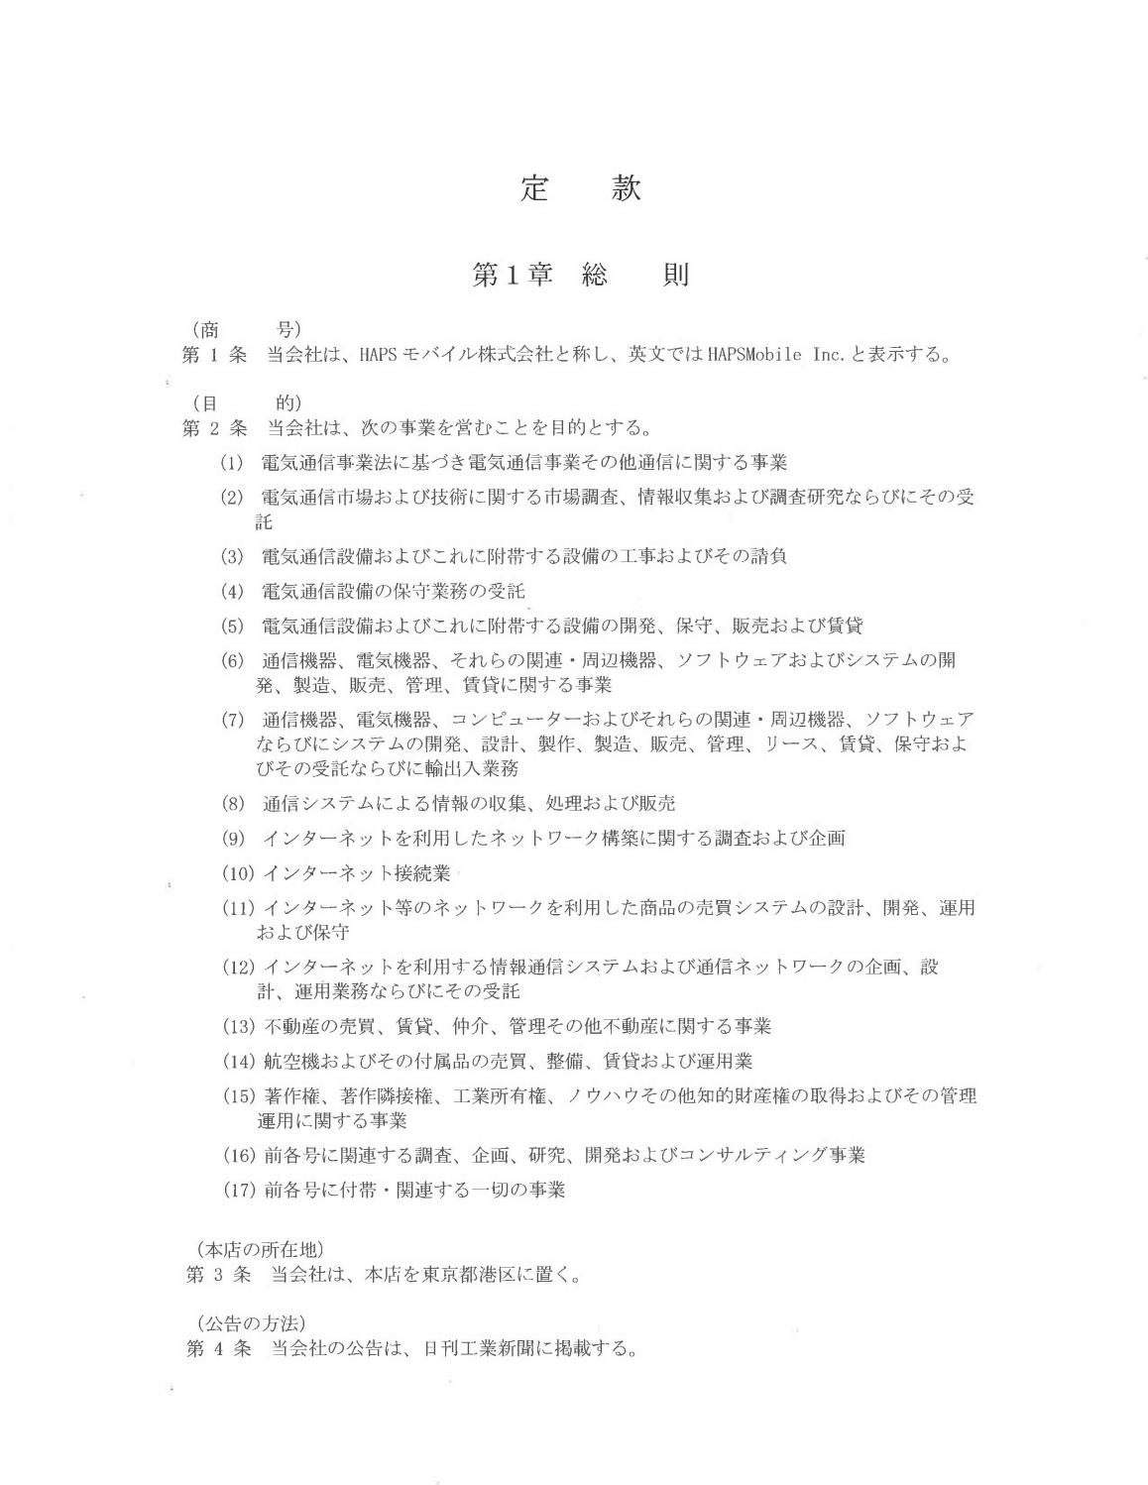

- Information has been omitted and filed separately with the Securities and Exchange Commission. Confidential treatment has been requested with respect to the omitted portions.

-18

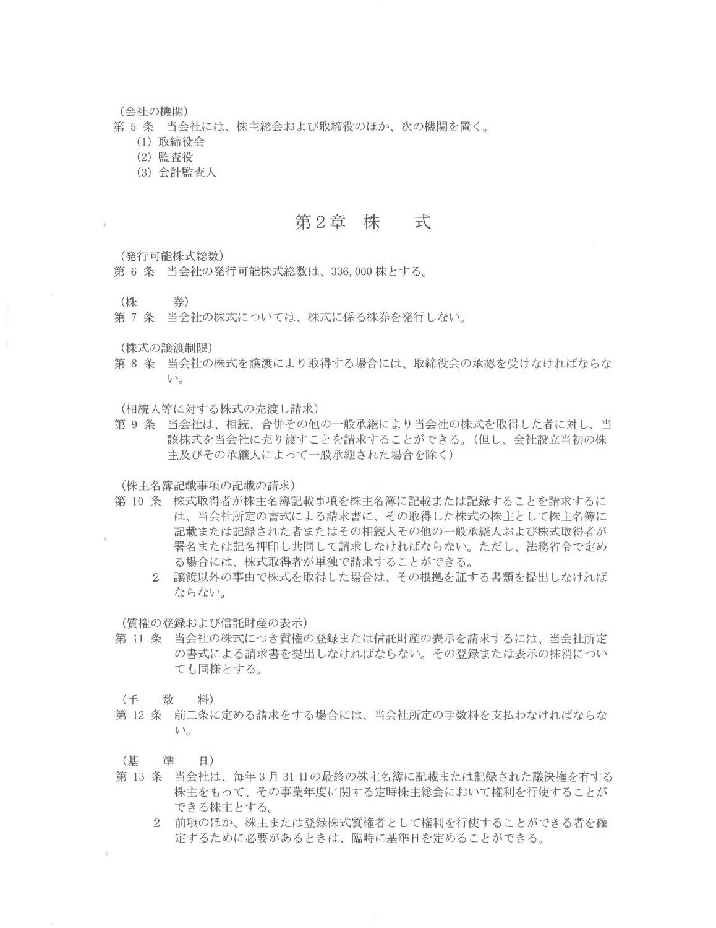

- Information has been omitted and filed separately with the Securities and Exchange Commission. Confidential treatment has been requested with respect to the omitted portions.

-19

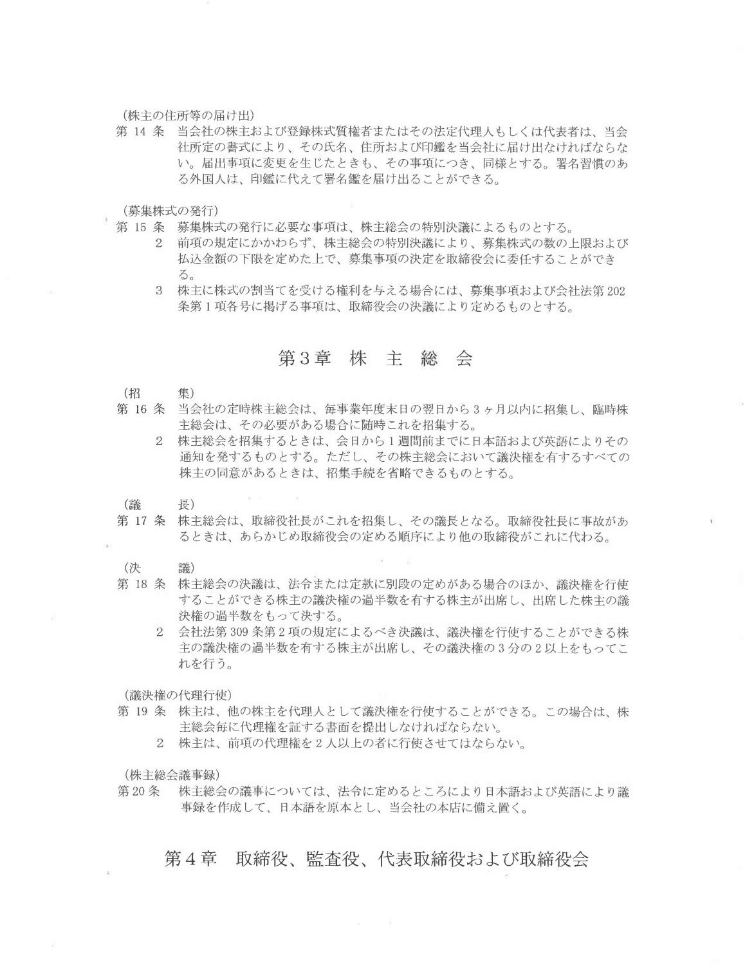

- Information has been omitted and filed separately with the Securities and Exchange Commission. Confidential treatment has been requested with respect to the omitted portions.

-20

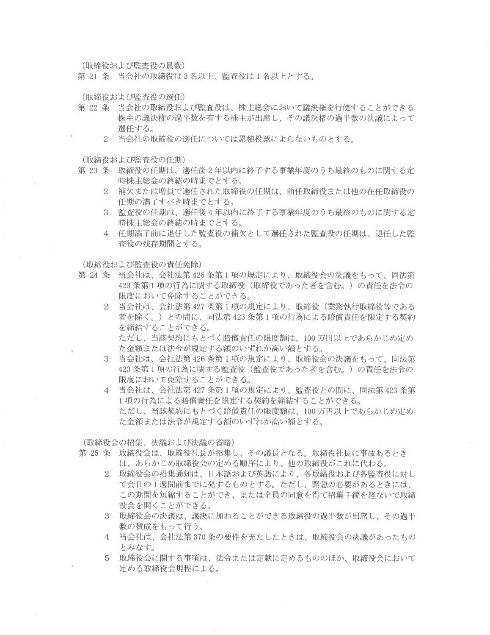

- Information has been omitted and filed separately with the Securities and Exchange Commission. Confidential treatment has been requested with respect to the omitted portions.

-21

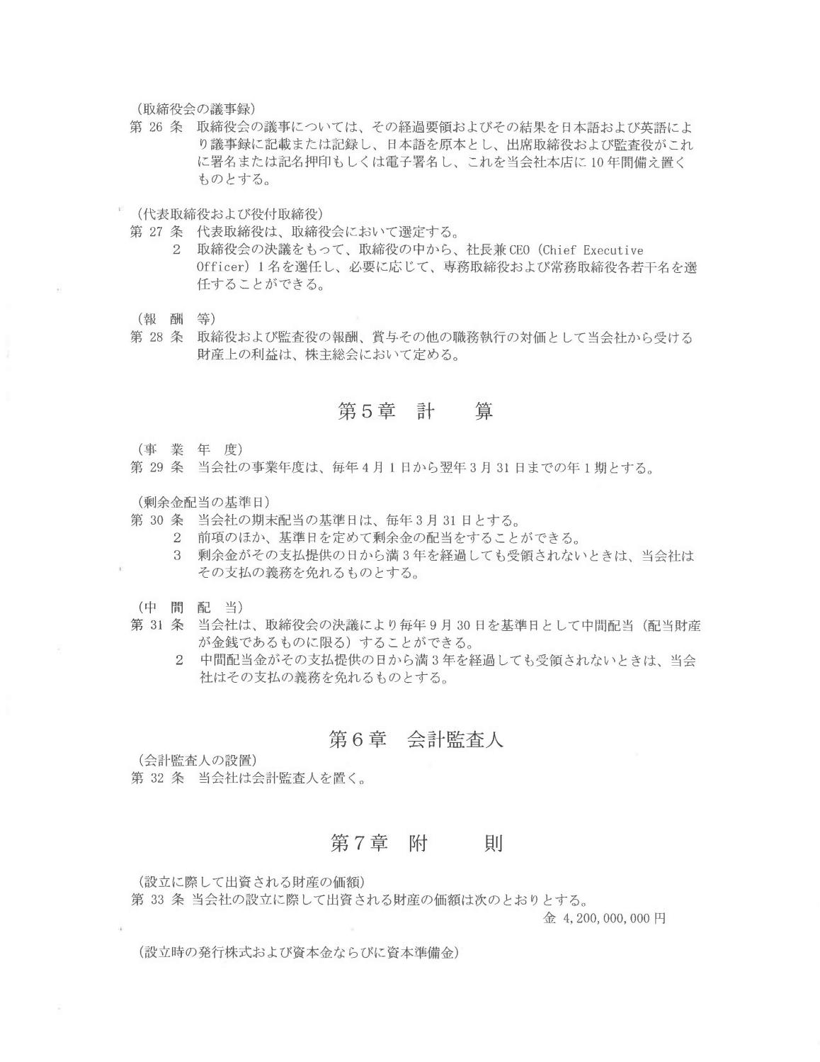

- Information has been omitted and filed separately with the Securities and Exchange Commission. Confidential treatment has been requested with respect to the omitted portions.

-22

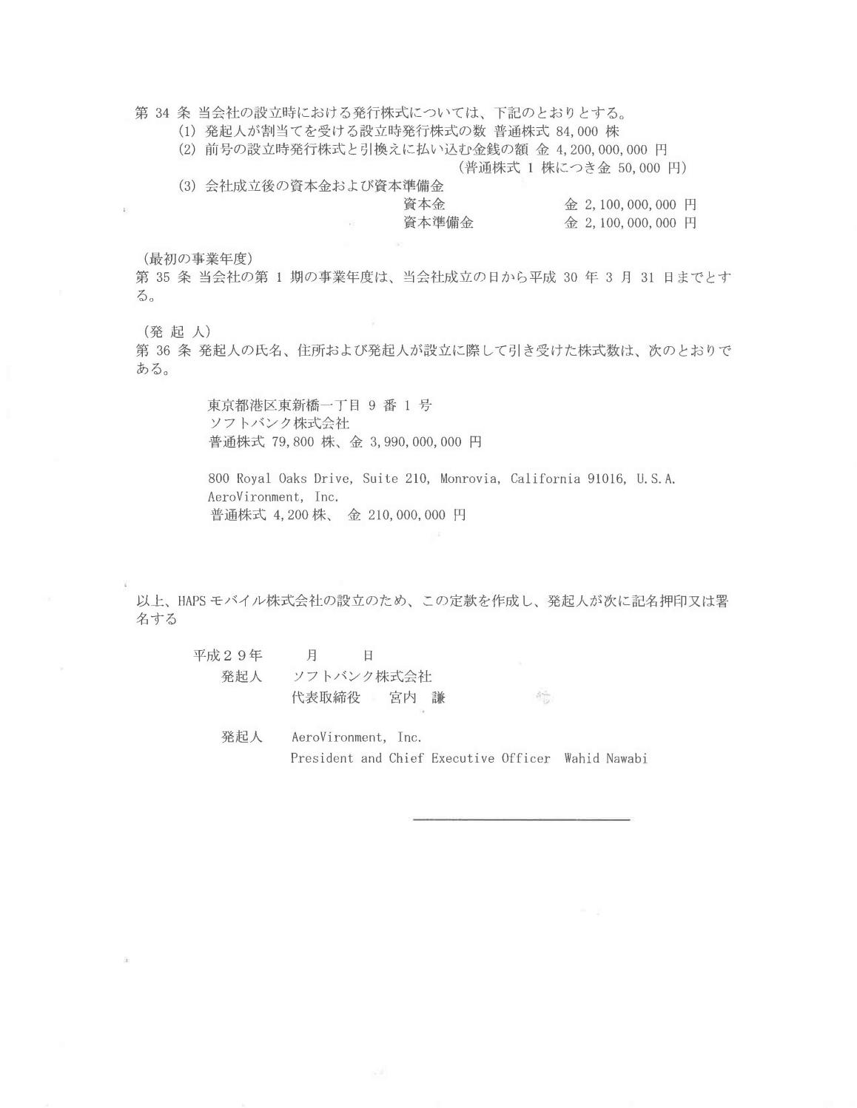

- Information has been omitted and filed separately with the Securities and Exchange Commission. Confidential treatment has been requested with respect to the omitted portions.

-23

EXHIBIT C

THE INITIAL BUSINESS PLAN AND INITIAL ANNUAL BUDGET

[see attached]

[***]

- Information has been omitted and filed separately with the Securities and Exchange Commission. Confidential treatment has been requested with respect to the omitted portions.

-24

[***]

- Information has been omitted and filed separately with the Securities and Exchange Commission. Confidential treatment has been requested with respect to the omitted portions.

-25

EXHIBIT D

CAPITAL PLAN

[see attached]

- Information has been omitted and filed separately with the Securities and Exchange Commission. Confidential treatment has been requested with respect to the omitted portions.

-26

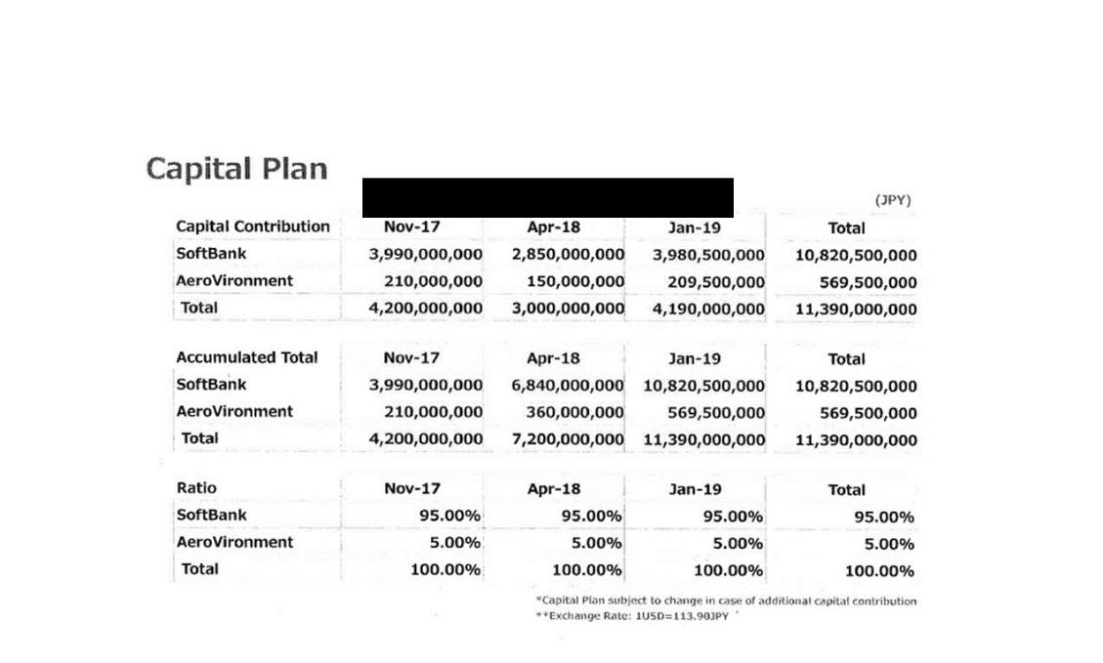

- Information has been omitted and filed separately with the Securities and Exchange Commission. Confidential treatment has been requested with respect to the omitted portions.

[___] = [***]


[***]

- Information has been omitted and filed separately with the Securities and Exchange Commission. Confidential treatment has been requested with respect to the omitted portions.

Exhibit 10.2

CERTAIN MATERIAL (INDICATED BY AN ASTERISK [***]) HAS BEEN OMITTED FROM THIS DOCUMENT PURSUANT TO A REQUEST FOR CONFIDENTIAL TREATMENT. THE OMITTED MATERIAL HAS BEEN FILED SEPARATELY WITH THE SECURITIES AND EXCHANGE COMMISSION.

DESIGN AND DEVELOPMENT AGREEMENT (STEP 2)

This Step 2 Design and Development Agreement (this “Agreement”) is entered into as of, 2017 (the “Effective Date”) by and between HAPSMobile Inc., a Japanese corporation having its principal place of business at 1-9-1 Higashi-Shimbashi, Minato-ku, Tokyo, Japan (“HAPSMobile”) and AeroVironment, Inc., a Delaware corporation having its principal place of business at 800 Royal Oaks Drive, Suite 210, Monrovia, CA 91016, U.S.A. (“AV”). HAPSMobile and AV hereinafter will be referred to individually as “Party” and collectively as “Parties”.

RECITALS

- AV is a company with a well-established history in the business of the design and manufacture of unmanned, solar-powered, high altitude aircraft, along with the provision of associated operational and logistics services;

- HAPSMobile is a joint venture company established pursuant to a Joint Venture Agreement (“JVA”) dated December 1, 2017 by and between AV and SoftBank Corp. (“SoftBank”), and is in the business of, among other things, researching Solar HAPS (as defined below);

- AV and SoftBank previously entered into a Design Agreement dated April 26, 2017 pursuant to which AV completed preliminary design work for a Solar HAPS as detailed in such Design Agreement, which comprises Step 1 of the contemplated business relationship among AV, SoftBank and HAPSMobile;

- In advance of the establishment of HAPSMobile, AV and SoftBank entered into a Bridge Engineering Services Agreement dated October 19, 2017 (the “Bridge Agreement”) for the purpose of enabling AV to commence work on the design and development that will be subsumed into and become a part of this Agreement, and for SoftBank to be reimbursed by HAPSMobile for the amounts paid to AV under the Bridge Agreement;

- The Parties and Softbank intend to enter into an Intellectual Property License Agreement (the “IPLA”) to define various terms and conditions related to intellectual property rights of the Parties and SoftBank; and

- The Parties now desire to enter into this Agreement to define and set out the terms and conditions of a definitive working relationship to carry out the detailed design and development work for the Solar HAPS which comprises Step 2 of the contemplated business relationship between AV and HAPSMobile.

In consideration of the mutual covenants, promises and agreements contained herein, the Parties agree with each other as follows:

1. DEFINITIONS

In this Agreement, unless otherwise specified, the following terms shall have the meanings ascribed thereto:

1.1 “Acceptance Certificate” means the written document issued by HAPSMobile to AV in the form attached as Attachment B that confirms HAPSMobile’s acceptance of a Deliverable.

1.2 “Acceptance Tests” means acceptance process and criteria as defined in the Acceptance as Attachment B hereto.

1.3 “Agreement” means this Agreement and the Attachments attached to it, as amended from time to time.

1.4 “Aircraft Deliverables” means the [***] Prototype aircraft to be delivered by AV to HAPSMobile as set forth in Attachment A entitled Deliverables.

1.5 “Aircraft Intellectual Property” means New IP embodied in the Aircraft Deliverables.

- Information has been omitted and filed separately with the Securities and Exchange Commission. Confidential treatment has been requested with respect to the omitted portions.

1.6 “Aircraft Technology” means Solar HAPS aircraft related: technology, formulae, algorithms, procedures, processes, methods, techniques, know-how, ideas, creations, inventions, discoveries, and improvements (whether patentable or unpatentable and whether or not reduced to practice), information and materials, software, specifications, designs, models, devices, prototypes, schematics, mask works, and other works of authorship; databases; trade secrets and other confidential and proprietary information, which are embodied in the Aircraft Deliverables.

1.7 “Aircraft Work Product” subject to and in accordance with Section 4.8 of the IPLA, means Aircraft Technology and Aircraft Intellectual Property in such Aircraft Technology that AV first creates, develops and conceives for HAPSMobile in performance required by AV under this Agreement which is embodied in the Aircraft Deliverables. The intellectual Property rights of the Aircraft Work Product shall be incorporated into the New IP. For the avoidance of doubt, “Aircraft Work Product” and the “New IP” do not include any AV Background IP or any Third Party IP.

1.8 “Attachments” mean the Attachments to this Agreement.

1.9 “AV Background IP” has the meaning ascribed thereto in the IPLA.

1.10 “Business Day” means any day other than Saturday, Sunday and any day which is a legal holiday in either Japan or the State of California.

1.11 “Change Control” means a requested Change to Attachments A or C or D to this Agreement, in the format and in accordance with Attachment G.

1.12 “Estimated Completion Dates” means the expected dates on which the Deliverables and Milestones are to be completed by AV as specified in Attachment A and Attachment H.

1.13 “Deliverables” means the Document Deliverables and Hardware Deliverables set forth in Attachment A that AV will deliver to HAPSMobile under this Agreement.

1.14 “Delivery Terms” means the Incoterms applicable for delivery of Hardware Deliverables, which Incoterms will be CIF or CIP, depending on the necessary method of transport.

1.15 “Document Deliverables” means the designs, drawings, schematics, specifications, engineering documents, part lists, test plans and other documents that are a part of or otherwise included in the Deliverables set forth in Attachment A.

1.16 “Flight Tests” means the “Low Altitude Flight Test” and the “High Altitude Flight Test” specified as Milestones [***], respectively, on Attachments E and H.

1.17 “Force Majeure” means events that are beyond the reasonable control of the Party claiming Force Majeure, which occur after the Effective Date and which were not reasonably foreseeable prior to that Effective Date and whose effects are not capable of being overcome. Events of Force Majeure include but are not limited to governmental act, war, the threat of imminent war, riots, civil commotion, fires, explosions, storms, floods, lightning, earthquakes and other natural calamities. Inability of a Party, notwithstanding its reasonable efforts, to acquire necessary export/import authorizations shall constitute Force Majeure.

1.18 “Ground Control Systems” means the specific Ground Control Station referred to in Attachment A entitled Deliverables.

1.19 “Hardware Deliverables” means the hardware to be delivered to HAPSMobile as listed on Attachment A, which includes the Aircraft Deliverables.

1.20 “[***] Prototype” means the specific [***] Prototype stratospheric solar aircraft [***] referred to in Attachment A entitled Deliverables.

1.21 “[***] Systems” means both [***] Prototype and Ground Control Systems.

1.22 “Incurred Costs” means all costs actually incurred by AV in performance of this Agreement including but not limited to engineering, administrative, service and manufacturing labor, materials, subcontracts, travel and other direct costs. This shall include all applicable indirect rates for engineering overhead, manufacturing overhead, material overhead and selling general and administrative costs.

- Information has been omitted and filed separately with the Securities and Exchange Commission. Confidential treatment has been requested with respect to the omitted portions.

2

1.23 “Incurred Cost Documentation” means the documentation to be supplied by AV to HAPSMobile with each invoice for payment which sets forth the details of the Incurred Costs for such invoice, in accordance with Attachment F.

1.24 “Insolvency Event” means each and any of the following:

- the issue of a petition for winding up which is not dismissed within twenty eight (28) days of its issue; or

- the making of an order or an effective resolution being passed for winding up except for the purposes of a solvent reconstruction or amalgamation on a basis previously approved (where such approval can reasonably be sought in advance, taking account of commercial confidentiality and regulatory requirements) and where the resulting entity assumes in writing all of the obligations of the relevant Party under this Agreement; or

- the making of an order for the appointment of an administrative receiver, administrator, trustee, liquidator, manager or similar officer; or

- an encumbrancer, receiver (including an administrative receiver) or other similar officer taking possession of the whole or any part (which is material in the context of the performance of the affected Party’s obligations under this Agreement) of such Party’s undertaking, property or assets; or

- the making or proposing of making of a composition with creditors generally;

1.25 “Intellectual Property” has the meaning ascribed thereto in the JVA.

1.26 “IPLA” means the Intellectual Property License Agreement of even date herewith among HAPSMobile, AV and SoftBank.

1.27 “JVA” means the joint venture agreement between AV and SoftBank referred to in Recital B above.

1.28 Milestone(s) – means the Milestones listed on Attachment H which are to be completed by AV under this Agreement.

1.29 “New IP” has the meaning ascribed thereto in the IPLA.

1.30 “Order” means a purchase order or a work order issued under this Agreement that specifies the Statement of Work, Deliverables, related to the work to be performed. Orders will be issued by HAPSMobile and acknowledged by AV.

1.31 “Quarterly Status Report” means the report to be provided by AV to HAPSMobile on a quarterly basis during the term of the Agreement in accordance with Article 3.3 below.

1.32 “Range Fee” means the facility fee and related service fee for using of the test ranges necessary for the implementation of the Flight Test series.

1.33 “Solar HAPS” has the meaning ascribed thereto in the JVA.

1.34 “Specifications” means the HAPSMobile agreed upon requirements for the Deliverables as set forth in Attachment D entitled Specifications.

1.35 “Statement of Work” or “SOW” means the statement of work attached hereto as Attachment C.

1.36 “Technology” means any and all technology, formulae, algorithms, procedures, processes, methods, techniques, know-how, ideas, creations, inventions, discoveries, and improvements (whether patentable or unpatentable and whether or not reduced to practice); information and materials; software, specifications, designs, models, devices, prototypes, schematics, mask works, and other works of authorship; databases; trade secrets and other confidential and proprietary information.

1.37 “Third Party IP” means any Technology or Intellectual Property rights owned or controlled by a third party, including any open-source software licensed by a Party from third parties.

- Information has been omitted and filed separately with the Securities and Exchange Commission. Confidential treatment has been requested with respect to the omitted portions.

3

1.38 “Work Product” means all Technology and Intellectual Property in such Technology, that AV or an AV third party contractor or consultant of AV, first creates, develops, or conceives for HAPSMobile in the performance of this Agreement in connection with the Deliverables. “Work Product” includes all materials and Hardware Deliverables required to be delivered to HAPSMobile under this Agreement but, for the avoidance of doubt, does not include Background IP or Third Party IP.

2. SCOPE AND TERM OF AGREEMENT

2.1 This Agreement shall come into force when signed by authorized representatives of both Parties as of the Effective Date and shall remain in force until AV’s completion of the last Milestone unless terminated earlier under the provisions of Article 12 of this Agreement and all payments required by HAPSMobile have been paid.

2.2 Upon execution of this Agreement, HAPSMobile authorizes AV to begin performance in accordance with the Agreement by providing the first Order.

2.3 Scope of Agreement.

2.3.1 AV agrees to perform the work (the “Work”) specified in the Statement of Work as shown in Attachment C in accordance with the specifications in the Statement of Work, and to provide the Deliverables specified in Attachment A and complete the Milestones listed in Attachment H to HAPSMobile (such obligations, the “Scope of Agreement”). The Parties agree that all Work performed by AV under this Agreement shall be done on a “Best Efforts” basis, meaning that AV will, subject to the terms and conditions herein provided, use commercially reasonable efforts to take, or cause to be taken, actions and to do, or cause to be done, all things reasonably necessary, proper or advisable to perform its obligations under this Agreement up to the funding authorized on Attachment F. AV service provided under the Agreement is performed for the purpose of discovering information that is technical in nature, the results of which are intended to be useful in the development of a new product.

2.3.2 In consideration for AV’s performance of the Work specified in the Statement of Work, HAPSMobile agrees to pay AV the amount specified in Attachment F in accordance with the procedures and terms and conditions specified in such attachment. HAPSMobile agrees to issue the first Order covering the Work to be performed from the Effective Date until March 31, 2018 within ten (10) days of the Effective Date, the terms and conditions of which Order shall be governed by the terms and conditions of this Agreement.

2.4 Change Control. Either Party may propose changes to Attachments A, C or D (a "Change") in accordance with the procedures described in Attachment G ("Change Control"). Neither Party shall be entitled to or obligated by any such Change until it has been presented and approved by both Parties in accordance with such Change Control and the Parties have executed a Change Control. Once executed, a Change Control shall be deemed to supplement or modify, as applicable, the terms and conditions of this Agreement. Unless otherwise agreed, use of the Change Control does not limit or waive any other rights a Party may have in relation to the remedies under this Agreement, including but not limited to, remedies for schedule delays or breach of this Agreement. Unless otherwise agreed, the pricing relating to a Change Control will be calculated using the price basis set forth in Attachment F.

3. DELIVERABLES & MILESTONES

3.1 Milestones. Attachment H defines a series of Milestones for the Work and the completion criteria applicable to the Milestones.

Attachment E defines the particular testing activities associated with the Flight Tests.

3.2 Prevention of Delays. AV agrees to act in a commercially reasonable manner to prevent and minimise delays in completing the Deliverables and Milestones in accordance with the Estimated Completion Dates as provided in Attachment A and Attachment H.

- Information has been omitted and filed separately with the Securities and Exchange Commission. Confidential treatment has been requested with respect to the omitted portions.

4

3.3 Notification of Delays. During the term of the Agreement, AV shall provide to HAPSMobile a Quarterly Status Report per Attachment F, Exhibit B on its performance under the Statement of Work and completion of the Deliverables and Milestones on a quarterly basis. If AV has reason to believe that it will not be able to complete a Deliverable or Milestone on or before its applicable Estimated Completion Date, it shall notify HAPSMobile in the Quarterly Status Report of:

- The cause of the delay;

- The expected period of delay;

- The steps proposed to be taken by AV to minimise the delay; and

- The impact of the delay as related to any projected increase of expected Incurred Costs.

3.4 Changes to Deliverables and Milestones. Any proposed changes to the Specifications, budget or the Estimated Completion Date of a Deliverable or Milestone shall be addressed in accordance with a Change Agreement.

3.5 For Hardware Deliverables, title and risk of loss of all materials, parts and components purchased by AV for the purpose of incorporating into the Hardware Deliverables (together, “Materials”), respectively, upon payment will transfer to HAPSMobile, and HAPSMobile shall pay AV the fee for Materials subject to Clause 1.3 of Attachment F. For the avoidance of doubt, (a) acceptance of fully assembled and finished Hardware Deliverables by HAPSMobile will be made [***], (b) risk of loss of the Hardware Deliverables during Flight Test series will be borne by HAPSMobile, and (c) AV will consult with HAPSMobile for its appropriate insurance arrangement to cover the risk of loss to the Hardware Deliverables during the Flight Test series.

3.6 AV will provide all necessary records to reasonably demonstrate the stock location of the Materials and logistic or manufacturing status of the Materials on a quarterly basis. AV will track and report on the inventory status of Material and assemblies of the Materials on a quarterly basis.

3.7 AV will maintain adequate levels of property insurance to cover replacement costs for the HAPSMobile owned Materials, assemblies thereof, and finished Hardware Deliverables located at AV’s facility. AV also agrees that it will ensure, prior to providing any HAPSMobile-owned Materials, assemblies thereof, or finished Hardware Deliverables, to any of AV’s subcontractors or vendors (including, but not limited to, laboratories, test beds, test yards or warehouses) that such subcontractors and/or vendors maintain adequate levels of property insurance to cover replacement costs for the HAPSMobile property being provided by AV to such subcontractor or vendor. AV will provide reasonable access and assistance to HAPSMobile for its inventory control or stock taking on HAPSMobile owned Materials, assemblies thereof, or finished Hardware Deliverables.

3.8 To the extent that the Work requires the application of California use tax to AV’s procurement of Materials, subcontracting by AV and other direct costs incurred, AV shall itemize and bill such use tax as part of AV’s monthly invoices to HAPSMobile.

  - RESERVED

- EXPORT RULES AND REGULATIONS

5.1 Export Rules and Regulations. Each Party agrees to comply with all applicable governmental regulations as they relate to the import, export and re-export of information and Deliverables. Without limiting the foregoing, neither Party shall disclose or deliver any information or Deliverables in any manner contrary to any applicable export or import laws and regulations. The Parties acknowledge that these laws and regulations impose restrictions on the import, export and transfer to third parties and countries of certain types of Deliverables, and that authorizations or

- Information has been omitted and filed separately with the Securities and Exchange Commission. Confidential treatment has been requested with respect to the omitted portions.

5

licenses from the applicable regulatory agency may be required before such items may be disclosed or delivered.

6. ACCEPTANCE OF DELIVERABLES AND COMPLETION OF MILESTONES

6.1 Completion of Deliverables. For each Deliverable, AV shall provide written notice to HAPSMobile of the anticipated actual completion date for such Deliverable no later than 30 days prior to such date. During said 30-day period, AV will reasonably endeavour to provide advance access to the Deliverables to HAPSMobile in order to facilitate prompt acceptance for the purpose of limiting impact on the schedule of the development program contemplated by this Agreement.

6.2 Acceptance of Deliverables. The procedures for the acceptance by HAPSMobile of the Deliverables is detailed in Attachment B.

6.3 Delivery of Hardware Deliverables. Delivery of the Hardware Deliverables shall be per the applicable Delivery Terms. HAPSMobile Acceptance is required prior to shipment of the Hardware Deliverables.

6.4 Completion of Milestones. Upon the completion of the completion criteria for each Milestone specified on Attachment H, AV will provide written notice to HAPSMobile

6.5 Disputes. In the event that a dispute arises between the Parties regarding the acceptance or rejection of a Deliverable or completion of a Milestone such dispute shall be dealt with in accordance with Article 17.

7. PRICE AND PAYMENT

7.1 Payment for the Work; HAPSMobile shall pay to AV the fees set forth at Attachment F (collectively, the “Fees”) according to the payment terms specified therein. The Fees may incorporate any adjustments resulting from Change Agreements executed during the Agreement term.

7.2 Expenses; Unless otherwise stated in the Statement of Work or in any Change Control or any other amendments to this Agreement, the Fees are inclusive of travel and related expenses. If expressly set forth in a Change Control or any other amendments to this Agreement, HAPSMobile shall reimburse AV for the reasonable actual Incurred Cost and [***]% fee for expenses incurred in the performance of Work to the extent such expenses are not included in the Fees, provided they are authorized in writing in advance and copies of receipts are submitted with all invoices at the beginning of each month, for expenses incurred during the prior month.

7.3 Method of Payment; Finance Charges. Invoices will be submitted by AV to HAPSMobile in accordance with Attachment F. All amounts to be paid to AV under this Agreement shall be paid by wire transfer to the account or accounts designated by AV from time to time or by such other method as is mutually determined by the Parties. Any amount owed by HAPSMobile to AV that is not paid on or before the date such amount is due will bear interest until paid at a rate equal to [***]% per annum or the maximum rate permitted by law, whichever is less.

7.4 AV will provide updates on the potential for cost increases or decreases for the completion of the Scope of Agreement in the Quarterly Status Report as identified in Attachment F.

7.5 Unutilized Consideration and Excess Incurred Costs. Unutilized consideration and excess Incurred Costs shall be utilized as set forth in Attachment F.

7.6 Currency. All payments under this Agreement shall be made in United States dollars.

8. AV’S REPRESENTATIONS AND WARRANTIES

8.1 AV represents, warrants and covenants to HAPSMobile that:

- Information has been omitted and filed separately with the Securities and Exchange Commission. Confidential treatment has been requested with respect to the omitted portions.

6

- Agreement - it shall execute and perform its obligations under this Agreement in good faith with due care, diligence, skill and competence, applying all of its knowledge, experience and ability and in accordance with best industry practice;

- Incorporation - it is a company duly incorporated under the laws of Delaware, USA and has the corporate power and authority to accept the terms of this Agreement and to perform its obligations hereunder;

- Execution & Delivery - The execution and delivery by AV of this Agreement, the performance by AV of its obligations hereunder and the consummation by AV of the transactions contemplated herein have been duly authorized by all requisite corporate action on the part of AV. This Agreement has been duly executed and delivered by AV and (assuming due authorization, execution and delivery by HAPSMobile) this Agreement constitutes a legal, valid and binding obligation of AV enforceable against AV in accordance with its terms;

- Software - AV shall perform an industry standard reasonable screening process on software supplied pursuant to this Agreement to screen such software for viruses, or other contaminants or devices (including, without limitation), worms, logic
bombs, spyware, trojan horses or other programs that are intended to, and do, cause malfunctions or damage to, or erase the software or data contained in, recipient’s other software or data, and if any such items are detected, AV will promptly remove such malicious technology;

- Work - Work will be provided in a timely, professional, and workmanlike manner. Work will be performed by technically appropriate and fitting process and methodology for specific market of same category of engineering service. It will be including, but not limited to, the implementation of necessary set of computer based structured analysis, aero dynamics analysis, and other necessary CAE process;

- AV Personnel - AV Personnel will have the requisite experience, skills, knowledge, training and education to perform Work in accordance with this Agreement.

- Hardware Deliverables will comply necessary regulations, of the relevant governmental or other related authorities to perform the necessary Flight Test at the baseline test location, as set forth in Attachment C or E hereto.

- AV to provide third-party commercial warranty coverage as applicable on a component level if such warranty is being provided from its suppliers. No Deliverable level warranty shall exist as this program is for the design and development of prototype equipment. AV to maintain and operate the Hardware Deliverables as required throughout the Flight Tests on a Best Effort basis.

- Documentation - AV will provide, maintain, and update all documentation, which documentation will be detailed, comprehensive, and prepared in conformance with generally accepted best industry standards of professional care, skill, diligence, and competence.

- AV acknowledges and agrees that in entering into this Agreement it has not relied and is not relying on any representations, warranties or other statements whatsoever, whether written or oral, other than those expressly set out in this Agreement (or other related documents referred to herein) and that it will not have any right or remedy rising out of any representation, warranty or other statement not expressly set out in this Agreement.

8.2 HAPSMobile represents and warrants to AV that:

  - Agreement - it shall execute and perform its obligations under this Agreement in good faith with due care, diligence, skill and competence, applying all of its knowledge, experience and ability and in accordance with best industry practice.

- Information has been omitted and filed separately with the Securities and Exchange Commission. Confidential treatment has been requested with respect to the omitted portions.

7

  - Incorporation - it is a company duly formed and existing under the laws of Japan, and has the corporate power and authority to accept the terms of this Agreement and to perform its obligations hereunder.

  - Execution & Delivery - The execution and delivery by HAPSMobile of this Agreement, the performance by HAPSMobile of its obligations hereunder and the consummation by HAPSMobile of the transactions contemplated herein have been duly authorized by all requisite corporate action on the part of HAPSMobile. This Agreement has been duly executed and delivered by HAPSMobile and (assuming due authorization, execution and delivery by AV) this Agreement constitutes a legal, valid and binding obligation of HAPSMobile enforceable against HAPSMobile in accordance with its terms.

    - HAPSMobile acknowledges and agrees that in entering into this Agreement it has not relied and is not relying on any representations, warranties or other statements whatsoever, whether written or oral, other than those expressly set out in this Agreement (or other related documents referred to herein) and that it will not have any right or remedy rising out of any representation, warranty or other statement not expressly set out in this Agreement.

- PROJECT MANAGEMENT

9.1 Project Managers. Each Party shall designate a project manager (each, a "Project Manager"). The Project Managers shall have overall responsibility for day-to-day management and administration of the Work provided under this Agreement and shall otherwise perform the responsibilities set forth in the SOW. Project Management shall be performed as described within Attachment I.

9.2 Steering Committee. The Parties shall establish a steering committee (the "Steering Committee") made up of not less than three key executives from each Party (inclusive of the AV Project Manager and the HAPSMobile Project Manager), which shall meet, from time to time, and at such time as its members or the Parties deem appropriate. Each Party may replace its members of the Steering Committee after providing the other Party with reasonable advance written notice and after consultation with the other Party. Each Party shall use reasonable efforts to minimize the turnover of individuals serving on the Steering Committee. The Steering Committee shall meet at such times and places as are agreed upon by the Parties, but at least once per month. The Steering Committee shall (i) prepare written minutes of its meetings, (ii) monitor overall project status and service performance, (iii) review new service and project requests, (iv) review and approve all Change Agreement proposals, (v) review and approve major information technology related decisions and (vi) resolve Disputes in accordance with dispute resolution process. The Change Control shall be used to implement applicable recommendations and decisions of the Steering Committee. The members of the Steering Committee will not have separate voting rights; instead, each Party will have one vote. All actions of the Steering Committee required under this Agreement will require the unanimous vote of the Parties.

9.3 AV Staffing. AV shall assign personnel and subcontractors to the HAPSMobile account who possess the training, education, experience and skill levels appropriate for the Work to be provided by such personnel and in accordance with the SOW. AV reserves the right to determine which of its personnel shall be assigned to perform Work, and to replace or reassign such personnel during the Agreement Term; provided, however, that AV, subject to scheduling and staffing considerations, shall use good faith efforts to honor HAPSMobile's request for or lawful objection to specific individuals. Except in the event of resignation, death, disability, termination, end of principal task or assignment, or promotion, demotion, or disciplinary issue, AV may not remove AV Key Personnel without providing written notification to the Project Owner set forth in Attachment I, which consent shall not be unreasonably withheld. HAPSMobile will not incur any additional Fees (including any additional expenses) due to any change in AV or AV’s subcontractor personnel. In the event AV removes any AV Key personnel, AV shall assign an equivalent or more skilled and experienced replacement without delay. Both Parties acknowledge and understand that nothing in

- Information has been omitted and filed separately with the Securities and Exchange Commission. Confidential treatment has been requested with respect to the omitted portions.

8

this Agreement shall alter, and that AV has no obligation pursuant to this Agreement to alter, the at-will nature of any AV employee.

9.4 HAPSMobile Staffing. HAPSMobile shall assign personnel for the performance of the HAPSMobile responsibilities who possess the appropriate qualifications. Upon reasonable request by AV, HAPSMobile shall remove and/or replace specific personnel assigned to perform effort under this Agreement by HAPSMobile. Except in the event of resignation, death, disability or termination, HAPSMobile shall notify AV in writing at least 30 days prior to replacing any HAPSMobile Key Personnel. In the event of any replacement of HAPSMobile Key Personnel, HAPSMobile shall provide for an appropriate transition (overlap) period for the new individual and use commercially reasonable efforts to minimize any disruption such replacement may cause in the performance of HAPSMobile's obligations under this Agreement.

9.5 Non-solicitation of Employees. Neither Party shall solicit, offer work to, employ or contract with the other Party's personnel who are performing effort under this Agreement as an employee, partner or independent contractor (collectively “Covered Individuals”) during the term of that individual's involvement under this Agreement for a period of [***] following that individual's participation in any effort under the Agreement, without first obtaining the written consent of the other Party; provided, however, that the foregoing restrictions shall not apply to any Covered Individual of a Party who responds to a general solicitation or advertisement by the other Party that is not directed specifically at Covered Individuals of such other Party.

10. INTELLECTUAL PROPERTY

10.1 No Implied Rights. Except as otherwise expressly indicated in this Agreement, HAPSMobile will not, by any reason including AV’s performance of this Agreement and/or delivery of the Deliverables, acquire any right, title or interest (including any covenant, immunity, authorization, license rights, or other rights) in any of AV’s Background IP. Other than as expressly set forth in this Article 10, no right, title or interest in any Intellectual Property of AV is granted to HAPSMobile pursuant to this Agreement.

10.2 All Aircraft Work Product will be the property of HAPSMobile and shall be incorporated into the New IP provided that HAPSMobile grants back to AV the licenses to the New IP as set forth in the IPLA.

10.3 The Parties agree to that to the extent relevant, the terms and conditions of the IPLA shall be fully applicable to, and incorporated by reference into, this Agreement.

10.4 Deliverables. Without limitation of any delivery obligations with respect to specific Work Product as set forth in this Agreement, upon termination of this Agreement, or at any time HAPSMobile requests prior to termination, AV will deliver [***]. Such delivery shall not be required to the extent it may violate export control laws and/or regulations.

11. INSURANCE

11.1. Minimum Insurance Coverage

AV will at its own expense, obtain and maintain during the Term the following minimum insurance coverage against liability arising in any way under of this Agreement:

  - Commercial general liability, including bodily injury, property damage, personal and advertising injury liability, and contractual liability covering operations, independent contractor and products/completed operations hazards, with limits of not less than $[***] for [***] and $[***] [***], endorsed to name HAPSMobile as an additional insured;

- Information has been omitted and filed separately with the Securities and Exchange Commission. Confidential treatment has been requested with respect to the omitted portions.

9

- Workers’ compensation as provided for under any workers’ compensation or similar law in the jurisdiction where work is performed with an employer’s liability limit of not less than $[***] for bodily injury by accident or disease;

- Business auto liability covering ownership, maintenance or use of all owned, hired and non-owned autos used in connection with this Agreement with limits of not less than $[***] [***] for bodily injury and property damage liability, endorsed to name HAPSMobile as additional insureds;

- Umbrella/excess liability with limits of not less than $[***] [***] and [***] in excess of the commercial general liability, business auto liability and employer’s liability;

- “All Risk” property insurance (excluding earthquake and flood insurance) covering the replacement cost of AV’s (and Subcontractor’s, if any) personal property, with a waiver of subrogation in favor of HAPSMobile as it is agreed that HAPSMobile will not be held liable for loss or damage to any such property from any cause whatsoever. HAPSMobile will be named as a loss payee as its interest may appear; and

A “Claims Made” policy not renewed or replaced will have an extended reporting period or “tail” of not less than 2 years.

11.2. Certificates of Insurance

AV will obtain and maintain the required coverage with insurers with A.M. Best ratings of not less than A-, VII. Insurers must be authorized to do business in all jurisdictions where work is performed under this Agreement. Each policy will contain a waiver of subrogation in favor of HAPSMobile. Upon request, AV will include copies of relevant endorsements or policy provisions with the required certificate of insurance. At the request of HAPSMobile, AV will provide a certified copy of each insurance policy required under this Agreement provided that HAPSMobile has been named as an additional insured on each policy and there has been an occurrence for which such policy provides coverage. The required insurance coverage provided by AV pursuant to this Agreement may not be construed as a limitation on AV’s responsibility or liability or as a cap on damages as defined in article 28 Limitation of Liability.

11.3. Flight Test Coverage

AV agrees that during the Flight Tests that it shall maintain aviation liability insurance to cover third-party claims arising from damages sustained by any third parties due to the operation of the [***] Prototype during the Flight Tests. During the Flight Tests, AV agrees to carry the minimum aviation liability insurance required by the owners of the locations of the Flight Tests.

12. TERMINATION

12.1 Right to Terminate for Material Breach. Each Party has the right, without prejudice to its other rights or remedies, to terminate this Agreement immediately, by written notice to the other Party if the other Party is in material breach of its obligations under this Agreement and either it fails to remedy that breach within sixty (60) days after receiving written notice from the other Party or that the breach is incapable of remedy.

12.2 Right to Terminate for Force Majeure. If either Party is prevented by Force Majeure from performing its obligations for a period longer than one hundred eighty (180) days from the date of its giving notice or such other time as may be agreed by the Parties, the other Party shall be entitled to terminate this Agreement by giving seven (7) days’ notice in writing to the affected Party.

12.3 Right to Terminate for Insolvency, etc. Each Party has the right to terminate this Agreement immediately by written notice to the other Party if an Insolvency Event occurs with respect to such other Party.

12.4 Termination for Convenience. HAPSMobile at any time may terminate this Agreement for convenience by providing written notice to AV. Upon receipt of such written notification AV shall (a) immediately take commercially reasonable steps to minimize further expenses under this

- Information has been omitted and filed separately with the Securities and Exchange Commission. Confidential treatment has been requested with respect to the omitted portions.

10

Agreement and (b) timely notify all subcontractors and suppliers of the termination of this Agreement. AV to provide final invoices for all Incurred Costs and obligations, subcontractor termination expenses, ramp down expenses and submit final invoice to HAPSMobile. Invoice will include all expenses incurred by AV in support of this contract SOW less what has been already paid by HAPSMobile. For the avoidance of doubt, AV shall be reimbursed for 100% of all costs and obligations incurred in support of this contract plus applicable [***]% fee.

12.5 Consequences for Terminating. Upon termination of this Agreement, AV shall immediately conduct a sixty (60) day ramp down period during which AV will wind down its activities under this Agreement and take all commercially reasonable efforts to minimize costs under this Agreement. AV shall provide a final invoice with supporting Incurred Costs Documentation within 30 days of expiration of the ramp down period as described in Attachment F.

12.6 Accrued Rights and Liabilities. Any termination of this Agreement shall not affect any accrued rights or liabilities of either Party nor shall it affect the coming into force or the continuance in force of any provision of this Agreement or any other contract which is expressly or by implication intended to come into or continue in force on or after such termination.

13. AMENDMENTS

Amendments in Writing. Any amendment to this Agreement shall not be binding on the Parties unless it is mutually agreed upon in writing except for Class II Changes defined in Attachment G.

14. CONFIDENTIALITY

Any information or materials disclosed by one Party to the other in connection with this Agreement will be subject to the terms of the Non-Disclosure Agreement between HAPSMobile and AV dated being executed concurrently with this Agreement (the “NDA”). The terms, conditions and existence of this Agreement and related negotiations will be considered Confidential Information of each Party as defined in and governed by the terms of such NDA.

15. PUBLICITY

Subject to either Party’s obligation under applicable law or regulation to publicly disclose this Agreement and the transactions contemplated herein, neither Party shall advertise nor make any public announcement in respect of this Agreement nor use or refer to the name, trademark or trade name of the other Party in any disclosure without the prior written consent of the other Party.

16. FORCE MAJEURE

16.1 Notification, Obligations, Mitigation. If either Party is affected by Force Majeure it shall:

- promptly notify the other Party in writing of the nature and extent of the Force Majeure and the estimated duration of any delay caused by the Force Majeure; and

- use its commercially reasonable efforts to mitigate the effect of Force Majeure upon this Agreement.

16.2 Liabilities. Subject to compliance with the notice requirement in this article, the affected Party shall be excused from, and shall not be liable for, any delay or non-performance of its obligations under this Agreement to the extent that its performance is interrupted or prevented by Force Majeure.

17. RESOLUTION OF DISPUTES

17.1 Resolution by the Parties. In the event of any dispute between the Parties arising out of or relating to this Agreement, representatives of the Parties from a level of management who have authority

- Information has been omitted and filed separately with the Securities and Exchange Commission. Confidential treatment has been requested with respect to the omitted portions.

11

to settle the dispute shall, within seven (7) days of receipt of a written notice from either Party to the other, meet (either in person, electronically or telephonically) in an effort to resolve the dispute. Unless concluded with a written legally binding agreement, all negotiations connected with any dispute shall be conducted in confidence and without prejudice to the rights of the Parties in any future proceedings.

17.2 Referral of the Dispute. If any dispute cannot be resolved at such meeting or within seven (7) days from its conclusion, the Parties shall be entitled to initiate arbitration, in accordance with the Article 24.2.

18. NOTICES

18.1 Addresses for Providing Notices. Any notice or other document to be provided under this Agreement may (except as expressly provided herein) be delivered, or sent by post or by facsimile to the following address:

For AV:

Contractual Contact: AeroVironment, Inc. 900 Innovators Way Simi Valley, CA 93065 Attn: General Counsel

Technical Contact:

AeroVironment, Inc.

900 Innovators Way

Simi Valley, CA 93065

Attn: [***]

or such other address as AV may subsequently notify to HAPSMobile , and

For HAPSMobile:

Contractual Contact:

1-9-1 Higashi-Shimbashi,

Technical Contact:

1-9-1 Higashi-Shimbashi,

Minato-ku, Tokyo

Japan

Attn: [***]

Minato-ku, Tokyo

Japan

Attn: [***]

or such other address as HAPSMobile may subsequently notify to AV.

18.2 Delivery of Notices. Any notice or document which are required to contemplated by this Agreement shall be deemed to have been delivered:

  - if hand-delivered, at the time of delivery to the recipient’s address specified in this Agreement;

  - if sent via a recognized, next-day courier service, upon the later of (i) delivery if delivered during the recipient’s normal business hours or (ii) if delivery is not during normal business hours, at noon local time of the recipient on the next business day following delivery; or

  - if sent by facsimile or email, at the time of transmission if within the normal business hours of the recipient and, if not, noon local time of the recipient on the next following business day, provided that, for a facsimile, a confirming copy is delivered by courier to the recipient within forty eight (48) hours after transmission.

- Information has been omitted and filed separately with the Securities and Exchange Commission. Confidential treatment has been requested with respect to the omitted portions.

12

19. ENTIRE AGREEMENT

19.1 Prior Understandings and Agreements. The Agreement, and the documents incorporated herein, supersede all prior understandings and Parties Agreements (as defined in the IPLA) between the Parties relating to the subject matter hereof and contain the entire agreement between the Parties with respect to the subject matter hereof.

19.2 Representations and Warranties. Each Party acknowledges that in agreeing to enter into this Agreement it has not relied on any representation, warranty or other assurance of the other Party except those set out in this Agreement.

19.3 Articles to Survive Termination. Notwithstanding anything contained herein to the contrary, the Articles 10, 12.5, 14, 17, 18, 19.3, 25, 26 and 28 and any other articles which are intended to survive termination shall survive termination of this Agreement and shall continue in full force and effect thereafter.

20. WAIVER

The failure of either Party to enforce any of its rights or to require the performance of any obligation, responsibility or liability of the other Party under this Agreement shall not of itself be taken as a waiver of either Party’s rights, obligations, responsibilities or liabilities under this Agreement.

- DISCLAIMER OF WARRANTIES OF MERCHANTABILITY AND FITNESS FOR A PARTICULAR PURPOSE EXCEPT AS EXPRESSLY SET FORTH IN THIS AGREEMENT, EACH PARTY EXPRESSLY DISCLAIMS, WAIVES, RELEASES AND RENOUNCES ANY WARRANTY, EXPRESS OR IMPLIED, INCLUDING, WITHOUT LIMITATION, ANY WARRANTY OF MERCHANTABILITY, FITNESS FOR A PARTICULAR PURPOSE OR NONINFRINGEMENT.

- SEVERABILITY

The invalidity, illegality or unenforceability of any of the provisions of this Agreement shall not affect the validity, legality and enforceability of the remaining provisions of this Agreement and this Agreement shall be construed as if such invalid, illegal or unenforceable provision was not a part of this Agreement.

23. ASSIGNMENT AND SUB-CONTRACTING

23.1 Assignment. Except as expressly provided herein, neither Party may assign, sub-license, transfer, or otherwise dispose of any of its rights or any of its obligations under this Agreement or any part thereof or the benefit or advantage of this Agreement or any part thereof without the prior written consent of the other Party, such consent not to be unreasonably withheld, conditioned or delayed.

23.2 Subcontracting AV may use subcontractors and shall have full discretion to select the vendors and AV’s suppliers, subcontractors, and procure the materials and other services and supplies as necessary in completion of the Agreement, provided however that for HAPSMobile to successfully operate the Solar HAPS. After the Effective Date [***]. AV will remain fully liable for the work performed and for the acts or omissions of any Subcontractor. AV will require any Subcontractor to comply with the terms of this Agreement applicable to the obligations of AV that are performed by the Subcontractor.

23.3 AV shall pass through or assign to HAPSMobile any warranties that AV obtains from manufacturers of materials that AV obtains from a third party that are integrated into the Hardware Deliverables to the extent that such warranties are transferable.

- Information has been omitted and filed separately with the Securities and Exchange Commission. Confidential treatment has been requested with respect to the omitted portions.

13

24. COMPLIANCE WITH LAW AND REGULATIONS

24.1 AV to Obtain All Permits. AV shall obtain any permit, licence or other authorisations required by any governmental or other regulatory body to enable AV to perform its obligations under this Agreement; provided, however, that HAPSMobile shall obtain any permit, licence or other authorisations required by any governmental or other regulatory body to enable performance of this Agreement in regards to hardware importation, flight clearance or test range access, or provision of commercial services.

24.2 HAPSMobile to Assist. HAPSMobile shall, on request, provide all reasonable assistance to AV in obtaining information regarding local Japanese laws, agreements, regulations, by-laws and requirements, including, without limitation, export controls.

25. GOVERNING LAW AND ARBITRATION

25.1 Governing Law. The Agreement is governed by and shall be construed in accordance with the laws of the State of New York. The Parties specifically exclude application of the United Nations Convention on Contracts for the International Sale of Goods (CISG), which shall not apply to this Agreement.

25.2 Arbitration. All disputes arising out of or in connection with this Agreement that are not resolved in accordance with Article 17.1 shall be finally settled under the Commercial Arbitration Rules of the Japan Commercial Arbitration Association by one or more arbitrators, fluent in English and appointed in accordance with the said rules. The place of the arbitration shall be Tokyo, Japan and the proceedings shall be conducted in English. Each Party shall be responsible for its own costs related to arbitration proceedings.

26 HEADINGS.

Titles and headings of Articles and sections of this Agreement are for convenience only and shall not affect the construction or interpretation of any provision of this Agreement

27 TEST RANGE AND FLIGHT TEST

- The [***] Prototype aircraft developed and built during Step 2 shall undergo Flight Testing, in accordance with the mutually agreed requirements within Attachment E.

- The Flight Test Ranges to be used for conducting Flight Tests shall be selected and mutually agreed by the Parties, except the low altitude Flight Test Range shall be solely selected by AV. High altitude and long endurance Flight Test Range costs are separate and not included within the Agreement work scope, and shall be paid by HAPSMobile.

- In recognition of the inherent risk in an aircraft development program as contemplated by this Agreement, and to the extent permitted by applicable law, should a [***] Prototype aircraft delivered by AV to HAPSMobile pursuant to this Agreement or any payload provided by HAPSMobile be destroyed or damaged (other than de minimis) as an incident of such development, including during the Flight Tests, each Party agrees to hold harmless, defend and indemnify the other Party, its officers, directors, employees, agents and insurers from and against any and all claims, demands, lawsuits, losses, damages, injuries (including personal injury, sickness, death or property damage), expenses (including attorneys’ fees), and other liabilities of any kind or nature asserted by each other or their employees, agents, customers or any other third party, whether in contract or in tort, or under any statute or otherwise, arising out of or in connection with such incident. After a thorough investigation of such incident, conducted under the joint supervision of both Parties, the Parties agree to evaluate in good faith the results of such investigation, and, based on such evaluation, to reach a decision whether to continue or terminate this Agreement and the development program contemplated hereby. HAPSMobile shall be solely responsible for the risk of loss and damage to the [***] Prototype aircraft and any HAPSMobile payload that occurs during the Flight Tests and shall solely be responsible for obtaining insurance coverage, if it so

- Information has been omitted and filed separately with the Securities and Exchange Commission. Confidential treatment has been requested with respect to the omitted portions.

14

chooses, to insure against any loss or damage that occurs to the [***] Prototype aircraft or any HAPSMobile payload during the Flight Tests, regardless of the reason for any such damage or loss.

28 LIMITATION OF LIABILITY.

(a) TO THE EXTENT PERMITTED BY LAW, EACH OF AV’S AND HAPSMOBILE’S RESPECTIVE LIABILITY IN THE AGGREGATE UNDER THE IPLA AND THIS AGREEMENT, SHALL NOT EXCEED [***] UNITED STATES DOLLARS ($[***]).

NOTWITHSTANDING THE FOREGOING, THE PARTIES ACKNOWLEDGE AND AGREE THAT THE FOREGOING LIMITATIONS OF LIABILITY FOR HAPSMOBILE AND AV REPRESENT THEIR RESPECTIVE AGGREGATE LIMITATIONS OF LIABILITY UNDER THIS AGREEMENT AND SECTION 19 OF THE IPLA AND THAT ANY SATISFACTION OF LIABILITY BY HAPSMOBILE OR AV, AS THE CASE MAY BE, UNDER EITHER THIS AGREEMENT OR THE IPLA SHALL AUTOMATICALLY OPERATE TO REDUCE THE AGGREGATE AMOUNT OF ANY REMAINING LIABILITY LIMITATION AVAILABLE WITH RESPECT TO HAPSMOBILE OR AV, AS THE CASE MAY BE, UNDER THIS AGREEMENT AND THE IPLA.

- EXCEPT AS OTHERWISE PROVIDED HEREIN, IN NO EVENT SHALL EITHER PARTY BE LIABLE FOR ANY INCIDENTAL, INDIRECT, SPECIAL, PUNITIVE, ECONOMIC OR CONSEQUENTIAL DAMAGES, INCLUDING BUT NOT LIMITED TO LOSS OF REVENUE OR PROFITS, SUFFERED OR INCURRED, AS A RESULT OF THE PRODUCTS OR SERVICES THAT ARE THE SUBJECT OF THIS AGREEMENT. LIMITATIONS OF LIABILITY PROVIDED HEREIN WILL APPLY WHETHER THE LIABILITY ARISES UNDER BREACH OF CONTRACT OR WARRANTY; TORT, INCLUDING NEGLIGENCE; STRICT LIABILITY; STATUTORY LIABILITY; OR ANY OTHER CAUSE OF ACTION, AND SHALL INCLUDE A PARTY’S AFFILIATES, OFFICERS, EMPLOYEES, AGENTS, AND SUBCONTRACTORS. THIS LIMITATION APPLIES TO THE ENTIRETY OF THIS AGREEMENT.

IN WITNESS WHEREOF the Parties hereto have signed and executed this Agreement on the Effective Date.

SIGNED for and on behalf of |  | SIGNED for and on behalf of
HAPSMobile Inc. |  | AeroVironment, Inc.
By: /s/ Junichi Miyakawa |  | By: /s/ Wahid Nawabi
Name: Junichi Miyakawa |  | Name: Wahid Nawabi
Title: President & CEO |  | Title: President & CEO
Date: [undated] |  | Date: [undated]

- Information has been omitted and filed separately with the Securities and Exchange Commission. Confidential treatment has been requested with respect to the omitted portions.

15

LIST OF ATTACHMENTS

TO Agreement (Step 2)

ATTACHMENT A - ATTACHMENT B - ATTACHMENT C - ATTACHMENT D - ATTACHMENT E - ATTACHMENT F - ATTACHMENT G - ATTACHMENT H - ATTACHMENT I -

DELIVERABLES

ACCEPTANCE

STATEMENT OF WORK (“SOW”)

HAP ([***]) PROTOTYPE UAS SPECIFICATION

FLIGHT TEST

INVOICE AND INCURRED COSTS DOCUMENTATION

CHANGE CONTROL

PROJECT MILESTONE

PROJECT MANAGEMENT

- Information has been omitted and filed separately with the Securities and Exchange Commission. Confidential treatment has been requested with respect to the omitted portions.

16

CONFIDENTIAL

ATTACHMENT A

DELIVERABLES

- Hardware Deliverables

1.1 Aircraft Deliverables

Deliverables |  |  | Relevant | Milestone | Estimated
Deliverables |  | Deliverable Description | Relevant | Milestone | Completion
Name |  | Deliverable Description | WBS | No. | Completion
Name |  |  | WBS | No. | Date
[***]
*1. [***].
*2. [***].
1.2 Ground Control System
Deliverables |  |  | Relevant | Milestone | Estimated
Deliverables |  | Deliverable Description | Relevant | Milestone | Completion
Name |  | Deliverable Description | WBS | No. | Completion
Name |  |  | WBS | No. | Date
Ground Control Stations |  | Ground Control Station [***]. | 2.2.6 | [***] | [***]
and Misc. Equipment
[***] Prototype |  | Technical Data Package. | 1.2.4.1 | [***] | [***]
Operating Manuals
[***] Prototype Training |  | Technical Data Package. | 1.2.4.2 | [***] | [***]
Manuals
2. Document Deliverables
Deliverables |  |  | Relevant | Milestone | Estimated
Deliverables |  | Deliverable Description | Relevant | Milestone | Completion
Name |  | Deliverable Description | WBS | No. | Completion
Name |  |  | WBS | No. | Date
CDR & Component |  | Technical Data Package. RFPs, RFIs, | 2.2 | [***] | [***]
Engineering Technical |  | and RFQs
Data Package

Use or disclosure of data contained on this page is subject to the confidentiality restriction stated on the cover page of this document

- Information has been omitted and filed separately with the Securities and Exchange Commission. Confidential treatment has been requested with respect to the omitted portions.

A-1

 |  |  |  |  | CONFIDENTIAL
Update Component |  | Technical Data Package | 2.2 | [***] | [***]
Engineering
Fab & Test First Wing |  | Technical Data Package. Recorded | 2.2.3.1 | [***] | [***]
Panel |  | measurement data aerodynamic test
 |  | data.
Functional Test Reports |  | Acceptance test reports for components | 2.3 | [***] | [***]
 |  | and assemblies.
Integrated Test Reports |  | Acceptance test reports for aircraft & | 2.3.2.2 | [***] | [***]
 |  | Ground Control Station.
[***] |  | [***]. | 1.1.5 | [***] | [***]
Low Altitude Flight Test |  | Descriptive test report, Ships logs, | 3.1 | [***] | [***]
Reports |  | maintenance report. Recorded flight
 |  | data.
High Altitude Flight Test |  | Descriptive test report, Ships logs, | 3.2 | [***] | [***]
Reports |  | maintenance report. Recorded flight
 |  | data.
Long Duration Flight |  | Descriptive test report, Ships logs, | 3 | [***] | [***]
Test Reports |  | maintenance report. Recorded flight
 |  | data (All command and telemetry
 |  | stream data between the ground control
 |  | station as Raw Data)
Final Engineering |  | Technical Data Package. [***] Solar | Various | [***] | [***]
Technical Data Package |  | Aircraft System controlling
 |  | specifications and requirements.
Logistics | Instruction | Logistics Instruction Manuals for | Various | All | Corresponding
Document Package |  | Assembly/Disassembly, Packaging, |  |  | Milestone Completion
 |  | Transporting, etc. for management |  |  | Date
 |  | purpose.

As used in this Attachment A, and as limited by Section 4.8 in the IPLA, “Technical Data Package” means:

- [***]

- [***]
- System specifications
- System description documents
- System performance data
- [***]
- [***].

Use or disclosure of data contained on this page is subject to the confidentiality restriction stated on the cover page of this document

- Information has been omitted and filed separately with the Securities and Exchange Commission. Confidential treatment has been requested with respect to the omitted portions.

A-2

CONFIDENTIAL

“Technical Data Package” transfer could be in various forms, for example:

- Agile database export in PDX file which will include PDF files for assembly drawings, DOC for procedures and test plans, and EXE files for executable code.

- Specifications, descriptions, Program Data Memos, test data in a ZIP file which can include a combination of DOC, XLS, and other data formats.

Use or disclosure of data contained on this page is subject to the confidentiality restriction stated on the cover page of this document

- Information has been omitted and filed separately with the Securities and Exchange Commission. Confidential treatment has been requested with respect to the omitted portions.

A-3

CONFIDENTIAL

Exhibit A

Source Code to be Provided by AV to HAPSMobile

- Software and Firmware Tabular View

[***]

Use or disclosure of data contained on this page is subject to the confidentiality restriction stated on the cover page of this document

- Information has been omitted and filed separately with the Securities and Exchange Commission. Confidential treatment has been requested with respect to the omitted portions.

A-4

CONFIDENTIAL

ATTACHMENT B

ACCEPTANCE

General

- All Deliverables which comprise the Hardware Deliverables, as specified in Attachment A, must progress through the Acceptance Testing Procedure set out in clauses 8 to 16 of this Attachment B in accordance with the applicable Specifications in Attachments D and E. All Document Deliverables, as specified in Attachment A, must progress though the sign-off and acceptance process set out in clauses 2 to 7 of this Attachment B.

Sign-off and Acceptance Process for Document Deliverables

- AV must deliver all Document Deliverables in English, as specified in the Attachment C SOW, to HAPSMobile. If AV is unable to provide a Document Deliverable on or prior to its applicable Estimated Completion Date specified in Attachment A, AV will provide HAPSMobile with the required notification of the delay in accordance with Article 3 of the Agreement.

- HAPSMobile shall have thirteen (13) Business Days after its receipt of each Document Deliverable (such period, the “Document Inspection Period”) to inspect and review such Document Deliverable for conformance with the applicable Specifications and to either:

  - accept such Document Deliverable by providing AV with an Acceptance Certificate for such Document Deliverable; or

  - reject such Document Deliverable by providing written notice to AV of the rejection (such notice, a “Rejection Notice”) of such Document Deliverable for non-conformance with the applicable Specifications, which Rejection Notice must contain an explanation for such rejection and the reason(s) HAPSMobile believes that such Document Deliverable does not conform to the applicable Specifications.

- If HAPSMobile does not deliver an Acceptance Certificate or Rejection Notice to AV prior to the expiration of the Document Inspection Period, HAPSMobile shall be deemed to have accepted the applicable Document Deliverable.

- Within 3 Business Days from the time it receives a Rejection Notice, AV shall respond in writing addressing the points raised by HAPSMobile in the Rejection Notice and, as appropriate, revise or amend the Document Deliverable and submit any such amended or revised Document Deliverable to HAPSMobile (such response, a “Rejection Notice Response”).

- HAPSMobile will, within 3 Business Days of receiving the Rejection Notice Response and/or the amended Document Deliverable, provide AV with either:

  - an Acceptance Certificate for the applicable Document Deliverable; or

  - a Rejection Notice.

If HAPSMobile does not provide an Acceptance Certificate or Rejection Notice within such 3 Business Day period, HAPSMobile shall be deemed to have accepted the applicable Document Deliverable.

- The Parties will then repeat the processes in clauses 5 and 6 until HAPSMobile accepts (or is deemed to have accepted) the Document Deliverable.

Use or disclosure of data contained on this page is subject to the confidentiality restriction stated on the cover page of this document.
- Information has been omitted and filed separately with the Securities and Exchange Commission. Confidential treatment has been requested with respect to the omitted portions.

B-1

CONFIDENTIAL

Acceptance Testing Procedure for Hardware Deliverables

- Each Hardware Deliverable will progress through some or all of the following test phases (as more fully specified in the SOW) (such phases, the “Test Phases”) in the acceptance tests for such Deliverables, in accordance with the applicable Detailed Test Plan (as defined below):

  - [***];

  - [***];

  - [***];

  - [***]

  - [***];

  - [***];

  - [***]

  - [***];

- AV will draft a master test plan for the Hardware Deliverables and provide such master test plan to HAPSMobile for approval by HAPSMobile at the milestone review meetings. HAPSMobile shall have 10 Business Days to review the master test plan draft and provide AV with either (a) written notice of its approval of the plan or (b) written notice of its rejection of the plan, detailing the specific reasons for its rejection. If HAPSMobile does not provide written notice of its approval or rejection of the master test plan to AV within such 10 Business Day period, HAPSMobile shall be deemed to have accepted the master test plan. If HAPSMobile provides written notice of its rejection of the master test plan, the Parties agree to work in good faith to resolve the issues for such rejection and finalize the master test plan in a timely manner.

- After the master test plan has been finalized, AV will provide HAPSMobile with detailed test plans and test strategies for each Test Phase (the “Detailed Test Plans”) for the acceptance tests for the Hardware Deliverables for each in accordance with the SOW of Attachment C, which will set out in detail the responsibilities of each Party in each Test Phase. AV will provide each Detailed Test Plan for each Test Phase to HAPSMobile at least 5 Business Days prior to the commencement of the applicable Test Phase for HAPSMobile to review such Detailed Test Plan however, AV shall not be required to obtain approval for HAPSMobile of any Detailed Test Plan.

- AV will execute each Test Phase in accordance with the relevant Detailed Test Plan.

- AV may only allow a Hardware Deliverable to enter a Test Phase if the entry criteria for the applicable Test Phase, as set out in the Detailed Test Plan, have been substantially met or if otherwise agreed by both Parties (as defined in the Detailed Test Plan).

- A Hardware Deliverable may only exit a Test Phase if AV has demonstrated in a test summary report for such Test Phase that the exit criteria for the Test Phase, as set out in the Detailed Test Plan, have been met.

Acceptance Testing for Hardware Deliverables

- For the acceptance tests of the Hardware Deliverables (the “Acceptance Tests”), AV will provide baseline test cases/conditions in the Detailed Test Plans that the deliverables must meet and HAPSMobile will review and perform its validation of the Hardware Deliverable conformance with

Use or disclosure of data contained on this page is subject to the confidentiality restriction stated on the cover page of this document.
- Information has been omitted and filed separately with the Securities and Exchange Commission. Confidential treatment has been requested with respect to the omitted portions.

B-2

CONFIDENTIAL

the Specifications in accordance with the relevant Detailed Test Plans. AV will manage the Acceptance Tests by providing test environment support and execution to HAPSMobile.

- Without limiting the relevant Detailed Test Plans, the purpose of the Acceptance Tests is to determine whether the tested Hardware Deliverables substantially conform to the Specifications.

- HAPSMobile, and any persons authorized by HAPSMobile (and approved by AV, which approval shall not unreasonably be withheld) may observe any of the tests described in the Detailed Test Plans, provided that all observers strictly adhere to the safety conditions and confidentiality provisions under this Agreement and the observation is conducted in a manner that does not materially impact AV’s obligations under this Agreement in terms of labor, cost or schedule. To allow HAPSMobile to observe, AV must provide HAPSMobile with reasonable advance notice of each such test and HAPSMobile must provide AV with reasonable advance notice of its intent to have authorized persons observe such test. Any such observation by HAPSMobile or its agents shall be at HAPSMobile’s expense. Any HAPSMobile personnel and persons authorized by HAPSMobile may be required to execute a full waiver for any injuries that may occur from observation of any test. The Parties agree that AV shall not be liable for any injuries or damages sustained by any HAPSMobile personnel and persons authorized by HAPSMobile who observe a test. The Parties agree HAPSMobile shall not be liable for any injuries or damages sustained by any AV personnel during the tests.

HAPSMobile’s Notice of Acceptance of Hardware Deliverables

- HAPSMobile shall have ten (10) calendar days after its receipt of the test summary report for the final Test Phase for such deliverable from AV to issue an Acceptance Certificate for the applicable Hardware Deliverable, if it is determined that:

  - all applicable Test Phases for the Hardware Deliverable shall have been executed successfully in accordance with the applicable Detailed Test Plans;

  - all defects in applicable Hardware Deliverable have been reported by AV using the defect tracking method set out in the Detailed Test Plans;

  - AV has fixed and retested all critical defects, and fixed and retested, or implemented a workaround and tested for all major defects and minor defects (referring to the Detailed Test Plans for definitions of the defect categories);

  - there are no outstanding critical or major defects and minor defects (referring to the Detailed Test Plans for definitions of the defect categories), unless HAPSMobile agrees to have minor defects fixed by AV at a later time; and

  - AV has agreed that any cosmetic defects may or may not be fixed or the fix may be deferred per an agreed timeline at HAPSMobile’s option.

Failure to Pass a Test Phase

- If AV has completed a Test Phase but has not satisfied the exit criteria for such Test Phase as set out in the applicable Detailed Test Plan, AV in consultation with HAPSMobile, will determine the reason for the failure and the Parties will agree on a new test date for the applicable Test Phase upon which date a further test will be carried out on the same terms as the initial test for such Test Phase, except as otherwise agreed by the Parties. Prior to the date for the further test, AV will use all reasonable efforts to remedy all failures noted in the summary test report for the failed test.

- If, after the further test has been carried out, the Hardware Deliverable does not satisfy all of the exit criteria for the applicable Test Phase, AV will notify HAPSMobile of this in writing.

Use or disclosure of data contained on this page is subject to the confidentiality restriction stated on the cover page of this document.
- Information has been omitted and filed separately with the Securities and Exchange Commission. Confidential treatment has been requested with respect to the omitted portions.

B-3

CONFIDENTIAL

- After providing the notice referred to in clause 19, AV will use all reasonable efforts to remedy the failure specified in the notice within an agreed period, at which time a third round of tests for the applicable Test Phase will be conducted.

Failure of Acceptance Tests

- If a Hardware Deliverable fails its third round of tests for a single Test Phase conducted under clause 20 of this Attachment B, HAPSMobile may (in its sole discretion) by notice in writing to AV:

  - accept the Hardware Deliverable “as is”; or

  - terminate the Agreement for convenience as provided in Article 12 of the Agreement.

Use or disclosure of data contained on this page is subject to the confidentiality restriction stated on the cover page of this document.
- Information has been omitted and filed separately with the Securities and Exchange Commission. Confidential treatment has been requested with respect to the omitted portions.

B-4

CONFIDENTIAL

ATTACHMENT B-2

ACCEPTANCE CERTIFICATE

HAPSMobile Letterhead

Our Ref: ……..

Date:

Contact: [NAME]

AeroVironment, Inc.

800 Royal Oaks Drive

Suite 210

Monrovia, CA 91016

U.S.A.

For the attention of [NAME].

Dear Sirs,

ACCEPTANCE CERTIFICATE

Agreement No:

Design and Development Agreement

This is to certify that as of [DATE] the Deliverables were accepted in accordance with Article 6 of the Agreement between HAPSMobile (“HAPSMobile”) and AeroVironment, Inc. (“AV”) entered into as at [DATE] for the [AGREEMENT SUBJECT MATTER] {except as provided below}.

{This Acceptance Certificate is issued only on the condition that AV undertakes the stipulated remedial actions to remedy the defects within the timescales detailed in Attachment 1 hereto.

However, it is essential that AV acknowledges the content of this Acceptance Certificate and confirms by return that it is in agreement with the stipulated remedial actions contained in Attachment 1.}

The issuance of this Acceptance Certificate shall not prejudice any claim of HAPSMobile in respect of any defects which may subsequently become apparent or be discovered.

Yours Faithfully,

For HAPSMobile.

[NAME]

Use or disclosure of data contained on this page is subject to the confidentiality restriction stated on the cover page of this document.
- Information has been omitted and filed separately with the Securities and Exchange Commission. Confidential treatment has been requested with respect to the omitted portions.

B-5

CONFIDENTIAL

[TITLE]

Attachment 1 to Acceptance Certificate

Outstanding Defects On Agreement No. [REFERENCE]

at Acceptance on [DATE]

 | Defect Number |  | Details |  |  | Remedy By

Use or disclosure of data contained on this page is subject to the confidentiality restriction stated on the cover page of this document.
- Information has been omitted and filed separately with the Securities and Exchange Commission. Confidential treatment has been requested with respect to the omitted portions.

B-6

CONFIDENTIAL

Attachment C

AeroVironment Statement of Work (SOW) for

- Prototype Program

- Scope Purpose

  - Prototype Objectives

Scope

- Services

- [***] PROTOTYPE

- [***]

1.1 [***]

1.1.1 [***]

Objective: [***]

Approach: [***]

[***]

[***]

[***]

[***]

[***]

[***]

[***]

Exit Criteria: [***]

Task Output:

[***]

[***]

Use or disclosure of data contained on this page is subject to the confidentiality restriction stated on the cover page of this document.

- Information has been omitted and filed separately with the Securities and Exchange Commission. Confidential treatment has been requested with respect to the omitted portions.

C-1

CONFIDENTIAL

1.1.2 [***]

Objective: [***]

Approach: [***]

[***]

[***]

[***]

[***]

[***]

[***]

[***]

[***]

[***]

Exit Criteria: [***]

Task Output:

[***]

1.1.3 [***]

Objective: [***]

Approach: [***]

[***]

[***]

[***]

[***]

Exit Criteria: [***]

Task Output:

[***]

[***]

[***]

[***]

1.1.4 [***]

Objective: [***]

Approach: [***]

Exit Criteria: [***]

Task Output:

Use or disclosure of data contained on this page is subject to the confidentiality restriction stated on the cover page of this document.

- Information has been omitted and filed separately with the Securities and Exchange Commission. Confidential treatment has been requested with respect to the omitted portions.

C-2

CONFIDENTIAL

[***]

[***]

1.1.5 [***]

Objective: [***]

Approach: [***]

[***]

[***]

[***]

[***]

Exit Criteria: [***]

Task Output:

[***]

[***]

[***]

[***]

[***]

1.2 [***]

1.2.1 [***]

Objective: [***]

Approach: [***]

[***]

[***]

[***]

[***]

[***]

[***]

Exit Criteria: [***]

Task Output:

[***]

[***]

[***]

[***]

[***]

[***]

Use or disclosure of data contained on this page is subject to the confidentiality restriction stated on the cover page of this document.

- Information has been omitted and filed separately with the Securities and Exchange Commission. Confidential treatment has been requested with respect to the omitted portions.

C-3

CONFIDENTIAL

1.2.2 [***]

Objective: [***]

Approach: [***]

[***]

[***]

[***]

[***]

[***]

[***]

[***]

[***]

[***]

Exit Criteria: [***]

Task Output:

[***]

[***]

[***]

[***]

[***]

[***]

1.2.3 [***]

Objective: [***]

Approach: [***]

[***]

[***]

[***]

Exit Criteria: [***]

Task Output:

[***]

[***]

[***]

Use or disclosure of data contained on this page is subject to the confidentiality restriction stated on the cover page of this document.

- Information has been omitted and filed separately with the Securities and Exchange Commission. Confidential treatment has been requested with respect to the omitted portions.

C-4

CONFIDENTIAL

1.2.4 [***]

Objective: [***]

Approach: [***]

[***]

[***]

[***]

[***]

[***]

[***]

[***]

[***]

Exit Criteria: [***]

Task Output:

[***]

[***]

[***]

[***]

[***]

[***]

1.2.5 [***]

Objective: [***]

Approach: [***]

[***]

[***]

[***]

[***]

Exit Criteria: [***]

Task Output:

[***]

[***]

Use or disclosure of data contained on this page is subject to the confidentiality restriction stated on the cover page of this document.

- Information has been omitted and filed separately with the Securities and Exchange Commission. Confidential treatment has been requested with respect to the omitted portions.

C-5

CONFIDENTIAL

- [***] Prototype Design and Manufacturing

2.1[***]

2.1.1 [***]

2.1.1.1 [***] Objective: [***] Approach: [***]

[***]

[***]

[***]

[***]

Exit Criteria: [***]

Task Output:

[***]

[***]

2.1.1.2 [***]

Objective: [***]

Approach: [***]

[***]

[***]

[***]

[***]

[***]

[***]

Exit Criteria: [***]

Task Output:

[***]

2.1.1.3 [***]

Objective: [***]

Approach: [***]

Use or disclosure of data contained on this page is subject to the confidentiality restriction stated on the cover page of this document.

- Information has been omitted and filed separately with the Securities and Exchange Commission. Confidential treatment has been requested with respect to the omitted portions.

C-6

CONFIDENTIAL

[***]

[***]

[***]

[***]

[***]

[***]

[***]

[***]

[***]

Exit Criteria: [***]

Task Output:

[***]

[***]

[***]

2.2 Aircraft Design and Development

2.2.1 [***]

Objective: [***]

Approach: [***]

[***]

[***]

[***]

[***]

Exit Criteria: [***]

Task Output:

[***]

[***]

2.2.2 [***]

Objective: [***]

Approach: [***]

[***]

[***]

[***]

[***]

Use or disclosure of data contained on this page is subject to the confidentiality restriction stated on the cover page of this document.

- Information has been omitted and filed separately with the Securities and Exchange Commission. Confidential treatment has been requested with respect to the omitted portions.

C-7

CONFIDENTIAL

Exit Criteria: [***]

Task Output:

[***]

[***]

2.2.3 [***]

Objective: [***]

Approach: [***]

[***]

[***]

[***]

[***]

[***]

[***]

[***]

Exit Criteria: [***]

Task Output:

[***]

[***]

2.2.4 [***]

Objective: [***]

Approach: [***]

[***]

[***]

[***]

[***]

[***]

[***]

[***]

[***]

[***]

Exit Criteria: [***]

Task Output:

Use or disclosure of data contained on this page is subject to the confidentiality restriction stated on the cover page of this document.

- Information has been omitted and filed separately with the Securities and Exchange Commission. Confidential treatment has been requested with respect to the omitted portions.

C-8

CONFIDENTIAL

[***]

[***]

[***]

2.2.5 [***]

Objective: [***]

Approach: [***]

[***]

[***]

[***]

[***]

Exit Criteria: [***]

Task Output:

[***]

[***]

[***]

2.2.6 [***]

Objective: [***]

Approach: [***]

[***]

[***]

[***]

[***]

[***]

[***]

Exit Criteria: [***]

Task Output:

[***]

[***]

2.2.7 [***]

Objective: [***]

Approach: [***]

Use or disclosure of data contained on this page is subject to the confidentiality restriction stated on the cover page of this document.

- Information has been omitted and filed separately with the Securities and Exchange Commission. Confidential treatment has been requested with respect to the omitted portions.

C-9

CONFIDENTIAL

[***]

[***]

[***]

Exit Criteria: [***]

Task Output:

[***]

[***]

3

3.1 [***]

Objective: [***]

Approach: [***]

[***]

[***]

[***]

[***]

[***]

[***]

[***]

[***]

[***]

Exit Criteria: [***]

Task Output:

[***]

[***]

[***]

[***]

[***]

3.2 [***]

Objective: [***]

Approach: [***]

[***]

[***]

[***]

[***]

Use or disclosure of data contained on this page is subject to the confidentiality restriction stated on the cover page of this document.

- Information has been omitted and filed separately with the Securities and Exchange Commission. Confidential treatment has been requested with respect to the omitted portions.

C-10

CONFIDENTIAL

[***]

[***]

[***]

[***]

[***]

Exit Criteria: [***]

Task Output:

[***]

[***]

[***]

[***]

[***]

- [***]

Approach: [***]

[***]

[***]

[***]

[***]

[***]

[***]

[***]

Exit Criteria: [***]

Task Output:

[***]

[***]

[***]

As used in this Attachment C, “Technical Data Package” shall have the same meaning as provided in Attachment A to this Agreement.

Use or disclosure of data contained on this page is subject to the confidentiality restriction stated on the cover page of this document.

- Information has been omitted and filed separately with the Securities and Exchange Commission. Confidential treatment has been requested with respect to the omitted portions.

C-11

ATTACHMENT D


High Altitude Platform (HAP) [***] Prototype

Unmanned Aircraft System Specification

Prepared by

AeroVironment, Inc.

Proprietary and confidential, any disclosure and distribution of document contents is controlled and limited by agreement between the recipient and AeroVironment, Inc., including the Design Agreement dated April 28, 2017 and the Non-Disclosure Agreement dated February 3, 2017. This document may contain information subject to United States
international trade laws and regulations, the Export Administration Regulations (EAR), and the trade sanctions regulations administered by the U.S. Department of the Treasury’s Office of Foreign Assets Control applies to this material. Any hardware, software, technology or services related to this material are subject to U.S. export control restrictions.

- Information has been omitted and filed separately with the Securities and Exchange Commission. Confidential treatment has been requested with respect to the omitted portions.

Page 1 of 10

 |  |  |  |  | Revision 4
 |  |  |  |  | November 14, 2017
 |  |  | HAP [***] Prototype Unmanned Aircraft System Specification
 |  |  |  | Revision History
Revision |  | Date |  | Author | Description
- | 10 | July 2017 |  | [***] | Initial Release
1 | 20 | July 2017 |  | [***] | [***]
2 | 18 | August 2017 |  | [***] | [***]
3 | 10 | November 2017 |  | [***] | [***]
4 | 14 | November 2017 |  | [***] | [***]


The data herein are subject to the restrictions on the title page of this document..

- Information has been omitted and filed separately with the Securities and Exchange Commission. Confidential treatment has been requested with respect to the omitted portions.

Page 2 of 10

 |  |  |  |  | Revision 4
 |  |  |  |  | November 14, 2017
 |  |  |  |  | HAP [***] Prototype Unmanned Aircraft System Specification
 |  |  |  |  | Table of Contents
1 | [***] |  |  |  | 10
 | 1.1 | [***] |  |  | 10
 | 1.2 | [***] |  |  | 10
 | 1.2.1 |  | [***] |  | 10
 | 1.3 | [***] |  |  | 10
2 | [***] |  |  |  | 11
 | 2.1 | [***] |  |  | 11
 | 2.2 | [***] |  |  | 11
 | 2.3 | [***] |  |  | 11
 | 2.4 | [***] |  |  | 11
3 | [***] |  |  |  | 12
 | 3.1 | [***] |  |  | 12
 | 3.1.1 |  | [***] |  | 12
 | 3.1.2 |  | [***] |  | 13
 | 3.2 | [***] |  |  | 13
 | 3.2.1 |  | [***] |  | 13
 |  | 3.2.1.1 |  | [***] | 13
 |  | 3.2.1.2 |  | [***] | 13
 |  | 3.2.1.3 |  | [***] | 14
 |  | 3.2.1.4 |  | [***] | 14
 |  | 3.2.1.5 |  | [***] | 14
 |  | 3.2.1.6 |  | [***] | 14
 | 3.2.2 |  | [***] |  | 14
 | 3.2.3 |  | [***] |  | 15
 | 3.2.4 |  | [***] |  | 15
 | 3.2.5 |  | [***] |  | 15
 | 3.2.6 |  | [***] |  | 15
 | 3.3 | [***] |  |  | 15
 | 3.3.1 |  | [***] |  | 15

The data herein are subject to the restrictions on the title page of this document..

- Information has been omitted and filed separately with the Securities and Exchange Commission. Confidential treatment has been requested with respect to the omitted portions.

Page 3 of 10

 |  |  |  | Revision 4
 |  |  |  | November 14, 2017
 |  |  |  | HAP [***] Prototype Unmanned Aircraft System Specification
3.3.2 |  | [***] |  | 15
 | 3.3.2.1 |  | [***] | 16
 | 3.3.2.2 |  | [***] | 16
 | 3.3.2.3 |  | [***] | 16
3.4 | [***] |  |  | 16
3.4.1 |  | [***] |  | 16
 | 3.4.1.1 |  | [***] | 16
 | 3.4.1.2 |  | [***] | 16
 | 3.4.1.3 |  | [***] | 17
 | 3.4.1.4 |  | [***] | 17
 | 3.4.1.5 |  | [***] | 17
 | 3.4.1.6 |  | [***] | 18
3.4.2 |  | [***] |  | 18
 | 3.4.2.1 |  | [***] | 18
 | 3.4.2.2 |  | [***] | 18
 | 3.4.2.3 |  | [***] | 19
 | 3.4.2.4 |  | [***] | 19
 | 3.4.2.5 |  | [***] | 19
 | 3.4.2.6 |  | [***] | 19
 | 3.4.2.7 |  | [***] | 19
3.4.3 | [***] |  |  | 20
 | 3.4.3.1 |  | [***] | 20
 | 3.4.3.2 |  | [***] | 23
 | 3.4.3.3 |  | [***] | 23
3.5 | [***] |  |  | 25
3.5.1 |  | [***] |  | 25
 | 3.5.1.1 |  | [***] | 25
 | 3.5.1.2 |  | [***] | 26
3.5.2 |  | [***] |  | 28
 | 3.5.2.1 |  | [***] | 29
 | 3.5.2.2 |  | [***] | 29


The data herein are subject to the restrictions on the title page of this document..

- Information has been omitted and filed separately with the Securities and Exchange Commission. Confidential treatment has been requested with respect to the omitted portions.

Page 4 of 10

 |  |  | Revision 4
 |  |  | November 14, 2017
 |  |  | HAP [***] Prototype Unmanned Aircraft System Specification
3.5.2.3 |  | [***] | 30
3.5.2.4 |  | [***] | 30
3.5.2.5 |  | [***] | 30
3.5.3 | [***] |  | 30
3.5.3.1 |  | [***] | 30
3.5.3.2 |  | [***] | 32
3.5.3.3 |  | [***] | 33
3.5.3.4 |  | [***] | 33
3.5.4 | [***] |  | 34
3.5.4.1 |  | [***] | 34
3.5.4.2 |  | [***] | 35
3.5.4.3 |  | [***] | 36
3.5.4.4 |  | [***] | 36
3.5.4.5 |  | [***] | 37
3.5.4.6 |  | [***] | 38
3.5.4.7 |  | [***] | 39
3.5.4.8 |  | [***] | 41
3.5.4.9 |  | [***] | 41
3.5.5 | [***] |  | 42
3.5.5.1 |  | [***] | 42
3.5.5.2 |  | [***] | 42
3.5.5.3 |  | [***] | 43
3.5.5.4 |  | [***] | 43
3.5.6 | [***] |  | 43
3.5.6.1 |  | [***] | 44
3.5.6.2 |  | [***] | 46
3.5.6.3 |  | [***] | 46
3.5.7 | [***] |  | 46
3.5.7.1 |  | [***] | 46
3.5.7.2 |  | [***] | 47
3.5.7.3 |  | [***] | 49

The data herein are subject to the restrictions on the title page of this document..

- Information has been omitted and filed separately with the Securities and Exchange Commission. Confidential treatment has been requested with respect to the omitted portions.

Page 5 of 10

 |  |  |  | Revision 4
 |  |  |  | November 14, 2017
 |  |  |  | HAP [***] Prototype Unmanned Aircraft System Specification
 | 3.5.7.4 |  | [***] | 49
 | 3.5.7.5 |  | [***] | 50
 | 3.5.7.6 |  | [***] | 51
3.6 | [***] |  |  | 51
3.6.1 |  | [***] |  | 52
3.6.1.1 | [***] |  |  | 52
 | 3.6.1.2[***] |  |  | 52
 | 3.6.1.3 |  | [***] | 52
 | 3.6.1.4 |  | [***] | 52
 | 3.6.1.5 |  | [***] | 52
 | 3.6.1.6 |  | [***] | 53
 | 3.6.1.7 |  | [***] | 53
 | 3.6.1.8 |  | [***] | 53
3.6.2 |  | [***] |  | 53
 | 3.6.2.1 |  | [***] | 53
 | 3.6.2.2 |  | [***] | 54
 | 3.6.2.3 |  | [***] | 55
3.6.3 |  | [***] |  | 55
 | 3.6.3.1 |  | [***] | 55
 | 3.6.3.2 |  | [***] | 55
 | 3.6.3.3 |  | [***] | 56
 | 3.6.3.4 |  | [***] | 56
 | 3.6.3.5 |  | [***] | 56
 | 3.6.3.6 |  | [***] | 58
3.6.4 |  | [***] |  | 58
 | 3.6.4.1 |  | [***] | 58
 | 3.6.4.2 |  | [***] | 58
 | 3.6.4.3 |  | [***] | 58
 | 3.6.4.4 |  | [***] | 58
 | 3.6.4.5 |  | [***] | 59
 | 3.6.4.6 |  | [***] | 59

The data herein are subject to the restrictions on the title page of this document..

- Information has been omitted and filed separately with the Securities and Exchange Commission. Confidential treatment has been requested with respect to the omitted portions.

Page 6 of 10

 |  |  |  | Revision 4
 |  |  |  | November 14, 2017
 |  |  |  | HAP [***] Prototype Unmanned Aircraft System Specification
3.6.5 |  | [***] |  | 59
 | 3.6.5.1 |  | [***] | 59
3.6.6 |  | [***] |  | 59
 | 3.6.6.1 |  | [***] | 59
 | 3.6.6.2 |  | [***] | 60
3.6.7 |  | [***] |  | 60
 | 3.6.7.1 |  | [***] | 60
 | 3.6.7.2 |  | [***] | 60
 | 3.6.7.3 |  | [***] | 60
 | 3.7 | [***] |  | 61
3.7.1 |  | [***] |  | 61
3.7.2 |  | [***] |  | 61
3.7.3 |  | [***] |  | 61
3.7.4 |  | [***] |  | 61
3.7.4.1 | [***] |  |  | 61
3.8 | [***] |  |  | 62
3.8.1 |  | [***] |  | 62
 | 3.8.1.1 |  | [***] | 62
 | 3.8.1.2 |  | [***] | 62
 | 3.8.1.3 |  | [***] | 63
 | 3.8.1.4 |  | [***] | 64
 | 3.8.1.5 |  | [***] | 64
 | 3.8.1.6 |  | [***] | 65
 | 3.8.1.7 |  | [***] | 65
 | 3.8.1.8 |  | [***] | 65
 | 3.8.1.9 |  | [***] | 65
 | 3.8.1.10 |  | [***] | 65
 | 3.8.1.11 |  | [***] | 65
 | 3.8.1.12 |  | [***] | 66
 | 3.8.1.13 |  | [***] | 66
 | 3.8.1.14 |  | [***] | 66

The data herein are subject to the restrictions on the title page of this document..

- Information has been omitted and filed separately with the Securities and Exchange Commission. Confidential treatment has been requested with respect to the omitted portions.

Page 7 of 10

 |  |  |  | Revision 4
 |  |  |  | November 14, 2017
 |  |  |  | HAP [***] Prototype Unmanned Aircraft System Specification
 | 3.8.1.15 |  | [***] | 66
 | 3.8.2 | [***] |  | 66
 | 3.8.2.1 |  | [***] | 66
 | 3.8.2.2 |  | [***] | 66
 | 3.8.3 | [***] |  | 67
 | 3.8.3.1 |  | [***] | 67
 | 3.8.3.2 |  | [***] | 67
 | 3.8.3.3 |  | [***] | 67
 | 3.8.3.4 |  | [***] | 67
 | 3.8.3.5 |  | [***] | 67
 | 3.8.3.6 |  | [***] | 68
 | 3.8.4 | [***] |  | 68
3.8.4.1 [***] |  |  |  | 68
3.9 | [***] |  |  | 69
 | 3.9.1 | [***] |  | 69
 | 3.9.1.1 |  | [***] | 69
 | 3.9.1.2 |  | [***] | 69
 | 3.9.1.3 |  | [***] | 69
 | 3.9.2 | [***] |  | 70
 | 3.9.2.1 |  | [***] | 70
 | 3.9.2.2 |  | [***] | 70
 | 3.9.3 | [***] |  | 71
 | 3.9.3.1 |  | [***] | 71
 | 3.9.3.2 |  | [***] | 71
3.10 | [***] |  |  | 71
 | 3.10.1 | [***] |  | 71
 | 3.10.1.1 |  | [***] | 71
 | 3.10.1.2 |  | [***] | 72
 | 3.10.1.3 |  | [***] | 72
 | 3.10.2 | [***] |  | 72
 | 3.10.3 | [***] |  | 72

The data herein are subject to the restrictions on the title page of this document..

- Information has been omitted and filed separately with the Securities and Exchange Commission. Confidential treatment has been requested with respect to the omitted portions.

Page 8 of 10

 |  |  |  |  | Revision 4
 |  |  |  |  | November 14, 2017
 |  |  |  |  | HAP [***] Prototype Unmanned Aircraft System Specification
 |  | 3.10.3.1 |  | [***] | 72
 |  | 3.10.3.2 |  | [***] | 72
 |  | 3.10.3.3 |  | [***] | 72
 | 3.10.4 |  | [***] |  | 73
 | 3.10.5 |  | [***] |  | 73
3.11 |  | [***] |  |  | 73
 | 3.11.1 |  | [***] |  | 73
4 | [***] |  |  |  | 73
 | 4.1 | [***] |  |  | 73
 | 4.2 | [***] |  |  | 74
5 | [***] |  |  |  | 74
 | 5.1 | [***] |  |  | 74

The data herein are subject to the restrictions on the title page of this document..

- Information has been omitted and filed separately with the Securities and Exchange Commission. Confidential treatment has been requested with respect to the omitted portions.

Page 9 of 10

[***]

- Information has been omitted and filed separately with the Securities and Exchange Commission. Confidential treatment has been requested with respect to the omitted portions.

Confidential treatment requested for pages 10-76.

Page 10 through 76

CONFIDENTIAL

ATTACHMENT E

FLIGHT TEST

AV will perform a flight test plan which will optimize data collection efficiency during the Flight Tests. A build-up approach to the flight test campaign will be conducted which efficiently demonstrates aircraft handling and performance at low altitude prior to transitioning to high altitude. Ref. PDM AV 55266-1019.

Data will be collected to verify that the final aircraft configuration meets the requirements defined for FAA basis of certification as detailed in PDM AV55266-1020 – FAA Standards Development and Coordination. The details of the flight test program pertain to the prototype version of the [***] Prototype with the goal of demonstrating [***] flight endurance.

Prior to the beginning of the initial Flight Test, the AV team will accomplish exhaustive build-up testing in venues such as environmental qualification laboratories, the HAP System Integration Laboratory, and HAP flight deck and flight test control room simulation environments.

The Ground Test and Flight Test Plan listed in PDM AV 55266-1019 list the following test elements to be successfully completed for the [***] Prototype flight test program.

Ground test campaign:

- Aircraft functional tests with motor runs
- Ground handling
- Airfield operations

- Baseline location is [***]

- This phase consists of notionally [***] on [***] and [***]
- Flight Test events are planned to be executed at the rate of [***]
- Test objectives include:
  - Basic controllability and maneuverability data

  - Subsystem performance (power, thermal, efficiency, etc.)

  - Flight data for correlation of analysis and design tools [***] [***] [***] [***] [***] [***] [***]

[***]

High altitude and endurance test campaign (with Flight Test Instrumentation System)

- [***]
- [***]

Use or disclosure of data contained on this page is subject to the confidentiality restriction stated on the cover page of this document.

- Information has been omitted and filed separately with the Securities and Exchange Commission. Confidential treatment has been requested with respect to the omitted portions.

E-1

CONFIDENTIAL

- [***]

- [***]
- [***]
- Test objectives:
  - [***]

  - [***]

  - [***]

  - [***]

[***]

[***]

[***]

[***]

[***]

[***]

[***]

- [***]
- [***]
- [***]
- [***]
- [***]
[***]

[***]

- [***]

[***]

[***]

[***]

[***]

- [***]

[***]

[***]

[***]

- [***]

[***]

[***]

[***]

[***]

[***]

- [***]

[***]

[***]

[***]

- [***]
- [***]
- [***]
[***]

[***]

Use or disclosure of data contained on this page is subject to the confidentiality restriction stated on the cover page of this document.

- Information has been omitted and filed separately with the Securities and Exchange Commission. Confidential treatment has been requested with respect to the omitted portions.

E-2

CONFIDENTIAL

Payload Test Campaign

- Test objectives:
  - [***]

  - [***]

  - [***]

  - [***]

  - [***]

  - [***]

  - [***]

  - [***]

AV will coordinate with HAPSMobile and provide a test flight schedule for Payload test. HAPSMobile will have full responsibility to operate its Payload during the Payload test.

AV will conduct airport survey, selection and perform all maintenance on the [***] Prototype Aircraft system during the Flight Test program.

Use or disclosure of data contained on this page is subject to the confidentiality restriction stated on the cover page of this document.

- Information has been omitted and filed separately with the Securities and Exchange Commission. Confidential treatment has been requested with respect to the omitted portions.

E-3

ATTACHMENT F

INVOICE AND INCURRED COSTS DOCUMENTATION

PRICING AND PAYMENT SCHEDULE

1. Payment for Work Step2

The total amount of Design and Development Fees payable for Step 2 is Not-to-Exceed USD $71,000,159 based on Best Efforts (the “Initial Contract Value”). The Initial Contract Value may be modified by the Parties as a result of Change Control or by any other amendment to the Agreement (the current contract value at any time under this Agreement shall be the “Contract Value”). The Parties agree to account for payment of USD $5,988,678 already made by SoftBank to AV as payment for the consideration of Step 2 Bridge Contract as partial payment for commencing Step 2. HAPSMobile shall pay to AV the remaining balance of USD $65,011,481 in accordance with Exhibit A to this Attachment F Project Funds Status Report through a combined Milestone & Monthly Invoice approach as detailed further in this Attachment F. Each Milestone payment shall be payable after completion of the applicable Milestone according to Completion criteria on Attachment H.

HAPSMobile agrees to issue (3) three separate Orders to AV for authorization of Work. The Orders shall be issued as follows: initial Order [***]; second Order [***]; and the third Order [***]. Each Order will be issued pursuant to the terms and conditions of this Agreement including the attachments thereto. Work performed under the Orders will be in support of the entire Statement of Work, up to the value funded on the Order.

1.1 Milestone Target Budget Values & Forecast Revisions

Exhibit A (Project Funds Status Report) to this Attachment F assigns Initial Target Budget values for each of the 8 Milestones identified in Attachment H.

AV will provide updates and revisions to the Initial Target Budget values for each Milestone and revised and updated forecasts for such Milestones to HAPSMobile at least on a quarterly basis. Milestone values are subject to Change Control based on updated forecasts of program resource requirements to complete the Work required under this Agreement, including the SOW(Attachment C). Milestone values will be based on the AV labor projected spend plan forecasted for each AV fiscal month.

1.2 Milestone Invoicing & Payment

Upon AV’s written notification to HAPSMobile of AV’s completion of a Milestone, AV will provide an invoice for all AV labor Incurred Costs and [***]% fee. Invoices will include all program labor expenses incurred by AV up through the date of the Milestone acceptance, less any labor already paid for in prior Milestone invoices. Milestones completed before the [***] of the calendar month will be based on actuals from the prior AV fiscal month end. Milestones completed after the [***] of the calendar month will be invoiced upon completion of that fiscal month. [***].

[***].

- Information has been omitted and filed separately with the Securities and Exchange Commission. Confidential treatment has been requested with respect to the omitted portions.

F-1

1.3 Non-Milestone Invoicing & Payment (Monthly Invoices)

Program expenses for material, subcontract and other direct costs will be invoiced by AV to HAPSMobile on a monthly basis based on actual Incurred Cost and [***]% fee. Invoices to be submitted within 4 Business Days after each calendar month end. HAPSMobile agrees to pay each such invoice within the same calendar month. Invoices for material related Cost will be provided with applicable level of detailed description for HAPSMobile’s book keeping purpose.

1.4 Currency

All payments under this Agreement shall be made in United States dollars.

1.5 Excess Incurred Costs

In the event that AV identifies a projected increase in Incurred Costs by AV for the performance of its obligations under the Agreement as identified in the Quarterly Status Report, in excess of the initial total amount of the Order as identified in Article 2.3, HAPSMobile may,

- agree to authorize AV to incur the excess costs and provide a modification to increase the Contract Value, provided however that both Parties shall follow the Change Control set forth in Article 2.4 of the Agreement or Amendment of Agreement set forth in Article 13. Should HAPSMobile authorize additional spending, all of AV’s Incurred Costs must be paid to AV with the applicable [***]% fee;

- agree in accordance with the Change Control or Amendment of Agreement to reduce the Scope of Agreement so that AV’s performance of the Scope of Agreement will be projected to fall within the amount of the then current Contract Value; or

- Terminate the Agreement for convenience as contemplated by Article 12.4 of the Agreement and pay AV all Termination Liability as defined in paragraph 1.7 of this attachment.

1.6 Unutilized Consideration

In the event of a projected cost underrun as identified in a Quarterly Status Report, any amounts from the Order which remain after completion of the Scope of Agreement may be utilized for AV’s risk reduction or additional scope to be defined through written mutual agreement, and subject to the terms of this Agreement. To avoid confusion, the total amount as identified in paragraph 1 of this Attachment and any portion thereof, to the extent that it is utilized, must be utilized only for matters or items within the Scope of Agreement and any additional scope as agreed. Incurred Costs shall be inclusive of any applicable consumption, value added tax or any other applicable sales/use tax. For the avoidance of doubt, the Incurred Costs shall be exclusive of any and all import duties.

1.7 Termination Liability

AV’s Termination Liability (defined as: all of AV’s Step 2 Incurred Costs incurred prior to the date of the ramp down period specified in Article 12.5 of the Agreement plus the applicable [***]% fee, less all payments received by AV from HAPSMobile under this Agreement, plus all material, subcontract, other direct costs including open commitments and other wind down costs outstanding as of the start of the ramp down period, plus 60 days of AV labor costs incurred during the ramp down period) will be billed to HAPSMobile 30 days after the end of ramp down period and Termination Liability shall not exceed then current Contract Value but AV labor cost may be compensated exceeding then current Contract Value based

- Information has been omitted and filed separately with the Securities and Exchange Commission. Confidential treatment has been requested with respect to the omitted portions.

F-2

upon actual Work performed. Schedule delays may occur and be resolved subject to Article 3.2 of the Agreement.

2.Fee Assumptions

Range Fees for the High Altitude and Endurance Flight Tests shall be borne by, and be the sole responsibility of, HAPSMobile. AV and HAPSMobile will mutually consult to set up an appropriate implementation plan for High Altitude and Endurance Flight Tests minimizing such Range Fees in accordance with Attachment C and D.

3. Change Control & Agreement Amendments Payment Schedule

3.1 Change Control & Agreement Amendments Payment Schedule

HAPSMobile agrees to pay to AV all additional Incurred Costs resulting from any fee adjustments for the Work pursuant to any Change Control per Attachment G or any other amendments to the Agreement. After being provided with a request or providing a Change Control Proposal as provided on Attachment G or any other amendment to the Agreement. AV will provide HAPSMobile with a Change Assessment (as contemplated by Attachment G) or a similar assessment or other proposed amendments to the Agreement with estimated additional or reduced Incurred Costs plus the applicable fee for the applicable Change Control Proposal or other proposed Agreement amendment along with the costs estimation documentation. In the event of a projected increase in Incurred Costs by AV in performance of the Agreement pursuant to Change Control Proposal or other proposed Agreement amendment would result in a total Contract Value that exceeds the then-current Contract Value, HAPSMobile will agree to authorize AV to incur the excess costs (thus increasing the Contract Value) or the Parties will agree in the Change Control (or pursuant to any other Agreement amendment) to reduce the Scope of Agreement so that AV’s performance of the Scope of Agreement will fall within the then-current Contract Value. Any increase in Contract Value that exceeds causes the value of this Agreement to exceed the Initial Contract Value shall require approval by HAPSMobile's board of directors.

The tables below provide the basis for calculating the additional Fees applicable for Change Controls and other Agreement amendments as a result of a Change or other Agreement amendment that may be required from time to time in accordance with relevant clauses of the Agreement.

 | Cost Element |  |  | Description
 | Labor |  | [***]
 | Labor Total Cost w/[***]% Fee |  | [***]
 | Material Total Cost w/[***]% Fee |  | [***]
 | Subcontract Total Cost w/[***]% Fee |  | [***]
 | Other Direct Costs (ODC) Total Cost w/[***]% Fee |  | [***]

- Information has been omitted and filed separately with the Securities and Exchange Commission. Confidential treatment has been requested with respect to the omitted portions.

F-3

Exhibit A – Project Funds Status Report

Exhibit B – Quarterly Status Report (Example)

Exhibit C – Milestone Invoice (Example)

- Information has been omitted and filed separately with the Securities and Exchange Commission. Confidential treatment has been requested with respect to the omitted portions.

F-4

Exhibit A to Attachment F – Project Funds Status Report
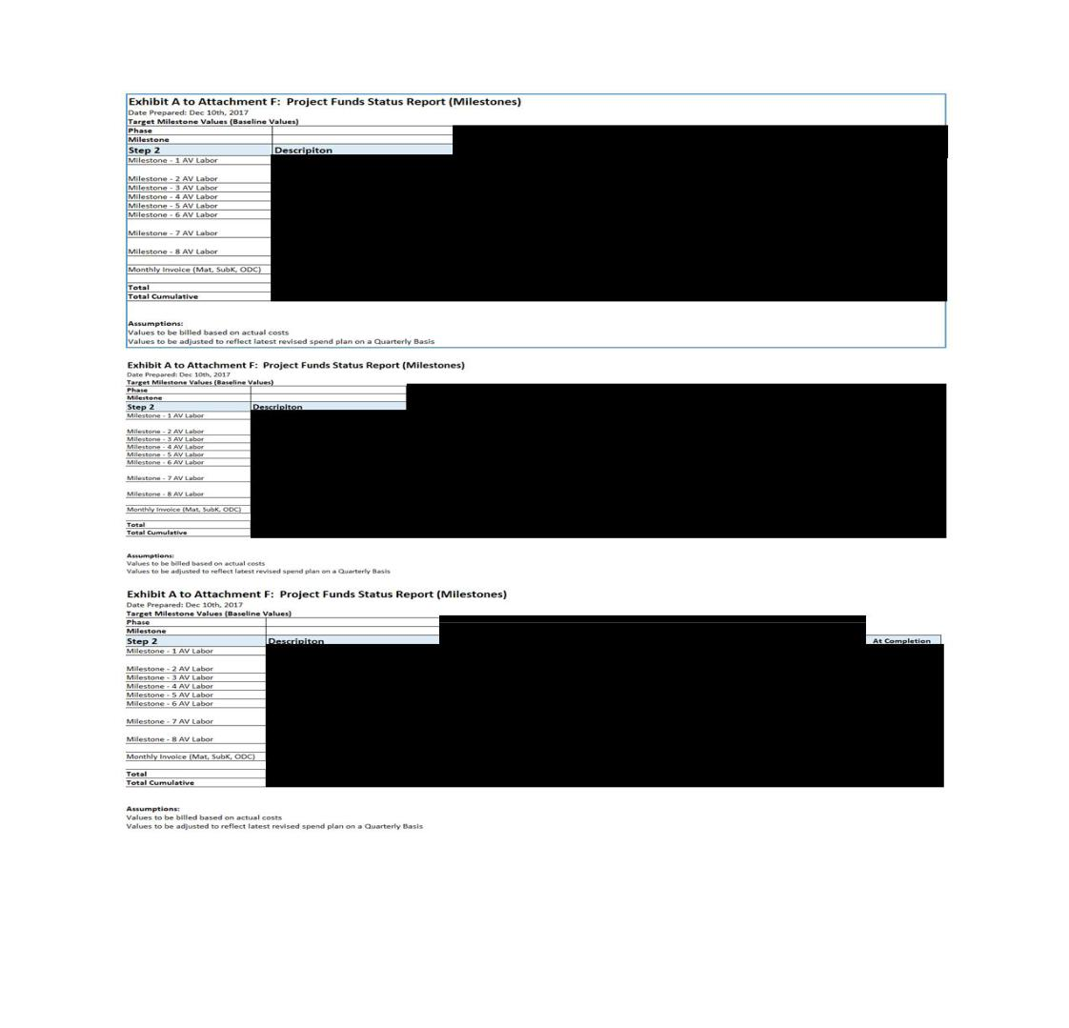

- Information has been omitted and filed separately with the Securities and Exchange Commission. Confidential treatment has been requested with respect to the omitted portions.

[__] = [***]

F-5

Exhibit B to Attachment F – Quarterly Status Report (Example)
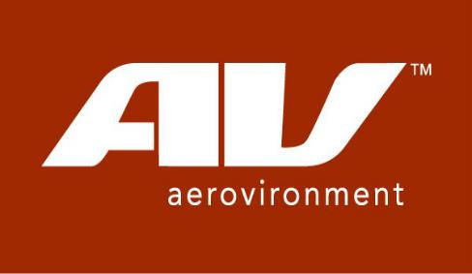

AeroVironment Inc.

980 Enchanted Way

Simi Valley, California 93065 – U.S.A.

Telephone 1(805) 581-2187 – FAX 1(805) 584-6922

- Information has been omitted and filed separately with the Securities and Exchange Commission. Confidential treatment has been requested with respect to the omitted portions.

F-6

Approvals:

<Enter Name here> |  | Date
Originator
<Enter Name here>
 |  | Date
Project Manager
<Enter Name here>
 |  | Date
Program Manager

- Information has been omitted and filed separately with the Securities and Exchange Commission. Confidential treatment has been requested with respect to the omitted portions.

F-7

Revision History


REV | EDIT DATE | AUTHOR | DESCRIPTION

- MM/DD/YYYY

- Information has been omitted and filed separately with the Securities and Exchange Commission. Confidential treatment has been requested with respect to the omitted portions.

F-8

TABLE OF CONTENTS

Table of Contents
Approvals: | 12
Revision History | 13
Introduction | 2
Technical Accomplishments | 2
Schedule Update | 2
Spend Plan | 9
Cost Performance Report | 10
Schedule Performance Report | 11
Monthly Invoice | 12

- Information has been omitted and filed separately with the Securities and Exchange Commission. Confidential treatment has been requested with respect to the omitted portions.

[__] = [***]

1

Introduction

<<HIGH LEVEL PROGRAM OVERVIEW>>

<<STOPLIGHT CHART>>
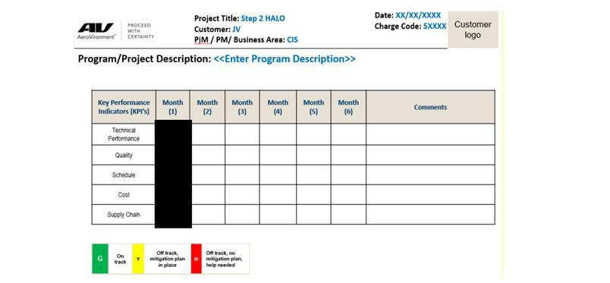

Technical Accomplishments

What efforts were started this period?

<<Description of work started and performed during the reporting month>>

Task 5

Task 6

Task 7

Task …X

What efforts were completed this period?

<<Description of work completed and performed during the reporting month>>

Task 1

Task 2

Task 3

Task 4

Key Subcontract Status:

Subcontractor A:

Subcontractor B:

Subcontractor C:

- Information has been omitted and filed separately with the Securities and Exchange Commission. Confidential treatment has been requested with respect to the omitted portions.

[__] = [***]

2

Schedule Update

Integrated Master Schedule Update <<EXAMPLE>>

[***]

Milestone Status Update

- Information has been omitted and filed separately with the Securities and Exchange Commission. Confidential treatment has been requested with respect to the omitted portions.

1

Reference to Attachment H

- Information has been omitted and filed separately with the Securities and Exchange Commission. Confidential treatment has been requested with respect to the omitted portions.

2

Spend Plan

Spend Plan Update
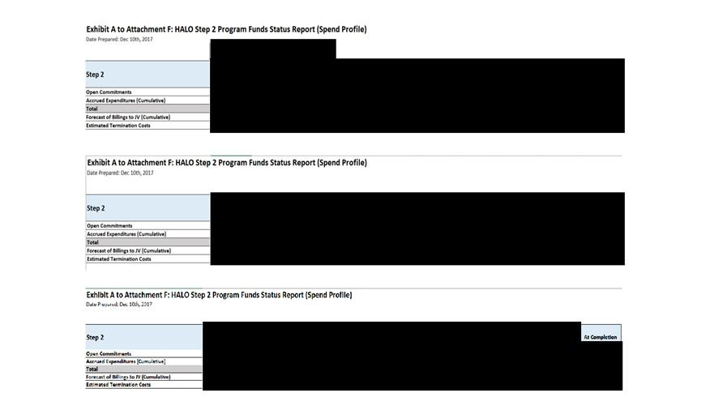

Cost Performance Report

Cost Performance Update

- Information has been omitted and filed separately with the Securities and Exchange Commission. Confidential treatment has been requested with respect to the omitted portions.

[__] = [***]

3

Cost Performance

[***]

Schedule Performance Report
<<Schedule Performance Report>>

Critical Path Analysis

Schedule Performance Index (if applicable)

Near term upcoming milestones (30 – 60 days )

  - Milestone 1 =

  - Milestone 2 =

  - Milestone X =

- Information has been omitted and filed separately with the Securities and Exchange Commission. Confidential treatment has been requested with respect to the omitted portions.

4

Monthly Invoice – (Non-Labor)

[***]

- Information has been omitted and filed separately with the Securities and Exchange Commission. Confidential treatment has been requested with respect to the omitted portions.

5

Exhibit C to Attachment F

[***]

- Information has been omitted and filed separately with the Securities and Exchange Commission. Confidential treatment has been requested with respect to the omitted portions.

6

CONFIDENTIAL

ATTACHMENT G

CHANGE CONTROL

CHANGE CONTROL PROCEDURES

The following Change Control Procedures shall only apply to Changes to Attachments A, C, and D.

- To propose a Change, the Party's Project Manager shall deliver a written proposal (a "Change Control Proposal") in the form provided in this Attachment G to the Project Manager of the other Party specifying (i) the proposed Change, (ii) the objective or purpose of such Change, (iii) the requirements and specifications of the deliverables to be delivered pursuant to such Change, and (iv) the requested prioritization and schedule for such Change. HAPSMobile and AV shall cooperate in good faith in discussing the scope and nature of the Change Control Proposal, the availability of AV personnel, expertise and resources to provide such Change and the time period in which such change will be implemented. Within five business days of the receipt of the Change Control Proposal from HAPSMobile, AV shall prepare and deliver to HAPSMobile a written assessment of the proposal (the "Change Assessment") (i) describing any changes in products, services, assignment of personnel and other resources that AV believes will be required, (ii) estimating the increase or decrease in the AV charges that would be required due to such Change, (iii) estimating the increase in HAPSMobile costs that would be required due to such Change (iii) estimating scheduling changes including Milestones, (iv) specifying how the proposed Change would be implemented, (v) describing the effect, if any, such Change would have on this Agreement, (vi) estimating all resources required to implement such Change, (vii) describing the delivery risks and associated risk mitigation plans and (viii) providing such other information as may be relevant to the proposed Change. To the extent that a proposed Change is of such multitude, magnitude or complexity that it is not feasible for AV to produce a detailed Change Assessment within five business days of its receipt of a Change Control Proposal from HAPSMobile, AV shall prepare and deliver to HAPSMobile a summary Change Assessment outlining such details regarding the prospective Change as AV can ascertain within such five business day period, and the Parties shall agree upon a schedule for the production of a more detailed Change Assessment. If required as part of the Change Assessment, AV will assist HAPSMobile with organizing the Hardware and Software vendors’ input and responses in a timely manner.

- HAPSMobile shall review the Change Assessment and respond within five business days of its receipt of a Change Assessment, indicating whether HAPSMobile desires AV to implement the Change pursuant to the Change Assessment. Upon Steering Committee approval, the Parties will execute a Change Control (a “Change Control”) based upon such Change Assessment. All Change Controls must be approved in writing by AV and HAPSMobile before AV commences work on the proposed Change.

- The Parties shall modify and update the Agreement (including the Estimated Completion Dates) and the pricing schedule as necessary to reflect any such Change Controls.

Change Classes

Class I Changes

Changes will be classified as Class I in accordance with the following definitions. A Change will be classified Class I when one or more of the following conditions exist:

a. functional or allocated configuration change;

b. product configuration change;

Use or disclosure of data contained on this page is subject to the confidentiality restriction stated on the cover page of this document.
- Information has been omitted and filed separately with the Securities and Exchange Commission. Confidential treatment has been requested with respect to the omitted portions.

G-1

CONFIDENTIAL

c. technical requirements change;

d. Customer furnished equipment change;

e. safety change;

f. operational capability change;

g. non-compatibility with support equipment;

h. configuration to the extent that retrofit action would be required;

i. Revision to delivered operation and maintenance manuals;

j. pre-set adjustments or schedule affecting operating limits or performance to such extent as to require assignment of a new identification number; or

k. interchangeability, substitutability or replace ability as applied to items, excluding the pieces and parts of non-repairable sub-assemblies.

As required by this Agreement, AV will not implement a Class I Change with an effectivity after the establishment of the baseline configuration without prior approval of HAPSMobile, which approval will be obtained through the Change Control procedures included in this Attachment G. AV will submit a each Class I Change to HAPSMobile as required under this Agreement including data document and contract control.

Class I Changes will be incorporated at the earliest possible time authorized by HAPSMobile after the execution of a Change Control.

If either party identifies an opportunity for upgrading cost efficiency, optimum technology, sourcing altenative or higher performance subcontractors, they will implement a Change Control action in accordance with this Attachment G to secure additional budget, identify cost reductions, and assess impacts to program schedules.

Class II Changes

A Change will be classified as Class II when it does not fall within the definition of a Class I Change, and includes, but is not limited to:

a. A change in documentation only (e.g., correction of errors, addition of clarifying notes or views);

b. A change in hardware (e.g., substitution of an alternative material) which does not affect any Deviation requirement factors; or

c. changes that do not affect form, fit, or function.

When a Change is classified as a Class II Change, AV shall have considered all factors for a Class I Change and determined the factors are not applicable to such Change.

Class II changes are not required to be submitted to HAPSMobile for approval, but will be provided by AV to HAPSMobile for review by HAPSMobile’s Configuration Management or Quality Assurance Representative for concurrence as to the classification of the Change.

Change Management Form

See attached Exhibit 1 - ECP Class I change Form

Use or disclosure of data contained on this page is subject to the confidentiality restriction stated on the cover page of this document.
- Information has been omitted and filed separately with the Securities and Exchange Commission. Confidential treatment has been requested with respect to the omitted portions.

G-2

CONFIDENTIAL

Exhibit 1 -Class I change Form
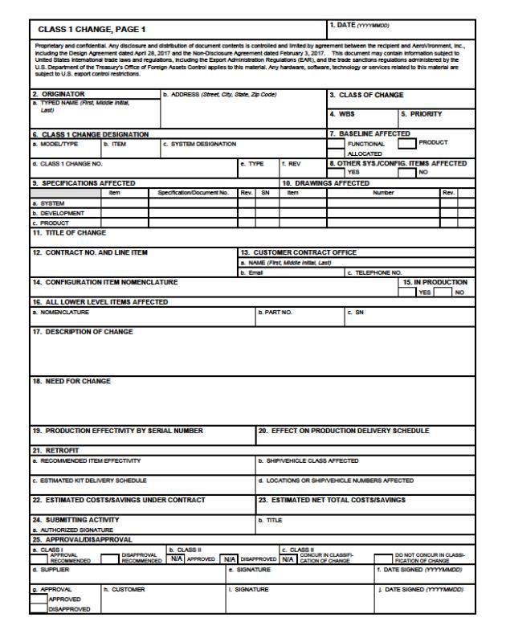

Use or disclosure of data contained on this page is subject to the confidentiality restriction stated on the cover page of this document.
- Information has been omitted and filed separately with the Securities and Exchange Commission. Confidential treatment has been requested with respect to the omitted portions.

G-3

CONFIDENTIAL
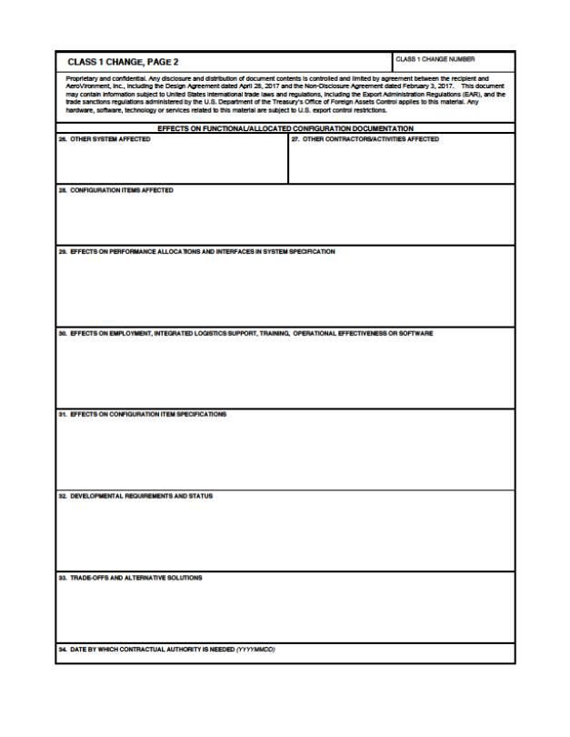

Use or disclosure of data contained on this page is subject to the confidentiality restriction stated on the cover page of this document.
- Information has been omitted and filed separately with the Securities and Exchange Commission. Confidential treatment has been requested with respect to the omitted portions.

G-4

CONFIDENTIAL
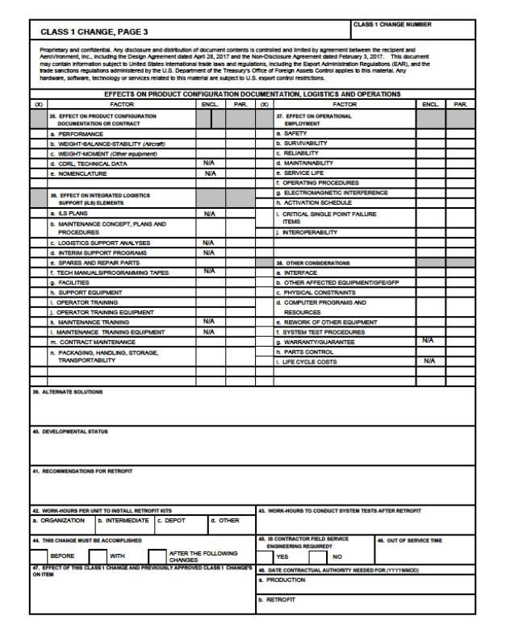

Use or disclosure of data contained on this page is subject to the confidentiality restriction stated on the cover page of this document.
- Information has been omitted and filed separately with the Securities and Exchange Commission. Confidential treatment has been requested with respect to the omitted portions.

G-5

CONFIDENTIAL
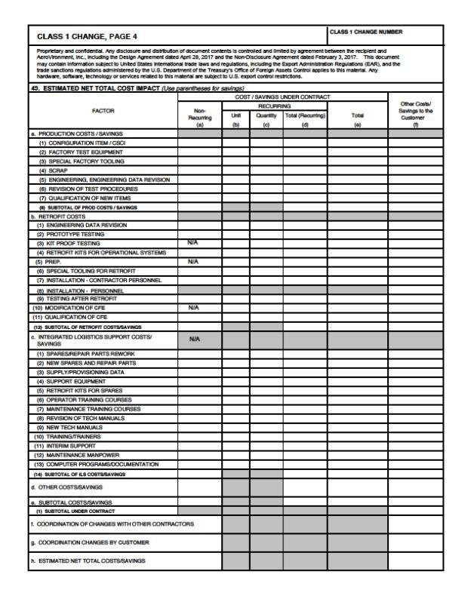

Use or disclosure of data contained on this page is subject to the confidentiality restriction stated on the cover page of this document.
- Information has been omitted and filed separately with the Securities and Exchange Commission. Confidential treatment has been requested with respect to the omitted portions.

G-6

 |  |  |  |  | CONFIDENTIAL
 |  |  | ATTACHMENT H
 |  |  | PROJECT MILESTONE
# | Milestone |  | Criteria |  | Date
1 | [***] |  |  |  | [***]
 | [***]
 | Milestone Objective:
 | [***]
 |  | Completion Criteria
 |  | [***]
 |  | [***]
 |  | [***]
 |  | [***]
 |  | [***]
 |  | [***]
 |  | [***]
 |  | [***]
 |  | [***]
 |  | [***]
 |  | [***]
 |  | [***]
 |  | [***]
 |  | [***]
2 | [***] |  |  |  | [***]
 | [***]
 | Milestone Objective:
 | [***]
 |  | Completion Criteria
 |  | [***]
 |  | [***]
 |  | [***]
 |  | [***]
 |  | [***]
3 | [***] |  |  |  | [***]
 | [***]
 | Milestone Objective:
 | [***]
 |  | Completion Criteria
 |  | [***]
 |  | [***]
 |  | [***]
 |  | [***]
 |  | [***]
 |  | [***]
4 | [***] |  |  |  | [***]
 | [***]
 | Milestone Objective:
 | [***]

Use or disclosure of data contained on this page is subject to the confidentiality restriction stated on the cover page of this document.
- Information has been omitted and filed separately with the Securities and Exchange Commission. Confidential treatment has been requested with respect to the omitted portions.

H-1

CONFIDENTIAL

 |  | Completion Criteria
 |  | [***]
 |  | [***]
 |  | [***]
 |  | [***]
 |  | [***]
 |  | [***]
 |  | [***]
5 | [***] |  | [***]
 | [***]
 | Milestone Objective:
 | [***]
 |  | Completion Criteria
 |  | [***], to include:
 |  | [***]
 |  | [***]
 |  | [***]
 |  | [***]
 |  | [***]
6 | [***] |  | [***]
 | [***]
 | Milestone Objective:
 | [***]
 |  | Completion Criteria
 |  | [***], to include:
 |  | [***]
 |  | [***]
 |  | [***]
 |  | [***]
 |  | [***]
 |  | [***]
7 | [***] |  | [***]
 | [***]
 | Milestone Objective:
 | [***]
 |  | Completion Criteria
 |  | [***], for:
 |  | [***]
 |  | [***]
8 | [***] |  | [***]
 | [***]
 | Milestone Objective:
 | [***]
 |  | Completion Criteria
 |  | [***]
 |  | [***]

Use or disclosure of data contained on this page is subject to the confidentiality restriction stated on the cover page of this document.
- Information has been omitted and filed separately with the Securities and Exchange Commission. Confidential treatment has been requested with respect to the omitted portions.

H-2

CONFIDENTIAL

ATTACHMENT I

PROJECT MANAGEMENT

1. Project Roles & Responsibilities

1.1 Project Organization. Figure I-1 below illustrates the basic organizational structure and high-level roles that will be used in the project.

Detailed project roles & responsibilities are described in “ATTACHMENT C SOW”.

Figure I-1
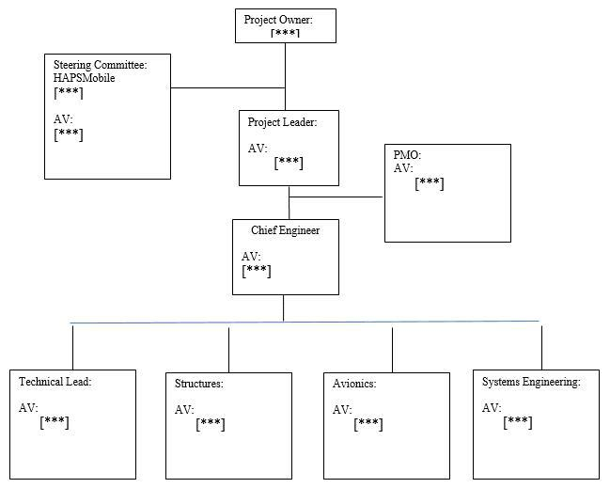

A List of Project key persons for AV (Key Persons List) is as follows.
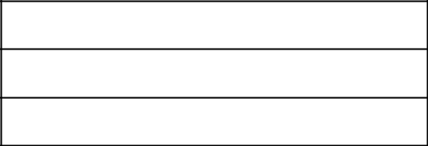

AV

[***]

[***]

Use or disclosure of data contained on this page is subject to the confidentiality restriction stated on the cover page of this document.

- Information has been omitted and filed separately with the Securities and Exchange Commission. Confidential treatment has been requested with respect to the omitted portions.

I-1

CONFIDENTIAL
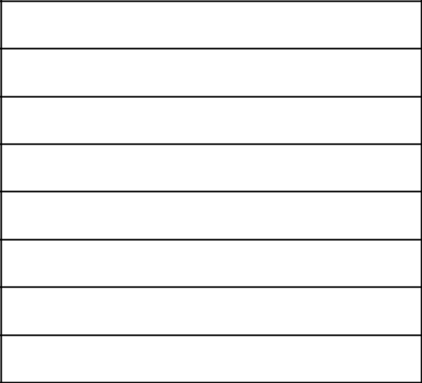

[***]

[***]

[***]

[***]

[***]

[***]

[***]

[***]

1.2 Project Methodology. AV’s methodology for large scale complex projects will be used to ensure that all elements of the project are appropriately considered and aligned. The major components of the design approach are:

Development, design, build and test the [***] Prototype Solar Stratospheric Aircraft System testing [***] @ [***] altitude [***] and [***] endurance through Flight Test and engineering analysis.

2. Project Governance

2.1 Project Management. Project Management organizes and delivers the support and supervision to deliver an integrated design capability. It includes:

- Establishing work plans, resources and disciplines to get the project activities initiated and progressed to work towards achieving on-time delivery.

- Directing, coordinating and monitoring the activities of the entire project to assist in achieving desired project outcomes.

- Managing the integration of the various components of the project so that they support the overall business architecture.

The detailed scope of these activities is defined in “ATTACHMENT C SOW”.

2.2 Project Management Office (PMO)

PMO will execute the project management approach. In PMO, project management operations will be handled by both HAPSMobile and AV. Project management of external projects and external systems is beyond the scope of work for PMO. PMO will coordinate design activities with other external systems and/or projects.

2.3 Project/Organization Definition.

AV defines the project organization and schedule, and HAPSMobile reviews them at the beginning of the project. Mutually agreed changes can be made.

2.4 Define Project Management Processes and Training.

- AV defines the project management processes and HAPSMobile reviews them. Mutually agreed changes can be made.

- AV will provide highly skilled PMO and Project Management personnel. Additional training with HAPSMobile support will be initiated as required. An official training session for each project management area will be scheduled for the project members. The PMO office will be responsible for arranging any follow-up session for absent/new people. HAPSMobile and AV will be responsible for follow-up activities for their own members.

Use or disclosure of data contained on this page is subject to the confidentiality restriction stated on the cover page of this document.

- Information has been omitted and filed separately with the Securities and Exchange Commission. Confidential treatment has been requested with respect to the omitted portions.

I-2

CONFIDENTIAL

2.5 Human Resource Management.

- AV and HAPSMobile create and maintain their own resource plans respectively.

- AV and HAPSMobile should provide enough people, based on respective resource plans, in order to complete project deliverables in line with the schedule.

- Resource shortage and/or personnel problems will be mutually resolved according to the Agreement.

2.6 Progress Management

- AV defines the progress management processes and HAPSMobile reviews them. Mutually agreed changes on the format of such progress reports can be made.

- A PMO member participates in the PMO meeting once a month or as needed and the Project operational meeting once a week or as needed. HAPSMobile and AV will provide and input accurate data in a timely manner.

- AV and HAPSMobile will undertake the following activities in cooperation:

  - Collection of progress information

  - Preparing progress materials

  - Participating in progress meeting

2.7 Scope Management/Change Control Process

- One of the key activities for Project Management will closely manage the scope so that delivery commitments and schedule milestones can be met. All scope changes will be handled through the Change Procedures described in the Agreement. The scope of events that fall under a Change request and the detailed Change request process to be used in the project must be in accordance with the Change Procedures described in the Agreement.

2.8 Issue Management Processes

- Issue management will follow a defined process with appropriate issues escalated to PMO.

- PMO or operational meeting issues which are HAPSMobile's responsibility should be resolved by the designated due dates. If HAPSMobile in-charge person cannot resolve the issue, it should be escalated to a higher level in a timely manner so as not to jeopardize the overall project schedule, quality and cost.

- AV and HAPSMobile will undertake the following activities in cooperation:

  - Collection of issues

  - Making issue management materials

2.9 Risk Management Processes

- Risk management will follow a defined process with appropriate risks escalated to PMO.

- PMO or operational meeting risks, which are HAPSMobile's responsibility, should be mitigated by the due dates. If HAPSMobile in-charge person cannot mitigate the risks, it should be escalated to a higher level in a timely manner so as not to impact the overall project schedule, quality and cost.

- AV and HAPSMobile will undertake the following activities in cooperation:

  - Collection of risks

  - Prepare risk management materials

  - Planning the approach for risk mitigation

  - Leading meetings/taking minutes

2.10 Business Management Processes

Use or disclosure of data contained on this page is subject to the confidentiality restriction stated on the cover page of this document.

- Information has been omitted and filed separately with the Securities and Exchange Commission. Confidential treatment has been requested with respect to the omitted portions.

I-3

CONFIDENTIAL

- Coordinate that each area/office develops the standards according to the project plan, and undertakes designs, developments, and reviews in accordance with the standards.

- Appropriate area/office develops standards and each office undertakes compliance activities in accordance with the business management standards.

(c)

(d)

2.11 Communication Management.

- Communication management will follow a defined process, and each office member should participate and operate meetings in line with the meeting purpose.

- Steering Committee will be held on a monthly basis.

(d)

(e)

- The following communication management tasks will be undertaken:

(1) Steering Committee

  - Preparing materials

  - Preparing and Arranging

  - Facilitating

  - Taking Minutes

- Create and maintain a stakeholder list in cooperation

2.12 Vendor Management. Vendor management will occur as described in the Agreement.

- PMO is responsible, at the appropriate points in the project, to track and report that all defined Deliverables are developed and reviewed.

- The Deliverables are defined in Attachment A.

- Acceptance of Deliverables will follow the acceptance process defined in Attachment B.

- HAPSMobile internal activities having no direct relation to the project will not be supported.

- AV translators, interpreters and secretaries will work only for AV under the instruction of AV.

Use or disclosure of data contained on this page is subject to the confidentiality restriction stated on the cover page of this document.

- Information has been omitted and filed separately with the Securities and Exchange Commission. Confidential treatment has been requested with respect to the omitted portions.

I-4

Exhibit 10.3

CERTAIN MATERIAL (INDICATED BY AN ASTERISK [***]) HAS BEEN OMITTED FROM THIS DOCUMENT PURSUANT TO A REQUEST FOR CONFIDENTIAL TREATMENT. THE OMITTED MATERIAL HAS BEEN FILED SEPARATELY WITH THE SECURITIES AND EXCHANGE COMMISSION.

INTELLECTUAL PROPERTY LICENSE AGREEMENT

This Intellectual Property License Agreement (this “IPLA” or “Agreement”) is entered into as of December 27, 2017 (the “Effective Date”) by and among HAPSMobile Inc., a Japanese corporation having its principal place of business at 1-9-1 Higashi-Shimbashi, Minato-ku, Tokyo, Japan (“HAPSMobile”); SoftBank Corp., a Japanese corporation having its principal place of business at 1-9-1 Higashi-Shimbashi, Minato-ku, Tokyo 105-7317, Japan (“SoftBank”) and AeroVironment, Inc., a Delaware corporation having its principal place of business at 800 Royal Oaks Drive, Suite 210, Monrovia, CA 91016, U.S.A. (“AV”). SoftBank, AV and HAPSMobile hereinafter will be referred to individually as “Party”, and as two or more collectively as “Parties”.

RECITALS

- AV is a company with a well-established history in the business of design and manufacture of unmanned, solar-powered high altitude aircraft, along with associated operational and logistics services;

- SoftBank is a company in the business of, among other things, providing telecommunications products and associated internet broadband services;

- HAPSMobile is a joint venture company established pursuant to a Joint Venture Agreement dated December 1, 2017 by and between AV and SoftBank (the “Joint Venture Agreement”), and is in the business of, among other things, researching, developing and manufacturing Solar HAPS;

- AV and SoftBank previously entered into a side agreement dated December 1, 2017 (the “Side Agreement”);

- AV and SoftBank previously entered into a Design Agreement dated April 26, 2017 (the “Preliminary Design Agreement”) pursuant to which AV completed preliminary design work for a Solar HAPS as detailed in such Design Agreement, which comprises Step 1 of the contemplated business relationships among AV, SoftBank and HAPSMobile;

- In advance of the establishment of HAPSMobile, AV and SoftBank entered into a Bridge Engineering Services Agreement dated October 19, 2017 (the “Bridge Agreement”) for the purpose of enabling AV to commence work on the design and development that will be subsumed into and become a part of the Design and Development Agreement referred to in G below; and

- HAPSMobile and AV hereby concurrently enter into a Design and Development Agreement (Step 2) of even date herewith (the “Design and Development Agreement”) under which the Parties enter into a definitive working relationship for the purpose of carrying out the detailed design and development work for the Solar HAPS which comprises Step 2 of the contemplated business relationships between AV and HAPSMobile.

- The Joint Venture Agreement, The Side Agreement, Preliminary Design Agreement, Bridge Agreement and Design, Development Agreement, and this Agreement shall collectively be referred to as the “Parties’ Agreements”.

- The Parties now desire to enter into this Agreement to set out the terms and conditions under which the Parties shall license certain intellectual property to facilitate contemplated business relationships among AV, SoftBank and HAPSMobile.

In consideration of the mutual covenants, promises and agreements contained herein, the Parties agree with each other as follows:

1. DEFINITIONS

In this Agreement, unless otherwise specified, the following terms shall have the meanings ascribed thereto:

- Information has been omitted and filed separately with the Securities and Exchange Commission. Confidential treatment has been requested with respect to the omitted portions.

Exhibit 10.3

CERTAIN MATERIAL (INDICATED BY AN ASTERISK [***]) HAS BEEN OMITTED FROM THIS DOCUMENT PURSUANT TO A REQUEST FOR CONFIDENTIAL TREATMENT. THE OMITTED MATERIAL HAS BEEN FILED SEPARATELY WITH THE SECURITIES AND EXCHANGE COMMISSION.

1.1 “Agreement” means this Agreement and the attachments attached to it, if any, as amended from time to time.

1.2 “AV Background IP” subject to and in accordance with Section 4.8.2, means any and all Intellectual Property owned by AV prior to the Effective Date of this Agreement, or third-party Intellectual Property which AV has sufficient rights to sub-license on the same terms as AV licenses its own Intellectual Property herein, that is of a Solar HAPS capable of operating at [***] of [***] and that is necessary to operate the Solar HAPS provided by AV to HAPSMobile. AV Background IP shall not include any intellectual property of: small unmanned aerial systems; hand-held unmanned systems; man-portable unmanned systems; systems with air vehicles under [***]; which was prohibited from export at the time it was developed; which was developed for a military or defense application; methods of operations, associated devices and/or support equipment thereof each that are of the foregoing systems; battery powered non-solar systems; fuelled systems; electrical vehicle charging and/or electronic test equipment; and/or any other non-high altitude, long-endurance, solar powered systems.

1.3 “Background Royalty” means a royalty that shall not be applied during the Research and Development Phase and, subject to the remainder of this paragraph, shall be applied at a FRAND Royalty once the Commercial Phase begins. The Parties agree that upon the start of the Commercial Phase that they shall negotiate in good faith the amount of the Background Royalty paid per year by HAPSMobile to each AV and SoftBank, as the case may be, shall be [***] ([***]%) of HAPSMobile’s total net revenue; provided, however, that the Parties understand that upon implementation of Background Royalty hereunder that an adjustment to the amount or percentage of the Background Royalty may be necessary to address any problems or issues reasonably determined by the Parties, based on the advice of their respective auditing, tax and/or legal advisers, that the use of such [***] ([***]%) would result in adverse consequences under applicable tax laws and regulations to any Party, such as, by way of example but not limitation, the inability of HAPSMobile to claim the full amount of the royalty paid as an expense for tax purposes or the assessment on any Party of gift or similar taxes, the Parties may adjust the royalty rate upward or downward from [***] ([***]%) to be charged to HAPSMobile so as to avoid such adverse consequences.

1.4 “Commercial Phase” shall mean the date on which HAPSMobile first generates revenue from Solar HAPS in its entirety, or from any portion of the New IP.

1.5 “Commercial Applications” means any sale, use, development, manufacture or other activity not within the scope of Non-Commercial Applications as defined herein. The definition of “Commercial Applications” expressly excludes Non-Commercial Applications.

1.6 “Executable Code” or “Executable Software” means non-human readable machine language compiled code.

1.7 “FRAND Royalty” means a fair, reasonable and non-discriminatory royalty, that is determined in consideration of the potential impact by the Parties’ relevant tax considerations and/or reasonably related fair market rates. The Parties agree to negotiate in good faith and agree on a mutually acceptable FRAND Royalty for each application thereof.

1.8 “HAPSMobile Intended Business” means, [***], to research, develop and manufacture Solar HAPS and to research, and develop the payload as a potential solution for the HAPSMobile’s next generation businesses. [***].

1.9 “Intellectual Property” means same as defined and set forth as ‘Intellectual Property’ in the Joint Venture Agreement, Exhibit

A DEFINED TERMS

1.10 “IPR Claim” means an action or claim by any third party that the use of Intellectual Property licensed under this Agreement infringes the Intellectual Property of that person.

1.11 “Licensed Product” means any product, device, items, article, item, good, thing, service, method, process, operation, action or the like, which utilizes, embodies, encompasses, incorporates, uses, and/or which would infringe and/or misappropriate the Intellectual Property licensed under this Agreement in any manner.

- Information has been omitted and filed separately with the Securities and Exchange Commission. Confidential treatment has been requested with respect to the omitted portions.

Exhibit 10.3

CERTAIN MATERIAL (INDICATED BY AN ASTERISK [***]) HAS BEEN OMITTED FROM THIS DOCUMENT PURSUANT TO A REQUEST FOR CONFIDENTIAL TREATMENT. THE OMITTED MATERIAL HAS BEEN FILED SEPARATELY WITH THE SECURITIES AND EXCHANGE COMMISSION.

1.12 “New IP” subject to and in accordance with Section 4.8.2, means any and all Intellectual Property created by, for or on behalf of, assigned to, or otherwise owned by, HAPSMobile under or in connection with a development or engineering agreement between HAPSMobile and either AV or SoftBank, including without limitation the Design and Development Agreement, and in the event that SoftBank transfers the SoftBank PDA IP to HAPSMobile, the SoftBank PDA IP shall be deemed to be integrated into, and otherwise added to, the definition of New IP.

1.13 “New IP Royalty” means a royalty that shall not be applied with respect to research and development and that shall be applied on the basis of a FRAND Royalty once any revenue is generated from the use of any New IP or SoftBank PDA IP.

1.14 “Non-Commercial” means same as defined and set forth as ‘Non-Commercial’ in the Joint Venture Agreement, Exhibit A DEFINED TERMS

1.15 “Research and Development Phase” mean, unless otherwise mutually agreed, the period commencing on the Effective Date and extending until the first revenue is generated by HAPSMobile from any New IP, AV Background IP SoftBank Background IP, Solar HAPS, or other products that incorporates or embodies any New IP, AV Background IP or SB Background IP, as the case may be.

1.16 “SoftBank Background IP” means the SoftBank PDA IP and any and all Intellectual Property owned by SoftBank prior to the Effective Date of this Agreement, or third-party Intellectual Property which SoftBank has sufficient rights to sub-license on the same terms as SoftBank herein licenses its own Intellectual Property herein of this Agreement that is of the payload aspect of the Solar HAPS; provided, however, that in the event that SoftBank transfers the SoftBank PDA IP to HAPSMobile, the SoftBank PDA IP shall be deemed to be integrated into, and otherwise added to, the definition of New IP.

1.17 “SoftBank PDA IP” means any and all Intellectual Property assigned, transferred, and/or provided to, and/or developed, created and/or invented by, SoftBank under either the Preliminary Design Agreement and/or the Bridge Agreement.

1.18 “Solar HAPS” means same as defined and set forth as ‘Solar HAPS’ in the Joint Venture Agreement, Exhibit A DEFINED TERMS.

1.19 “Source Code” means source code, human-readable code, non-compiled code, and/or other non-executable software.

2. TERM OF AGREEMENT

The Agreement shall come into force and effect when signed by authorized representatives of all Parties and shall remain in force until the earlier of either: (1) the Joint Venture Agreement expires or is terminated; (2) HAPSMobile is dissolved; or (3) this Agreement is terminated, under the provisions herein.

3. EXPORT RULES AND REGULATIONS

Export Rules and Regulations. Each Party agrees to comply with all applicable governmental regulations as they relate to the import, export and re-export of information and materials. Without limiting the foregoing, neither Party shall disclose or deliver any information in any manner contrary to any applicable export or import laws and regulations. The Parties acknowledge that these laws and regulations impose restrictions on the import, export and transfer to third countries of certain types of information and materials, and that authorizations or licenses from the applicable regulatory agency may be required before such items may be disclosed or delivered.

4. INTELLECTUAL PROPERTY

4.1 Background IP License:

- Information has been omitted and filed separately with the Securities and Exchange Commission. Confidential treatment has been requested with respect to the omitted portions.

Exhibit 10.3

CERTAIN MATERIAL (INDICATED BY AN ASTERISK [***]) HAS BEEN OMITTED FROM THIS DOCUMENT PURSUANT TO A REQUEST FOR CONFIDENTIAL TREATMENT. THE OMITTED MATERIAL HAS BEEN FILED SEPARATELY WITH THE SECURITIES AND EXCHANGE COMMISSION.

4.1.1 AV License to HAPSMobile: For the term of this Agreement, and subject to payment by HAPSMobile to AV of the Background Royalty, and upon and subject to all the terms and conditions of this Agreement, AV hereby grants to HAPSMobile a non-exclusive, non-transferrable, non-assignable, worldwide, license, without sub-license rights, to use the AV Background IP, but only to the extent reasonably necessary for HAPSMobile to [***], provided that HAPSMobile does not disclose any of the AV Background IP to any third party without AV express written permission.

4.1.2 SoftBank License to HAPSMobile: For the term of this Agreement, and subject to the payment by HAPSMobile to SoftBank of the Background Royalty, and upon and subject to all the terms and conditions of this Agreement, SoftBank hereby grants to HAPSMobile a non-exclusive, non-transferrable, non-assignable, worldwide, license, without sub-license rights (except HAPSMobile will grant a sub-license to AV pursuant to Section 4.1.3 below), to use the SoftBank Background IP, but only to the extent reasonably necessary for HAPSMobile to engage in the HAPSMobile Intended Business and for the other purpose expressly stated in Section 4.1.3 below, provided that HAPSMobile does not disclose any of the SoftBank Background IP to any third party without SoftBank express written permission.

4.1.3 HAPSMobile License to AV for the Parties’ Agreement: For the term of this Agreement, and upon and subject to all the terms and conditions of this Agreement, HAPSMobile hereby grants to AV a non-exclusive, non-transferable, non-assignable, worldwide, license, without sub-license rights (except as necessary with sub-contractors to develop products and services for HAPSMobile), to the SoftBank PDA IP, but only to the extent reasonably necessary for AV to perform its obligations under any of the Parties’ Agreements. AV shall not disclose the SoftBank PDA IP to any non-customer third party without the prior written consent of HAPSMobile (AV may disclose the SoftBank PDA IP to sub-licensed sub-contractors for AV to perform its obligations under any of the Parties’ Agreement). The license rights granted in this section 4.1.3 from HAPSMobile to AV shall survive in the event SoftBank later transfers ownership of the PDA IP to HAPSMobile, wherein the SoftBank PDA IP shall be included in the definition of the New IP.

4.1.4 SoftBank License to AV only for Non-Commercial: Until the assignment of ownership of the SoftBank PDA IP to HAPSMobile, wherein the SoftBank PDA IP shall be fully incorporated into the New IP and licensed to AV per Section 4.2.1 herein, and subject to the payment by AV to SoftBank of the New IP Royalty, and upon and subject to all the terms and conditions of this Agreement and AV’s compliance with the terms of Article 12.2 of the Joint Venture Agreement, SoftBank hereby grants to AV an exclusive, non-transferable and non-assignable, perpetual, world-wide, license, without sub-license rights (except as necessary with sub-contractors to develop products and services for Non-Commercial applications and customers of such Non-Commercial applications), to the SoftBank PDA IP, but only for Non-Commercial applications (except for Non-Commercial applications for the Japanese government). AV shall not disclose the SoftBank PDA IP to any non-customer third party for Non-Commercial applications without the prior written consent of SoftBank (AV may disclose the SoftBank PDA IP to sub-licensed sub-contractors for Non-Commercial applications).

4.1.5 To a Party Under a Prior Agreement: Nothing in this Agreement shall terminate, limit or otherwise alter any license granted to a Party under either the Design and Development Agreement, the Side Agreement, the Preliminary Design Agreement, the Bridge Agreement.

4.2 New IP Licenses:

4.2.1 HAPSMobile to AV only for Non-Commercial: Subject to the payment by AV to HAPSMobile of the New IP Royalty, and upon and subject to all the terms and conditions of this Agreement and AV’s compliance with the terms of Article 12.2 of the Joint Venture Agreement, HAPSMobile hereby grants to AV an exclusive, non-transferable and non-assignable, perpetual, world-wide, license, without sub-license rights (except as necessary with sub-contractors to develop products and services for Non-

- Information has been omitted and filed separately with the Securities and Exchange Commission. Confidential treatment has been requested with respect to the omitted portions.

Exhibit 10.3

CERTAIN MATERIAL (INDICATED BY AN ASTERISK [***]) HAS BEEN OMITTED FROM THIS DOCUMENT PURSUANT TO A REQUEST FOR CONFIDENTIAL TREATMENT. THE OMITTED MATERIAL HAS BEEN FILED SEPARATELY WITH THE SECURITIES AND EXCHANGE COMMISSION.

Commercial applications and customers of such Non-Commercial applications), to the New IP, but only for Non-Commercial applications (except for Non-Commercial applications for the Japanese government) . Upon any transfer of ownership of the SoftBank PDA IP to HAPSMobile, the SoftBank PDA IP shall be integrated into, and otherwise added to the definition of New IP and the license provided herein shall extent to include the SoftBank PDA IP. AV shall not disclose the New IP to any non-customer third party for Non-Commercial applications without the prior written consent of HAPSMobile (AV may disclose the New IP to sub-licensed sub-contractors for Non-Commercial applications). Parties agree that Non-Commercial applications are within AV’s now current business.

4.2.2 HAPSMobile to SoftBank: For the term of this Agreement and subject to the payment by SoftBank to HAPSMobile of the New IP Royalty, and upon and subject to all the terms and conditions of this Agreement, HAPSMobile hereby grants to SoftBank a non-exclusive, non-transferable and non-assignable, world-wide, license, without sub-license rights, to the New IP, but only for any resale to use by, or substantially for the benefit of the Japanese government, public entity and/or agency, service, entity, organization, or the like thereof; and for the development, manufacture of the payload for or on behalf of, or substantially for the benefit of the Japanese government, wherein such use is in Japan. SoftBank shall not disclose the New IP to any non-customer third party without the prior written consent of HAPSMobile.

4.2.3 HAPSMobile to AV for the Parties’ Agreements: For the term of this Agreement, and upon and subject to all the terms and conditions of this Agreement, HAPSMobile hereby grants to AV a non-exclusive, non-transferable, non-assignable, worldwide, license, without sub-license rights (except as necessary with sub-contractors to develop products and services for HAPSMobile), to the New IP, but only to the extent reasonably necessary for AV to perform its obligations under any of the Parties’ Agreements. AV shall not disclose the New IP to any non-licensed third party without the prior written consent of HAPSMobile.

4.3 Government Disclosure: In the event that AV is required to disclose to its Non-Commercial customers that the Solar HAPS includes technology licensed by the HAPSMobile, AV shall promptly notify HAPSMobile in advance of such requirement and take steps reasonably necessary to limit the disclosure of information to that which is necessary and to maintain the confidentiality of the information to be disclosed.

4.4 No Implied Rights: Except as otherwise expressly indicated in this Agreement, HAPSMobile will not, by any reason including AV and SoftBank’s performance of this Agreement or any other agreement between the Parties, acquire any right, title or interest (including any covenant, immunity, authorization, license rights, or other rights) in any of AV’s Background IP and SoftBank’s Background IP. Other than as expressly set forth in this Article 4, no right, title or interest in any Intellectual Property of AV and SoftBank is granted to HAPSMobile pursuant to this Agreement.

4.5 During the Research and Development Phase, HAPSMobile agrees to grant only those licenses and/or rights as expressly set forth herein, and shall not grant any other license or rights, without the written consent of AV and SoftBank which shall not be unreasonably withheld.

4.6 AV hereby represents and warrants to HAPSMobile that (a) AV shall take reasonable efforts so that all Intellectual Property in the Deliverables as defined in the Attachment A of the Design and Development Agreement shall include only AV Background IP, SoftBank PDA IP, SoftBank Background IP or New IP, and shall not include any third party Intellectual Property that does not otherwise comprise a portion of AV Background, SoftBank PDA IP and SoftBank Background IP, and (b) none of the Intellectual Property embodied in such Deliverables was prohibited from export at the time it was developed or was developed for a military or defense application. In the event AV breaches this warranty, AV shall have thirty (30) days to cure such breach by removing, and replacing if necessary, such unwarranted Intellectual Property.

- Information has been omitted and filed separately with the Securities and Exchange Commission. Confidential treatment has been requested with respect to the omitted portions.

Exhibit 10.3

CERTAIN MATERIAL (INDICATED BY AN ASTERISK [***]) HAS BEEN OMITTED FROM THIS DOCUMENT PURSUANT TO A REQUEST FOR CONFIDENTIAL TREATMENT. THE OMITTED MATERIAL HAS BEEN FILED SEPARATELY WITH THE SECURITIES AND EXCHANGE COMMISSION.

4.7 Royalty Terms:

The Parties understand that upon implementation of any royalty hereunder that revisions and/or adjustments to the terms of this Section 4.7 may be necessary to address any problems or issues then arising and/or to facilitate a more efficient or rational execution of the royalty terms, and therefore the Parties agree to use reasonable efforts at such time to negotiate in good faith, taking into account any reasonable requests or concerns of the Parties, any necessary or appropriate revisions hereto.

  - The royalty owed the licensor shall be calculated on a quarter annual calendar basis (the “Royalty Period”) and shall be payable by no later than the end of the second (2nd) month after the termination of the preceding full quarter-annual period, i.e., commencing on the first (1st) day of April, July, October, January, except that a calendar period may be "short” depending on the commencement of the applicable Royalty Period.

  - Within fifteen (15) business days after the end of each Royalty Period, the applicable licensee under the license(s) granted under this Agreement shall provide the applicable licensor under such license(s) with a written royalty statement certified as accurate by a duly authorized officer of licensee, reciting, on a country by country basis, the basis upon which the applicable Background Royalty or New IP Royalty, as the case may be, has accrued and the amount of such royalty due. Such statements shall be furnished to licensor regardless of whether any Licensed Products were sold during the Royalty Period or whether any actual royalty was owed.

  - Where the applicable royalty is based on the sales or net sales of Licensed Products, a royalty obligation shall accrue upon the sale of the Licensed Product regardless of the time of collection by the licensee, and the Licensed Product shall be considered "sold” when such Licensed Product is billed, invoiced, shipped, or paid for, whichever occurs first.

  - Where the applicable royalty is based on the sales or net sales of Licensed Products, if the licensee sells any Licensed Products to any affiliated or related party at a price less than the regular price charged to other parties, the royalty shall be computed at the regular price.

  - The receipt or acceptance by the licensor of any royalty statement or payment shall not prevent the licensor from subsequently challenging the validity or accuracy of such statement or payment.

  - Upon expiration or termination of this Agreement, all royalty obligations, shall be accelerated and shall immediately become due and payable.

  - The licensee’s obligations for the payment of royalties shall survive expiration or termination of this Agreement and will continue for so long as the licensee continues to sell the Licensed Products.

  - All payments due the licensor shall be made in the currency specified by the licensor by bank transfer, unless otherwise specified by the licensor.

  - Any late payments shall incur interest at the lower of [***]% per annum or the maximum rate permitted by applicable law in the jurisdiction of the paying party.

  - Each licensor shall have the right, upon reasonable notice (no less than ten (10) days), to inspect a licensee’s books and records and all other documents and material in licensee’s possession or control but only with respect to the subject matter of this Agreement. Any such inspection shall be done through an independent certified public accountant acceptable to the relevant licensee (who shall not unreasonably withhold such acceptance). Such examination shall occur at the place where the licensee maintains such records during normal business hours. The licensor shall have free and full access thereto for such purposes and may make copies thereof. In no

- Information has been omitted and filed separately with the Securities and Exchange Commission. Confidential treatment has been requested with respect to the omitted portions.

Exhibit 10.3

CERTAIN MATERIAL (INDICATED BY AN ASTERISK [***]) HAS BEEN OMITTED FROM THIS DOCUMENT PURSUANT TO A REQUEST FOR CONFIDENTIAL TREATMENT. THE OMITTED MATERIAL HAS BEEN FILED SEPARATELY WITH THE SECURITIES AND EXCHANGE COMMISSION.

event shall the licensor have the right to examine information with respect to licensee’s costs, pricing formulas, or percentages of markup. Each licensee shall impose similar obligations on any of its sublicensees, if any, for the benefit of itself and of the licensor.

- Each licensee agrees to keep accurate books of accounts and records at its principal place of business covering all transactions relating to the subject matter of this Agreement, including but not limited to any and all royalty obligation thereof.

- All books and records pertaining to the obligations of a licensee hereunder shall be maintained and kept accessible and available to a licensor for inspection for at least five (5) years after the date to which they pertain.

- In the event that such inspection reveals an underpayment by the licensee of the actual royalty owed the licensor, the licensee shall pay the difference, plus interest calculated at the rate of [***]% per month. If such underpayment be in excess of [***]% of the royalty due for any Royalty Period, the licensee shall also reimburse the licensor for the cost of such inspection.

- Only one royalty shall be paid hereunder as to Licensed Product whether or not it is covered by more than one article of Intellectual Property, including but not limited to more than one (1) claim of a patent, by the claims of more than one (1) patent, or by the claims of patents of more than one (1) country.

4.8 Software and Documents:

4.8.1 Solar HAPS Operational Software and Documents: AV shall provide to HAPSMobile, any newly developed (first created by AV in performance under the Design and Development Agreement) Source Code and documents (Technical Data Package as defined in the Design and Development Agreement) set forth in Attachment A of the Design and Development Agreement (“Solar HAPS Disclosed Materials”). AV shall provide to HAPSMobile [***].

4.8.2 [***]: [***].

4.8.3 [***]: [***].

4.8.4 Third Party Source Code: AV agrees that in AV’s Request for Proposals (RFPs), Request for Quotation (RFQ) and Request for Information (RFI) issued to potential key component third-party sub-contractors or suppliers for work to be performed for AV under any of the Parties’ Agreements, AV will request such third-parties to provide the Source Code of the software that third-party will deliver under the sub-contract to be disclosed to HAPSMobile and pricing. However, HAPSMobile understands and agrees that this shall only be a request to such third-party, who may accept or deny the request at the third-party’s discretion and AV shall have no control over such action by the third-party and selection of such third-party as sub-contractor, supplier or otherwise shall not be dependent upon such third-party’s decision to disclose or not to disclose its Source Code to HAPSMobile or to AV. In the event that such third-party agrees to disclose its Source Code to HAPSMobile, AV shall then disclose such third-party’s Source Code to HAPSMobile.

4.8.5 Accident Investigations: AV agrees that in response to a request by the United States Federal Aviation Administration (FAA), the United States National Transportation Safety Board (NTSB) or a foreign or international government agency equivalent to the FAA and/or NTSB, arising from an investigation by such organization into an accident or other incident involving the Solar HAPS, AV shall allow access to such relevant Source Code as necessary for such investigation.

4.8.6 Other than as expressly set forth in this Section 4.8, AV shall not be required to provide any other [***], unless otherwise agreed by the Parties in writing.

- Information has been omitted and filed separately with the Securities and Exchange Commission. Confidential treatment has been requested with respect to the omitted portions.

Exhibit 10.3

CERTAIN MATERIAL (INDICATED BY AN ASTERISK [***]) HAS BEEN OMITTED FROM THIS DOCUMENT PURSUANT TO A REQUEST FOR CONFIDENTIAL TREATMENT. THE OMITTED MATERIAL HAS BEEN FILED SEPARATELY WITH THE SECURITIES AND EXCHANGE COMMISSION.

4.9 [RESERVED]

4.10 Obtaining IP Protection: Any licensee under the New IP and the SoftBank PDA IP (only if it has not been integrated into the New IP) under this Agreement may request licensor(s) to file an application for patent protection in any specific jurisdiction with respect to such New IP and the SoftBank PDA IP (only if it has not been integrated into the New IP). The request from the licensee shall contain (a) a description of the invention for which patent protection is sought in reasonable detail sufficient to enable one versed in the art to analyze and assess the patentability of the invention, licensor(s) shall have fifteen (15) business days to review such request and either accept such request or provide the licensee with written objection stating the reasonable basis for such rejection; provided, however, that any such request shall not be unreasonably rejected. If licensor(s) do not pursue such patent protection, then it shall do so solely at its own cost. If licensor(s) does not indicate it will pursue the requested patent protection and/or if licensor(s) does not institute an application of such protection within a reasonable time after a licensee’s written request, the licensee may independently seek such protection at licensee’s sole cost, provided, however, that such licensee shall keep licensor(s) informed of all actions and developments taken or occurring in connection with such application and consult in good faith with licensor(s) in advance prior to taking, or refraining from taking, any action or position in the prosecution of such application that limits the scope of such application or otherwise is or could be detrimental to licensor(s) , and agree to a recourse or course of action that minimizes the detriment to, and/or maximizes, the reasonable interests of licensor(s) and such licensee. Upon request of the Party pursuing patent protection, the other Parties shall execute all papers and otherwise reasonably cooperate in and for the preparing, filing and prosecution of such patent application. The party filing the patent application shall reimburse the other party for the expenses incurred as a result of such cooperation.

4.11 IP Enforcement: Any licensee under the New IP and the SoftBank PDA IP (only if it has not been integrated into the New IP) under this Agreement may request licensor(s) to take appropriate action against any third party that appears to infringe any New IP and the SoftBank PDA IP (only if it has not been integrated into the New IP) licensed to such licensee. The request from the licensee shall contain [***].

5. INTELLECTUAL PROPERTY RIGHTS INDEMNITY

5.1 Indemnity Against Infringement.

Subject to the limitations of liability herein, each Party granting a license under this Agreement (the “Indemnifying Party”) agrees to indemnify defend and hold the licensee Party under such license, its officers, directors, agents and employees (together, the “Indemnitee”), harmless from and against any and all liability, loss, damage, costs and expenses (including reasonable and necessary legal expenses) awarded against, incurred by or paid or payable by the Indemnitee from an IPR Claim arising from the Indemnifying Party’s actions or inactions during the Term of this Agreement.

5.2 Indemnity Exclusions.

An Indemnifying Party’s indemnity shall not apply to any infringement resulting directly from: (1) [***]; (2) [***]; or (3) [***].

5.3 Indemnitee Obligations. Each Indemnitee agrees that:

- it shall promptly notify the Indemnifying Party(ies), in writing, of any IPR Claim asserted against the Indemitee;

- it shall not make any admission as to liability or agree to any settlement of or compromise any IPR Claim without the prior written consent of the Indemnifying Party(ies); and

- The Indemnitee shall, at the Indemnifying Party(ies) request and expense, give the indemnifying Party(ies) [***].

5.4 Indemnifying Party(ies) Obligations to Remedy Infringement. If any IPR Claim is made against an Indemnitee, the

Indemnifying Party(ies) shall act promptly at its own expense and at its sole discretion, to either:

  - [***]; or

  - [***]; or

  - [***]; or

  - [***].

- Information has been omitted and filed separately with the Securities and Exchange Commission. Confidential treatment has been requested with respect to the omitted portions.

Exhibit 10.3

CERTAIN MATERIAL (INDICATED BY AN ASTERISK [***]) HAS BEEN OMITTED FROM THIS DOCUMENT PURSUANT TO A REQUEST FOR CONFIDENTIAL TREATMENT. THE OMITTED MATERIAL HAS BEEN FILED SEPARATELY WITH THE SECURITIES AND EXCHANGE COMMISSION.

6. TERMINATION

6.1 Right to Terminate for Material Breach. Each Party has the right, without prejudice to its other rights or remedies, to terminate this Agreement immediately, by written notice to the other Party if the other Party is in material breach of its obligations under this Agreement and either it fails to remedy that breach within sixty (60) days after receiving written notice from the other Party or that the breach is incapable of remedy; provided, however, that the Agreement shall be partially terminated with respect to the relevant Party and this Agreement shall remain in force between the non-breaching Parties.

6.2 Right to Terminate for Insolvency, etc. Each Party has the right to terminate this Agreement immediately by written notice to the other Party if an insolvency event occurs with respect to such other Party; provided, however, that the Agreement shall be partially terminated with respect to the relevant Party and this Agreement shall remain in force between the remaining Parties.

6.3 Consequences for Terminating. All perpetual license granted herein shall survive the term and/or termination of this Agreement, all non-perpetual licenses granted hereunder shall terminate with this Agreement; provided, however, the applicable Parties shall negotiate in good faith to continue to grant such license under a new agreement with the same license terms herein except royalties to be based on FRAND principles.

6.4 Accrued Rights and Liabilities. Subject to all other provisions of this Agreement, any termination of this Agreement shall not affect any accrued rights or liabilities of either Party nor shall it affect the coming into force or the continuance in force of any provision of this Agreement is expressly or by implication intended to come into or continue in force on or after such termination.

7. DISSOLUTIONS, TERMINATIONS, AND BUY-OUTS

7.1 Upon any of the following to occur:

- HAPSMobile has ceased operations without the prospect of re-commencing operations, within a reasonable timeframe considering the mutual interest of the Parties to commercialize the New IP, and any Party has notified the other Parties in writing thereof, or

- if (a) above has not occurred, and the Steering Committee, as such term is defined in the Joint Venture Agreement, (i) agrees that AV and/or SoftBank may exercise its right to purchase ownership of the New IP and the SoftBank PDA IP (only if it has not been integrated into the New IP), or (ii) decides not to commercialize the New IP;

AV and SoftBank each shall have the option to jointly, or singularly, purchase the New IP and the SoftBank PDA IP (only if it has not been integrated into the New IP), as set forth below.

Within twenty (20) business days after the occurrence of either (a) or (b) above, AV and SoftBank each may issue a written notice to the other Parties that it intends to exercise its right to purchase the New IP (the “Purchase Notice”).

In the event that only one of AV or SoftBank has issued a Purchase Notice and the other Party (in this case, AV or SoftBank, as the case may be) has not issued a Purchase Notice, the Party issuing the Purchase Notice shall purchase the New IP as a sole owner at an amount determined as follows:

  - In the case of a purchase under (a), the amount shall be equal to (i) the cost of the development of the New IP, excluding the cost associated with any and all hardware and the development of the payload, in all the purchase orders issued under the Design and Development Agreement, the Preliminary Design Agreement (but only if the SoftBank PDA IP has been transferred to HAPSMobile), the Bridge Agreement, and any other agreements for the development of the Solar HAPS which has been paid to AV under such agreements, and (ii) subject to the discretion of the Steering Committee, costs related to Solar HAPS hardware with attendant purchase and transfer of title of Solar HAPS hardware; and

  - In the case of a purchase under (b) above, the amount shall be as agreed by the Steering Committee.

- Information has been omitted and filed separately with the Securities and Exchange Commission. Confidential treatment has been requested with respect to the omitted portions.

Exhibit 10.3

CERTAIN MATERIAL (INDICATED BY AN ASTERISK [***]) HAS BEEN OMITTED FROM THIS DOCUMENT PURSUANT TO A REQUEST FOR CONFIDENTIAL TREATMENT. THE OMITTED MATERIAL HAS BEEN FILED SEPARATELY WITH THE SECURITIES AND EXCHANGE COMMISSION.

In the event that AV and SoftBank both have issued a Purchase Notice, each shall have the right to purchase the New IP, as a joint owner, at an amount equal to the greater of 50% (to be paid by AV and SoftBank respectively) of:

- the cost of the development of the New IP, excluding the cost associated with any and all hardware and the development of the payload, in all the purchase orders issued under the Design and Development Agreement, the Preliminary Design Agreement (but only if the SoftBank PDA IP has been transferred to HAPSMobile), the Bridge Agreement, and any other agreements for the development of the Solar HAPS which has been paid to AV under such agreements; or

- the fair market value of the New IP.

If both AV and SoftBank exercises its option to purchase set forth herein, any and all terms between the Parties limiting or preventing AV or SoftBank from competing with any other Party, including but not limited to Section 12 (Non-Compete) of the Joint Venture Agreement, shall terminate and/or cease to be enforceable.

If only one of AV and SoftBank exercises its option to purchase set forth herein, any and all terms between the Parties limiting or preventing AV or SoftBank from competing with any other Party, including but not limited to Section 12 (Non-Compete) of the Joint Venture Agreement, shall remain in effect and be enforceable.

And this Agreement shall terminate.

7.2 Upon either:

- SoftBank or AV ceases to be a shareholder of HAPSMobile, or

- the Joint Venture Agreement terminates or expires;

HAPSMobile shall continue to grant a license for the use of the New IP and the SoftBank PDA IP (only if it has not been integrated into the New IP), by entering into a new license agreement between HAPSMobile and the ceasing shareholder on terms and royalty at least as favourable as provided by HAPSMobile to that shareholder herein, and any and all terms between the Parties limiting or preventing SoftBank or AV from competing with any other Party, including but not limited to Section 12 (Non-Compete) of the Joint Venture Agreement, shall survive and continue to be in force for [***].

And this Agreement shall terminate.

8. AMENDMENTS AND CHANGES

Amendments in Writing. Any amendment to this Agreement shall not be binding on the Parties unless it is mutually agreed upon in writing.

9. CONFIDENTIALITY

Any information or materials disclosed by one Party to the other in connection with this Agreement will be subject to the terms of the Non-Disclosure Agreement between SoftBank and AV dated February 3, 2017 and Section 10 (Confidentiality and Publicity) of the Joint Venture Agreement (together the “NDA”) as if HAPSMobile was a signatory to the NDA. The terms, conditions and existence of this Agreement and related negotiations will be considered Confidential Information of each Party as defined in and governed by the terms of such NDA.

10. PUBLICITY

Subject to any Party’s obligation under applicable law or regulation to publicly disclose this Agreement, no Party shall advertise nor make any public announcement in respect of this Agreement nor use or refer to the name, trademark or trade name of the other Part(ies) in any disclosure without the prior written consent of such other Part(ies). If a Party is not obligated to publicly disclose this Agreement, the other Part(ies) shall be fully entitled to withhold its consent to any public disclosure and shall be under no obligation to provide any explanation for such action.

- [RESERVED]

  - RESOLUTION OF DISPUTES

- Information has been omitted and filed separately with the Securities and Exchange Commission. Confidential treatment has been requested with respect to the omitted portions.

Exhibit 10.3

CERTAIN MATERIAL (INDICATED BY AN ASTERISK [***]) HAS BEEN OMITTED FROM THIS DOCUMENT PURSUANT TO A REQUEST FOR CONFIDENTIAL TREATMENT. THE OMITTED MATERIAL HAS BEEN FILED SEPARATELY WITH THE SECURITIES AND EXCHANGE COMMISSION.

12.1 Resolution by the Parties. In the event of any dispute between the Parties arising out of or relating to this Agreement, representatives of the Parties from a level of management who have authority to settle the dispute shall, within seven (7) days of receipt of a written notice from either Party to the other, meet (either in person, electronically or telephonically) in an effort to resolve the dispute. Unless concluded with a written legally binding agreement, all negotiations connected with any dispute shall be conducted in confidence and without prejudice to the rights of the Parties in any future proceedings.

12.2 Referral of the Dispute. If any dispute cannot be resolved at such meeting or within seven (7) days from its conclusion, the Parties shall be entitled to initiate arbitration, in accordance with the Article 18.2.

- Information has been omitted and filed separately with the Securities and Exchange Commission. Confidential treatment has been requested with respect to the omitted portions.

Exhibit 10.3

CERTAIN MATERIAL (INDICATED BY AN ASTERISK [***]) HAS BEEN OMITTED FROM THIS DOCUMENT PURSUANT TO A REQUEST FOR CONFIDENTIAL TREATMENT. THE OMITTED MATERIAL HAS BEEN FILED SEPARATELY WITH THE SECURITIES AND EXCHANGE COMMISSION.

13. NOTICES

13.1 Addresses for Providing Notices. Any notice or other document to be provided under this Agreement may (except as expressly provided herein) be delivered, or sent by post or by facsimile to the following address:

For AV:

Contractual Contact:

AeroVironment, Inc.

900 Innovators Way

Simi Valley, CA 93065

Attn: General Counsel

Technical Contact:

AeroVironment, Inc.

900 Innovators Way

Simi Valley, CA 93065

Attn: [***]

or such other address as AV may subsequently notify, and

For SoftBank:

1-9-1 Higashi-Shimbashi, Minato-ku, Tokyo

105-7317, Japan

Attn: [***]

or such other address as SB may subsequently notify, and

For HAPSMobile:

1-9-1 Higashi-Shimbashi, Minato-ku, Tokyo, Japan

Attn: [***]

or such other address as HAPSMobile may subsequently notify.

13.2 Delivery of Notices. Any notice or document which are required to contemplated by this Agreement shall be deemed to have been delivered:

- if hand-delivered, at the time of delivery to the recipient’s address specified in this Agreement;

- if sent via a recognized, next-day courier service, upon the later of (i) delivery if delivered during the recipient’s normal business hours or (ii) if delivery is not during normal business hours, at noon local time of the recipient on the next business day following delivery; or

- if sent by facsimile or email, at the time of transmission if within the normal business hours of the recipient and, if not, noon local time of the recipient on the next following business day, provided that, for a facsimile, a confirming copy is delivered by courier to the recipient within forty eight (48) hours after transmission.

14. ENTIRE AGREEMENT

14.1 Prior Understandings and Agreements. This Agreement including the documents incorporated herein, and the Joint Venture Agreement, the Preliminary Design Agreement, the Bridge Agreement and the Design and Development Agreement each including the documents incorporated therein, supersede all prior understandings and agreements between the Parties relating to the subject matter hereof and contains the entire agreement between the Parties with respect to the subject matter hereof.

- Information has been omitted and filed separately with the Securities and Exchange Commission. Confidential treatment has been requested with respect to the omitted portions.

Exhibit 10.3

CERTAIN MATERIAL (INDICATED BY AN ASTERISK [***]) HAS BEEN OMITTED FROM THIS DOCUMENT PURSUANT TO A REQUEST FOR CONFIDENTIAL TREATMENT. THE OMITTED MATERIAL HAS BEEN FILED SEPARATELY WITH THE SECURITIES AND EXCHANGE COMMISSION.

14.2 Representations and Warranties. Each Party acknowledges that in agreeing to enter into this Agreement it has not relied on any representation, warranty or other assurance or the other Party except those set out in this Agreement.

15. WAIVER

The failure of either Party to enforce any of its rights or to require the performance of any obligation, responsibility or liability of the other Party under this Agreement shall not of itself be taken as a waiver of either Party’s rights, obligations, responsibilities or liabilities under this Agreement.

16. SEVERABILITY

The invalidity, illegality or unenforceability of any of the provisions of this Agreement shall not affect the validity, legality and enforceability of the remaining provisions of this Agreement and this Agreement shall be construed as if such invalid, illegal or unenforceable provision was not a part of this Agreement.

17. ASSIGNMENT AND SUB-CONTRACTING

Assignment. Except as expressly provided herein, neither Party may assign, sub-license, transfer, or otherwise dispose of any of its rights or any of its obligations under this Agreement or any part thereof or the benefit or advantage of this Agreement or any part thereof without the prior written consent of the other Party, such consent not to be unreasonably withheld, conditioned or delayed.

18. GOVERNING LAW AND ARBITRATION

18.1 Governing Law. The Agreement is governed by and shall be construed in accordance with the laws of the State of New York. The Parties specifically exclude application of the United Nations Convention on Contracts for the International Sale of Goods (CISG), which shall not apply to this Agreement.

18.2 Arbitration. All disputes arising out of or in connection with this Agreement that are not resolved in accordance with Article 12.1 shall be finally settled under the Commercial Arbitration Rules of the Japan Commercial Arbitration Association by one or more arbitrators, fluent in English and appointed in accordance with the said rules. The place of the arbitration shall be Tokyo, Japan and the proceedings shall be conducted in English. Each Party shall be responsible for its own costs related to arbitration proceedings.

19. LIMITATION OF LIABILITY.

19.1 (a) TO THE EXTENT PERMITTED BY LAW, EACH OF THE PARTIES’ RESPECTIVE LIABILITY IN THE AGGREGATE UNDER THIS AGREEMENT AND THE DESIGN AND DEVELOPMENT AGREEMENT, SHALL NOT EXCEED [***] UNITED STATES DOLLARS ($[***]). NOTWITHSTANDING THE FOREGOING, THE PARTIES ACKNOWLEDGE AND AGREE THAT THE FOREGOING LIMITATIONS OF LIABILITY FOR HAPSMOBILE AND AV REPRESENT THEIR RESPECTIVE AGGREGATE LIMITATIONS OF LIABILITY UNDER THIS AGREEMENT AND SECTION 28 OF THE DESIGN AND DEVELOPMENT AGREEMENT AND THAT ANY SATISFACTION OF LIABILITY BY HAPSMOBILE OR AV, AS THE CASE MAY BE, UNDER EITHER THIS AGREEMENT OR THE DESIGN AND DEVELOPMENT AGREEMENT SHALL AUTOMATICALLY OPERATE TO REDUCE THE AGGREGATE AMOUNT OF ANY REMAINING LIABILITY LIMITATION AVAILABLE WITH RESPECT TO HAPSMOBILE OR AV, AS THE CASE MAY BE, UNDER THIS AGREEMENT AND THE DESIGN AND DEVELOPMENT AGREEMENT AND (b) FURTHER, THE PARTIES HEREBY AGREE THAT THE FOREGOING LIMITATIONS OF LIABILITY ARE APPROPRIATE FOR THE RESEARCH AND DEVELOPMENT PHASE OF THEIR INTENDED COLLABORATION, AND AGREE TO NEGOTIATE AND AGREE IN GOOD FAITH ON REVISED LIMITATIONS OF LIABIITY THAT WILL APPLY UPON AND AFTER COMMENCEMENT OF THE COMMERCIAL PHASE, AND THAT SUCH REVISED LIMITATIONS OF LIABILTIY SHALL TAKE INTO CONSIDERATION, AMONG OTHER THINGS, THE DEGREE OF RISKS, THE REVENUE DERIVED BY EACH PARTY AND THE SCALE AND SCOPE OF COMMERCIALIZATION.

- Information has been omitted and filed separately with the Securities and Exchange Commission. Confidential treatment has been requested with respect to the omitted portions.

Exhibit 10.3

CERTAIN MATERIAL (INDICATED BY AN ASTERISK [***]) HAS BEEN OMITTED FROM THIS DOCUMENT PURSUANT TO A REQUEST FOR CONFIDENTIAL TREATMENT. THE OMITTED MATERIAL HAS BEEN FILED SEPARATELY WITH THE SECURITIES AND EXCHANGE COMMISSION.

IN THE EVENT THAT THE PARTIES FAIL TO AGREE TO SUCH REVISED LIMITATIONS OF LIABILTIY WITHIN [***] AFTER COMMENCEMENT OF THE COMMERCIAL PHASE, THE LICENSES GRANTED UNDER THIS AGREEMENT SHALL BE SUSPENDED UNTIL SUCH REVISED LIMITATIONS OF LIABILITY IS AGREED.

19.2 EXCEPT AS OTHERWISE PROVIDED HEREIN, IN NO EVENT SHALL ANY PARTY BE LIABLE FOR ANY INCIDENTAL, INDIRECT, SPECIAL, PUNITIVE, ECONOMIC OR CONSEQUENTIAL DAMAGES, INCLUDING BUT NOT LIMITED TO LOSS OF REVENUE OR PROFITS, SUFFERED OR INCURRED. LIMITATIONS OF LIABILITY PROVIDED HEREIN WILL APPLY WHETHER THE LIABILITY ARISES UNDER BREACH OF CONTRACT OR WARRANTY; TORT, INCLUDING NEGLIGENCE; STRICT LIABILITY; STATUTORY LIABILITY; OR ANY OTHER CAUSE OF ACTION, AND SHALL INCLUDE A PARTY’S AFFILIATES, OFFICERS, EMPLOYEES, AGENTS, AND SUBCONTRACTORS. THIS LIMITATION APPLIES TO THE ENTIRETY OF THIS AGREEMENT.

19.3 NOTWITHSTANDING THE FOREGOING OR ANYTHING ELSE CONTAINED HEREIN, IN NO EVENT SHALL HAPSMOBILE BE LIABLE TO EITHER AV OR SOFTBANK FOR ANY IPR CLAIMS TO THE EXTENT THAT SUCH CLAIMS ARISE OUT OF USE OF ANY NEW IP OWNED BY HAPSMOBILE THAT WAS CREATED BY AV OR SOFTBANK, RESPECTFULLY, AND OWNERSHIP OF WHICH WAS TRANSFERRED TO HAPSMOBILE.

[The remainder of this page is intentionally left blank.]

- Information has been omitted and filed separately with the Securities and Exchange Commission. Confidential treatment has been requested with respect to the omitted portions.

Exhibit 10.3

CERTAIN MATERIAL (INDICATED BY AN ASTERISK [***]) HAS BEEN OMITTED FROM THIS DOCUMENT PURSUANT TO A REQUEST FOR CONFIDENTIAL TREATMENT. THE OMITTED MATERIAL HAS BEEN FILED SEPARATELY WITH THE SECURITIES AND EXCHANGE COMMISSION.

IN WITNESS WHEREOF the Parties hereto have signed and executed this Agreement on the date first mentioned above.

SIGNED for and on behalf of |  |  |  | SIGNED for and on behalf of
SoftBank Corp. |  |  |  | AeroVironment, Inc.
By:_ _/s/ Junichi Miyakawa_________________________________ |  |  |  | By:___/s/ Wahid Nawabi_______________________________
Name: Junichi Miyakawa |  |  |  | Name: Wahid Nawabi
Title: Executive Vice President, Director & CTO |  |  |  | Title: President and CEO
Date: [undated] |  |  |  | Date: [undated]
SIGNED for and on behalf of
HAPSMobile Inc.
By:___/s/ Junichi Miyakawa_________________________________
Name: Junichi Miyakawa
Title: President and CEO
Date: [undated]

- Information has been omitted and filed separately with the Securities and Exchange Commission. Confidential treatment has been requested with respect to the omitted portions.

AMENDED AND RESTATED SEVERANCE PROTECTION AGREEMENT

This AMENDED AND RESTATED SEVERANCE PROTECTION AGREEMENT (this “Agreement”) dated as of March 5, 2018, is by and between AeroVironment, Inc., a Delaware corporation (the “Company”), and Melissa Brown (the “Executive”).

PURPOSE

The Board of Directors of the Company (the “Board”) recognizes that executives can be concerned about the possibility of a Change in Control (as hereinafter defined) of the Company and that the perceived threat or occurrence of a Change in Control may result in the distraction of its key management personnel because of the uncertainties inherent in such a situation.

The Board has determined that it is essential and in the best interests of the Company and its stockholders to retain the services of the Executive in the event of the threat or occurrence of a Change in Control and to ensure the Executive’s continued dedication and efforts in such event without undue concern for the Executive’s personal financial and employment security.

The Company and Executive entered into a Severance Protection Agreement dated as of January 23, 2017 (the “Prior Agreement”) to induce the Executive to remain in the employ of the Company, particularly in the event of the threat or occurrence of a Change in Control, and to provide the Executive with certain benefits in the event the Executive’s employment is terminated as a result of, or in connection with, a Change in Control or, under certain circumstances, apart from a Change in Control.

The Company and Executive desire to enter into this Agreement to amend and restate the Prior Agreement in its entirety as hereinafter provided due to Executive’s appointment as an executive officer of the Company on Rule 3b-7 promulgated under the Securities Exchange Act.

NOW, THEREFORE, in consideration of the respective agreements of the parties contained herein, it is agreed as follows:

SECTION 1. Definitions.

For purposes of this Agreement, the following terms have the meanings set forth below:

“Accrued Compensation” means an amount which includes all amounts earned or accrued by the Executive through and including the Termination Date but not paid to the Executive on or prior to such date, including (a) all base salary, (b) reimbursement for all reasonable and necessary expenses incurred by the Executive on behalf of the Company during the period ending on the Termination Date, (c) all vacation, and (d) all bonuses and incentive compensation (other than the Pro Rata Bonus).

“Base Salary Amount” means the greater of the Executive’s annual base salary (a) at the rate in effect on the Termination Date or (b) if the Executive’s termination occurs within eighteen months following a Change in Control, at the highest rate in effect at any time during the 180-day period prior to a Change in Control, and will include all amounts of the Executive’s base salary that are deferred under any qualified or non-qualified employee benefit plan of the Company or any other agreement or arrangement.

“Beneficial Owner” has the meaning as used in Rule 13d-3 promulgated under the Securities Exchange Act. The terms “Beneficially Owned” and “Beneficial Ownership” each have a correlative meaning.

“Board” means the Board of Directors of the Company.

“Bonus Amount” means the annual target bonus established and payable to the Executive pursuant to any annual bonus or incentive plan maintained by the Company in respect of the fiscal year in which the Termination Date occurs (or actual annual bonus paid or payable in respect of the most recently completed fiscal year if the Termination Date occurs prior to the establishment of an annual target bonus for the fiscal year in which the Termination Date occurs). Bonus Amount includes only the short-term incentive portion of the annual bonus and does not include restricted stock awards, options or other long-term incentive compensation awarded to the Executive.

“Cause” for the termination of the Executive’s employment with the Company will be deemed to exist if (a) the Executive has been convicted for committing an act of fraud, embezzlement, theft or other act constituting a felony (other than traffic related offenses or as a result of vicarious liability), (b) the Executive willfully engages in illegal conduct or gross misconduct that is significantly injurious to the Company; however, no act or failure to act, on the Executive’s part shall be considered “willful” unless done or omitted to be done, by the Executive not in good faith and without reasonable belief that his or her action or omission was in the best interest of the Company or (c) failure to perform his or her duties in a reasonably satisfactory manner after the receipt of a notice from the Company detailing such failure if the failure is incapable of cure, and if the failure is capable of cure, upon the failure to cure such failure within 30 days of such notice or upon its recurrence.

“Change in Control” of the Company means, and shall be deemed to have occurred upon, any of the following events:

  - The acquisition by any Person of Beneficial Ownership of twenty-five percent (25%) or more of the outstanding voting power; provided, however, that the following acquisitions shall not constitute a Change in Control for purposes of this subparagraph (a): (A) any acquisition directly from the Company; (B) any acquisition by the Company or any of its Subsidiaries; (C) any acquisition by any employee benefit plan (or related trust) sponsored or maintained by the Company or any of its Subsidiaries; or (D) any acquisition by any corporation pursuant to a transaction which complies with clauses (i), (ii) and (iii) of subparagraph (c) below; or

  - Individuals who at the beginning of any two year period constitute the Board (the “Incumbent Board”) cease for any reason to constitute at least a majority of the Board; provided, however, that any individual who becomes a director of the Company during such two year period and whose election, or whose nomination for election by the Company’s stockholders, to the Board was either (i) approved by a vote of at least a majority of the directors then comprising the Incumbent Board or (ii) recommended by a nominating committee comprised entirely of directors who are then Incumbent Board members shall be considered as though such individual were a member of the Incumbent Board, but excluding, for this purpose, any such individual whose initial assumption of office occurs as a result of either an actual or threatened election contest (as such terms are used in Rule 14a-11 of Regulation 14A promulgated under the Securities Exchange Act), other actual or threatened solicitation of proxies or consents or an actual or threatened tender offer; or

  - Consummation of a reorganization, merger, or consolidation or sale or other disposition of all or substantially all of the assets of the Company (a “Business Combination”), in each case unless following such Business Combination,
- all or substantially all of the Persons who were the Beneficial Owners, respectively, of the outstanding shares and outstanding voting securities immediately prior to such Business Combination own, directly or indirectly, more than fifty percent (50%) of the combined voting power of the then outstanding voting securities entitled to vote generally in the election of directors of the Company, as the case may be, of the entity resulting from the Business Combination (including, without limitation, an entity which as a result of such transaction owns the Company or all or substantially all of the Company’s assets either directly or through one or more subsidiaries) in substantially the same proportions as their ownership, immediately prior to such Business Combination, of the outstanding voting securities (provided, however, that for purposes of this clause (i) any shares of common stock or voting securities of such resulting entity received by such Beneficial Owners in such Business Combination other

than as the result of such Beneficial Owners’ ownership of outstanding shares or outstanding voting securities immediately prior to such Business Combination shall not be considered to be owned by such Beneficial Owners for the purposes of calculating their percentage of ownership of the outstanding common stock and voting power of the resulting entity); (ii) no Person (excluding any entity resulting from such Business Combination or any employee benefit plan (or related trust) of the Company or such entity resulting from the Business Combination) beneficially owns, directly or indirectly, twenty-five percent (25%) or more of the combined voting power of the then outstanding voting securities of such entity resulting from the Business Combination unless such Person owned twenty-five percent

(25%) or more of the outstanding shares or outstanding voting securities immediately prior to the Business Combination; and (iii) at least a majority of the members of the Board of the entity resulting from such Business Combination were members of the Incumbent Board at the time of the execution of the initial agreement, or the action of the Board, providing for such Business Combination; or

(d) Approval by the Company’s stockholders of a complete liquidation or dissolution of the Company.

For purposes of clause (c), any Person who acquires outstanding voting securities of the entity resulting from the Business Combination by virtue of ownership, prior to such Business Combination, of outstanding voting securities of both the Company and the entity or entities with which the Company is combined shall be treated as two Persons after the Business Combination, who shall be treated as owning outstanding voting securities of the entity resulting from the Business Combination by virtue of ownership, prior to such Business Combination of, respectively, outstanding voting securities of the Company, and of the entity or entities with which the Company is combined.

In addition, if a Change in Control constitutes a payment event with respect to any payment under Section 3 of this Agreement which constitutes a deferral of compensation and is subject to Code Section 409A, the transaction or event described above with respect to such payment must also constitute a “change in control event,” as defined in Treasury Regulation Section 1.409A-3(i)(5) to the extent required by Code Section 409A.

“Code” means the Internal Revenue Code of 1986, as amended.

“Code Section 409A” has the meaning set forth in Section 18.

“Company” means AeroVironment, Inc., a Delaware corporation, or by another direct or indirect Subsidiary of AeroVironment, Inc. The term “Company” when referring to the employment relationship and the compensation or benefits related thereto shall include the employer of Executive as the context requires.

“Continuation Period” has the meaning set forth in Section 3.1(b)(iii).

“Disability” means the status of disability determined conclusively by the Company based upon certification of disability by the Social Security Administration or upon such other proof as the Company may reasonably require, effective upon receipt of such certification or other proof by the Company.

“Full Release” means a written release, in a form satisfactory to the Company (and similar to the Agreement set forth in Exhibit A (with such changes as may be reasonably required to such form to help ensure its enforceability in light of any changes in applicable law) pursuant to which the Executive fully and completely releases the Company from all claims that the Executive may have against the Company (other than any claims that may or have arisen under this Agreement). The Executive’s Full Release must become effective in accordance with its terms prior to the date that is thirty (30) days following the Termination Date (including the expiration of any revocation period thereunder without the Executive’s revocation of the Full Release).

“Good Reason” means the occurrence of any of the events or conditions described in clauses (a) through (d) hereof, without the Executive’s prior written consent:

(a)(i) any material adverse change in the Executive’s authority, duties or responsibilities (including reporting responsibilities) from the Executive’s authority, duties or responsibilities as in effect at any time within three months

preceding the date of the Change in Control or at any time thereafter, or (ii) in the case of an Executive who is an executive officer of the Company a significant portion of whose responsibilities relate to the Company’s status as a public company, the failure of such Executive to continue to serve as an executive officer of a public company, in each case except in connection with the termination of the Executive’s employment for Disability, Cause, as a result of the Executive’s death or by the Executive other than for Good Reason;

- a material reduction in Executive’s base salary;

- the imposition of a requirement that the Executive be based at any place outside a 60-mile radius from the Executive’s principal place of employment immediately prior to the Change in Control except for reasonably required travel on Company business which is not materially greater in frequency or duration than prior to the Change in Control; or

- any material breach by the Company of any provision of this Agreement.

Notwithstanding anything to the contrary in this Agreement, no termination will be deemed to be for Good Reason hereunder unless (i) the Executive provides written notice to the Company identifying the applicable event or condition within 90 days of the occurrence of the event or the initial existence of the condition, and (ii) the Company fails to remedy the event or condition within a period of 30 days following such notice.

“Notice of Termination” means a written notice from the Company or the Executive of the termination of the Executive’s employment which indicates the specific termination provision in this Agreement relied upon and which sets forth in reasonable detail the facts and circumstances claimed to provide a basis for termination of the Executive’s employment under the provision so indicated.

“Person” has the meaning as defined in Section 3(a)(9) of the Securities Exchange Act and used in Section 13(d) or 14(d) of the Securities Exchange Act, and will include any “group” as such term is used in such sections.

“Pro Rata Bonus” means an amount equal to the target or actual Bonus Amount multiplied by a fraction, the numerator of which is the number of days elapsed in the then-current fiscal year through and including the Termination Date and the denominator of which is 365.

“Securities Exchange Act” means the Securities Exchange Act of 1934, as amended.

“Subsidiary” means any corporation with respect to which another specified corporation has the power under ordinary circumstances to vote or direct the voting of sufficient securities to elect a majority of the directors.

“Successor” means a corporation or other entity acquiring all or substantially all the assets and business of the Company, whether by operation of law, by assignment or otherwise.

“Termination Date” means (a) in the case of the Executive’s death, the Executive’s date of death, (b) in the case of the termination of the Executive’s employment with the Company by the Executive for Good Reason, the date the Company’s 30-day cure period expires without a cure of the underlying event or condition constituting Good Reason, and (c) in all other cases, the date specified in the Notice of Termination; provided that if the Executive’s employment is terminated by the Company for Cause or due to Disability, the date specified in the Notice of Termination will be at least 30 days after the date the Notice of Termination is given to the Executive. Notwithstanding anything to the contrary herein, to the extent necessary to comply with or secure an exemption from Code Section 409A, an Executive’s employment shall not be considered to have terminated unless the executive has experienced a “separation from service,” as defined in Code Section 409A and the regulations thereunder.

SECTION 2. Term of Agreement.

The term of this Agreement (the “Term”) will commence on the date of this Agreement, and will continue in effect until December 31, 2018; provided that in the event a Change in Control occurs during the Term, the Term will be extended to the date 18 months after the date of the occurrence of such Change in Control.

SECTION 3. Termination of Employment.

3.1 If, during the Term, the Executive’s employment with the Company is terminated within 18 months following a Change in Control, the Executive will be entitled to the following compensation and benefits:

  - If the Executive’s employment with the Company is terminated (i) by the Company for Cause, (ii) by reason of Disability, (iii) by reason of the Executive’s death or (iv) by the Executive other than for Good Reason, the Company will pay to the Executive the Accrued Compensation and, if such termination is by reason of the Executive’s Disability or the Executive’s death, a Pro Rata Bonus.

  - If the Executive’s employment with the Company is terminated by the Company without Cause or by the Executive for Good Reason, the Executive will be entitled to the following:

    - the Company will pay the Executive all Accrued Compensation and a Pro Rata Bonus;

    - subject to the Executive providing the Company with a Full Release and complying with his or her obligations under Section 6, the Company will pay the Executive as severance pay, and in lieu of any further compensation for periods subsequent to the Termination Date, in a single payment an amount in cash equal to the sum of

- the Base Salary Amount and (B) the Bonus Amount;

    - subject to the Executive providing the Company with a Full Release and complying with his or her obligations under Section 6, the Company will, for a period of 12 months (the “Continuation Period”), at its expense provide to the Executive and the Executive’s dependents and beneficiaries the same or equivalent life insurance, disability, medical, dental, and hospitalization benefits (the “Continuation Period Benefits”) provided to other similarly situated executives who continue in the employ of the Company during the Continuation Period (“similarly situated executives”). The obligations of the Company to provide the Executive and the Executive’s dependents and beneficiaries with the Continuation Period Benefits shall not restrict or limit the Company’s right to terminate or modify the benefits made available by the Company to its similarly situated executives or other employees and following any such termination or modification, the Continuation Period Benefits that Executive (and the Executive’s dependents and beneficiaries) shall be entitled to receive shall be so terminated or modified. If any of the Company’s insurance benefits are self-funded as of the Termination Date, or if the Company cannot provide the foregoing insurance benefits in a manner that is exempt from Code Section 409A (as defined below) or that is otherwise compliant with applicable law (including, without limitation, Section 2716 of the Public Health Service Act), instead of providing the insurance benefits as set forth above, the Company shall instead pay to the Executive the Executive’s monthly premium amount for such benefits (determined by reference to the premiums in effect immediately prior to the Termination Date) as a taxable monthly payment for the Continuation Period (or any remaining portion thereof). The Company’s obligation hereunder with respect to the foregoing benefits will be limited to the extent that the Executive becomes eligible to obtain any such benefits pursuant to a subsequent employer’s benefit plans, in which case the Company may reduce the coverage of any benefits it is required to provide the Executive hereunder as long as the coverages and benefits of the combined benefit plans are no less favorable to the Executive than the coverages and benefits required to be provided hereunder. This Section 3.1(b)(iii) will not be interpreted so as to limit any benefits to which the Executive or the Executive’s dependents or beneficiaries may be entitled under any of the Company’s employee benefit plans, programs or practices following the Executive’s termination of employment;

    - the Company shall provide the Executive with outplacement services suitable to the Executive’s position for a period of 12 months following the Termination Date or, if earlier, until the first acceptance by the Executive of an offer of employment; and

- the acceleration of vesting, exercisability and other similar benefits under award agreements regarding options to purchase Company stock, restricted stock, restricted stock units or other equity compensation awards granted to or otherwise applicable to Executive effective as of the Termination Date. You expressly acknowledge and agree that any equity award agreement(s) between you and the Company evidencing your outstanding equity compensation awards are hereby amended to the extent necessary to reflect the terms and conditions of this Section 3.1(b)(v), and that this Agreement supersedes any contrary provision of any such equity compensation award agreement(s) with respect to the subject matter of this Section 3.1(b)(v).

The benefits set forth in subsections (iii) and (iv) above and Section 3.3(a)(iii) below, shall be subject to the following conditions and restrictions: (1) the payment or provision of a benefit in any particular year shall not (except as may be provided in the medical, dental and hospitalization plans in which the Executive participates) affect the benefits to be provided in any other year, (2) to the extent the Executive is entitled to reimbursement of any expenses, the reimbursement shall be made no later than the Executive’s taxable year following the taxable year in which the expense was incurred, and (3) no right to reimbursement or in-kind benefits may be subject to liquidation or exchange for any other benefit.

- The amounts provided for in Section 3.1(a) and Sections 3.1(b)(i) and (ii) will be paid in a single lump sum cash payment by the Company to the Executive thirty days after the Termination Date (or such earlier date as may be required under applicable law with respect to the Accrued Compensation).

- The Executive will not be required to mitigate the amount of any payment provided for in this Agreement by seeking other employment or otherwise, and no such payment will be offset or reduced by the amount of any compensation or benefits provided to the Executive in any subsequent employment, except as specifically provided in Section 3.1(b)(iii) and 3.1(b)(iv).

3.2 Notwithstanding anything in this Agreement to the contrary, if, the Executive’s employment is terminated by the Company without Cause or by the Executive for Good Reason, and a Change in Control occurs prior to the earlier of
- the date that is three (3) months following the Termination Date or (b) the February 14 of the calendar year following the calendar year in which the Termination Date occurs, the Executive will be entitled to the amounts provided for in Sections 3.1(b) above; provided, however, that the amounts payable pursuant to Section 3.1(b)(ii) that are in excess of the amounts to which the Executive is entitled pursuant to Section 3.3 below as a result of such termination will be paid in a single lump sum cash payment by the Company to the Executive thirty days after the later of (i) the Termination Date or (ii) the Change in Control; and provided, further, that the equity compensation award acceleration pursuant to Section 3.1(b)(v) shall be effective on the later of (i) the Termination Date or (ii) the Change in Control.

3.3 (a) If, during the Term, the Executive’s employment with the Company is (i) terminated by the Company for any reason other than Cause and not within 18 months following a Change in Control, (ii) terminated by reason of Disability, or (iii) terminated by reason of the Employee’s death, the Executive will be entitled to the following:

- the Company will pay the Executive all Accrued Compensation and a Pro Rata Bonus;

- subject to the Executive providing the Company with a Full Release and complying with his or her obligations under Section 6, the Company will pay the Executive as severance pay, and in lieu of any further compensation for periods subsequent to the Termination Date, in a single payment an amount in cash equal to the Base Salary Amount; and

- subject to the Executive providing the Company with a Full Release and complying with his or her obligations under Section 6, the Company will, for the Continuation Period, at its expense provide to the

Executive and the Executive’s dependents and beneficiaries the Continuation Period Benefits provided to similarly situated executives. The obligations of the Company to provide the Executive and the Executive’s dependents and beneficiaries with the Continuation Period Benefits shall not restrict or limit the Company’s right to terminate or modify the benefits made available by the Company to its similarly situated executives or other employees and following any such termination or modification, the Continuation Period Benefits that Executive (and the Executive’s dependents and beneficiaries) shall be entitled to receive shall be so terminated or modified. If any of the Company’s insurance benefits are self-funded as of the Termination Date, or if the Company cannot provide the foregoing insurance benefits in a manner that is exempt from Code Section 409A (as defined below) or that is otherwise compliant with applicable law (including, without limitation, Section 2716 of the Public Health Service Act), instead of providing the insurance benefits as set forth above, the Company shall instead pay to the Executive the Executive’s monthly premium amount for such benefits (determined by reference to the premiums in effect immediately prior to the Termination Date) as a taxable monthly payment for the Continuation Period (or any remaining portion thereof). The Company’s obligation hereunder with respect to the foregoing benefits will be limited to the extent that the Executive becomes eligible to obtain any such benefits pursuant to a subsequent employer’s benefit plans, in which case the Company may reduce the coverage of any benefits it is required to provide the Executive hereunder as long as the coverages and benefits of the combined benefit plans are no less favorable to the Executive than the coverages and benefits required to be provided hereunder. This Section 3.3(a)(iii) will not be interpreted so as to limit any benefits to which the Executive or the Executive’s dependents or beneficiaries may be entitled under any of the Company’s employee benefit plans, programs or practices following the Executive’s termination of employment.

  - The amounts provided for in Section 3.3(a)(i) and (ii) will be paid in a single lump sum cash payment by the Company to the Executive thirty days after the Termination Date (or such earlier date as may be required under applicable law with respect to the Accrued Compensation).

- The Executive will not be required to mitigate the amount of any payment provided for in this Agreement by seeking other employment or otherwise, and no such payment will be offset or reduced by the amount of any compensation or benefits provided to the Executive in any subsequent employment, except as specifically provided in Section 3.3(a)(iii).

3.4 Except as otherwise noted herein, the compensation to be paid to the Executive pursuant to this Agreement will be in lieu of any similar severance or termination compensation (i.e., compensation based directly on the Executive’s annual salary or annual salary and bonus) to which the Executive may be entitled under this Agreement, any other Company severance or termination agreement, plan, program, policy, practice or arrangement. The Executive’s entitlement to any compensation or benefits of a type not provided in this Agreement will be determined in accordance with the Company’s employee benefit plans and other applicable programs, policies and practices as in effect from time to time.

SECTION 4. Notice of Termination. Following a Change in Control, any purported termination of the Executive’s employment by the Company will be communicated by a Notice of Termination to the Executive. For purposes of this Agreement, no such purported termination will be effective without such Notice of Termination.

SECTION 5. Excise Tax Adjustments.

5.1 In the event Executive becomes entitled to receive the benefits provided pursuant to this Agreement, and the Company determines that such benefits (the “Total Payments”) will be subject to the tax (the “Excise Tax”) imposed by Section 4999 of the Code, or any similar tax that may hereafter be imposed, the Company shall compute the “Net After-Tax Amount,” and the “Reduced Amount,” and shall adjust the Total Payments as described below. The Net After-Tax Amount shall mean the present value of all amounts payable to the Executive hereunder, net of all federal income, excise and employment taxes imposed on the Executive by reason of such payments. The Reduced Amount shall mean the largest aggregate amount of the Total Payments that if paid to the Executive would result in the Executive receiving a Net After-Tax Amount that is equal to or greater than the Net After-Tax Amount that the Executive would have received if the Total Payments had been made. If the Company determines that there

is a Reduced Amount, the Total Payments will be reduced to the Reduced Amount. Such reduction to the Total Payments shall be made by first reducing or eliminating any cash severance benefits, then by reducing or eliminating any accelerated vesting of stock options, then by reducing or eliminating any accelerated vesting of other equity awards, then by reducing or eliminating any other remaining Total Payments, in each case in reverse order beginning with the payments which are to be paid the farthest in time from the date of the transaction triggering the Excise Tax.

5.2 For purposes of determining whether the Total Payments will be subject to the Excise Tax and the amounts of such Excise Tax and for purposes of determining the Reduced Amount and the Net After-Tax Amount:

- Any other payments or benefits received or to be received by the Executive in connection with a Change in Control of the Company or the Executive’s termination of employment (whether pursuant to the terms of this Agreement or any other plan, arrangement, or agreement with the Company, or with any individual, entity, or group of individuals or entities (individually and collectively referred to in this subsection (a) as “Persons”) whose actions result in a change in control of the Company or any Person affiliated with the Company or such Persons) shall be treated as “parachute payments” within the meaning of Section 280G(b)(2) of the Code, and all “excess parachute payments” within the meaning of Section 280G(b)(1) of the Code shall be treated as subject to the Excise Tax, unless in the opinion of a tax advisor selected by the Company and reasonably acceptable to the Executive (“Tax Counsel”), such other payments or benefits (in whole or in part) should be treated by the courts as representing reasonable compensation for services actually rendered (within the meaning of Section 280G(b)(4)(B) of the Code), or otherwise not subject to the Excise Tax;

- The amount of the Total Payments that shall be treated as subject to the Excise Tax shall be equal to the lesser of (i) the total amount of the Total Payments; or (ii) the amount of excess parachute payments within the meaning of Section 280G(b)(1) of the Code (after applying clause (a) above);

- In the event that the Executive disputes any calculation or determination made by the Company, the matter shall be determined by Tax Counsel, the fees and expenses of which shall be borne solely by the Company; and

- The Executive shall be deemed to pay federal income taxes at the highest marginal rate of federal income taxation in the calendar year in which the Change in Control of the Company occurs, and state and local income taxes at the highest marginal rate of taxation in the state and locality of the Executive’s residence on the effective date of the Change in Control of the Company, net of the maximum reduction in federal income taxes which could be obtained from deduction of such state and local taxes, taking into account the reduction in itemized deduction under Section 68 of the Code.

SECTION 6. Covenants.

- During the Continuation Period pursuant to which the Executive receives the benefits pursuant to Section 3.1(b)(iii) or Section 3.3(b)(iii), the Executive covenants and agrees as follows:

  - the Executive agrees to comply with his or her obligations under the Patent and Confidentiality Agreement that he or she entered into with the Company;

  - the Executive acknowledges that the Executive has knowledge of confidential and proprietary information concerning the current salary, benefits, skills, and capabilities of Company employees and that it would be improper for the Executive to use such Company proprietary information in any manner adverse to the Company’s interests. The Executive agrees that he or she will not recruit or solicit for employment, directly or indirectly, any employee of the Company during the Continuation Period; and

  - the Executive agrees not to make, directly or indirectly, any oral or written public statements that are disparaging of, or are intended to disparage, discredit or injure, the Company, the products and services it offers or any of its partners, affiliates, successors, assigns, including any of its present or former officers, directors, partners, agents, or employees.

- The Company agrees to pay to the Executive all cash compensation to which the Executive is entitled from the Company by the applicable payment date specified in any agreement with the Company or applicable law. Any failure to pay any such cash compensation by the Company shall constitute a material breach of this Agreement by the Company.

SECTION 7. Successors; Binding Agreement.

This Agreement will be binding upon and will inure to the benefit of the Company and its Successors, and the Company will require any Successors to expressly assume and agree to perform this Agreement in the same manner and to the same extent that the Company would be required to perform it if no such succession or assignment had taken place. The Company’s failure to obtain, as contemplated by this Section 7, an agreement from any Successor to assume and agree to perform this Agreement shall constitute a material breach of this Agreement by the Company. Neither this Agreement nor any right or interest hereunder will be assignable or transferable by the Executive or by the Executive’s beneficiaries or legal representatives, except by will or by the laws of descent and distribution. This Agreement will inure to the benefit of and be enforceable by the Executive’s legal representatives.

SECTION 8. Fees and Expenses.

The Company will pay as they become due all legal fees and related expenses (including the costs of experts) incurred by the Executive, in good faith, in (a) contesting or disputing, any such termination of employment and
- seeking to obtain or enforce any right or benefit provided by this Agreement or by any other plan or arrangement maintained by the Company under which the Executive is or may be entitled to receive benefits. If the dispute is resolved by a final decision of an arbitrator pursuant to Section 15 in the favor of the Company, the Executive shall reimburse the Company for all such legal fees and related expenses (including costs of experts) paid by the Company on behalf of the Executive. To the extent necessary to comply with Code Section 409A, any reimbursements pursuant to this Section 8 shall be paid to the Executive on or before the last day of the Executive’s taxable year following the taxable year in which the related expense was incurred. Such reimbursements are not subject to liquidation or exchange for another benefit and the amount of such benefits and reimbursements that the Executive receives in one taxable year shall not affect the amount of such benefits or reimbursements that the Executive receives in any other taxable year.

SECTION 9. Notice.

For the purposes of this Agreement, notices and all other communications provided for in the Agreement (including the Notice of Termination) will be in writing and will be deemed to have been duly given (i) when personally delivered, (ii) upon acknowledgment of receipt when sent by e-mail or other electronic transmission (excluding acknowledgements generated automatically without an affirmative act by the recipient), or (iii) when sent by certified mail, return receipt requested, postage prepaid, addressed to the respective addresses last given by each party to the other, provided that all notices to the Company will be directed to the attention of the Board with a copy to the Secretary of the Company. All notices and communications will be deemed to have been received on the date of delivery thereof or on the third business day after the mailing thereof, except that notice of change of address will be effective only upon receipt.

SECTION 10. Dispute Concerning Termination.

If prior to the Termination Date (as determined without regard to this Section 10), the party receiving the Notice of Termination notifies the other party that a dispute exists concerning the termination, the Termination Date

shall be extended until the earlier of (i) the date on which the Term ends or (ii) the date on which the dispute is finally resolved, either by mutual written agreement of the parties or by a final judgment, order or decree of an arbitrator or a court of competent jurisdiction (which is not appealable or with respect to which the time for appeal therefrom has expired and no appeal has been perfected); provided, however, that the Termination Date shall be extended by a notice of dispute given by the Executive only if such notice is given in good faith and the Executive pursues the resolution of such dispute with reasonable diligence; provided, further, that the foregoing extension shall not apply to the extent it would cause the payments or benefits under this Agreement to fail to be exempt from, or to fail to comply with, Code Section 409A and would result in the imposition of additional taxes on the Executive with respect to such payments under Code Section 409A.

SECTION 11. Compensation During Dispute.

If a purported termination occurs and during the Term and the Termination Date is extended in accordance with Section 10 hereof, the Company shall continue to pay the Executive the full compensation in effect when the notice giving rise to the dispute was given (including, but not limited to, salary) and continue the Executive as an employee and a participant in all compensation, benefit and insurance plans in which the Executive was participating when the Notice of Termination was given, until the Termination Date, as determined in accordance with Section 10 hereof. Amounts paid under this Section 11 are in addition to all other amounts due under this Agreement and shall not be offset against or reduce any other amounts due under this Agreement or otherwise.

SECTION 12. Nonexclusivity of Rights.

Nothing in this Agreement will prevent or limit the Executive’s continuing or future participation in any benefit, bonus, incentive or other plan or program provided by the Company for which the Executive may qualify, nor will anything herein limit or reduce such rights as the Executive may have under any other agreements with the Company (except for any severance or termination agreement). Amounts which are vested benefits or which the Executive is otherwise entitled to receive under any plan or program of the Company will be payable in accordance with such plan or program, except as specifically modified by this Agreement.

SECTION 13. No Set-Off.

The Company’s obligation to make the payments provided for in this Agreement and otherwise to perform its obligations hereunder will not be affected by any circumstances, including any right of set-off, counterclaim, recoupment, defense or other right which the Company may have against the Executive or others, except for any obligation under the Dodd Frank Act or similar provisions of applicable law to recoup incentive-based compensation erroneously paid to the Executive following a required accounting restatement as reflected in the Company’s existing Compensation Recoupment Policy (as such policy may be in effect from time to time) or the terms of any other recoupment, clawback or similar policy of the Company as it may be in effect from time to time.

SECTION 14. Miscellaneous.

No provision of this Agreement may be modified, waived or discharged unless such waiver, modification or discharge is agreed to in writing and signed by the Executive and the Company. No waiver by either party hereto at any time of any breach by the other party hereto of, or compliance with, any condition or provision of this Agreement to be performed by such other party will be deemed a waiver of similar or dissimilar provisions or conditions at the same or at any prior or subsequent time. No agreement or representation, oral or otherwise, express or implied, with respect to the subject matter hereof has been made by either party which is not expressly set forth in this Agreement.

SECTION 15. Governing Law and Binding Arbitration.

This Agreement will be governed by and construed and enforced in accordance with the laws of the State of California without giving effect to the conflict of laws principles thereof. All disputes relating to this Agreement, including its enforceability, shall be resolved by final and binding arbitration before an arbitrator appointed by the Judicial Arbitration and Mediation Service (JAMS), in accordance with the rules and procedures of arbitration under the Company’s Dispute Resolution Program, attached hereto as Exhibit C, with the arbitration to be held in Simi Valley, California. Judgment upon the award may be entered in any court having jurisdiction thereof.

SECTION 16. Severability.

The provisions of this Agreement will be deemed severable and the invalidity or unenforceability of any provision will not affect the validity or enforceability of the other provisions hereof.

SECTION 17. Entire Agreement.

This Agreement constitutes the entire agreement between the parties hereto and supersedes all prior agreements, if any, understandings and arrangements, oral or written, between the parties hereto with respect to severance protection.

SECTION 18. Code Section 409A.

It is intended that any amounts payable under this Agreement shall either be exempt from or comply with

Section 409A of the Code (including the Treasury regulations and other published guidance relating thereto) (“Code
Section 409A”) so as not to subject the Executive to payment of any interest or additional tax imposed under Code
Section 409A and any ambiguities herein will be interpreted to ensure that such payments and benefits be so exempt or,

if not so exempt, comply with Section 409A of the Code. To the extent that any amount payable under this Agreement

would trigger the additional tax, penalty or interest imposed by Code Section 409A, this Agreement shall be modified to

avoid such additional tax, penalty or interest yet preserve (to the nearest extent reasonably possible) the intended benefit
payable to the Executive. If the Executive is a “specified employee” within the meaning of Treasury Regulation
Section 1.409A-1(i) as of the Termination Date, the Executive shall not be entitled to any payment or benefit pursuant to
Section 3.1(b) until the earlier of (i) the date which is six months after the Termination Date, or (ii) the date of the
Executive’s death. The provisions of this Section 18 shall only apply if, and to the extent, required to avoid the
imputation of any tax, penalty or interest pursuant to Code Section 409A. Any amounts otherwise payable to the

Executive upon or in the six month period following the Executive’s Termination Date that are not so paid by reason of

this Section 18 shall be paid (without interest) as soon as practicable (and in all events within five days) after the date

that is six months after the Executive’s Termination Date (or, if earlier, as soon as practicable, and in all events within

five days, after the date of the Executive’s death). Each series of installment payments made under this Agreement is

hereby designated as a series of “separate payments” within the meaning of Section 409(A) of the Code.

IN WITNESS WHEREOF, the parties have executed and delivered this Agreement as of the date first above written.

AEROVIRONMENT, INC.

/s/ Wahid Nawabi
Name: Wahid Nawabi

Title: President and Chief Executive Officer

EXECUTIVE

/s/ Melissa Brown
Melissa Brown

Exhibit A
 |  |  |  | RELEASE OF ALL CLAIMS AND POTENTIAL CLAIMS
 |  | 1. This Release of All Claims and Potential Claims (“Release”) is entered into by and between
(“ |  | ”) and AeroVironment, Inc., a Delaware corporation (hereinafter the “Company”). |  |  |  |  |  |  |  |  | and the
 |  |  | have previously entered into a Severance Protection Agreement dated |  |  |  |  | (“
 | Company |  |  |  |  |  |  | (“ | Severance Agreement”). In
consideration of the promises made herein and the consideration due |  |  |  |  |  | under the |  | Severance Agreement, this
Release is entered into between the parties.

2.(a) The purposes of this Release are to settle completely and release the Company, its individual and/or collective officers, directors, stockholders, agents, parent companies, subsidiaries, affiliates, predecessors, successors, assigns, employees (including all former employees, officers, directors, stockholders and/or agents), attorneys, representatives and employee benefit programs (including the trustees, administrators, fiduciaries and insurers of such programs) (referred to collectively as “Releasees”) in a final and binding manner from every claim and potential claim for relief, cause of action and liability of any and every kind, nature and character whatsoever, known or unknown, that

has or may have against Releasees arising out of, relating to or resulting from any events occurring prior to the execution of this Release, including but not limited to any claims and potential claims for relief, causes of action and
liabilities arising out of, relating to or resulting from the employment relationship between and the Company and
its subsidiaries, affiliates and predecessors, and/or the termination of that relationship including any and all claims and rights under the Age Discrimination in Employment Act, and any personal gain with respect to any claim arising under
the qui tam provisions of the False Claims Act, 31 U.S.C. 3730, but excluding any rights or benefits to which |  |  |  |  |  |  |  |  |  | is
entitled |  |  | under the Severance Agreement.
 |  |  |  | (b) This is a compromise settlement of all such claims and potential claims, known or unknown, and
therefore this Release does not constitute either an admission of liability on the part of |  |  |  |  |  |  |  | and the Company or an
admission, directly or by implication, that |  |  |  |  |  | and/or the Company, its subsidiaries, | affiliates or predecessors, have
violated any law, rule, regulation, contractual right or any other duty or obligation. The parties hereto specifically deny that they have violated any law, rule, regulation, contractual right or any other duty or obligation.

(c) This Release is entered into freely and voluntarily by and the Company solely to avoid further
costs, risks and hazards of litigation and to settle all claims and potential claims and disputes, known or unknown, in a final and binding manner.

3. For and in consideration of the promises and covenants made by |  |  |  |  | to the Company and the Company to
 | , contained herein, |  | and the Company have agreed and do | agree as | follows:

- waives, releases and forever discharges Releasees from any claims and potential claims for relief, causes of action and liabilities, known or unknown, that [he/she] has or may have against Releasees arising out of, relating to or resulting from any events occurring prior to the execution of this Release, including but not limited to any claims and potential claims for relief, causes of action and liabilities of any and every kind, nature and character whatsoever, known or unknown, arising out of, relating to or resulting from the employment relationship between

and the Company and its subsidiaries, affiliates and predecessors, and the termination of that relationship including any and all claims and rights under the Age Discrimination in Employment Act, and any personal gain with respect to any claim arising under the qui tam provisions of the False Claims Act, 31 U.S.C. 3730 but excluding any
rights or benefits to which is entitled under the Severance Agreement. In addition, this Release does not cover,
and nothing in this Release shall be construed to cover, any claim that cannot be so released as a matter of applicable law.

- agrees that [he/she] will not directly or indirectly institute any legal proceedings against Releasees before any court, administrative agency, arbitrator or any other tribunal or forum whatsoever by reason of any claims and potential claims for relief, causes of action and liabilities of any and every kind, nature and character whatsoever, known or unknown, arising out of, relating to or resulting from any events occurring prior to the

execution of this Release, including but not limited to any claims and potential claims for relief, causes of action and

liabilities arising out of, relating to or resulting from the employment relationship between and the Company and its subsidiaries, affiliates and predecessors, and/or the termination of that relationship including any and all claims and rights under the Age Discrimination in Employment Act.

- is presently unaware of any injuries that [he/she] may have suffered as a result of working at the Company or its subsidiaries, affiliates or predecessors, and has no present intention of filing a workers’ compensation
claim. Should any such claim arise in the future, |  | waives and releases any right to proceed against the Company
or its subsidiaries, affiliates or predecessors, for | such a | claim. |  |  | also waives any right to bring any disability claim
against the Company or its subsidiaries, affiliates or predecessors, or |  |  |  |  | its or their carriers.
4. As a material part of the consideration for this Agreement, |  |  |  |  |  | and [his/her] agents and attorneys, agree to
keep completely confidential and not disclose to any person or entity, except immediate family, attorney, accountant, or tax preparers, or in response to a court order or subpoena, the terms and/or conditions of this Release and/or any understandings, agreements, provisions and/or information contained herein or with regard to the employment

relationship between and the Company and its subsidiaries, affiliates and predecessors.

- Any dispute, claim or controversy of any kind or nature, including but not limited to the issue of arbitrability, arising out of or relating to this Release, or the breach thereof, or any disputes which may arise in the future, shall be settled in a final and binding before an arbitrator appointed by the Judicial Arbitration and Mediation Service in accordance with the rules and procedures of arbitration under the Company’s Dispute Resolution Program attached as Exhibit C to the Severance Agreement. The prevailing party shall be entitled to recover all reasonable attorneys’ fees, costs and necessary disbursements incurred in connection with the arbitration proceeding. Judgment upon the award may be entered in any court having jurisdiction thereof.

6. It is further understood and agreed that has not relied upon any advice whatsoever from the Company
and/or its attorneys individually and/or collectively as to the taxability, whether pursuant to Federal, State or local income tax statutes or regulations, or otherwise, of the consideration transferred hereunder and that [he/she] will be
solely liable for all of [his/her] tax obligations. |  | understands and agrees that the Company or its subsidiaries,
affiliates or predecessors, may be required by law to report all or a portion of the amounts paid to [him/her] and/or
[his/her] attorney in connection with this Release to federal and state taxing authorities. |  |  |  | waives, releases, forever
discharges and agrees to indemnify, defend and hold the Company harmless with respect to any actual or potential tax obligations imposed by law.

- acknowledges that [he/she] has read, understood and truthfully completed the Business Ethics and Conduct Disclosure Statement attached hereto as Exhibit B.

- It is further understood and agreed that Releasees and/or their attorneys shall not be further liable either jointly
and/or severally to |  | and/or [his/her] attorneys individually or collectively for costs and/or attorneys fees,
including any provided for |  | by statute, nor shall |  | and/or [his/her] attorneys be liable either jointly and/or severally
to the Company and/or its attorneys individually and/or collectively for costs and/or attorneys’ fees, including any provided for by statute.

- understands and agrees that if the facts with respect to which this Release are based are found hereafter to be other than or different from the facts now believed by [him/her] to be true, [he/she] expressly accepts and assumes the risk of such possible difference in facts and agrees that this Release shall be and remain effective notwithstanding such difference in facts.

10. |  | understands and agrees that there is a risk that the damage and/or injury suffered by |  |  |  | may
become more serious than [he/she] now expects or anticipates. |  |  |  | expressly accepts and assumes this risk, and
agrees that this Release shall be and remains effective notwithstanding any such misunderstanding as to the seriousness of said injuries or damage.

- understands and agrees that if [he/she] hereafter commences any suit arising out of, based upon or relating to any of the claims and potential claims for relief, cause of action and liability of any and every kind, nature and
character whatsoever, known or unknown, [he/she] has released herein, agrees to pay Releasees, and each of
them, in addition to any other damages caused to Releasees thereby, all attorneys’ fees incurred by Releasees in defending or otherwise responding to said suit.

12. It is further understood and agreed that this Release shall be binding upon and will inure to the benefit of
’s spouse, heirs, successors, assigns, agents, employees, representatives, executors and administrators and shall be binding upon and will inure to the benefit of the individual and/or collective successors and assigns of Releasees and their successors, assigns, agents and/or representatives.

- This Release shall be construed in accordance with and governed for all purposes by the laws of the State of California.

- agrees that [he/she] will not seek future employment with, nor need to be considered for any future openings with the Company, any division thereof, or any subsidiary or related corporation or entity.

- and Releasees waive all rights under Section 1542 of the California Civil Code, which section has been fully explained to them by their respective legal counsel and which they fully understand, and any other similar provision or the law of any other state or jurisdiction. Section 1542 provides as follows:

A general release does not extend to claims which the creditor does not know or suspect to exist in his or her favor at the time of executing the release, which if known by him or her must have materially affected his or her settlement with the debtor.

16. Notwithstanding anything in this Agreement to the contrary, does not waive, release or discharge any
rights to indemnification for actions occurring through [his/her] affiliation with the Company or its subsidiaries, affiliates or predecessors, whether those rights arise from statute, corporate charter documents or any other source nor
does waive, release or discharge any right may have pursuant to any insurance policy or coverage
provided or maintained by the Company or its subsidiaries, affiliates or predecessors.

- If any part of this Agreement is found to be either invalid or unenforceable, the remaining portions of this Agreement will still be valid.

18. This Agreement is intended to release and discharge any claims of under the Age Discrimination and
Employment Act. To satisfy the requirements of the Older Workers’ Benefit Protection Act, 29 U.S.C. section 626(f), the parties agree as follows:

- acknowledges that [he/she] has read and understands the terms of this Agreement.

- acknowledges that [he/she] has been advised in writing to consult with an attorney, if desired, concerning this Agreement and has received all advice [he/she] deems necessary concerning this Agreement.

- acknowledges that [he/she] has been given twenty-one (21) days to consider whether or not to enter into this Agreement, has taken as much of this time as necessary to consider whether to enter into this Agreement, and has chosen to enter into this Agreement freely, knowingly and voluntarily.

D. For a seven day period following the execution of this Agreement, may revoke this Agreement by
delivering a written revocation to at the Company. This Agreement shall not become effective and enforceable until the revocation period has expired.

- acknowledges that [he/she] has been encouraged to seek the advice of an attorney of [his/her] choice with regard to this Release. Having read the foregoing, having understood and agreed to the terms of this Release, and having had the opportunity to and having been advised by independent legal counsel, the parties hereby voluntarily affix their signatures.

- This Agreement is to be interpreted without regard to the draftsperson. The terms and intent of the Agreement shall be interpreted and construed on the express assumption that all parties participated equally in its drafting.

- This Release constitutes a single integrated contract expressing the entire agreement of the parties hereto. Except for the Severance Agreement, which defines certain obligations on the part of both parties, and this Release, there are no agreements, written or oral, express or implied, between the parties hereto, concerning the subject matter herein.

Dated: , 20

[Signature]

[Print Name]

AeroVironment, Inc.

By:

Name:

Its:

EXHIBIT B

CODE OF BUSINESS CONDUCT AND ETHICS

DISCLOSURE STATEMENT

Are you aware of any illegal or unethical practices or conduct anywhere within AeroVironment, Inc. or its subsidiaries, affiliates or predecessors (the “Company”) (including, but not limited to, improper charging practices, or any violations of the Company’s Code of Business Conduct and Ethics

Yes | No

(Your answer to all questions on this form will not have any bearing on the fact or terms of your Release with the Company.)

If the answer to the preceding question is “yes,” list here, in full and complete detail, all such practices or conduct. (Use additional pages if necessary.)

Have any threats or promises been made to you in connection with your answers to the questions on this form?

Yes | No

If “yes,” please identify them in full and complete detail. Also, notify the Company’s General Counsel at 805 581-2198 ext. 1369 immediately.

I declare under penalty of perjury, under the laws of the State of California and of the United States, that the foregoing is true and correct.

Executed this of , 20

EXHIBIT C

ARBITRATION

Capitalized terms not defined in this Exhibit C (this “Exhibit”) are defined in the Severance Protection Agreement (the “Award Agreement”) with respect to which this Exhibit C is a part. AeroVironment, Inc., a Delaware corporation (the “Company”), and Participant agree as follows. Participant’s execution of the Award Agreement constitutes acceptance of these terms:

- Agreement to Arbitrate Disputes.

The Company, on behalf of itself and its employees, and the Participant, on behalf of him or herself and any assistant(s) employed or utilized by the Participant, agree to resolve any and all timely and legally cognizable past, present and future controversies, disputes or claims of any nature in any way arising out of or relating to the Plan or the Award Agreement or the relationship between the parties (hereinafter, a “Claim” or “Claims”), by mandatory, binding, individual arbitration. This agreement to arbitrate covers claims of any nature, whether at law or equity, statute or common law.

- Mandatory Dispute Resolution Process Prior to Arbitration.

Each party shall notify the other of any dispute arising under Paragraph 1 of this Exhibit prior to filing a claim in arbitration. The Company will notify the Participant of such dispute by informing the Participant in writing at the Company’s office where the Participant is primarily headquartered (or at the Participant’s last known address if no longer employed by the Company). The Participant will notify the Company of any dispute in writing addressed to the attention of General Counsel. Within a reasonable period of time, the parties shall meet informally, either in person or by telephone to attempt to resolve the dispute in good faith.

- Arbitration Procedural Rules

In the event the parties are unable to resolve their dispute under Paragraph 2 of this Exhibit, either party may initiate an arbitration under the then-current JAMS’ Streamlined or Comprehensive Arbitration Rules and Procedures. The applicable arbitral rules are available for review at www.jamsadr.com (under the Rules/Clauses tab).

3.1. The parties will make reasonable efforts to agree upon a mutually satisfactory arbitrator chosen from the JAMS panels. If the parties are unable to agree upon an arbitrator, the Company will request from JAMS a list of qualified arbitrators. The parties will then select an arbitrator in accordance with JAMS Streamlined or Comprehensive Arbitration Rules and

Procedures. Unless otherwise mutually agreed, the arbitrator shall be a practicing attorney with at least 15 years of experience and at least five years of experience as an arbitrator.

3.2. The Company and the Participant agree that the arbitration will be conducted by a single arbitrator in the JAMS office (as applicable) closest to Simi Valley, California (or such other location as is mutually agreed to by the parties).

3.3. The nature of the substantive claims asserted will determine which body of substantive laws will apply. In the event that there is a dispute regarding which substantive laws apply, the arbitrator shall decide that issue.

3.4. The parties agree that all proceedings before the arbitrator will remain confidential between the parties, including but not limited to any depositions, discovery, pleadings, exhibits, testimony, or award. The parties will inform third parties (including witnesses) necessary to the proceeding that the proceeding is confidential, and use reasonable efforts to secure that individual’s agreement to maintain such confidentiality. The requirement of confidentiality, however, will not apply in the event that either party seeks to confirm an arbitral award and enter a judgment thereon in an appropriate court, or if any such arbitral award is appealed to an appropriate court.

- Injunctive or Other Interim Relief.

The Company or the Participant may apply to the arbitrator seeking injunctive relief until the arbitration award is rendered or the controversy is otherwise resolved. Either party also may, without waiving any remedy under this Paragraph 4, seek from any court having jurisdiction any interim or provisional relief that is necessary to protect the rights of that party, pending the establishment of the arbitral tribunal (or pending the arbitral tribunal’s determination of the merits of the controversy).

- Remedies, Written Decision, Fees.

Final resolution of any dispute through arbitration may include any remedy or relief available under applicable law. At the conclusion of the arbitration, if either party requests, the arbitrator will issue a written decision that sets forth the essential findings and conclusions upon which the arbitrator’s award or decision is based. Any costs unique to arbitration (such as the costs of the arbitrator and room fees) will be paid by the Company and the parties will otherwise bear their own fees and costs, including attorneys’ fees and expert fees. The Company and the Participant acknowledge and agree that they are hereby waiving any rights to trial by jury in any action, proceeding or counterclaim brought by either of the parties against the other in connection with any matter whatsoever arising out of or related to the Plan and the Award Agreement or their relationship. A successful party may make application to the arbitrator for an award of fees and/or costs and the arbitrator may award such fees and costs consistent with applicable law.

- Class Action Waiver.

The Company and the Participant agree that all Claims pursued against each other will be on an individual basis. To that end, the Company and the Participant hereby waive their right to commence, to become a party to, or to remain a participant in, any group, representative, class, collective, or hybrid class/collective action in any court, arbitration proceeding, or any other forum, against the other. The parties agree that any claim by or against the Company or the Participant shall be heard in arbitration without joinder of parties or consolidation of such claim with any other person or entity’s claim, except as otherwise agreed to in writing by the Company and the Participant.

- Right to Enforce or Challenge Class Action Waiver In Court.

All parties agree that this Exhibit does not limit any party’s right to initiate an action in state or federal court enforcing or challenging the enforceability of the group, representative, class, collective, or hybrid action waiver set forth herein. If the Participant chooses to exercise that right, the Company will not retaliate against the Participant for doing so. The Company, however, reserves the right to oppose such a challenge to enforcement of this Exhibit.

- Void if Class Action Waiver Void.

If the waivers in Paragraph 6 of this Exhibit are found to be unenforceable in their entirety for any reason in a case in which class action, representative action or similar allegations have been made, the remainder of this arbitration clause in this Exhibit shall also be void. If, however, some, but not all, of the waivers in Paragraph 6 of this Exhibit are found to be unenforceable for any reason in a case in which class action, representative action or similar allegations have been made, the Participant’s individual claims shall be decided in arbitration. Any class action, representative action or similar action as to which the class action waiver in Paragraph 6 of this Exhibit is found to be unenforceable shall be decided in court and not in arbitration.

- Application of FAA and Questions of Arbitrability.

The Company and the Participant agree that the Federal Arbitration Act, 9 U.S.C. § 1 et seq. (“FAA”) governs the enforceability of any and all of the arbitration provisions in this Exhibit and judgment upon the award rendered by the arbitrator may be entered by any court of competent jurisdiction. Questions related to procedures (including venue and choice of arbitrator), timeliness, and arbitrability (that is whether an issue is subject to arbitration under this Exhibit) shall be decided by the arbitrator, except any issues related to the enforceability of Paragraphs 6 and 7 shall be decided solely by a court of law having jurisdiction over the issue, and except as provided in Paragraphs 7 and 8. Claims filed must be timely, i.e., within the time set by the applicable statute(s) of limitations.

- Administrative Remedies.

The parties further agree that nothing in this Exhibit precludes any party from filing or participating in administrative proceedings before the California Unemployment Insurance Appeals Board, California Workers Compensation Appeals Board, California Labor Commissioner, California Division of Labor Standards Enforcement, the California Department of Fair Employment & Housing, or similar California or federal administrative agencies, to address alleged violations of law enforced by those agencies. If the Participant exercises such administrative remedies, the Company will not retaliate against the Participant for doing so. The Company, however, reserves the right to oppose any such administrative proceeding, including on the grounds that such agency(ies) lack jurisdiction over any dispute, because of the parties’ independent contractor relationship. Notwithstanding the foregoing, to the extent permitted by law, if the Participant or the Company seeks to appeal any such administrative award to a court of competent jurisdiction and/or for a trial de novo in such a court, the Participant and the Company agree that that such appeal or trial de novo is subject to the binding arbitration requirement described above in this Exhibit.

- The Participant Understands His/Her Agreement to Arbitrate.

The Participant represents and warrants that he/she understands the meaning and effect of the agreement to arbitrate and has been provided reasonable time and opportunity to consult with legal counsel regarding this agreement to arbitrate.

Exhibit 31.1

Certification of Principal Executive Officer
Pursuant to Rule 13a-14(a)/15d-14(a) of the Securities Exchange Act of 1934

I, Wahid Nawabi, certify that:

- I have reviewed this quarterly report on Form 10-Q of AeroVironment, Inc.;

- Based on my knowledge, this report does not contain any untrue statement of a material fact or omit to state a material fact necessary to make the statements made, in light of the circumstances under which such statements were made, not misleading with respect to the period covered by this report;

- Based on my knowledge, the financial statements, and other financial information included in this report, fairly present in all material respects the financial condition, results of operations and cash flows of the registrant as of, and for, the periods presented in this report;

- The registrant’s other certifying officer and I are responsible for establishing and maintaining disclosure controls and procedures (as defined in Exchange Act Rules 13a-15(e) and 15d-15(e)) and internal control over financial reporting (as defined in Exchange Act Rules 13a-15(f) and 15d-15(f)) for the registrant and have:

  - Designed such disclosure controls and procedures, or caused such disclosure controls and procedures to be designed under our supervision, to ensure that material information relating to the registrant, including its consolidated subsidiaries, is made known to us by others within those entities, particularly during the period in which this report is being prepared;

  - Designed such internal control over financial reporting, or caused such internal control over financial reporting to be designed under our supervision, to provide reasonable assurance regarding the reliability of financial reporting and the preparation of financial statements for external purposes in accordance with generally accepted accounting principles;

  - Evaluated the effectiveness of the registrant’s disclosure controls and procedures and presented in this report our conclusions about the effectiveness of the disclosure controls and procedures, as of the end of the period covered by this report based on such evaluation; and

  - Disclosed in this report any change in the registrant’s internal control over financial reporting that occurred during the registrant’s most recent fiscal quarter (the registrant’s fourth fiscal quarter in the case of an annual report) that has materially affected, or is reasonably likely to materially affect, the registrant’s internal control over financial reporting; and

- The registrant’s other certifying officer and I have disclosed, based on our most recent evaluation of internal control over financial reporting, to the registrant’s auditors and the audit committee of the registrant’s board of directors (or persons performing the equivalent functions):

  - All significant deficiencies and material weaknesses in the design or operation of internal control over financial reporting which are reasonably likely to adversely affect the registrant’s ability to record, process, summarize and report financial information; and

  - Any fraud, whether or not material, that involves management or other employees who have a significant role in the registrant’s internal control over financial reporting.

Date: March 6, 2018

/s/ Wahid Nawabi
Wahid Nawabi
President and Chief Executive Officer

Exhibit 31.2

Certification of Principal Financial Officer
Pursuant to Rule 13a-14(a)/15d-14(a) of the Securities Exchange Act of 1934

I, Teresa P. Covington, certify that:

- I have reviewed this quarterly report on Form 10-Q of AeroVironment, Inc.;

- Based on my knowledge, this report does not contain any untrue statement of a material fact or omit to state a material fact necessary to make the statements made, in light of the circumstances under which such statements were made, not misleading with respect to the period covered by this report;

- Based on my knowledge, the financial statements, and other financial information included in this report, fairly present in all material respects the financial condition, results of operations and cash flows of the registrant as of, and for, the periods presented in this report;

- The registrant’s other certifying officer and I are responsible for establishing and maintaining disclosure controls and procedures (as defined in Exchange Act Rules 13a-15(e) and 15d-15(e)) and internal control over financial reporting (as defined in Exchange Act Rules 13a-15(f) and 15d-15(f)) for the registrant and have:

  - Designed such disclosure controls and procedures, or caused such disclosure controls and procedures to be designed under our supervision, to ensure that material information relating to the registrant, including its consolidated subsidiaries, is made known to us by others within those entities, particularly during the period in which this report is being prepared;

  - Designed such internal control over financial reporting, or caused such internal control over financial reporting to be designed under our supervision, to provide reasonable assurance regarding the reliability of financial reporting and the preparation of financial statements for external purposes in accordance with generally accepted accounting principles;

  - Evaluated the effectiveness of the registrant’s disclosure controls and procedures and presented in this report our conclusions about the effectiveness of the disclosure controls and procedures, as of the end of the period covered by this report based on such evaluation; and

  - Disclosed in this report any change in the registrant’s internal control over financial reporting that occurred during the registrant’s most recent fiscal quarter (the registrant’s fourth fiscal quarter in the case of an annual report) that has materially affected, or is reasonably likely to materially affect, the registrant’s internal control over financial reporting; and

- The registrant’s other certifying officer and I have disclosed, based on our most recent evaluation of internal control over financial reporting, to the registrant’s auditors and the audit committee of the registrant’s board of directors (or persons performing the equivalent functions):

  - All significant deficiencies and material weaknesses in the design or operation of internal control over financial reporting which are reasonably likely to adversely affect the registrant’s ability to record, process, summarize and report financial information; and

  - Any fraud, whether or not material, that involves management or other employees who have a significant role in the registrant’s internal control over financial reporting.

Date: March 6, 2018

/s/ Teresa P. Covington
Teresa P. Covington
Senior Vice President and Chief Financial Officer

Exhibit 32

Certification
Pursuant to Section 906 of the Sarbanes-Oxley Act of 2002
(Subsections (a) and (b) of Section 1350, Chapter 63 of Title 18, United States Code)

Pursuant to Section 906 of the Sarbanes-Oxley Act of 2002 (Subsections (a) and (b) of Section 1350, Chapter 63 of Title 18, United States Code) (the “Act”), each of the undersigned officers of AeroVironment, Inc., a Delaware corporation (the “Company”), does hereby certify, to each such officer’s knowledge, that:

The Quarterly Report on Form 10-Q for the quarter ended January 27, 2018 (the “Periodic Report”) of the Company fully complies with the requirements of Section 13(a) or 15(d) of the Securities Exchange Act of 1934 (15 U.S.C. 78m or 78o(d)) and information contained in the Periodic Report fairly presents, in all material respects, the financial condition and results of operations of the Company.

/s/ Wahid Nawabi
Wahid Nawabi
President and Chief Executive Officer

/s/ Teresa P. Covington
Teresa P. Covington
Senior Vice President and Chief Financial Officer

Dated: March 6, 2018

A signed original of this written statement required by Section 906 has been provided to the Company and will be retained by the Company and furnished to the Securities and Exchange Commission or its staff upon request.

1

