UNITED STATES
SECURITIES AND EXCHANGE COMMISSION
Washington, D.C. 20549

FORM 8-K

CURRENT REPORT
Pursuant to Section 13 or 15(d) of the Securities Exchange Act of 1934

Date of Report (Date of earliest event reported): September 9, 2026

AEROVIRONMENT, INC.
(Exact name of registrant as specified in its charter)

Delaware |  | 001-33261 |  | 95-2705790
(State or other jurisdiction of |  | (Commission File Number) |  | (I.R.S. Employer Identification No.)
incorporation or organization)
​

241 18th Street South, Suite 650
Arlington, Virginia |  | 22202
(Address of Principal Executive Offices) |  | (Zip Code)

Registrant’s telephone number, including area code: (703) 418-2828
​
Securities registered pursuant to Section 12(b) of the Act:
​

 | ​
Title of each class | ​ | Trading Symbol(s) | Name of each exchange on which registered
Common Stock, par value $0.0001 per share | ​ | AVAV | The NASDAQ Stock Market LLC
​
Check the appropriate box below if the Form 8-K filing is intended to simultaneously satisfy the filing obligation of the registrant under any of the following provisions (see General Instruction A.2. below):

☐ Written communications pursuant to Rule 425 under the Securities Act (17 CFR 230.425)

☐ Soliciting material pursuant to Rule 14a-12 under the Exchange Act (17 CFR 240.14a-12)

​
☐ Pre-commencement communications pursuant to Rule 14d-2(b) under the Exchange Act (17 CFR 240.14d-2(b))

☐ Pre-commencement communications pursuant to Rule 13e-4(c) under the Exchange Act (17 CFR 240.13e-4(c))

Indicate by check mark whether the registrant is an emerging growth company as defined in Rule 405 of the Securities Act of 1933 (§230.405 of this chapter) or Rule 12b-2 of the Securities Exchange Act of 1934 (§240.12b-2 of this chapter).
​
Emerging growth company ☐
​
If an emerging growth company, indicate by check mark if the registrant has elected not to use the extended transition period for complying with any new or revised financial accounting standards provided pursuant to Section 13(a) of the Exchange Act. ☐
Item 2.02. Results of Operations and Financial Condition

On September 9, 2026, AeroVironment, Inc. (the “Company”) issued a press release announcing first quarter results for the period ended August 1, 2026, a copy of which is attached hereto as Exhibit 99.1.
​
Item 7.01. Regulation FD Disclosure
​
The information under Item 2.02 above is incorporated herein by reference.
​
Attached as Exhibit 99.2 hereto is a presentation containing additional information regarding the Company’s first quarter fiscal 2027 financial results for the period ended August 1, 2026. A copy of the presentation is also available on the investor relations section of the Company’s website at https://investor.avinc.com/events-and-presentations. The information contained on the Company’s website is not incorporated by reference into, and does not form a part of, this Current Report on Form 8-K.

The information in this Current Report on Form 8-K, including the exhibits, is furnished pursuant to Items 2.02 and 7.01 and shall not be deemed “filed” for purposes of Section 18 of the Securities Exchange Act of 1934, as amended (the “Exchange Act”), or otherwise subject to the liabilities of that section, nor shall it be deemed incorporated by reference in any filing of AeroVironment, Inc. under the Securities Act of 1933, as amended, or the Exchange Act, whether made before or after the date hereof, except as shall be expressly set forth by specific reference in such filing.
​
Item 9.01. Financial Statements and Exhibits

(d) Exhibits.

Exhibit
Number |  | Description
99.1 |  | Press release issued by AeroVironment, Inc., dated September 9, 2026.
99.2 | ​ | Presentation regarding AeroVironment, Inc.’s first quarter fiscal 2027 financial results dated September 9, 2026.
104 | ​ | Cover Page Interactive Data File (embedded within the Inline XBRL document).
​
​
2
SIGNATURE

Pursuant to the requirements of the Securities Exchange Act of 1934, the Registrant has duly caused this report to be signed on its behalf by the undersigned hereunto duly authorized.

 | AEROVIRONMENT, INC.
Date: September 9, 2026 | By: | /s/ Wahid Nawabi
 |  | Wahid Nawabi
 |  | Chairman, President and Chief Executive Officer
​
​
​
3
Exhibit 99.1
​
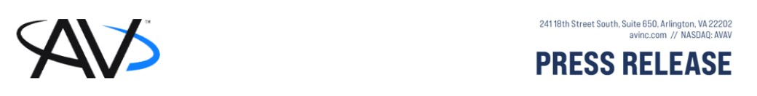
​
AeroVironment Announces Fiscal 2027 First Quarter Results
​
ARLINGTON, VA, September 9, 2026 — AeroVironment, Inc. (NASDAQ: AVAV) (“AeroVironment” or the “Company”) reported today financial results for the fiscal first quarter ended August 1, 2026.
​
First Quarter Highlights:
​
 | ● | Record revenue for the first quarter of $480.5 million, up 6% year-over-year
 | ● | Bookings of $0.7 billion and book-to-bill ratio of 1.4 for the quarter
 | ● | Record funded backlog of $1.5 billion, up 37% year-over-year
“AV's fiscal year 2027 is off to a strong start, with record first-quarter revenue and funded backlog and landmark strategic wins,” said Wahid Nawabi, AeroVironment chairman, president and chief executive officer. “Our team is united in our mission to execute with discipline and capture demand for the key franchise programs that matter most to our customers, and that is exactly what we did in the first quarter.”
​
“Our customers are continuing to field autonomous capabilities at increasing scale, and our priority is expanding manufacturing capacity across our sites and strengthening our supply chain so we can deliver for our customers at the speed their missions require. We are excited for the opportunities ahead as we extend our track record of value creation for shareholders, customers and all stakeholders that rely on AV.”
​
FISCAL 2027 FIRST QUARTER RESULTS
​
Revenue for the first quarter of fiscal 2027 was $480.5 million, an increase of 6% as compared to $454.7 million for the first quarter of fiscal 2026, due to higher product sales of $15.5 million and higher service revenue of $10.3 million. From a segment standpoint, Autonomous Systems (“AxS”) recorded revenue of $346.0 million and Space, Cyber and Directed Energy (“SCDE”) recorded revenue of $134.5 million.
​
Gross margin for the first quarter of fiscal 2027 was $124.6 million, an increase of 31% as compared to $95.1 million for the first quarter of fiscal 2026, reflecting higher product margin of $32.6 million, partially offset by lower service margin of $(3.2) million. Fiscal 2027 first quarter gross margin was negatively impacted by $18.5 million of intangible amortization expense and other related non-cash purchase accounting expenses, as compared to $37.4 million in the first quarter of fiscal 2026. As a percentage of revenue, gross margin rose to 26% from 21%, primarily due to a decrease in intangible amortization and other non-cash purchasing accounting expenses.
​
Loss from operations for the first quarter of fiscal 2027 was $(10.9) million as compared to $(69.3) million for the first quarter of last fiscal year. The current quarter was negatively impacted by $43.4 million of intangible amortization and other related non-cash purchase accounting expenses as compared to $79.7 million in the first quarter of fiscal 2026. The decreased year-over-year loss was primarily due to an increase in gross margin of $29.5 million; a decrease in selling, general and administrative expense of $19.8 million, which includes a decrease of $17.4 million of intangible amortization expense and a decrease of $22.5 million in acquisition related expenses, partially offset by an increase in employee related costs associated with incremental headcount; and a decrease in research and development (“R&D”) expense of $9.2 million.
​
Other income, net for the first quarter of fiscal 2027 was $3.5 million, as compared to other loss, net of $(15.1) million for the first quarter of fiscal 2026. The increase year-over-year was primarily due a decrease in interest expense related to
1

the term and revolver facility loans obtained in conjunction with the BlueHalo acquisition in the prior year and subsequently settled with proceeds from the issuances of convertible notes and equity in July 2025.
​
Benefit from income taxes for the first quarter of fiscal 2027 was $(0.4) million, as compared to $(15.2) million for the first quarter of last fiscal year. The decrease in tax benefit was primarily attributable to the decrease in net loss before income taxes.
​
Net loss for the first quarter of fiscal 2027 was $(5.1) million, or $(0.10) per diluted share, as compared to $(67.4) million, or $(1.44) per diluted share, in the prior year period, respectively. The current quarter was negatively impacted by $43.4 million, or $0.69 per diluted share, of intangible amortization and other related non-cash purchase accounting expenses as compared to $79.7 million, or $1.34 per diluted share, in the first quarter of fiscal 2026.
​
Non-GAAP adjusted EBITDA for the first quarter of fiscal 2027 was $53.4 million and non-GAAP earnings per diluted share were $0.59, as compared to $56.6 million and $0.32, respectively, for the first quarter of fiscal 2026.
​
BACKLOG
​
As of August 1, 2026, funded backlog (defined as remaining performance obligations under firm orders for which funding is currently appropriated to us under a customer contract) was $1.5 billion, as compared to $1.2 billion as of April 30, 2026.
​
FISCAL 2027 — OUTLOOK FOR THE FULL YEAR
​
For fiscal year 2027, the Company continues to expect revenue of between $2.125 billion and $2.225 billion, net income of between $10 million and $27 million, non-GAAP adjusted EBITDA of between $305 million and $325 million, earnings per diluted share of between $0.21 and $0.53 and non-GAAP earnings per diluted share, which excludes amortization of intangible assets and other non-cash purchase accounting expenses, of between $3.02 and $3.34.
​
The foregoing estimates are forward-looking and reflect management’s view of current and future market conditions, subject to certain risks and uncertainties, including certain assumptions with respect to our ability to efficiently and on a timely basis integrate acquisitions, obtain and retain government contracts, changes in the timing and/or amount of government spending, react to changes in the demand for our products and services, activities of competitors, changes in the regulatory environment, and general economic and business conditions in the United States and elsewhere in the world. Investors are reminded that actual results may differ materially from these estimates and investors should review all risks related to achievement of the guidance reflected under “forward-looking statements” below and in the Company’s filings with the Securities and Exchange Commission.
​
CONFERENCE CALL AND PRESENTATION
​
In conjunction with this release, AeroVironment, Inc. will host a conference call today, Wednesday, September 9, 2026, at 4:30 pm Eastern Time that will be webcast live. Wahid Nawabi, chairman, president and chief executive officer, Sean T. Woodward, executive vice president and chief financial officer, and Denise Pacioni, investor relations director, will host the call.
​
Investors may access the call by registering via the following participant registration link up to ten minutes prior to the start time.
​
Participant registration URL:
https://register-conf.mediaserver.com/register/BId4b51029829c4cc2bf060cb73f3e901f
​
Investors may also listen to the live audio webcast via the Investor Relations page of the AeroVironment, Inc. website, http://investor.avinc.com. Please allow 15 minutes prior to the call to download and install any necessary audio software.
2

A supplementary investor presentation for the first quarter fiscal year 2027 can be accessed at https://investor.avinc.com/events-and-presentations.
​
Audio Replay
​
An audio replay of the event will be archived on the Investor Relations section of the Company's website at http://investor.avinc.com.
​
ABOUT AEROVIRONMENT, INC.
​
AeroVironment (“AV”) (NASDAQ: AVAV) is a defense technology leader delivering integrated capabilities across air, land, sea, space, and cyber. The company develops and deploys autonomous systems, precision strike systems, counter-UAS technologies, space-based platforms, directed energy systems, and cyber and electronic warfare capabilities—built to meet the mission needs of today’s warfighter and tomorrow’s conflicts. With a national manufacturing footprint and a deep innovation pipeline, AV delivers proven systems and future-defining capabilities with speed, scale, and operational relevance. For more information visit: www.avinc.com.
​
FORWARD-LOOKING STATEMENTS
​
This press release contains "forward-looking statements" as that term is defined in the Private Securities Litigation Reform Act of 1995. Forward-looking statements include, without limitation, any statement that may predict, forecast, indicate or imply future results, performance or achievements, and may contain words such as “will,” “believe,” “anticipate,” “expect,” “estimate,” “intend,” “project,” “plan,” or words or phrases with similar meaning. Forward-looking statements are based on current expectations, forecasts and assumptions that involve risks and uncertainties, including, but not limited to, economic, competitive, governmental and technological factors outside of our control, that may cause our business, strategy or actual results to differ materially from the forward-looking statements.
​
Factors that could cause actual results to differ materially from the forward-looking statements include, but are not limited to, the impact of our ability to successfully close and integrate acquisitions into our operations and avoid disruptions from acquisition transactions that will harm our business; the recording of goodwill and other intangible assets as part of acquisitions that are subject to potential impairments in the future and any realization of such impairments; any actual or threatened disruptions to our relationships with our distributors, suppliers, customers and employees, including shortages in components for our products, whether due to restrictions and sanctions imposed by foreign governments or otherwise; the ability to timely and sufficiently integrate international operations into our ongoing business and compliance programs; reliance on sales to the U.S. government, including uncertainties in classification, pricing or potentially burdensome imposed terms for certain types of government contracts; availability of U.S. government funding for defense procurement and R&D programs; our ability to win U.S. and international government R&D and procurement programs, including foreign military financing aid; changes in the timing and/or amount of government spending, including due to continuing resolutions and/or changing government priorities; adverse impacts of any U.S. government shutdown; our ability to realize the anticipated benefits of the BlueHalo transaction or other acquisitions; our ability to execute contracts for anticipated sales, perform under such contracts and other existing contracts and obtain new contracts; risks related to our international business, including compliance with export control laws; the extensive and increasing regulatory requirements governing our contracts with the U.S. government and international customers; the consequences to our financial position, business and reputation that could result from failing to comply with applicable law, regulatory requirements, and contractual obligations; unexpected technical and marketing difficulties inherent in major research and product development efforts; the impact of potential security and cyber threats or the risk of unauthorized access to and resulting misuse of our, our customers’ and/or our suppliers’ information and systems; failure to remain a market innovator, to create new market opportunities or to expand into new markets; our ability to increase production capacity to support anticipated growth; unexpected changes in significant operating expenses, including components and raw materials; failure to develop new products or integrate new technology into current products; any increase in litigation activity or unfavorable results in legal proceedings, including pending class actions, or litigation that may arise from or in conjunction with our recent acquisitions; our ability to respond and adapt to legal, regulatory and government budgetary changes; our ability to comply with the covenants in our loan documents, outstanding convertible notes or acquisition and merger agreements for acquisitions; our ability to attract and retain skilled employees, including retention of employees of acquired companies; the impact of inflation; and general economic and business conditions in the United States and elsewhere in the world; and the failure to establish and maintain effective internal control over financial reporting. For a further list and description of such risks and uncertainties, see the reports we file with the Securities and Exchange Commission. We do not intend, and undertake no obligation, to update any forward-looking statements, whether as a result of new information, future events or otherwise.
3

​
NON-GAAP MEASURES
​
In addition to the financial measures prepared in accordance with generally accepted accounting principles (GAAP), this earnings release also contains non-GAAP financial measures. See in the financial tables below the calculation of these measures, the reasons why we believe these measures provide useful information to investors, and a reconciliation of these measures to the most directly comparable GAAP measures.
​
– Financial Tables Follow –
4

AeroVironment, Inc.
Consolidated Statements of Operations
(In thousands except share and per share data)
​
​ | ​ | ​ | ​ | ​ | ​ | ​ | ​
​ | ​ | Three Months Ended |  |  |  |  | ​
​ | ​ | August 1, |  | ​ | August 2, |  | ​
​ | ​ ​ ​ | 2026 |  | ​ | 2025
​ | ​ | (Unaudited) |  |  |  |  | ​
Revenue: | ​ | ​ | ​ | ​ | ​ | ​ | ​
Product sales | ​ | $ | 329,058 | ​ | $ | 313,533 | ​
Contract services | ​ |  | 151,432 | ​ | ​ | 141,143 | ​
​ | ​ |  | 480,490 | ​ | ​ | 454,676 | ​
Cost of sales: | ​ | ​ | ​ | ​ | ​ | ​ | ​
Product sales | ​ |  | 213,565 | ​ | ​ | 230,687 | ​
Contract services | ​ |  | 142,326 | ​ | ​ | 128,871 | ​
​ | ​ |  | 355,891 | ​ | ​ | 359,558 | ​
Gross margin: | ​ |  | ​ | ​ | ​ | ​ | ​
Product sales | ​ | ​ | 115,493 | ​ | ​ | 82,846 | ​
Contract services | ​ | ​ | 9,106 | ​ | ​ | 12,272 | ​
​ | ​ | ​ | 124,599 | ​ | ​ | 95,118 | ​
Selling, general and administrative | ​ |  | 111,508 | ​ | ​ | 131,276 | ​
Research and development | ​ |  | 23,962 | ​ | ​ | 33,114 | ​
Loss from operations | ​ |  | (10,871) | ​ | ​ | (69,272) | ​
Other income (loss): | ​ | ​ | ​ | ​ | ​ | ​ | ​
Interest income (expense), net | ​ |  | 4,136 | ​ | ​ | (17,415) | ​
Other (expense) income, net | ​ |  | (595) | ​ | ​ | 2,361 | ​
Loss before income taxes | ​ |  | (7,330) | ​ | ​ | (84,326) | ​
Benefit from income taxes | ​ |  | (397) | ​ | ​ | (15,169) | ​
Equity method investment income, net of tax | ​ | ​ | 1,867 | ​ | ​ | 1,787 | ​
Net loss | ​ | $ | (5,066) | ​ | $ | (67,370) | ​
Net loss per share | ​ | ​ | ​ | ​ | ​ | ​ | ​
Basic | ​ | $ | (0.10) | ​ | $ | (1.44) | ​
Diluted | ​ | $ | (0.10) | ​ | $ | (1.44) | ​
Weighted-average shares outstanding: | ​ | ​ | ​ | ​ | ​ | ​ | ​
Basic | ​ |  | 49,822,595 | ​ | ​ | 46,882,350 | ​
Diluted | ​ |  | 49,822,595 | ​ | ​ | 46,882,350 | ​
​
​
​
5

AeroVironment, Inc.
Consolidated Balance Sheets
(In thousands except share data)
​
​ | ​ | ​ | ​ | ​ | ​ | ​ | ​
​ | ​ | August 1, |  | ​ ​ ​ | April 30, |  | ​
​ | ​ | 2026 |  | ​ | 2026 |  | ​
Assets | ​ | ​ | ​ | ​ | ​ | ​ | ​
Current assets: | ​ | ​ | ​ | ​ | ​ | ​ | ​
Cash and cash equivalents | ​ | $ | 278,390 | ​ | $ | 377,325 | ​
Short-term investments | ​ | ​ | 301,837 | ​ | ​ | 254,972 | ​
Accounts receivable, net of allowance for credit losses of $6,515 at August 1, 2026 and $1,961 at April 30, 2026 | ​ |  | 183,133 | ​ |  | 316,167 | ​
Unbilled receivables and retentions | ​ |  | 637,832 | ​ |  | 570,408 | ​
Inventories, net | ​ |  | 410,773 | ​ |  | 312,856 | ​
Income taxes receivable | ​ | ​ | 5,806 | ​ | ​ | 6,210 | ​
Prepaid expenses and other current assets | ​ |  | 63,863 | ​ |  | 52,485 | ​
Total current assets | ​ |  | 1,881,634 | ​ |  | 1,890,423 | ​
Long-term investments | ​ | ​ | 94,777 | ​ | ​ | 81,128 | ​
Property and equipment, net | ​ |  | 202,653 | ​ |  | 166,719 | ​
Operating lease right-of-use assets | ​ | ​ | 113,830 | ​ | ​ | 100,392 | ​
Intangibles, net | ​ | ​ | 886,469 | ​ | ​ | 929,826 | ​
Goodwill | ​ | ​ | 2,493,886 | ​ | ​ | 2,493,678 | ​
Other assets | ​ |  | 57,444 | ​ |  | 54,576 | ​
Total assets | ​ | $ | 5,730,693 | ​ | $ | 5,716,742 | ​
Liabilities and stockholders’ equity | ​ | ​ | ​ | ​ | ​ | ​ | ​
Current liabilities: | ​ | ​ | ​ | ​ | ​ | ​ | ​
Accounts payable | ​ | $ | 174,836 | ​ | $ | 160,507 | ​
Wages and related accruals | ​ |  | 70,933 | ​ |  | 98,056 | ​
Customer advances | ​ |  | 87,546 | ​ |  | 79,607 | ​
Current operating lease liabilities | ​ | ​ | 17,823 | ​ | ​ | 17,594 | ​
Income taxes payable | ​ | ​ | 487 | ​ | ​ | 524 | ​
Other current liabilities | ​ |  | 90,105 | ​ |  | 82,949 | ​
Total current liabilities | ​ |  | 441,730 | ​ |  | 439,237 | ​
Long-term debt | ​ | ​ | 730,057 | ​ | ​ | 728,967 | ​
Non-current operating lease liabilities | ​ | ​ | 102,943 | ​ | ​ | 88,228 | ​
Other non-current liabilities | ​ | ​ | 1,984 | ​ | ​ | 1,986 | ​
Liability for uncertain tax positions | ​ |  | 7,430 | ​ |  | 7,430 | ​
Deferred income taxes | ​ | ​ | 50,494 | ​ | ​ | 50,494 | ​
Commitments and contingencies | ​ | ​ | ​ | ​ | ​ | ​ | ​
Stockholders’ equity: | ​ | ​ | ​ | ​ | ​ | ​ | ​
Preferred stock, $0.0001 par value: | ​ | ​ | ​ | ​ | ​ | ​ | ​
Authorized shares—10,000,000; none issued or outstanding at August 1, 2026 and April 30, 2026 | ​ |  | — | ​ |  | — | ​
Common stock, $0.0001 par value: | ​ | ​ | ​ | ​ | ​ | ​ | ​
Authorized shares—100,000,000 | ​ | ​ | ​ | ​ | ​ | ​ | ​
Issued and outstanding shares—50,822,963 shares at August 1, 2026 and 50,610,514 shares at April 30, 2026 | ​ |  | 6 | ​ |  | 6 | ​
Additional paid-in capital | ​ |  | 4,397,684 | ​ |  | 4,396,845 | ​
Accumulated other comprehensive loss | ​ |  | (5,753) | ​ |  | (5,635) | ​
Retained (loss) earnings | ​ |  | 4,118 | ​ |  | 9,184 | ​
Total stockholders’ equity | ​ | ​ | 4,396,055 | ​ | ​ | 4,400,400 | ​
Total liabilities and stockholders’ equity | ​ | $ | 5,730,693 | ​ | $ | 5,716,742 | ​
​
​
​
6

AeroVironment, Inc.
Consolidated Statements of Cash Flows
(In thousands)
​ | ​ | ​ | ​ | ​ | ​ | ​ | ​
​ | ​ | Three Months Ended |  |  |  |  | ​
​ | ​ ​ ​ | August 1, |  | ​ ​ ​ | August 2,
Operating activities | ​ | 2026 |  | ​ | 2025 |  | ​
Net loss | ​ | $ | (5,066) | ​ | $ | (67,370) | ​
Adjustments to reconcile net loss to cash provided by (used in) operating activities: | ​ | ​ | ​ | ​ | ​ | ​ | ​
Depreciation and amortization | ​ |  | 56,033 | ​ |  | 90,254 | ​
Gain from equity method investments | ​ | ​ | (1,867) | ​ | ​ | (1,787) | ​
Amortization of debt issuance costs | ​ | ​ | 1,089 | ​ | ​ | 7,829 | ​
Provision for credit losses | ​ |  | 4,590 | ​ |  | 173 | ​
Reserve for inventory excess and obsolescence | ​ | ​ | 2,199 | ​ | ​ | 1,178 | ​
Other non-cash expense, net | ​ | ​ | 1,623 | ​ | ​ | 616 | ​
Non-cash lease expense | ​ | ​ | 7,664 | ​ | ​ | 6,850 | ​
Loss on foreign currency transactions | ​ |  | 23 | ​ |  | 161 | ​
Gain on sale of equity securities, net | ​ | ​ | — | ​ | ​ | (2,702) | ​
Stock-based compensation | ​ |  | 4,927 | ​ |  | 11,429 | ​
Loss on disposal of property and equipment | ​ | ​ | — | ​ | ​ | 48 | ​
Amortization of debt securities | ​ | ​ | (47) | ​ | ​ | — | ​
Changes in operating assets and liabilities, net of acquisitions: | ​ | ​ | ​ | ​ | ​ | ​ | ​
Accounts receivable | ​ |  | 128,346 | ​ |  | (15,693) | ​
Unbilled receivables and retentions | ​ |  | (68,041) | ​ |  | (74,510) | ​
Inventories | ​ |  | (100,310) | ​ |  | (12,704) | ​
Income taxes receivable | ​ | ​ | 712 | ​ | ​ | (16,390) | ​
Prepaid expenses and other assets | ​ |  | (13,389) | ​ |  | (1,749) | ​
Accounts payable | ​ |  | 12,820 | ​ |  | (29,625) | ​
Other liabilities | ​ | ​ | (17,810) | ​ | ​ | (19,734) | ​
Net cash provided by (used in) operating activities | ​ |  | 13,496 | ​ |  | (123,726) | ​
Investing activities | ​ | ​ | ​ | ​ | ​ | ​ | ​
Acquisition of property and equipment | ​ |  | (44,033) | ​ |  | (22,728) | ​
Acquisition of capitalized software to be sold | ​ | ​ | (5,417) | ​ | ​ | (9,340) | ​
Purchase of available-for-sale investments | ​ | ​ | (114,578) | ​ | ​ | — | ​
Redemption of available-for-sale investments | ​ | ​ | 55,792 | ​ | ​ | — | ​
Business acquisitions, net of cash acquired | ​ | ​ | — | ​ | ​ | (844,580) | ​
Net cash used in investing activities | ​ |  | (108,236) | ​ |  | (876,648) | ​
Financing activities | ​ | ​ | ​ | ​ | ​ | ​ | ​
Proceeds from revolving credit facility | ​ | ​ | — | ​ | ​ | 233,939 | ​
Principal payments of term loan | ​ | ​ | — | ​ | ​ | (700,000) | ​
Proceeds from term loan | ​ | ​ | — | ​ | ​ | 693,202 | ​
Principal payments of revolver | ​ | ​ | — | ​ | ​ | (265,000) | ​
Proceeds from shares issued, net of underwriter costs | ​ | ​ | — | ​ | ​ | 968,515 | ​
Proceeds from convertible debt, net of underwriter costs | ​ | ​ | — | ​ | ​ | 726,944 | ​
Payment of debt issuance costs | ​ | ​ | — | ​ | ​ | (2,445) | ​
Payment of equity issuance costs | ​ | ​ | — | ​ | ​ | (1,388) | ​
Tax withholding payment related to net settlement of equity awards | ​ | ​ | (9,563) | ​ | ​ | (10,786) | ​
Employee stock purchase plan contributions | ​ | ​ | 5,475 | ​ | ​ | 2,467 | ​
Other | ​ | ​ | (1) | ​ | ​ | (5) | ​
Net cash (used in) provided by financing activities | ​ |  | (4,089) | ​ |  | 1,645,443 | ​
Effects of currency translation on cash and cash equivalents | ​ | ​ | (106) | ​ | ​ | (128) | ​
Net (decrease) increase in cash and cash equivalents | ​ |  | (98,935) | ​ |  | 644,941 | ​
Cash and cash equivalents at beginning of period | ​ |  | 377,325 | ​ |  | 40,862 | ​
Cash and cash equivalents at end of period | ​ | $ | 278,390 | ​ | $ | 685,803 | ​
Supplemental disclosures of cash flow information | ​ | ​ | ​ | ​ | ​ | ​ | ​
Cash (received) paid, net during the period for: | ​ | ​ | ​ | ​ | ​ | ​ | ​
Income taxes | ​ | $ | (272) | ​ | $ | (223) | ​
Interest | ​ | $ | 321 | ​ | $ | 11,854 | ​
Non-cash activities | ​ | ​ | ​ | ​ | ​ | ​ | ​
Issuance of common stock for business acquisition | ​ | $ | — | ​ | $ | 2,640,365 | ​
Unrealized loss on available-for-sale investments | ​ | $ | (186) | ​ | $ | — | ​
Change in foreign currency translation adjustments | ​ | $ | 68 | ​ | $ | 639 | ​
Acquisitions of property and equipment included in accounts payable | ​ | $ | 5,880 | ​ | $ | 1,951 | ​
​
​
​
​
​
​
​
7

AeroVironment, Inc.
Reportable Segment Results (Unaudited)
(In thousands)
​ | ​ | ​ | ​ | ​ | ​ | ​ | ​ | ​ | ​
​ | ​ | Three Months Ended August 1, 2026
​ | ​ ​ ​ | AxS |  | ​ ​ ​ | SCDE |  | ​ | Total
Revenue | ​ | $ | 345,969 | ​ | $ | 134,521 | ​ | $ | 480,490
​ | ​ | ​ | ​ | ​ | ​ | ​ | ​ | ​ | ​
Segment adjusted EBITDA | ​ | $ | 62,285 | ​ | $ | (8,896) | ​ | $ | 53,389
​
​ | ​ | ​ | ​ | ​ | ​ | ​ | ​ | ​ | ​
​ | ​ | Three Months Ended August 2, 2025
​ | ​ ​ ​ | AxS |  | ​ ​ ​ | SCDE |  | ​ | Total
Revenue | ​ | $ | 285,324 | ​ | $ | 169,352 | ​ | $ | 454,676
​ | ​ | ​ | ​ | ​ | ​ | ​ | ​ | ​ | ​
Segment adjusted EBITDA | ​ | $ | 52,760 | ​ | $ | 3,796 | ​ | $ | 56,556
​
AeroVironment, Inc.
Reconciliation of non-GAAP Earnings per Diluted Share (Unaudited)
​ | ​ | ​ | ​ | ​ | ​ | ​
​ | ​ | ​ | ​ | ​ | ​
​ | ​ | Three Months Ended |  | ​ | Three Months Ended
​ | ​ ​ ​ | August 1, 2026 |  | ​ | August 2, 2025
​ | ​ | ​ | ​ | ​ | ​ | ​
Loss per diluted share | ​ | $ | (0.10) | ​ | $ | (1.44)
Amortization of acquired intangible assets and other purchase accounting adjustments | ​ | ​ | 0.69 | ​ | ​ | 1.34
Acquisition-related expenses | ​ | ​ | 0.04 | ​ | ​ | 0.52
Equity method and equity securities investments activity, net | ​ | ​ | (0.04) | ​ | ​ | (0.10)
Earnings per diluted share as adjusted (non-GAAP) | ​ | $ | 0.59 | ​ | $ | 0.32
​
​
Reconciliation of non-GAAP adjusted EBITDA (Unaudited)
​ | ​ | ​ | ​ | ​ | ​ | ​
​ | ​ | ​ | ​ | ​ | ​ | ​
​ | ​ | Three Months Ended |  | ​ | Three Months Ended
(in millions) | ​ | August 1, 2026 |  | ​ | August 2, 2025
Net loss | ​ | $ | (5.1) | ​ | $ | (67.4)
Interest (income) expense, net | ​ | ​ | (4.1) | ​ | ​ | 17.4
Benefit from income taxes | ​ | ​ | (0.4) | ​ | ​ | (15.2)
Depreciation | ​ | ​ | 12.6 | ​ | ​ | 10.6
Amortization | ​ | ​ | 43.4 | ​ | ​ | 79.7
EBITDA (non-GAAP) | ​ | ​ | 46.4 | ​ | ​ | 25.1
Amortization of cloud computing arrangement implementation | ​ | ​ | 1.9 | ​ | ​ | 0.9
Stock-based compensation | ​ | ​ | 4.9 | ​ | ​ | 11.4
Acquisition-related expenses | ​ | ​ | 2.1 | ​ | ​ | 23.7
Equity method and equity securities investments activity, net | ​ | ​ | (1.9) | ​ | ​ | (4.5)
Adjusted EBITDA (non-GAAP) | ​ | $ | 53.4 | ​ | $ | 56.6
​
​
8

Reconciliation of Forecast Earnings per Diluted Share (Unaudited)
​
​ | ​ | ​ | ​
​ | ​ | ​ | ​
​ | ​ | Fiscal year ending
​ | ​ ​ ​ | April 30, 2027
Forecast earnings per diluted share | ​ | $ | 0.21 - 0.53
Amortization of acquired intangible assets and other purchase accounting adjustments | ​ | ​ | 2.70
Acquisition-related expenses | ​ | ​ | 0.15
Equity method and equity securities investments activity, net | ​ | ​ | (0.04)
Forecast earnings per diluted share as adjusted (non-GAAP) | ​ | $ | 3.02 - 3.34
​
​
Reconciliation of 2027 Forecast and Fiscal Year 2026 Actual Non-GAAP adjusted EBITDA (Unaudited)
​
​ | ​ | ​ | ​ | ​ | ​ | ​
​ | ​ | ​ | ​ | ​ | ​ | ​
​ | ​ | Fiscal year ending |  | ​ | Fiscal year ended
(in millions) | ​ | April 30, 2027 |  | ​ | April 30, 2026
Net income (loss) | ​ | $ | 10 - 27 | ​ | $ | (265)
Interest (income) expense, net | ​ | ​ | (10) | ​ | ​ | 6
(Benefit from) provision for income taxes | ​ | ​ | (4) - 1 | ​ | ​ | (23)
Depreciation | ​ | ​ | 75 - 73 | ​ | ​ | 42
Amortization | ​ | ​ | 173 | ​ | ​ | 223
EBITDA (non-GAAP) | ​ | ​ | 244 - 264 | ​ | ​ | (17)
Amortization of cloud computing arrangement implementation | ​ | ​ | 13 | ​ | ​ | 6
Stock-based compensation | ​ | ​ | 40 | ​ | ​ | 38
Acquisition-related expenses | ​ | ​ | 10 | ​ | ​ | 48
Equity method and equity securities investments activity, net | ​ | ​ | (2) | ​ | ​ | (29)
Goodwill impairment | ​ | ​ | — | ​ | ​ | 241
Adjusted EBITDA (non-GAAP) | ​ | $ | 305 - 325 | ​ | $ | 287
​
​
9

Statement Regarding Non-GAAP Measures
​
The non-GAAP measures set forth above should be considered in addition to, and not as a replacement for or superior to, the comparable GAAP measures, and may not be comparable to similarly titled measures reported by other companies. Management believes that these measures provide useful information to investors by offering additional ways of viewing our results that, when reconciled to the corresponding GAAP measures, help our investors to understand the long-term profitability trends of our business and compare our profitability to prior and future periods and to our peers. In addition, management uses these non-GAAP measures to evaluate our operating and financial performance.
​
Non-GAAP Earnings per Diluted Share
​
We exclude acquisition-related expenses, amortization of acquisition-related intangible assets, equity method investment gains and losses, equity securities investments gains or losses, goodwill impairment and one-time non-operating items because we believe this facilitates more consistent comparisons of operating results over time between our newly acquired and existing businesses, and with our peer companies. We believe, however, that it is important for investors to understand that such intangible assets contribute to revenue generation and that intangible asset amortization will recur in future periods until such intangible assets have been fully amortized.
​
Adjusted EBITDA (Non-GAAP)
​
Adjusted EBITDA is defined as net income before interest income, interest expense, income tax expense (benefit) and depreciation and amortization, adjusted for the impact of certain other non-cash items, including amortization of implementation of cloud computing arrangements, stock-based compensation, acquisition related expenses, equity method investment gains or losses, equity securities investments gains or losses, goodwill impairment and one-time non-operating gains or losses. We present Adjusted EBITDA, which is not a recognized financial measure under U.S. GAAP, because we believe it is frequently used by analysts, investors and other interested parties to evaluate companies in our industry. We believe this facilitates more consistent comparisons of operating results over time between our newly acquired and existing businesses, and with our peer companies. We believe, however, that it is important for investors to understand that such intangible assets contribute to revenue generation, intangible asset amortization will recur in future periods until such intangible assets have been fully amortized and that interest and income tax expenses will recur in future periods. In addition, Adjusted EBITDA may not be comparable to similarly titled measures used by other companies in our industry or across different industries.
​
10

/////////////////////////////////////////////////////////////////////////////////////////////////////////////////////////////////////
For additional media and information, please follow us

​
CONTACT
Denise Pacioni
+1 805-795-4108
ir@avinc.com
https://investor.avinc.com/contact-and-faq/contact-us
11

Exhibit 99.2
 | 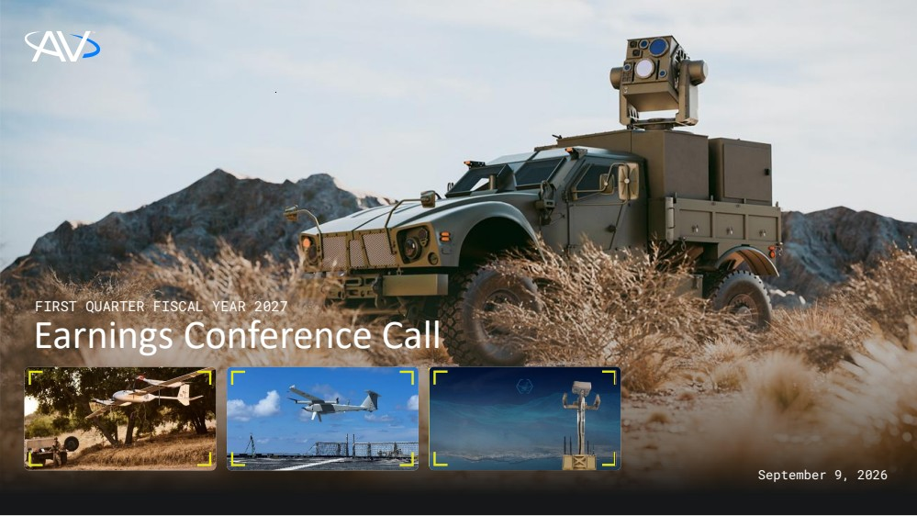 | FIRST QUARTER FISCAL YEAR 2027 Earnings Conference Call September 9, 2026
 | 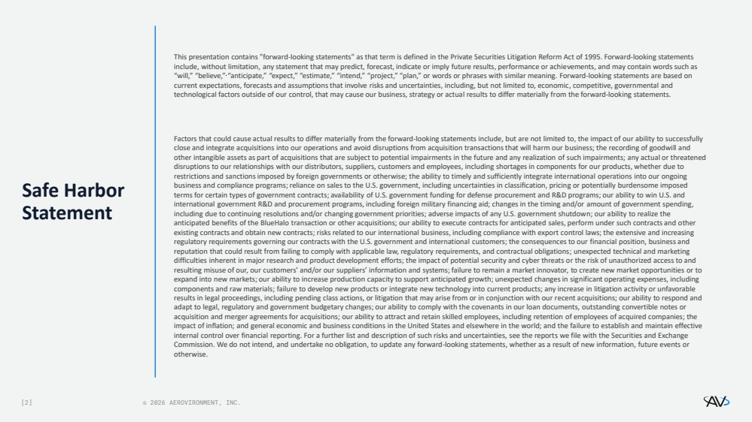 | [2] © 2026 AEROVIRONMENT, INC. Safe Harbor Statement This presentation contains "forward-looking statements" as that term is defined in the Private Securities Litigation Reform Act of 1995. Forward-looking statements include, without limitation, any statement that may predict, forecast, indicate or imply future results, performance or achievements, and may contain words such as “will,” “believe,” “anticipate,” “expect,” “estimate,” “intend,” “project,” “plan,” or words or phrases with similar meaning. Forward-looking statements are based on current expectations, forecasts and assumptions that involve risks and uncertainties, including, but not limited to, economic, competitive, governmental and technological factors outside of our control, that may cause our business, strategy or actual results to differ materially from the forward-looking statements. Factors that could cause actual results to differ materially from the forward-looking statements include, but are not limited to, the impact of our ability to successfully close and integrate acquisitions into our operations and avoid disruptions from acquisition transactions that will harm our business; the recording of goodwill and other intangible assets as part of acquisitions that are subject to potential impairments in the future and any realization of such impairments; any actual or threatened disruptions to our relationships with our distributors, suppliers, customers and employees, including shortages in components for our products, whether due to restrictions and sanctions imposed by foreign governments or otherwise; the ability to timely and sufficiently integrate international operations into our ongoing business and compliance programs; reliance on sales to the U.S. government, including uncertainties in classification, pricing or potentially burdensome imposed terms for certain types of government contracts; availability of U.S. government funding for defense procurement and R&D programs; our ability to win U.S. and international government R&D and procurement programs, including foreign military financing aid; changes in the timing and/or amount of government spending, including due to continuing resolutions and/or changing government priorities; adverse impacts of any U.S. government shutdown; our ability to realize the anticipated benefits of the BlueHalo transaction or other acquisitions; our ability to execute contracts for anticipated sales, perform under such contracts and other existing contracts and obtain new contracts; risks related to our international business, including compliance with export control laws; the extensive and increasing regulatory requirements governing our contracts with the U.S. government and international customers; the consequences to our financial position, business and reputation that could result from failing to comply with applicable law, regulatory requirements, and contractual obligations; unexpected technical and marketing difficulties inherent in major research and product development efforts; the impact of potential security and cyber threats or the risk of unauthorized access to and resulting misuse of our, our customers’ and/or our suppliers’ information and systems; failure to remain a market innovator, to create new market opportunities or to expand into new markets; our ability to increase production capacity to support anticipated growth; unexpected changes in significant operating expenses, including components and raw materials; failure to develop new products or integrate new technology into current products; any increase in litigation activity or unfavorable results in legal proceedings, including pending class actions, or litigation that may arise from or in conjunction with our recent acquisitions; our ability to respond and adapt to legal, regulatory and government budgetary changes; our ability to comply with the covenants in our loan documents, outstanding convertible notes or acquisition and merger agreements for acquisitions; our ability to attract and retain skilled employees, including retention of employees of acquired companies; the impact of inflation; and general economic and business conditions in the United States and elsewhere in the world; and the failure to establish and maintain effective internal control over financial reporting. For a further list and description of such risks and uncertainties, see the reports we file with the Securities and Exchange Commission. We do not intend, and undertake no obligation, to update any forward-looking statements, whether as a result of new information, future events or otherwise.
 | 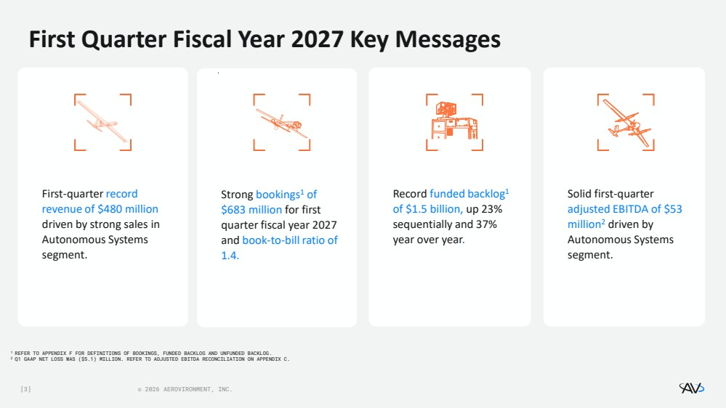 | [3] © 2026 AEROVIRONMENT, INC. Solid first-quarter adjusted EBITDA of $53 million2 driven by Autonomous Systems segment. Record funded backlog1 of $1.5 billion, up 23% sequentially and 37% year over year. First-quarter record revenue of $480 million driven by strong sales in Autonomous Systems segment. Strong bookings1 of $683 million for first quarter fiscal year 2027 and book-to-bill ratio of 1.4. First Quarter Fiscal Year 2027 Key Messages 1 REFER TO APPENDIX F FOR DEFINITIONS OF BOOKINGS, FUNDED BACKLOG AND UNFUNDED BACKLOG. 2 Q1 GAAP NET LOSS WAS ($5.1) MILLION. REFER TO ADJUSTED EBITDA RECONCILIATION ON APPENDIX C.
 | 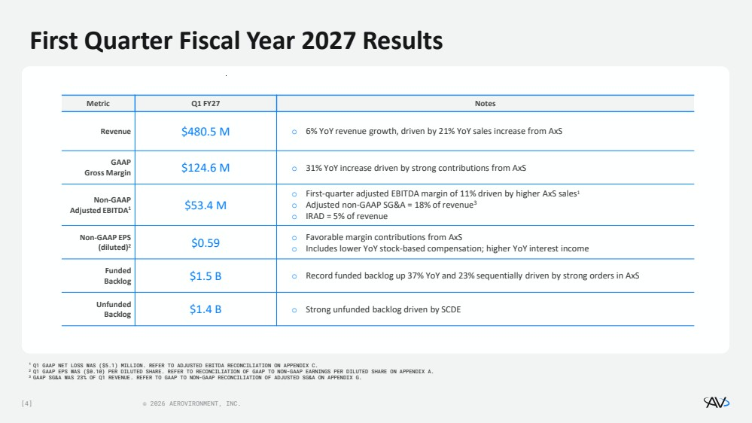 | [4] © 2026 AEROVIRONMENT, INC. First Quarter Fiscal Year 2027 Results 1 Q1 GAAP NET LOSS WAS ($5.1) MILLION. REFER TO ADJUSTED EBITDA RECONCILIATION ON APPENDIX C. 2 Q1 GAAP EPS WAS ($0.10) PER DILUTED SHARE. REFER TO RECONCILIATION OF GAAP TO NON-GAAP EARNINGS PER DILUTED SHARE ON APPENDIX A. 3 GAAP SG&A WAS 23% OF Q1 REVENUE. REFER TO GAAP TO NON-GAAP RECONCILIATION OF ADJUSTED SG&A ON APPENDIX G. Metric Q1 FY27 Notes Revenue $480.5 M o 6% YoY revenue growth, driven by 21% YoY sales increase from AxS GAAP Gross Margin $124.6 M o 31% YoY increase driven by strong contributions from AxS Non-GAAP Adjusted EBITDA1 $53.4 M o First-quarter adjusted EBITDA margin of 11% driven by higher AxS sales1 o Adjusted non-GAAP SG&A = 18% of revenue3 o IRAD = 5% of revenue Non-GAAP EPS (diluted)2 $0.59 o Favorable margin contributions from AxS o Includes lower YoY stock-based compensation; higher YoY interest income Funded Backlog $1.5 B o Record funded backlog up 37% YoY and 23% sequentially driven by strong orders in AxS Unfunded Backlog $1.4 B o Strong unfunded backlog driven by SCDE
 | 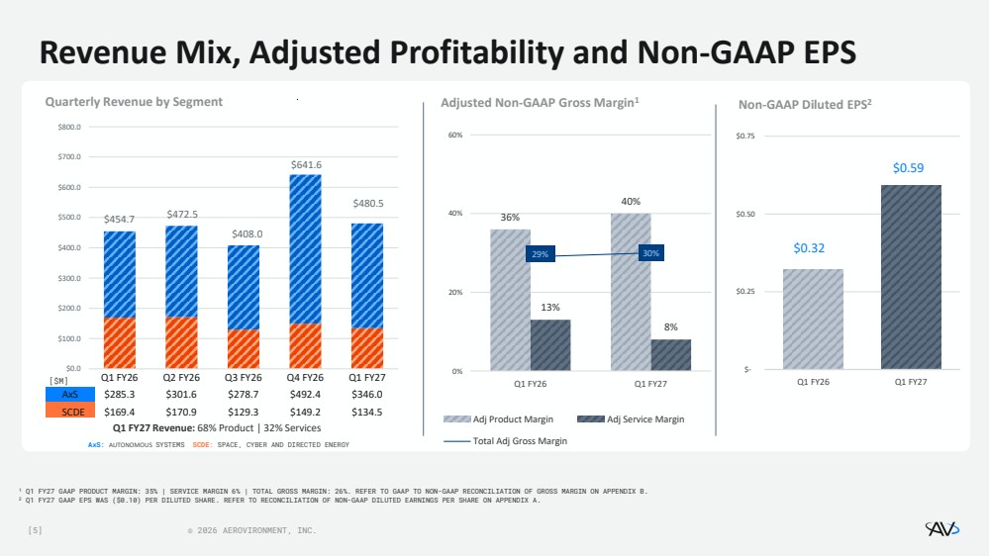 | [5] © 2026 AEROVIRONMENT, INC. $454.7 $472.5 $408.0 $641.6 $480.5 $0.0 $100.0 $200.0 $300.0 $400.0 $500.0 $600.0 $700.0 $800.0 Q1 FY26 Q2 FY26 Q3 FY26 Q4 FY26 Q1 FY27 AxS $285.3 $301.6 $278.7 $492.4 $346.0 SCDE $169.4 $170.9 $129.3 $149.2 $134.5 Revenue Mix, Adjusted Profitability and Non-GAAP EPS 1 Q1 FY27 GAAP PRODUCT MARGIN: 35% | SERVICE MARGIN 6% | TOTAL GROSS MARGIN: 26%. REFER TO GAAP TO NON-GAAP RECONCILIATION OF GROSS MARGIN ON APPENDIX B. 2 Q1 FY27 GAAP EPS WAS ($0.10) PER DILUTED SHARE. REFER TO RECONCILIATION OF NON-GAAP DILUTED EARNINGS PER SHARE ON APPENDIX A. Quarterly Revenue by Segment AxS: AUTONOMOUS SYSTEMS SCDE: SPACE, CYBER AND DIRECTED ENERGY 36% 40% 13% 8% 29% 30% 0% 20% 40% 60% Q1 FY26 Q1 FY27 Adj Product Margin Adj Service Margin Total Adj Gross Margin $0.32 $0.59 $- $0.25 $0.50 $0.75 Q1 FY26 Q1 FY27 Q1 FY27 Revenue: 68% Product | 32% Services Adjusted Non-GAAP Gross Margin1 Non-GAAP Diluted EPS2 [$M]
 | 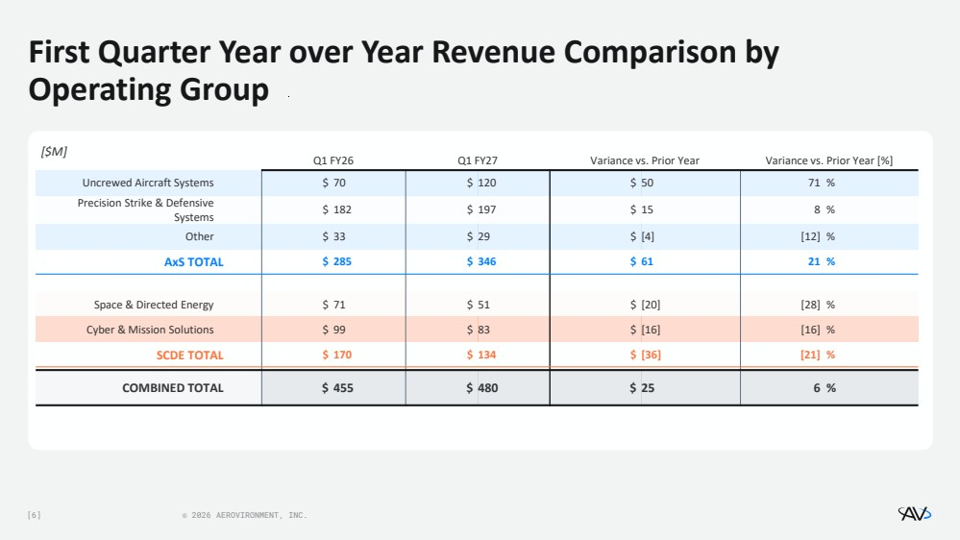 | [6] © 2026 AEROVIRONMENT, INC. First Quarter Year over Year Revenue Comparison by Operating Group [$M] Q1 FY26 Q1 FY27 Variance vs. Prior Year Variance vs. Prior Year [%] Uncrewed Aircraft Systems $ 70 $ 120 $ 50 71 % Precision Strike & Defensive Systems $ 182 $ 197 $ 15 8 % Other $ 33 $ 29 $ [4] [12] % AxS TOTAL $ 285 $ 346 $ 61 21 % Space & Directed Energy $ 71 $ 51 $ [20] [28] % Cyber & Mission Solutions $ 99 $ 83 $ [16] [16] % SCDE TOTAL $ 170 $ 134 $ [36] [21] % COMBINED TOTAL $ 455 $ 480 $ 25 6 % Saved in SlideLizard CREATOR library
 | 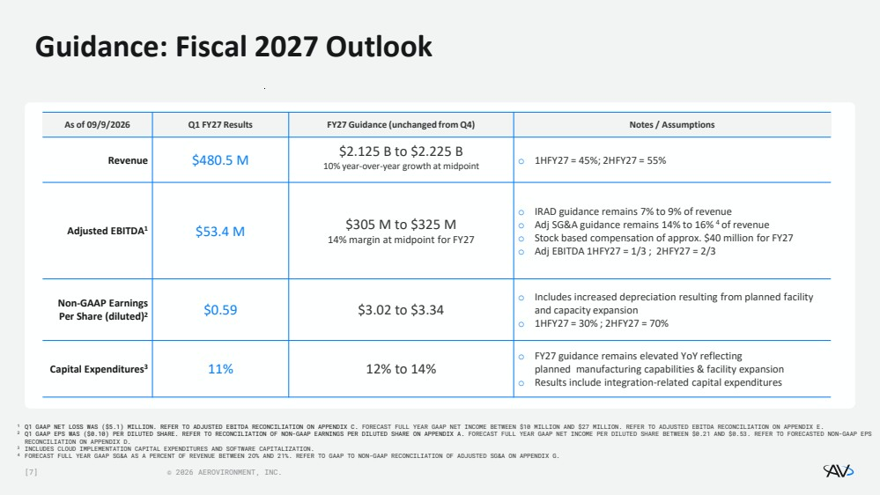 | [7] © 2026 AEROVIRONMENT, INC. Guidance: Fiscal 2027 Outlook As of 09/9/2026 Q1 FY27 Results FY27 Guidance (unchanged from Q4) Notes / Assumptions Revenue $480.5 M $2.125 B to $2.225 B 10% year-over-year growth at midpoint o 1HFY27 = 45%; 2HFY27 = 55% Adjusted EBITDA1 $53.4 M $305 M to $325 M 14% margin at midpoint for FY27 o IRAD guidance remains 7% to 9%​ of revenue o Adj SG&A guidance remains 14% to 16%​ 4 of revenue o Stock based compensation of approx. $40 million for FY27 o Adj EBITDA 1HFY27 = 1/3 ; 2HFY27 = 2/3 Non-GAAP Earnings Per Share (diluted)2 $0.59 $3.02 to $3.34 o Includes increased depreciation resulting from planned facility and capacity expansion o 1HFY27 = 30% ; 2HFY27 = 70% Capital Expenditures3 11% 12% to 14% o FY27 guidance remains elevated YoY reflecting planned manufacturing capabilities & facility expansion o Results include integration-related capital expenditures 1 Q1 GAAP NET LOSS WAS ($5.1) MILLION. REFER TO ADJUSTED EBITDA RECONCILIATION ON APPENDIX C. FORECAST FULL YEAR GAAP NET INCOME BETWEEN $10 MILLION AND $27 MILLION. REFER TO ADJUSTED EBITDA RECONCILIATION ON APPENDIX E. 2 Q1 GAAP EPS WAS ($0.10) PER DILUTED SHARE. REFER TO RECONCILIATION OF NON-GAAP EARNINGS PER DILUTED SHARE ON APPENDIX A. FORECAST FULL YEAR GAAP NET INCOME PER DILUTED SHARE BETWEEN $0.21 AND $0.53. REFER TO FORECASTED NON-GAAP EPS RECONCILIATION ON APPENDIX D. 3 INCLUDES CLOUD IMPLEMENTATION CAPITAL EXPENDITURES AND SOFTWARE CAPITALIZATION. 4 FORECAST FULL YEAR GAAP SG&A AS A PERCENT OF REVENUE BETWEEN 2O% AND 21%. REFER TO GAAP TO NON-GAAP RECONCILIATION OF ADJUSTED SG&A ON APPENDIX G.
 | 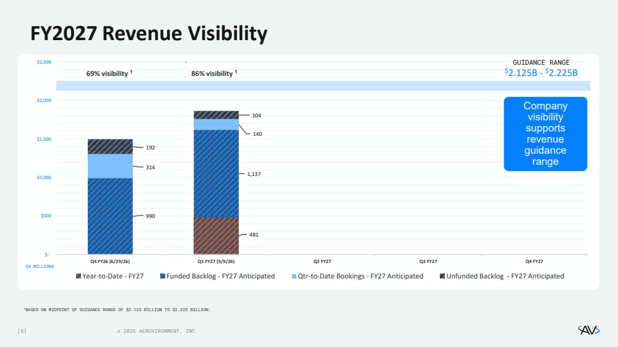 | [8] © 2026 AEROVIRONMENT, INC. 481 990 1,137 314 140 192 104 $- $500 $1,000 $1,500 $2,000 $2,500 Q4 FY26 (6/29/26) Q1 FY27 (9/9/26) Q2 FY27 Q3 FY27 Q4 FY27 Year-to-Date - FY27 Funded Backlog - FY27 Anticipated Qtr-to-Date Bookings - FY27 Anticipated Unfunded Backlog - FY27 Anticipated 86% visibility 1 FY2027 Revenue Visibility 1BASED ON MIDPOINT OF GUIDANCE RANGE OF $2.125 BILLION TO $2.225 BILLION. Company visibility supports revenue guidance range 69% visibility 1 GUIDANCE RANGE $2.125B - $2.225B IN MILLIONS
 | 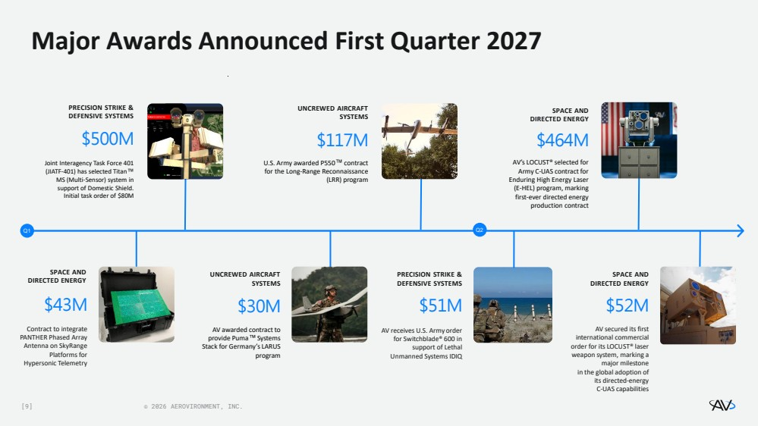 | [9] © 2026 AEROVIRONMENT, INC. PRECISION STRIKE & DEFENSIVE SYSTEMS AV receives U.S. Army order for Switchblade® 600 in support of Lethal Unmanned Systems IDIQ $51M Major Awards Announced First Quarter 2027 Q1 $30M AV awarded contract to provide Puma Systems Stack for Germany’s LARUS program UNCREWED AIRCRAFT SYSTEMS UNCREWED AIRCRAFT SYSTEMS $117M U.S. Army awarded P550 contract for the Long-Range Reconnaissance (LRR) program $52M AV secured its first international commercial order for its LOCUST® laser weapon system, marking a major milestone in the global adoption of its directed-energy C-UAS capabilities SPACE AND DIRECTED ENERGY Q2 $43M Contract to integrate PANTHER Phased Array Antenna on SkyRange Platforms for Hypersonic Telemetry SPACE AND DIRECTED ENERGY SPACE AND DIRECTED ENERGY $464M AV’s LOCUST® selected for Army C-UAS contract for Enduring High Energy Laser (E-HEL) program, marking first-ever directed energy production contract $500M Joint Interagency Task Force 401 (JIATF-401) has selected Titan MS (Multi-Sensor) system in support of Domestic Shield. Initial task order of $80M PRECISION STRIKE & DEFENSIVE SYSTEMS
 | 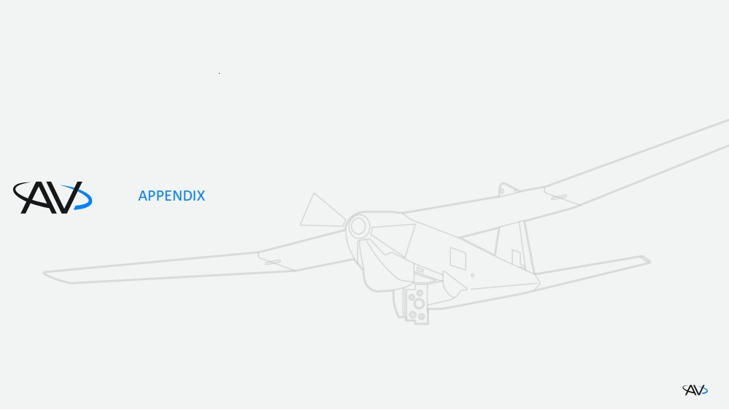 | APPENDIX
 | 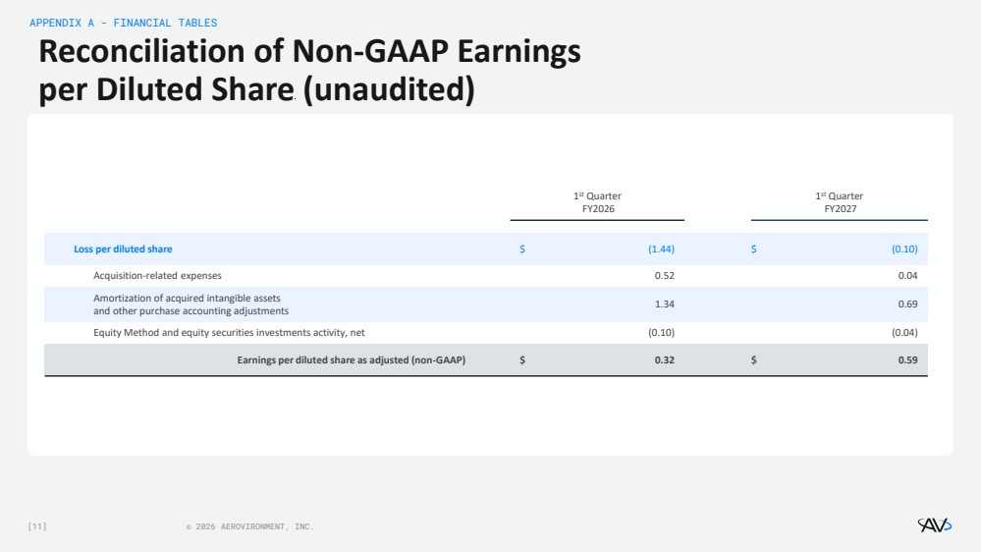 | [11] © 2026 AEROVIRONMENT, INC. Reconciliation of Non-GAAP Earnings per Diluted Share (unaudited) 1 st Quarter FY2026 1 st Quarter FY2027 Loss per diluted share $ (1.44) $ (0.10) Acquisition-related expenses 0.52 0.04 Amortization of acquired intangible assets and other purchase accounting adjustments 1.34 0.69 Equity Method and equity securities investments activity, net (0.10) (0.04) Earnings per diluted share as adjusted (non-GAAP) $ 0.32 $ 0.59 APPENDIX A - FINANCIAL TABLES
 | 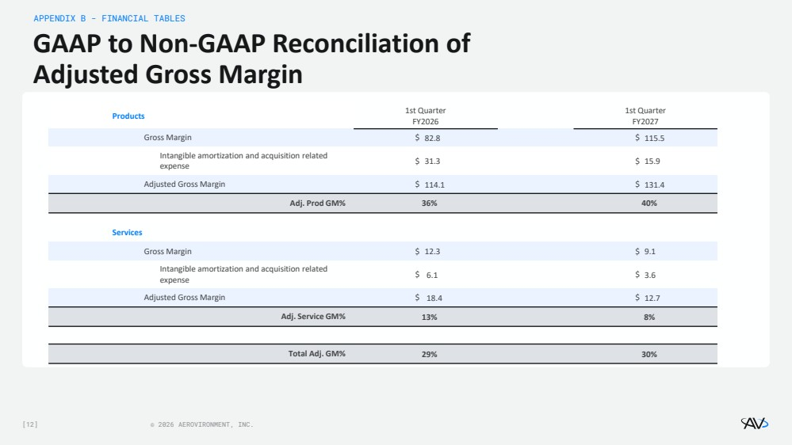 | [12] © 2026 AEROVIRONMENT, INC. GAAP to Non-GAAP Reconciliation of Adjusted Gross Margin APPENDIX B - FINANCIAL TABLES Products 1st Quarter FY2026 1st Quarter FY2027 Gross Margin $ 82.8 $ 115.5 Intangible amortization and acquisition related expense $ 31.3 $ 15.9 Adjusted Gross Margin $ 114.1 $ 131.4 Adj. Prod GM% 36% 40% Services Gross Margin $ 12.3 $ 9.1 Intangible amortization and acquisition related expense $ 6.1 $ 3.6 Adjusted Gross Margin $ 18.4 $ 12.7 Adj. Service GM% 13% 8% Total Adj. GM% 29% 30%
 | 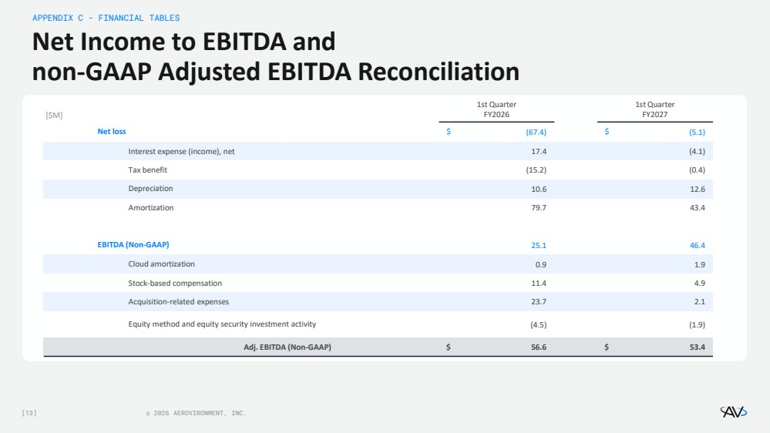 | [13] © 2026 AEROVIRONMENT, INC. Net Income to EBITDA and non-GAAP Adjusted EBITDA Reconciliation APPENDIX C - FINANCIAL TABLES 1st Quarter FY2026 1st Quarter FY2027 Net loss $ (67.4) $ (5.1) Interest expense (income), net 17.4 (4.1) Tax benefit (15.2) (0.4) Depreciation 10.6 12.6 Amortization 79.7 43.4 EBITDA (Non-GAAP) 25.1 46.4 Cloud amortization 0.9 1.9 Stock-based compensation 11.4 4.9 Acquisition-related expenses 23.7 2.1 Equity method and equity security investment activity (4.5) (1.9) Adj. EBITDA (Non-GAAP) $ 56.6 $ 53.4 [$M]
 | 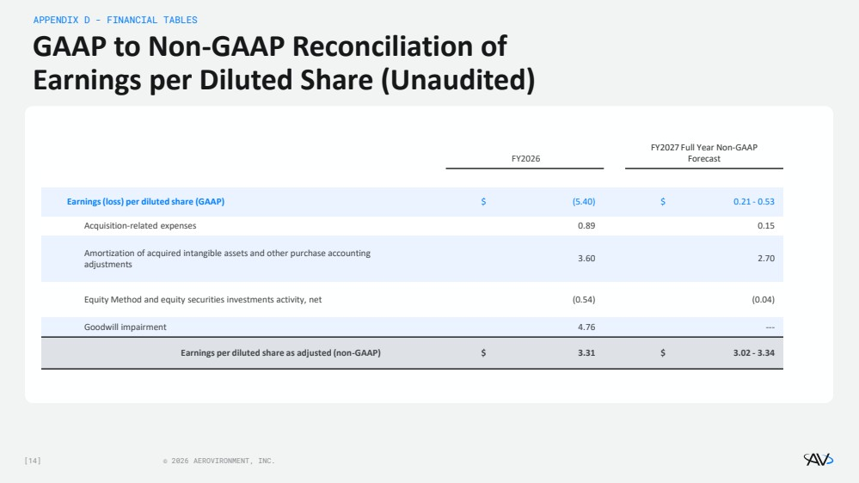 | [14] © 2026 AEROVIRONMENT, INC. GAAP to Non-GAAP Reconciliation of Earnings per Diluted Share (Unaudited) APPENDIX D - FINANCIAL TABLES FY2026 FY2027 Full Year Non-GAAP Forecast Earnings (loss) per diluted share (GAAP) $ (5.40) $ 0.21 - 0.53 Acquisition-related expenses 0.89 0.15 Amortization of acquired intangible assets and other purchase accounting adjustments 3.60 2.70 Equity Method and equity securities investments activity, net (0.54) (0.04) Goodwill impairment 4.76 --- Earnings per diluted share as adjusted (non-GAAP) $ 3.31 $ 3.02 - 3.34
 | 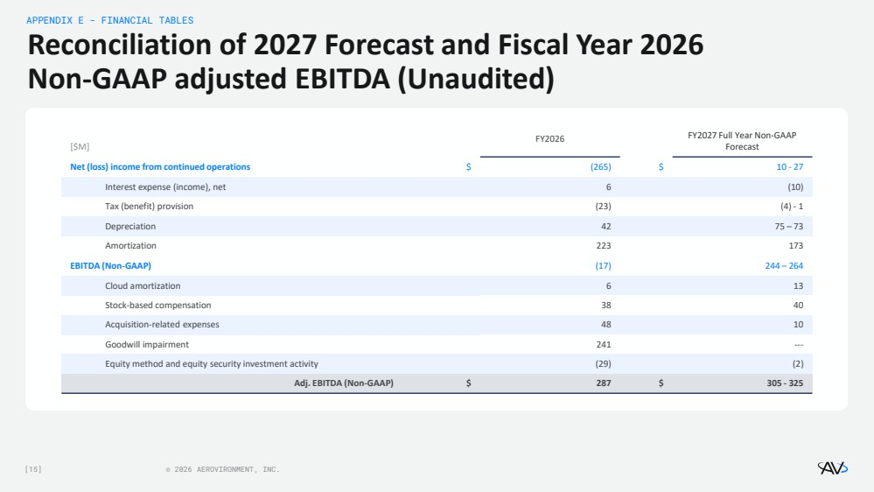 | [15] © 2026 AEROVIRONMENT, INC. Reconciliation of 2027 Forecast and Fiscal Year 2026 Non-GAAP adjusted EBITDA (Unaudited) APPENDIX E - FINANCIAL TABLES [$M] FY2026 FY2027 Full Year Non-GAAP Forecast Net (loss) income from continued operations $ (265) $ 10 - 27 Interest expense (income), net 6 (10) Tax (benefit) provision (23) (4) - 1 Depreciation 42 75 – 73 Amortization 223 173 EBITDA (Non-GAAP) (17) 244 – 264 Cloud amortization 6 13 Stock-based compensation 38 40 Acquisition-related expenses 48 10 Goodwill impairment 241 --- Equity method and equity security investment activity (29) (2) Adj. EBITDA (Non-GAAP) $ 287 $ 305 - 325
 | 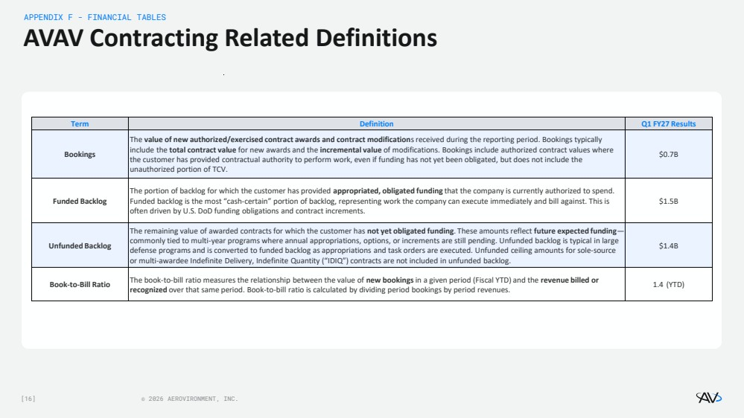 | [16] © 2026 AEROVIRONMENT, INC. AVAV Contracting Related Definitions APPENDIX F - FINANCIAL TABLES Term Definition Q1 FY27 Results Bookings The value of new authorized/exercised contract awards and contract modifications received during the reporting period. Bookings typically include the total contract value for new awards and the incremental value of modifications. Bookings include authorized contract values where the customer has provided contractual authority to perform work, even if funding has not yet been obligated, but does not include the unauthorized portion of TCV. $0.7B Funded Backlog The portion of backlog for which the customer has provided appropriated, obligated funding that the company is currently authorized to spend. Funded backlog is the most “cash-certain” portion of backlog, representing work the company can execute immediately and bill against. This is often driven by U.S. DoD funding obligations and contract increments. $1.5B Unfunded Backlog The remaining value of awarded contracts for which the customer has not yet obligated funding. These amounts reflect future expected funding— commonly tied to multi-year programs where annual appropriations, options, or increments are still pending. Unfunded backlog is typical in large defense programs and is converted to funded backlog as appropriations and task orders are executed. Unfunded ceiling amounts for sole-source or multi-awardee Indefinite Delivery, Indefinite Quantity (“IDIQ”) contracts are not included in unfunded backlog. $1.4B Book-to-Bill Ratio The book-to-bill ratio measures the relationship between the value of new bookingsin a given period (Fiscal YTD) and the revenue billed or recognized over that same period. Book-to-bill ratio is calculated by dividing period bookings by period revenues. 1.4 (YTD)
 | 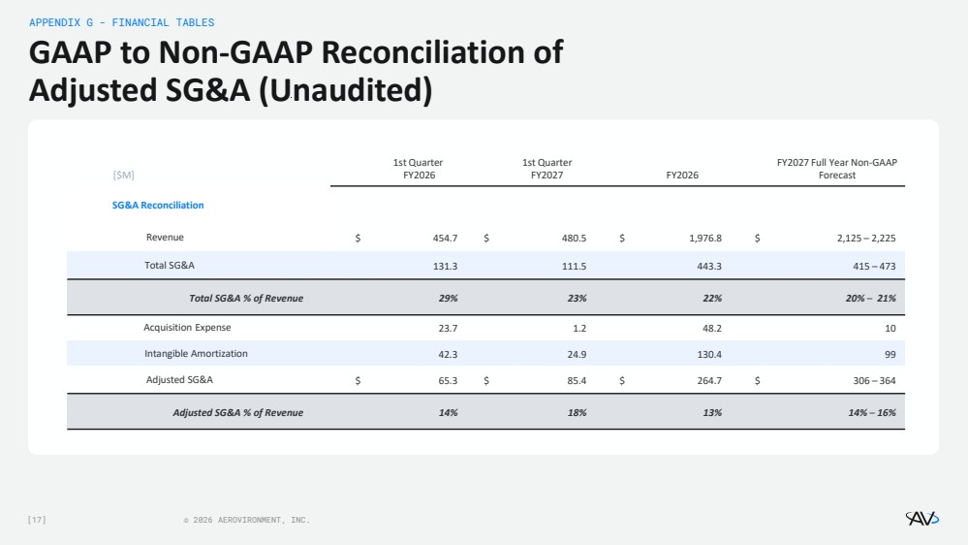 | [17] © 2026 AEROVIRONMENT, INC. GAAP to Non-GAAP Reconciliation of Adjusted SG&A (Unaudited) APPENDIX G - FINANCIAL TABLES [$M] 1st Quarter FY2026 1st Quarter FY2027 FY2026 FY2027 Full Year Non-GAAP Forecast SG&A Reconciliation Revenue $ 454.7 $ 480.5 $ 1,976.8 $ 2,125 – 2,225 Total SG&A 131.3 111.5 443.3 415 – 473 Total SG&A % of Revenue 29% 23% 22% 20% – 21% Acquisition Expense 23.7 1.2 48.2 10 Intangible Amortization 42.3 24.9 130.4 99 Adjusted SG&A $ 65.3 $ 85.4 $ 264.7 $ 306 – 364 Adjusted SG&A % of Revenue 14% 18% 13% 14% – 16%
 | 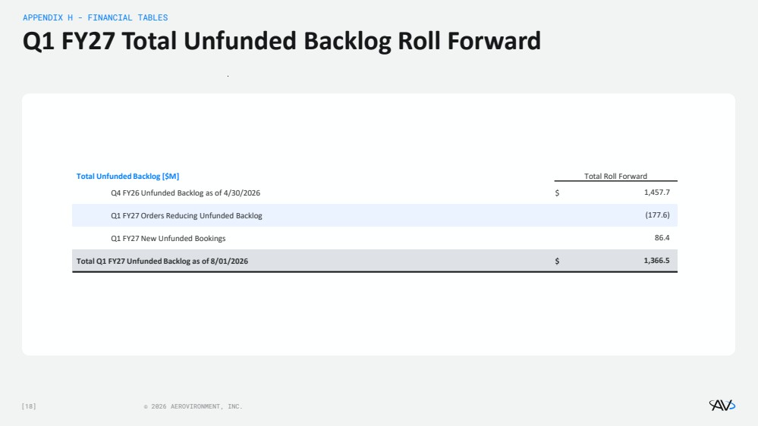 | [18] © 2026 AEROVIRONMENT, INC. Q1 FY27 Total Unfunded Backlog Roll Forward APPENDIX H - FINANCIAL TABLES Total Unfunded Backlog [$M] Total Roll Forward Q4 FY26 Unfunded Backlog as of 4/30/2026 $ 1,457.7 Q1 FY27 Orders Reducing Unfunded Backlog (177.6) Q1 FY27 New Unfunded Bookings 86.4 Total Q1 FY27 Unfunded Backlog as of 8/01/2026 $ 1,366.5

