Table of Contents

UNITED STATES

SECURITIES AND EXCHANGE COMMISSION
WASHINGTON, D.C. 20549

FORM 10-Q

- QUARTERLY REPORT PURSUANT TO SECTION 13 OR 15(d) OF THE SECURITIES EXCHANGE ACT OF 1934.

For the quarterly period ended October 31, 2020

OR

- TRANSITION REPORT PURSUANT TO SECTION 13 OR 15(d) OF THE SECURITIES EXCHANGE ACT OF 1934

For the transition period from to

Commission File Number: 001-33261

AEROVIRONMENT, INC.

(Exact name of registrant as specified in its charter)

Delaware | 95-2705790
(State or other jurisdiction of incorporation or organization) | (I.R.S. Employer Identification No.)
900 Innovators Way
Simi Valley, California | 93065
(Address of principal executive offices) | (Zip Code)

(805) 520-8350

(Registrant’s telephone number, including area code)

N/A

(Former name, former address and former fiscal year, if changed since last report)

Securities registered pursuant to Section 12(b) of the Act:

Title of each class |  | Trading Symbol(s) | Name of each exchange on which registered
Common Stock, par value $0.0001 per share |  | AVAV | The NASDAQ Stock Market LLC

Indicate by check mark whether the registrant (1) has filed all reports required to be filed by Section 13 or 15(d) of the Securities Exchange Act of 1934 during the preceding 12 months (or for such shorter period that the registrant was required to file such reports), and (2) has been subject to such filing requirements for the past 90 days. Yes ☒ No ☐

Indicate by check mark whether the registrant has submitted electronically, every Interactive Data File required to be submitted pursuant to Rule 405 of Regulation S-T (§232.405 of this chapter) during the preceding 12 months (or for such shorter period that the registrant was required to submit such files). Yes ☒ No ☐

Indicate by check mark whether the registrant is a large accelerated filer, an accelerated filer, a non-accelerated filer, a smaller reporting company, or an emerging growth company. See the definitions of “large accelerated filer,” “accelerated filer,” “smaller reporting company,” and “emerging growth company” in Rule 12b-2 of the Exchange Act.

Large accelerated filer ☒

Accelerated filer ☐

Non-accelerated filer ☐

Smaller reporting company ☐

Emerging growth company ☐

If an emerging growth company, indicate by check mark if the registrant has elected not to use the extended transition period for complying with any new or revised financial accounting standards provided pursuant to Section 13(a) of the Exchange Act. ☐

Indicate by check mark whether the registrant is a shell company (as defined in Rule 12b-2 of the Exchange Act). Yes ☐ No ☒ As of December 2, 2020, the number of shares outstanding of the registrant’s common stock, $0.0001 par value, was 24,103,980.

Table of Contents

 |  |  |  |  | AeroVironment, Inc.
 |  |  |  |  | Table of Contents
Item 1. | Financial Statements:
 |  | Consolidated Balance Sheets as of October 31, 2020 (Unaudited) and April 30, 2020 |  |  |  |  |  |  |  |  |  | 3
 |  | Consolidated Statements of Operations for the three and six months ended October 31, 2020 |  |  |  |  |  |  |  |  |  | 4
 |  |  | (Unaudited) and October 26, 2019 (Unaudited)
 |  | Consolidated Statements of Comprehensive Income for the three and six months ended October 31, |  |  |  |  |  |  |  |  |  | 5
 |  |  | 2020 (Unaudited) and October 26, 2019 (Unaudited)
 |  | Consolidated Statements of Stockholders’ Equity for the three and six months ended October 31, |  |  |  |  |  |  |  |  |  | 7
 |  |  | 2020 (Unaudited) and October 26, 2019 (Unaudited)
 |  | Consolidated Statements of Cash Flows for the six months ended October 31, 2020 (Unaudited) and |  |  |  |  |  |  |  |  |  | 8
 |  |  | October 26, 2019 (Unaudited)
 | Notes to Consolidated Financial Statements (Unaudited) |  |  |  |  |  |  |  |  |  |  | 9
Item 2. | Management’s Discussion and Analysis of Financial Condition and Results of Operations |  |  |  |  |  |  |  |  |  |  | 26
Item 3. | Quantitative and Qualitative Disclosures About Market Risk |  |  |  |  |  |  |  |  |  |  | 34
Item 4. | Controls and Procedures |  |  |  |  |  |  |  |  |  |  | 34
PART II. OTHER INFORMATION
Item 1. | Legal Proceedings |  |  |  |  |  |  |  |  |  |  | 35
Item 1A. | Risk Factors |  |  |  |  |  |  |  |  |  |  | 35
Item 2. | Unregistered Sales of Equity Securities and Use of Proceeds |  |  |  |  |  |  |  |  |  |  | 37
Item 3. | Defaults Upon Senior Securities |  |  |  |  |  |  |  |  |  |  | 37
Item 4. | Mine Safety Disclosures |  |  |  |  |  |  |  |  |  |  | 37
Item 5. | Other Information |  |  |  |  |  |  |  |  |  |  | 38
Item 6. | Exhibits |  |  |  |  |  |  |  |  |  |  | 38
Signatures |  |  |  |  |  |  |  |  |  |  |  | 39

2

Table of Contents

PART I. FINANCIAL INFORMATION

ITEM 1. FINANCIAL STATEMENTS

AeroVironment, Inc.

Consolidated Balance Sheets

(In thousands except share and per share data)

 |  | October 31, |  |  |  |  | April 30,
 |  | 2020 |  |  |  |  | 2020
 |  | (Unaudited)
Assets
Current assets:
Cash and cash equivalents | $ | 280,099 |  |  | $ |  | 255,142
Short-term investments |  | 67,137 |  |  |  |  | 47,507
Accounts receivable, net of allowance for doubtful accounts of $561 at October 31, 2020 and
$1,190 at April 30, 2020 |  | 30,701 |  |  |  |  | 73,660
Unbilled receivables and retentions (inclusive of related party unbilled receivables of $14,974 at
October 31, 2020 and $15,779 at April 30, 2020) |  | 70,573 |  |  |  |  | 75,837
Inventories |  | 51,779 |  |  |  |  | 45,535
Prepaid expenses and other current assets |  | 7,310 |  |  |  |  | 6,246
Total current assets |  |  | 507,599 |  |  |  | 503,927
Long-term investments |  | 20,976 |  |  |  |  | 15,030
Property and equipment, net |  | 22,868 |  |  |  |  | 21,694
Operating lease right-of-use assets |  | 12,363 |  |  |  |  | 8,793
Deferred income taxes |  | 5,546 |  |  |  |  | 4,928
Intangibles, net |  | 12,213 |  |  |  |  | 13,637
Goodwill |  | 6,340 |  |  |  |  | 6,340
Other assets |  | 102 |  |  |  |  | 10,605
Total assets | $ | 588,007 |  |  |  | $ | 584,954
Liabilities and stockholders’ equity
Current liabilities:
Accounts payable | $ | 14,225 |  |  | $ |  | 19,859
Wages and related accruals |  | 18,737 |  |  |  |  | 23,972
Customer advances |  | 2,957 |  |  |  |  | 7,899
Current operating lease liabilities |  | 4,030 |  |  |  |  | 3,380
Income taxes payable |  | 3,018 |  |  |  |  | 1,065
Other current liabilities |  | 10,511 |  |  |  |  | 10,778
Total current liabilities |  | 53,478 |  |  |  |  | 66,953
Non-current operating lease liabilities |  | 9,422 |  |  |  |  | 6,833
Other non-current liabilities |  | 243 |  |  |  |  | 250
Liability for uncertain tax positions |  | 1,017 |  |  |  |  | 1,017
Commitments and contingencies
Stockholders’ equity:
Preferred stock, $0.0001 par value:
Authorized shares—10,000,000; none issued or outstanding at October 31, 2020 and
April 30, 2020 |  |  | — |  |  |  | —
Common stock, $0.0001 par value:
Authorized shares—100,000,000
Issued and outstanding shares—24,103,980 shares at October 31, 2020 and 24,063,639 shares at
April 30, 2020 |  | 2 |  |  |  |  | 2
Additional paid-in capital |  | 183,298 |  |  |  |  | 181,481
Accumulated other comprehensive income |  | 342 |  |  |  |  | 328
Retained earnings |  | 340,264 |  |  |  |  | 328,090
Total AeroVironment, Inc. stockholders’ equity |  | 523,906 |  |  |  |  | 509,901
Noncontrolling interest |  | (59) |  |  |  |  | —
Total equity |  | 523,847 |  |  |  |  | 509,901
Total liabilities and stockholders’ equity | $ | 588,007 |  |  |  | $ | 584,954

See accompanying notes to consolidated financial statements (unaudited).

3

Table of Contents

AeroVironment, Inc.

Consolidated Statements of Operations (Unaudited)

(In thousands except share and per share data)

 |  | Three Months Ended |  |  |  |  |  | Six Months Ended
 |  | October 31, |  |  | October 26, |  |  | October 31, |  |  | October 26,
 |  | 2020 |  |  | 2019 |  |  | 2020 |  |  | 2019
Revenue:
Product sales | $ | 65,528 |  | $ | 57,386 |  | $ | 123,885 |  | $ | 123,225
Contract services (inclusive of related party revenue of $11,452
and $13,393 for the three months ended October 31, 2020 and
October 26, 2019, respectively; and $27,838 and $25,728 for the
six months ended October 31, 2020 and October 26, 2019,
respectively) |  | 27,137 |  |  | 25,885 |  |  | 56,230 |  |  | 46,957
 |  | 92,665 |  |  | 83,271 |  |  | 180,115 |  |  | 170,182
Cost of sales:
Product sales |  | 34,209 |  |  | 30,802 |  |  | 66,293 |  |  | 61,210
Contract services |  | 17,605 |  |  | 17,303 |  |  | 37,560 |  |  | 32,534
 |  | 51,814 |  |  | 48,105 |  |  | 103,853 |  |  | 93,744
Gross margin:
Product sales |  | 31,319 |  |  | 26,584 |  |  | 57,592 |  |  | 62,015
Contract services |  | 9,532 |  |  | 8,582 |  |  | 18,670 |  |  | 14,423
 |  | 40,851 |  |  | 35,166 |  |  | 76,262 |  |  | 76,438
Selling, general and administrative |  | 14,977 |  |  | 16,255 |  |  | 26,988 |  |  | 29,923
Research and development |  | 11,976 |  |  | 10,858 |  |  | 23,079 |  |  | 19,567
Income from operations |  | 13,898 |  |  | 8,053 |  |  | 26,195 |  |  | 26,948
Other income:
Interest income, net |  | 115 |  |  | 1,266 |  |  | 323 |  |  | 2,595
Other income, net |  | 72 |  |  | 157 |  |  | 105 |  |  | 512
Income before income taxes |  | 14,085 |  |  | 9,476 |  |  | 26,623 |  |  | 30,055
Provision for income taxes |  | 2,491 |  |  | 1,108 |  |  | 3,698 |  |  | 3,241
Equity method investment loss, net of tax |  | (9,522) |  |  | (863) |  |  | (10,810) |  |  | (2,210)
Net income |  | 2,072 |  |  | 7,505 |  |  | 12,115 |  |  | 24,604
Net loss (income) attributable to noncontrolling interest |  | 22 |  |  | (4) |  |  | 59 |  |  | 7
Net income attributable to AeroVironment, Inc. | $ | 2,094 |  | $ | 7,501 |  | $ | 12,174 |  | $ | 24,611
Net income per share attributable to AeroVironment, Inc.
Basic | $ | 0.09 |  | $ | 0.32 |  | $ | 0.51 |  | $ | 1.04
Diluted | $ | 0.09 |  | $ | 0.31 |  | $ | 0.50 |  | $ | 1.02
Weighted-average shares outstanding:
Basic |  | 23,936,950 |  |  | 23,804,364 |  |  | 23,914,737 |  |  | 23,775,355
Diluted |  | 24,196,912 |  |  | 24,061,810 |  |  | 24,190,316 |  |  | 24,063,775

See accompanying notes to consolidated financial statements (unaudited).

4

Table of Contents

AeroVironment, Inc.

Consolidated Statements of Comprehensive Income (Unaudited)

(In thousands)

 |  |  | Three Months Ended |  |  |  |  |  | Six Months Ended
 |  | October 31, |  |  | October 26, |  |  | October 31, |  |  |  | October 26,
 |  |  | 2020 |  |  | 2019 |  |  | 2020 |  |  |  | 2019
Net income |  | $ | 2,072 |  | $ | 7,505 |  | $ | 12,115 |  |  | $ | 24,604
Other comprehensive income:
Change in foreign currency translation adjustments |  |  | — |  |  | 10 |  |  | 75 |  |  |  | 179
Unrealized loss on available-for-sale investments, net of deferred
tax (expense) benefit of ($3) and $1 for the three and six months
ended October 31, 2020, respectively |  |  | (9) |  |  | — |  |  | (61) |  |  |  | —
Total comprehensive income |  |  | 2,063 |  | $ | 7,515 |  |  | 12,129 |  |  |  | 24,783
Net loss (income) attributable to noncontrolling interest |  |  | 22 |  |  | (4) |  |  | 59 |  |  |  | 7
Comprehensive income attributable to AeroVironment, Inc. |  | $ | 2,085 |  | $ | 7,511 |  | $ | 12,188 |  |  | $ | 24,790

See accompanying notes to consolidated financial statements (unaudited).

5

Table of Contents

AeroVironment, Inc.

Consolidated Statements of Stockholders’ Equity

For the six months ended October 31, 2020 and October 26, 2019 (Unaudited)

(In thousands except share data)

 |  |  |  |  |  |  |  |  |  | Accumulated
 |  |  |  |  |  | Additional |  |  |  |  | Other |  | Total |  | Non-
 | Common Stock |  |  |  |  | Paid-In |  | Retained |  | Comprehensive AeroVironment, Inc. Controlling
 | Shares | Amount |  |  |  | Capital |  | Earnings |  |  | Loss |  | Equity |  | Interest |  | Total
Balance at April 30, 2020 | 24,063,639 |  | $ | 2 |  | $ 181,481 |  | $ 328,090 |  | $ | 328 | $ | 509,901 | $ | — |  | $ 509,901
Net income (loss) | — |  |  | — |  | — | 12,174 |  |  |  | — |  | 12,174 |  | (59) | 12,115
Unrealized loss on investments | — |  |  | — |  | — |  | — |  |  | (61) |  | (61) |  | — | (61)
Foreign currency translation | — |  |  | — |  | — |  | — |  |  | 75 |  | 75 |  | — | 75
Stock options exercised | 3,500 |  |  | — |  | 86 |  | — |  |  | — |  | 86 |  | — | 86
Restricted stock awards | 60,592 |  |  | — |  | — |  | — |  |  | — |  | — |  | — |  | —
Restricted stock awards forfeited | (515) |  |  | — |  | — |  | — |  |  | — |  | — |  | — |  | —
Tax withholding payment related to
net share settlement of equity awards | (23,236) |  |  | — |  | (1,778) |  | — |  |  | — |  | (1,778) |  | — | (1,778)
Stock based compensation | — |  |  | — |  | 3,509 |  | — |  |  | — |  | 3,509 |  | — | 3,509
Balance at October 31, 2020 | 24,103,980 |  | $ | 2 |  | $ 183,298 |  | $ 340,264 |  | $ | 342 | $ | 523,906 | $ | (59) |  | $ 523,847
 |  |  |  |  |  |  |  |  |  | Accumulated
 |  |  |  |  |  | Additional |  |  |  |  | Other |  | Total |  | Non-
 | Common Stock |  |  |  |  | Paid-In |  | Retained |  | Comprehensive AeroVironment, Inc. Controlling
 | Shares | Amount |  |  |  | Capital |  | Earnings |  |  | Loss |  | Equity |  | Interest |  | Total
Balance at April 30, 2019 | 23,946,293 | $ |  | 2 |  | $ 176,216 | $ 286,351 |  | $ |  | 2 | $ | 462,571 | $ | 4 | $ 462,575
Adoption of ASU 2018-09 | — |  |  | — |  | — | 665 |  |  |  | — |  | 665 |  | — | 665
Net income (loss) | — |  |  | — |  | — | 24,611 |  |  |  | — |  | 24,611 |  | (7) | 24,604
Unrealized gain on investments | — |  |  | — |  | — |  | — |  |  | — |  | — |  | — |  | —
Foreign currency translation | — |  |  | — |  | — |  | — |  |  | 179 |  | 179 |  | — | 179
Stock options exercised | 3,000 |  |  | — |  | 93 |  | — |  |  | — |  | 93 |  | — | 93
Restricted stock awards | 65,692 |  |  | — |  | — |  | — |  |  | — |  | — |  | — |  | —
Restricted stock awards forfeited | (11,005) |  |  | — |  | — |  | — |  |  | — |  | — |  | — |  | —
Tax withholding payment related to
net share settlement of equity awards | (13,364) |  |  | — |  | (743) |  | — |  |  | — |  | (743) |  | — | (743)
Stock based compensation | — |  |  | — |  | 2,984 |  | — |  |  | — |  | 2,984 |  | — |  | 2,984
Balance at October 26, 2019 | 23,990,616 | $ |  | 2 |  | $ 178,550 | $ 311,627 |  | $ |  | 181 | $ | 490,360 | $ | (3) | $ 490,357

See accompanying notes to consolidated financial statements (unaudited).

6

Table of Contents

AeroVironment, Inc.

Consolidated Statements of Stockholders’ Equity

For the three months ended October 31, 2020 and October 26, 2019 (Unaudited)

(In thousands except share data)

 |  |  |  |  |  |  |  |  |  |  | Accumulated
 |  |  |  |  |  |  | Additional |  |  |  |  | Other |  | Total |  | Non-
 | Common Stock |  |  |  |  |  | Paid-In |  | Retained | ComprehensiveAeroVironment, Inc. Controlling
 | Shares | Amount |  |  |  |  | Capital |  | Earnings |  |  | Income |  | Equity |  | Interest |  |  | Total
Balance at August 1, 2020 | 24,104,564 |  | $ | 2 |  |  | $ 181,406 |  | $ 338,170 |  | $ | 351 | $ | 519,929 | $ | (37) |  |  | $ 519,892
Net income (loss) | — |  |  | — |  |  | — | 2,094 |  |  |  | — |  | 2,094 |  | (22) |  | 2,072
Unrealized loss on investments | — |  |  | — |  |  | — |  | — |  |  | (9) |  | (9) |  | — |  | (9)
Restricted stock awards forfeited | (245) |  |  | — |  |  | — |  | — |  |  | — |  | — |  | — |  |  | —
Tax withholding payment related to net
share settlement of equity awards | (339) |  |  | — |  | (22) |  |  | — |  |  | — |  | (22) |  | — |  | (22)
Stock based compensation | — |  |  | — |  | 1,914 |  |  | — |  |  | — |  | 1,914 |  | — |  | 1,914
Balance at October 31, 2020 | 24,103,980 |  | $ | 2 |  |  | $ 183,298 |  | $ 340,264 |  | $ | 342 | $ | 523,906 | $ | (59) |  |  | $ 523,847
 |  |  |  |  |  |  |  |  |  |  | Accumulated
 |  |  |  |  |  |  | Additional |  |  |  |  | Other |  | Total |  | Non-
 | Common Stock |  |  |  |  |  | Paid-In |  | Retained | ComprehensiveAeroVironment, Inc. Controlling
 | Shares | Amount |  |  |  |  | Capital |  | Earnings |  |  | Income |  | Equity |  | Interest |  |  | Total
Balance at July 27, 2019 | 23,990,459 |  |  | 2 |  |  | 177,207 |  | 304,126 |  |  | 171 |  | 481,506 |  | (7) |  |  | 481,499
Net income | — |  |  | — |  |  | — | 7,501 |  |  |  | — |  | 7,501 |  | 4 |  | 7,505
Foreign currency translation | — |  |  | — |  |  | — |  | — |  |  | 10 |  | 10 |  | — |  | 10
Restricted stock awards | 7,831 |  |  | — |  |  | — |  | — |  |  | — |  | — |  | — |  |  | —
Restricted stock awards forfeited | (6,285) |  |  | — |  |  | — |  | — |  |  | — |  | — |  | — |  |  | —
Tax withholding payment related to net
share settlement of equity awards | (1,389) |  |  | — |  | (75) |  |  | — |  |  | — |  | (75) |  | — |  | (75)
Stock-based compensation | — |  |  | — |  | 1,418 |  |  | — |  |  | — |  | 1,418 |  | — |  | 1,418
Balance at October 26, 2019 | 23,990,616 |  | $ | 2 |  |  | $ 178,550 |  | $ 311,627 |  | $ | 181 | $ | 490,360 | $ | (3) |  |  | $ 490,357

See accompanying notes to consolidated financial statements (unaudited).

7

Table of Contents

AeroVironment, Inc.

Consolidated Statements of Cash Flows (Unaudited)

(In thousands)

 |  | Six Months Ended
 |  | October 31, |  |  |  | October 26,
 |  | 2020 |  |  |  | 2019
Operating activities
Net income | $ | 12,115 |  | $ |  | 24,604
Adjustments to reconcile net income to cash provided by operating activities:
Depreciation and amortization |  | 5,693 |  |  |  | 4,486
Losses from equity method investments |  | 10,810 |  |  |  | 2,210
Realized gain from sale of available-for-sale investments |  | (11) |  |  |  | —
Provision for doubtful accounts |  | (156) |  |  |  | 14
Other non-cash (income) expense |  | (473) |  |  |  | 81
Non-cash lease expense |  | 2,393 |  |  |  | 2,255
Loss on foreign currency transactions |  | 2 |  |  |  | 1
Deferred income taxes |  | (621) |  |  |  | (669)
Stock-based compensation |  | 3,509 |  |  |  | 2,984
Loss (gain) on sale of property and equipment |  | 2 |  |  |  | (75)
Amortization of debt securities |  | (12) |  |  |  | (984)
Changes in operating assets and liabilities, net of acquisitions:
Accounts receivable |  | 43,115 |  |  |  | (9,400)
Unbilled receivables and retentions |  | 5,264 |  |  |  | (9,350)
Inventories |  | (6,244) |  |  |  | 1,621
Income tax receivable |  | — |  |  |  | 821
Prepaid expenses and other assets |  | (1,029) |  |  |  | (1,051)
Accounts payable |  | (5,028) |  |  |  | (5,046)
Other liabilities |  | (10,736) |  |  |  | (4,583)
Net cash provided by operating activities |  | 58,593 |  |  |  | 7,919
Investing activities
Acquisition of property and equipment |  | (6,052) |  |  |  | (6,850)
Equity method investments |  | (1,173) |  |  |  | (4,569)
Business acquisition, net of cash acquired |  | — |  |  |  | (18,641)
Proceeds from sale of property and equipment |  | — |  |  |  | 81
Redemptions of held-to-maturity investments |  | — |  |  |  | 159,839
Purchases of held-to-maturity investments |  | — |  |  |  | (169,148)
Redemptions of available-for-sale investments |  | 92,226 |  |  |  | —
Purchases of available-for-sale investments |  | (116,945) |  |  |  | (4,947)
Net cash used in investing activities |  | (31,944) |  |  |  | (44,235)
Financing activities
Tax withholding payment related to net settlement of equity awards |  | (1,778) |  |  |  | (743)
Exercise of stock options |  | 86 |  |  |  | 93
Net cash used in financing activities |  | (1,692) |  |  |  | (650)
Net increase (decrease) in cash, cash equivalents, and restricted cash |  | 24,957 |  |  |  | (36,966)
Cash, cash equivalents and restricted cash at beginning of period |  | 255,142 |  |  |  | 172,708
Cash, cash equivalents and restricted cash at end of period | $ | 280,099 |  |  | $ | 135,742
Supplemental disclosures of cash flow information
Cash paid, net during the period for:
Income taxes | $ | 2,364 |  | $ |  | 518
Non-cash activities
Unrealized loss on available-for-sale investments, net of deferred tax (expense) benefit of ($3) and $1 for the three
and six months ended October 31, 2020, respectively | $ | 61 |  | $ |  | —
Change in foreign currency translation adjustments | $ | 75 |  | $ |  | 179
Acquisitions of property and equipment included in accounts payable | $ | 818 |  | $ |  | 761

See accompanying notes to consolidated financial statements (unaudited).

8

Table of Contents

AeroVironment, Inc.

Notes to Consolidated Financial Statements (Unaudited)

1. Organization and Significant Accounting Policies

Organization

AeroVironment, Inc., a Delaware corporation (the “Company”), is engaged in the design, development, production, support and operation of unmanned aircraft systems (“UAS”) for various industries and governmental agencies.

Basis of Presentation

The accompanying unaudited consolidated financial statements have been prepared in accordance with accounting principles generally accepted in the United States (“U.S. GAAP”) for interim financial information and with the instructions of Form 10-Q and Article 10 of Regulation S-X. Accordingly, they do not include all of the information and footnotes required by U.S. GAAP for complete financial statements. In the opinion of management, all adjustments, consisting only of normal recurring adjustments necessary for a fair presentation with respect to the interim financial statements have been included. The results of operations for the three and six months ended October 31, 2020 are not necessarily indicative of the results for the full year ending April 30, 2021. For further information, refer to the consolidated financial statements and footnotes thereto for the year ended April 30, 2020, included in the Company’s Annual Report on Form 10-K.

The preparation of financial statements in conformity with U.S. GAAP requires management to make estimates and assumptions, including estimates of anticipated contract costs and revenue utilized in the revenue recognition process, that affect the reported amounts in the consolidated financial statements and accompanying notes. Actual results could differ from those estimates.

The Company’s consolidated financial statements include the assets, liabilities and operating results of wholly-owned subsidiaries. All intercompany accounts and transactions have been eliminated.

In December 2017, the Company and SoftBank Corp. (“SoftBank”) formed a joint venture, HAPSMobile Inc. (“HAPSMobile”). As the Company has the ability to exercise significant influence over the operating and financial policies of HAPSMobile, the Company’s investment has been accounted for as an equity method investment. The Company has presented its proportion of HAPSMobile’s net loss in equity method investment loss, net of tax in the consolidated statements of operations. The carrying value of the investment in HAPSMobile was recorded in other assets. During the three months ended October 31, 2020, the Company recorded its proportion of a loss for HAPSMobile’s impairment of its investment in Loon LLC in the amount of $8,363,000. Refer to Note 6—Equity Method Investments for further details.

On June 10, 2019, the Company purchased 100% of the issued and outstanding member units of Pulse Aerospace, LLC (“Pulse”) pursuant to the terms of a Unit Purchase Agreement (the “Pulse Purchase Agreement”). The assets, liabilities and operating results of Pulse have been included in the Company’s consolidated financial statements. Refer to Note 17— Business Acquisitions for further details.

During the three months ended October 27, 2019, the Company dissolved its wholly-owned subsidiary, Skytower, Inc., the results of which were not material to the consolidated financial statements.

Recently Adopted Accounting Standards

Effective May 1, 2020, the Company adopted Accounting Standards Update (“ASU”) 2016-13, Financial Instruments— Credit Losses (Topic 326): Measurement of Credit Losses on Financial Instruments, along with several additional clarification ASU’s issued during 2018 and 2019, collectively “CECL”. CECL requires the reporting entity to estimate expected credit losses over the life of a financial asset. CECL requires the credit loss to be recognized upon initial

9

Table of Contents

recognition of the financial asset. ASU 2016-13 requires the entity to adopt CECL using the modified retrospective transition approach through a cumulative-effect adjustment to the opening balance of retained earnings in the period of adoption. As part of the assessment of the adequacy of the Company’s allowances for credit losses, the Company considered a number of factors including, but not limited to, customer credit ratings, age of receivables, and expected loss rates. However, the adoption of CECL did not have a material impact to retained earnings for the Company.

Effective May 1, 2020, the Company adopted ASU 2018-15, “Intangibles—Goodwill and Other— Internal-Use Software (Subtopic 350-40) Customer’s Accounting for Implementation Costs Incurred in a Cloud Computing Arrangement That Is a Service Contract” (“ASU 2018-15”). ASU 2018-15 provides guidance on the treatment of accounting for fees paid by a customer in a cloud computing arrangement. This guidance includes the requirements for capitalizing implementation costs incurred in a hosting arrangement. The Company adopted ASU 2018-15 using the prospective method, applying the new guidance to all implementation costs incurred after adoption. The adoption of ASU 2018-15 did not have an impact on the Company’s consolidated financial statements.

Revenue Recognition

The Company’s revenue is generated pursuant to written contractual arrangements to design, develop, manufacture and/or modify complex products and to provide related engineering, technical and other services according to the specifications of the customers. These contracts may be firm fixed price (“FFP”), cost plus fixed fee (“CPFF”), or time and materials (“T&M”). The Company considers all such contracts to be within the scope of ASC Topic 606.

Performance Obligations

A performance obligation is a promise in a contract to transfer distinct goods or services to a customer, and it is the unit of account in ASC Topic 606. A contract’s transaction price is allocated to each distinct performance obligation and revenue is recognized when each performance obligation under the terms of a contract is satisfied. Revenue is measured at the amount of consideration the Company expects to receive in exchange for transferring goods or providing services. For contracts with multiple performance obligations, the Company allocates the contract’s transaction price to each performance obligation using its observable standalone selling price for products and services. When the standalone selling price is not directly observable, the Company uses its best estimate of the standalone selling price of each distinct good or service in the contract using the cost plus margin approach. This approach estimates the Company’s expected costs of satisfying the performance obligation and then adds an appropriate margin for that distinct good or service.

Contract modifications are routine in the performance of the Company’s contracts. In most instances, contract modifications are for additional goods and/or services that are distinct and, therefore, accounted for as new contracts.

The Company’s performance obligations are satisfied over time or at a point in time. Performance obligations are satisfied over time if the customer receives the benefits as the Company performs, if the customer controls the asset as it is being developed or produced, or if the product being produced for the customer has no alternative use and the Company has a contractual right to payment for the Company’s costs incurred to date plus a reasonable margin. The contractual right to payment is generally supported by termination for convenience clauses that allow the customer to unilaterally terminate the contract for convenience, pay the Company for costs incurred plus a reasonable profit, and take control of any work in process. Revenue for tactical missile systems (“TMS”) product deliveries and Customer-Funded Research and Development contracts is recognized over time as costs are incurred. Contract services revenue is composed of revenue recognized on contracts for the provision of services, including repairs and maintenance, training, engineering design, development and prototyping activities, and technical support services. Contract services revenue is recognized over time as services are rendered. Typically, revenue is recognized over time using an input measure (e.g., costs incurred to date relative to total estimated costs at completion) to measure progress. Training services are recognized over time using an output method based on days of training completed.

For performance obligations satisfied over time, revenue is generally recognized using costs incurred to date relative to total estimated costs at completion to measure progress. Incurred costs represent work performed, which correspond with, and thereby best depict, transfer of control to the customer. Contract costs include labor, materials, subcontractors’ costs, other direct costs, and indirect costs applicable on government and commercial contracts.

10

Table of Contents

For performance obligations which are not satisfied over time per the aforementioned criteria above, revenue is recognized at the point in time in which each performance obligation is fully satisfied. The Company’s small UAS product sales revenue is composed of revenue recognized on contracts for the delivery of small UAS systems and spare parts. Revenue is recognized at the point in time when control transfers to the customer, which generally occurs when title and risk of loss have passed to the customer.

Performance obligations satisfied over time accounted for 40% and 39% of revenue during the three and six months ended October 31, 2020, respectively. Performance obligations satisfied at a point in time accounted for 60% and 61% of revenue during the three and six months ended October 31, 2020, respectively.

On October 31, 2020, the Company had approximately $130,588,000 of remaining performance obligations under fully funded contracts with its customers, which the Company also refers to as funded backlog. The Company currently expects to recognize approximately 92% of the remaining performance obligations as revenue in fiscal 2021, an additional 8% in fiscal 2022, and the balance thereafter.

The Company collects sales, value added, and other taxes concurrent with revenue producing activities, which are excluded from revenue when they are both imposed on a specific transaction and collected from a customer.

Contract Estimates

Accounting for contracts and programs primarily with a duration of less than six months involves the use of various techniques to estimate total contract revenue and costs. For long-term contracts, the Company estimates the total expected costs to complete the contract and recognizes revenue based on the percentage of costs incurred at period end. Typically, revenue is recognized over time using costs incurred to date relative to total estimated costs at completion to measure progress toward satisfying the Company’s performance obligations. Incurred costs represent work performed, which corresponds with, and thereby best depicts, the transfer of control to the customer. Contract costs include labor, materials, subcontractors’ costs, other direct costs, and indirect costs applicable on government and commercial contracts.

Contract estimates are based on various assumptions to project the outcome of future events that may span several years. These assumptions include labor productivity and availability, the complexity of the work to be performed, the cost and availability of materials, the performance of subcontractors, and the availability and timing of funding from the customer.

The nature of the Company’s contracts gives rise to several types of variable consideration, including penalty fees and incentive awards generally for late delivery and early delivery, respectively. The Company generally estimates such variable consideration as the most likely amount. In addition, the Company includes the estimated variable consideration to the extent that it is probable that a significant reversal in the amount of cumulative revenue recognized will not occur when the related uncertainty is resolved. These estimates are based on historical award experience, anticipated performance and the Company’s best judgment at the time. Because of the certainty in estimating these amounts, they are included in the transaction price of the Company’s contracts and the associated remaining performance obligations.

As a significant change in one or more of these estimates could affect the profitability of the Company’s contracts, the Company regularly reviews and updates its contract-related estimates. Changes in cumulative revenue estimates, due to changes in the estimated transaction price or cost estimates, are recorded using a cumulative catch-up adjustment in the period identified for contracts with performance obligations recognized over time. If at any time the estimate of contract profitability indicates an anticipated loss on the contract, the Company recognizes the total loss in the quarter it is identified, and it is recorded in other current liabilities.

The impact of adjustments in contract estimates on the Company’s operating earnings can be reflected in either operating costs and expenses, or revenue. The aggregate impact of adjustments in contract estimates on revenue related to performance obligations satisfied or partially satisfied in previous periods was not significant for the three or six month periods ended October 31, 2020 or the three or six month periods ended October 26, 2019. No adjustment on any one

11

Table of Contents

contract was material to the Company’s unaudited consolidated financial statements for the three or six month periods ended October 31, 2020. During the three and six month periods ended October 26, 2019, the Company revised its estimates of the total expected costs to complete a contract associated with a design and development agreement. The impact of the revised estimate on this contract on revenue related to performance obligations satisfied or partially satisfied in previous periods was an increase of approximately $1,118,000 and $976,000, respectively.

Revenue by Category

The following tables present the Company’s revenue disaggregated by major product line, contract type, customer category and geographic location (in thousands):

 |  | Three Months Ended |  |  |  | Six Months Ended
Revenue by major product line/program |  | October 31, |  | October 26, |  | October 31, |  |  | October 26,
Revenue by major product line/program | 2020 |  | 2019 |  | 2020 |  | 2019
Small UAS |  | $ 58,265 |  | $ 59,157 |  | $ 114,467 |  |  | $ 125,903
TMS | 18,961 |  | 7,924 |  | 28,495 |  | 13,511
HAPS | 11,452 |  | 13,393 |  | 27,838 |  | 25,728
Other | 3,987 |  | 2,797 |  | 9,315 |  | 5,040
Total revenue |  | $ 92,665 |  | $ 83,271 |  | $ 180,115 |  |  | $ 170,182
 |  | Three Months Ended |  |  |  | Six Months Ended
Revenue by contract type |  | October 31, |  | October 26, |  | October 31, |  |  | October 26,
Revenue by contract type | 2020 |  | 2019 |  | 2020 |  | 2019
FFP |  | $ 68,425 |  | $ 60,518 |  | $ 129,300 |  |  | $ 128,462
CPFF | 24,230 |  | 21,257 |  | 50,799 |  | 39,521
T&M | 10 |  | 1,496 |  | 16 |  | 2,199
Total revenue |  | $ 92,665 |  | $ 83,271 |  | $ 180,115 |  |  | $ 170,182

Each of these contract types presents advantages and disadvantages. Typically, the Company assumes more risk with FFP contracts. However, these types of contracts generally offer additional profits when the Company completes the work for less than originally estimated. CPFF contracts generally subject the Company to lower risk. Accordingly, the associated base fees are usually lower than fees on FFP contracts. Under T&M contracts, the Company’s profit may vary if actual labor hour rates vary significantly from the negotiated rates.

 |  | Three Months Ended |  |  |  | Six Months Ended
Revenue by customer category |  | October 31, |  | October 26, |  | October 31, |  | October 26,
Revenue by customer category | 2020 |  | 2019 |  | 2020 |  |  |  | 2019
U.S. government |  | $ 55,594 |  | $ 50,302 |  | $ 109,390 |  | $ | 99,436
Non-U.S. government | 37,071 |  | 32,969 |  | 70,725 |  |  |  | 70,746
Total revenue |  | $ 92,665 |  | $ 83,271 |  | $ 180,115 |  | $ 170,182
 |  | Three Months Ended |  |  |  | Six Months Ended
Revenue by geographic location |  | October 31, |  | October 26, |  | October 31, |  | October 26,
Revenue by geographic location | 2020 |  | 2019 |  | 2020 |  |  |  | 2019
Domestic |  | $ 46,398 |  | $ 49,965 |  | $ 99,828 |  | $ | 88,773
International | 46,267 |  | 33,306 |  | 80,287 |  |  |  | 81,409
Total revenue |  | $ 92,665 |  | $ 83,271 |  | $ 180,115 |  | $ 170,182

Contract Balances

The timing of revenue recognition, billings, and cash collections results in billed accounts receivable, unbilled receivables, and customer advances and deposits on the consolidated balance sheet. In the Company’s services contracts, amounts are billed as work progresses in accordance with agreed-upon contractual terms, either at periodic intervals, which is generally monthly, or upon the achievement of contractual milestones. Generally, billing occurs subsequent to

12

Table of Contents

revenue recognition, resulting in contract assets recorded in unbilled receivables and retentions on the consolidated balance sheet. However, the Company sometimes receives advances or deposits from its customers before revenue is recognized, resulting in contract liabilities recorded in customer advances on the consolidated balance sheet. Contract liabilities are not a significant financing component as they are generally utilized to pay for contract costs within a one-year period or are used to ensure the customer meets contractual requirements. These assets and liabilities are reported on the consolidated balance sheet on a contract-by-contract basis at the end of each reporting period. For the Company’s product revenue, the Company generally receives cash payments subsequent to satisfying the performance obligation via delivery of the product, resulting in billed accounts receivable. Changes in the contract asset and liability balances during the six month period ended October 31, 2020 were not materially impacted by any other factors. For the Company’s contracts, there are no significant gaps between the receipt of payment and the transfer of the associated goods and services to the customer for material amounts of consideration.

Revenue recognized for the three and six month periods ended October 31, 2020 that was included in contract liability balances at the beginning of each year was $3,451,000 and $5,423,000, respectively; and revenue recognized for the three and six month periods ended October 26, 2019 that was included in contract liability balances at the beginning of each year was $828,000 and $1,658,000, respectively.

Segments

Operating segments are defined as components of an enterprise about which separate financial information is available that is evaluated regularly by the Chief Operating Decision Maker (“CODM”) in deciding how to allocate resources and in assessing performance. The Company’s CODM, who is the Chief Executive Officer, makes operating decisions, assesses performance and makes resource allocation decisions, including the focus of research and development (“R&D”), on a consolidated basis for the Company’s continuing operations. Accordingly, the Company operates its business as a single reportable segment.

Investments

The Company’s investments are accounted for as available-for-sale and are reported at fair value. Unrealized gains and losses are excluded from earnings and reported as a separate component of stockholders’ equity, net of deferred income taxes for available-for-sale investments. Gains and losses realized on the disposition of investment securities are determined on the specific identification basis and credited or charged to income. Management determines the appropriate classification of securities at the time of purchase and reevaluates such designation as of each balance sheet date.

Investments are considered to be impaired if the fair value of the investment is less than its amortized cost basis. On a quarterly basis, the Company considers available quantitative and qualitative evidence in evaluating potential impairment of its investments. If the cost of an investment exceeds its fair value, the Company evaluates if the decline in fair value resulted from a credit loss or other factors. The Company considers factors such as general market conditions and potential adverse conditions related to the financial health of the issuer based on rating agency actions. Impairments relating to credit losses are recorded in earnings through an allowance for credit losses. The allowance is limited by the amount that the fair value is less than the amortized cost basis. Impairments not related to credit losses are recorded through other comprehensive income, net of applicable taxes.

Fair Values of Financial Instruments

Fair values of cash and cash equivalents, accounts receivable, unbilled receivables and retentions, and accounts payable approximate cost due to the short period of time to maturity.

Government Contracts

Payments to the Company on government CPFF or T&M contracts are based on provisional, or estimated indirect rates, which are subject to an annual audit by the Defense Contract Audit Agency (“DCAA”). The cost audits result in the negotiation and determination of the final indirect cost rates that the Company may use for the period(s) audited. The final rates, if different from the provisional rates, may create an additional receivable or liability for the Company for

13

Table of Contents

CPFF and T&M contracts.

For example, during the course of its audits, the DCAA may question the Company’s incurred costs, and if the DCAA believes the Company has accounted for such costs in a manner inconsistent with the requirements under Federal Acquisition Regulations, the DCAA auditor may recommend to the Company’s administrative contracting officer to disallow such costs. Historically, the Company has not experienced material disallowed costs as a result of government audits. However, the Company can provide no assurance that the DCAA or other government audits will not result in material disallowances for incurred costs in the future.

The Company’s revenue recognition policy calls for revenue recognized on all cost reimbursable government contracts to be recorded at actual rates unless collectability is not reasonably assured. During the fiscal year ended April 30, 2020, the Company settled rates for its incurred cost claims with the DCAA for fiscal year 2015 for an amount not significant. At October 31, 2020 and April 30, 2020, the Company had no reserve for incurred cost claim audits.

Earnings Per Share

Basic earnings per share is computed using the weighted-average number of common shares outstanding, excluding shares of unvested restricted stock.

The reconciliation of basic to diluted shares is as follows (in thousands except share data):

 | Three Months Ended |  |  |  | Six Months Ended
 | October 31, 2020 |  | October 26, 2019 |  | October 31, 2020 |  | October 26, 2019
Denominator for basic earnings per share:
Weighted average common shares | 23,936,950 |  | 23,804,364 |  | 23,914,737 |  | 23,775,355
Dilutive effect of employee stock options,
restricted stock and restricted stock units | 259,962 |  | 257,446 |  | 275,579 |  | 288,420
Denominator for diluted earnings per share | 24,196,912 |  | 24,061,810 |  | 24,190,316 |  | 24,063,775

Potentially dilutive shares not included in the computation of diluted weighted-average common shares because their effect would have been anti-dilutive were 23 and 269 for the three and six months ended October 31, 2020. Potentially dilutive shares not included in the computation of diluted weighted-average common shares because their effect would have been anti-dilutive were 8,402 and 4,358 for the three and six months ended October 26, 2019, respectively.

Recently Issued Accounting Standards

In December 2019, the FASB issued ASU 2019-12, Simplifying the Accounting for Income Taxes (Topic 740). This ASU simplifies the accounting for income taxes by removing certain exceptions to the general principles in Topic 740. The guidance is effective for fiscal years beginning after December 15, 2020 and interim periods therein, with early adoption permitted. The adoption method is dependent on the specific amendment included in this update as certain amendments require retrospective adoption, modified retrospective adoption, an option of retrospective or modified retrospective, and prospective adoption. The Company is evaluating the potential impact of this adoption on its consolidated financial statements.

In January 2020, the FASB issued ASU 2020-01, Clarifying the Interactions between Topic 321, Topic 323, and Topic 815 (Topic 321, Topic 323, and Topic 815). This ASU clarifies accounting certain topics impacted by Topic 321 Investments— Equity Securities. These topics include measuring equity securities using the measurement alternative, how the measurement alternative should be applied to equity method accounting, and certain forward contracts and purchased options which would be accounted for under the equity method of accounting upon settlement or exercise. The guidance is effective for fiscal years beginning after December 15, 2020 and interim periods therein, with early adoption permitted. The amendments should be adopted prospectively. The Company is evaluating the potential impact of this adoption on its consolidated financial statements.

14

Table of Contents

2. Discontinued Operations

On June 29, 2018, the Company completed the sale of substantially all of the assets and related liabilities of its efficient energy systems business segment (the “EES Business”) to Webasto Charging Systems, Inc. (“Webasto”) pursuant to an Asset Purchase Agreement (the “Purchase Agreement”) between Webasto and the Company. In accordance with the terms of the Purchase Agreement, as amended by a side letter agreement executed at the closing, the Company received cash consideration of $31,994,000 upon closing, which resulted in a gain of $11,420,000 and has been recorded in gain on sale of business, net of tax in the consolidated statements of income. During the year ended April 30, 2019, the Company recorded a reduction to the gain resulting from a working capital adjustment of $486,000. During the year ended April 30, 2020, the Company and Webasto engaged an independent accounting firm to resolve a working capital dispute with a maximum exposure of $922,000 pursuant to the terms of the Purchase Agreement. In June 2020, the independent accounting firm determined the final adjustment to the working capital dispute to be $341,000 which has been recorded net of tax as a loss of discontinued operations in the consolidated statements of income for the year ended April 30, 2020.

The Company is entitled to receive additional cash consideration of $6,500,000 (the “Holdback”) upon tendering consents to assignment of two remaining customer contracts to Webasto. The Holdback was not recorded in the Company’s consolidated financial statements as the amount was not realized or realizable as of October 31, 2020. The Company’s satisfaction of the requirements for the payment of the Holdback is currently in dispute.

On February 22, 2019, Webasto filed a lawsuit alleging several claims against the Company for breach of contract, indemnity, and bad faith, including allegations regarding inaccuracy of certain diligence disclosures, failure to provide certain consents to contract assignments and related to a previously announced product recall. Webasto seeks to recover the costs of the recall and other damages totaling a minimum of $6,500,000 in addition to attorneys’ fees, costs, and punitive damages. On August 16, 2019, the Company filed a counterclaim against Webasto seeking payment of the Holdback and declaratory relief regarding Webasto’s cancellation of an assigned contract. The Company believes that the allegations are generally meritless and is mounting a vigorous defense.

During the three months ended October 27, 2018, Webasto filed a recall report with the National Highway Traffic Safety Administration that named certain of the Company’s EES products as subject to the recall. The Company is continuing to assess the facts giving rise to the recall. Under the terms of the Purchase Agreement, the Company may be responsible for certain costs of such recall of named products the Company manufactured, sold or serviced prior to the closing of the sale of the EES Business. On August 14, 2019, Benchmark Electronics, Inc. (“Benchmark”), the company that assembled the products subject to the recall, served a demand for arbitration to the Company and Webasto, and a third-party part supplier pursuant to its contracts with the Company and Webasto, respectively. The Company filed a responsive pleading in the Benchmark arbitration on October 29, 2019, consisting of a general denial, affirmative defenses, and a reservation of the right to file counter-claims at a later date. Webasto challenged the validity of the Benchmark arbitration by filing an action in New York Superior Court. In December 2019, Webasto and Benchmark reached a settlement of their disputed claims. Benchmark withdrew its Notice of Arbitration against Webasto and the Company, but reserved its right to pursue indemnity claims against suppliers. The recall remains a significant part of the Webasto lawsuit.

Concurrent with the execution of the Purchase Agreement, the Company entered into a transition services agreement (the “TSA”) to provide certain general and administrative services to Webasto for a defined period. Income from performing services under the TSA was $0 and $38,000 and has been recorded in other income, net in the consolidated statements of operations for three and six months ended October 31, 2020, respectively, and $45,000 and $489,000 for three and six months ended October 26, 2019, respectively.

15

Table of Contents

3. Investments

Investments consist of the following (in thousands):

 |  |  | October 31, |  |  | April 30,
 |  |  | 2020 |  |  | 2020
Short-term investments:
Available-for-sale securities:
Municipal securities |  |  | 13,279 |  |  | 5,244
U.S. government securities |  |  | 44,024 |  |  | 33,771
Corporate bonds |  |  | 9,834 |  |  | 8,492
Total short-term investments |  | $ | 67,137 |  | $ | 47,507
Long-term investments:
Available-for-sale securities:
Municipal securities |  |  | 5,640 |  |  | 1,592
U.S. government securities |  |  | 10,001 |  |  | 8,996
Total available-for-sale investments |  |  | 15,641 |  |  | 10,588
Equity method investments
Investment in limited partnership fund |  |  | 5,335 |  |  | 4,442
Total equity method investments |  |  | 5,335 |  |  | 4,442
Total long-term investments |  | $ | 20,976 |  | $ | 15,030

Available-For-Sale Securities

As of October 31, 2020 and April 30, 2020, the balance of available-for-sale securities consisted of state and local government municipal securities, U.S. government securities, U.S. government agency securities, and investment grade corporate bonds. Interest earned from these investments is recorded in interest income. Realized gains on sales of these investments on the basis of specific identification is recorded in interest income.

The following table is a summary of the activity related to the available-for-sale investments recorded in short-term and long-term investments as of October 31, 2020 and April 30, 2020, respectively (in thousands):

 |  |  |  |  |  |  |  | October 31, 2020
 |  |  | Amortized |  |  |  |  | Gross |  |  |  |  | Gross |  |  |  |  | Fair
 |  |  |  |  |  |  |  | Unrealized |  |  |  |  | Unrealized
 |  |  | Cost |  |  |  |  | Gains |  |  |  |  | Losses |  |  |  |  | Value
Municipal securities |  | $ | 18,915 |  |  |  | $ | 9 |  |  |  | $ | (5) |  |  |  | $ | 18,919
U.S. government securities |  |  | 54,022 |  |  |  |  | 3 |  |  |  |  | — |  |  |  |  | 54,025
Corporate bonds |  |  | 9,838 |  |  |  |  | — |  |  |  |  | (4) |  |  |  |  | 9,834
Total available-for-sale investments |  | $ | 82,775 |  |  |  | $ | 12 |  |  |  | $ | (9) |  |  |  | $ | 82,778
 |  |  |  |  |  |  |  | April 30, 2020
 |  |  | Amortized |  |  |  |  | Gross |  |  |  |  | Gross |  |  |  |  | Fair
 |  |  |  |  |  |  | Unrealized |  |  |  |  | Unrealized
 |  |  | Cost |  |  |  |  | Gains |  |  |  |  | Losses |  |  |  |  | Value
Municipal securities | $ |  | 6,807 |  |  | $ |  | 29 |  |  | $ |  | — |  |  | $ |  | 6,836
U.S. government securities |  |  | 42,730 |  |  |  |  | 41 |  |  |  |  | (4) |  |  |  |  | 42,767
Corporate bonds |  |  | 8,495 |  |  |  |  | — |  |  |  |  | (3) |  |  |  |  | 8,492
Total available-for-sale investments | $ |  | 58,032 |  |  | $ |  | 70 |  |  | $ |  | (7) |  |  | $ |  | 58,095
 |  |  | 16

Table of Contents

The amortized cost and fair value of the available-for-sale debt securities by contractual maturity at October 31, 2020 were as follows (in thousands):

 |  | Cost |  | Fair Value
Due within one year | $ | 67,135 |  | $ | 67,137
Due after one year through five years |  | 15,640 |  |  | 15,641
Total | $ | 82,775 |  | $ | 82,778

4. Fair Value Measurements

Fair value is the price that would be received to sell an asset or paid to transfer a liability (an exit price) in the principal or most advantageous market for the asset or liability in an orderly transaction between market participants on the measurement date. The fair value hierarchy contains three levels as follows:

- Level 1—Inputs to the valuation based upon quoted prices (unadjusted) for identical assets or liabilities in active markets that are accessible as of the measurement date.

- Level 2—Inputs to the valuation include quoted prices in either markets that are not active, or in active markets for similar assets or liabilities, inputs other than quoted prices that are observable, and inputs that are derived principally from or corroborated by observable market data.

- Level 3—Inputs to the valuation that are unobservable inputs for the asset or liability.

The Company’s financial assets measured at fair value on a recurring basis at October 31, 2020, were as follows (in thousands):

 |  |  |  | Fair Value Measurement Using
 |  | Quoted prices in |  |  |  | Significant |  |  | Significant
 |  |  |  |  |  |  | other
 | active markets for |  |  |  |  | observable |  | unobservable
Description |  |  | identical assets |  |  |  | inputs |  |  | inputs |  |  |  | Total
Description |  |  |  | (Level 1) |  | (Level 2) |  |  |  | (Level 3)
Available-for-sale securities |  | $ |  | — |  | $ 82,778 |  |  | $ | — |  |  | $ 82,778
Total | $ |  |  | — | $ |  | 82,778 | $ |  | — |  | $ |  | 82,778

The Company’s financial assets measured at fair value on a recurring basis at April 30, 2020, were as follows (in thousands):

 |  |  |  |  | Fair Value Measurement Using
 |  |  | Quoted prices in |  |  |  | Significant |  |  | Significant
 |  |  |  |  |  |  |  | other
 |  | active markets for |  |  |  |  | observable |  | unobservable
Description |  |  |  | identical assets |  |  |  | inputs |  |  | inputs |  |  | Total
Description |  |  |  |  | (Level 1) |  | (Level 2) |  |  |  | (Level 3) |  |  | Total
Available-for-sale securities |  |  | $ |  | — |  | $ 58,095 |  |  | $ | — |  | $ | 58,095
Total | $ |  |  |  | — | $ |  | 58,095 | $ |  | — | $ |  | 58,095
 | 17

Table of Contents

5. Inventories, net

Inventories consist of the following (in thousands):

 |  | October 31, |  |  |  | April 30,
 |  |  | 2020 |  |  | 2020
Raw materials |  | $ | 21,060 |  | $ | 15,988
Work in process |  |  | 10,960 |  |  | 10,340
Finished goods |  |  | 28,356 |  |  | 29,439
Inventories, gross |  |  | 60,376 |  |  | 55,767
Reserve for inventory excess and obsolescence |  |  | (8,597) |  |  | (10,232)
Inventories, net |  | $ | 51,779 |  | $ | 45,535

6. Equity Method Investments

In December of 2017, the Company and SoftBank formed a joint venture, HAPSMobile, which is a Japanese corporation. As of October 31, 2020, the Company’s ownership stake in HAPSMobile was approximately 7%, with the remaining 93% held by SoftBank. In connection with the formation of the joint venture on December 27, 2017, the Company initially purchased shares of HAPSMobile representing a 5% ownership interest in exchange for an investment of 210,000,000 yen ($1,860,000). The Company subsequently purchased additional shares of HAPSMobile in order to maintain a 5% ownership stake in the joint venture. The first such purchase occurred on April 17, 2018, at which time the Company invested 150,000,000 yen ($1,407,000) for the purchase of additional shares of HAPSMobile. On January 29, 2019, the Company invested an additional 209,500,000 yen ($1,926,000) to maintain its 5% ownership stake. On February 9, 2019, the Company elected to purchase 632,800,000 yen ($5,671,000) of additional shares of HAPSMobile to increase the Company’s ownership in the joint venture from 5% to 10%, and on May 10, 2019, the Company purchased 500,000,000 yen ($4,569,000) of additional shares of HAPSMobile to maintain its 10% ownership stake. The Company’s ownership percentage was subsequently diluted from 10% to approximately 5%. On December 4, 2019, the Company purchased 540,050,000 yen ($4,982,000) of additional shares of HAPSMobile to increase its ownership stake to approximately 7%.

As the Company has the ability to exercise significant influence over the operating and financial policies of HAPSMobile pursuant to the applicable Joint Venture Agreement and related organizational documents, the Company’s investment is accounted for as an equity method investment. For the three and six months ended October 31, 2020, the Company recorded its ownership percentage of the net loss of HAPSMobile, or $9,522,000 and $10,810,000, respectively, in equity method investment loss, net of tax in the unaudited consolidated statement of income, of which $8,363,000 related to the Company’s proportion of a loss for HAPSMobile’s impairment of its investment in Loon LLC. HAPSMobile initially made its investment in Loon LLC in April 2019. For the three and six months ended October 26, 2019, the Company recorded its ownership percentage of the net loss of HAPSMobile, or $863,000 and $2,210,000, respectively, in equity method investment loss, net of tax in the unaudited consolidated statement of operations. At October 31, 2020 and April 30, 2020, the carrying value of the investment in HAPSMobile of $0 and $10,455,000, respectively, was recorded in other assets. As the Company’s investment has been written down to zero, no future losses of HAPSMobile Inc. will be recorded in equity method investment loss, net of tax in subsequent periods.

Investment in Limited Partnership Fund

In July 2019, the Company made its initial capital contribution to a limited partnership fund focusing on highly relevant technologies and start-up companies serving defense and industrial markets. On July 15, 2020, the Company made an additional contribution of $1,173,000. Under the terms of the limited partnership agreement, the Company has committed to make additional capital contributions of $3,880,000 to the fund. The Company accounts for investments in limited partnerships as equity method investments as the Company is deemed to have influence when it holds more than a minor interest. For the three and six months ended October 31, 2020, the Company recorded its ownership percentage of the net loss of the limited partnership, or $0 and $280,000, respectively, in equity method investment loss in the consolidated statements of income. For the three and six months ended October 26, 2019, the Company recorded no net loss of the limited partnership. At October 31, 2020 and April 30, 2020, the carrying value of the investment in the

18

Table of Contents

limited partnership of $5,335,000 and $4,442,000, respectively, was recorded in long-term investments.

7. Warranty Reserves

The Company accrues an estimate of its exposure to warranty claims based upon both current and historical product sales data and warranty costs incurred. The warranty reserve is included in other current liabilities. The related expense is included in cost of sales. Warranty reserve activity is summarized as follows for the three and six months ended October 31, 2020 and October 26, 2019, respectively (in thousands):

 |  |  | Three Months Ended |  |  |  |  |  |  |  |  | Six Months Ended
 |  | October 31, |  |  |  |  | October 26, |  |  |  | October 31, |  |  |  |  | October 26,
 |  |  | 2020 |  |  |  | 2019 |  |  |  |  | 2020 |  |  |  |  | 2019
Beginning balance |  | $ | 2,031 |  |  | $ | 1,849 |  |  |  | $ | 2,015 |  |  |  | $ | 1,704
Warranty expense |  |  | 310 |  |  |  | 534 |  |  |  |  | 761 |  |  |  |  | 1,219
Changes in estimates related to pre-existing warranties |  |  | — |  |  |  | (189) |  |  |  |  | — |  |  |  |  | (189)
Warranty costs settled |  |  | (215) |  |  |  | (319) |  |  |  |  | (650) |  |  |  |  | (859)
Ending balance |  | $ | 2,126 |  |  | $ | 1,875 |  |  |  | $ | 2,126 |  |  |  | $ | 1,875
8. Intangibles, net
The components of intangibles are as follows (in thousands):
 |  |  |  |  |  |  |  | October 31, |  |  |  |  |  |  |  | April 30,
 |  |  |  |  |  |  |  |  |  | 2020 |  |  |  |  |  |  | 2020
Technology |  |  |  |  |  |  |  | $ |  | 14,950 |  |  |  |  | $ |  | 14,950
Licenses |  |  |  |  |  |  |  |  |  | 1,006 |  |  |  |  |  |  | 1,006
Customer relationships |  |  |  |  |  |  |  |  |  |  |  | 873 |  |  |  |  | 873
In-process research and development |  |  |  |  |  |  |  |  |  |  |  | 550 |  |  |  |  | 550
Non-compete agreements |  |  |  |  |  |  |  |  |  |  |  | 320 |  |  |  |  | 320
Trademarks and tradenames |  |  |  |  |  |  |  |  |  |  |  | 68 |  |  |  |  | 68
Other |  |  |  |  |  |  |  |  |  |  |  | 3 |  |  |  |  | 3
Intangibles, gross |  |  |  |  |  |  |  |  |  | 17,770 |  |  |  |  |  |  | 17,770
Less accumulated amortization |  |  |  |  |  |  |  |  |  | (5,557) |  |  |  |  |  |  | (4,133)
Intangibles, net |  |  |  |  |  |  |  | $ |  | 12,213 |  |  |  |  | $ |  | 13,637

The weighted average amortization period at October 31, 2020 and April 30, 2020 was four years. Amortization expense for the three and six months ended October 31, 2020 was $715,000 and $1,424,000, respectively. Amortization expense for the three and six months ended October 26, 2019 was $755,000 and $1,327,000, respectively.

Technology, in-process research and development, customer relationships, trademarks and tradenames, and non-compete agreements were recognized in conjunction with the Company’s acquisition of Pulse on June 10, 2019. Refer to Note 17— Business Acquisitions for further details.

Estimated amortization expense for the next five years is as follows (in thousands):

 |  |  | Year ending
 |  |  | April 30,
2021 |  | $ | 1,380
2022 |  |  | 2,829
2023 |  |  | 2,688
2024 |  |  | 2,629
2025 |  |  | 2,492
 |  | $ | 12,018

19

Table of Contents

9. Goodwill

At October 31, 2020 and April 30, 2020, the goodwill balance was $6,340,000, which represents the goodwill attributable to the acquisition of Pulse. Refer to Note 17—Business Acquisitions for further details.

10. Leases

The Company leases certain buildings, land and equipment. At contract inception the Company determines whether the contract is, or contains, a lease and whether the lease should be classified as an operating or a financing lease. Operating leases are recorded in operating lease right-of-use assets, current operating lease liabilities and non-current operating lease liabilities.

The Company recognizes operating lease right-of-use assets and operating lease liabilities based on the present value of the future minimum lease payments over the lease term at commencement date. The Company uses its incremental borrowing rate based on the information available at commencement date to determine the present value of future payments and the appropriate lease classification. The Company defines the initial lease term to include renewal options determined to be reasonably certain. The Company’s leases have remaining lease terms of less than one year to six years, some of which may include options to extend the lease for up to 10 years, and some of which may include options to terminate the lease after two years. None of the Company’s options to extend or terminate are reasonably certain of being exercised, and are therefore not included in the Company’s determination of lease assets and liabilities. For operating leases, the Company recognizes lease expense for these leases on a straight-line basis over the lease term.

Many of the Company’s real estate lease agreements contain incentives for tenant improvements, rent holidays, or rent escalation clauses. For tenant improvement incentives, if the incentive is determined to be a leasehold improvement owned by the lessee, the Company generally records incentive as a reduction to fixed lease payments thereby reducing rent expense. For rent holidays and rent escalation clauses during the lease term, the Company records rental expense on a straight-line basis over the term of the lease. For these lease incentives, the Company uses the date of initial possession as the commencement date, which is generally when the Company is given the right of access to the space and begins to make improvements in preparation for intended use.

The Company does not have any finance leases. The Company does not have any material restrictions or covenants in its lease agreements, sale-leaseback transactions, land easements or residual value guarantees.

In determining the inputs to the incremental borrowing rate calculation, the Company makes judgments about the value of the leased asset, its credit rating and the lease term including the probability of its exercising options to extend or terminate the underlying lease. Additionally, the Company makes judgments around contractual asset substitution rights in determining whether a contract contains a lease.

20

Table of Contents

The components of lease costs recorded in cost of sales for product sales and contract services and selling, general and administrative (“SG&A”) expense were as follows (in thousands):

 |  |  |  | Six Months Ended |  |  |  | Six Months Ended
 |  |  |  |  | October 31, |  |  |  | October 26,
 |  |  |  |  | 2020 |  |  |  |  | 2019
 | Operating lease cost |  |  | $ | 2,393 |  |  | $ |  | 2,234
 | Short term lease cost |  |  |  | 276 |  |  |  |  | 347
 | Variable lease cost |  |  |  | 2 |  |  |  |  | 413
 | Sublease income |  |  |  | (48) |  |  |  |  | (174)
 | Total lease costs, net |  |  | $ | 2,623 |  |  | $ |  | 2,820
Supplemental lease information were as follows:
 |  |  | Six Months Ended |  |  |  |  | Six Months Ended
 |  |  |  |  | October 31, |  |  |  | October 26,
 |  |  |  |  | 2020 |  |  |  |  | 2019
 |  |  |  |  | (In thousands) |  |  | (In thousands)
 | Cash paid for amounts included in the measurement of operating lease liabilities | $ |  |  | 2,727 |  | $ |  |  | 2,733
 | Right-of-use assets obtained in exchange for new lease liabilities | $ |  |  | 5,757 |  | $ |  |  | 10,941
 | Weighted average remaining lease term |  |  |  | 44 months |  |  |  |  | 36 months
 | Weighted average discount rate |  |  |  | 3.4% |  |  |  |  | 3.7%
Maturities of operating lease liabilities as of October 31, 2020 were as follows (in thousands):
 | 2021 |  |  |  |  |  | $ |  |  | 2,234
 | 2022 |  |  |  |  |  |  |  |  | 4,581
 | 2023 |  |  |  |  |  |  |  |  | 3,173
 | 2024 |  |  |  |  |  |  |  |  | 2,608
 | 2025 |  |  |  |  |  |  |  |  | 1,661
 | Thereafter |  |  |  |  |  |  |  |  | 763
 | Total lease payments |  |  |  |  |  |  |  |  | 15,020
 | Less: imputed interest |  |  |  |  |  |  |  |  | (1,568)
 | Total present value of operating lease liabilities |  |  |  |  |  |  |  | $ | 13,452

11. Accumulated Other Comprehensive Income and Reclassifications Adjustments

The components of accumulated other comprehensive income and adjustments are as follows (in thousands):

 |  | Six Months Ended |  |  |  |  | Six Months Ended
 |  |  | October 31, |  |  |  | October 26,
 |  |  | 2020 |  |  |  | 2019
Balance, net of $0 deferred taxes, as of April 30, 2020 and April 30, 2019 |  | $ | 328 |  |  | $ | 2
Changes in foreign currency translation adjustments |  |  | 75 |  |  |  | 179
Unrealized losses, net of $1 of deferred taxes for the six months ended October
31, 2020 |  |  | (61) |  |  |  | —
Balance, net of $1 and $0 deferred taxes, as of October 31, 2020 and October 26, | $ |  | 342 |  | $ |  | 181
2019, respectively |  |  | 342 |  |  |  | 181

12. Customer-Funded Research & Development

Customer-funded R&D costs are incurred pursuant to contracts (revenue arrangements) to perform R&D activities according to customer specifications. These costs are direct contract costs and are expensed to cost of sales as costs are

21

Table of Contents

incurred. Revenue from customer-funded R&D contracts are recognized in accordance with Topic 606 over time as costs are incurred. Revenue from customer-funded R&D was approximately $20,742,000 and $44,168,000 for the three and six months ended October 31, 2020, respectively. Revenue from customer-funded R&D was approximately $17,506,000 and $32,626,000 for the three and six months ended October 26, 2019, respectively.

13. Long-Term Incentive Awards

During the three months ended August 1, 2020, the Company granted awards under its amended and restated 2006 Equity Incentive Plan (the “Restated 2006 Plan”) to key employees (“Fiscal 2021 LTIP”). Awards under the Fiscal 2021 LTIP consist of: (i) time-based restricted stock awards, which vest in equal tranches in July 2021, July 2022 and July 2023, and

- performance-based restricted stock units (“PRSUs”), which vest based on the Company’s achievement of revenue and operating income targets for the three-year period ending April 30, 2023. At the award date, target achievement levels for each of the financial performance metrics were established for the PRSUs, at which levels the PRSUs would vest at 100% for each such metric. Threshold achievement levels for which the PRSUs would vest at 50% for each such metric and maximum achievement levels for which such awards would vest at 250% for each such metric were also established. The actual payout for the PRSUs at the end of the performance period will be calculated based upon the Company’s achievement of the established revenue and operating income targets for the performance period. Settlement of the PRSUs will be made in fully-vested shares of common stock. For the three and six months ended October 31, 2020, the Company recorded $347,000 and $438,000 of compensation expense related to the Fiscal 2021 LTIP. The Company recorded no compensation expense related to the Fiscal 2021 LTIP for the three and six months ended October 26, 2019. At October 31, 2020, the maximum compensation expense that may be recorded for the performance-based portion of the Fiscal 2021 LTIP is $7,946,000.

During the three months ended July 27, 2019, the Company granted awards under the Restated 2006 Plan to key employees (“Fiscal 2020 LTIP”). Awards under the Fiscal 2020 LTIP consist of: (i) time-based restricted stock awards, which vest in equal tranches in July 2020, July 2021 and July 2022, and (ii) PRSUs, which vest based on the Company’s achievement of revenue and operating income targets for the three-year period ending April 30, 2022. At the award date, target achievement levels for each of the financial performance metrics were established for the PRSUs, at which levels the PRSUs would vest at 100% for each such metric. Threshold achievement levels for which the PRSUs would vest at 50% for each such metric and maximum achievement levels for which such awards would vest at 200% for each such metric were also established. The actual payout for the PRSUs at the end of the performance period will be calculated based upon the Company’s achievement of the established revenue and operating income targets for the performance period. Settlement of the PRSUs will be made in fully-vested shares of common stock. For the three and six months ended October 31, 2020, the Company recorded $264,000 and $345,000 of compensation expense related to the Fiscal 2020 LTIP, respectively. For the three and six months ended October 26, 2019, the Company recorded $166,000 and $297,000 of compensation expense related to the Fiscal 2020 LTIP, respectively. At October 31, 2020, the maximum compensation expense that may be recorded for the performance-based portion of the Fiscal 2020 LTIP is $4,263,000.

During the three months ended July 28, 2018, the Company also granted awards under the Restated 2006 Plan to key employees (“Fiscal 2019 LTIP”). Awards under the Fiscal 2019 LTIP consist of: (i) time-based restricted stock awards, which vest in equal tranches in July 2019, July 2020 and July 2021, and (ii) PRSUs, which vest based on the Company’s achievement of revenue and operating income targets for the three-year period ending April 30, 2021. At the award date, target achievement levels for each of the financial performance metrics were established for the PRSUs, at which levels the PRSUs would vest at 100% for each such metric. Threshold achievement levels for which the PRSUs would vest at 50% for each such metric and maximum achievement levels for which such awards would vest at 200% for each such metric were also established. The actual payout for the PRSUs at the end of the performance period will be calculated based upon the Company’s achievement of the established revenue and operating income targets for the performance period. Settlement of the PRSUs will be made in fully-vested shares of common stock. For the three and six months ended October 31, 2020, the Company recorded $189,000 and $264,000 of compensation expense related to the Fiscal 2019 LTIP, respectively. For the three and six months ended October 26, 2019, the Company recorded $16,000 and $48,000 of compensation expense related to the Fiscal 2019 LTIP, respectively. At October 31, 2020, the maximum compensation expense that may be recorded for the performance-based portion of the Fiscal 2019 LTIP is $2,478,000.

During the three months ended July 29, 2017, the Company also granted awards under the Restated 2006 Plan to key

22

Table of Contents

employees (“Fiscal 2018 LTIP”). Awards under the Fiscal 2018 LTIP consist of: (i) time-based restricted stock awards, which vest in equal tranches in July 2018, July 2019 and July 2020, and (ii) PRSUs, which vest based on the Company’s achievement of revenue and operating income targets for the three-year period ending April 30, 2020. During the three months ended August 1, 2020, the Company issued a total of 16,228 fully-vested shares of common stock to settle the PRSUs in the Fiscal 2018 LTIP. For the three and six months ended October 31, 2020, the Company recorded no compensation expense. For the three and six months ended October 26, 2019, the Company reversed $46,000 and $39,000 of compensation expense related to the Fiscal 2018 LTIP, respectively.

At October 31, 2020 and April 30, 2020, the Company recorded cumulative stock-based compensation expense from the Fiscal 2021 LTIP, Fiscal 2020 LTIP and Fiscal 2019 LTIP of $2,653,000 and $1,607,000, respectively. At each reporting period, the Company reassesses the probability of achieving the performance targets for the PRSUs. The estimation of whether the performance targets will be achieved requires judgment, and to the extent actual results or updated estimates differ from the Company’s current estimates, the cumulative effect on current and prior periods of those changes will be recorded in the period estimates are revised. No compensation cost is ultimately recognized for awards for which employees do not render the requisite service and are forfeited.

14. Income Taxes

For the three and six months ended October 31, 2020, the Company recorded a provision for income taxes of $2,491,000 and $3,698,000, respectively, yielding an effective tax rate of 17.7% and 13.9%, respectively. For the three and six months ended October 26, 2019, the Company recorded a provision for income taxes of $1,108,000 and $3,241,000, respectively, yielding an effective tax rate of 11.7% and 10.8%, respectively. The variance from statutory rates for the three and six months ended October 31, 2020 was primarily due to federal R&D credits, foreign derived intangible income deductions and the recording of discrete excess tax benefits resulting from the vesting of restricted stock awards and exercises of stock options. The variance from statutory rates for the three and six months ended October 26, 2019 was primarily due to federal R&D credits, foreign derived intangible income deduction and the recording of discrete excess tax benefits resulting from the vesting of restricted stock awards and exercises of stock options.

15. Share Repurchase

In September 2015, the Company’s Board of Directors authorized a program to repurchase up to $25,000,000 of the Company’s common stock with no specified termination date for the program. No shares were repurchased under the program during the three and six months ended October 31, 2020 or October 26, 2019. As of October 31, 2020 and April 30, 2020, approximately $21,200,000 remained authorized for future repurchases under this program.

16. Related Party Transactions

Related party transactions are defined as transactions between the Company and entities either controlled by the Company or that the Company can significantly influence. Although SoftBank has a controlling interest in HAPSMobile, the Company determined that it has the ability to exercise significant influence over HAPSMobile. As such, HAPSMobile and SoftBank are considered related parties of the Company. Concurrent with the formation of HAPSMobile, the Company executed a Design and Development Agreement (the “DDA”) with HAPSMobile. Under the DDA and related efforts, the Company will use its best efforts, up to a maximum net value of $173,820,000, to design and build prototype solar powered high altitude aircraft and ground control stations for HAPSMobile and conduct low altitude and high altitude flight tests of the prototype aircraft.

The Company recorded revenue under the DDA and preliminary design agreements between the Company and SoftBank of $11,452,000 and $27,838,000 for the three and six months ended October 31, 2020, respectively. The Company recorded revenue under the DDA and preliminary design agreements between the Company and SoftBank of $13,393,000 and $25,728,000 for the three and six months ended October 26, 2019, respectively. At October 31, 2020 and April 30, 2020, the Company had unbilled related party receivables from HAPSMobile of $14,974,000 and $15,779,000 recorded in unbilled receivables and retentions on the consolidated balance sheets, respectively. At April 30, 2019, the Company owned a 10% stake in accordance with the Joint Venture Agreement which was diluted to approximately 5% during the first three months ended July 27, 2019. On December 4, 2019, the Company purchased

23

Table of Contents

540,050,000 yen ($4,982,000) of additional shares of HAPSMobile to increase its ownership stake to approximately 7%.

Refer to Note 6—Equity Method Investments for further details.

17. Business Acquisitions

On June 10, 2019, the Company purchased 100% of the issued and outstanding member units of Pulse pursuant to the terms of the Pulse Purchase Agreement. The Company’s acquisition of Pulse’s helicopter UAS product family strengthens AeroVironment’s leading family of fixed-wing small unmanned aircraft systems and increases the mission capabilities of AeroVironment’s family of systems.

Pursuant to the Pulse Purchase Agreement, at closing, the Company paid $20,650,000 in cash, less closing indebtedness and transaction costs as defined in the Pulse Purchase Agreement, less a $250,000 retention to cover any post-closing indemnification claims, and less a $1,250,000 holdback amount, with the retention and holdback to be released to the member unit holders of Pulse, less any amounts paid or reserved, 18 months after the closing of the transactions in accordance with the terms of the Pulse Purchase Agreement. The closing cash consideration included the payoff of the outstanding indebtedness of Pulse as of the closing date. The Company financed the acquisition entirely from available cash on hand.

In addition to the consideration paid at closing, the acquisition of Pulse included contingent consideration arrangements that required additional consideration to be paid by the Company to the sellers of Pulse if two specified research and development milestones were achieved by December 10, 2021 and the continued employment of specified employees. Amounts were payable upon the achievement of the milestones. The range of the undiscounted amounts the Company could pay under each of the contingent consideration agreements were zero or $2,500,000 ($5,000,000 in total if both milestones are achieved and specific key employees continued employment). The fair value of the contingent consideration recognized on the acquisition date of $1,703,000 was estimated by applying the income approach. That measure was based on significant Level 3 inputs not observable in the market. Key assumptions include (1) a discount rate of 4.5% and (2) the probability that each of the milestones would be achieved.

During the year ended April 30, 2020, one of the research and development milestones was achieved, and the requirements for the payout of remaining contingent consideration were concluded to not have been met. As a result, the Company recorded a gain of $832,000 which was recorded in selling, general, and administrative expense in the consolidated statements of income. On February 26, 2020, $2,500,000 of contingent consideration was paid to the sellers for the achieved milestone.

During the fiscal year ended April 30, 2020, the Company finalized its determination of the fair value of the assets and liabilities assumed as of the acquisition date, which is summarized in the following table (in thousands):

 |  |  |  | June 10,
 |  |  |  | 2019
 | Technology |  | $ | 14,950
 | Goodwill |  |  | 6,340
 | In-process R&D |  |  | 550
 | Inventory |  |  | 334
 | Non-compete agreements |  |  | 320
 | Other assets, net of liabilities assumed |  |  | (614)
 | Total net identified assets acquired |  | $ | 21,880
 | Fair value of consideration:
 | Cash | $ |  | 18,677
 | Holdback |  |  | 1,250
 | Retention |  |  | 250
 | Contingent consideration |  |  | 1,703
Total |  |  | $ | 21,880

24

Table of Contents

Determining the fair value of the intangible assets acquired requires significant judgment, including the amount and timing of expected future cash flows, long-term growth rates and discount rates. The fair value of the intangibles assets was determined using a discounted cash flow analysis, which were based on the Company’s best estimate of future sales, earnings and cash flows after considering such factors as general market conditions, anticipated customer demand, changes in working capital, long term business plans and recent operating performance. Use of different estimates and judgments could yield materially different results.

The goodwill is attributable to the synergies the Company expects to achieve through leveraging the acquired technology to its existing customers, the workforce of Pulse and expected future customers in the helicopter UAS market. For tax purposes the acquisition was treated as an asset purchase and the goodwill is deductible ratably over a period of fifteen years.

Supplemental Pro Forma Information (unaudited)

The following unaudited pro forma summary presents consolidated information of the Company as if the business acquisition had occurred on May 1, 2018 (in thousands):

 |  |  | Three Months Ended |  |  |  |  |  | Six Months Ended
 |  |  | October 26 |  |  | October 27 |  |  | October 26 |  |  | October 27
 |  |  | 2019 |  |  | 2018 |  |  | 2019 |  |  | 2018
Revenue |  | $ | 83,271 |  | $ | 73,297 |  | $ | 170,409 |  | $ | 152,610
Net income attributable to AeroVironment, Inc. | $ |  | 7,526 | $ |  | 5,396 | $ |  | 23,721 | $ |  | 31,781
 |  |  | 25

Table of Contents

The Company did not have any material, nonrecurring pro forma adjustments directly attributable to the business acquisition included in the reported pro forma revenue and earnings.

These pro forma amounts have been calculated by applying the Company’s accounting policies, assuming transaction costs had been incurred during the three months ended July 28, 2018, reflecting the additional amortization that would have been charged assuming the fair value adjustments to intangible assets had been applied from May 1, 2018 with the consequential tax effects, and including the results of Pulse prior to acquisition.

The Company incurred approximately $18,000 and $359,000 of acquisition-related expenses for the three and six months ended October 26, 2019, respectively. These expenses are included in selling, general and administrative, research and development, and product cost of sales on the Company’s consolidated statement of operations.

The unaudited pro forma supplemental information is based on estimates and assumptions, which the Company believes are reasonable and are not necessarily indicative of the results that have been realized had the acquisitions been consolidated in the tables above as of May 1, 2018, nor are they indicative of results of operations that may occur in the future.

18. Subsequent Events

On December 3, 2020, the Company entered into a Share Purchase Agreement (the “Purchase Agreement”) with Unmanned Systems Investments GmbH, a German limited liability company incorporated under the laws of Germany (the “Seller”), and each of the unit holders of the Seller (collectively, the “Shareholders”), to purchase 100% of the issued and outstanding shares of Seller’s wholly-owned subsidiary, Telerob Gesellschaft für Fernhantierungstechnik mbH, a German company based in Ostfildern (near Stuttgart), Germany (“Telerob”), including Telerob’s wholly owned subsidiary, Telerob USA, Inc. (“Telerob USA,” and collectively with Telerob, the “Telerob Group”). The Telerob Group develops, manufactures, sells, and services remote-controlled ground robots and transport vehicles for civil and defense applications. Upon closing of the transactions contemplated by the Purchase Agreement, Telerob will become a wholly-owned subsidiary of the Company.

Pursuant to the Purchase Agreement, the Company will pay approximately €37,455,000 (approximately $45.4 million) in cash at the closing to the Seller, subject to certain purchase price adjustments, less (a) €3,000,000 (approximately $3.6 million) to be held in escrow for breaches of the Seller’s warranties; (b) transaction-related fees and costs incurred by the Seller; (c) 50% of the cost of obtaining the warranty insurance policy; and (d) payments to Shareholders or outside the ordinary course of business if made after September 30, 2020. In addition, at closing the Company will pay off approximately €7.8 million (approximately $9.4 million) of certain indebtedness of the Telerob Group. This indebtedness may be offset by any cash on hand at the Telerob Group at closing. The escrow amount is to be released to the Seller, less any amounts paid or reserved, 30 months following the closing date.

In addition, the Seller may receive up to a total of €6,000,000 (approximately $7.3 million) in additional cash consideration over a three year period contingent upon the achievement of three distinct milestones. The first two milestones are the achievement of specific revenue targets and the third milestone is obtaining certain contract awards from the U.S. military are achieved.

The transactions contemplated by the Purchase Agreement are subject to certain closing conditions, including: (i) clearance by the German government; (ii) the accuracy of each party’s warranties (subject to customary materiality qualifiers); (iii) each party’s compliance with its covenants and agreements contained in the Purchase Agreement (subject to customary materiality qualifiers); and (iv) other customary closing conditions.

ITEM 2. MANAGEMENT’S DISCUSSION AND ANALYSIS OF FINANCIAL CONDITION AND RESULTS OF OPERATIONS

The following is a discussion and analysis of our financial condition and the results of operations as of and for the periods presented below. The following discussion and analysis should be read in conjunction with the “Consolidated

26

Table of Contents

Financial Statements” and notes thereto included elsewhere in this Quarterly Report on Form 10-Q. This section and other parts of this Quarterly Report on Form 10-Q contain forward-looking statements that involve risks and uncertainties. In some cases, forward-looking statements can be identified by words such as “anticipates,” “believes,” “could,” “estimates,” “expects,” “intends,” “may,” “plans,” “potential,” “predicts,” “projects,” “should,” “will,” “would” or similar expressions. Such forward-looking statements are based on current expectations, estimates and projections about our industry, our management’s beliefs and assumptions made by our management. Forward-looking statements are not guarantees of future performance and our actual results may differ significantly from the results discussed in the forward-looking statements. Factors that might cause such differences include, but are not limited to, those discussed in Part I, Item 1A, “Risk Factors” in our Annual Report on Form 10-K for the fiscal year ended April 30, 2020, as updated by our subsequent filings under the Securities and Exchange Act of 1934, as amended (“the Exchange Act”).

Unless required by law, we expressly disclaim any obligation to update publicly any forward-looking statements, whether as result of new information, future events or otherwise.

Critical Accounting Policies and Estimates

The following should be read in conjunction with the critical accounting estimates presented in our Annual Report on Form 10-K for the fiscal year ended April 30, 2020.

Management’s Discussion and Analysis of Financial Condition and Results of Operations discusses our consolidated financial statements, which have been prepared in accordance with accounting principles generally accepted in the United States. When we prepare these consolidated financial statements, we are required to make estimates and assumptions that affect the reported amounts of assets and liabilities and the disclosure of contingent assets and liabilities at the date of the financial statements and the reported amounts of revenue and expenses during the reporting period. Some of our accounting policies require that we make subjective judgments, including estimates that involve matters that are inherently uncertain. Our most critical estimates include those related to revenue recognition, inventory reserves for excess and obsolescence, intangible assets acquired in a business combination, goodwill, and income taxes. We base our estimates and judgments on historical experience and on various other factors that we believe to be reasonable under the circumstances, the results of which form the basis for our judgments about the carrying values of assets and liabilities that are not readily apparent from other sources. Our actual results may differ from these estimates under different assumptions or conditions.

We recognize revenue in accordance with ASU 2014-09, Revenue from Contracts with Customers (Topic 606). Topic 606 requires revenue to be recognized when promised goods or services are transferred to customers in amounts that reflect the consideration to which we expect to be entitled in exchange for those goods or services.

Revenue for small UAS product contracts with both the U.S. government and foreign governments are recognized at the point in time when the transfer of control passes to the customer, which is generally when title and risk of loss transfer. Revenue for TMS contracts is recognized over time as costs are incurred. Revenue for Customer-Funded R&D contracts is recognized over time as costs are incurred.

We review cost performance and estimates-to-complete at least quarterly and in many cases more frequently. Adjustments to original estimates for a contract’s revenue, estimated costs at completion and estimated profit or loss are often required as work progresses under a contract, as experience is gained and as more information is obtained, even though the scope of work required under the contract may not change, or if contract modifications occur. The impact of revisions in estimate of completion for all types of contracts are recognized on a cumulative catch-up basis in the period in which the revisions are made. During the three and six months ended October 31, 2020 and October 26, 2019, changes in accounting estimates on contracts recognized over time are presented below.

27

Table of Contents

For the three months ended October 31, 2020 and October 26, 2019, favorable and unfavorable cumulative catch-up adjustments included in revenue were as follows (in thousands):

 |  |  | Three Months Ended
 |  |  | October 31, |  |  |  | October 26,
 |  |  | 2020 |  |  |  | 2019
Gross favorable adjustments | $ |  | 1,140 |  | $ |  | 2,013
Gross unfavorable adjustments |  |  | (891) |  |  |  | (1,587)
Net favorable adjustments |  | $ | 249 |  |  | $ | 426

For the three months ended October 31, 2020, favorable cumulative catch-up adjustments of $1.1 million were primarily due to final cost adjustments on nine contracts, which individually were not material. For the same period, unfavorable cumulative catch-up adjustments of $0.9 million were primarily related to higher than expected costs on 30 contracts, which individually were not material.

For the three months ended October 26, 2019, favorable cumulative catch-up adjustments of $2.0 million were primarily due to final cost adjustments on 14 contracts. The Company revised its estimates of the total expected costs to complete a contract associated with a design and development agreement which had a favorable impact of $1.1 million. For the same period, unfavorable cumulative catch-up adjustments of $1.6 million were primarily related to higher than expected costs on 11 contracts, which individually were not material.

 |  |  |  | Six Months Ended
 |  |  |  | October 31, |  |  | October 26,
 |  |  |  | 2020 |  |  | 2019
 | Gross favorable adjustments | $ |  | 1,505 | $ |  | 2,142
 | Gross unfavorable adjustments |  |  | (1,015) |  |  | (1,651)
 | Net favorable adjustments |  | $ | 490 |  | $ | 491

For the six months ended October 31, 2020, favorable cumulative catch-up adjustments of $1.5 million were primarily due to final cost adjustments on 13 contracts, which individually were not material. For the same period, unfavorable cumulative catch-up adjustments of $1.0 million were primarily related to higher than expected costs on 21 contracts, which individually were not material.

For the six months ended October 26, 2019, favorable cumulative catch-up adjustments of $2.1 million were primarily due to final cost adjustments on 20 contracts. The Company revised its estimates of the total expected costs to complete a contract associated with a design and development agreement, which had a favorable impact of $1.0 million. For the same period, unfavorable cumulative catch-up adjustments of $1.7 million were primarily related to higher than expected costs on 14 contracts, which individually were not material.

Fiscal Periods

Due to our fixed year end date of April 30, our first and fourth quarters each consist of approximately 13 weeks. The second and third quarters each consist of exactly 13 weeks. Our first three quarters end on a Saturday. Our 2021 fiscal year ends on April 30, 2021 and our fiscal quarters end on August 1, 2020, October 31, 2020 and January 30, 2021, respectively.

28

Table of Contents

Results of Operations

The following tables set forth our results of operations for the period indicated (in thousands):

Three Months Ended October 31, 2020 Compared to Three Months Ended October 26, 2019

 |  |  | Three Months Ended
 |  |  | October 31, |  |  |  | October 26,
 |  |  | 2020 |  |  |  | 2019
Revenue | $ |  | 92,665 |  | $ |  | 83,271
Cost of sales |  |  | 51,814 |  |  |  | 48,105
Gross margin |  |  | 40,851 |  |  |  | 35,166
Selling, general and administrative |  |  | 14,977 |  |  |  | 16,255
Research and development |  |  | 11,976 |  |  |  | 10,858
Income from operations |  |  | 13,898 |  |  |  | 8,053
Other income:
Interest income, net |  |  | 115 |  |  |  | 1,266
Other income, net |  |  | 72 |  |  |  | 157
Income from continuing operations before income taxes |  |  | 14,085 |  |  |  | 9,476
Provision for income taxes |  |  | 2,491 |  |  |  | 1,108
Equity method investment loss, net of tax |  |  | (9,522) |  |  |  | (863)
Net income from continuing operations |  | $ | 2,072 |  |  | $ | 7,505

Revenue. Revenue for the three months ended October 31, 2020 was $92.7 million, as compared to $83.3 million for the three months ended October 26, 2019, representing an increase of approximately $9.4 million, or 11%. The increase in revenue was primarily due to an increase in product revenue of $8.1 million and an increase in service revenue of $1.3 million. The increase in product revenue was primarily due to an increase in TMS revenue. Within small UAS, decreases in product deliveries to customers within the U.S. Department of Defense were largely offset by increases in product deliveries to international allied customers. The increase in service revenue was primarily due to an increase in customer-funded R&D revenue.

Cost of Sales. Cost of sales for the three months ended October 31, 2020 was $51.8 million, as compared to $48.1 million for the three months ended October 26, 2019, representing an increase of $3.7 million, or 8%. The increase in cost of sales was a result of an increase in product cost of sales of $3.4 million and an increase in service costs of sales of $0.3 million. The increase in product cost of sales was primarily due to an increase in product sales, partially offset by a favorable mix.

The increase in service costs of sales was primarily due to the increase in service revenue. As a percentage of revenue, cost of sales decreased from 58% to 56%, primarily due to an increase in the proportion of product sales to total revenue and a favorable mix.

Gross Margin. Gross margin for the three months ended October 31, 2020 was $40.9 million, as compared to $35.2 million for the three months ended October 26, 2019, representing an increase of $5.7 million, or 16%. The increase in gross margin was primarily due to an increase in product margin of $4.7 million and an increase in service margin of $1.0 million. The increase in product margin was primarily due to the increase in product sales and a favorable mix. The increase in service margin was primarily due to the increase in service revenue. As a percentage of revenue, gross margin increased from 42% to 44%, primarily due to an increase in the proportion of product sales to total revenue and a favorable mix.

Selling, General and Administrative. SG&A expense for the three months ended October 31, 2020 was $15.0 million, or 16% of revenue, as compared to SG&A expense of $16.3 million, or 20% of revenue, for the three months ended October 26, 2019.

Research and Development. R&D expense for the three months ended October 31, 2020 was $12.0 million, or 13% of revenue, as compared to R&D expense of $10.9 million, or 13% of revenue, for the three months ended October 26,

29

Table of Contents

2019. R&D expense increased by $1.1 million, or 10%, for the three months ended October 31, 2020, primarily due to an increase in development activities regarding enhanced capabilities for our products and development of new product lines.

Interest Income, net. Interest income, net for the three months ended October 31, 2020 was $0.1 million compared to interest income, net of $1.3 million for the three months ended October 26, 2019. The decrease in interest income was primarily due to a decrease in the average interest rate earned on our investment portfolio.

Other Income, net. Other income, net, for the three months ended October 31, 2020 was $0.1 million compared to other income, net of $0.2 million for the three months ended October 26, 2019. The decrease in other income, net was primarily due to a decrease in transition services performed on behalf of the buyer of the discontinued EES Business.

Provision for Income Taxes. Our effective income tax rate was 17.7% for the three months ended October 31, 2020, as compared to 11.7% for the three months ended October 26, 2019. The increase in the effective income tax rate was primarily due to higher projected annual effective tax rate in the current fiscal year over last fiscal year.

Equity Method Investment Loss, net of tax. Equity method investment loss, net of tax for the three months ended October 31, 2020 was $9.5 million compared to $0.9 million for the three months ended October 26, 2019. The increase was primarily due to a loss of $8.4 million for our proportion of HAPSMobile impairment of its investment in Loon LLC.

Six Months Ended October 31, 2020 Compared to Six Months Ended October 26, 2019

 |  |  |  | Six Months Ended
 |  |  |  | October 31, |  |  | October 26,
 |  |  |  | 2020 |  |  | 2019
 | Revenue | $ |  | 180,115 | $ |  | 170,182
 | Cost of sales: |  |  | 103,853 |  |  | 93,744
 | Gross margin |  |  | 76,262 |  |  | 76,438
 | Selling, general and administrative |  |  | 26,988 |  |  | 29,923
 | Research and development |  |  | 23,079 |  |  | 19,567
 | Income from operations |  |  | 26,195 |  |  | 26,948
 | Other income:
 | Interest income, net |  |  | 323 |  |  | 2,595
 | Other income, net |  |  | 105 |  |  | 512
 | Income from continuing operations before income taxes |  |  | 26,623 |  |  | 30,055
 | Provision for income taxes |  |  | 3,698 |  |  | 3,241
 | Equity method investment loss, net of tax |  |  | (10,810) |  |  | (2,210)
 | Net income from continuing operations |  | $ | 12,115 |  | $ | 24,604

Revenue. Revenue for the six months ended October 31, 2020 was $180.1 million, as compared to $170.2 million for the six months ended October 26, 2019, representing an increase of $9.9 million, or 6%. The increase in revenue was due an increase in service revenue of $9.3 million and an increase in product deliveries of $0.7 million. The increase in service revenue was primarily due to an increase in customer-funded R&D revenue. The increase in product deliveries was primarily due to an increase in TMS revenue, partially offset by a decrease in product deliveries of small UAS.

Cost of Sales. Cost of sales for the six months ended October 31, 2020 was $103.9 million, as compared to $93.7 million for the six months ended October 26, 2019, representing an increase of $10.1 million, or 11%. The increase in cost of sales was a result of an increase in product cost of sales of $5.1 million and an increase in service costs of sales of $5.0 million. The increase in product costs was primarily due to the increase in product deliveries. The increase in service costs of sales was primarily due to the increase in service revenue. As a percentage of revenue, cost of sales increased from 55% to 58%, primarily due to an unfavorable product mix.

30

Table of Contents

Gross Margin. Gross margin for the six months ended October 31, 2020 was $76.3 million, as compared to $76.4 million for the six months ended October 26, 2019. The decrease in gross margin was primarily due to a decrease in product margin of $4.4 million, partially offset by an increase in service margin of $4.2 million. The decrease in product margin was primarily due to an unfavorable product mix. The increase in service margin was primarily due to an increase in service revenue. As a percentage of revenue, gross margin decreased from 45% to 42%, primarily due to a decrease in the proportion of product revenue to total revenue and an unfavorable product mix.

Selling, General and Administrative. SG&A expense for the six months ended October 31, 2020 was $27.0 million, or 15% of revenue, as compared to SG&A expense of $29.9 million, or 18% of revenue, for the six months ended October 26, 2019. The decrease in SG&A expense was primarily due to lower advertising, business travel and trade show expenses primarily related to COVID-19 related restrictions.

Research and Development. R&D expense for the six months ended October 31, 2020 was $23.1 million, or 13% of revenue, as compared to R&D expense of $19.6 million, or 11% of revenue, for the six months ended October 26, 2019. R&D expense increased by $3.5 million, or 18%, for the six months ended October 26, 2019, primarily due to an increase in development activities for certain strategic initiatives.

Interest Income, net. Interest income, net for the six months ended October 31, 2020 was $0.3 million compared to interest income, net of $2.6 million for the six months ended October 26, 2019. The decrease in interest income was primarily due to a decrease in the average interest rate earned on our investment portfolio.

Other Income, net. Other income, net, for the six months ended October 31, 2020 was $0.1 million compared to other income, net of $0.5 million for the six months ended October 26, 2019. The decrease in other income, net was primarily due to a decrease in transition services performed on behalf of the buyer of the discontinued EES Business.

Provision for Income Taxes. Our effective income tax rate was 13.9% for the six months ended October 31, 2020, as compared to 10.8% for the six months ended October 26, 2019. The increase in effective income tax rate was primarily due to higher projected annual effective tax rate in the current fiscal year over last fiscal year.

Equity Method Investment Activity, net of tax. Equity method investment activity, net of tax for the six months ended October 31, 2020 was a loss of $10.8 million compared to equity method investment activity, net of tax of $2.2 million for the six months ended October 26, 2019. The increase was primarily due to a loss of $8.4 million for our proportion of HAPSMobile’s impairment of its investment in Loon LLC.

Backlog

Consistent with ASC 606, we define funded backlog as remaining performance obligations under firm orders for which funding is currently appropriated to us under a customer contract. As of October 31, 2020, our funded backlog was approximately $130.6 million.

In addition to our funded backlog, we also had unfunded backlog of $116.8 million as of October 31, 2020. Unfunded backlog does not meet the definition of a performance obligation under ASC Topic 606. We define unfunded backlog as the total remaining potential order amounts under cost reimbursable and fixed price contracts with (i) multiple one-year options and indefinite delivery, indefinite quantity (“IDIQ”) contracts, or (ii) incremental funding. Unfunded backlog does not obligate the customer to purchase goods or services. There can be no assurance that unfunded backlog will result in any orders in any particular period, if at all. Management believes that unfunded backlog does not provide a reliable measure of future estimated revenue under our contracts. Unfunded backlog, with the exception of the remaining potential value of the FCS domain, does not include the remaining potential value associated with a U.S. Army IDIQ-type contract for small UAS because values for each of the other domains within the contract have not been disclosed by the customer, and we cannot be certain that we will secure all task orders issued against the contract.

Because of possible future changes in delivery schedules and/or cancellations of orders, backlog at any particular date is not necessarily representative of actual sales to be expected for any succeeding period, and actual sales for the year may not meet or exceed the backlog represented. Our backlog is typically subject to large variations from quarter to quarter as

31

Table of Contents

existing contracts expire or are renewed or new contracts are awarded. A majority of our contracts, specifically our IDIQ contracts, do not currently obligate the U.S. government to purchase any goods or services. Additionally, all U.S. government contracts included in backlog, whether or not they are funded, may be terminated at the convenience of the U.S. government.

Liquidity and Capital Resources

We currently have no material cash commitments, except for normal recurring trade payables, accrued expenses and ongoing R&D costs, all of which we anticipate funding through our existing working capital and funds provided by operating activities. The majority of our purchase obligations are pursuant to funded contractual arrangements with our customers. We believe that our existing cash, cash equivalents, cash provided by operating activities and other financing sources will be sufficient to meet our anticipated working capital and capital expenditure requirements during the next twelve months. There can be no assurance, however, that our business will continue to generate cash flow at current levels. If we are unable to generate sufficient cash flow from operations, then we may be required to sell assets, reduce capital expenditures or obtain additional financing. We anticipate that existing sources of liquidity and cash flows from operations will be sufficient to satisfy our cash needs for the foreseeable future.

Our primary liquidity needs are for financing working capital, investing in capital expenditures, supporting product development efforts, introducing new products and enhancing existing products, and marketing acceptance and adoption of our products and services. Our future capital requirements, to a certain extent, are also subject to general conditions in or affecting the defense industry and are subject to general economic, political, financial, competitive, legislative and regulatory factors that are beyond our control. Moreover, to the extent that existing cash, cash equivalents, cash from operations, and cash from short term borrowing are insufficient to fund our future activities, we may need to raise additional funds through public or private equity or debt financing. In addition, we may also need to seek additional equity funding or debt financing if we become a party to any agreement or letter of intent for potential investments in, or acquisitions of, businesses, services or technologies.

Our working capital requirements vary by contract type. On cost-plus-fee programs, we typically bill our incurred costs and fees monthly as work progresses, and therefore working capital investment is minimal. On fixed-price contracts, we typically are paid as we deliver products, and working capital is needed to fund labor and expenses incurred during the lead time from contract award until contract deliveries begin.

To date, COVID-19 has not had a significant impact on our liquidity, cash flows or capital resources. However, the continued spread of COVID-19 has led to disruption and volatility in the global capital markets, which, depending on future developments, could impact our capital resources and liquidity in the future. In consideration of the impact of the COVID-19 pandemic, we continue to hold a significant portion of our investments in cash and cash equivalents and U.S. government and U.S. government agency securities.

Although not material in value alone or in aggregate, during the six months ended October 31, 2020, we made certain commitments outside of the ordinary course of business, including a capital contribution of $1.2 million to a limited partnership fund. Under the terms of the limited partnership agreement, we have committed to make capital contributions totaling $10.0 million to the fund of which $3.9 million was remaining at October 31, 2020.

32

Table of Contents

Cash Flows

The following table provides our cash flow data for the six months ended October 31, 2020 and October 26, 2019 (in thousands):

 |  |  | Six Months Ended
 |  |  | October 31, |  |  | October 26,
 |  |  | 2020 |  |  | 2019
 |  |  | (Unaudited)
Net cash provided by operating activities | $ |  | 58,593 | $ |  | 7,919
Net cash used in investing activities | $ |  | (31,944) | $ |  | (44,235)
Net cash used in financing activities | $ |  | (1,692) | $ |  | (650)

Cash Provided by Operating Activities. Net cash provided by operating activities for the six months ended October 31, 2020 increased by $50.7 million to $58.6 million, as compared to net cash provided by operating activities of $7.9 million for the six months ended October 26, 2019. The increase in net cash provided by operating activities was primarily due to an increase in cash as a result of changes in operating assets and liabilities of $52.3 million, largely related to collections of receivables, and losses from equity method investments of $8.6 million, partially offset by a decrease in net income $12.5 million.

Cash Used in Investing Activities. Net cash used in investing activities decreased by $12.3 million to $31.9 million for the six months ended October 31, 2020, as compared to net cash used by investing activities of $44.2 million for the six months ended October 26, 2019. The decrease in net cash used in investing activities was primarily due a decrease in cash used in business acquisition of $18.6 million and a decrease in purchases net of redemptions of held-to-maturity investments of $9.3 million, partially offset by an increase in purchases net of redemptions of available-for-sale investments of $19.8 million.

Cash Used in Financing Activities. Net cash used in financing activities increased by $1.0 million to $1.7 million for the six months ended October 31, 2020, as compared to net cash used by financing activities of $0.7 million for the six months ended October 26, 2019. The increase in net cash used by financing activities was primarily due to an increase in tax withholding payments related to net settlement of equity awards of $1.0 million.

Contractual Obligations

During the three months ended October 31, 2020, there were no material changes in our contractual obligations and commercial commitments from those disclosed in our Annual Report on Form 10-K for the fiscal year ended April 30, 2020.

Off-Balance Sheet Arrangements

As of October 31, 2020, we had no off‑balance sheet arrangements as defined in Item 303(a)(4) of Regulation S‑K.

Inflation

Our operations have not been, and we do not expect them to be, materially affected by inflation. Historically, we have been successful in adjusting prices to our customers to reflect changes in our material and labor costs.

New Accounting Standards

Please refer to Note 1—Organization and Significant Accounting Policies to our unaudited consolidated financial statements in Part I, Item 1 of this Quarterly Report on Form 10-Q for a discussion of new accounting pronouncements and accounting pronouncements adopted during the six months ended October 31, 2020.

33

Table of Contents

ITEM 3. QUANTITATIVE AND QUALITATIVE DISCLOSURES ABOUT MARKET RISK

In the ordinary course of business, we are exposed to various market risk factors, including fluctuations in interest rates, changes in general economic conditions, domestic and foreign competition, and foreign currency exchange rates.

Interest Rate Risk

It is our policy not to enter into interest rate derivative financial instruments. We do not currently have any significant interest rate exposure.

Foreign Currency Exchange Rate Risk

Since a significant part of our sales and expenses are denominated in U.S. dollars, we have not experienced significant foreign exchange gains or losses to date and do not expect to incur significant foreign exchange gains or losses in the future. We occasionally engage in forward contracts in foreign currencies to limit our exposure on non-U.S. dollar transactions.

ITEM 4. CONTROLS AND PROCEDURES

Controls and Procedures

We maintain disclosure controls and procedures (as defined in Rules 13a-15(e) and 15d-15(e) under the Exchange Act) that are designed to ensure that information required to be disclosed in our Exchange Act reports is recorded, processed, summarized and reported within the time periods specified in the SEC’s rules and forms, and that such information is accumulated and communicated to our management, including our Chief Executive Officer and Chief Financial Officer, as appropriate, to allow for timely decisions regarding required disclosure.

In designing and evaluating the disclosure controls and procedures, management recognizes that any controls and procedures, no matter how well designed and operated, can provide only reasonable assurance of achieving the desired control objectives, and management is required to apply its judgment in evaluating the cost-benefit relationship of possible controls and procedures.

As required by Rule 13a-15(b) under the Exchange Act, we carried out an evaluation, under the supervision and with the participation of our management, including our Chief Executive Officer and Chief Financial Officer, of the effectiveness of the design and operation of our disclosure controls and procedures, as of October 31, 2020, the end of the period covered by this Quarterly Report on Form 10-Q.

Based on the foregoing, our Chief Executive Officer and Chief Financial Officer concluded that, as of October 31, 2020, the end of the period covered by this Quarterly Report on Form 10-Q, our disclosure controls and procedures were effective and were operating at a reasonable assurance level.

Changes in Internal Control over Financial Reporting

There were no changes in our internal control over financial reporting or in other factors identified in connection with the evaluation required by paragraph (d) of Rules 13a-15 or 15d-15 under the Exchange Act that occurred during the quarter ended October 31, 2020 that have materially affected, or are reasonably likely to materially affect, our internal control over financial reporting (as defined in Rules 13a-15(f) and 15d-15(f) under the Exchange Act).

34

Table of Contents

PART II. OTHER INFORMATION

ITEM 1. LEGAL PROCEEDINGS

On February 22, 2019, Webasto filed a lawsuit, which was subsequently amended on April 5, 2019, against us in Delaware Superior Court, arising from the sale of the EES Business to Webasto in June 2018. The lawsuit generally alleges several claims against us for breach of contract, indemnity, declaratory judgment, and fraud and misrepresentation, including allegations regarding inaccuracy of certain diligence disclosures, failure to provide certain consents to contract assignments and related to the previously announced recall. Webasto seeks to recover the costs of the recall and other damages totaling over $100 million in addition to attorneys’ fees, costs, and punitive damages. Additionally, Webasto is seeking a declaratory judgment that we did not meet the requirements to receive the additional $6.5 million of the purchase price which was held back at the closing of the transaction (the “Holdback Amount”). On August 16, 2019, we filed our answer to Webasto’s complaint and a counterclaim against Webasto seeking payment of the Holdback Amount and declaratory relief regarding Webasto’s cancellation of an assigned contract. As to the Webasto lawsuit, our initial evaluation is that many of the allegations are meritless and that we lack sufficient information to fully analyze other allegations at this time. Discovery in this lawsuit has begun and is ongoing and, as of June 17, 2020, a trial has been set for July 14, 2021. At present, the parties continue to engage in discovery and started conducting depositions in October 2020. However, due to nationwide court closures and restrictions resulting from the global COVID-19 pandemic, we expect that the depositions may begin at a later time in light of current conditions. We also expect to seek and obtain a trial continuance to account for pandemic-related delays, and therefore anticipate a new trial date in late 2021 or early 2022. We continue to mount a vigorous defense.

On August 14, 2019, Benchmark, the company that assembled the products subject to the recall, served a demand for arbitration to AeroVironment and Webasto pursuant to its contracts with AeroVironment and Webasto, respectively. In December 2019, Benchmark dismissed, without prejudice, all claims against us in the demand for arbitration. The recall remains a significant part of our pending litigation with Webasto.

We are subject to lawsuits, government investigations, audits and other legal proceedings from time to time in the ordinary course of our business. It is not possible to predict the outcome of any legal proceeding with any certainty. The outcome or costs we incur in connection with a legal proceeding could adversely impact our operating results and financial position.

ITEM 1A. RISK FACTORS

Except as set for below, there have been no material changes to the risk factors disclosed under Part I, Item 1A, “Risk Factors,” of our Annual Report on Form 10-K for the fiscal year ended April 30, 2020. Please refer to that section for disclosures regarding the risks and uncertainties related to our business.

Acquisitions could be difficult to integrate, divert the attention of key personnel, disrupt our business, dilute stockholder value and impair our financial results.

In June 2019, we consummated the acquisition of Pulse Aerospace, LLC, a Kansas based developer of VTOL UAS. In December 2020, we announced the planned acquisition of Telerob Gesellschaft für Fernhantierungstechnik mbH, a German company ("Telerob") that develops, manufactures, sells, and services remote-controlled ground robots and transport vehicles for civil and defense applications. We intend to consider additional acquisitions that could add to our customer base, technological capabilities or system offerings. Acquisitions involve numerous risks, any of which could harm our business, including the following:

- difficulties in integrating the operations, technologies, products, existing contracts, accounting and personnel of the target company and realizing the anticipated synergies of the combined businesses;

- difficulties in supporting and transitioning customers, if any, of the target company;

- diversion of financial and management resources from existing operations;

35

Table of Contents

- the price we pay or other resources that we devote may exceed the value we realize, or the value we could have realized if we had allocated the purchase price or other resources to another opportunity;

- risks of entering new markets in which we have limited or no experience (including the introduction of international operations upon the planned acquisition of Telerob);

- potential loss of key employees, customers and strategic alliances from either our current business or the target company’s business;

- assumption of unanticipated problems or latent liabilities, such as problems with the quality of the target company’s products or its regulatory compliance;

- expanded regulatory compliance complexity and risk; and

- inability to generate sufficient revenue to offset acquisition costs.

Acquisitions also frequently result in the recording of goodwill and other intangible assets which are subject to potential impairments in the future that could harm our financial results. In addition, if we finance acquisitions by issuing equity, or securities convertible into equity, then our existing stockholders may be diluted, which could lower the market price of our common stock. If we finance acquisitions through debt, then such future debt financing may contain covenants or other provisions that limit our operational or financial flexibility.

If we fail to properly evaluate acquisitions or investments, then we may not achieve the anticipated benefits of any such acquisitions, and we may incur costs in excess of what we anticipate. The failure to successfully evaluate and execute acquisitions or investments or otherwise adequately address these risks could materially harm our business and financial results.

We face various risks related to the COVID-19 novel coronavirus pandemic and similar public health crises which may adversely impact our business.

In December 2019, a novel strain of a virus named SARS-CoV-2 (severe acute respiratory syndrome coronavirus 2), or coronavirus, which causes coronavirus disease, or COVID-19, was reported to have surfaced in Wuhan, China, and has reached multiple other regions and countries, including the United States and, more specifically, Southern California, where our primary operations are located. The coronavirus pandemic is evolving, and to date has led to the implementation of various responses, including government-imposed stay-at-home orders and quarantines, travel restrictions and other public health safety measures. Although our operations have mostly continued uninterrupted during the COVID-19 outbreak, adoption of work from home protocols, social distancing measures in the workplace and other responsive actions have required certain changes to our operations. If the current COVID-19 outbreak continues and results in additional periods of travel and other similar logistics restrictions, this may further reduce our and our customers’ capabilities to travel, domestically and internationally, which may impact our ability to perform certain contracts, develop and renew contracts, or market our products, or could otherwise disrupt portions of our business and have a material adverse effect on our results of operations.

Global health concerns, such as coronavirus, could result in social, economic and labor instability in the countries in which we or the third parties with whom we engage operate. It is not currently possible to ascertain the overall impact of the COVID-19 outbreak, if any, on our business. The extent to which COVID-19 impacts on our business, financial condition and results of operations and those of our third party partners will depend on future developments as to the geographic presence of COVID-19 and government and healthcare responses to such spread including the duration of the outbreak, new information that may emerge concerning the severity of the coronavirus and the actions to contain the coronavirus or treat its impact, among others, which remain highly uncertain. We cannot presently predict the scope and severity of any potential business disruptions, but if we or any of the third parties with whom we engage, including suppliers and other third parties with whom we conduct business, were to experience prolonged shutdowns or other business disruptions, including a slowdown in the effectiveness of our workforce due to illness or otherwise, our ability

36

Table of Contents

to conduct our business in the manner presently planned could be materially and negatively impacted. The COVID-19 outbreak has caused delays in the timing of our customers’ awarding of contracts to us, and while such delays have not yet had a significant impact on our business, there can be no assurances that any such delays would not have a material adverse impact on our business and results of operations in the future. The COVID-19 pandemic could also cause delays or limits in the ability of our customers to make timely payments to us. Additionally, our government customers may have more limited resources available to purchase our products due to deteriorating economic conditions or due to the diversion of resources to other budget priorities, including efforts to address the COVID-19 pandemic. The future progression of the COVID-19 outbreak and its resulting effects on our business, financial condition and results of operations are uncertain and are continuing to be assessed.

A decline in the U.S. and other government budgets, changes in spending or budgetary priorities, or delays in contract awards may significantly and adversely affect our future revenue.

Because we generate a significant portion of our total sales and our small UAS and tactical missile systems sales from the U.S. government and its agencies, our results of operations could be adversely affected by government spending caps or changes in government budgetary priorities, as well as by delays in the government budget process, program starts, or the award of contracts or orders under existing contracts. As a result, our business may be impacted due to shifts in the political environment and changes in the government and agency leadership positions as a result of the 2020 presidential election, as well as future election cycles. We cannot assure you that current levels of congressional funding for our products and services will continue and that our business will not decline. If annual budget appropriations or continuing resolutions are not enacted timely, we could face U.S. government shutdowns, which could adversely impact our programs and contracts with the U.S. government, our ability to receive timely payment from U.S. government entities and our ability to timely obtain export licenses for our products to fulfill contracts with our international customers.

Additionally, there is a possibility that political decisions following the 2020 presidential and congressional campaigns, or an impasse on policy issues, could impact future spending and program authorizations may not increase or may decrease or shift to programs in areas in which we do not provide services or are less likely to be awarded contracts. Such changes in spending authorizations and budgetary priorities may occur as a result of shifts in spending priorities from defense-related and other programs as a result of competing demands for federal funds, including in response to the COVID-19 pandemic, and the number and intensity of military conflicts or other factors.

ITEM 2. UNREGISTERED SALES OF EQUITY SECURITIES AND USE OF PROCEEDS

Issuer Purchases of Equity Securities

On September 24, 2015, we announced that on September 23, 2015 our Board of Directors authorized a share repurchase program (the “Share Repurchase Program”), pursuant to which we may repurchase up to $25.0 million of our common stock from time to time, in amounts and at prices we deem appropriate, subject to market conditions and other considerations. Share repurchases may be executed through open market transactions or negotiated purchases and may be made under a Rule 10b5-1 plan. There is no expiration date for the Share Repurchase Program. The Share Repurchase Program does not obligate us to acquire any particular amount of common stock and may be suspended at any time by our Board of Directors. No shares were repurchased in the six months ended October 31, 2020. As of October 31, 2020, approximately $21.2 million remained authorized for future repurchases under the Share Repurchase Program.

ITEM 3. DEFAULTS UPON SENIOR SECURITIES

None.

ITEM 4. MINE SAFETY DISCLOSURES

Not applicable.

37

Table of Contents

ITEM 5. OTHER INFORMATION

None.

ITEM 6. EXHIBITS

Exhibit
Number |  |  |  |  |  |  | Description
 | 3.1(1) |  |  | Amended and Restated Certificate of Incorporation of AeroVironment, Inc.
3.2(2) |  |  | Third Amended and Restated Bylaws of AeroVironment, Inc.
 | 10.1ǂ |  | Amendment No. 12 to the Design and Development Agreement by and between AeroVironment, Inc. and
 | 10.2ǂ |  | HAPSMobile Inc., dated as of September 18, 2020.
 | 10.2ǂ |  | Amendment No. 13 to the Design and Development Agreement by and between AeroVironment, Inc. and
 |  |  | HAPSMobile Inc., dated as of October 28, 2020.
31.1 |  |  | Certification of Chief Executive Officer pursuant to Rule 13a-14(a) and Rule 15d-14(a) of the Securities
 |  |  | Exchange Act of 1934, as amended.
31.2 |  |  | Certification of Interim Chief Financial Officer pursuant to Rule 13a-14(a) and Rule 15d-14(a) of the
 |  |  | Securities Exchange Act of 1934, as amended.
32# |  |  | Certification of Chief Executive Officer and Interim Chief Financial Officer pursuant to 18 U.S.C.
 |  |  | Section 1350, as adopted pursuant to Section 906 of the Sarbanes-Oxley Act of 2002.
 | 101.INS |  | XBRL Instance Document – The instance document does not appear in the Interactive Data Files because its
 |  |  | XBRL tags are embedded within the Inline XBRL document.
 | 101.SCH |  | Inline XBRL Taxonomy Extension Schema Document.
 | 101.CAL |  | Inline XBRL Taxonomy Extension Calculation Linkbase Document.
 | 101.DEF |  | Inline XBRL Taxonomy Extension Definition Linkbase Document.
 | 101.LAB |  | Inline XBRL Taxonomy Extension Label Linkbase Document.
 | 101.PRE |  | Inline XBRL Taxonomy Extension Presentation Linkbase Document.

  - Cover Page Interactive Data File formatted as Inline XBRL and contained in Exhibit 101

- Incorporated by reference herein to Exhibit 3.1 to the Company’s Quarterly Report on Form 10‑Q filed March 9, 2007 (File No. 001‑33261).

- Incorporated by reference herein to Exhibit 3.3 to the Company’s Annual Report on Form 10-K filed July 1, 2015 (File No. 001-33261).

- Pursuant to Item 601(b)(2) of Regulation S-K, certain immaterial provisions of the agreement that would likely cause competitive harm to the Company if publicly disclosed have been redacted or omitted.

- The information in Exhibit 32 shall not be deemed “filed” for purposes of Section 18 of the Securities Exchange Act of 1934, as amended, or the Exchange Act, or otherwise subject to the liabilities of that section, nor shall it be deemed incorporated by reference in any filing under the Securities Act of 1933, as amended, or the Exchange Act (including this report), unless the Company specifically incorporates the foregoing information into those documents by reference.

38

Table of Contents

SIGNATURES

Pursuant to the requirements of the Securities Exchange Act of 1934, the registrant has duly caused this report to be signed on its behalf by the undersigned, thereunto duly authorized.

Date: December 8, 2020 AEROVIRONMENT, INC.

By: /s/ Wahid Nawabi

Wahid Nawabi

President and Chief Executive Officer

(Principal Executive Officer)

/s/ Kevin P. McDonnell

Kevin P. McDonnell

Senior Vice President and Chief Financial Officer

(Principal Financial and Accounting Officer)

39

Exhibit 10.1

CERTAIN IMMATERIAL PROVISIONS OF THIS DOCUMENT THAT WOULD LIKELY CAUSE COMPETITIVE HARM TO THE REGISTRANT IF PUBLICLY DISCLOSED (INDICATED BY AN ASTERISK [***]) HAVE BEEN OMITTED PURSUANT TO ITEM 601(b)(2) OF REGULATION S-K. A COPY OF THE UNREDACTED DOCUMENT WILL BE FURNISHED TO THE SECURITIES AND EXCHANGE COMMISSION UPON REQUEST.

AMENDMENT NO. 12 TO

THE DESIGN AND DEVELOPMENT AGREEMENT (STEP 2)

This Amendment No. 12 to the Design and Development Agreement (Step2) (“Amendment”) is entered into as of the date of last signature below by and between HAPSMobile Inc. and AeroVironment, Inc. to amend the Design and Development Agreement (Step2) made as of December 27, 2017 (as amended by Amendment No.1 as of March 30, 2018, Amendment No.2 as of June 25, 2018, Amendment No.3 as of August 28, 2018, Amendment No.4 as of December 5, 2018, Amendment No.5 as of March 19, 2019, Amendment No.6 as of March 29, 2019, Amendment No.7 as of April 24, 2019, Amendment No.8 as of June 20, 2019 and Amendment No.9 as of December 2, 2019, Amendment No. 10 as of January 24, and Amendment No.11 as of April 30, 2020 between HAPSMobile and AV) (collectively, the “DDA”).

Background

The Parties hereby agree to amend the total fees of Design and Development for Step 2 due to the material changes of the project schedule and the Statement of Work as set forth herein (the “Change”).

Therefore, to formalize and reflect both the Changes and Program Management Improvement, the Parties hereby agree with the amendments to the DDA as follows:

Amendments

- Attachment A (DELIVERABLES) to the DDA (as amended by the Amendments No.1, 2, 3, 4, 6, 7, 8, and 11) is hereby deleted in its entirety and replaced with the attached new attachment herein, Attachment A, entitled (DELIVELABLES).

- Attachment C (AeroVironment Statement of Work (SOW) for Hawk30 Prototype Program Statement of Work) to the DDA (as amended by the Amendments No.5, 7, 9 and 11) is hereby deleted in its entirety and replaced with the attached new attachment herein, Attachment C, entitled (AeroVironment Statement of Work (SOW) for Hawk30 Prototype Program Statement of Work).

- Attachment E (FLIGHT TESTS) to the DDA (as amended by the Amendments No.7, 9 and 11) is hereby deleted in its entirety and replaced with the attached new attachment herein, Attachment E, entitled (FLIGHT TEST).

- Attachment F (INVOICE AND INCURRED COSTS DOCUMENTATION) to the DDA (as amended by the Amendments No.1, 5, 7, 9 and 11) is hereby deleted in its entirety and replaced with the attached new attachment herein, Attachment F, entitled (INVOICE AND INCURRED COSTS DOCUMENTATION).

- Information has been omitted pursuant to Item 601(b)(2) of Regulation S-K. [___] = [***]

- Attachment H (PROJECT MILESTONE) to the DDA (as amended by the Amendments No.2, 4, 5, 6, 7 and 11) is hereby deleted in its entirety and replaced with the attached new attachment herein, Attachment H, entitled (PROJECT MILESTONE).

- All other terms and conditions not specifically modified or amended herein remain in full force and effect as provided for in the DDA and its Attachments, including Amendments 1 through 11. Capitalized terms, unless otherwise defined herein, shall have the meaning set forth in the DDA. This Amendment may only be modified or amended by a written document executed by the parties hereto.

2

- Information has been omitted pursuant to Item 601(b)(2) of Regulation S-K. [___] = [***]

IN WITNESS WHEREOF the Parties hereto have signed and executed this Amendment on the date(s) below.

SIGNED for and on behalf of |  |  | SIGNED for and on behalf of
HAPSMobile Inc. |  |  | AeroVironment, Inc.
By: | /s/ Junichi Miyakawa |  | By: | /s/ Trace Stevenson
 |  |  | Name:
Name:Junichi Miyakawa |  |  | Name: | Trace Stevenson
Title: President and CEO |  |  | Title: | Vice President Emerging Business and Deputy GM
Date: | 2020-09-18 |  | Date: | 2020-09-18

3

- Information has been omitted pursuant to Item 601(b)(2) of Regulation S-K. [___] = [***]

ATTACHMENT A

DELIVERABLES

(This Attachment A is revised in its entirety by the Amendment No. 12 to the DDA)

- Hardware Deliverables

1.1 Aircraft Deliverables

Deliverables | Deliverable Description | Relevant | Milestone | Estimated
Name |  | WBS | No. | Completion
 |  |  |  | Date
Hawk30 Prototype | Stratospheric solar aircraft [***] | 2.3.2.3 | [***] | [***]
[***]
Hawk30 Prototype | Stratospheric solar aircraft [***] | 2.3.2.6 | [***] | [***]
[***]

*1. [***].

*2. [***].

*3. [***].

The current physical solar array implementation plan is as follows:

Hawk30 Prototype [***] will have [***].

Hawk30 Prototype [***] will have [***].

4

- Information has been omitted pursuant to Item 601(b)(2) of Regulation S-K. [___] = [***]



1.2 Ground Control System

Deliverables Name |  | Deliverable Description | Relevant | Milestone | Estimated
 |  |  | WBS | No. | Completion
 |  |  |  |  | Date
Ground Control Stations and |  | Ground Control Station [***] of the | 2.2.6 | [***] | [***]
Misc. Equipment |  | Hawk30 Prototype [***]
Hawk30 Prototype |  | Technical Data Package | 1.2.4.1 | [***] | [***]
Operating Manuals
Hawk30 Prototype |  | Technical Data Package | 1.2.4.2 | [***] | [***]
Training Manuals
*1 [***].
1.3 Motor Development
Deliverables Name |  | Deliverable Description | Relevant | Milestone | Estimated
 |  |  | WBS | No. | Completion
 |  |  |  |  | Date
[***] |  | [***] Project Data Memo | 2.2.1 | [***] | [***]
[***] |  | [***] | 2.2.1 | [***] | [***]
[***] |  | Technical data package of In- house | 2.2.1 | [***] | [***]
 |  | Motor First Article ([***])
[***] |  | [***] | 2.2.1 | [***] | [***]

5

- Information has been omitted pursuant to Item 601(b)(2) of Regulation S-K. [___] = [***]

1.4 Real Estate Deliverables

Deliverables Name |  |  | Deliverable Description | Relevant | Milestone |  | Estimated
 |  |  |  | WBS | No. |  | Completion
 |  |  |  |  |  |  | Date
Hanger at SA Flight |  | Newly constructed hanger facility in SA, NM |  | 2.3.3 | [***] |  | [***]
Test Site
2. Document Deliverables
Deliverables Name |  |  | Deliverable Description | Relevant | Milestone |  | Estimated
 |  |  |  | WBS | No. |  | Completion
 |  |  |  |  |  |  | Date
CDR & Component |  |  | Technical Data Package. RFPs, RFIs, and | 2.2 | [***] | [***]
Engineering Technical Data |  |  | RFQs.
Package
Update Component |  |  | Technical Data Package | 2.2 | [***] | [***]
Engineering
Fab & Test First Wing Panel |  |  | Technical Data Package. Recorded | 2.2.3.1 | [***] | [***]
 |  |  | measurement data aerodynamic test data.
Functional Test |  |  | Acceptance test reports for | 2.3 | [***] | [***]
Reports |  |  | components and assemblies
Initial Integrated Test |  |  | Initial Acceptance test reports for | 2.3.2.3 | [***] | [***]
Reports ([***]) |  |  | aircraft & Ground Control Station
Integrated Test Reports |  |  | Acceptance test reports for aircraft & | 2.3.2.3 | [***] | [***]
([***]) |  |  | Ground Control Station
Integrated Test Reports |  |  | Acceptance test reports for aircraft | 2.3.2.6 | [***] | [***]
([***])
[***] |  |  | Acceptance inspection and close- | 2.3.2.8 | [***] | [***]
 |  |  | out reports
[***] |  |  | Final key drawing, asset list and utility | 2.3.3 | [***] | [***]
 |  |  | explanatory for Flight Range facility
Final Bill of Materials |  |  | BOM listing all materials consumed in | 1.1.5 | [***] | [***]
(BOM) |  |  | the manufacturing of the Hawk30 Solar
 |  |  | Aircraft and
 |  |  | Ground Control Station
Low Altitude Flight Test |  |  | Descriptive test report, Ships logs, | 3.1, 3.2 | [***] | [***]
Report |  |  | maintenance report, and recorded raw
 |  |  | flight data during test session.
High Altitude Conversion |  |  | Descriptive conversion work and test | 2.2.2.5, | [***] | [***]
Report |  |  | report for High Altitude Conversion | 2.2.2.6
 |  |  | Package
 |  |  | implementation
High Altitude Touch Flight |  |  | Descriptive test report, Ships logs, | 3.2 | [***] | [***]
Test Report |  |  | maintenance report. Recorded flight data.

6

- Information has been omitted pursuant to Item 601(b)(2) of Regulation S-K. [___] = [***]

 | High Altitude Flight Test | Descriptive test report, maintenance | 3.2 | [***] | [***]
 | Report** | report, and recorded raw flight data
 |  | during test session
 | [***]** | [***] | 3.2 | [***] | [***]
 | Long Duration Flight | Descriptive test report, Ships logs, | 3.2 | [***] | [***]
 | Test Report** | maintenance report.
 | Final Engineering Technical | Technical Data Package. Hawk30 Solar | Various | [***] | [***]
 | Data Package | Aircraft System controlling specifications
 |  | and
 |  | requirements.
 | Logistics Instruction | Logistics Instruction Manuals for | Various | All | Corresponding
 | Document Package | Assembly/Disassembly, Packaging, |  |  | Milestone
 |  | Transporting, etc. for |  |  | Completion
 |  | management purpose. |  |  | Date
 | **[***].

As used in this Attachment A, and as limited by Section 4.8 in the IPLA, “Technical Data Package” means:

- [***]

- [***]
- System specifications
- System description documents
- System performance data
- [***]
- [***].

“Technical Data Package” transfer could be in various forms, for example:

- Agile database export in PDX file which will include PDF files for assembly drawings, DOC for procedures and test plans, and EXE files for executable code.

- Specifications, descriptions, Program Data Memos, test data in a ZIP file which can include a combination of DOC, XLS, and other data formats.

7

- Information has been omitted pursuant to Item 601(b)(2) of Regulation S-K. [___] = [***]

Exhibit A

Source Code to be Provided by AV to HAPSMobile

1. Software and Firmware Tabular View


8

- Information has been omitted pursuant to Item 601(b)(2) of Regulation S-K. [___] = [***]

Attachment C

AeroVironment Statement of Work (SOW) for Hawk30 Prototype Program

(This Attachment A is revised in its entirety by the Amendment No. 12 to the DDA)

A) Scope

Purpose

[***].

Hawk30 Prototype Objectives

[***].

Scope

[***]:

  - [***].
  - [***].
  - [***]

- Services

- HAWK30 PROTOTYPE

- PROGRAM MANAGEMENT & SYSTEMS ENGINEERING 1.1 [***]

1.1.1 [***]

Objective: [***].

Approach: [***]:

- [***]

- [***]

9

- Information has been omitted pursuant to Item 601(b)(2) of Regulation S-K. [___] = [***]

- [***]

- [***]
- [***]
- [***]
- [***]
- [***];
    - [***]
    - [***]
    - [***]
    - [***]
- [***]:
  - [***]
  - [***]
  - [***]
  - [***].

10

- Information has been omitted pursuant to Item 601(b)(2) of Regulation S-K. [___] = [***]

Reporting Process diagram


Exit Criteria: [***]

Task Output:

- [***]
- [***]
- [***].
REMARK: [***].

1.1.2 [***]

Objective[***].

Approach: [***]:
- [***]
- [***]
- [***]
- [***]
- [***]

11

- Information has been omitted pursuant to Item 601(b)(2) of Regulation S-K. [___] = [***]

- [***]

- [***]
- [***]
- [***]

- [***]

1.1.3 [***]

Objective: [***].

Approach: [***]:
- [***]
- [***]
- [***]
- [***]

- [***]

- [***]
- [***]
- [***]

1.1.4 [***]

Objective: [***].

Approach: [***].

Exit Criteria: [***].

Task Output:
- [***]
- [***]

1.1.5 [***]

Objective: [***].

Approach: [***]:
- [***]
- [***]

12

- Information has been omitted pursuant to Item 601(b)(2) of Regulation S-K. [___] = [***]

- [***]

- [***]

- [***]

- [***]
- [***]
- [***]
- [***]

1.1.6 [***]

Objective: [***].

Approach: [***].

Exit Criteria: [***].

Task Output:

- [***]

1.1.7 Reserved

1.1.8 [***]

Objective: [***]

Approach: [***].

Exit Criteria: [***].

Task Output:
- [***]

1.1.9 Reserved

1.1.10 [***]

Objective: [***].

Approach: [***].

Exit Criteria: [***].

Task Output:

13

- Information has been omitted pursuant to Item 601(b)(2) of Regulation S-K. [___] = [***]

- [***]

1.1.11 [***]

Objective: [***].

Approach: [***]

Exit Criteria: [***]

Task Output:
- [***]

1.2 [***]

1.2.1 [***]

Objective: [***]:

- [***]
- [***]
- [***]
- [***]
- [***]
- [***]

- [***]

- [***]
- [***]
- [***]
- [***]
- [***]

1.2.2 [***]

Objective: [***].

Approach: [***]:
- [***]
- [***]
- [***]

14

- Information has been omitted pursuant to Item 601(b)(2) of Regulation S-K. [___] = [***]

- [***]

- [***]
- [***]
- [***]
[***].

- [***]

- [***]
- [***]
- [***]
- [***]
- [***]

1.2.3 [***]

Objective: [***].

Approach: [***]:
- [***]
- [***]
- [***]

- [***]

- [***]
- [***]

1.2.4 [***]

Objective: [***].

Approach: [***]:
- [***]
- [***]
- [***]
- [***]
- [***]

15

- Information has been omitted pursuant to Item 601(b)(2) of Regulation S-K. [___] = [***]

- [***]

- [***]
- [***]

- [***]

- [***]
- [***]
- [***]
- [***]
- [***]

1.2.5 [***]

Objective: [***].

Approach: [***]:
- [***]
- [***]
- [***]
- [***]

- [***]

- [***]

1.2.6 [***]

Objective: [***].

Approach: [***]:

- [***]

- [***]
- [***]
- [***]
- [***]

- [***].

16

- Information has been omitted pursuant to Item 601(b)(2) of Regulation S-K. [___] = [***]

1.2.7 Reserved

1.2.8 Reserved

1.2.9 [***]

Objective: [***].

Approach: [***].

Exit Criteria: [***].

Task Output: [***]

- [***]

2.1 [***]

2.1.1 [***]

2.1.1.1 Reserved.

2.1.1.2 [***]

Objective: [***].

Approach: [***]:
- [***]
- [***]
- [***]
- [***]

- [***].

- [***]

2.1.1.3 [***]

Objective: [***].

Approach: [***]:
- [***]
- [***]
- [***]
- [***]

17

- Information has been omitted pursuant to Item 601(b)(2) of Regulation S-K. [___] = [***]

- [***]

- [***]

- [***]

2.1.1.4 [***]

Objective: [***].

Approach: [***]:
- [***]
- [***]
- [***]
- [***]
- [***]
- [***]
- [***]
- [***]
- [***]

- [***]

- [***]
- [***]

2.1.1.5 [***]

Objective: [***].
Approach: [***]:
- [***].

- [***].

18

- Information has been omitted pursuant to Item 601(b)(2) of Regulation S-K. [___] = [***]

2.2 [***]

2.2.1 [***]

Objective: [***].

Approach: [***]:
- [***]
- [***]
- [***]
- [***]
- [***]
- [***]
  - [***]

- [***].

- [***]
- [***]

2.2.2 [***]

Objective: [***].

Approach: [***]:
  - [***]
  - [***]
  - [***]
- [***]
- [***]

- [***]

- [***]
- [***]
- [***]

19

- Information has been omitted pursuant to Item 601(b)(2) of Regulation S-K. [___] = [***]

- [***]

- [***]
- [***]:
o [***] o [***]

2.2.2.1 [***]

Objective: [***].

Approach: [***]:
- [***]
- [***].
- [***]

- [***]

- [***]

2.2.3 [***]

Objective: [***].

Approach: [***]:
- [***]
- [***]
- [***]
- [***]
- [***]
- [***]
- [***]

- [***]

- [***]

2.2.4 [***]

Objective: [***].

Approach: [***]:
- [***]
- [***]
- [***]
- [***]
- [***]
- [***]
- [***]
- [***]
- [***]
Exit Criteria: [***].
Task Output:

20

- Information has been omitted pursuant to Item 601(b)(2) of Regulation S-K. [___] = [***]

- [***]

- [***]
- [***]

2.2.5 [***]

Objective: [***].

Approach: [***]:
- [***]
- [***]
- [***]
- [***]
- [***].
- [***].

- [***]

- [***]
- [***]

21

- Information has been omitted pursuant to Item 601(b)(2) of Regulation S-K. [___] = [***]

2.2.6 [***]

Objective: [***].

Approach: [***]:

- [***]

- [***]
- [***]
- [***]
- [***]
- [***]

- [***]

- [***]

2.2.7 Reserved

2.2.8 [***]

Objective: [***].

Approach: [***]:

- [***]

- [***]
- [***]

- [***]

- [***]

2.3 [***]

2.3.1 Reserve

2.3.2 [***]

Objective[***].

Approach: [***]:
- [***]
- [***]

22

- Information has been omitted pursuant to Item 601(b)(2) of Regulation S-K. [___] = [***]

- [***]

- [***]

o [***]. o [***]. o [***]. o [***]. o [***]. o [***]).

Exit Criteria: [***].

Task Output:

- [***].
- [***].
- [***].

2.3.3 [***]

Objective: [***].

Approach: [***]:

- [***]

- [***].
- [***]
- [***]
- [***]

23

- Information has been omitted pursuant to Item 601(b)(2) of Regulation S-K. [___] = [***]

- [***]

- [***]
- [***]
- [***]
- [***]
- [***].

- [***]

- [***]
- [***]

3.1 [***]

Objective: [***].

Approach: [***].

- [***]

- [***]
- [***]
- [***]
- [***]
- [***]
- [***]
- [***]
- [***]

- [***]

- [***]
- [***]
- [***]
- [***]

3.2 [***]

24

- Information has been omitted pursuant to Item 601(b)(2) of Regulation S-K. [___] = [***]

Objective: [***]

[***].

Approach: [***].

- [***]
- [***]
- [***]
- [***]
- [***].
- [***]*
- [***]*
- [***].
- [***]
- [***]
- * [***]:
    - [***]
    - [***].
Exit Criteria: [***].
Task Output:
  - [***]
  - [***]* [***]
  - [***]
  - [***]
- [***]
  - [***]
  - [***]*

- Reserved.

25

- Information has been omitted pursuant to Item 601(b)(2) of Regulation S-K. [___] = [***]

- Reserved.

- [***]: [***]. Approach: [***]:
  - [***]
  - [***]
  - [***]
  - [***].
  - [***]
  - [***]
  - [***]
Exit Criteria: [***]

Task Output:

- [***]
- [***]
- [***]

As used in this Attachment C, “Technical Data Package” shall have the same meaning as provided in Attachment A to this Agreement.

26

- Information has been omitted pursuant to Item 601(b)(2) of Regulation S-K. [___] = [***]

ATTACHMENT E

FLIGHT TEST

(This Attachment E is revised in its entirety by the Amendment No.12 to the DDA)

1. Purpose

AV will perform a flight test plan which will optimize data collection efficiency during the Flight Tests. A build-up approach to the flight test campaign will be conducted which efficiently demonstrates aircraft handling and performance at low altitude prior to transitioning to high altitude. Ref. PDM AV 55266-1019.

Data will be collected to verify that the final aircraft configuration meets the requirements defined for FAA basis of certification as detailed in PDM AV55266-1020-FAA Standards Development and Coordination. The details of the flight test program pertain to the prototype version of the Hawk30 Prototype with the goal of demonstrating [***] flight endurance.

Prior to the beginning of the initial Flight Test, the AV team will accomplish exhaustive build-up testing in venues such as environmental qualification laboratories, the HAP System Integration Laboratory, and HAP flight deck and flight test control room simulation environments.

The AV team will support finding a suitable location and work with the payload team to integrate payload operations in the flight test plan.

2. Process

The Ground Test and Flight Test Plan listed in PDM AV 55266-1019 list the following test elements to be successfully completed for the Hawk30 Prototype flight test program.

- Ground test campaign:

  - Aircraft functional tests with motor runs
  - Ground handling
  - Airfield operations
- Low altitude flight test campaign (with Flight Test Instrumentation System)

  - [***] an airfield in SA, New Mexico and NASA Armstrong Flight Research Center, Edwards, California [***]
  - This phase consists of notionally [***] on [***] and [***] on [***]
  - Flight Test events are planned to be executed at the rate of [***]
  - Test objectives include:
    - Basic controllability and manoeuvrability data
    - Subsystem performance (power, thermal, efficiency, etc.)
    - Flight data for correlation of analysis and design tools
      - [***]
      - [***]
      - [***]
      - [***]
      - [***]
      - [***]
      - [***]

27

- Information has been omitted pursuant to Item 601(b)(2) of Regulation S-K. [___] = [***]

    - [***]

- High altitude and endurance test campaign (with Flight Test Instrumentation System) o [***] an airfield in SA, New Mexico
o [***] o [***] o [***] o [***]

o Test objectives:
  - [***]
  - [***]
  - [***]
  - [***]
    - [***]
    - [***]
    - [***]
    - [***]
    - [***]
    - [***]
    - [***]
    - [***]
    - [***]
    - [***]
    - [***]
    - [***]
  - [***]
  - [***]
- [***]
  - [***]
  - [***]
  - [***]
  - [***]
- [***]
  - [***]
  - [***]
  - [***]
- [***]
  - [***]
  - [***]
  - [***]
  - [***]
  - [***]
- [***]
  - [***]
  - [***]

28

- Information has been omitted pursuant to Item 601(b)(2) of Regulation S-K. [___] = [***]

- [***]

    - [***]
    - [***]
    - [***]
  - [***]
  - [***]
- Payload Test Campaign

- [***].

- [***].
- [***]

- [***].

- [***].

- [***]:
  - [***]
  - [***]
  - [***]
  - [***]
  - [***]
  - [***]
  - [***]
  - [***]

AV will coordinate with HAPSMobile and provide a test flight schedule for Payload test. HAPSMobile will have full responsibility to operate its Payload during the Payload test.

AV will conduct airport survey, selection and perform all maintenance on the Hawk30 Prototype Aircraft system during the Flight Test program.

- Requirement

3.1 Key Achievement Requirement
The following Table E-1 sets forth the key achievement requirement per each Flight Test campaign, and in case inconsistency occurring with other condition defined anywhere in the Agreement including Attachments, then the content defined in Table E-1 shall prevail.

Table E-1 Flight Test campaign key achievement requirement

Flight Test | Low Altitude | High Altitude | High Altitude | [***]* | Long Duration
Campaign | Flight Test | Flight Test | Flight Test |  | Flight Demons-
Type |  | High Touch | Overnight * |  | tration *
[***] | [***] | [***] | [***] | [***] | [***]
[***] |  | [***] | [***] | [***] | [***]

29

- Information has been omitted pursuant to Item 601(b)(2) of Regulation S-K. [___] = [***]

[***] | [***] | [***] | [***] | [***] | [***]
[***] | [***] | [***] | [***] | [***] | [***]
[***] | [***] | [***] | [***] | [***] | [***]
[***] | Meet completion criteria | Within planned flight | Within planned flight | Within planned flight | Within planned flight
 | as defined in | window, attempt flight | window, attempt flight | window, attempt flight | window, attempt flight
 | Attachment H Project | and achieve flight | and achieve flight | and achieve flight | and achieve flight
 | Milestones | session to maximize | session to maximize | session to maximize | session to maximize
 |  | flight opportunity | flight opportunity, and | flight opportunity | flight opportunity
 |  |  | subject to the SoW
 |  |  | coverage by Strategic
 |  |  | Performance
 |  |  | Extension
Note: * [***].

The COVID-19 government restrictions starting in March 2020 could have an impact on the [***] (due to a potential shift later in the summer season and [***]) and Target Schedule.

30

- Information has been omitted pursuant to Item 601(b)(2) of Regulation S-K. [___] = [***]

ATTACHMENT E-1

Flight Test Site Requirement Description

Following facility, utility, service and related availability will be provided at SA, NM. Subcontractor names of AV are listed, but it is anticipated for the convenience of SA operation only.

1. Product Purchasing

HAPSMobile will own following object procured from [***]:

- [***]

- [***]

- [***]

2.Service Provisioning

2-1. AV’s subcontractor name: Spaceport America

2-1-1. Lease & Services ( Flight services PoP [***])

- [***]

- [***].

- Details on what is being provided: o Summary: [***].
  - Summary: [***].

2-1-2.Other Service

- [***]

- [***]

- [***]

- [***]

- [***]

- [***]

- [***]

31

- Information has been omitted pursuant to Item 601(b)(2) of Regulation S-K. [___] = [***]

- [***]

- [***]

- [***]

2-2AV’s subcontractor name: [***]

2-2-1. Labor/Material Services: [***]

- PoP [***]

- Details on what is being provided:

- Summary: [***].

- Summary: [***].

2-2-2.Other Service

[***]

32

- Information has been omitted pursuant to Item 601(b)(2) of Regulation S-K. [___] = [***]

2-3.AV’s subcontractor name: [***]

2-3-1. Labor Services

- Target COA submission date is [***].

- Details on what is being provided: o Summary: [***].

- [***]

- [***]

2-4. AV’s subcontractor name: [***]

- 2-4-1. Labor Moving Services Details on what is being provided: o [***]

2-5. AV’s subcontractor name: [***]

2-5-1 : [***]

- Rental service: [***]

2-5-2.Details on what is being provided:

[***]

33

- Information has been omitted pursuant to Item 601(b)(2) of Regulation S-K. [___] = [***]

2-6. AV’s subcontractor name: [***]

2-6-1. [***]

2-7. AV’s subcontractor name: [***]

2-7-1.Labor Service

Unloading of the aircraft at SA Labor

34

- Information has been omitted pursuant to Item 601(b)(2) of Regulation S-K. [___] = [***]

ATTACHMENT F

INVOICE AND INCURRED COSTS DOCUMENTATION

(This Attachment F is revised in its entirety by the Amendment No. 12 to the DDA)

PRICING AND PAYMENT SCHEDULE

- Payment for Work Step2 1.1 Total Contract Value

The total amount of Design and Development Fees payable for Step 2 is Not-to-Exceed USD $165,383,012 based on Best Efforts. The Contract Value may be modified by the Parties as a result of Change Control or by any other amendment to the Agreement (the current contract value at any time under this Agreement shall be the “Contract Value”). The Parties agree to account for payment of USD $5,988,678 already made by SoftBank to AV as payment for the consideration of Step 2 Bridge Contract as partial payment for commencing Step 2. The Parties shall pay to AV the remaining balance of USD $159,394,334, consists from USD $69,800,624 as Initial Contract Value, and incremental amount by Amendment No.1, USD $17,226,306 as additional cost by Amendment No.5, USD $38,675,443 as additional cost by Amendment No.7, USD $14,557,250 as additional cost by Amendment No. 9, USD $17,531,644 as additional cost by Amendment No.11 and further additional funding of USD 1,603,067 by Amendment No. 12 subject to EAC adjustment activity done in [***], in accordance with Exhibit A to this Attachment F Project Funds Status Report accompanied by a combined Milestone & Monthly Invoice approach as detailed further in this Attachment F. Each Milestone payment shall be payable after completion of the applicable Milestone according to Completion criteria on Attachment H.

1.2 Contract Value Growing Transition

The Initial Contract Value may be modified by the Parties as a result of Change Control or by any other amendment to the Agreement (the current contract value at any time under this Agreement shall be the “Contract Value”). Each Party recognizes the total Project Cost has grown as follows;

- SoftBank and AV concluded Step 2 Bridge Contract for preliminary development activity for Step2, and payment of USD $5,988,678 was made to AV by SoftBank;

- SoftBank, HM, and AV agree to account for payment of USD $5,988,678 already made by SoftBank to AV as defined as above as partial payment ("Taken-Over Value”) for commencing Step 2. HAPSMobile;

- Initial contract value for DDA was USD $65,011,481 (“Initial Value”), and USD $71,000,159 in case including Taken-Over Value;

- USD $4,789,143 was added to Initial value by the execution of the Amendment No.1 and total value was modified to USD $69,800,624 (“Amendment 1 Value”), and USD $75,789,302 in case including Taken-Over Value;

- USD $17,226,306 was added to Amendment 1 Value by the execution of the Amendment No.5 and total value was modified to USD $87,026,930 (“Amendment 5 Value”), and USD

$93,015.608 in case including Taken-Over Value;

35

- Information has been omitted pursuant to Item 601(b)(2) of Regulation S-K. [___] = [***]

- USD $38,675,443 was added to Amendment 5 Value by the execution of the Amendment No.7 and total value was modified to USD $125,702,373, and USD $ 131,691,051 in case including Taken-Over Value;

- USD $14,557,250 was added to Amendment 7 Value by the execution of the Amendment No.9 and total value was modified to USD $140,259,623, and USD $ 146,248,301 in case including Taken-Over Value;

- USD $17,531,644 was added to Amendment 9 Value by the execution of the Amendment No.11 and total value was modified to USD $157,791,267, and USD $ 163,779,945 in case including Taken-Over Value;

- USD $1,603,067 as further incremental funding subject to EAC adjustment activity done on [***] and caused by the change in Deliverables as defined in Attachment A and F herein and milestone changes as defined in detail in Attachment H herein; and the contract value reaches USD $159,394,334, in case including Taken-Over Value then USD$165,383,012.

1.3 Work Order Issuance Schedule

HAPSMobile agrees to issue five (5) scheduled separate Orders and may issue four (4) optional separate Orders (“Optional Orders”) to AV for authorization of Work. The Orders shall be issued as follows:

- initial Order [***];

- second Order [***];

- the third Order [***];

- the fourth Order [***];

- the fifth Order [***];

- and four more optional Orders will be defined further more in detail in 4.1 herein. Each Order will be issued pursuant to the terms and conditions of this Agreement including the attachments thereto. Work performed under the Orders will be in support of the entire Statement of Work based on best effort, up to the value funded on the Order.

1.4 Milestone Target Budget Values & Forecast Revisions

Exhibit A (Project Funds Status Report) to this Attachment F assigns Initial Target Budget values for each of the 11 Milestones identified in Attachment H.

AV will provide updates and revisions to the Initial Target Budget values for each Milestone and revised and updated forecasts for such Milestones to HAPSMobile on a monthly basis. Milestone values are subject to Change Control based on updated forecasts of program resource requirements to complete the Work required under this Agreement, including the SOW(Attachment C). Milestone values will be based on the AV labor projected spend plan forecasted for each AV fiscal month.

1.5 Milestone Invoicing & Payment

Upon AV’s written notification to HAPSMobile of AV’s completion of a Milestone, AV will provide an invoice for all AV labor Incurred Costs and [***]% fee. Invoices will include all program labor expenses incurred by AV up through the date of the Milestone acceptance, less any labor already paid

36

- Information has been omitted pursuant to Item 601(b)(2) of Regulation S-K. [___] = [***]

for in prior Milestone invoices. Milestones completed before the 15th of the calendar month will be based on actuals from the prior AV fiscal month end. Milestones completed after the 15th of the calendar month will be invoiced upon completion of that fiscal month. [***].

[***].

Notwithstanding the foregoing provisions of this section 1.5, Milestone invoiced amount especially for Milestone 5 [***], and Milestone 7 ([***]) shall be paid in respect of each valid invoice no later than, but not be obliged to pay before April 15, 2020. All Milestone payments thereafter will be restored to its original NET 15 payment.

Notwithstanding the foregoing provisions contained in the body of DDA or Attachment F herein, SA readiness related AV labor, material, and subcontracting fee will be invoiced by AV and compensated by HAPSMobile by three (3) instrument basis together with the milestone invoiced amount for Milestone 6 ([***]), 8 [***]) and the [***]invoice to be sent by AV on 4/15/2021 and to be paid no later than 4/25/2021. If Milestones [***] and/or [***] are not achieved by [***]in any reason, AV will invoice the applicable instrumental equivalent amount costs (excluding [***] instrument value on April 2021) are to be paid within 30 calendar days of invoice submittal.

1.6 Non-Milestone Invoicing & Payment (Monthly Invoices)

Program expenses for material, subcontract and other direct costs will be invoiced by AV to HAPSMobile on a monthly basis based on actual Incurred Cost and [***]% fee. Invoices to be submitted within 4 Business Days after each calendar month end. HAPSMobile agrees to pay each such invoice within the same calendar month. Invoices for material related Cost will be provided with applicable level of detailed description for HAPSMobile’s book keeping purpose.

Notwithstanding the foregoing provisions of this section 1.6, for the Monthly Invoice for November of 2019 through March 2020, HAPSMobile shall make payment in respect of each valid Monthly Invoice no later than, but not be obliged to pay before, ninety (90) calendar days of the end of the calendar month in which the relevant invoice was received by HAPSMobile All non-milestone payments thereafter will be restored to its original NET 30 calendar days payment.

1.7 Currency

All payments under this Agreement shall be made in United States dollars.

1.8 Excess Incurred Costs

- In the event that AV identifies a projected increase in Incurred Costs by AV for the performance of its obligations under the Agreement as identified in the Monthly Status Report, in excess of the Not-to-Exceed Value of the Order as identified in Article 2.3 then the Parties agree the excess of the amount and continue to proceed the Project subject to the process set forth in the Section 4 of this ATTACHMENT F, HAPSMobile may,

37

- Information has been omitted pursuant to Item 601(b)(2) of Regulation S-K. [___] = [***]

- agree to authorize AV to incur the excess costs and provide a modification to increase the Contract Value, provided however that both Parties shall follow the Change Control set forth in Article 2.4 of the Agreement or Amendment of Agreement set forth in Article 13. Should HAPSMobile authorize additional spending, all of AV’s Incurred Costs must be paid to AV with the applicable [***]% fee;

- agree in accordance with the Change Control or Amendment of Agreement to reduce the Scope of Agreement so that AV’s performance of the Scope of Agreement will be projected to fall within the amount of the then current Contract Value; or

- Terminate the Agreement for convenience as contemplated by Article 12.3 of the Agreement and pay AV all Termination Liability as defined in paragraph 1.7 of this attachment.

1.9 Unutilized Consideration

In the event of a projected cost underrun as identified in a Monthly Status Report, any amounts from the Order which remain after completion of the Scope of Agreement may be reimbursed or, if authorized by HAPSMobile separately and specifically, utilized for AV’s risk reduction or additional scope to be defined through written mutual agreement subject to the terms of this Agreement. To avoid confusion, the total amount as identified in paragraph 1 of this Attachment and any portion thereof, to the extent that it is utilized, must be utilized only for matters or items within the Scope of Agreement and any additional scope as agreed. Incurred Costs shall be inclusive of any applicable consumption, value added tax or any other applicable sales/use tax. For the avoidance of doubt, the Incurred Costs shall be exclusive of any and all import duties.

1.10Termination Liability

AV’s Termination Liability (defined as: all of AV’s Step 2 Incurred Costs incurred prior to the date of the ramp down period specified in Article 12.5 of the Agreement plus the applicable [***]% fee, less all payments received by AV from HAPSMobile under this Agreement, plus all material, subcontract, other direct costs including open commitments and other wind down costs outstanding as of the start of the ramp down period, plus 60 days of AV labor costs incurred during the ramp down period) will be billed to HAPSMobile 30 days after the end of ramp down period and Termination Liability shall not exceed then current Contract Value but AV labor cost may be compensated exceeding then current Contract Value based upon actual Work performed. Schedule delays may occur and be resolved subject to Article 3.2 of the Agreement.

- Fee Assumptions 2.1 Exclusion
- Range Fees for the High Altitude and Endurance Flight Tests shall be borne by, and be the sole responsibility of, HAPSMobile. AV and HAPSMobile will mutually consult to set up an appropriate implementation plan for High Altitude and Endurance Flight Tests minimizing such Range Fees in accordance with Attachment C and D.

  - [***], AV and HM have agreed to continue flight test operations at Spaceport America, New Mexico after concluding flights at NASA AFRC. The flight test site preparation is led by AV and the flight test site preparation and ongoing operational costs are included as part of Amendment No. 11.

38

- Information has been omitted pursuant to Item 601(b)(2) of Regulation S-K. [___] = [***]

b. Notwithstanding the terms and conditions defined in this Section 2.1-1 above, for the task of flight range acquisition and maintaining will be a part of AV’s obligation and contained in its Scope of Work relating to Spaceport America, New Mexico.

- Payload Integration is based on the Loon payload [***], any changes to Payload Supplier and/or integration will be subject change control process.

- Labor, shipping and other costs are not included, however is inclusive of labor for obtaining the clearance and permission under EAR or related export regulations for delivery of [***] and GCS at other than the Spaceport America flight test location. Any changes to the final delivery location will be subject to change control process.

3. Change Control & Agreement Amendments Payment Schedule

HAPSMobile agrees to pay to AV all additional Incurred Costs resulting from any fee adjustments for the Work pursuant to any Change Control per Attachment G or any other amendments to the Agreement, but in any case subject to the terms set forth in Section 1.9 in this ATTACHMENT F. After being provided with a request or providing a Change Control Proposal as provided on Attachment G or any other amendment to the Agreement. AV will provide HAPSMobile with a Change Assessment (as contemplated by Attachment G) or a similar assessment or other proposed amendments to the Agreement with estimated additional or reduced Incurred Costs plus the applicable fee for the applicable Change Control Proposal or other proposed Agreement amendment along with the costs estimation documentation. In the event of a projected increase in Incurred Costs by AV in performance of the Agreement pursuant to Change Control Proposal or other proposed Agreement amendment would result in a total Contract Value that exceeds the then-current Contract Value, HAPSMobile will agree to authorize AV to incur the excess costs (thus increasing the Contract Value) or the Parties will agree in the Change Control (or pursuant to any other Agreement amendment) to reduce the Scope of Agreement so that AV’s performance of the Scope of Agreement will fall within the then-current Contract Value. Any increase in Contract Value that exceeds causes the value of this Agreement to exceed the Initial Contract Value shall require approval by HAPSMobile's board of directors.

The tables below provide the basis for calculating the additional Fees applicable for Change Controls and other Agreement amendments as a result of a Change or other Agreement amendment that may be required from time to time in accordance with relevant clauses of the Agreement.

Cost Element

Labor

Description


[***]

39

- Information has been omitted pursuant to Item 601(b)(2) of Regulation S-K. [___] = [***]

Labor Total Cost w/[***] % Fee | [***]
Material Total Cost w/[***] % Fee | [***]
Subcontract Total Cost w/[***] % Fee | [***]
Other Direct Costs (ODC) Total Cost w/[***] % Fee | [***]

- Remaining Work Orders

4.1 Order Schedule

The Fifth Work Order and the following Optional Orders will be organized as follows;

Name | Covered SoW | Covered | WO value | WO due
 |  | Milestone | (USD) | date
The fifth Work Order | [***] | [***] | [***] | [***]
The sixth Work Order | [***] | [***] | [***] | [***]
The Seventh Work | [***] | [***] | [***] | [***]
Order

40

- Information has been omitted pursuant to Item 601(b)(2) of Regulation S-K. [___] = [***]

 | [***] |  | [***] |  | [***] |  |  | [***]
The Eighth Work | [***] |  | [***] |  | [***] |  |  | [***]
Order
The Ninth Work | [***] |  | [***] |  | [***] |  |  | [***]
Order
Definition |  | Meaning |  |  |  |  | Decision Due Date
[***] |  | [***] |  |  |  | [***]
Flight Location Change |  | Additional tasks associated with; |  |  |  | [***]
 |  | a) a change from the original flight location,
 |  | Lanai, to an alternate site,
 |  | SÁ in New Mexico
 |  | b) detailed flight test planning of [***] |  | to be
 |  | tested and related planning optimization of
 |  | other flight test campaign.
 |  | In case either Party may request changes to the
 |  | conditions defined in Attachments A, C, D, E, F or H
 |  | relating the task herein defined, then follows the
 |  | procedures defined in Clause 2.4 in DDA or
 |  | Attachment G
 |  | ("Change Control").
Milestone [***] |  | [***] |  |  |  | [***]
Strategic Performance Extension |  | [***] |  |  |  | [***]

4.2 Effect of No Issuance of Optional Order

41

- Information has been omitted pursuant to Item 601(b)(2) of Regulation S-K. [___] = [***]

In case HM does not issue the Optional Order before or on the due date, AV may suspend the entrance of the equivalent Milestone and covered Works until AV receives the Optional Order. In the event of Optional Work Orders are not exercised, AV will transfer all assets to HAPSMobile.

Exhibit A – Project Funds Status Report

Exhibit B – Monthly Status Report (Example)

Exhibit C – Milestone Invoice (Example)

42

- Information has been omitted pursuant to Item 601(b)(2) of Regulation S-K. [___] = [***]

Exhibit A to Attachment F – Project Funds Status Report

1. Estimate at Completion on Dec.10,2017
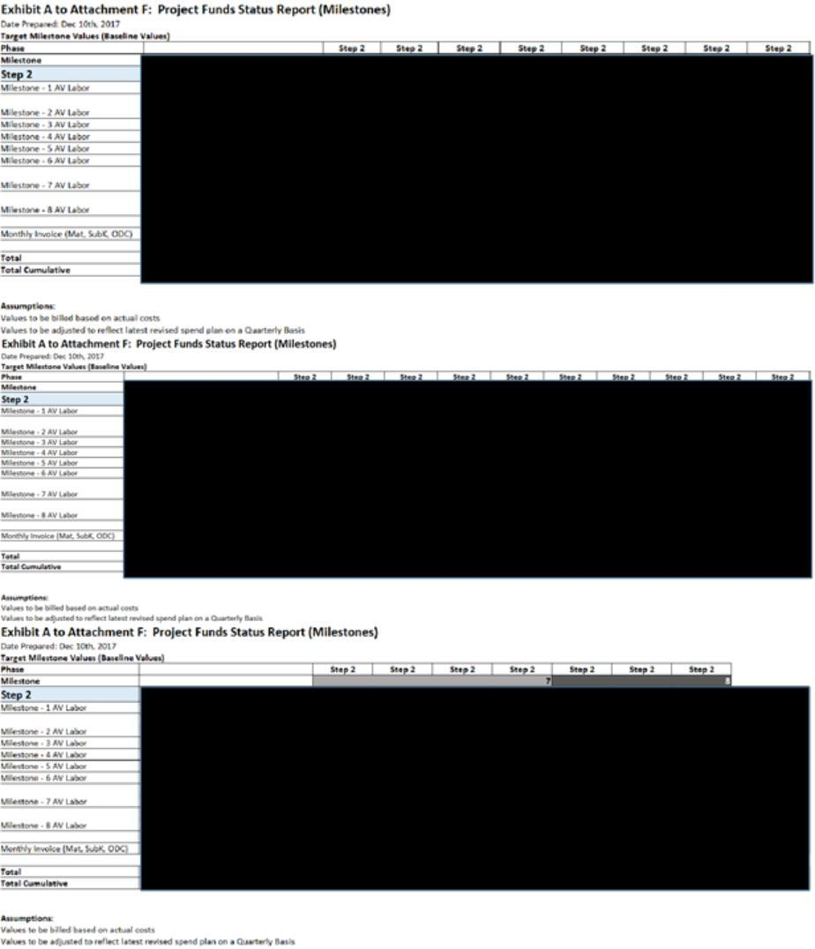

43

- Information has been omitted pursuant to Item 601(b)(2) of Regulation S-K. [___] = [***]

2. Estimate at Completion on Dec.10,2018
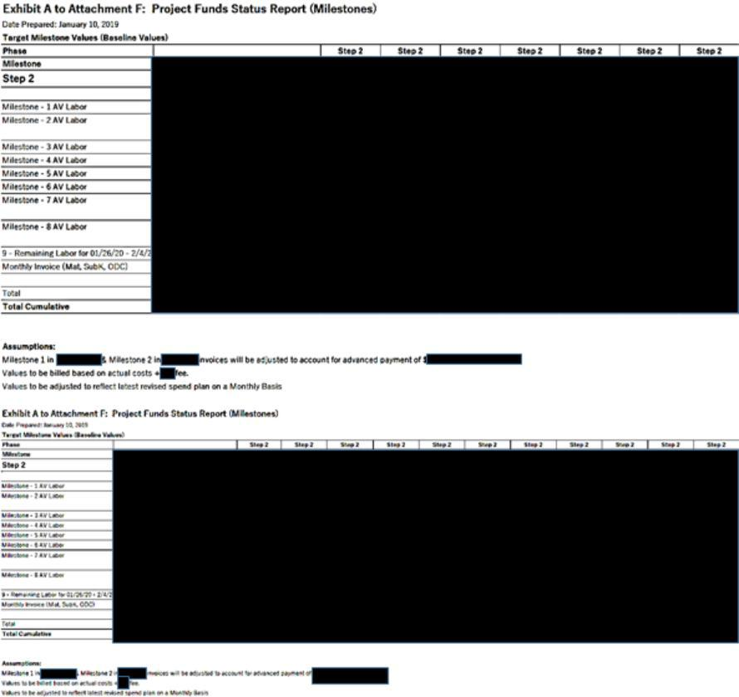

44

- Information has been omitted pursuant to Item 601(b)(2) of Regulation S-K. [___] = [***]

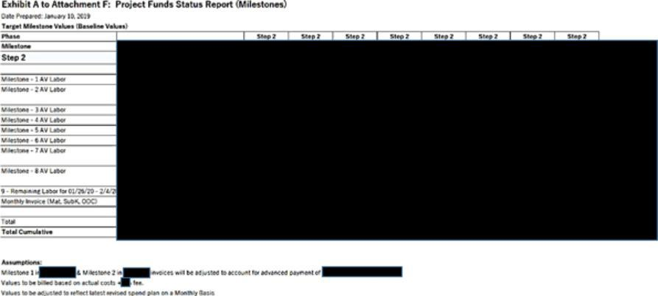

45

- Information has been omitted pursuant to Item 601(b)(2) of Regulation S-K. [___] = [***]

3. Estimate at Completion on March 4,2019
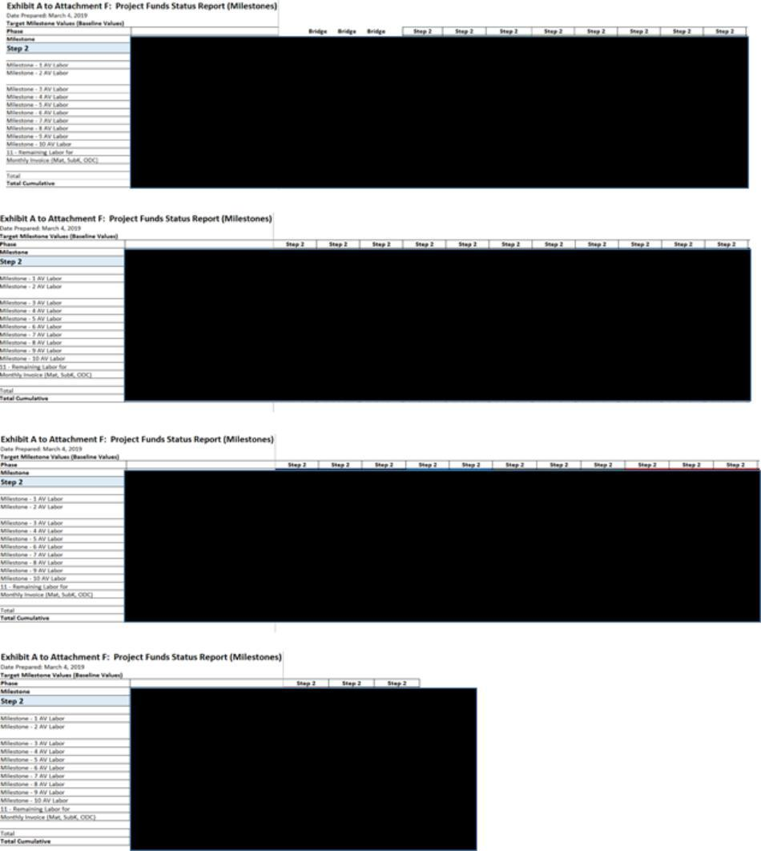

46

- Information has been omitted pursuant to Item 601(b)(2) of Regulation S-K. [___] = [***]

4. Estimate at Completion on September 2019
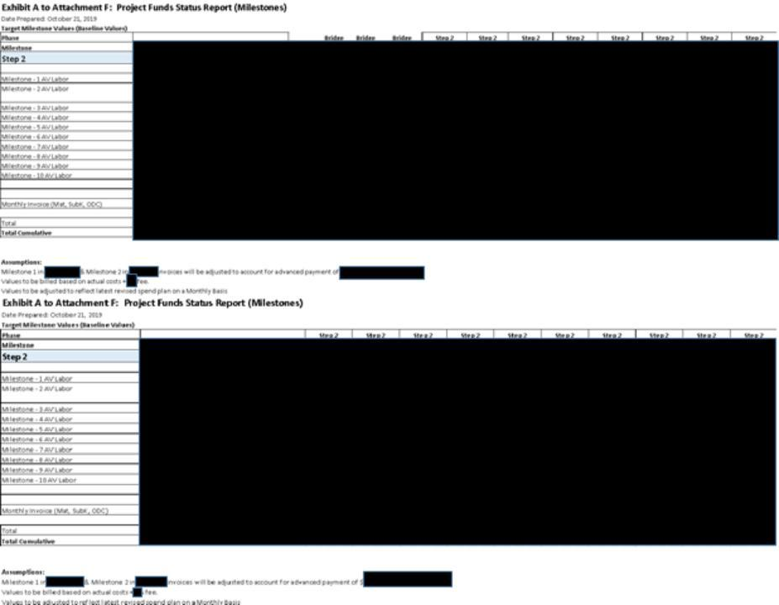

47

- Information has been omitted pursuant to Item 601(b)(2) of Regulation S-K. [___] = [***]

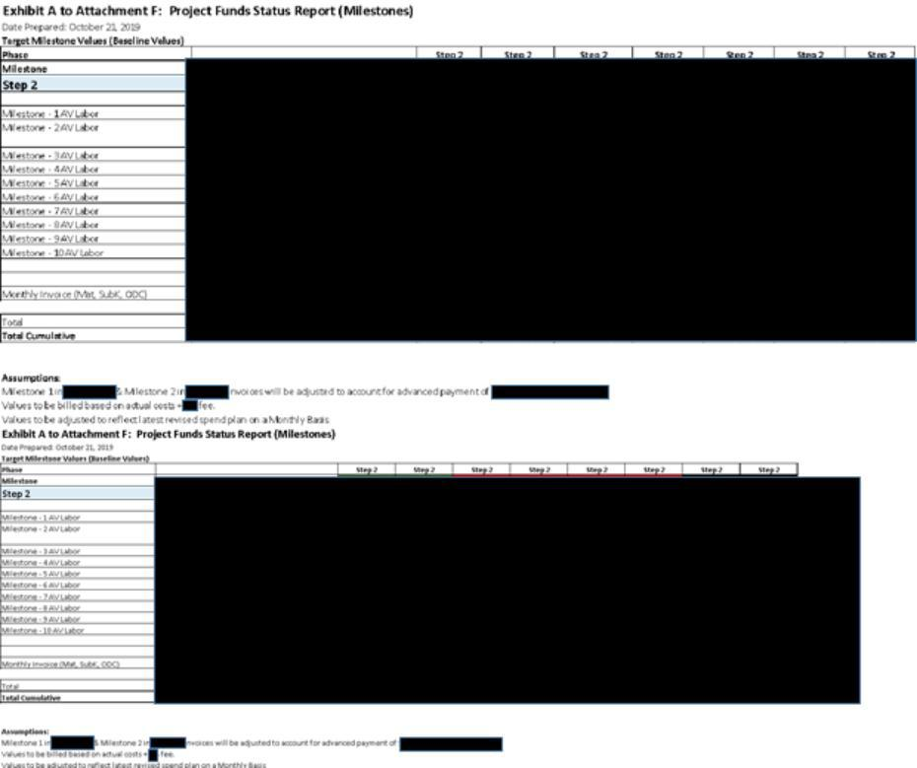

5. Estimate at Completion on April 2020
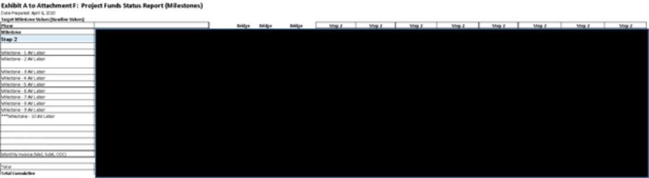

48

- Information has been omitted pursuant to Item 601(b)(2) of Regulation S-K. [___] = [***]

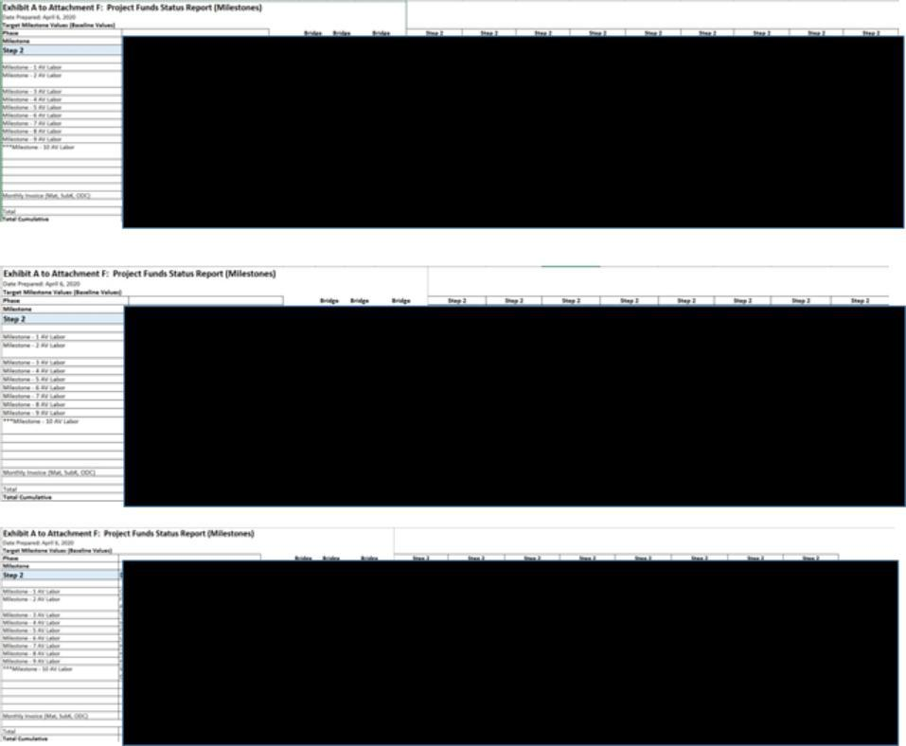

6. Estimate at Completion on July 2020
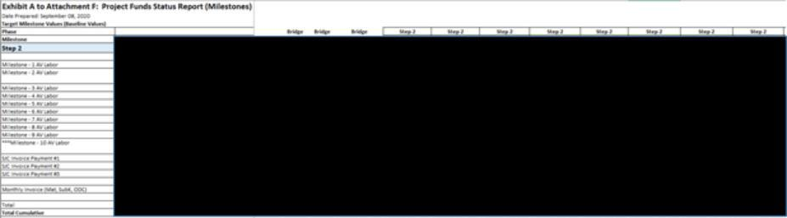

49

- Information has been omitted pursuant to Item 601(b)(2) of Regulation S-K. [___] = [***]

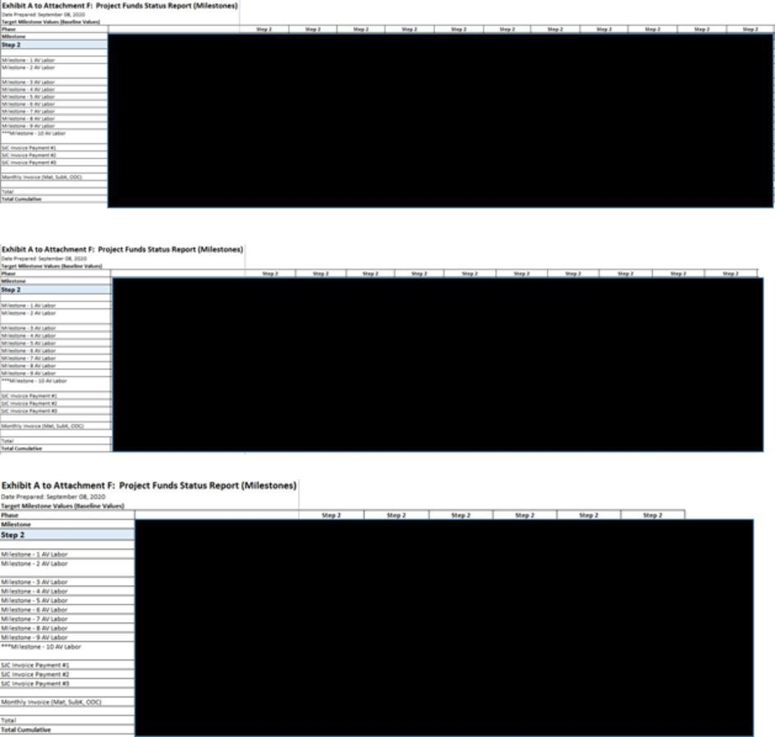

50

- Information has been omitted pursuant to Item 601(b)(2) of Regulation S-K. [___] = [***]

Exhibit B to Attachment F – Monthly Status Report (Example)


AeroVironment Inc.

980 Enchanted Way

Simi Valley, California 93065 – U.S.A.

Telephone 1(805) 581-2187 – FAX 1(805) 584-6922

Approvals:

51

- Information has been omitted pursuant to Item 601(b)(2) of Regulation S-K. [___] = [***]

REVISION HISTORY


REV | EDIT DATE | AUTHOR | DESCRIPTION
- MM/DD/YYYY

52

- Information has been omitted pursuant to Item 601(b)(2) of Regulation S-K. [___] = [***]

TABLE OF CONTENTS
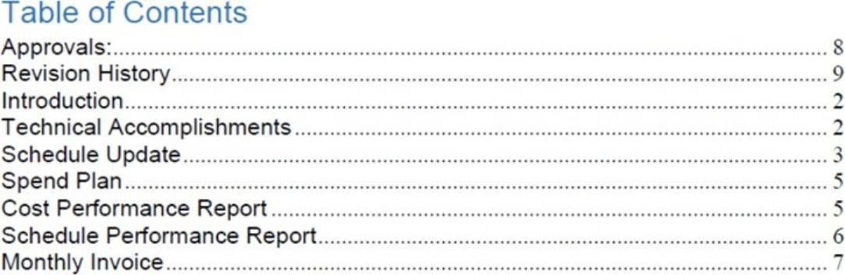

53

- Information has been omitted pursuant to Item 601(b)(2) of Regulation S-K. [___] = [***]

INTRODUCTION

<<HIGH LEVEL PROGRAM OVERVIEW>>

<<STOPLIGHT CHART>>
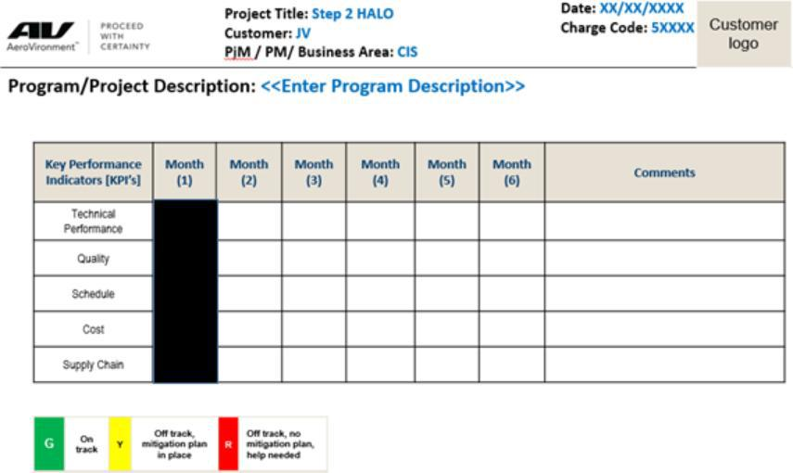

TECHNICAL ACCOMPLISHMENTS

What efforts were started this period?

<<Description of work started and performed during the reporting month>>

Task 5
Task 6
Task 7

Task …X

What efforts were completed this period?

<<Description of work completed and performed during the reporting month>> Task 1
Task 2
Task 3

Task 4

Key Subcontract Status:

54

- Information has been omitted pursuant to Item 601(b)(2) of Regulation S-K. [___] = [***]

Subcontractor A:

Subcontractor B:

Subcontractor C:

SCHEDULE UPDATE

Integrated Master Schedule Update <<EXAMPLE>>


Milestone Status Update

REFERENCE TO ATTACHMENT H

55

- Information has been omitted pursuant to Item 601(b)(2) of Regulation S-K. [___] = [***]

SPEND PLAN

Spend Plan Update
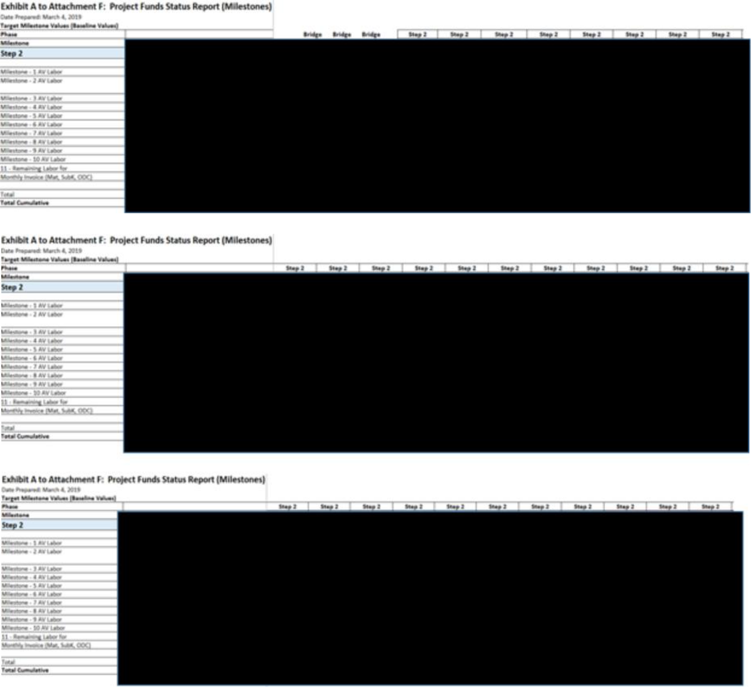

56

- Information has been omitted pursuant to Item 601(b)(2) of Regulation S-K. [___] = [***]

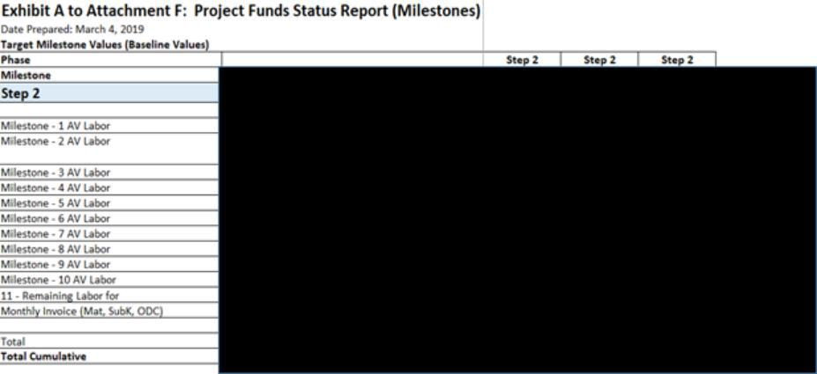

COST PERFORMANCE REPORT

Cost Performance Update
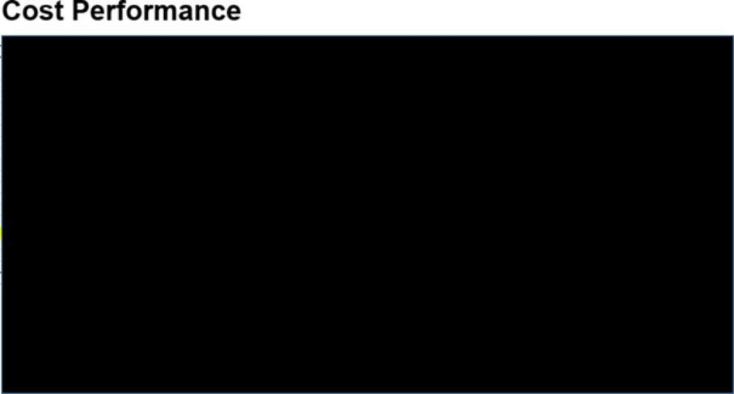

SCHEDULE PERFORMANCE REPORT

<<Schedule Performance Report>>

- Critical Path Analysis

57

- Information has been omitted pursuant to Item 601(b)(2) of Regulation S-K. [___] = [***]

- Schedule Performance Index (if applicable)

- Near term upcoming milestones (30 – 60 days ) o Milestone 1 =

o Milestone 2 = o Milestone X =

MONTHLY INVOICE – (NON-LABOR)


58

- Information has been omitted pursuant to Item 601(b)(2) of Regulation S-K. [___] = [***]

Exhibit C to Attachment F


59

- Information has been omitted pursuant to Item 601(b)(2) of Regulation S-K. [___] = [***]



60

- Information has been omitted pursuant to Item 601(b)(2) of Regulation S-K. [___] = [***]



61

- Information has been omitted pursuant to Item 601(b)(2) of Regulation S-K. [___] = [***]

ATTACHMENT H

PROJECT MILESTONE

(This Attachment H is revised in its entirety by the Amendment No. 12 to the DDA)

# | Milestone | Criteria | Date
1 | [***] |  | [***]
 | [***] |  | [***]
 | [***] | [***] | [***]
2 | [***] |  | [***]
 | [***] |  | [***]

62

- Information has been omitted pursuant to Item 601(b)(2) of Regulation S-K. [___] = [***]

[***]


3 | [***] |  | [***]
 | [***] |  | [***]
 | [***] | [***] | [***]
4 | [***] |  | [***]
 | [***] |  | [***]
 | [***] | [***] | [***]
5 | [***] |  | [***]
 | [***] |  | [***]
 | [***] | [***] | [***]
6 | [***] |  | [***]

63

- Information has been omitted pursuant to Item 601(b)(2) of Regulation S-K. [___] = [***]

[***]

[***]

64

- Information has been omitted pursuant to Item 601(b)(2) of Regulation S-K. [___] = [***]

 | [***] |  | [***]
 | [***] | [***]
7 | [***] |  | [***]
 | [***] |  | [***]
 | [***] | [***] .
8 | [***] |  | [***]
 | [***] |  | [***]
 | [***] | [***]
9 | [***] |  | [***]
 | [***] |  | [***]
 |  | [***]

65

- Information has been omitted pursuant to Item 601(b)(2) of Regulation S-K. [___] = [***]

- [***]

  - [***]

- [***]

- [***]

[***]

[***]

[***]

[***]

[***]

[***]

66

- Information has been omitted pursuant to Item 601(b)(2) of Regulation S-K. [___] = [***]

Exhibit 10.2

CERTAIN IMMATERIAL PROVISIONS OF THIS DOCUMENT THAT WOULD LIKELY CAUSE COMPETITIVE HARM TO THE REGISTRANT IF PUBLICLY DISCLOSED (INDICATED BY AN ASTERISK [***]) HAVE BEEN OMITTED PURSUANT TO ITEM 601(b)(2) OF REGULATION S-K. A COPY OF THE UNREDACTED DOCUMENT WILL BE FURNISHED TO THE SECURITIES AND EXCHANGE COMMISSION UPON REQUEST.

AMENDMENT NO. 13 TO

THE DESIGN AND DEVELOPMENT AGREEMENT (STEP 2)

This Amendment No. 13 to the Design and Development Agreement (Step2) (“Amendment”) is entered into as of the date of last signature below by and between HAPSMobile Inc. and AeroVironment, Inc. to amend the Design and Development Agreement (Step2) made as of December 27, 2017 (as amended by Amendment No.1 as of March 30, 2018, Amendment No.2 as of June 25, 2018, Amendment No.3 as of August 28, 2018, Amendment No.4 as of December 5, 2018, Amendment No.5 as of March 19, 2019, Amendment No.6 as of March 29, 2019, Amendment No.7 as of April 24, 2019, Amendment No.8 as of June 20, 2019 and Amendment No.9 as of December 2, 2019, Amendment No. 10 as of January 24, Amendment No.11 as of April 30, 2020, and Amendment No.12 as of September 21, 2020between HAPSMobile and AV) (collectively, the “DDA”).

Background

The Parties hereby agree to amend the total fees of Design and Development for Step 2 due to the phased strategic extension of the project term of performance and the change to the Statement of Work as set forth herein (the “Change”).

Therefore, to formalize and reflect both the Changes and Program Management Improvement, the Parties hereby agree with the amendments to the DDA as follows:

Amendments

1. Attachment A (DELIVERABLES) to the DDA (as amended by the Amendments No.1, 2, 3, 4, 6, 7, 8, 11 and 12) is hereby deleted in its entirety and replaced with the attached new attachment herein, Attachment A, entitled (DELIVELABLES).

2. Attachment C (AeroVironment Statement of Work (SOW) for Hawk30 Prototype Program Statement of Work) to the DDA (as amended by the Amendments No.5, 7, 9,11 and 12) is hereby deleted in its entirety and replaced with the attached new attachment herein, Attachment C and C-1, entitled (AeroVironment Statement of Work (SOW) for Hawk30 Prototype Program Statement of Work).

3. Attachment F (INVOICE AND INCURRED COSTS DOCUMENTATION) to the DDA (as amended by the Amendments No.1, 5, 7, 9,11 and 12) is hereby deleted in its entirety and replaced with the attached new attachment herein, Attachment F, entitled (INVOICE AND INCURRED COSTS DOCUMENTATION).

1

- Information has been omitted pursuant to Item 601(b)(2) of Regulation S-K. = [***]

4. Attachment H (PROJECT MILESTONE) to the DDA (as amended by the Amendments No.2, 4, 5, 6, 7,11 and 12) is hereby deleted in its entirety and replaced with the attached new attachment herein, Attachment H, entitled (PROJECT MILESTONE).

5. All other terms and conditions not specifically modified or amended herein remain in full force and effect as provided for in the DDA and its Attachments, including Amendments 1 through 12. Capitalized terms, unless otherwise defined herein, shall have the meaning set forth in the DDA. This Amendment may only be modified or amended by a written document executed by the parties hereto.

2

- Information has been omitted pursuant to Item 601(b)(2) of Regulation S-K. = [***]

IN WITNESS WHEREOF the Parties hereto have signed and executed this Amendment on the date(s) below.

SIGNED for and on behalf of |  | SIGNED for and on behalf of
HAPSMobile Inc. |  | AeroVironment, Inc.
By: | /s/ Junichi Miyakawa | By: | /s/Trace Stevenson
Name: | Junichi Miyakawa | Name: | Trace Stevenson
Title: | President & CEO | Title: | Vice President Emerging Business and Deputy GM
Date: | 2020/10/28 | Date: | 2020/10/28

3

- Information has been omitted pursuant to Item 601(b)(2) of Regulation S-K. = [***]

ATTACHMENT A

DELIVERABLES

(This Attachment A is revised in its entirety by the Amendment No. 13 to the DDA)

- Hardware Deliverables

1.1 Aircraft Deliverables

Deliverables | Deliverable Description | Relevant | Milestone | Estimated
Name |  | WBS | No. | Completion
 |  |  |  | Date
Hawk30 Prototype | Stratospheric solar aircraft [***] | 2.3.2.3 | [***] | [***]
[***]
Hawk30 Prototype | Stratospheric solar aircraft [***] | 2.3.2.6 | [***] | [***]
[***]

*1. [***].

*2. [***].

*3. [***].

The current physical solar array implementation plan is as follows:

Hawk30 Prototype [***] will have [***].

Hawk30 Prototype [***] will have [***].


4

- Information has been omitted pursuant to Item 601(b)(2) of Regulation S-K. = [***]

1.2 Ground Control System

Deliverables Name |  | Deliverable Description |  | Relevant | Milestone | Estimated
 |  |  |  | WBS | No. | Completion
 |  |  |  |  |  | Date
Ground Control |  | Ground Control Station [***] of the Hawk30 | 2.2.6 |  | [***] | [***]
Stations and Misc. |  | Prototype [***]
Equipment
Hawk30 Prototype |  | Technical Data Package | 1.2.4.1 |  | [***] | [***]
Operating Manuals
Hawk30 Prototype |  | Technical Data Package | 1.2.4.2 |  | [***] | [***]
Training Manuals
*1 [***].
1.3 Motor Development
Deliverables Name |  | Deliverable Description |  | Relevant | Milestone | Estimated
 |  |  |  | WBS | No. | Completion
 |  |  |  |  |  | Date
[***] |  | [***] Project Data Memo | 2.2.1 |  | [***] | [***]
[***] |  | [***] | 2.2.1 |  | [***] | [***]
[***] |  | Technical data package of In-house Motor | 2.2.1 |  | [***] | [***]
 |  | First Article ([***])
[***] |  | [***] | 2.2.1 |  | [***] | [***]
1.4 Real Estate Deliverables
Deliverables |  | Deliverable Description |  | Relevant | Milestone | Estimated
Name |  |  |  | WBS | No. | Completion
 |  |  |  |  |  | Date
Hanger at SA Flight |  | Newly constructed hanger facility in SA, NM | 2.3.3 |  | [***] | [***]
Test Site |  | Newly constructed hanger facility in SA, NM
2. Document Deliverables
Deliverables Name |  | Deliverable Description |  | Relevant | Milestone | Estimated
 |  |  |  | WBS | No. | Completion
 |  |  |  |  |  | Date
CDR & Component |  | Technical Data Package. |  | 2.2 | [***] | [***]
Engineering |  | RFPs, RFIs, and RFQs.
Technical Data
Package
Update Component |  | Technical Data Package |  | 2.2 | [***] | [***]
Engineering
Fab & Test First Wing |  | Technical Data Package. |  | 2.2.3.1 | [***] | [***]
Panel |  | Recorded measurement data aerodynamic test
 |  | data.
Functional Test |  | Acceptance test reports for components and |  | 2.3 | [***] | [***]
Reports |  | assemblies

5

- Information has been omitted pursuant to Item 601(b)(2) of Regulation S-K. = [***]

Initial Integrated Test | Initial Acceptance test reports for aircraft & | 2.3.2.3 | [***] | [***]
Reports ([***]) | Ground Control Station
Integrated Test | Acceptance test reports for aircraft & Ground | 2.3.2.3 | [***] | [***]
Reports ([***]) | Control Station
Integrated Test | Acceptance test reports for aircraft | 2.3.2.6 | [***] | [***]
Reports ([***])
[***] | Acceptance inspection and close-out reports | 2.3.2.8 | [***] | [***]
[***] | Final key drawing, asset list and utility | 2.3.3 | [***] | [***]
 | explanatory for Flight Range facility
[***] | [***] | N/A | [***] | [***]

**[***].

As used in this Attachment A, and as limited by Section 4.8 in the IPLA, “Technical Data Package” means:

- [***]

- [***]
- System specifications
- System description documents
- System performance data
- [***]
- [***].

“Technical Data Package” transfer could be in various forms, for example:

- Agile database export in PDX file which will include PDF files for assembly drawings, DOC for procedures and test plans, and EXE files for executable code.

- Specifications, descriptions, Program Data Memos, test data in a ZIP file which can include a combination of DOC, XLS, and other data formats.

6

- Information has been omitted pursuant to Item 601(b)(2) of Regulation S-K. = [***]

Exhibit A

Source Code to be Provided by AV to HAPSMobile

1. Software and Firmware Tabular View

7

- Information has been omitted pursuant to Item 601(b)(2) of Regulation S-K. = [***]

Attachment C

AeroVironment Statement of Work (SOW) for

Hawk30 Prototype Program

(This Attachment C is revised in its entirety by the Amendment No. 13 to the DDA)

- Scope Purpose [***].
Hawk30 Prototype Objectives [***].
Scope

[***]:

  - [***].
  - [***].
  - [***]

- Services

- HAWK30 PROTOTYPE

- PROGRAM MANAGEMENT & SYSTEMS ENGINEERING

2.1[***]

2.1.1 [***]

Objective: [***].

Approach: [***]:

- [***]

- [***]
- [***]
- [***]
- [***]
- [***]
- [***]
- [***];
  - [***]
  - [***]
  - [***]
  - [***]
- [***]:

[***].

8

- Information has been omitted pursuant to Item 601(b)(2) of Regulation S-K. = [***]

Reporting Process diagram


Exit Criteria: [***]

Task Output:

- [***]
- [***]
- [***].
REMARK: [***].

2.1.2 [***]

Objective: [***].

Approach: [***]:
- [***]
- [***]
- [***]
- [***]
- [***]
- [***]
- [***]
- [***]
- [***]
Exit Criteria: [***].
Task Output:
[***]

9

- Information has been omitted pursuant to Item 601(b)(2) of Regulation S-K. = [***]

2.1.3 [***]

Objective: [***].

Approach: [***]:
- [***]
- [***]
- [***]
- [***]

  - [***]

  - [***]
  - [***]
- [***]

2.1.4 [***]

Objective: [***].

Approach: [***].
Exit Criteria: [***].
Task Output:
- [***]
- [***]

2.1.5 [***]

Objective: [***].

Approach: [***]:
- [***]
- [***]
- [***]
- [***]

  - [***]

  - [***]
  - [***]
  - [***]
  - [***]
1.1.6 [***]
1.1.7 Objective: [***].
1.1.8 Approach: [***]. Exit Criteria: [***].
Task Output:
- [***]
1.1.9 Reserved

10

- Information has been omitted pursuant to Item 601(b)(2) of Regulation S-K. = [***]

1.1.10 [***]

Objective: [***].

Approach: [***].

Exit Criteria[ ***].

Task Output:
- [***]

1.1.11 Reserved

1.1.12 [***]

Objective: [***].

Approach: [***].

Exit Criteria: [***].

Task Output:
- [***]

1.1.13 [***]

Objective: [***].

Approach: [***]

Exit Criteria: [***]

Task Output:
- [***]

2.2 [***]

2.2.1 [***]

Objective: [***]:

- [***]
- [***]
- [***]
- [***]
- [***]
- [***]

- [***]

- [***]
- [***]
- [***]
- [***]

11

- Information has been omitted pursuant to Item 601(b)(2) of Regulation S-K. = [***]

- [***]

2.2.2 [***]

Objective: [***]

Approach: [***]:
- [***]
- [***]
- [***]
- [***]
- [***]
- [***]
- [***]
- [***].

- [***]

- [***]
- [***]
- [***]
- [***]
- [***]

2.2.3 [***]

Objective: [***].

Approach: [***]:
- [***]
- [***]
- [***]

- [***]

- [***]
- [***]

2.2.4 [***]

Objective: [***].

Approach: [***]:
- [***]
- [***]
- [***]
- [***]
- [***]
- [***]
- [***]

12

- Information has been omitted pursuant to Item 601(b)(2) of Regulation S-K. = [***]

- [***]

- [***]

- [***]
- [***]
- [***]
- [***]
- [***]

2.2.5 [***]

Objective: [***].

Approach: [***]:
- [***]
- [***]
- [***]
- [***]

- [***]

- [***]

2.2.6 [***]

Objective: [***].

Approach: [***]:

- [***]

- [***]
- [***]
- [***]
- [***]

- [***].

2.2.7 Reserved

2.2.8 Reserved

2.2.9 [***]

Objective: [***].

Approach: [***].

Exit Criteria: [***].

Task Output:
- [***].

13

- Information has been omitted pursuant to Item 601(b)(2) of Regulation S-K. = [***]

- [***]

2.1 [***]

2.1.1 [***]

2.1.1.1 Reserved.

2.1.1.2 [***]

Objective: [***].

Approach: [***]:
- [***]
- [***]
- [***]
- [***]

- [***].

- [***]
2.1.1.3 [***]

Objective: [***].

Approach: [***]:
- [***]
- [***]
- [***]
- [***]
- [***]
- [***]

- [***]

2.1.1.4 [***]

Objective: [***].

Approach: [***]:
- [***]
- [***]
- [***]
- [***]
- [***]
- [***]
- [***]
- [***]
- [***]

14

- Information has been omitted pursuant to Item 601(b)(2) of Regulation S-K. = [***]

Exit Criteria: [***].

Task Output:
- [***]
- [***]
- [***]
2.1.1.5 [***]

Objective: [***].
Approach: [***]:
- [***].

- [***].

2.2 [***]

2.2.1 [***]

Objective: [***].

Approach: [***]:
- [***]
- [***]
- [***]
- [***]
- [***]
  - [***]
  - [***]

- [***]

- [***]
- [***]

2.2.2 [***]

Objective: [***].

Approach: [***]:
  - [***]
  - [***]
- [***]
- [***]
- [***]

- [***]

- [***]
- [***]
- [***]

15

- Information has been omitted pursuant to Item 601(b)(2) of Regulation S-K. = [***]

- [***]

- [***]
- [***]:
o [***] o [***]

2.2.2.1 [***]

Objective: [***].

Approach: [***]:
- [***]
- [***]
- [***]

  - [***]

- [***]

2.2.3 [***]

Objective: [***].

Approach: [***]:
- [***]
- [***]
- [***]
- [***]
- [***]
- [***]
- [***]

- [***]

- [***]
2.2.4 [***]

Objective: [***].

Approach: [***]:
- [***]
- [***]
- [***]
- [***]
- [***]
- [***]
- [***]
- [***]
- [***]
Exit Criteria: [***].

16

- Information has been omitted pursuant to Item 601(b)(2) of Regulation S-K. = [***]

Task Output:

- [***]
- [***]
- [***]
2.2.5 [***]

Objective: [***].

Approach: [***]:
- [***]
- [***]
- [***]
- [***]
- [***]
- [***].

- [***]

- [***]
- [***]

2.2.6 [***]

Objective: [***].

Approach: [***]:
- [***]
- [***]
- [***]
- [***]
- [***]
- [***]

- [***]

- [***]

2.2.7 Reserved

2.2.8 [***]

Objective: [***].

Approach: [***]:

- [***]

- [***]
- [***]
Exit Criteria: [***].

17

- Information has been omitted pursuant to Item 601(b)(2) of Regulation S-K. = [***]

 | Task Output:
 | • | [***]
 | • | [***]
2.3 | [***]

2.3.1 | Reserve
2.3.2 | [***]

Objective: [***].

Approach: [***]:
- [***]
- [***]
- [***]
- [***]
o [***] o [***] o [***] o [***] o [***] o [***].

Exit Criteria: [***].

Task Output:
- [***]
- [***]
- [***].
2.3.3 [***]

Objective[***].

Approach: [***]:

- [***]

- [***]
- [***]
- [***]
- [***]
- [***]
- [***]
- [***]
- [***]
- [***]
- [***].

- [***]

- [***]

18

- Information has been omitted pursuant to Item 601(b)(2) of Regulation S-K. = [***]

- [***]

[***]
Objective: [***].

Approach: [***].

- [***]

- [***]
- [***]
- [***]
- [***]
- [***]
- [***]
- [***]
- [***].

- [***]

- [***]
- [***]
- [***]
- [***]
2.2 [***] Objective: [***].

- [***].

Approach: [***].

- [***]
- [***]
- [***]
- [***]
- [***]
- [***]*
- [***]*
- [***]
- [***]
- [***]
- * [***]:
    - [***]
    - [***].
Exit Criteria: [***].
Task Output:
  - [***]
  - [***]* [***]
  - [***]
- [***]

19

- Information has been omitted pursuant to Item 601(b)(2) of Regulation S-K. = [***]

- [***] ([***]* [***])

  - [***]
  - [***]*

- Reserved.

- Reserved. [***]: [***]. Approach: [***]:
  - [***]
  - [***]
  - [***]
  - [***]
  - [***]
  - [***]
  - [***]
Exit Criteria: [***]

Task Output:

- [***]
- [***]
- [***]

As used in this Attachment C, “Technical Data Package” shall have the same meaning as provided in Attachment A to this Agreement.

20

- Information has been omitted pursuant to Item 601(b)(2) of Regulation S-K. = [***]

Attachment C-1

Statement of Work (SOW) for Phased Strategic Performance Extension of term

[***]

This specific Attachment sets forth the unique added task by implementation of the Amendment #13.

Scope
Purpose
[***].
Background and Approach
Background:
[***].
Approach:
[***].
Assumptions
[***]:
- [***]
- [***]
- [***].

21

- Information has been omitted pursuant to Item 601(b)(2) of Regulation S-K. = [***]

- [***]

Objective: [***].
Initial Condition: [***]. Approach:
[***]
[***].
[***]
  - [***]
  - [***]:
      - [***].
      - [***]
[***]
    - [***]
    - [***]
    - [***]:
      - [***]
      - [***]
      - [***]
      - [***]
      - [***]
      - [***]
      - [***]
      - [***]
      - [***].

[***]

- [***]
- [***]
- [***];
  - [***]
  - [***]
- [***];
  - [***]
  - [***]
  - [***];
    - [***].
    - [***].

22

- Information has been omitted pursuant to Item 601(b)(2) of Regulation S-K. = [***]

ATTACHMENT F

INVOICE AND INCURRED COSTS DOCUMENTATION

(This Attachment F is revised in its entirety by the Amendment No. 13 to the DDA)

PRICING AND PAYMENT SCHEDULE

- Payment for Work Step2 1.1 Total Contract Value

The total amount of Design and Development Fees payable for Step 2 is Not-to-Exceed USD $171,383,012 based on Best Efforts. The Contract Value may be modified by the Parties as a result of Change Control or by any other amendment to the Agreement (the current contract value at any time under this Agreement shall be the “Contract Value”). The Parties agree to account for payment of USD $5,988,678 already made by SoftBank to AV as payment for the consideration of Step 2 Bridge Contract as partial payment for commencing Step 2. The Parties shall pay to AV the remaining balance of USD $165,394,334, consists from USD $69,800,624 as Initial Contract Value and incremental amount by Amendment No.1, USD $17,226,306 as additional cost by Amendment No.5, USD $38,675,443 as additional cost by Amendment No.7, USD $14,557,250 as additional cost by Amendment No. 9, USD $17,531,644 as additional cost by Amendment No.11, USD $1,603,067 as additional cost by Amendment No.12, and further additional funding of USD $6,000,000 by Amendment No. 13 subject to the phased strategic extension of the project term of performance and EAC adjustment activity done in [***], in accordance with Exhibit A to this Attachment F Project Funds Status Report accompanied by a combined Milestone & Monthly Invoice approach as detailed further in this Attachment F. Each Milestone payment shall be payable after completion of the applicable Milestone according to Completion criteria on Attachment H.

1.2 Contract Value Growing Transition

The Initial Contract Value may be modified by the Parties as a result of Change Control or by any other amendment to the Agreement (the current contract value at any time under this Agreement shall be the “Contract Value”). Each Party recognizes the total Project Cost has grown as follows;

- SoftBank and AV concluded Step 2 Bridge Contract for preliminary development activity for Step2, and payment of USD $5,988,678 was made to AV by SoftBank;

- SoftBank, HM, and AV agree to account for payment of USD $5,988,678 already made by SoftBank to AV as defined as above as partial payment ("Taken-Over Value”) for commencing Step 2. HAPSMobile;

- Initial contract value for DDA was USD $65,011,481 (“Initial Value”), and USD $71,000,159 in case including Taken-Over Value;

- USD $4,789,143 was added to Initial value by the execution of the Amendment No.1 and total value was modified to USD $69,800,624 (“Amendment 1 Value”), and USD $75,789,302 in case including Taken-Over Value;

- USD $17,226,306 was added to Amendment 1 Value by the execution of the Amendment No.5 and total value was modified to USD $87,026,930 (“Amendment 5 Value”), and USD $93,015.608 in case including Taken-Over Value;

23

- Information has been omitted pursuant to Item 601(b)(2) of Regulation S-K. = [***]

- USD $38,675,443 was added to Amendment 5 Value by the execution of the Amendment No.7 and total value was modified to USD $125,702,373, and USD $ 131,691,051 in case including Taken-Over Value;

- USD $14,557,250 was added to Amendment 7 Value by the execution of the Amendment No.9 and total value was modified to USD $140,259,623, and USD $ 146,248,301 in case including Taken-Over Value;

- USD $17,531,644 was added to Amendment 9 Value by the execution of the Amendment No.11 and total value was modified to USD $157,791,267, and USD $ 163,779,945 in case including Taken-Over Value;

- USD $1,603,067 was added to Amendment 11 Value by the execution of the Amendment 12 and total value was modified to USD $159,394,334, and USD$165,383,012 in case including Taken-Over Value;

- USD $6,000,000 as further incremental funding subject to EAC adjustment activity done on [***] and caused by the change in Deliverables as defined in Attachment A and F herein and milestone changes as defined in detail in Attachment H herein; and the contract value reaches USD $165,394,334, in case including Taken-Over Value then USD$171,383,012.

1.3 Work Order Issuance Schedule

HAPSMobile agrees to issue five (5) scheduled separate Orders and may issue four (4) optional separate Orders (“Optional

Orders”) to AV for authorization of Work. The Orders shall be issued as follows:

- initial Order [***];

- second Order [***];

- the third Order [***];

- the fourth Order [***];

- the fifth Order [***];

f. and five more optional Orders will be defined further more in detail in 4.1 herein. Each Order will be issued pursuant to the terms and conditions of this Agreement including the attachments thereto. Work performed under the Orders will be in support of the entire Statement of Work based on best effort, up to the value funded on the Order.

1.4 Milestone Target Budget Values & Forecast Revisions

Exhibit A (Project Funds Status Report) to this Attachment F assigns Initial Target Budget values for each of the 11 Milestones identified in Attachment H.

AV will provide updates and revisions to the Initial Target Budget values for each Milestone and revised and updated forecasts for such Milestones to HAPSMobile on a monthly basis. Milestone values are subject to Change Control based on updated forecasts of program resource requirements to complete the Work required under this Agreement, including the SOW(Attachment C). Milestone values will be based on the AV labor projected spend plan forecasted for each AV fiscal month.

24

- Information has been omitted pursuant to Item 601(b)(2) of Regulation S-K. = [***]

1.5 Milestone Invoicing & Payment

Upon AV’s written notification to HAPSMobile of AV’s completion of a Milestone, AV will provide an invoice for all AV labor Incurred Costs and [***]% fee. Invoices will include all program labor expenses incurred by AV up through the date of the Milestone acceptance, less any labor already paid for in prior Milestone invoices. Milestones completed before the 15th of the calendar month will be based on actuals from the prior AV fiscal month end. Milestones completed after the 15th of the calendar month will be invoiced upon completion of that fiscal month. [***].

[***].

Notwithstanding the foregoing provisions of this section 1.5, Milestone invoiced amount especially for Milestone 5 [***], and Milestone 7 ([***]) shall be paid in respect of each valid invoice no later than, but not be obliged to pay before April 15, 2020. All Milestone payments thereafter will be restored to its original NET 15 payment.

Notwithstanding the foregoing provisions contained in the body of DDA or Attachment F herein, SA readiness related AV labor, material, and subcontracting fee will be invoiced by AV and compensated by HAPSMobile by three (3) instrument basis together with the milestone invoiced amount for Milestone 6 ([***]), 8 ([***]) and the last invoice to be sent by AV on 4/15/2021 and to be paid no later than 4/25/2021. If Milestones [***] and/or [***] are not achieved by October 2020 in any reason, AV will invoice the applicable instrumental equivalent amount costs (excluding [***] instrument value on April 2021) are to be paid within 30 calendar days of invoice submittal.

At the timing of “[***]” scheduled on [***].

1.6 Non-Milestone Invoicing & Payment (Monthly Invoices)

Program expenses for material, subcontract and other direct costs will be invoiced by AV to HAPSMobile on a monthly basis based on actual Incurred Cost and [***]% fee. Invoices to be submitted within 4 Business Days after each calendar month end. HAPSMobile agrees to pay each such invoice within the same calendar month. Invoices for material related Cost will be provided with applicable level of detailed description for HAPSMobile’s book keeping purpose.

Notwithstanding the foregoing provisions of this section 1.6, for the Monthly Invoice for November of 2019 through March 2020, HAPSMobile shall make payment in respect of each valid Monthly Invoice no later than, but not be obliged to pay before, ninety (90) calendar days of the end of the calendar month in which the relevant invoice was received by HAPSMobile All non-milestone payments thereafter will be restored to its original NET 30 calendar days payment.

1.7 Currency

All payments under this Agreement shall be made in United States dollars.

1.8 Excess Incurred Costs

- In the event that AV identifies a projected increase in Incurred Costs by AV for the performance of its obligations under the Agreement as identified in the Monthly Status Report, in excess of the Not-to-Exceed Value of the Order as identified in Article 2.3 then the Parties agree the excess of the amount and continue to proceed the Project subject to the process set forth in the Section 4 of this ATTACHMENT F, HAPSMobile may,

25

- Information has been omitted pursuant to Item 601(b)(2) of Regulation S-K. = [***]

- agree to authorize AV to incur the excess costs and provide a modification to increase the Contract Value, provided however that both Parties shall follow the Change Control set forth in Article 2.4 of the Agreement or Amendment of Agreement set forth in Article 13. Should HAPSMobile authorize additional spending, all of AV’s Incurred Costs must be paid to AV with the applicable [***]% fee;

- agree in accordance with the Change Control or Amendment of Agreement to reduce the Scope of Agreement so that AV’s performance of the Scope of Agreement will be projected to fall within the amount of the then current Contract Value; or

- Terminate the Agreement for convenience as contemplated by Article 12.3 of the Agreement and pay AV all Termination Liability as defined in paragraph 1.7 of this attachment.

1.9 Unutilized Consideration

In the event of a projected cost underrun as identified in a Monthly Status Report, any amounts from the Order which remain after completion of the Scope of Agreement may be reimbursed or, if authorized by HAPSMobile separately and specifically, utilized for AV’s risk reduction or additional scope to be defined through written mutual agreement subject to the terms of this Agreement. To avoid confusion, the total amount as identified in paragraph 1 of this Attachment and any portion thereof, to the extent that it is utilized, must be utilized only for matters or items within the Scope of Agreement and any additional scope as agreed. Incurred Costs shall be inclusive of any applicable consumption, value added tax or any other applicable sales/use tax. For the avoidance of doubt, the Incurred Costs shall be exclusive of any and all import duties.

1.10Termination Liability

AV’s Termination Liability (defined as: all of AV’s Step 2 Incurred Costs incurred prior to the date of the ramp down period specified in Article 12.5 of the Agreement plus the applicable [***]% fee, less all payments received by AV from HAPSMobile under this Agreement, plus all material, subcontract, other direct costs including open commitments and other wind down costs outstanding as of the start of the ramp down period, plus 60 days of AV labor costs incurred during the ramp down period) will be billed to HAPSMobile 30 days after the end of ramp down period and Termination Liability shall not exceed then current Contract Value but AV labor cost may be compensated exceeding then current Contract Value based upon actual Work performed. Schedule delays may occur and be resolved subject to Article 3.2 of the Agreement.

- Fee Assumptions 2.1 Exclusion

- Range Fees for the High Altitude and Endurance Flight Tests shall be borne by, and be the sole responsibility of, HAPSMobile. AV and HAPSMobile will mutually consult to set up an appropriate implementation plan for High Altitude and Endurance Flight Tests minimizing such Range Fees in accordance with Attachment C and D.

a. [***], AV and HM have agreed to continue flight test operations at Spaceport America, New Mexico after concluding flights at NASA AFRC. The flight test site preparation is led by AV and the flight test site preparation and ongoing operational costs are included as part of Amendment No. 11.

26

- Information has been omitted pursuant to Item 601(b)(2) of Regulation S-K. = [***]

b. Notwithstanding the terms and conditions defined in this Section 2.1-1 above, for the task of flight range acquisition and maintaining will be a part of AV’s obligation and contained in its Scope of Work relating to Spaceport America, New Mexico.

- Payload Integration is based on the Loon payload [***], any changes to Payload Supplier and/or integration will be subject change control process.

- Labor, shipping and other costs are not included, however is inclusive of labor for obtaining the clearance and permission under EAR or related export regulations for delivery of [***], [***] and GCS at other than the Spaceport America flight test location. Any changes to the final delivery location will be subject to change control process.

3. Change Control & Agreement Amendments Payment Schedule

HAPSMobile agrees to pay to AV all additional Incurred Costs resulting from any fee adjustments for the Work pursuant to any Change Control per Attachment G or any other amendments to the Agreement, but in any case subject to the terms set forth in Section 1.9 in this ATTACHMENT F. After being provided with a request or providing a Change Control Proposal as provided on Attachment G or any other amendment to the Agreement. AV will provide HAPSMobile with a Change Assessment (as contemplated by Attachment G) or a similar assessment or other proposed amendments to the Agreement with estimated additional or reduced Incurred Costs plus the applicable fee for the applicable Change Control Proposal or other proposed Agreement amendment along with the costs estimation documentation. In the event of a projected increase in Incurred Costs by AV in performance of the Agreement pursuant to Change Control Proposal or other proposed Agreement amendment would result in a total Contract Value that exceeds the then-current Contract Value, HAPSMobile will agree to authorize AV to incur the excess costs (thus increasing the Contract Value) or the Parties will agree in the Change Control (or pursuant to any other Agreement amendment) to reduce the Scope of Agreement so that AV’s performance of the Scope of Agreement will fall within the then-current Contract Value. Any increase in Contract Value that exceeds causes the value of this Agreement to exceed the Initial Contract Value shall require approval by HAPSMobile's board of directors.

The tables below provide the basis for calculating the additional Fees applicable for Change Controls and other Agreement amendments as a result of a Change or other Agreement amendment that may be required from time to time in accordance with relevant clauses of the Agreement.

 | Cost Element |  | Description
 | Labor |  | [***]
 | Labor Total Cost w/[***]% Fee |  | [***]
 | Material Total Cost w/[***]% Fee |  | [***]
 | Subcontract Total Cost w/[***]% Fee |  | [***]
 | Other Direct Costs (ODC) Total Cost w/[***]% Fee |  | [***]

27

- Information has been omitted pursuant to Item 601(b)(2) of Regulation S-K. = [***]

- Remaining Work Orders

4.1 Order Schedule

The Fifth Work Order and the following Optional Orders will be organized as follows;

Name |  | Covered SoW | Covered |  | WO value | WO due
 |  |  | Milestone |  | (USD) | date
The fifth Work Order | [***] |  | [***] |  | [***] | [***]
The sixth Work Order | [***] |  | [***] |  | [***] | [***]
The Seventh Work | [***] |  | [***] |  | [***] | [***]
Order
The Eighth Work Order | [***] |  | [***] |  | [***] | [***]
The Ninth Work Order | [***] |  | [***] |  | [***] | [***]
The Tenth Work Order | [***] |  | [***] |  | [***] | [***]
Definition |  | Meaning |  |  | Decision Due Date
[***] |  | [***]. |  |  | [***]
Flight Location Change |  | Additional tasks associated with; |  |  | [***]
 |  | a) a change from the original flight location,
 |  | Lanai, to an alternate site, SÁ in New
 |  | Mexico
 |  | b) detailed flight test planning of [***] to be
 |  | tested and related planning optimization of
 |  | other flight test campaign.
 |  | In case either Party may request changes to the
 |  | conditions defined in Attachments A, C, D, E, F or H
 |  | relating the task herein defined, then follows the
 |  | procedures defined in Clause 2.4 in DDA or
 |  | Attachment G ("Change Control").
[***] |  | [***] |  |  | [***]
Strategic Performance |  | [***] |  |  | [***]
Extension
[***]) |  | [***] |  |  | [***]

4.2 Effect of No Issuance of Optional Order

In case HM does not issue the Optional Order before or on the due date, AV may suspend the entrance of the equivalent Milestone and covered Works until AV receives the Optional Order. In the event of Optional Work Orders are not exercised, AV will transfer all assets to HAPSMobile.

28

- Information has been omitted pursuant to Item 601(b)(2) of Regulation S-K. = [***]

Exhibit A – Project Funds Status Report

Exhibit B – Monthly Status Report (Example)

Exhibit C – Milestone Invoice (Example)

29

- Information has been omitted pursuant to Item 601(b)(2) of Regulation S-K. = [***]

Exhibit A to Attachment F – Project Funds Status Report 1. Estimate at Completion on Dec.10,2017
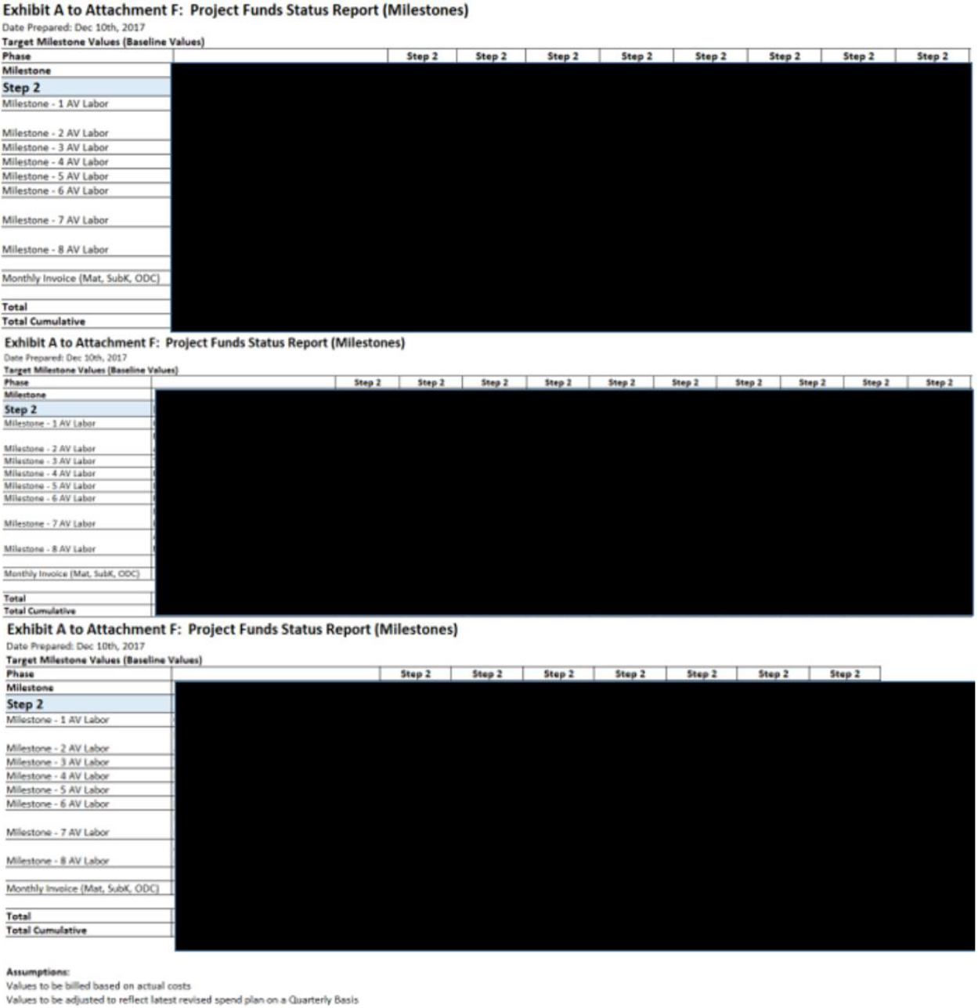

30

- Information has been omitted pursuant to Item 601(b)(2) of Regulation S-K. = [***]

2. Estimate at Completion on Dec.10,2018
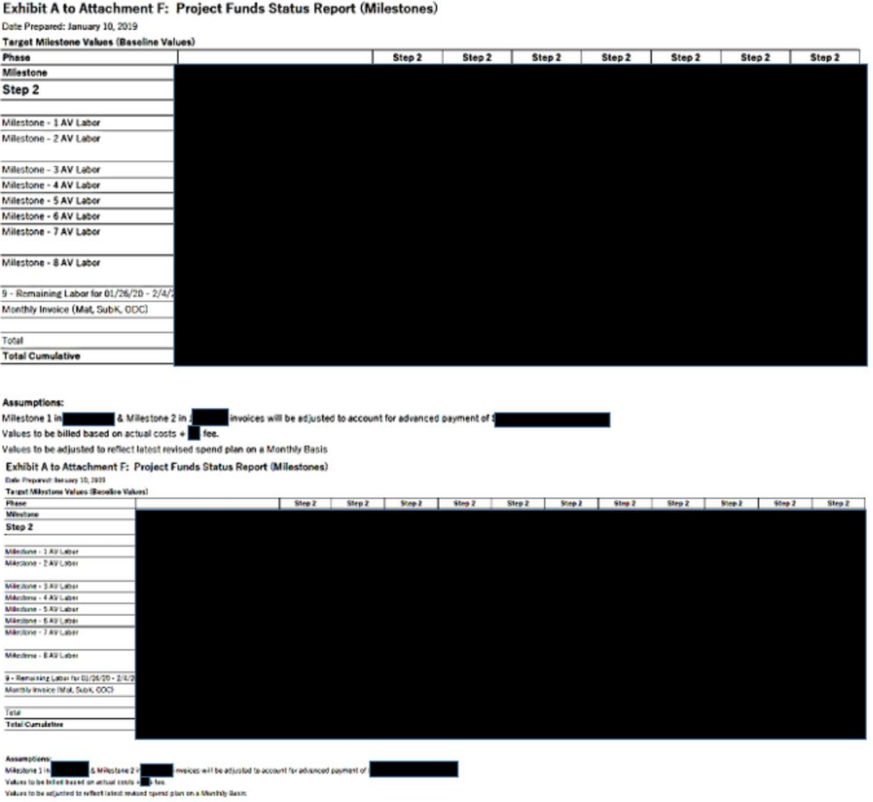

31

- Information has been omitted pursuant to Item 601(b)(2) of Regulation S-K. = [***]

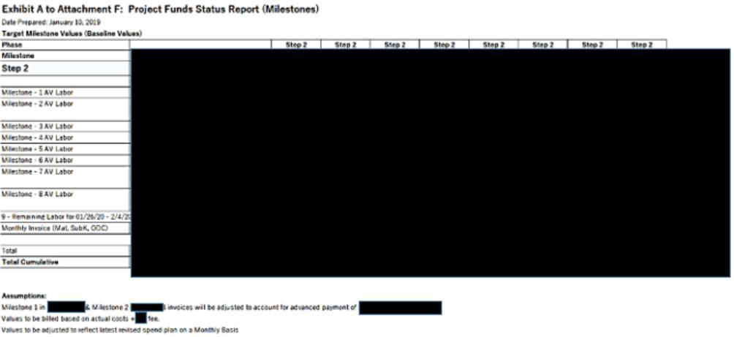

32

- Information has been omitted pursuant to Item 601(b)(2) of Regulation S-K. = [***]

3. Estimate at Completion on March 4,2019
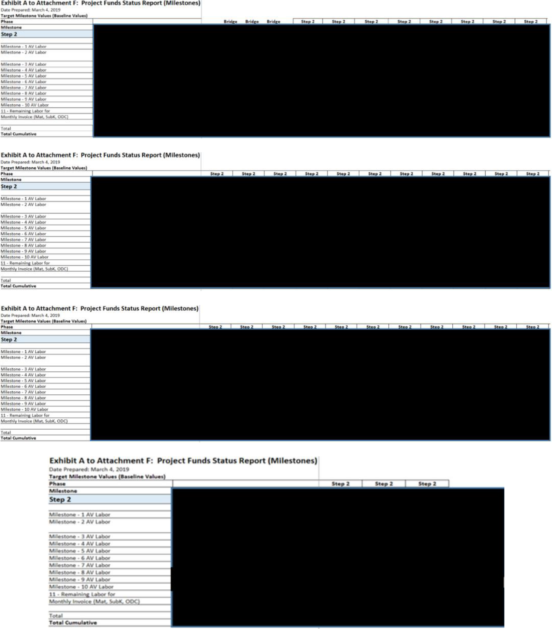

33

- Information has been omitted pursuant to Item 601(b)(2) of Regulation S-K. = [***]

4. Estimate at Completion on September 2019
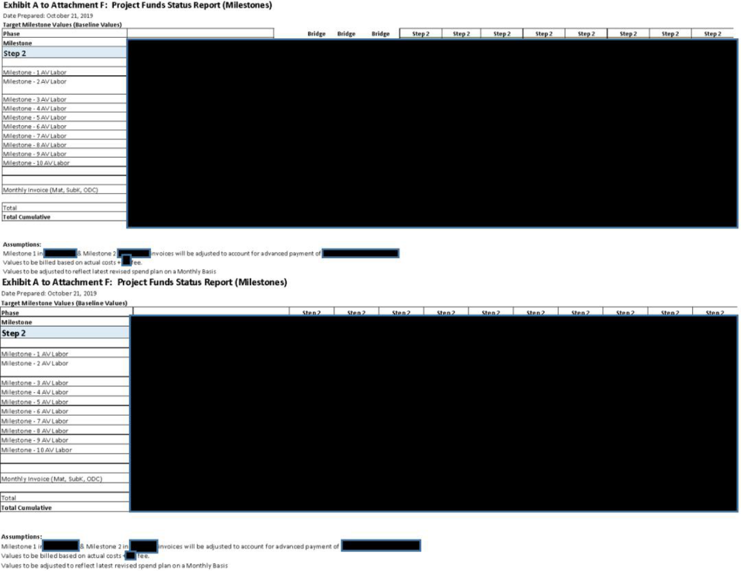

34

- Information has been omitted pursuant to Item 601(b)(2) of Regulation S-K. = [***]

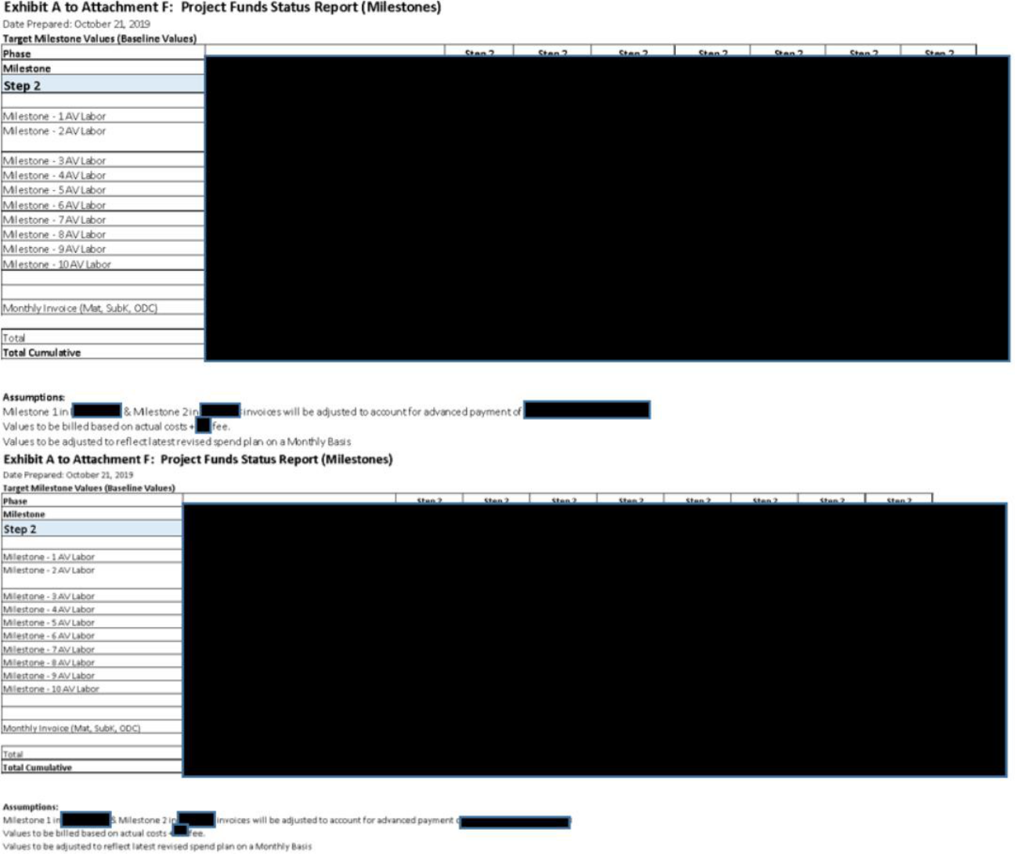

5. Estimate at Completion on April 2020
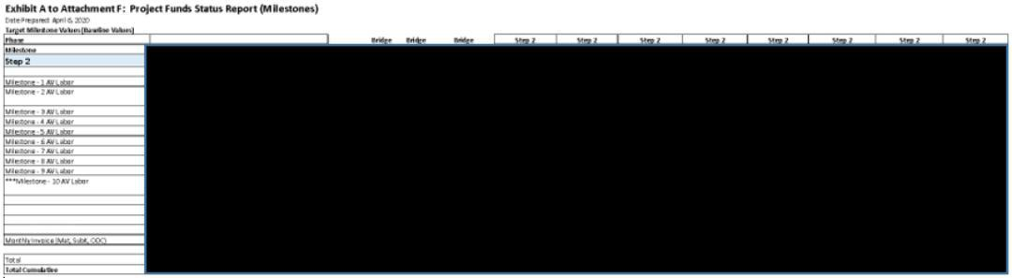

35

- Information has been omitted pursuant to Item 601(b)(2) of Regulation S-K. = [***]

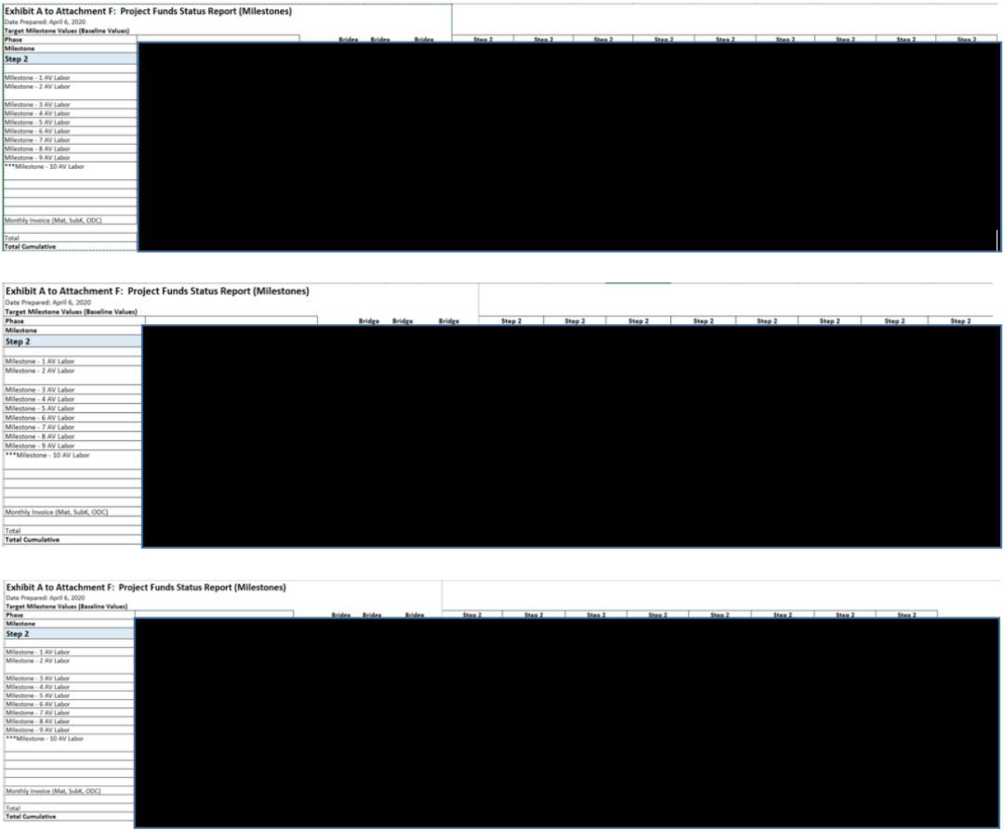

6. Estimate at Completion on July 2020
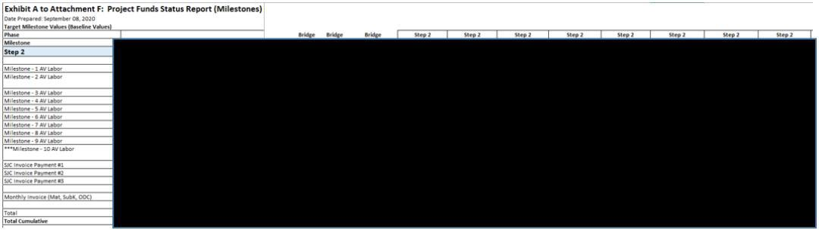

36

- Information has been omitted pursuant to Item 601(b)(2) of Regulation S-K. = [***]

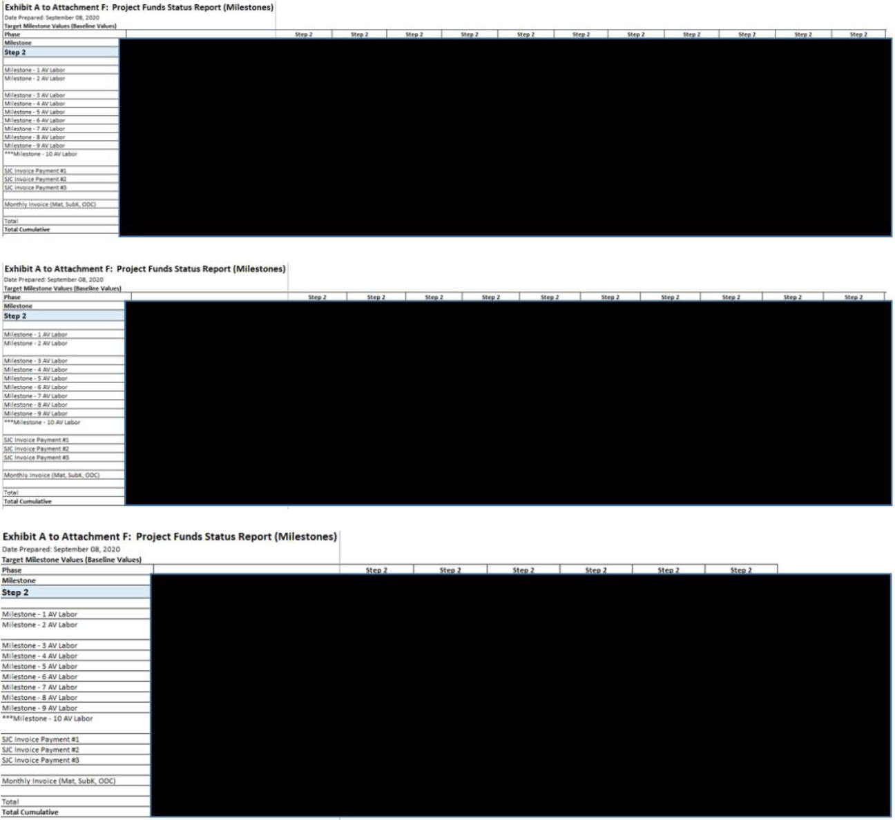

37

- Information has been omitted pursuant to Item 601(b)(2) of Regulation S-K. = [***]

6. Estimate at Completion on October 2020
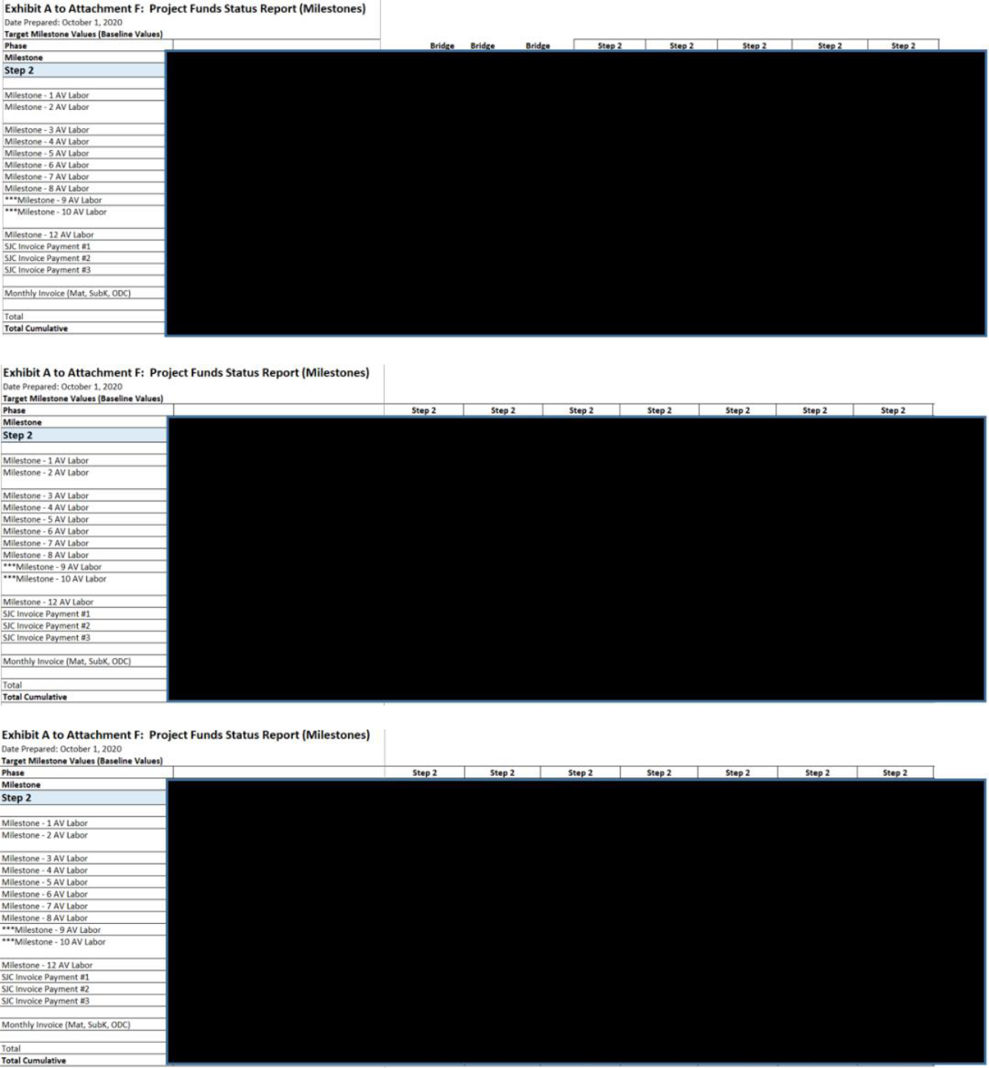

38

- Information has been omitted pursuant to Item 601(b)(2) of Regulation S-K. = [***]

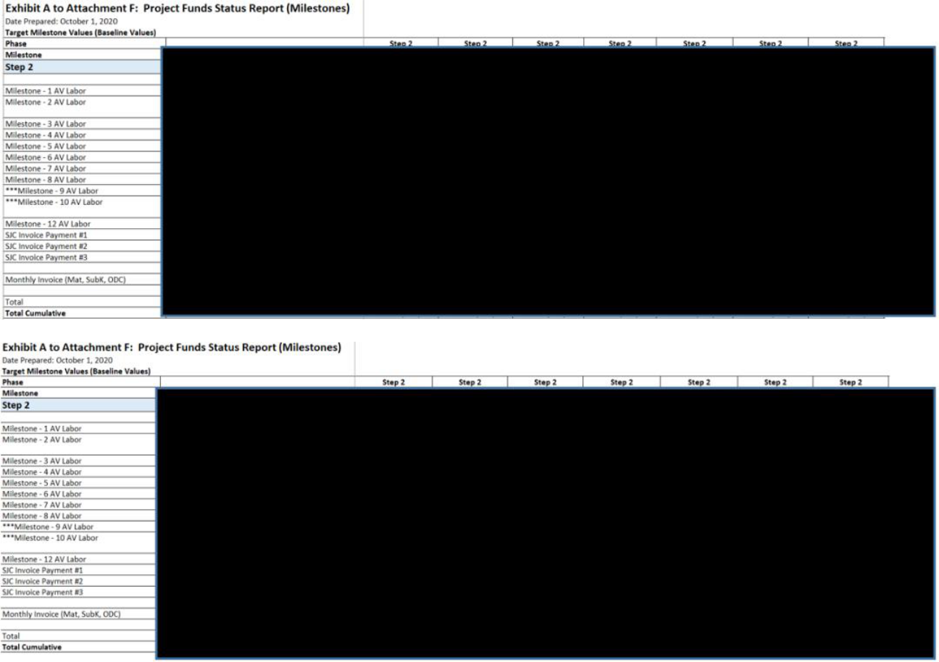

39

- Information has been omitted pursuant to Item 601(b)(2) of Regulation S-K. = [***]

Exhibit B to Attachment F – Monthly Status Report (Example)


AeroVironment Inc.

980 Enchanted Way

Simi Valley, California 93065 – U.S.A.

Telephone 1(805) 581-2187 – FAX 1(805) 584-6922

40

- Information has been omitted pursuant to Item 601(b)(2) of Regulation S-K. = [***]

Approvals:

41

- Information has been omitted pursuant to Item 601(b)(2) of Regulation S-K. = [***]

REVISION HISTORY


REV | EDIT DATE AUTHOR | DESCRIPTION
- MM/DD/YYYY

42

- Information has been omitted pursuant to Item 601(b)(2) of Regulation S-K. = [***]

CERTAIN IMMATERIAL PROVISIONS OF THIS DOCUMENT THAT WOULD LIKELY CAUSE COMPETITIVE HARM TO THE REGISTRANT IF PUBLICLY DISCLOSED (INDICATED BY AN ASTERISK [***]) HAVE BEEN OMITTED PURSUANT TO ITEM 601(b)(2) OF REGULATION S-K. A COPY OF THE UNREDACTED DOCUMENT WILL BE FURNISHED TO THE SECURITIES AND EXCHANGE COMMISSION UPON REQUEST.

TABLE OF CONTENTS
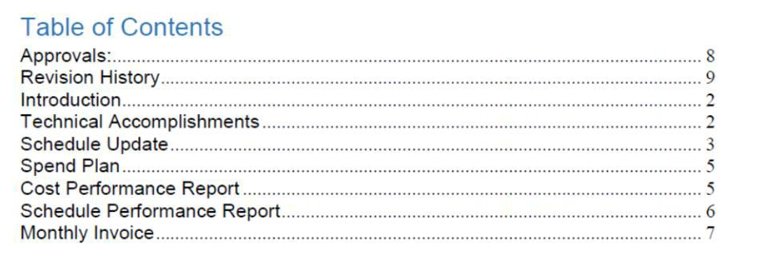

43

- Information has been omitted pursuant to Item 601(b)(2) of Regulation S-K. = [***]

INTRODUCTION

<<HIGH LEVEL PROGRAM OVERVIEW>>

<<STOPLIGHT CHART>>
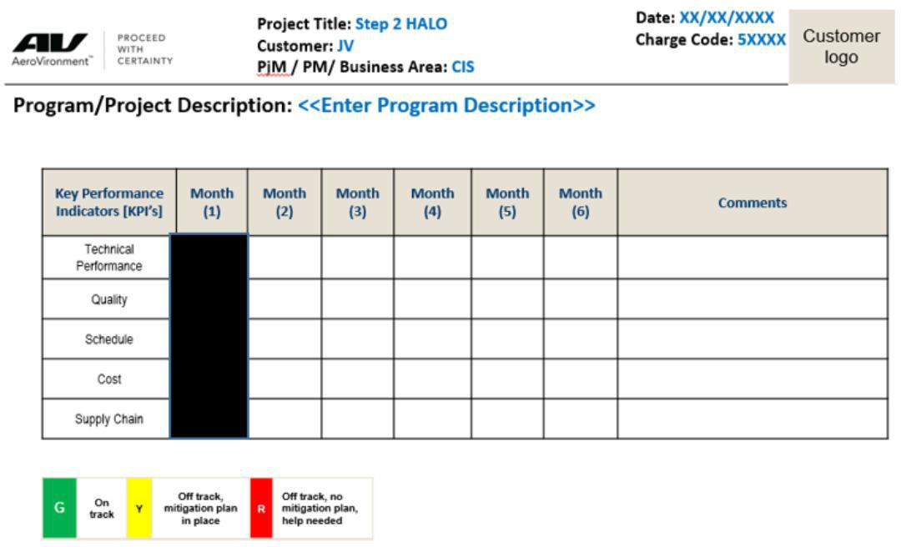

TECHNICAL ACCOMPLISHMENTS

What efforts were started this period?

<<Description of work started and performed during the reporting month>>

Task 5
Task 6
Task 7
Task …X

What efforts were completed this period?

<<Description of work completed and performed during the reporting month>>

Task 1
Task 2
Task 3
Task 4

44

- Information has been omitted pursuant to Item 601(b)(2) of Regulation S-K. = [***]

Key Subcontract Status:

Subcontractor A:

Subcontractor B:

Subcontractor C:

SCHEDULE UPDATE

Integrated Master Schedule Update <<EXAMPLE>>


Milestone Status Update

REFERENCE TO ATTACHMENT H

45

- Information has been omitted pursuant to Item 601(b)(2) of Regulation S-K. = [***]

SPEND PLAN

Spend Plan Update
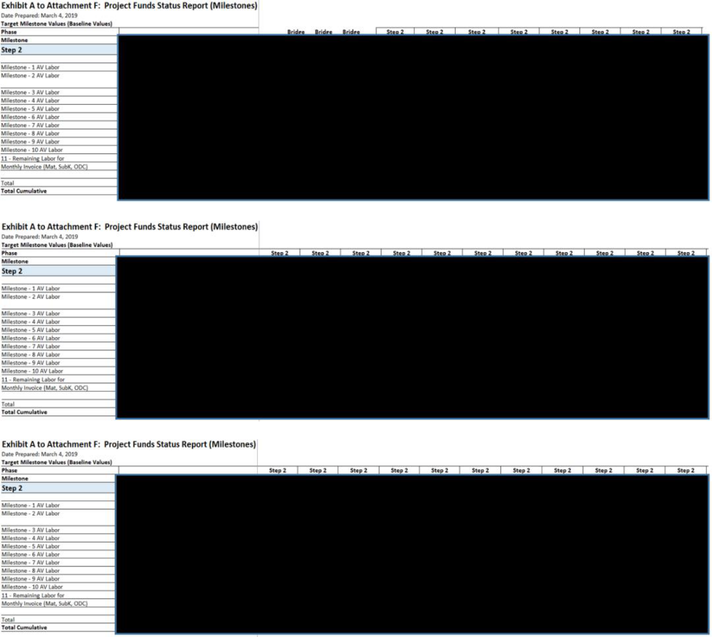

46

- Information has been omitted pursuant to Item 601(b)(2) of Regulation S-K. = [***]

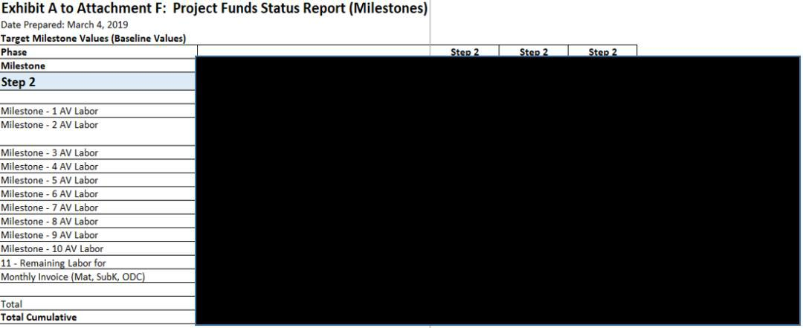

COST PERFORMANCE REPORT

Cost Performance Update
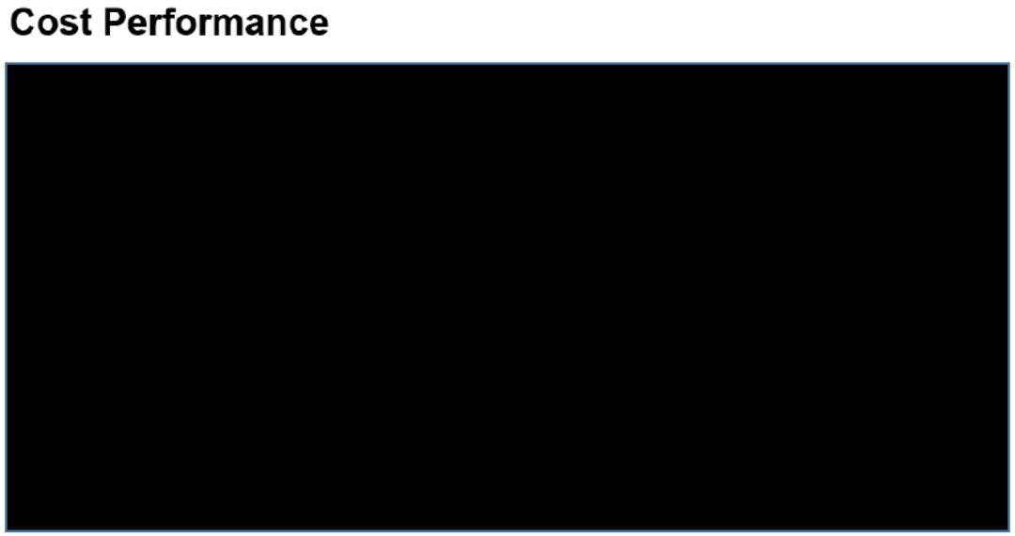

SCHEDULE PERFORMANCE REPORT

<<Schedule Performance Report>>

- Critical Path Analysis

47

- Information has been omitted pursuant to Item 601(b)(2) of Regulation S-K. = [***]

48

- Information has been omitted pursuant to Item 601(b)(2) of Regulation S-K. = [***]

- Schedule Performance Index (if applicable)

- Near term upcoming milestones (30 – 60 days ) o Milestone 1 =

o Milestone 2 = o Milestone X =

MONTHLY INVOICE – (NON-LABOR)


49

- Information has been omitted pursuant to Item 601(b)(2) of Regulation S-K. = [***]

Exhibit C to Attachment F

50

- Information has been omitted pursuant to Item 601(b)(2) of Regulation S-K. = [***]

51

- Information has been omitted pursuant to Item 601(b)(2) of Regulation S-K. = [***]

52

- Information has been omitted pursuant to Item 601(b)(2) of Regulation S-K. = [***]

ATTACHMENT H

PROJECT MILESTONE

(This Attachment H is revised in its entirety by the Amendment No. 13 to the DDA)

# | Milestone |  |  | Criteria | Date
1 | [***] |  |  |  | [***]
 | [***] |  |  |  | [***]
 | [***] |  | · | [***] | [***]
2 | [***] |  |  |  | [***]
 | [***] |  |  |  | [***]
 | [***] |  | · | [***] | [***]
3 | [***] |  |  |  | [***]
 | [***] |  |  |  | [***]
 | [***] |  | · | [***] | [***]
4 | [***] |  |  |  | [***]
 | [***] |  |  |  | [***]
 | [***] |  | · | [***] | [***]
5 | [***] |  |  |  | [***]
 | [***] |  |  |  | [***]
 | [***] |  | · | [***] | [***]
6 | [***] |  |  |  | [***]
 | [***] |  |  |  | [***]
 | [***] |  | [***] |  | [***]
7 | [***] |  |  |  | [***]
 | [***] |  |  |  | [***]
 | [***] |  | [***] |  | [***]
8 | [***] |  |  |  | [***]
 | [***] |  |  |  | [***]
 | [***] |  | [***] |  | [***]
9 | [***] |  |  |  | [***]
 | [***] |  |  |  | [***]
 | [***] |  | · | [***] | [***]
10 | [***] |  |  |  | [***]
 | [***] |  |  |  | [***]
 | [***] |  | [***] |  | [***]

53

- Information has been omitted pursuant to Item 601(b)(2) of Regulation S-K. = [***]

11 | [***] |  | [***]
 | [***] |  | [***]
 | [***] | [***] | [***]
12 | [***] |  | [***]
 | [***] |  | [***]
 | [***] | [***] | [***]

54

- Information has been omitted pursuant to Item 601(b)(2) of Regulation S-K. = [***]

Exhibit 31.1

Certification of Principal Executive Officer

Pursuant to Rule 13a-14(a)/15d-14(a) of the Securities Exchange Act of 1934

I, Wahid Nawabi, certify that:

- I have reviewed this quarterly report on Form 10-Q of AeroVironment, Inc.;

- Based on my knowledge, this report does not contain any untrue statement of a material fact or omit to state a material fact necessary to make the statements made, in light of the circumstances under which such statements were made, not misleading with respect to the period covered by this report;

- Based on my knowledge, the financial statements, and other financial information included in this report, fairly present in all material respects the financial condition, results of operations and cash flows of the registrant as of, and for, the periods presented in this report;

- The registrant’s other certifying officer and I are responsible for establishing and maintaining disclosure controls and procedures (as defined in Exchange Act Rules 13a-15(e) and 15d-15(e)) and internal control over financial reporting (as defined in Exchange Act Rules 13a-15(f) and 15d-15(f)) for the registrant and have:

  - Designed such disclosure controls and procedures, or caused such disclosure controls and procedures to be designed under our supervision, to ensure that material information relating to the registrant, including its consolidated subsidiaries, is made known to us by others within those entities, particularly during the period in which this report is being prepared;

  - Designed such internal control over financial reporting, or caused such internal control over financial reporting to be designed under our supervision, to provide reasonable assurance regarding the reliability of financial reporting and the preparation of financial statements for external purposes in accordance with generally accepted accounting principles;

  - Evaluated the effectiveness of the registrant’s disclosure controls and procedures and presented in this report our conclusions about the effectiveness of the disclosure controls and procedures, as of the end of the period covered by this report based on such evaluation; and

  - Disclosed in this report any change in the registrant’s internal control over financial reporting that occurred during the registrant’s most recent fiscal quarter (the registrant’s fourth fiscal quarter in the case of an annual report) that has materially affected, or is reasonably likely to materially affect, the registrant’s internal control over financial reporting; and

- The registrant’s other certifying officer and I have disclosed, based on our most recent evaluation of internal control over financial reporting, to the registrant’s auditors and the audit committee of the registrant’s board of directors (or persons performing the equivalent functions):

  - All significant deficiencies and material weaknesses in the design or operation of internal control over financial reporting which are reasonably likely to adversely affect the registrant’s ability to record, process, summarize and report financial information; and

  - Any fraud, whether or not material, that involves management or other employees who have a significant role in the registrant’s internal control over financial reporting.

Date: December 8, 2020

/s/ Wahid Nawabi

Wahid Nawabi
President and Chief Executive Officer

Exhibit 31.2

Certification of Principal Financial Officer

Pursuant to Rule 13a-14(a)/15d-14(a) of the Securities Exchange Act of 1934

I, Kevin P. McDonnell, certify that:

- I have reviewed this quarterly report on Form 10-Q of AeroVironment, Inc.;

- Based on my knowledge, this report does not contain any untrue statement of a material fact or omit to state a material fact necessary to make the statements made, in light of the circumstances under which such statements were made, not misleading with respect to the period covered by this report;

- Based on my knowledge, the financial statements, and other financial information included in this report, fairly present in all material respects the financial condition, results of operations and cash flows of the registrant as of, and for, the periods presented in this report;

- The registrant’s other certifying officer and I are responsible for establishing and maintaining disclosure controls and procedures (as defined in Exchange Act Rules 13a-15(e) and 15d-15(e)) and internal control over financial reporting (as defined in Exchange Act Rules 13a-15(f) and 15d-15(f)) for the registrant and have:

  - Designed such disclosure controls and procedures, or caused such disclosure controls and procedures to be designed under our supervision, to ensure that material information relating to the registrant, including its consolidated subsidiaries, is made known to us by others within those entities, particularly during the period in which this report is being prepared;

  - Designed such internal control over financial reporting, or caused such internal control over financial reporting to be designed under our supervision, to provide reasonable assurance regarding the reliability of financial reporting and the preparation of financial statements for external purposes in accordance with generally accepted accounting principles;

  - Evaluated the effectiveness of the registrant’s disclosure controls and procedures and presented in this report our conclusions about the effectiveness of the disclosure controls and procedures, as of the end of the period covered by this report based on such evaluation; and

  - Disclosed in this report any change in the registrant’s internal control over financial reporting that occurred during the registrant’s most recent fiscal quarter (the registrant’s fourth fiscal quarter in the case of an annual report) that has materially affected, or is reasonably likely to materially affect, the registrant’s internal control over financial reporting; and

- The registrant’s other certifying officer and I have disclosed, based on our most recent evaluation of internal control over financial reporting, to the registrant’s auditors and the audit committee of the registrant’s board of directors (or persons performing the equivalent functions):

  - All significant deficiencies and material weaknesses in the design or operation of internal control over financial reporting which are reasonably likely to adversely affect the registrant’s ability to record, process, summarize and report financial information; and

  - Any fraud, whether or not material, that involves management or other employees who have a significant role in the registrant’s internal control over financial reporting.

Date: December 8, 2020

/s/ Kevin P. McDonnell

Kevin P. McDonnell
Senior Vice President and Chief Financial Officer

Exhibit 32

Certification

Pursuant to Section 906 of the Sarbanes-Oxley Act of 2002
(Subsections (a) and (b) of Section 1350, Chapter 63 of Title 18, United States Code)

Pursuant to Section 906 of the Sarbanes-Oxley Act of 2002 (Subsections (a) and (b) of Section 1350, Chapter 63 of Title 18, United States Code) (the “Act”), each of the undersigned officers of AeroVironment, Inc., a Delaware corporation (the “Company”), does hereby certify, to each such officer’s knowledge, that:

The Quarterly Report on Form 10-Q for the quarter ended October 31, 2020 (the “Periodic Report”) of the Company fully complies with the requirements of Section 13(a) or 15(d) of the Securities Exchange Act of 1934 (15 U.S.C. 78m or 78o(d)) and information contained in the Periodic Report fairly presents, in all material respects, the financial condition and results of operations of the Company.

/s/ Wahid Nawabi

Wahid Nawabi
President and Chief Executive Officer

/s/ Kevin P. McDonnell

Kevin P. McDonnell
Senior Vice President and Chief Financial Officer

Dated: December 8, 2020

A signed original of this written statement required by Section 906 has been provided to the Company and will be retained by the Company and furnished to the Securities and Exchange Commission or its staff upon request.

1

