Table of Contents

UNITED STATES

SECURITIES AND EXCHANGE COMMISSION
WASHINGTON, D.C. 20549

FORM 10-Q

- QUARTERLY REPORT PURSUANT TO SECTION 13 OR 15(d) OF THE SECURITIES EXCHANGE ACT OF 1934.

For the quarterly period ended January 25, 2020

OR

- TRANSITION REPORT PURSUANT TO SECTION 13 OR 15(d) OF THE SECURITIES EXCHANGE ACT OF 1934

For the transition period from to

Commission File Number: 001-33261

AEROVIRONMENT, INC.

(Exact name of registrant as specified in its charter)

Delaware | 95-2705790
(State or other jurisdiction of incorporation or organization) | (I.R.S. Employer Identification No.)
900 Innovators Way
Simi Valley, California | 93065
(Address of principal executive offices) | (Zip Code)

(805) 520-8350

(Registrant’s telephone number, including area code)

N/A

(Former name, former address and former fiscal year, if changed since last report)

Securities registered pursuant to Section 12(b) of the Act:

Title of each class |  | Trading Symbol(s) | Name of each exchange on which registered
Common Stock, par value $0.0001 per share |  | AVAV | The NASDAQ Stock Market LLC

Indicate by check mark whether the registrant (1) has filed all reports required to be filed by Section 13 or 15(d) of the Securities Exchange Act of 1934 during the preceding 12 months (or for such shorter period that the registrant was required to file such reports), and (2) has been subject to such filing requirements for the past 90 days.

Yes ☒ No ☐

Indicate by check mark whether the registrant has submitted electronically, every Interactive Data File required to be submitted pursuant to Rule 405 of Regulation S-T (§232.405 of this chapter) during the preceding 12 months (or for such shorter period that the registrant was required to submit such files). Yes ☒ No ☐

Indicate by check mark whether the registrant is a large accelerated filer, an accelerated filer, a non-accelerated filer, a smaller reporting company, or an emerging growth company. See the definitions of “large accelerated filer,” “accelerated filer,” “smaller reporting company,” and “emerging growth company” in Rule 12b-2 of the Exchange Act.

Large accelerated filer ☒

Accelerated filer ☐

Non-accelerated filer ☐

Smaller reporting company ☐

Emerging growth company ☐

If an emerging growth company, indicate by check mark if the registrant has elected not to use the extended transition period for complying with any new or revised financial accounting standards provided pursuant to Section 13(a) of the Exchange Act. ☐

Indicate by check mark whether the registrant is a shell company (as defined in Rule 12b-2 of the Exchange Act). Yes ☐ No ☒ As of February 25, 2020, the number of shares outstanding of the registrant’s common stock, $0.0001 par value, was 23,995,109.

Table of Contents

 |  |  |  |  |  |  |  |  |  |  |  |  |  |  | AeroVironment, Inc.
 |  |  |  |  |  |  |  |  |  |  |  |  |  |  | Table of Contents
Item 1. |  |  |  | Financial Statements:
 |  |  |  |  |  | Consolidated Balance Sheets as of January 25, 2020 (Unaudited) and April 30, 2019 |  |  |  |  |  |  |  |  |  |  |  |  |  |  |  |  |  |  |  | 3
 |  |  |  |  |  | Consolidated Statements of Operations for the three and nine months ended January 25, 2020 |  |  |  |  |  |  |  |  |  |  |  |  |  |  |  |  |  |  |  | 4
 |  |  |  |  |  |  | (Unaudited) and January 26, 2019 (Unaudited)
 |  |  |  |  |  | Consolidated Statements of Comprehensive (Loss) Income for the three and nine months ended |  |  |  |  |  |  |  |  |  |  |  |  |  |  |  |  |  |  |  | 5
 |  |  |  |  |  |  | January 25, 2020 (Unaudited) and January 26, 2019 (Unaudited)
 |  |  |  |  |  | Consolidated Statements of Stockholders’ Equity for the three and nine months ended January 25, 2020 |  |  |  |  |  |  |  |  |  |  |  |  |  |  |  |  |  |  |  | 6
 |  |  |  |  |  |  | (Unaudited) and January 26, 2019 (Unaudited)
 |  |  |  |  |  | Consolidated Statements of Cash Flows for the nine months ended January 25, 2020 (Unaudited) and |  |  |  |  |  |  |  |  |  |  |  |  |  |  |  |  |  |  |  | 8
 |  |  |  |  |  |  | January 26, 2019 (Unaudited)
 |  |  |  | Notes to Consolidated Financial Statements (Unaudited) |  |  |  |  |  |  |  |  |  |  |  |  |  |  |  |  |  |  |  |  |  | 9
Item 2. |  |  |  | Management’s Discussion and Analysis of Financial Condition and Results of Operations |  |  |  |  |  |  |  |  |  |  |  |  |  |  |  |  |  |  |  |  |  | 30
Item 3. |  |  |  | Quantitative and Qualitative Disclosures About Market Risk |  |  |  |  |  |  |  |  |  |  |  |  |  |  |  |  |  |  |  |  |  | 38
Item 4. |  |  |  | Controls and Procedures |  |  |  |  |  |  |  |  |  |  |  |  |  |  |  |  |  |  |  |  |  | 38
PART II. OTHER INFORMATION
Item 1. |  |  |  | Legal Proceedings |  |  |  |  |  |  |  |  |  |  |  |  |  |  |  |  |  |  |  |  |  | 39
Item 1A. |  |  |  | Risk Factors |  |  |  |  |  |  |  |  |  |  |  |  |  |  |  |  |  |  |  |  |  | 39
Item 2. |  |  |  | Unregistered Sales of Equity Securities and Use of Proceeds |  |  |  |  |  |  |  |  |  |  |  |  |  |  |  |  |  |  |  |  |  | 41
Item 3. |  |  |  | Defaults Upon Senior Securities |  |  |  |  |  |  |  |  |  |  |  |  |  |  |  |  |  |  |  |  |  | 41
Item 4. |  |  |  | Mine Safety Disclosures |  |  |  |  |  |  |  |  |  |  |  |  |  |  |  |  |  |  |  |  |  | 41
Item 5. |  |  |  | Other Information |  |  |  |  |  |  |  |  |  |  |  |  |  |  |  |  |  |  |  |  |  | 41
Item 6. |  |  |  | Exhibits |  |  |  |  |  |  |  |  |  |  |  |  |  |  |  |  |  |  |  |  |  | 42
Signatures |  |  |  |  |  |  |  |  |  |  |  |  |  |  |  |  |  |  |  |  |  |  |  |  |  | 43

2

Table of Contents

PART I. FINANCIAL INFORMATION

ITEM 1. FINANCIAL STATEMENTS

AeroVironment, Inc.

Consolidated Balance Sheets

(In thousands except share and per share data)

 |  |  | January 25, |  |  |  | April 30,
 |  |  | 2020 |  |  |  | 2019
 |  |  | (Unaudited)
Assets
Current assets:
Cash and cash equivalents | $ |  | 131,496 |  |  | $ | 172,708
Short-term investments |  |  | 148,502 |  |  |  | 150,487
Accounts receivable, net of allowance for doubtful accounts of $1,039 at January 25, 2020 and
$1,041 at April 30, 2019 |  |  | 27,936 |  |  |  | 31,051
Unbilled receivables and retentions (inclusive of related party unbilled receivables of $28,849 at
January 25, 2020 and $9,028 at April 30, 2019) |  |  | 77,411 |  |  |  | 53,047
Inventories |  |  | 65,156 |  |  |  | 54,056
Prepaid expenses and other current assets |  |  | 6,833 |  |  |  | 7,418
Income taxes receivable |  |  |  | — |  |  | 821
Total current assets |  |  |  | 457,334 |  |  | 469,588
Long-term investments |  |  | 26,409 |  |  |  | 9,386
Property and equipment, net |  |  | 19,877 |  |  |  | 16,905
Operating lease right-of-use assets |  |  | 9,472 |  |  |  | —
Deferred income taxes |  |  | 8,296 |  |  |  | 6,685
Intangibles, net |  |  | 14,357 |  |  |  | 459
Goodwill |  |  | 6,340 |  |  |  | —
Other assets |  |  | 16,995 |  |  |  | 5,821
Total assets |  | $ | 559,080 |  |  | $ | 508,844
Liabilities and stockholders’ equity
Current liabilities:
Accounts payable | $ |  | 14,269 |  |  | $ | 15,972
Wages and related accruals |  |  | 17,636 |  |  |  | 18,507
Customer advances |  |  | 10,633 |  |  |  | 2,962
Current operating lease liabilities |  |  | 2,083 |  |  |  | —
Income taxes payable |  |  | 2,809 |  |  |  | —
Other current liabilities |  |  | 13,046 |  |  |  | 7,425
Total current liabilities |  |  | 60,476 |  |  |  | 44,866
Deferred rent |  |  |  | — |  |  | 1,173
Non-current operating lease liabilities |  |  | 7,556 |  |  |  | —
Other non-current liabilities |  |  | 250 |  |  |  | 150
Deferred tax liability |  |  | 29 |  |  |  | 29
Liability for uncertain tax positions |  |  | 51 |  |  |  | 51
Commitments and contingencies
Stockholders’ equity:
Preferred stock, $0.0001 par value:
Authorized shares—10,000,000; none issued or outstanding at January 25, 2020 and
April 30, 2019 |  |  |  | — |  |  | —
Common stock, $0.0001 par value:
Authorized shares—100,000,000
Issued and outstanding shares—23,995,109 shares at January 25, 2020 and 23,946,293 shares at
April 30, 2019 |  |  | 2 |  |  |  | 2
Additional paid-in capital |  |  | 180,051 |  |  |  | 176,216
Accumulated other comprehensive loss |  |  | 69 |  |  |  | 2
Retained earnings |  |  | 310,619 |  |  |  | 286,351
Total AeroVironment stockholders’ equity |  |  | 490,741 |  |  |  | 462,571
Noncontrolling interest |  |  | (23) |  |  |  | 4
Total equity |  |  | 490,718 |  |  |  | 462,575
Total liabilities and stockholders’ equity |  | $ | 559,080 |  |  | $ | 508,844

See accompanying notes to consolidated financial statements (unaudited).

3

Table of Contents

AeroVironment, Inc.

Consolidated Statements of Operations (Unaudited)

(In thousands except share and per share data)

 |  | Three Months Ended |  |  |  |  |  |  | Nine Months Ended
 |  | January 25, |  |  |  | January 26, |  |  | January 25, |  |  | January 26,
 |  | 2020 |  |  |  | 2019 |  |  | 2020 |  |  | 2019
Revenue:
Product sales | $ | 36,432 |  | $ |  | 50,024 |  | $ | 159,657 |  | $ | 152,393
Contract services (inclusive of related party revenue of $11,762 and
$13,586 for the three months ended January 25, 2020 and January
26, 2019, respectively; and $37,491 and $37,981 for the nine
months ended January 25, 2020 and January 26, 2019, respectively) |  | 25,459 |  |  |  | 25,298 |  |  | 72,416 |  |  | 73,951
 |  | 61,891 |  |  |  | 75,322 |  |  | 232,073 |  |  | 226,344
Cost of sales:
Product sales |  | 21,034 |  |  |  | 26,780 |  |  | 82,244 |  |  | 83,158
Contract services |  | 17,361 |  |  |  | 18,150 |  |  | 49,895 |  |  | 51,806
 |  | 38,395 |  |  |  | 44,930 |  |  | 132,139 |  |  | 134,964
Gross margin:
Product sales |  | 15,398 |  |  |  | 23,244 |  |  | 77,413 |  |  | 69,235
Contract services |  | 8,098 |  |  |  | 7,148 |  |  | 22,521 |  |  | 22,145
 |  | 23,496 |  |  |  | 30,392 |  |  | 99,934 |  |  | 91,380
Selling, general and administrative |  | 13,223 |  |  |  | 14,464 |  |  | 43,146 |  |  | 40,066
Research and development |  | 11,381 |  |  |  | 8,087 |  |  | 30,948 |  |  | 22,631
(Loss) income from continuing operations |  | (1,108) |  |  |  | 7,841 |  |  | 25,840 |  |  | 28,683
Other income:
Interest income, net |  | 1,122 |  |  |  | 1,272 |  |  | 3,717 |  |  | 3,246
Other income, net |  | 120 |  |  |  | 962 |  |  | 632 |  |  | 10,641
Income from continuing operations before income taxes |  | 134 |  |  |  | 10,075 |  |  | 30,189 |  |  | 42,570
(Benefit from) provision for income taxes |  | (38) |  |  |  | 946 |  |  | 3,203 |  |  | 4,724
Equity method investment loss, net of tax |  | (1,200) |  |  |  | (717) |  |  | (3,410) |  |  | (2,071)
Net (loss) income from continuing operations |  | (1,028) |  |  |  | 8,412 |  |  | 23,576 |  |  | 35,775
Discontinued operations:
Gain on sale of business, net of tax expense of $2,463 |  | — |  |  |  | — |  |  | — |  |  | 8,452
Loss from discontinued operations, net of tax |  | — |  |  |  | (62) |  |  | — |  |  | (2,511)
Net (loss) income from discontinued operations |  | — |  |  |  | (62) |  |  | — |  |  | 5,941
Net (loss) income |  | (1,028) |  |  |  | 8,350 |  |  | 23,576 |  |  | 41,716
Net loss attributable to noncontrolling interest |  | 20 |  |  |  | 19 |  |  | 27 |  |  | 40
Net (loss) income attributable to AeroVironment | $ | (1,008) |  |  | $ | 8,369 |  | $ | 23,603 |  | $ | 41,756
Net (loss) income per share attributable to AeroVironment—Basic
Continuing operations | $ | (0.04) |  | $ |  | 0.35 |  | $ | 0.99 |  | $ | 1.52
Discontinued operations |  | — |  |  |  | — |  |  | — |  |  | 0.25
Net (loss) income per share attributable to AeroVironment—Basic | $ | (0.04) |  |  | $ | 0.35 |  | $ | 0.99 |  | $ | 1.77
Net (loss) income per share attributable to AeroVironment—Diluted
Continuing operations | $ | (0.04) |  | $ |  | 0.35 |  | $ | 0.98 |  | $ | 1.49
Discontinued operations |  | — |  |  |  | — |  |  | — |  |  | 0.25
Net (loss) income per share attributable to AeroVironment— | $ | (0.04) |  | $ |  | 0.35 |  | $ | 0.98 |  | $ | 1.74
Diluted |  |  |  |  |  |  |  | $ | 0.98 |  | $ | 1.74
Weighted-average shares outstanding:
Basic |  | 23,821,145 |  |  |  | 23,687,672 |  |  | 23,790,788 |  |  | 23,643,866
Diluted |  | 23,821,145 |  |  |  | 24,081,819 |  |  | 24,076,195 |  |  | 24,064,008

See accompanying notes to consolidated financial statements (unaudited).

4

Table of Contents

AeroVironment, Inc.

Consolidated Statements of Comprehensive (Loss) Income (Unaudited)

(In thousands)

 |  |  | Three Months Ended |  |  |  |  |  |  | Nine Months Ended
 |  | January 25, |  |  | January 26, |  |  |  | January 25, |  |  | January 26,
 |  |  | 2020 |  |  | 2019 |  |  |  | 2020 |  |  | 2019
Net (loss) income |  | $ | (1,028) |  | $ | 8,350 |  |  | $ | 23,576 |  | $ | 41,716
Other comprehensive (loss) income:
Change in foreign currency translation adjustments |  |  | (112) |  |  | (1) |  |  |  | 67 |  |  | (32)
Unrealized gain on investments, net of deferred tax expense of $51 |  |  | — |  |  | — |  |  |  | — |  |  | 57
Total comprehensive (loss) income |  |  | (1,140) |  | $ | 8,349 |  |  |  | 23,643 |  |  | 41,741
Net loss attributable to noncontrolling interest |  |  | 20 |  |  | 19 |  |  |  | 27 |  |  | 40
Comprehensive (loss) income attributable to AeroVironment |  | $ | (1,120) |  | $ | 8,368 |  |  | $ | 23,670 |  | $ | 41,781

See accompanying notes to consolidated financial statements (unaudited).

5

Table of Contents

AeroVironment, Inc.

Consolidated Statements of Stockholders’ Equity

For the nine months ended January 25, 2020 and January 26, 2019 (Unaudited)

(In thousands except share data)

 |  |  |  |  |  |  |  |  |  |  |  | Accumulated
 |  |  |  |  |  | Additional |  |  |  |  |  | Other |  | Total |  | Non-
 | Common Stock |  |  |  |  | Paid-In |  |  | Retained |  | Comprehensive AeroVironment Controlling
 | Shares |  | Amount |  |  | Capital |  |  | Earnings |  |  | Loss |  | Equity |  | Interest |  |  |  | Total
Balance at April 30, 2019 | 23,946,293 |  | $ | 2 |  | $ 176,216 |  | $ | 286,351 |  | $ | 2 | $ | 462,571 | $ | 4 |  |  | $ | 462,575
Adoption of ASU 2018-09 | — |  |  | — |  | — |  |  | 665 |  |  | — |  | 665 |  | — |  |  |  | 665
Net income (loss) | — |  |  | — |  | — |  |  | 23,603 |  |  | — |  | 23,603 |  | (27) |  |  |  | 23,576
Foreign currency translation | — |  |  | — |  | — |  |  | — |  |  | 67 |  | 67 |  | — |  |  |  | 67
Stock options exercised | 3,000 |  |  | — | 93 |  |  |  | — |  |  | — |  | 93 |  | — |  |  |  | 93
Restricted stock awards | 74,892 |  |  | — |  | — |  |  | — |  |  | — |  | — |  | — |  |  |  | —
Restricted stock awards forfeited | (11,769) |  |  | — |  | — |  |  | — |  |  | — |  | — |  | — |  |  |  | —
Tax withholding payment related to net
share settlement of equity awards | (17,307) |  |  | — | (1,009) |  |  |  | — |  |  | — |  | (1,009) |  | — |  |  |  | (1,009)
Stock based compensation | — |  |  | — | 4,751 |  |  |  | — |  |  | — |  | 4,751 |  | — |  |  |  | 4,751
Balance at January 25, 2020 | 23,995,109 |  | $ | 2 |  | $ 180,051 |  | $ | 310,619 |  | $ | 69 | $ | 490,741 | $ | (23) |  |  | $ | 490,718
 |  |  |  |  |  |  |  |  |  |  |  | Accumulated
 |  |  |  |  |  | Additional |  |  |  |  |  | Other |  | Total |  | Non-
 | Common Stock |  |  |  |  | Paid-In |  |  | Retained |  | Comprehensive AeroVironment Controlling
 | Shares |  | Amount |  |  | Capital |  |  | Earnings |  |  | Loss |  | Equity |  | Interest |  |  |  | Total
Balance at April 30, 2018 | 23,908,736 | $ |  | 2 | $ 170,139 |  | $ |  | 238,913 | $ |  | (21)$ |  | 409,033 | $ | 23 |  | $ |  | 409,056
Net income (loss) | — |  |  | — |  | — |  |  | 41,756 |  |  | — |  | 41,756 |  | (40) |  |  |  | 41,716
Unrealized gain on investments | — |  |  | — |  | — |  |  | — |  |  | 57 |  | 57 |  | — |  |  |  | 57
Foreign currency translation | — |  |  | — |  | — |  |  | — |  |  | (32) |  | (32) |  | — |  |  |  | (32)
Stock options exercised | 12,725 |  |  | — | 71 |  |  |  | — |  |  | — |  | 71 |  | — |  |  |  | 71
Restricted stock awards | 39,823 |  |  | — |  | — |  |  | — |  |  | — |  | — |  | — |  |  |  | —
Restricted stock awards forfeited | (15,100) |  |  | — |  | — |  |  | — |  |  | — |  | — |  | — |  |  |  | —
Tax withholding payment related to net
share settlement of equity awards | (13,724) |  |  | — | (1,033) |  |  |  | — |  |  | — |  | (1,033) |  | — |  |  |  | (1,033)
Stock-based compensation | — |  |  | — |  | 5,714 |  |  | — |  |  | — |  | 5,714 |  | — |  |  |  | 5,714
Balance at January 26, 2019 | 23,932,460 | $ |  | 2 | $ 174,891 |  | $ |  | 280,669 | $ |  | 4 | $ | 455,566 | $ | (17) |  | $ |  | 455,549

See accompanying notes to consolidated financial statements (unaudited)

6

Table of Contents

AeroVironment, Inc.

Consolidated Statements of Stockholders’ Equity

For the three months ended January 25, 2020 and January 26, 2019 (Unaudited)

(In thousands except share data)

 |  |  |  |  |  |  |  |  |  |  |  | Accumulated
 |  |  |  |  |  | Additional |  |  |  |  |  | Other |  | Total |  | Non-
 | Common Stock |  |  |  |  | Paid-In |  |  | Retained |  | Comprehensive AeroVironment Controlling
 | Shares |  | Amount |  |  | Capital |  |  | Earnings |  |  | Loss |  | Equity |  | Interest |  |  |  | Total
Balance at October 26, 2019 | 23,990,616 |  | $ | 2 |  | $ 178,550 |  | $ | 311,627 |  | $ | 181 | $ | 490,360 | $ | (3) |  |  | $ | 490,357
Net loss | — |  |  | — |  | — |  |  | (1,008) |  |  | — |  | (1,008) |  | (20) |  |  |  | (1,028)
Foreign currency translation | — |  |  | — |  | — |  |  | — |  |  | (112) |  | (112) |  | — |  |  |  | (112)
Restricted stock awards | 9,200 |  |  | — |  | — |  |  | — |  |  | — |  | — |  | — |  |  |  | —
Restricted stock awards forfeited | (764) |  |  | — |  | — |  |  | — |  |  | — |  | — |  | — |  |  |  | —
Tax withholding payment related to net
share settlement of equity awards | (3,943) |  |  | — | (266) |  |  |  | — |  |  | — |  | (266) |  | — |  |  |  | (266)
Stock based compensation | — |  |  | — | 1,767 |  |  |  | — |  |  | — |  | 1,767 |  | — |  |  |  | 1,767
Balance at January 25, 2020 | 23,995,109 |  | $ | 2 |  | $ 180,051 |  | $ | 310,619 |  | $ | 69 | $ | 490,741 | $ | (23) |  |  | $ | 490,718
 |  |  |  |  |  |  |  |  |  |  |  | Accumulated
 |  |  |  |  |  | Additional |  |  |  |  |  | Other |  | Total |  | Non-
 | Common Stock |  |  |  |  | Paid-In |  |  | Retained |  | Comprehensive AeroVironment Controlling
 | Shares |  | Amount |  |  | Capital |  |  | Earnings |  |  | Loss |  | Equity |  | Interest |  |  |  | Total
Balance at October 27, 2018 | 23,928,373 |  | $ | 2 |  | $ 171,867 |  | $ | 272,300 |  | $ | 5 | $ | 444,174 | $ | 2 |  |  | $ | 444,176
Net income (loss) | — |  |  | — |  | — |  |  | 8,369 |  |  | — |  | 8,369 |  | (19) |  |  |  | 8,350
Foreign currency translation | — |  |  | — |  | — |  |  | — |  |  | (1) |  | (1) |  | — |  |  |  | (1)
Restricted stock awards | 5,377 |  |  | — |  | — |  |  | — |  |  | — |  | — |  | — |  |  |  | —
Restricted stock awards forfeited | (445) |  |  | — |  | — |  |  | — |  |  | — |  | — |  | — |  |  |  | —
Tax withholding payment related to net
share settlement of equity awards | (845) |  |  | — | (58) |  |  |  | — |  |  | — |  | (58) |  | — |  |  |  | (58)
Stock-based compensation | — |  |  | — | 3,082 |  |  |  | — |  |  | — |  | 3,082 |  | — |  |  |  | 3,082
Balance at January 26, 2019 | 23,932,460 |  | $ | 2 |  | $ 174,891 |  | $ | 280,669 |  | $ | 4 | $ | 455,566 | $ | (17) |  |  | $ | 455,549

See accompanying notes to consolidated financial statements (unaudited).

7

Table of Contents

AeroVironment, Inc.

Consolidated Statements of Cash Flows (Unaudited)

(In thousands)

 |  |  | Nine Months Ended
 |  |  | January 25, |  |  |  | January 26,
 |  |  | 2020 |  |  |  | 2019
Operating activities
Net income | $ |  | 23,576 |  | $ |  | 41,716
Gain on sale of business, net of tax |  |  | — |  |  |  | (8,452)
Loss from discontinued operations, net of tax |  |  | — |  |  |  | 2,511
Net income from continuing operations |  |  | 23,576 |  |  |  | 35,775
Adjustments to reconcile net income from continuing operations to cash provided by operating activities from
continuing operations:
Depreciation and amortization |  |  | 7,107 |  |  |  | 5,530
Loss from equity method investment |  |  | 3,410 |  |  |  | 2,071
Provision for doubtful accounts |  |  | (2) |  |  |  | (33)
Other non-cash gain, net |  |  | (719) |  |  |  | —
Non-cash lease expense |  |  | 3,453 |  |  |  | —
Gains on foreign currency transactions |  |  | — |  |  |  | (10)
Deferred income taxes |  |  | (946) |  |  |  | (1,214)
Stock-based compensation |  |  | 4,751 |  |  |  | 5,599
(Gain) loss on sale of property and equipment |  |  | (71) |  |  |  | 51
Amortization of debt securities |  |  | (1,291) |  |  |  | (941)
Changes in operating assets and liabilities, net of acquisitions:
Accounts receivable |  |  | 3,245 |  |  |  | 22,817
Unbilled receivables and retentions |  |  | (24,364) |  |  |  | (34,760)
Inventories |  |  | (10,766) |  |  |  | (12,954)
Income tax receivable |  |  | 821 |  |  |  | —
Prepaid expenses and other assets |  |  | 216 |  |  |  | (1,791)
Accounts payable |  |  | (1,301) |  |  |  | (10,645)
Other liabilities |  |  | 7,947 |  |  |  | (2,598)
Net cash provided by operating activities of continuing operations |  |  | 15,066 |  |  |  | 6,897
Investing activities
Acquisition of property and equipment |  |  | (8,504) |  |  |  | (6,806)
Equity method investments |  |  | (9,551) |  |  |  | —
Business acquisition, net of cash acquired |  |  | (18,641) |  |  |  | —
Proceeds from sale of business |  |  | — |  |  |  | 31,994
Proceeds from sale of property and equipment |  |  | 81 |  |  |  | —
Redemptions of held-to-maturity investments |  |  | 166,917 |  |  |  | 191,455
Purchases of held-to-maturity investments |  |  | (162,517) |  |  |  | (211,120)
Redemptions of available-for-sale investments |  |  | 41,150 |  |  |  | 2,250
Purchases of available-for-sale investments |  |  | (59,297) |  |  |  | —
Net cash (used in) provided by investing activities from continuing operations |  |  | (50,362) |  |  |  | 7,773
Financing activities
Principal payments of capital lease obligations |  |  | — |  |  |  | (154)
Tax withholding payment related to net settlement of equity awards |  |  | (1,009) |  |  |  | (1,033)
Exercise of stock options |  |  | 93 |  |  |  | 71
Net cash used in financing activities from continuing operations |  |  | (916) |  |  |  | (1,116)
Discontinued operations
Operating activities of discontinued operations |  |  | — |  |  |  | (7,250)
Investing activities of discontinued operations |  |  | — |  |  |  | (452)
Net cash used in discontinued operations |  |  | — |  |  |  | (7,702)
Net (decrease) increase in cash, cash equivalents, and restricted cash |  |  | (36,212) |  |  |  | 5,852
Cash, cash equivalents, and restricted cash at beginning of period |  |  | 172,708 |  |  |  | 143,517
Cash, cash equivalents, and restricted cash at end of period |  | $ | 136,496 |  |  | $ | 149,369
Supplemental disclosures of cash flow information
Cash paid, net during the period for:
Income taxes | $ |  | 518 |  | $ |  | 6,777
Non-cash activities
Unrealized gain on investments, net of deferred tax expense of $51 | $ |  | — |  | $ |  | 57
Change in foreign currency translation adjustments | $ |  | 67 |  | $ |  | (32)
Acquisitions of property and equipment included in accounts payable | $ |  | 263 |  | $ |  | 58

See accompanying notes to consolidated financial statements (unaudited).

8

Table of Contents

AeroVironment, Inc.

Notes to Consolidated Financial Statements (Unaudited)

1. Organization and Significant Accounting Policies

Organization

AeroVironment, Inc., a Delaware corporation (the “Company”), is engaged in the design, development, production, support and operation of unmanned aircraft systems (“UAS”) for various industries and governmental agencies.

Basis of Presentation

The accompanying unaudited consolidated financial statements have been prepared in accordance with accounting principles generally accepted in the United States (“U.S. GAAP”) for interim financial information and with the instructions of Form 10-Q and Article 10 of Regulation S-X. Accordingly, they do not include all of the information and footnotes required by U.S. GAAP for complete financial statements. In the opinion of management, all adjustments, consisting only of normal recurring adjustments necessary for a fair presentation with respect to the interim financial statements have been included. The results of operations for the three and nine months ended January 25, 2020 are not necessarily indicative of the results for the full year ending April 30, 2020. For further information, refer to the consolidated financial statements and footnotes thereto for the year ended April 30, 2019, included in the Company’s Annual Report on Form 10-K.

The preparation of financial statements in conformity with U.S. GAAP requires management to make estimates and assumptions, including estimates of anticipated contract costs and revenue utilized in the revenue recognition process, that affect the reported amounts in the consolidated financial statements and accompanying notes. Actual results could differ from those estimates.

The Company’s consolidated financial statements include the assets, liabilities and operating results of wholly-owned subsidiaries. All intercompany accounts and transactions have been eliminated.

In December 2017, the Company and SoftBank Corp. (“SoftBank”) formed a joint venture, HAPSMobile, Inc. (“HAPSMobile”). As the Company has the ability to exercise significant influence over the operating and financial policies of HAPSMobile, the Company’s investment has been accounted for as an equity method investment. The Company has presented its proportion of HAPSMobile’s net loss in equity method investment activity, net of tax in the consolidated statements of operations. The carrying value of the investment in HAPSMobile was recorded in other assets. Refer to Note 6 —Equity Method Investments for further details.

On June 29, 2018, the Company completed the sale of substantially all of the assets and related liabilities of its Efficient Energy Systems business segment (the “EES Business”) to Webasto Charging Systems, Inc. (“Webasto”) pursuant to an Asset Purchase Agreement (the “Purchase Agreement”) between Webasto and the Company. The Company determined that the EES Business met the criteria for classification as an asset held for sale at April 30, 2018 and represents a strategic shift in the Company’s operations. Therefore, the assets and liabilities and the results of operations of the EES Business are reported as discontinued operations for all periods presented. Refer to Note 2—Discontinued Operations for further details.

On June 10, 2019, the Company purchased 100% of the issued and outstanding member units of Pulse Aerospace, LLC (“Pulse”) pursuant to the terms of a Unit Purchase Agreement (the “Pulse Purchase Agreement”). The assets, liabilities and operating results of Pulse have been included in the Company’s consolidated financial statements. Refer to Note 18— Business Acquisitions for further details.

During the three months ended October 27, 2019, the Company dissolved its wholly-owned subsidiary, Skytower, Inc., the results of which were not material to the consolidated financial statements.

9

Table of Contents

Recently Adopted Accounting Standards

Effective May 1, 2019, the Company adopted Accounting Standards Update (“ASU”) 2016-02, Leases (Topic 842), along with several additional clarification ASU’s issued during 2018, collectively the “New Lease Standard”. This New Lease Standard requires the lessee to recognize the assets and liabilities for the rights and obligations created by leases. The Company elected to adopt the New Lease Standard using the modified retrospective transition approach through a cumulative-effect adjustment to the opening balance of retained earnings in the period of adoption. As such the Company did not recast comparative consolidated financial statements. The Company also elected the package of practical expedients which allows the Company to not reassess existing or expired contracts for existence of a lease, lease classification, or amortization of previously capitalized initial direct leasing cost. Additionally, the Company elected the short-term lease exception to not record right-of-use assets and lease liabilities for leases with a term less than 12 months and the practical expedient to not separate lease and non-lease components. Adoption of the New Lease Standard resulted in the recording of lease assets and lease liabilities on the consolidated balance sheet with no cumulative impact to retained earnings and did not have a material impact on the consolidated statement of cash flows. Refer to Note 10—Leases for additional information required as part of the adoption of the New Lease Standard.

In July 2018, the FASB issued ASU 2018-09, “Codification Improvements” (“ASU 2018-09”). ASU 2018-09 provides technical corrections, clarifications and other improvements across a variety of accounting topics. Among the clarifications, ASU 2018-09 clarifies that an entity should recognize excess tax benefits in the period in which the amount of the deduction is determined. This includes deductions that are taken on the entity’s return in a different period from when the event that gives rise to the tax deduction occurs and the uncertainty about whether the entity will receive a tax deduction and the amount of the tax deduction is resolved. Certain amendments were applicable immediately while others provide transition guidance and are effective in the Company’s first quarter of fiscal year 2020. The Company adopted ASU 2018-09 on May 1, 2019 using the modified retrospective method. The adoption of ASU 2018-09 resulted in a cumulative adjustment to increase retained earnings by $665,000 at May 1, 2019.

Reclassifications

Certain prior year amounts have been reclassified to conform to the current year presentation. Specifically, the Company’s existing intangible assets have been reclassified from other assets to intangibles, net on the consolidated balance sheet for all periods presented.

Restricted Cash

The Company classifies cash accounts which are not available for general use as restricted cash. Pursuant to the terms of the Pulse Purchase Agreement, the Company maintains an escrow account to satisfy the payment of contingent consideration due to the sellers if certain objectives are met. The restricted funds in the escrow account are recorded in other assets on the consolidated balance sheet. As of January 25, 2020 restricted cash was $5,000,000. During the three months ended January 25, 2020, one of the research and development milestones was achieved, and the requirements for the remaining contingent consideration were concluded to not have been met. On February 26, 2020, $2,500,000 of contingent consideration was paid to the sellers for the achieved milestone, and the remaining $2,500,000 is no longer restricted. The Company had no restricted cash as of April 30, 2019.

Revenue Recognition

The Company’s revenue is generated pursuant to written contractual arrangements to design, develop, manufacture and/or modify complex products and to provide related engineering, technical and other services according to the specifications of the customers. These contracts may be firm fixed price (“FFP”), cost plus fixed fee (“CPFF”), or time and materials (“T&M”). The Company considers all such contracts to be within the scope of ASC Topic 606.

Performance Obligations

A performance obligation is a promise in a contract to transfer distinct goods or services to a customer, and it is the unit of account in ASC Topic 606. A contract’s transaction price is allocated to each distinct performance obligation and

10

Table of Contents

revenue is recognized when each performance obligation under the terms of a contract is satisfied. Revenue is measured at the amount of consideration the Company expects to receive in exchange for transferring goods or providing services. For contracts with multiple performance obligations, the Company allocates the contract’s transaction price to each performance obligation using its observable standalone selling price for products and services. When the standalone selling price is not directly observable, the Company uses its best estimate of the standalone selling price of each distinct good or service in the contract using the cost plus margin approach. This approach estimates the Company’s expected costs of satisfying the performance obligation and then adds an appropriate margin for that distinct good or service.

Contract modifications are routine in the performance of the Company’s contracts. In most instances, contract modifications are for additional goods and/or services that are distinct and, therefore, accounted for as new contracts.

The Company’s performance obligations are satisfied over time or at a point in time. Performance obligations are satisfied over time if the customer receives the benefits as the Company performs, if the customer controls the asset as it is being developed or produced, or if the product being produced for the customer has no alternative use and the Company has a contractual right to payment for the Company’s costs incurred to date plus a reasonable margin. The contractual right to payment is generally supported by termination for convenience clauses that allow the customer to unilaterally terminate the contract for convenience, pay the Company for costs incurred plus a reasonable profit, and take control of any work in process. Revenue for tactical missile systems (“TMS”) product deliveries and Customer-Funded Research and Development contracts is recognized over time as costs are incurred. Contract services revenue is composed of revenue recognized on contracts for the provision of services, including repairs and maintenance, training, engineering design, development and prototyping activities, and technical support services. Contract services revenue is recognized over time as services are rendered. Typically, revenue is recognized over time using an input measure (e.g., costs incurred to date relative to total estimated costs at completion) to measure progress. Training services are recognized over time using an output method based on days of training completed.

For performance obligations satisfied over time, revenue is generally recognized using costs incurred to date relative to total estimated costs at completion to measure progress. Incurred costs represent work performed, which correspond with, and thereby best depict, transfer of control to the customer. Contract costs include labor, materials, subcontractors’ costs, other direct costs, and indirect costs applicable on government and commercial contracts.

For performance obligations which are not satisfied over time per the aforementioned criteria above, revenue is recognized at the point in time in which each performance obligation is fully satisfied. The Company’s small UAS product sales revenue is composed of revenue recognized on contracts for the delivery of small UAS systems and spare parts. Revenue is recognized at the point in time when control transfers to the customer, which generally occurs when title and risk of loss have passed to the customer.

On January 25, 2020, the Company had approximately $125,958,000 of remaining performance obligations under fully funded contracts with its customers, which the Company also refers to as funded backlog. The Company currently expects to recognize approximately 75% of the remaining performance obligations as revenue in fiscal 2020, an additional 24% in fiscal 2021, and the balance thereafter.

The Company collects sales, value added, and other taxes concurrent with revenue producing activities, which are excluded from revenue when they are both imposed on a specific transaction and collected from a customer.

Contract Estimates

Accounting for contracts and programs primarily with a duration of less than six months involves the use of various techniques to estimate total contract revenue and costs. For long-term contracts, the Company estimates the total expected costs to complete the contract and recognizes revenue based on the percentage of costs incurred at period end. Typically, revenue is recognized over time using costs incurred to date relative to total estimated costs at completion to measure progress toward satisfying the Company’s performance obligations. Incurred costs represent work performed, which corresponds with, and thereby best depicts, the transfer of control to the customer. Contract costs include labor, materials, subcontractors’ costs, other direct costs, and indirect costs applicable on government and commercial contracts.

11

Table of Contents

Contract estimates are based on various assumptions to project the outcome of future events that may span several years. These assumptions include labor productivity and availability, the complexity of the work to be performed, the cost and availability of materials, the performance of subcontractors, and the availability and timing of funding from the customer.

The nature of the Company’s contracts gives rise to several types of variable consideration, including penalty fees and incentive awards generally for late delivery and early delivery, respectively. The Company generally estimates such variable consideration as the most likely amount. In addition, the Company includes the estimated variable consideration to the extent that it is probable that a significant reversal in the amount of cumulative revenue recognized will not occur when the related uncertainty is resolved. These estimates are based on historical award experience, anticipated performance and the Company’s best judgment at the time. Because of the certainty in estimating these amounts, they are included in the transaction price of the Company’s contracts and the associated remaining performance obligations.

As a significant change in one or more of these estimates could affect the profitability of the Company’s contracts, the Company regularly reviews and updates its contract-related estimates. Changes in cumulative revenue estimates, due to changes in the estimated transaction price or cost estimates, are recorded using a cumulative catch-up adjustment in the period identified for contracts with performance obligations recognized over time. If at any time the estimate of contract profitability indicates an anticipated loss on the contract, the Company recognizes the total loss in the quarter it is identified, and it is recorded in other current liabilities.

The impact of adjustments in contract estimates on the Company’s operating earnings can be reflected in either operating

costs and expenses or revenue. The aggregate net favorable impact of adjustments in contract estimates on revenue related to

performance obligations satisfied or partially satisfied in previous periods was approximately $1,152,000 and $1,169,000 for

the three and nine month periods ended January 25, 2020, respectively. No adjustment on any one contract was material to

the Company’s unaudited consolidated financial statements for the three month period ended January 25, 2020. During the

nine month period ended January 25, 2020, the Company revised its estimates of the total expected costs to complete a

contract associated with a design and development agreement. The impact of the revised estimate on this contract on revenue

related to performance obligations satisfied or partially satisfied in previous periods was an increase of approximately

$1,036,000. The aggregate net unfavorable impact of adjustments in contract estimates on revenue related to performance

obligations satisfied or partially satisfied in previous periods was approximately $1,705,000 for the three months ended

January 26, 2019. For the three months ended January 26, 2019, the Company revised its estimates of the total expected costs

to complete a TMS contract due to ongoing test and evaluation resulting from some systems not passing the customer’s final

lot acceptance tests which the Company anticipates to be resolved in a future period. The impact of the revised estimate on

this contract on revenue related to performance obligations satisfied or partially satisfied in previous periods was a reduction

of approximately $1,519,000. The aggregate impact of adjustments in contract estimates on revenue related to performance

obligations satisfied or partially satisfied in previous periods was not significant for the nine month period ended January 26,

2019. No adjustment on any one contract was material to the Company’s unaudited consolidated financial statements for the

nine month period ended January 26, 2019.

Revenue by Category

The following tables present the Company’s revenue disaggregated by major product line, contract type, customer category and geographic location (in thousands):

 |  |  | Three Months Ended |  |  |  |  | Nine Months Ended
Revenue by major product line/program |  | January 25, |  |  | January 26, |  |  | January 25, |  | January 26,
Revenue by major product line/program |  |  | 2020 |  |  | 2019 | 2020 |  |  |  | 2019
Small UAS |  | $ | 36,965 |  | $ | 47,704 |  | $ 162,868 |  | $ | 131,119
TMS |  |  | 7,908 |  |  | 11,270 | 21,419 |  |  |  | 49,055
HAPS |  |  | 11,762 |  |  | 13,586 | 37,490 |  |  |  | 37,981
Other |  |  | 5,256 |  |  | 2,762 | 10,296 |  |  |  | 8,189
Total revenue |  | $ | 61,891 |  | $ | 75,322 |  | $ 232,073 |  | $ | 226,344

12

Table of Contents

 |  |  | Three Months Ended |  |  |  |  | Nine Months Ended
Revenue by contract type |  | January 25, |  |  | January 26, |  |  | January 25, |  |  | January 26,
Revenue by contract type |  |  | 2020 |  |  | 2019 | 2020 |  |  | 2019
FFP |  | $ | 40,145 |  | $ | 52,833 |  | $ 168,607 |  |  | $ 160,890
CPFF |  |  | 20,863 |  |  | 22,370 | 60,384 |  |  | 65,223
T&M |  |  | 883 |  |  | 119 | 3,082 |  |  | 231
Total revenue |  | $ | 61,891 |  | $ | 75,322 |  | $ 232,073 |  |  | $ 226,344

Each of these contract types presents advantages and disadvantages. Typically, the Company assumes more risk with FFP contracts. However, these types of contracts generally offer additional profits when the Company completes the work for less than originally estimated. CPFF contracts generally subject the Company to lower risk. Accordingly, the associated base fees are usually lower than fees on FFP contracts. Under T&M contracts, the Company’s profit may vary if actual labor hour rates vary significantly from the negotiated rates.

 |  |  | Three Months Ended |  |  |  |  | Nine Months Ended
Revenue by customer category |  | January 25, |  |  | January 26, |  |  | January 25, |  | January 26,
Revenue by customer category |  |  | 2020 |  |  | 2019 | 2020 |  | 2019
U.S. government: |  | $ | 25,535 |  | $ | 52,383 |  | $ 124,971 |  | $ 135,232
Non-U.S. government |  |  | 36,356 |  |  | 22,939 | 107,102 |  | 91,112
Total revenue |  | $ | 61,891 |  | $ | 75,322 |  | $ 232,073 |  | $ 226,344
 |  |  | Three Months Ended |  |  |  |  | Nine Months Ended
Revenue by geographic location |  | January 25, |  |  | January 26, |  |  | January 25, |  | January 26,
Revenue by geographic location |  |  | 2020 |  |  | 2019 | 2020 |  | 2019
Domestic |  | $ | 27,626 |  | $ | 34,436 |  | $ 116,399 |  | $ 116,514
International |  |  | 34,265 |  |  | 40,886 | 115,674 |  | 109,830
Total revenue |  | $ | 61,891 |  | $ | 75,322 |  | $ 232,073 |  | $ 226,344

Contract Balances

The timing of revenue recognition, billings, and cash collections results in billed accounts receivable, unbilled receivables, and customer advances and deposits on the consolidated balance sheet. In the Company’s services contracts, amounts are billed as work progresses in accordance with agreed-upon contractual terms, either at periodic intervals, which is generally monthly, or upon the achievement of contractual milestones. Generally, billing occurs subsequent to revenue recognition, resulting in contract assets recorded in unbilled receivables and retentions on the consolidated balance sheet. However, the Company sometimes receives advances or deposits from its customers before revenue is recognized, resulting in contract liabilities recorded in customer advances on the consolidated balance sheet. Contract liabilities are not a significant financing component as they are generally utilized to pay for contract costs within a one-year period or are used to ensure the customer meets contractual requirements. These assets and liabilities are reported on the consolidated balance sheet on a contract-by-contract basis at the end of each reporting period. For the Company’s product revenue, the Company generally receives cash payments subsequent to satisfying the performance obligation via delivery of the product, resulting in billed accounts receivable. Changes in the contract asset and liability balances during the nine month period ended January 25, 2020 were not materially impacted by any other factors. For the Company’s contracts, there are no significant gaps between the receipt of payment and the transfer of the associated goods and services to the customer for material amounts of consideration.

Revenue recognized for the three and nine month periods ended January 25, 2020 that was included in contract liability balances at April 30, 2019 were $12,000 and $1,670,000, respectively; and revenue recognized for the three and nine month periods ended January 26, 2019 that was included in contract liability balances at April 30, 2018 were $10,000 and $1,587,000, respectively.

13

Table of Contents

Segments

Operating segments are defined as components of an enterprise about which separate financial information is available that is evaluated regularly by the Chief Operating Decision Maker (“CODM”) in deciding how to allocate resources and in assessing performance. The Company’s CODM, who is the Chief Executive Officer, makes operating decisions, assesses performance and makes resource allocation decisions, including the focus of research and development (“R&D”), on a consolidated basis for the Company’s continuing operations. Accordingly, the Company operates its business as a single reportable segment.

Investments

The Company’s investments are accounted for as held-to-maturity reported at amortized cost, available-for-sale reported at cost less impairment, and available-for-sale reported at fair value, which approximates book value. The Company has elected to measure available-for-sale investments that do not have readily determinable fair values at cost minus impairment, if any, adjusted for changes resulting from observable price changes in orderly transactions for the identical or a similar investment of the same issuer.

Fair Values of Financial Instruments

Fair values of cash and cash equivalents, accounts receivable, unbilled receivables and retentions, and accounts payable approximate cost due to the short period of time to maturity.

Government Contracts

Payments to the Company on government CPFF or T&M contracts are based on provisional, or estimated indirect rates, which are subject to an annual audit by the Defense Contract Audit Agency (“DCAA”). The cost audits result in the negotiation and determination of the final indirect cost rates that the Company may use for the period(s) audited. The final rates, if different from the provisional rates, may create an additional receivable or liability for the Company.

For example, during the course of its audits, the DCAA may question the Company’s incurred costs, and if the DCAA believes the Company has accounted for such costs in a manner inconsistent with the requirements under Federal Acquisition Regulations, the DCAA auditor may recommend to the Company’s administrative contracting officer to disallow such costs. Historically, the Company has not experienced material disallowed costs as a result of government audits. However, the Company can provide no assurance that the DCAA or other government audits will not result in material disallowances for incurred costs in the future.

The Company’s revenue recognition policy calls for revenue recognized on all CPFF or T&M government contracts to be recorded at actual rates to the extent it is probable that a significant reversal in the amount of cumulative revenue recognized will not occur. During the fiscal year ended April 30, 2019, the Company settled rates for its incurred cost claims with the DCAA for fiscal years 2016 and 2017 without payment of any consideration. At January 25, 2020 and April 30, 2019, the Company had $275,000 and $93,000 reserved for incurred cost claim audits, respectively.

Intangibles Assets — Acquired in Business Combinations

The Company performs valuations of assets acquired and liabilities assumed on each acquisition accounted for as a business combination and allocates the purchase price of the acquired business to the respective net tangible and intangible assets. Acquired intangible assets include technology, in-process research and development, customer relationships, trademarks and tradenames, and non-compete agreements. The Company determines the appropriate useful life by performing an analysis of expected cash flows based on historical experience of the acquired businesses and the Company’s comparable businesses. Intangible assets are amortized over their estimated useful lives using the straight-line method which approximates the pattern in which the economic benefits are consumed.

Goodwill

Goodwill represents the excess of the cost of an acquired entity over the fair value of the acquired net assets. Goodwill is

14

Table of Contents

tested for impairment annually during the fourth quarter of the Company’s fiscal year or when events or circumstances change in a manner that indicates goodwill might be impaired. Events or circumstances that could trigger an impairment review include, but are not limited to, a significant adverse change in legal factors or in the business or political climate, an adverse action or assessment by a regulator, unanticipated competition, a loss of key personnel, significant changes in the manner of the Company’s use of the acquired assets or the strategy for the Company’s overall business, significant negative industry or economic trends or significant underperformance relative to projected future results of operations.

(Loss) Earnings Per Share

Basic (loss) earnings per share is computed using the weighted-average number of common shares outstanding, excluding shares of unvested restricted stock.

The reconciliation of basic to diluted shares is as follows (in thousands except share data):

(Loss) income from |  | Three Months Ended |  |  |  |  |  | Nine Months Ended
(Loss) income from | January 25, 2020 |  |  | January 26, 2019 |  |  | January 25, 2020 |  |  | January 26, 2019
Continuing operations attributable to
AeroVironment | $ | (1,008) |  | $ | 8,431 |  | $ | 23,603 |  | $ | 35,815
Discontinued operations, net of tax |  | — |  |  | (62) |  |  | — |  |  | 5,941
Net (loss) income attributable to AeroVironment | $ | (1,008) |  | $ | 8,369 |  | $ | 23,603 |  | $ | 41,756
Denominator for basic (loss) earnings per share:
Weighted average common shares |  | 23,821,145 |  |  | 23,687,672 |  |  | 23,790,788 |  |  | 23,643,866
Dilutive effect of employee stock options, restricted
stock and restricted stock units |  | — |  |  | 394,147 |  |  | 285,407 |  |  | 420,142
Denominator for diluted (loss) earnings per share |  | 23,821,145 |  |  | 24,081,819 |  |  | 24,076,195 |  |  | 24,064,008

Due to the net loss for the three months ended January 25, 2020, no shares reserved for issuance upon exercise of stock options or shares of unvested restricted stock were included in the computation of diluted loss per share as their inclusion would have been anti-dilutive. Potentially dilutive shares not included in the computation of diluted weighted-average common shares because their effect would have been anti-dilutive were 287,408 and 3,076 for the three and nine months ended January 25, 2020, respectively. Potentially dilutive shares not included in the computation of diluted weighted-average common shares because their effect would have been anti-dilutive were 1,705 and 5,519 for the three and nine months ended January 26, 2019, respectively.

Recently Issued Accounting Standards

In June 2016, the FASB issued ASU 2016-13, Measurement of Credit Losses on Financial Instruments (Topic 326). This ASU, and several related amendments the FASB has issued to provide additional supplemental guidance on certain aspects of the original pronouncement, is intended to replace the incurred loss impairment methodology under GAAP with a methodology that reflects using a forward-looking expected credit loss model for accounts receivables, loans, and other financial instruments, and requires consideration of a broader range of reasonable and supportable information to determine credit loss estimates. The guidance is effective for fiscal years beginning after December 15, 2019 and the interim periods therein, with early adoption permitted. The Company plans to adopt the guidance May 1, 2020 using the modified retrospective approach. The Company does not believe the guidance will have a material impact the Company’s allowance for doubtful accounts for accounts receivable. The Company is still evaluating the potential impact on its consolidated financial statements for remaining financial instruments within the scope of this guidance, primarily the debt securities in the Company’s investment portfolio.

In August 2018, the FASB issued ASU 2018-13, Disclosure Framework—Changes to the Disclosure Requirements for Fair Value Measurement (Topic 820). This ASU removes or modifies current disclosures while adding certain new disclosure requirements. The guidance is effective for fiscal years beginning after December 15, 2019 and interim periods therein, with early adoption permitted for the removed or modified disclosures. The removed and modified disclosures can be adopted retrospectively, and the added disclosures should be adopted prospectively. The Company is evaluating the potential impact of this adoption on its consolidated financial statements.

15

Table of Contents

In August 2018, the FASB issued ASU 2018-15, Customer’s Accounting for Implementation Costs Incurred in a Cloud Computing Arrangement That Is a Service Contract (Topic 350-40). This ASU allows for capitalization of implementation costs associated with certain cloud computing arrangements. The guidance is effective for fiscal years beginning after December 15, 2019 and interim periods therein, with early adoption permitted. The Company is evaluating the potential impact of this adoption on its consolidated financial statements.

In December 2019, the FASB issued ASU 2019-12, Simplifying the Accounting for Income Taxes (Topic 740). This ASU simplifies the accounting for income taxes by removing certain exceptions to the general principles in Topic 740. The guidance is effective for fiscal years beginning after December 15, 2020 and interim periods therein, with early adoption permitted. The adoption method is dependent on the specific amendment included in this update as certain amendments require retrospective adoption, modified retrospective adoption, an option of retrospective or modified retrospective, and prospective adoption. The Company is evaluating the potential impact of this adoption on its consolidated financial statements.

In January 2020, the FASB issued ASU 2020-01, Clarifying the Interactions between Topic 321, Topic 323, and Topic 815 (Topic 321, Topic 323, and Topic 815). This ASU clarifies accounting certain topics impacted by Topic 321 Investments— Equity Securities. These topics include measuring equity securities using the measurement alternative, how the measurement alternative should be applied to equity method accounting, and certain forward contracts and purchased options which would be accounted for under the equity method of accounting upon settlement or exercise. The guidance is effective for fiscal years beginning after December 15, 2020 and interim periods therein, with early adoption permitted. The amendments should be adopted prospectively. The Company is evaluating the potential impact of this adoption on its consolidated financial statements.

2. Discontinued Operations

On June 29, 2018, the Company completed the sale of the EES Business to Webasto. In accordance with the terms of the Purchase Agreement, as amended by a side letter agreement executed at the closing, the Company received cash consideration of $31,994,000 upon closing, which resulted in a gain of $11,420,000 and has been recorded in gain on sale of business, net of tax in the consolidated statements of operations. During the nine months ended January 26, 2019, the Company recorded a reduction to the gain resulting from a working capital adjustment of $505,000. In addition, the Company and Webasto have engaged an independent accounting firm to resolve a working capital dispute in the amount of $922,000 pursuant to the terms of the Purchase Agreement. No amounts have been recorded in the consolidated financial statements related to the additional working capital dispute as the Company has assessed the likelihood of a loss to be less than probable.

The Company is entitled to receive additional cash consideration of $6,500,000 (the “Holdback”) upon tendering consents to assignment of two remaining customer contracts to Webasto. The Holdback was not recorded in the Company’s consolidated financial statements as the amount was not realized or realizable as of January 25, 2020. The Company’s satisfaction of the requirements for the payment of the Holdback is currently in dispute.

On February 22, 2019, Webasto filed a lawsuit alleging several claims against the Company for breach of contract, indemnity, and bad faith, including allegations regarding inaccuracy of certain diligence disclosures, failure to provide certain consents to contract assignments and related to a previously announced product recall. Webasto seeks to recover the costs of the recall and other damages totaling a minimum of $6,500,000 in addition to attorneys’ fees, costs, and punitive damages. On August 16, 2019, the Company filed a counterclaim against Webasto seeking payment of the Holdback and declaratory relief regarding Webasto’s cancellation of an assigned contract. The Company believes that the allegations are generally meritless and is mounting a vigorous defense.

On October 29, 2019, P.B.M S.r.l. (“PBM”), filed a Notice of Arbitration naming Webasto and the Company as defendants, alleging over $1,700,000, plus attorneys’ fees, for unpaid invoices and reliance damages stemming from a 2017 agreement that the Company assigned to Webasto in the sale of the EES Business. In December 2019, the Company reached a settlement with PBM, and PBM settled its claims against Webasto, concurrently. PBM has

16

Table of Contents

withdrawn its Notice of Arbitration, and the Company considers this matter closed. Parties to the Webasto lawsuit will amend their pleadings to reflect that any claims associated with PBM are no longer in dispute.

During the three months ended October 27, 2018, Webasto filed a recall report with the National Highway Traffic Safety Administration that named certain of the Company’s EES products as subject to the recall. The Company is continuing to assess the facts giving rise to the recall. Under the terms of the Purchase Agreement, the Company may be responsible for certain costs of such recall of named products the Company manufactured, sold or serviced prior to the closing of the sale of the EES Business. On August 14, 2019, Benchmark Electronics, Inc. (“Benchmark”), the company that assembled the products subject to the recall, served a demand for arbitration to the Company and Webasto, and a third-party part supplier pursuant to its contracts with the Company and Webasto, respectively. The Company filed a responsive pleading in the Benchmark arbitration on October 29, 2019, consisting of a general denial, affirmative defenses, and a reservation of the right to file counter-claims at a later date. Webasto challenged the validity of the Benchmark arbitration by filing an action in New York Superior Court. In December 2019, Webasto and Benchmark reached a settlement of their disputed claims. Benchmark withdrew its Notice of Arbitration against Webasto and the Company, but reserved its right to pursue indemnity claims against suppliers. The recall remains a significant part of the Webasto lawsuit.

Concurrent with the execution of the Purchase Agreement, the Company entered into a transition services agreement (the “TSA”) to provide certain general and administrative services to Webasto for a defined period. Income from performing services under the TSA was $57,000 and $545,000 has been recorded in other income, net in the consolidated statements of operations for three and nine months ended January 25, 2020, respectively, and $657,000 and $2,013,000 for three and nine months ended January 26, 2019, respectively.

The Company determined that the EES Business met the criteria for classification as an asset held for sale as of April 30, 2018 and represents a strategic shift in the Company’s operations. Therefore, the assets and liabilities and the results of operations of the EES Business are reported as discontinued operations for all periods presented. The table below presents the statements of operations data for the EES Business (in thousands).

 |  |  | Three Months |  | Nine Months
 |  |  | Ended |  |  | Ended
 |  |  | January 26, |  |  | January 26,
 |  |  | 2019 |  |  | 2019
Net sales |  | $ | — |  | $ | 4,256
Cost of sales |  |  | 54 |  |  | 5,080
Gross margin |  |  | (54) |  |  | (824)
Selling, general and administrative |  |  | 14 |  |  | 1,517
Research and development |  |  | 34 |  |  | 1,075
Other income, net |  |  | — |  |  | 1
Loss from discontinued operations before income taxes |  |  | (102) |  |  | (3,415)
Benefit for income taxes |  |  | (41) |  |  | (904)
Net loss from discontinued operations |  | $ | (61) |  | $ | (2,511)
Gain on sale of business, net of tax expense of $2,463 |  |  | (1) |  |  | 8,452
Net (loss) income from discontinued operations |  | $ | (62) |  | $ | 5,941
 | 17

Table of Contents

3. Investments

Investments consist of the following (in thousands):

 |  |  | January 25, |  |  | April 30,
 |  |  | 2020 |  |  | 2019
Short-term investments:
Held-to-maturity securities:
Municipal securities | $ |  | 7,565 | $ |  | 5,332
U.S. government securities |  |  | 45,439 |  |  | 63,205
Corporate bonds |  |  | 82,298 |  |  | 81,950
Total held-to-maturity investments |  |  | 135,302 |  |  | 150,487
Available-for-sale securities:
Variable rate demand notes |  |  | 13,200 |  |  | —
Total available-for-sale investments |  |  | 13,200 |  |  | —
Total short-term investments |  | $ | 148,502 |  | $ | 150,487
Long-term investments:
Held-to-maturity securities:
Municipal securities |  |  | 15,887 |  |  | —
U.S. government securities |  |  | — |  |  | 7,404
Corporate bonds |  |  | 4,558 |  |  | 1,982
Certificates of deposit |  |  | 1,017 |  |  | —
Total held-to-maturity investments |  |  | 21,462 |  |  | 9,386
Available-for-sale securities:
Investment in limited partnership fund |  |  | 4,947 |  |  | —
Total available-for-sale investments |  |  | 4,947 |  |  | —
Total long-term investments |  | $ | 26,409 |  | $ | 9,386

Held-To-Maturity Securities

As of January 25, 2020 and April 30, 2019, the balance of held-to-maturity securities consisted of state and local government municipal securities, U.S. government securities, U.S. government agency securities, highly rated corporate bonds, and certificates of deposit. Interest earned from these investments is recorded in interest income.

The amortized cost, gross unrealized gains, gross unrealized losses, and estimated fair value of the held-to-maturity investments as of January 25, 2020 were as follows (in thousands):

 |  |  |  |  | January 25, 2020
 |  | Amortized |  |  | Gross |  |  | Gross |  |  | Fair
 |  |  |  |  | Unrealized |  |  | Unrealized
 |  | Cost |  |  | Gains |  |  | Losses |  |  | Value
Municipal securities | $ | 23,452 |  | $ | 12 |  | $ | (4) |  | $ | 23,460
U.S. government securities |  | 45,439 |  |  | 63 |  |  | — |  |  | 45,502
Corporate bonds |  | 86,856 |  |  | 57 |  |  | — |  |  | 86,913
Certificates of deposit |  | 1,017 |  |  | 4 |  |  | — |  |  | 1,021
Total held-to-maturity investments | $ | 156,764 |  | $ | 136 |  | $ | (4) |  | $ | 156,896
 |  | 18

Table of Contents

The amortized cost, gross unrealized gains, gross unrealized losses, and estimated fair value of the held-to-maturity investments as of April 30, 2019 were as follows (in thousands):

 |  |  |  |  | April 30, 2019
 |  | Amortized |  |  | Gross |  |  | Gross |  |  | Fair
 |  |  |  |  | Unrealized |  |  | Unrealized
 |  | Cost |  |  | Gains |  |  | Losses |  |  | Value
Municipal securities | $ | 5,332 |  | $ | 2 |  | $ | (1) |  | $ | 5,333
U.S. government securities |  | 70,609 |  |  | 78 |  |  | (52) |  |  | 70,635
Corporate bonds |  | 83,932 |  |  | 20 |  |  | (5) |  |  | 83,947
Total held-to-maturity investments | $ | 159,873 |  | $ | 100 |  | $ | (58) |  | $ | 159,915

The amortized cost and fair value of the held-to-maturity securities by contractual maturity at January 25, 2020 were as follows (in thousands):

 |  | Cost |  |  | Fair Value
Due within one year | $ | 135,302 |  | $ | 135,418
Due after one year through five years |  | 21,462 |  |  | 21,478
Total | $ | 156,764 |  | $ | 156,896

Available-For-Sale Securities

Variable Rate Demand Notes

Variable rate demand notes (“VRDNs”) are floating rate municipal instruments usually with long maturities (commonly 20 or 30 years), and carry a coupon that resets periodically. VRDNs are classified as short-term based on their highly liquid nature and because they represent the investment of cash that is available for current operations. Despite the long-term nature of their stated contractual maturities, VRDNs typically have either a one- or seven-day put option which allows investors to put the security back to the remarketing agent at par value plus accrued interest in the event the Company decides to liquidate its investment in a particular VRDN.

The amortized cost and fair value of the available-for-sale debt securities by contractual maturity at January 25, 2020 were as follows (in thousands):

 |  |  | Cost |  | Fair Value
Due after 20 years |  | $ | 13,200 |  | $ | 13,200
Total |  | $ | 13,200 |  | $ | 13,200
 | 19

Table of Contents

Investment in Limited Partnership Fund

During the three months ended July 27, 2019, the Company made its initial capital contribution to a limited partnership fund focusing on highly relevant technologies and start-up companies serving defense and industrial markets. This investment does not have readily determinable fair values. The Company has elected to measure equity investments that do not have readily determinable fair values at cost minus impairment, if any, plus or minus changes resulting from observable price changes in orderly transactions for the identical or a similar investment of the same issuer.

The following table is a summary of the activity related to the available-for-sale investments recorded in short-term and long-term investments (in thousands):

 | April 30, 2019 |  |  |  | Changes in |  | Sales or |  | January 25, 2020
 |  | Carrying |  |  | Fair Value |  | Sales or |  |  | Carrying
 |  | Value |  | Reflected in Net Income |  |  | Purchases |  |  | Value
Variable rate demand notes | $ | — |  | $ | — |  | $ 13,200 |  | $ | 13,200
Investment in limited partnership |  | — |  |  | — | 4,947 |  |  |  | 4,947
Total available-for-sale investments | $ | — |  | $ | — |  | $ 18,147 |  | $ | 18,147

Auction Rate Securities

As of April 30, 2018, the balance of available-for-sale auction rate securities consisted of two investment grade auction rate municipal bonds with maturities ranging from 1 to 16 years. These investments have characteristics similar to short term investments. During the three months ended July 28, 2018, the remaining investment grade auction rate municipal bonds were redeemed at par value.

4. Fair Value Measurements

Fair value is the price that would be received to sell an asset or paid to transfer a liability (an exit price) in the principal or most advantageous market for the asset or liability in an orderly transaction between market participants on the measurement date. The fair value hierarchy contains three levels as follows:

- Level 1—Inputs to the valuation based upon quoted prices (unadjusted) for identical assets or liabilities in active markets that are accessible as of the measurement date.

- Level 2—Inputs to the valuation include quoted prices in either markets that are not active, or in active markets for similar assets or liabilities, inputs other than quoted prices that are observable, and inputs that are derived principally from or corroborated by observable market data.

- Level 3—Inputs to the valuation that are unobservable inputs for the asset or liability.

The Company’s financial liabilities measured at fair value on a recurring basis at January 25, 2020, were as follows (in thousands):

 |  |  |  | Fair Value Measurement Using
 |  | Quoted prices in |  |  |  | Significant |  |  |  | Significant
 |  |  |  |  |  |  | other |  |  | Significant
 |  | active markets for |  |  |  | observable |  |  | unobservable
Description |  |  | identical assets |  |  |  | inputs |  |  | inputs |  |  | Total
Description |  |  |  | (Level 1) |  | (Level 2) |  |  |  | (Level 3)
Variable rate demand notes |  | $ |  | — |  | $ 13,200 |  |  | $ | — |  | $ | 13,200
Contingent consideration |  |  |  | — |  |  | — |  |  | 2,500 |  |  | 2,500
Total | $ |  |  | — | $ |  | 13,200 | $ |  | 2,500 | $ |  | 15,700

20

Table of Contents

The following table provides a reconciliation between the beginning and ending balances of items measured at fair value on a recurring basis that used significant unobservable inputs (Level 3) (in thousands):

 |  |  | Fair Value
 |  | Measurements Using
 |  |  | Significant
Description |  | Unobservable Inputs
Description |  |  | (Level 3)
Balance at May 1, 2019 |  | $ | —
Business acquisition |  |  | 1,703
Transfers to Level 3 |  |  | —
Total (gains) losses (realized or unrealized)
Included in inventories |  |  | 380
Included in product cost of sales |  |  | 767
Included in selling, general and administrative |  |  | (703)
Included in research and development |  |  | 353
Included in other comprehensive income |  |  | —
Settlements |  |  | —
Balance at January 25, 2020 |  | $ | 2,500
The amount of total (gains) or losses for the period included in earnings attributable to the change in
unrealized gains or losses relating to assets or liabilities still held at January 25, 2020 | $ |  | —

Pursuant to the Pulse Purchase Agreement, the sellers may receive up to a maximum of $5,000,000 in additional cash consideration (“contingent consideration”), if specific research and development milestones are achieved by December 10, 2021 and the continued employment of specific key employees. The contingent consideration was valued using a probability weighted discounted cash flow model. The analysis considered, among other items, contractual terms of the Pulse Purchase Agreement, the Company’s discount rate, the timing of expected future cash flows and the probability that the milestones required for payment of the contingent consideration will be achieved. See Note 18—Business Acquisitions. During the three months ended January 25, 2020, one of the research and development milestones was achieved, and the requirements for the payout of remaining contingent consideration were concluded to not have been met. As a result, the Company recorded a gain of $832,000, which was recorded in selling, general, and administrative expense in the consolidated statements of operations. On February 26, 2020, $2,500,000 of contingent consideration was paid to the sellers for the achieved milestone, and the remaining $2,500,000 is no longer restricted.

5. Inventories, net

Inventories consist of the following (in thousands):

 |  | January 25, |  |  |  | April 30,
 |  | 2020 |  |  |  | 2019
Raw materials | $ | 19,119 |  |  | $ | 16,792
Work in process |  | 33,005 |  |  |  | 19,162
Finished goods |  | 23,169 |  |  |  | 25,926
Inventories, gross |  | 75,293 |  |  |  | 61,880
Reserve for inventory excess and obsolescence |  | (10,137) |  |  |  | (7,824)
Inventories, net | $ | 65,156 |  |  | $ | 54,056

During the nine months ended January 25, 2020, the Company recorded inventory reserve charges of approximately

$2,600,000 to impair the remaining net book value of the Company’s Quantix commercial UAS solution. For the three and nine months ended January 25, 2020, the Company recorded inventory reserve charges of $617,000 and $3,807,000, respectively. For the three and nine months end January 26, 2019 the Company recorded inventory impairment charges of $1,889,000 and $3,079,000, respectively.

21

Table of Contents

6. Equity Method Investments

In December of 2017, the Company and SoftBank formed a joint venture, HAPSMobile, which is a Japanese corporation. As of January 25, 2020, the Company’s ownership stake in HAPSMobile was approximately 7%, with the remaining 93% held by SoftBank. In connection with the formation of the joint venture on December 27, 2017, the Company initially purchased shares of HAPSMobile representing a 5% ownership interest in exchange for an investment of 210,000,000 yen ($1,860,000). The Company subsequently purchased additional shares of HAPSMobile in order to maintain a 5% ownership stake in the joint venture. The first such purchase occurred on April 17, 2018, at which time the Company invested 150,000,000 yen ($1,407,000) for the purchase of additional shares of HAPSMobile. On January 29, 2019, the Company invested an additional 209,500,000 yen ($1,926,000) to maintain its 5% ownership stake. On February 9, 2019, the Company elected to purchase 632,800,000 yen ($5,671,000) of additional shares of HAPSMobile to increase the Company’s ownership in the joint venture from 5% to 10%, and on May 10, 2019, the Company purchased 500,000,000 yen ($4,569,000) of additional shares of HAPSMobile to maintain its 10% ownership stake. The Company’s ownership percentage was subsequently diluted from 10% to approximately 5%. On December 4, 2019, the Company purchased 540,050,000 yen ($4,982,000) of additional shares of HAPSMobile to increase its ownership stake to approximately 7%.

As the Company has the ability to exercise significant influence over the operating and financial policies of HAPSMobile

pursuant to the applicable Joint Venture Agreement and related organizational documents, the Company’s investment is

accounted for as an equity method investment. For the three and nine months ended January 25, 2020, the Company recorded

its ownership percentage of the net loss of HAPSMobile, or $1,200,000 and $3,410,000, respectively, in equity method

investment loss, net of tax in the unaudited consolidated statement of operations. For the three and nine months ended

January 26, 2019, the Company recorded its ownership percentage of the net loss of HAPSMobile, or $717,000 and

$2,071,000, respectively, in equity method investment loss, net of tax in the unaudited consolidated statement of operations.

At January 25, 2020 and April 30, 2019, the carrying value of the investment in HAPSMobile of $11,819,000 and

$5,612,000, respectively, was recorded in other assets.

7. Warranty Reserves

The Company accrues an estimate of its exposure to warranty claims based upon both current and historical product sales data and warranty costs incurred. The warranty reserve is included in other current liabilities. The related expense is included in cost of sales. Warranty reserve activity is summarized as follows for the three and nine months ended January 25, 2020 and January 26, 2019, respectively (in thousands):

 |  | Three Months Ended |  |  |  |  |  | Nine Months Ended
 | January 25, |  |  |  | January 26, |  | January 25, |  |  |  | January 26,
 |  | 2020 |  |  | 2019 |  |  | 2020 |  |  |  | 2019
Beginning balance | $ | 1,875 |  | $ | 2,431 |  | $ | 1,704 |  |  | $ | 2,090
Warranty expense |  | 250 |  |  | 53 |  |  | 1,469 |  |  |  | 414
Changes in estimates related to pre-existing warranties |  | — |  |  | — |  |  | (189) |  |  |  | 519
Warranty costs settled |  | (289) |  |  | (354) |  |  | (1,148) |  |  |  | (893)
Ending balance | $ | 1,836 |  | $ | 2,130 |  | $ | 1,836 |  |  | $ | 2,130

22

Table of Contents

8. Intangibles

The components of intangibles are as follows (in thousands):

 |  | January 25, |  |  |  |  | April 30,
 |  |  | 2020 |  |  |  | 2019
Technology |  | $ | 14,950 |  |  | $ | -
Licenses |  |  | 1,006 |  |  |  | 1,006
Customer relationships |  |  | 873 |  |  |  | 733
In-process research and development |  |  | 550 |  |  |  | -
Non-compete agreements |  |  | 320 |  |  |  | -
Trademarks and tradenames |  |  | 68 |  |  |  | 28
Other |  |  | 3 |  |  |  | 3
Intangibles, gross |  |  | 17,770 |  |  |  | 1,770
Less accumulated amortization |  |  | (3,413) |  |  |  | (1,311)
Intangibles, net |  | $ | 14,357 |  |  | $ | 459

The weighted average amortization period at January 25, 2020 and April 30, 2019 was five years and one year, respectively.

Amortization expense for the three and nine months ended January 25, 2020 was $775,000 and $2,102,000, respectively.

Amortization expense for the three and nine months ended January 26, 2019 was $104,000 and $253,000, respectively.

Technology, in-process research and development, customer relationships, trademarks and tradenames, and non-compete agreements were recognized in conjunction with the Company’s acquisition of Pulse on June 10, 2019. Refer to Note 18— Business Acquisitions for further details.

Estimated amortization expense for the next five years is as follows (in thousands):

Year ending

April 30,

2020

2021

2022
2023

2024

9. Goodwill

The following table presents the changes in the Company’s goodwill balance (in thousands):

Balance at April 30, 2019

Additions to goodwill

Impairment of goodwill

Balance at January 25, 2020

- 720

2,792

2,829

2,688

2,629

- 11,658

- -

6,340

-

- 6,340

The increase of goodwill is attributable to the acquisition of Pulse. Refer to Note 18—Business Acquisitions for further details.

10. Leases

The Company leases certain buildings, land and equipment. Under the New Lease Standard, at contract inception the Company determines whether the contract is, or contains, a lease and whether the lease should be classified as an

23

Table of Contents

operating or a financing lease. Operating leases are recorded in operating lease right-of-use assets, current operating lease liabilities and non-current operating lease liabilities.

The Company recognizes operating lease right-of-use assets and operating lease liabilities based on the present value of the future minimum lease payments over the lease term at commencement date. The Company uses its incremental borrowing rate based on the information available at commencement date to determine the present value of future payments and the appropriate lease classification. The Company defines the initial lease term to include renewal options determined to be reasonably certain. The Company’s leases have remaining lease terms of less than one year to six years, some of which may include options to extend the lease for up to 10 years, and some of which may include options to terminate the lease after two years. None of the Company’s options to extend or terminate are reasonably certain of being exercised, and are therefore not included in the Company’s determination of lease assets and liabilities. For operating leases, the Company recognizes lease expense for these leases on a straight-line basis over the lease term.

Many of the Company’s real estate lease agreements contain incentives for tenant improvements, rent holidays, or rent escalation clauses. For tenant improvement incentives, if the incentive is determined to be a leasehold improvement owned by the lessee, the Company generally records incentive as a reduction to fixed lease payments thereby reducing rent expense. For rent holidays and rent escalation clauses during the lease term, the Company records rental expense on a straight-line basis over the term of the lease. For these lease incentives, the Company uses the date of initial possession as the commencement date, which is generally when the Company is given the right of access to the space and begins to make improvements in preparation for intended use.

The Company does not have any finance leases. The Company does not have any material restrictions or covenants in its lease agreements, sale-leaseback transactions, land easements or residual value guarantees.

In determining the inputs to the incremental borrowing rate calculation, the Company makes judgments about the value of the leased asset, its credit rating and the lease term including the probability of its exercising options to extend or terminate the underlying lease. Additionally, the Company makes judgments around contractual asset substitution rights in determining whether a contract contains a lease.

The components of lease costs recorded in cost of sales for product sales and contract services and selling, general and administrative (“SG&A”) expense were as follows (in thousands):

 |  |  |  | Nine Months Ended
 |  |  |  |  | January 25,
 |  |  |  |  | 2020
 | Operating lease cost |  |  | $ | 3,453
 | Short term lease cost |  |  |  | 489
 | Variable lease cost |  |  |  | 609
 | Sublease income |  |  |  | (230)
 | Total lease costs, net |  |  | $ | 4,321
Supplemental lease information were as follows:
 |  |  |  | Nine Months Ended
 |  |  |  |  | January 25,
 |  |  |  |  | 2020
 |  |  |  |  | (In thousands)
 | Cash paid for amounts included in the measurement of operating lease liabilities | $ |  |  | 4,029
 | Right-of-use assets obtained in exchange for new lease liabilities | $ |  |  | 12,634
 | Weighted average remaining lease term |  |  |  | 35 months
 | Weighted average discount rate |  |  |  | 3.6%
24

Table of Contents

Maturities of operating lease liabilities as of January 25, 2020 were as follows (in thousands):
 | 2020 | $ |  | (1,309)
 | 2021 |  |  | 4,496
 | 2022 |  |  | 3,749
 | 2023 |  |  | 2,171
 | 2024 |  |  | 1,055
 | Thereafter |  |  | 62
 | Total lease payments |  |  | 10,224
 | Less: imputed interest |  |  | (585)
 | Total present value of operating lease liabilities |  | $ | 9,639
Maturities of operating lease liabilities as of April 30, 2019 were as follows:
 | 2020 | $ |  | 5,298
 | 2021 |  |  | 3,527
 | 2022 |  |  | 2,723
 | 2023 |  |  | 1,554
 | 2024 |  |  | 953
 | Thereafter |  |  | —
 | Total lease payments |  | $ | 14,055

11. Accumulated Other Comprehensive Income and Reclassifications Adjustments

The components of accumulated other comprehensive income and adjustments are as follows (in thousands):

 |  |  | Accumulated Other
 |  |  | Income
Balance, net of $0 deferred taxes, as of April 30, 2019 |  | $ | 2
Reclassifications out of accumulated other comprehensive income, net of taxes |  |  | —
Change in foreign currency translation adjustments, net of $0 taxes |  |  | 67
Balance, net of $0 deferred taxes, as of January 25, 2020 |  | $ | 69

12. Customer-Funded Research & Development

Customer-funded R&D costs are incurred pursuant to contracts (revenue arrangements) to perform R&D activities according to customer specifications. These costs are direct contract costs and are expensed to cost of sales as costs are incurred. Revenue from customer-funded R&D contracts are recognized in accordance with Topic 606 over time as costs are incurred. Revenue from customer-funded R&D was approximately $17,939,000 and $50,565,000 for the three and nine months ended January 25, 2020, respectively. Revenue from customer-funded R&D was approximately $19,437,000 and $55,344,000 for the three and nine months ended January 26, 2019, respectively.

13. Long-Term Incentive Awards

During the three months ended July 27, 2019, the Company granted awards under its amended and restated 2006 Equity Incentive Plan (the “Restated 2006 Plan”) to key employees (“Fiscal 2020 LTIP”). Awards under the Fiscal 2020 LTIP consist of: (i) time-based restricted stock awards, which vest in equal tranches in July 2020, July 2021 and July 2022, and (ii) performance-based restricted stock units (“PRSUs”), which vest based on the Company’s achievement of revenue and operating income targets for the three-year period ending April 30, 2022. At the award date, target achievement levels for each of the financial performance metrics were established for the PRSUs, at which levels the PRSUs would vest at 100% for each such metric. Threshold achievement levels for which the PRSUs would vest at 50% for each such metric and maximum achievement levels for which such awards would vest at 200% for each such metric

25

Table of Contents

were also established. The actual payout for the PRSUs at the end of the performance period will be calculated based upon the Company’s achievement of the established revenue and operating income targets for the performance period. Settlement of the PRSUs will be made in fully-vested shares of common stock. For the three and nine months ended January 25, 2020, the Company recorded $215,000 and $512,000 of compensation expense related to the Fiscal 2020 LTIP. At January 25, 2020, the maximum compensation expense that may be recorded for the performance-based portion of the Fiscal 2020 LTIP is $4,263,000.

During the three months ended July 28, 2018, the Company also granted awards under the Restated 2006 Plan to key employees (“Fiscal 2019 LTIP”). Awards under the Fiscal 2019 LTIP consist of: (i) time-based restricted stock awards, which vest in equal tranches in July 2019, July 2020 and July 2021, and (ii) PRSUs, which vest based on the Company’s achievement of revenue and operating income targets for the three-year period ending April 30, 2021. At the award date, target achievement levels for each of the financial performance metrics were established for the PRSUs, at which levels the PRSUs would vest at 100% for each such metric. Threshold achievement levels for which the PRSUs would vest at 50% for each such metric and maximum achievement levels for which such awards would vest at 200% for each such metric were also established. The actual payout for the PRSUs at the end of the performance period will be calculated based upon the Company’s achievement of the established revenue and operating income targets for the performance period. Settlement of the PRSUs will be made in fully-vested shares of common stock. For the three and nine months ended January 25, 2020, the Company recorded $246,000 and $294,000 of compensation expense related to the Fiscal 2019 LTIP, respectively. For the three and nine months ended January 26, 2019, the Company recorded $226,000 and $482,000 of compensation expense related to the Fiscal 2019 LTIP, respectively. At January 25, 2020, the maximum compensation expense that may be recorded for the performance-based portion of the Fiscal 2019 LTIP is $2,478,000.

During the three months ended July 29, 2017, the Company also granted awards under the Restated 2006 Plan to key employees (“Fiscal 2018 LTIP”). Awards under the Fiscal 2018 LTIP consist of: (i) time-based restricted stock awards, which vest in equal tranches in July 2018, July 2019 and July 2020, and (ii) PRSUs, which vest based on the Company’s achievement of revenue and operating income targets for the three-year period ending April 30, 2020. At the award date, target achievement levels for each of the financial performance metrics were established for the PRSUs, at which levels the PRSUs would vest at 100% for each such metric. Threshold achievement levels for which the PRSUs would vest at 50% for each such metric and maximum achievement levels for which such awards would vest at 200% for each such metric were also established. The actual payout for the PRSUs at the end of the performance period will be calculated based upon the Company’s achievement of the established revenue and operating income targets for the performance period. Settlement of the PRSUs will be made in fully-vested shares of common stock. For the three and nine months ended January 25, 2020, the Company recorded $201,000 and $162,000 of compensation expense related to the Fiscal 2018 LTIP, respectively. For the three and nine months ended January 26, 2019, the Company recorded $317,000 and $653,000 of compensation expense related to the Fiscal 2018 LTIP, respectively. At January 25, 2020, the maximum compensation expense that may be recorded for the performance-based portion of the Fiscal 2018 LTIP is $1,850,000.

During the three months ended July 29, 2017, the Company also granted awards under the Restated 2006 Plan to key employees (“Fiscal 2017 LTIP”). Awards under the Fiscal 2017 LTIP consist of: (i) time-based restricted stock awards, which vested in equal tranches in July 2017, July 2018 and July 2019, and (ii) PRSUs, which vested based on the Company’s achievement of revenue and operating income targets for the three-year period ending April 30, 2019. During the three months ended July 27, 2019, the Company issued a total of 14,814 fully-vested shares of common stock to settle the PRSUs in the Fiscal 2017 LTIP. No compensation expense was recorded during the three and nine months ended January 25, 2020 for the Fiscal 2017 LTIP.

At January 25, 2020 and April 30, 2019, the Company recorded cumulative stock-based compensation expense from the Fiscal 2020 LTIP, Fiscal 2019 LTIP and Fiscal 2018 LTIP of $2,397,000 and $1,429,000, respectively. At each reporting period, the Company reassesses the probability of achieving the performance targets for the PRSUs. The estimation of whether the performance targets will be achieved requires judgment, and to the extent actual results or updated estimates differ from the Company’s current estimates, the cumulative effect on current and prior periods of those changes will be recorded in the period estimates are revised. No compensation cost is ultimately recognized for awards for which employees do not render the requisite service and are forfeited.

26

Table of Contents

14. Income Taxes

For the three and nine months ended January 25, 2020, the Company recorded a (benefit from) provision for income taxes of $(38,000) and $3,203,000, respectively, yielding an effective tax rate of (28.4)% and 10.6%, respectively. For the three and nine months ended January 26, 2019, the Company recorded a provision for income taxes of $946,000 and $4,724,000, respectively, yielding effective tax rates of 9.4% and 11.1%, respectively. The variance from statutory rates for the three and nine months ended January 25, 2020 was primarily due to federal R&D credits, foreign derived intangible income deductions and the recording of discrete excess tax benefits resulting from the vesting of restricted stock awards and exercises of stock options. The variance from statutory rates for the three and nine months ended January 26, 2019 was primarily due to federal R&D credits and the recording of discrete excess tax benefits resulting from the vesting of restricted stock awards and exercises of stock options.

15. Share Repurchase

In September 2015, the Company’s Board of Directors authorized a program to repurchase up to $25,000,000 of the Company’s common stock with no specified termination date for the program. No shares were repurchased under the program during the three and nine months ended January 25, 2020 or January 26, 2019. As of January 25, 2020 and April 30, 2019, approximately $21,200,000 remained authorized for future repurchases under this program.

16. Related Party Transactions

Related party transactions are defined as transactions between the Company and entities either controlled by the Company or that the Company can significantly influence. Although SoftBank has a controlling interest in HAPSMobile, the Company determined that it has the ability to exercise significant influence over HAPSMobile. As such, HAPSMobile and SoftBank are considered related parties of the Company. Concurrent with the formation of HAPSMobile, the Company executed a Design and Development Agreement (the “DDA”) with HAPSMobile. Under the DDA and related efforts, the Company will use its best efforts, up to a maximum net value of $148,576,000, to design and build prototype solar powered high altitude aircraft and ground control stations for HAPSMobile and conduct low altitude and high altitude flight tests of the prototype aircraft.

The Company recorded revenue under the DDA and preliminary design agreements between the Company and SoftBank of

$11,762,000 and $37,491,000 for the three and nine months ended January 25, 2020, respectively. The Company recorded

revenue under the DDA and preliminary design agreements between the Company and SoftBank of $13,586,000 and

$37,981,000 for the three and nine months ended January 26, 2019, respectively. At January 25, 2020 and April 30, 2019, the

Company had unbilled related party receivables from HAPSMobile of $28,849,000 and $9,028,000 recorded in unbilled

receivables and retentions on the consolidated balance sheets, respectively. During the year ended April 30, 2019, the

Company owned a 10% stake in accordance with the Joint Venture Agreement which was diluted to approximately 5%

during the first three months ended July 27, 2019. On December 4, 2019, the Company purchased 540,050,000 yen

($4,982,000) of additional shares of HAPSMobile to increase its ownership stake to approximately 7%. Refer to Note 6—

Equity Method Investments for further details.

27

Table of Contents

17. Legal Settlements

In May 2018, the Company entered into a settlement agreement to dismiss its claims against MicaSense Inc. and former AeroVironment employees, Gabriel Torres, Justin McAllister, and Jeff McBride. The terms and amount of the settlement agreement are confidential. The proceeds of the settlement were received during the three months ended July 28, 2018 and have been recorded in other income, net on the consolidated statements of operations.

18. Business Acquisitions

On June 10, 2019, the Company purchased 100% of the issued and outstanding member units of Pulse pursuant to the terms of the Pulse Purchase Agreement. The Company’s acquisition of Pulse’s helicopter UAS product family strengthens AeroVironment’s leading family of fixed-wing small unmanned aircraft systems and increases the mission capabilities of AeroVironment’s family of systems.

Pursuant to the Pulse Purchase Agreement, at closing, the Company paid $20,650,000 in cash, less closing indebtedness and transaction costs as defined in the Pulse Purchase Agreement, less a $250,000 retention to cover any post-closing indemnification claims, and less a $1,250,000 holdback amount, with the retention and holdback to be released to the member unit holders of Pulse, less any amounts paid or reserved, 18 months after the closing of the transactions in accordance with the terms of the Pulse Purchase Agreement. The closing cash consideration included the payoff of the outstanding indebtedness of Pulse as of the closing date. The Company financed the acquisition entirely from available cash on hand.

In addition to the consideration paid at closing, the acquisition of Pulse includes contingent consideration arrangements that require additional consideration to be paid by the Company to the sellers of Pulse if two specified research and development milestones are achieved by December 10, 2021 and the continued employment of specified employees. Amounts are payable upon the achievement of the milestones. The range of the undiscounted amounts the Company could pay under each of the contingent consideration agreements is zero or $2,500,000 ($5,000,000 in total if both milestones are achieved and specific key employees continued employment). The fair value of the contingent consideration recognized on the acquisition date of $1,703,000 was estimated by applying the income approach. That measure is based on significant Level 3 inputs not observable in the market. Key assumptions include (1) a discount rate of 4.5% and (2) the probability that each of the milestones will be achieved.

As of January 25, 2020, the fair value of the contingent consideration was $2,500,000 recorded in other current liabilities on the consolidated balance sheet. During the three months ended January 25, 2020, one of the research and development milestones was achieved, and the requirements for the payout of remaining contingent consideration were concluded to not have been met. As a result, the Company recorded a gain of $832,000 which was recorded in selling, general, and administrative expense in the consolidated statements of operations. On February 26, 2020, $2,500,000 of contingent consideration was paid to the sellers for the achieved milestone, and the remaining $2,500,000 is no longer restricted.

The following table summarizes the provisional allocation of the purchase price over the estimated fair value of the assets and liabilities assumed in the acquisition of Pulse (in thousands):

28

Table of Contents

 |  |  |  | June 10,
 |  |  |  | 2019
 | Technology |  | $ | 14,950
 | Goodwill |  |  | 6,340
 | In-process R&D |  |  | 550
 | Inventory |  |  | 334
 | Non-compete agreements |  |  | 320
 | Other assets, net of liabilities assumed |  |  | (614)
 | Total net identified assets acquired |  | $ | 21,880
 | Fair value of consideration:
 | Cash | $ |  | 18,677
 | Holdback |  |  | 1,250
 | Retention |  |  | 250
 | Contingent consideration |  |  | 1,703
Total |  |  | $ | 21,880

Determining the fair value of the intangible assets acquired requires significant judgment, including the amount and timing of expected future cash flows, long-term growth rates and discount rates. The fair value of the intangibles assets was determined using a discounted cash flow analysis, which were based on the Company’s best estimate of future sales, earnings and cash flows after considering such factors as general market conditions, anticipated customer demand, changes in working capital, long term business plans and recent operating performance. Use of different estimates and judgments could yield materially different results.

The goodwill is attributable to the synergies the Company expects to achieve through leveraging the acquired technology to its existing customers, the workforce of Pulse and expected future customers in the helicopter UAS market. For tax purposes the acquisition was treated as an asset purchase and the goodwill is deductible ratably over a period of fifteen years.

Supplemental Pro Forma Information (unaudited)

Pulse revenue for the three and nine months ended January 25, 2020 since acquisition on June 10, 2019 were $2,229,000 and $2,901,000, respectively. Other than the aforementioned revenue and intangible asset amortization expense of $671,000 and $1,790,000 for the three and nine months ended January 25, 2020 since acquisition on June 10, 2019, the Pulse financial results were not significant. The following unaudited pro forma summary presents consolidated information of the Company as if the business acquisition had occurred on May 1, 2018 (in thousands):

 |  |  | Three Months Ended |  |  |  |  |  | Nine Months Ended
 |  |  | January 25, |  |  | January 26, |  |  | January 25, |  |  | January 26,
 |  |  | 2020 |  |  | 2019 |  |  | 2020 |  |  | 2019
Revenue |  | $ | 61,891 |  | $ | 75,922 |  | $ | 232,300 |  | $ | 228,533
Net (loss) income attributable to AeroVironment | $ |  | (726) | $ |  | 7,244 | $ |  | 24,227 | $ |  | 38,471
 |  |  | 29

Table of Contents

The Company did not have any material, nonrecurring pro forma adjustments directly attributable to the business acquisition included in the reported pro forma revenue and earnings.

These pro forma amounts have been calculated by applying the Company’s accounting policies, assuming transaction costs had been incurred during the three months ended July 28, 2018, reflecting the additional amortization that would have been charged assuming the fair value adjustments to intangible assets had been applied from May 1, 2018 with the consequential tax effects, and including the results of Pulse prior to acquisition.

The Company incurred approximately $344,000 and $1,036,000 of acquisition-related expenses for the three and nine months ended January 25, 2020. These expenses are included in selling, general and administrative, research and development, and product cost of sales on the Company’s consolidated income statement.

The unaudited pro forma supplemental information is based on estimates and assumptions, which the Company believes are reasonable and are not necessarily indicative of the results that have been realized had the acquisitions been consolidated in the tables above as of May 1, 2018, nor are they indicative of results of operations that may occur in the future.

ITEM 2. MANAGEMENT’S DISCUSSION AND ANALYSIS OF FINANCIAL CONDITION AND RESULTS OF OPERATIONS

The following is a discussion and analysis of our financial condition and the results of operations as of and for the periods presented below. The following discussion and analysis should be read in conjunction with the “Consolidated Financial Statements” and notes thereto included elsewhere in this Quarterly Report on Form 10-Q. This section and other parts of this Quarterly Report on Form 10-Q contain forward-looking statements that involve risks and uncertainties. In some cases, forward-looking statements can be identified by words such as “anticipates,” “believes,” “could,” “estimates,” “expects,” “intends,” “may,” “plans,” “potential,” “predicts,” “projects,” “should,” “will,” “would” or similar expressions. Such forward-looking statements are based on current expectations, estimates and projections about our industry, our management’s beliefs and assumptions made by our management. Forward-looking statements are not guarantees of future performance and our actual results may differ significantly from the results discussed in the forward-looking statements. Factors that might cause such differences include, but are not limited to, those discussed in Part I, Item 1A, “Risk Factors” in our Annual Report on Form 10-K for the fiscal year ended April 30, 2019, as updated by our subsequent filings under the Securities and Exchange Act of 1934, as amended (“the Exchange Act”).

Unless required by law, we expressly disclaim any obligation to update publicly any forward-looking statements, whether as result of new information, future events or otherwise.

Critical Accounting Policies and Estimates

The following should be read in conjunction with the critical accounting estimates presented in our Annual Report on Form 10-K for the fiscal year ended April 30, 2019.

Investments

Our investments are accounted for as held-to-maturity reported at amortized cost, available-for-sale reported at cost less impairment, and available-for-sale reported at fair value, which approximates book value. We have elected to measure available-for-sale investments that do not have readily determinable fair values at cost minus impairment, if any, plus or minus changes resulting from observable price changes in orderly transactions for the identical or a similar investment of the same issuer.

Goodwill

Goodwill represents the excess of the cost of an acquired entity over the fair value of the acquired net assets. Goodwill is tested for impairment annually during the fourth quarter of our fiscal year or when events or circumstances change in a

30

Table of Contents

manner that indicates goodwill might be impaired. Events or circumstances that could trigger an impairment review include, but are not limited to, a significant adverse change in legal factors or in the business climate, an adverse action or assessment by a regulator, unanticipated competition, a loss of key personnel, significant changes in the manner of our use of the acquired assets or the strategy for our overall business, significant negative industry or economic trends or significant underperformance relative to expected historical or projected future results of operations.

Intangible Assets – Acquired in Business Combinations

We perform valuations of assets acquired and liabilities assumed on each acquisition accounted for as a business combination and allocate the purchase price of each acquired business to our respective net tangible and intangible assets. Acquired intangible assets include: technology, in-process research and development, customer relationships, trademarks and tradenames, and non-compete agreements. We use valuation techniques to value these intangibles assets, with the primary technique being a discounted cash flow analysis. A discounted cash flow analysis requires us to make various assumptions and estimates including projected revenue, gross margins, operating costs, growth rates, useful lives and discount rates. Intangible assets are amortized over their estimated useful lives using the straight-line method which approximates the pattern in which the economic benefits are consumed.

Management’s Discussion and Analysis of Financial Condition and Results of Operations discusses our consolidated financial statements, which have been prepared in accordance with accounting principles generally accepted in the United States. When we prepare these consolidated financial statements, we are required to make estimates and assumptions that affect the reported amounts of assets and liabilities and the disclosure of contingent assets and liabilities at the date of the financial statements and the reported amounts of revenue and expenses during the reporting period. Some of our accounting policies require that we make subjective judgments, including estimates that involve matters that are inherently uncertain. Our most critical estimates include those related to revenue recognition, inventories and reserves for excess and obsolescence, impairment of long-lived assets, intangible assets acquired, self-insured liabilities, accounting for stock-based awards and income taxes. We base our estimates and judgments on historical experience and on various other factors that we believe to be reasonable under the circumstances, the results of which form the basis for our judgments about the carrying values of assets and liabilities that are not readily apparent from other sources. Our actual results may differ from these estimates under different assumptions or conditions.

In the first quarter of our fiscal 2019, we adopted ASU 2014-09, Revenue from Contracts with Customers (Topic 606), using the full retrospective method. Topic 606 requires revenue to be recognized when promised goods or services are transferred to customers in amounts that reflect the consideration to which we expect to be entitled in exchange for those goods or services.

Revenue for small unmanned aircraft systems (“UAS”) product contracts with both the U.S. government and foreign governments under the new standard revenue are recognized at the point in time when the transfer of control passes to the customer, which is generally when title and risk of loss transfer. Revenue for Tactical Missile Systems (“TMS”) contracts is now recognized under the new standard over time as costs are incurred. Under previous U.S. generally accepted accounting principles (“U.S. GAAP”), revenue was generally recognized when deliveries of the related products were made. The new standard accelerates the timing of when the revenue is recognized, however, it does not change the total amount of revenue recognized on these contracts. The new standard does not affect revenue recognition for our Customer-Funded Research and Development (“R&D”) contracts. We continue to recognize revenue for these contracts over time as costs are incurred.

We review cost performance and estimates-to-complete at least quarterly and in many cases more frequently. Adjustments to original estimates for a contract’s revenue, estimated costs at completion and estimated profit or loss are often required as work progresses under a contract, as experience is gained and as more information is obtained, even though the scope of work required under the contract may not change, or if contract modifications occur. The impact of revisions in estimate of completion for all types of contracts are recognized on a cumulative catch-up basis in the period in which the revisions are made. During the three and nine months ended January 25, 2020 and January 26, 2019, changes in accounting estimates on contracts recognized over time are presented below.

31

Table of Contents

For the three months ended January 25, 2020 and January 26, 2019, favorable and unfavorable cumulative catch-up adjustments included in revenue were as follows (in thousands):

 |  |  | Three Months Ended
 |  |  | January 25, |  |  | January 26,
 |  |  | 2020 |  |  | 2019
Gross favorable adjustments | $ |  | 1,369 |  | $ | 878
Gross unfavorable adjustments |  |  | (217) |  |  | (2,583)
Net favorable adjustments |  | $ | 1,152 |  | $ | (1,705)

For the three months ended January 25, 2020, favorable cumulative catch-up adjustments of $1.4 million were primarily due to final cost adjustments on seven contracts, which individually were not material. For the same period, unfavorable cumulative catch-up adjustments of $0.2 million were primarily related to higher than expected costs on 13 contracts, which individually were not material.

For the three months ended January 26, 2019, favorable cumulative catch-up adjustments of $0.9 million were primarily due to final cost adjustments on five contracts, which individually were not material. For the same period, unfavorable cumulative catch-up adjustments of $2.6 million were primarily related to higher than expected costs on nine contracts. For the three months ended January 26, 2019, we revised our estimates of the total expected costs to complete a TMS contract due to ongoing test and evaluation resulting from some systems not passing the customer’s final lot acceptance tests which we anticipate to be resolved in a future period. These revised estimates resulted in an unfavorable cumulative catch-up adjustment of approximately $1.5 million.

For the nine months ended January 25, 2020 and January 26, 2019, favorable and unfavorable cumulative catch-up adjustments included in cost of sales were as follows (in thousands):

 |  |  |  | Nine Months Ended
 |  |  |  | January 25, |  |  | January 26,
 |  |  |  | 2020 |  |  | 2019
 | Gross favorable adjustments | $ |  | 1,878 | $ |  | 859
 | Gross unfavorable adjustments |  |  | (709) |  |  | (1,132)
 | Net favorable adjustments |  | $ | 1,169 |  | $ | (273)

For the nine months ended January 25, 2020, favorable cumulative catch-up adjustments of $1.9 million were primarily due to final cost adjustments on 17 contracts. The Company revised its estimates of the total expected costs to complete a contract associated with a design and development agreement, which had a favorable impact of $1.0 million. For the same period, unfavorable cumulative catch-up adjustments of $0.7 million were primarily related to higher than expected costs on 16 contracts, which individually were not material.

For the nine months ended January 26, 2019, favorable cumulative catch-up adjustments of $0.9 million were primarily due to final cost adjustments on five contracts, which individually were not material. For the same period, unfavorable cumulative catch-up adjustments of $1.1 million were primarily related to higher than expected costs on 12 contracts, which individually were not material.

Fiscal Periods

Due to our fixed year end date of April 30, our first and fourth quarters each consist of approximately 13 weeks. The second and third quarters each consist of exactly 13 weeks. Our first three quarters end on a Saturday. Our 2020 fiscal year ends on April 30, 2020 and our fiscal quarters end on July 27, 2019, October 26, 2019 and January 25, 2020, respectively.

32

Table of Contents

Results of Operations

The following tables set forth our results of operations for the period indicated (in thousands):

Three Months Ended January 25, 2020 Compared to Three Months Ended January 26, 2019

 |  |  | Three Months Ended
 |  |  | January 25, |  |  | January 26,
 |  |  | 2020 |  |  | 2019
Revenue | $ |  | 61,891 |  | $ | 75,322
Cost of sales |  |  | 38,395 |  |  | 44,930
Gross margin |  |  | 23,496 |  |  | 30,392
Selling, general and administrative |  |  | 13,223 |  |  | 14,464
Research and development |  |  | 11,381 |  |  | 8,087
(Loss) income from operations |  |  | (1,108) |  |  | 7,841
Other income:
Interest income, net |  |  | 1,122 |  |  | 1,272
Other income, net |  |  | 120 |  |  | 962
Income from continuing operations before income taxes |  |  | 134 |  |  | 10,075
(Benefit from) provision for income taxes |  |  | (38) |  |  | 946
Equity method investment loss, net of tax |  |  | (1,200) |  |  | (717)
Net (loss) income from continuing operations |  | $ | (1,028) |  | $ | 8,412

Revenue. Revenue for the three months ended January 25, 2020 was $61.9 million, as compared to $75.3 million for the three months ended January 26, 2019, representing a decrease of $13.4 million, or 18%. The decrease in revenue was primarily due to a decrease in product deliveries of $13.6 million. The decrease in product deliveries was primarily due to a decrease in product deliveries of small UAS and TMS.

Cost of Sales. Cost of sales for the three months ended January 25, 2020 was $38.4 million, as compared to $44.9 million for the three months ended January 26, 2019, representing a decrease of $6.5 million, or 15%. The decrease in cost of sales was a result of a decrease in product costs of sales of $5.7 million and a decrease in service cost of sales of $0.8 million. The decrease in product costs of sales was primarily due to a decrease in product deliveries. The decrease in service cost of sales was primarily due to a favorable mix. As a percentage of revenue, cost of sales increased from 60% to 62%, primarily due to an increase in intangible asset amortization expense associated with our acquisition of Pulse Aerospace in June 2019 and a decrease in the proportion of product revenue to total revenue, partially offset by a decrease in reserves for excess and obsolescence inventory.

Gross Margin. Gross margin for the three months ended January 25, 2020 was $23.5 million, as compared to $30.4 million for the three months ended January 26, 2019, representing a decrease of $6.9 million, or 23%. The decrease in gross margin was primarily due to a decrease in product margin of $7.8 million, partially offset by an increase in service margin of $1.0 million. The decrease in product margin was primarily due to a decrease in product deliveries. The increase in service margin was primarily due to a favorable mix. As a percentage of revenue, gross margin decreased from 40% to 38%, primarily due to an increase in intangible asset amortization expense associated with our acquisition of Pulse Aerospace in June 2019 and a decrease in the proportion of product revenue to total revenue, partially offset by a decrease in reserves for excess and obsolescence inventory.

Selling, General and Administrative. Selling, general and administrative (“SG&A”) expense for the three months ended January 25, 2020 was $13.2 million, or 21% of revenue, compared to SG&A expense of $14.5 million, or 19% of revenue, for the three months ended January 26, 2019. The decrease in SG&A expense was primarily due to a gain recorded for the unearned contingent consideration of the Pulse acquisition.

Research and Development. R&D expense for the three months ended January 25, 2020 was $11.4 million, or 18% of revenue, compared to R&D expense of $8.1 million, or 11% of revenue, for the three months ended January 26, 2019.

33

Table of Contents

R&D expense increased by $3.3 million, or 41%, for the three months ended January 25, 2020, primarily due to an increase in development activities for certain strategic initiatives.

Interest Income, net. Interest income, net for the three months ended January 25, 2020 was $1.1 million compared to interest income, net of $1.3 million for the three months ended January 26, 2019. The decrease in interest income was primarily due to a decrease in the interest rates earned on our investment portfolio.

Other Income, net. Other income, net, for the three months ended January 25, 2020 was $0.1 million compared to other income, net of $1.0 million for the three months ended January 26, 2019. The decrease in other income, net was primarily due to a decrease in transition services performed on behalf of the buyer of the discontinued Efficient Energy Systems (“EES”) business.

(Benefit from) Provision for Income Taxes. Our effective income tax rate was (28.4)% for the three months ended January 25, 2020, as compared to 9.4% for the three months ended January 26, 2019. The decrease in the effective income tax rate was primarily due to an increase in estimated federal R&D credits.

Equity Method Investment Loss, net of tax. Equity method investment loss, net of tax for the three months ended January 25, 2020 was $1.2 million compared to $0.7 million for the three months ended January 26, 2019. The increase was due to the equity method loss associated with our investment in the HAPSMobile joint venture formed in December 2017.

Nine Months Ended January 25, 2020 Compared to Nine Months Ended January 26, 2019

 |  | Nine Months Ended
 |  | January 25, |  |  | January 26,
 |  | 2020 |  |  | 2019
Revenue | $ | 232,073 |  | $ | 226,344
Cost of sales: |  | 132,139 |  |  | 134,964
Gross margin |  | 99,934 |  |  | 91,380
Selling, general and administrative |  | 43,146 |  |  | 40,066
Research and development |  | 30,948 |  |  | 22,631
Income from operations |  | 25,840 |  |  | 28,683
Other income:
Interest income, net |  | 3,717 |  |  | 3,246
Other income, net |  | 632 |  |  | 10,641
Income from continuing operations before income taxes |  | 30,189 |  |  | 42,570
Provision for income taxes |  | 3,203 |  |  | 4,724
Equity method investment loss, net of tax |  | (3,410) |  |  | (2,071)
Net income from continuing operations | $ | 23,576 |  | $ | 35,775

Revenue. Revenue for the nine months ended January 25, 2020 was $232.1 million, as compared to $226.3 million for the nine months ended January 26, 2019, representing an increase of $5.7 million, or 3%. The increase in revenue was due an increase in product deliveries of $7.3 million, partially offset by a decrease in service revenue of $1.5 million. The increase in product deliveries was primarily due to an increase in product deliveries of small UAS, partially offset by a decrease in product deliveries of TMS. During the nine months ended January 25, 2020, we continued to experience expansion in small UAS product deliveries to international customers. The decrease in service revenue was primarily due to a decrease in customer-funded R&D primarily associated with TMS and other development programs.

Cost of Sales. Cost of sales for the nine months ended January 25, 2020 was $132.1 million, as compared to $135.0 million for the nine months ended January 26, 2019, representing a decrease of $2.8 million, or 2%. The decrease in cost of sales was due to a decrease in service costs of sales of $1.9 million and a decrease in product costs of sales of $0.9 million. The decrease in service costs of sales was primarily due to the decrease in service revenue and a favorable mix. Product cost of sales for the nine months ended January 25, 2020 included $1.8 million of intangible asset amortization

34

Table of Contents

related to our acquisition of Pulse. As a percentage of revenue, cost of sales decreased from 60% to 57%, primarily due to an increase in sales volume, a favorable product mix and an increase in the proportion of product revenue to total revenue, partially offset by an increase in reserves for excess and obsolescence inventory.

Gross Margin. Gross margin for the nine months ended January 25, 2020 was $99.9 million, as compared to $91.4 million for the nine months ended January 26, 2019, representing an increase of $8.6 million, or 9%. The increase in gross margin was primarily due to an increase in product margin of $8.2 million and an increase in service margin of $0.4 million. The increase in product margin was primarily due to an increase in product deliveries and a favorable product mix, partially offset by an increase in reserves for excess and obsolescence inventory. Product gross margin for the nine months ended January 25, 2020 included $1.8 million of intangible asset amortization related to our acquisition of Pulse. The increase in service margin was primarily due to a favorable mix. As a percentage of revenue, gross margin increased from 40% to 43%, primarily due to a favorable mix and an increase in the proportion of product revenue to total revenue, partially offset by an increase in reserves for excess and obsolescence inventory.

Selling, General and Administrative. SG&A expense for the nine months ended January 25, 2020 was $43.1 million, or 19% of revenue, compared to SG&A expense of $40.1 million, or 18% of revenue, for the nine months ended January 26, 2019. The increase in SG&A expense was primarily due to an increase in commission on international sales, litigation and employee related expenses, partially offset by a decrease in corporate development expenses primarily related to the sale of our EES business.

Research and Development. R&D expense for the nine months ended January 25, 2020 was $30.9 million, or 13% of revenue, compared to R&D expense of $22.6 million, or 10% of revenue, for the nine months ended January 26, 2019. R&D expense increased by $8.3 million, or 37%, for the nine months ended January 26, 2019, primarily due to an increase in development activities for certain strategic initiatives.

Interest Income, net. Interest income, net for the nine months ended January 25, 2020 was $3.7 million compared to interest income, net of $3.2 million for the nine months ended January 26, 2019. The increase in interest income was primarily due to an increase in the average interest rates earned on our investment portfolio.

Other Income, net. Other income, net, for the nine months ended January 25, 2020 was $0.6 million compared to other income, net of $10.6 million for the nine months ended January 26, 2019. The decrease in other income, net was primarily due to a litigation settlement and income earned under a transition services agreement with the buyer of our former EES Business during the nine months ended January 26, 2019.

Provision for Income Taxes. Our effective income tax rate was 10.6% for the nine months ended January 25, 2020, as compared to 11.1% for the nine months ended January 26, 2019. The decrease in effective income tax rate was primarily due to an increase in estimated federal R&D credits.

Equity Method Investment Loss, net of tax. Equity method investment loss, net of tax for the nine months ended January 25, 2020 was $3.4 million compared to equity method investment loss, net of tax of $2.1 million for the nine months ended January 26, 2019. The increase was due to the equity method loss associated with our investment in the HAPSMobile joint venture formed in December 2017.

Backlog

Consistent with ASC 606, we define funded backlog as remaining performance obligations under firm orders for which funding is currently appropriated to us under a customer contract. As of January 25, 2020, our funded backlog was approximately $126.0 million.

In addition to our funded backlog, we also had unfunded backlog of $41.5 million as of January 25, 2020. Unfunded backlog does not meet the definition of a performance obligation under ASC Topic 606. We define unfunded backlog as the total remaining potential order amounts under cost reimbursable and fixed price contracts with multiple one-year options and indefinite delivery, indefinite quantity (“IDIQ”) contracts. Unfunded backlog does not obligate the U.S. government to purchase goods or services. There can be no assurance that unfunded backlog will result in any orders in

35

Table of Contents

any particular period, if at all. Management believes that unfunded backlog does not provide a reliable measure of future estimated revenue under our contracts. Unfunded backlog does not include the remaining potential value associated with a U.S. Army IDIQ-type contract for small UAS because the contract was awarded to seven companies in 2018, including AeroVironment, and we cannot be certain that we will receive task orders issued against the contract.

Because of possible future changes in delivery schedules and/or cancellations of orders, backlog at any particular date is not necessarily representative of actual sales to be expected for any succeeding period, and actual sales for the year may not meet or exceed the backlog represented. Our backlog is typically subject to large variations from quarter to quarter as existing contracts expire or are renewed or new contracts are awarded. A majority of our contracts, specifically our IDIQ contracts, do not currently obligate the U.S. government to purchase any goods or services. Additionally, all U.S. government contracts included in backlog, whether or not they are funded, may be terminated at the convenience of the U.S. government.

Liquidity and Capital Resources

We currently have no material cash commitments, except for normal recurring trade payables, accrued expenses and ongoing R&D costs, all of which we anticipate funding through our existing working capital and funds provided by operating activities. The majority of our purchase obligations are pursuant to funded contractual arrangements with our customers. In addition, we believe that our existing cash, cash equivalents, cash provided by operating activities and other financing sources will be sufficient to meet our anticipated working capital and capital expenditure requirements during the next twelve months. There can be no assurance, however, that our business will continue to generate cash flow at current levels. If we are unable to generate sufficient cash flow from operations, then we may be required to sell assets, reduce capital expenditures or obtain financing. We anticipate that existing sources of liquidity and cash flows from operations will be sufficient to satisfy our cash needs for the foreseeable future.

Our primary liquidity needs are for financing working capital, investing in capital expenditures, supporting product development efforts, introducing new products, enhancing existing products and marketing to stimulate acceptance and adoption of our products and services. Our future capital requirements, to a certain extent, are also subject to general conditions in or affecting the defense and commercial industries and are subject to general economic, political, financial, competitive, legislative and regulatory factors that are beyond our control. To the extent that existing cash, cash equivalents, and cash from operations are insufficient to fund our future activities, we may need to raise additional funds through public or private equity or debt financing. We may also need to seek additional equity funding or debt financing if we become a party to any agreement or letter of intent for potential investments in, or acquisitions of, businesses, services or technologies.

Our working capital requirements vary by contract type. On cost-plus-fee programs, we typically bill our incurred costs and fees monthly as work progresses, and therefore working capital investment is minimal. On fixed-price contracts, we typically are paid as we deliver products, and working capital is needed to fund labor and other expenses incurred during the lead time from contract award until contract deliveries begin.

Although not material in value alone or in aggregate, during the nine months ended January 25, 2020, we made certain commitments outside of the ordinary course of business. We made capital contributions of $4.9 million to a limited partnership fund. Under the terms of the limited partnership agreement, we have committed to make capital contributions totaling $10.0 million to the fund. In addition, pursuant to the Pulse Purchase Agreement, we maintain $5.0 million in an escrow account which will be paid to the sellers upon the achievement of specific research and development milestones. These milestones must be achieved by December 10, 2021. During the three months ended January 25, 2020 one of the research and development milestones was achieved, and the requirements for the remaining contingent consideration were concluded to not have been met. On February 26, 2020, $2,500,000 of contingent consideration was paid to the sellers for the achieved milestone, and the remaining $2,500,000 is no longer restricted.

36

Table of Contents

Cash Flows

The following table provides our cash flow data for the nine months ended January 25, 2020 and January 26, 2019 (in thousands):

 |  |  | Nine Months Ended
 |  |  | January 25, |  | January 26,
 |  |  | 2020 |  | 2019
 |  |  | (Unaudited)
Net cash provided by operating activities | $ |  | 15,066 | $ | 6,897
Net cash (used in) provided by investing activities | $ |  | (50,362) | $ | 7,773
Net cash used in financing activities | $ |  | (916) | $ | (1,116)

Cash Provided by Operating Activities. Net cash provided by operating activities for the nine months ended January 25, 2020 increased by $8.2 million to $15.1 million, compared to net cash provided by operating activities of $6.9 million for the nine months ended January 26, 2019. The increase in net cash provided by operating activities was primarily due to an increase in cash as a result of changes in operating assets and liabilities of $15.7 million, largely related to the timing of revenue recognition, billings for unbilled receivables and retentions, and collections of receivables and accounts payable turnover, partially offset by a decrease in net income from continuing operations of $12.2 million.

Cash (Used in) Provided by Investing Activities. Net cash used in investing activities increased by $58.1 million to $50.4 million for the nine months ended January 25, 2020, compared to net cash provided by investing activities of $7.8 million for the nine months ended January 26, 2019. The increase in net cash used in investing activities was primarily due to proceeds received from the sale of our EES Business of $32.0 million in the first quarter of fiscal 2019; an increase in purchases net of redemptions of available-for-sale investments of $20.4 million; cash used in the purchase of Pulse Aerospace, LLC, net of cash acquired of $18.6 million; an increase in cash used for the HAPS equity method investment of $9.6 million; partially offset by a decrease in purchases net of redemptions of held-to-maturity investments of $24.1 million.

Cash Used in Financing Activities. Net cash used in financing activities decreased by $0.2 million to $0.9 million for the nine months ended January 25, 2020, compared to net cash used by financing activities of $1.1 million for the nine months ended January 26, 2019.

Contractual Obligations

During the three and nine months ended January 25, 2020, there were no material changes in our contractual obligations and commercial commitments from those disclosed in our Annual Report on Form 10-K for the fiscal year ended April 30, 2019.

Off-Balance Sheet Arrangements

As of January 25, 2020, we had no off‑balance sheet arrangements as defined in Item 303(a)(4) of Regulation S‑K.

Inflation

Our operations have not been, and we do not expect them to be, materially affected by inflation. Historically, we have been successful in adjusting prices to our customers to reflect changes in our material and labor costs.

New Accounting Standards

Please refer to Note 1—Organization and Significant Accounting Policies to our unaudited consolidated financial statements in Part I, Item 1 of this Quarterly Report on Form 10-Q for a discussion of new accounting pronouncements and accounting pronouncements adopted during the nine months ended January 25, 2020.

37

Table of Contents

ITEM 3. QUANTITATIVE AND QUALITATIVE DISCLOSURES ABOUT MARKET RISK

In the ordinary course of business, we are exposed to various market risk factors, including fluctuations in interest rates, changes in general economic conditions, domestic and foreign competition, and foreign currency exchange rates.

Interest Rate Risk

It is our policy not to enter into interest rate derivative financial instruments. We do not currently have any significant interest rate exposure.

Foreign Currency Exchange Rate Risk

Since a significant part of our sales and expenses are denominated in U.S. dollars, we have not experienced significant foreign exchange gains or losses to date and do not expect to incur significant foreign exchange gains or losses in the future. We occasionally engage in forward contracts in foreign currencies to limit our exposure on non-U.S. dollar transactions.

ITEM 4. CONTROLS AND PROCEDURES

Controls and Procedures

We maintain disclosure controls and procedures (as defined in Rules 13a-15(e) and 15d-15(e) under the Exchange Act) that are designed to ensure that information required to be disclosed in our Exchange Act reports is recorded, processed, summarized and reported within the time periods specified in the SEC’s rules and forms, and that such information is accumulated and communicated to our management, including our Chief Executive Officer and Chief Financial Officer, as appropriate, to allow for timely decisions regarding required disclosure.

In designing and evaluating the disclosure controls and procedures, management recognizes that any controls and procedures, no matter how well designed and operated, can provide only reasonable assurance of achieving the desired control objectives, and management is required to apply its judgment in evaluating the cost-benefit relationship of possible controls and procedures.

As required by Rule 13a-15(b) under the Exchange Act, we carried out an evaluation, under the supervision and with the participation of our management, including our Chief Executive Officer and Chief Financial Officer, of the effectiveness of the design and operation of our disclosure controls and procedures, as of January 25, 2020, the end of the period covered by this Quarterly Report on Form 10-Q.

Based on the foregoing, our Chief Executive Officer and Chief Financial Officer concluded that, as of January 25, 2020, the end of the period covered by this Quarterly Report on Form 10-Q, our disclosure controls and procedures were effective and were operating at a reasonable assurance level.

Changes in Internal Control over Financial Reporting

There were no changes in our internal control over financial reporting or in other factors identified in connection with the evaluation required by paragraph (d) of Rules 13a-15 or 15d-15 under the Exchange Act that occurred during the quarter ended January 25, 2020 that have materially affected, or are reasonably likely to materially affect, our internal control over financial reporting (as defined in Rules 13a-15(f) and 15d-15(f) under the Exchange Act).

38

Table of Contents

PART II. OTHER INFORMATION

ITEM 1. LEGAL PROCEEDINGS

On April 18, 2018, a former employee of AeroVironment, Mark Anderson, filed a lawsuit against us and Wahid Nawabi, our President and Chief Executive Officer, in the Superior Court of the State of California for the County of Los Angeles. Mr. Anderson’s claims include whistle blower retaliation, race discrimination and wrongful termination related to the termination of his employment with the Company. Mr. Nawabi was subsequently dismissed as an individual defendant from all claims in the lawsuit. In December 2019, in order to avoid the future cost, expense, and distraction of continued litigation, we executed a settlement agreement, in which we admitted no fault or wrongdoing, with Mr. Anderson and fully settled all claims in the lawsuit for a confidential amount.

On February 22, 2019, Webasto filed a lawsuit, which was subsequently amended on April 5, 2019, against us in Delaware Superior Court, arising from the sale of the EES division to Webasto in June 2018. The lawsuit generally alleges several claims against us for breach of contract, indemnity, declaratory judgment, and fraud and misrepresentation, including allegations regarding inaccuracy of certain diligence disclosures, failure to provide certain consents to contract assignments and related to the previously announced recall. Webasto seeks to recover the costs of the recall and other damages totaling over $100 million in addition to attorneys’ fees, costs, and punitive damages. Additionally, Webasto is seeking a declaratory judgment that we did not meet the requirements to receive the additional $6.5 million of the purchase price which was held back at the closing of the transaction (the “Holdback Amount”). On August 16, 2019, we filed our answer to Webasto’s complaint and a counterclaim against Webasto seeking payment of the Holdback Amount and declaratory relief regarding Webasto’s cancellation of an assigned contract. As to the Webasto lawsuit, our initial evaluation is that many of the allegations are meritless and that we lack sufficient information to fully analyze other allegations at this time. Discovery in this lawsuit has begun and is ongoing. We continue to mount a vigorous defense.

On August 14, 2019, Benchmark Electronics, Inc. (“Benchmark”), the company that assembled the products subject to the recall, served a demand for arbitration to AeroVironment and Webasto pursuant to its contracts with AeroVironment and Webasto, respectively. In December 2019, Benchmark dismissed, without prejudice, all claims against us in the demand for arbitration. The recall remains a significant part of the Company’s pending litigation with Webasto.

On October 29, 2019, P.B.M S.r.l. (“PBM”), an Italian company with which we had a Memorandum of Understanding (“MOU”) that we assigned to Webasto as part of the sale of the EES division, filed a Notice of Arbitration with JAMS ADR in Los Angeles, California, naming Webasto and us as defendants. PBM alleged that it was owed over $1.7 million, plus attorneys’ fees, for unpaid invoices and reliance damages stemming from the MOU and its cancellation. In December 2019, PBM, Webasto and AeroVironment entered into a confidential settlement agreement and mutual release with each other which all parties fully settled all matters included in the arbitration demand. PBM withdrew its Notice of Arbitration and the Company considers this matter closed. Parties to the Webasto lawsuit will amend their pleadings to reflect that any claims associated with PBM are no longer in dispute.

We are subject to lawsuits, government investigations, audits and other legal proceedings from time to time in the ordinary course of our business. It is not possible to predict the outcome of any legal proceeding with any certainty. The outcome or costs we incur in connection with a legal proceeding could adversely impact our operating results and financial position.

ITEM 1A. RISK FACTORS

Except as set for below, there have been no material changes to the risk factors disclosed under Part I, Item 1A, “Risk Factors,” of our Annual Report on Form 10-K for the fiscal year ended April 30, 2019. Please refer to that section for disclosures regarding the risks and uncertainties related to our business.

We could be prohibited from shipping our products to certain countries if we are unable to obtain U.S. government authorization regarding the export of our products, or if current or future export laws limit or otherwise restrict our

39

Table of Contents

business. In addition, failure to comply with our Consent Agreement with the U.S. Department of State and export laws could result in fines, export restrictions and other sanctions and penalties.

We must comply with U.S. and other laws regulating the export of our products. In some cases, explicit authorization from the relevant U.S. government authorities is needed to export our products. The export regulations and the governing policies applicable to our business are subject to change. We cannot provide assurance that such export authorizations will be available for our products in the future. Compliance with these laws has not significantly limited our operations or our sales in the recent past, but could significantly limit them in the future. We maintain an export compliance program but there are risks that our compliance controls may be ineffective. In November 2019, we entered into a Consent Agreement with the U.S. Department of State’s Directorate of Defense Trade Controls Office of Defense Trade Controls Compliance (“DDTC”) to resolve various alleged violations of the Armed Export Control Act (the “AECA”) and the International Traffic in Arms Regulations ("ITAR”) that occurred between June 2014 and December 2016. The Consent Agreement has a two-year term and provides for, among other things: (i) a civil penalty of $1,000,000 payable in installments, $500,000 of which is suspended on the condition that such amount is used for future remedial compliance costs over the term of the Consent Agreement and/or credited against prior compliance enhancement costs already expended by us; (ii) the appointment of an external Special Compliance Officer for a minimum of one year to oversee our compliance with the Consent Agreement and ITAR; and (iii) one external audit of our compliance with the Consent Agreement and ITAR. We expect that the $500,000 suspension amount will be satisfied by our past and future compliance program remediation efforts. Our failure to comply with the terms of the Consent Agreement or export laws and regulations in general can subject us to additional fines, penalties and sanctions, including suspension of export privileges, which could have a material adverse impact on our business, operations and financial condition and limit or prevent us from being able to sell our products in certain international jurisdictions.

If critical components or raw materials used to manufacture our products become scarce or unavailable, then we may incur delays in manufacturing and delivery of our products, which could damage our business.

We obtain hardware components, various subsystems and systems from a limited group of suppliers. We do not have long term agreements with any of these suppliers that obligate them to continue to sell components, subsystems, systems or products to us. Our reliance on these suppliers involves significant risks and uncertainties, including whether our suppliers will provide an adequate supply of required components, subsystems, or systems of sufficient quality, will increase prices for the components, subsystems or systems and will perform their obligations on a timely basis.

In addition, certain raw materials and components used in the manufacture of our products are periodically subject to supply shortages, and our business is subject to the risk of price increases and periodic delays in delivery. Particularly, the market for electronic components is experiencing increased demand, creating substantial uncertainty regarding our suppliers’ continued production of key components for our products. If we are unable to obtain components from third party suppliers in the quantities and of the quality that we require, on a timely basis and at acceptable prices, then we may not be able to deliver our products on a timely or cost effective basis to our customers, which could cause customers to terminate their contracts with us, increase our costs and seriously harm our business, results of operations and financial condition. Moreover, if any of our suppliers become financially unstable, or otherwise unable or unwilling to provide us with raw materials or components, then we may have to find new suppliers. It may take several months to locate alternative suppliers, if required, or to redesign our products to accommodate components from different suppliers. We may experience significant delays in manufacturing and shipping our products to customers and incur additional development, manufacturing and other costs to establish alternative sources of supply if we lose any of these sources or are required to redesign our products. We cannot predict if we will be able to obtain replacement components within the time frames that we require at an affordable cost, if at all. If the current strain of coronavirus outbreak, known as COVID-19, continues and results in a prolonged period of commercial and/or governmental restrictions, this may impact our ability to obtain certain raw materials and certain components used in the manufacture of our products.

The COVID-19 novel coronavirus outbreak may adversely impact our business.

If the current outbreak of the strain of coronavirus known as COVID-19 continues and results in a prolonged period of travel and other similar logistics restrictions, this may reduce our and our customers’ capabilities to travel, domestically and internationally, which may impact our ability to perform certain contracts, develop and renew contracts, or

40

Table of Contents

commercially market our products, or could otherwise disrupt portions of our business. It is not currently possible to ascertain the overall impact of the COVID-19 outbreak, if any, on our business. The extent to which COVID-19 could have a material impact on our business, financial condition and results of operations will depend on future developments as to the geographic presence of COVID-19 and government and healthcare responses to such spread, which are presently highly uncertain.

ITEM 2. UNREGISTERED SALES OF EQUITY SECURITIES AND USE OF PROCEEDS

Issuer Purchases of Equity Securities

On September 24, 2015, we announced that on September 23, 2015 our Board of Directors authorized a share repurchase program (the “Share Repurchase Program”), pursuant to which we may repurchase up to $25.0 million of our common stock from time to time, in amounts and at prices we deem appropriate, subject to market conditions and other considerations. Share repurchases may be executed through open market transactions or negotiated purchases and may be made under a Rule 10b5-1 plan. There is no expiration date for the Share Repurchase Program. The Share Repurchase Program does not obligate us to acquire any particular amount of common stock and may be suspended at any time by our Board of Directors. No shares were repurchased in the nine months ended January 25, 2020. As of January 25, 2020, approximately $21.2 million remained authorized for future repurchases under the Share Repurchase Program.

ITEM 3. DEFAULTS UPON SENIOR SECURITIES

None.

ITEM 4. MINE SAFETY DISCLOSURES

Not applicable.

ITEM 5. OTHER INFORMATION

None.

41

Table of Contents

ITEM 6. EXHIBITS

Exhibit
Number |  |  |  |  | Description
 | 3.1(1) |  |  | Amended and Restated Certificate of Incorporation of AeroVironment, Inc.
3.2(2) |  |  | Third Amended and Restated Bylaws of AeroVironment, Inc.
 | 10.1ǂ |  | Amendment No.9 to the Design and Development Agreement by and between AeroVironment, Inc. and
 |  |  | HAPSMobile, Inc., dated as of December 2, 2019.
 | 10.2† |  | Offer Letter to Kevin McDonnell executed January 13, 2020
31.1 |  |  | Certification of Chief Executive Officer pursuant to Rule 13a-14(a) and Rule 15d-14(a) of the Securities
 |  |  | Exchange Act of 1934, as amended.
31.2 |  |  | Certification of Interim Chief Financial Officer pursuant to Rule 13a-14(a) and Rule 15d-14(a) of the Securities
 |  |  | Exchange Act of 1934, as amended.
32# |  |  | Certification of Chief Executive Officer and Interim Chief Financial Officer pursuant to 18 U.S.C.
 |  |  | Section 1350, as adopted pursuant to Section 906 of the Sarbanes-Oxley Act of 2002.
 | 101.INS |  | XBRL Instance Document – The instance document does not appear in the Interactive Data Files because its
 |  |  | XBRL tags are embedded within the Inline XBRL document.
 | 101.SCH |  | Inline XBRL Taxonomy Extension Schema Document.
 | 101.CAL |  | Inline XBRL Taxonomy Extension Calculation Linkbase Document.
 | 101.DEF |  | Inline XBRL Taxonomy Extension Definition Linkbase Document.
 | 101.LAB |  | Inline XBRL Taxonomy Extension Label Linkbase Document.
 | 101.PRE |  | Inline XBRL Taxonomy Extension Presentation Linkbase Document.

  - Cover Page Interactive Data File formatted as Inline XBRL and contained in Exhibit 101

- Incorporated by reference herein to Exhibit 3.1 to the Company’s Quarterly Report on Form 10‑Q filed March 9, 2007 (File No. 001‑33261).

- Incorporated by reference herein to Exhibit 3.3 to the Company’s Annual Report on Form 10-K filed July 1, 2015 (File No. 001-33261).

- Pursuant to Item 601(b)(2) of Regulation S-K, certain immaterial provisions of the agreement that would likely cause competitive harm to the Company if publicly disclosed have been redacted or omitted.

- Indicates management contract or compensatory plan.

- The information in Exhibit 32 shall not be deemed “filed” for purposes of Section 18 of the Securities Exchange Act of 1934, as amended, or the Exchange Act, or otherwise subject to the liabilities of that section, nor shall it be deemed incorporated by reference in any filing under the Securities Act of 1933, as amended, or the Exchange Act (including this report), unless the Company specifically incorporates the foregoing information into those documents by reference.

42

Table of Contents

SIGNATURES

Pursuant to the requirements of the Securities Exchange Act of 1934, the registrant has duly caused this report to be signed on its behalf by the undersigned, thereunto duly authorized.

Date: March 3, 2020 AEROVIRONMENT, INC.

By: /s/ Wahid Nawabi

Wahid Nawabi

President and Chief Executive Officer

(Principal Executive Officer)

/s/ Kevin P. McDonnell

Kevin P. McDonnell

Senior Vice President and Chief Financial Officer

(Principal Financial and Accounting Officer)

43

Exhibit 10.1

CERTAIN IMMATERIAL PROVISIONS OF THIS DOCUMENT THAT WOULD LIKELY CAUSE COMPETITIVE HARM TO THE REGISTRANT IF PUBLICLY DISCLOSED (INDICATED BY AN ASTERISK [***]) HAVE BEEN OMITTED PURSUANT TO ITEM 601(b)(2) OF REGULATION S-K. A COPY OF THE UNREDACTED DOCUMENT WILL BE FURNISHED TO THE SECURITIES AND EXCHANGE COMMISSION UPON REQUEST.

AMENDMENT NO. 9 TO

THE DESIGN AND DEVELOPMENT AGREEMENT (STEP 2)

This Amendment No. 9 to the Design and Development Agreement (Step2) (“Amendment”) is entered into as of the date of last signature below by and between HAPSMobile Inc. and AeroVironment, Inc. to amend the Design and Development Agreement (Step2) made as of December 27, 2017 (as amended by Amendment No.1 as of March 30, 2018, Amendment No.2 as of June 25, 2018, Amendment No.3 as of August 28, 2018, Amendment No.4 as of December 5, 2018, Amendment No.5 as of March 19, 2019, Amendment No.6 as of March 29, 2019, Amendment No.7 as of April 24, 2019, and Amendment No.8 as of June 20, 2019 between HAPSMobile and AV) (collectively, the “DDA”).

Background

The Parties hereby agree to amend the total fees of Design and Development for Step 2 due to the material changes of the project schedule and the Statement of Work as set forth herein (the “Change”).

Therefore, to formalize and reflect both the Changes and Program Management Improvement, the Parties hereby agree with the amendments to the DDA as follows:

Amendments

1. The following Section 3.12 is hereby newly inserted after Section 3.11 “[***]” (subsection of “3. [***]”) of Attachment D (High

Altitude Platform (HAP) Hawk30 Prototype Unmanned Aircraft System Specification) to the DDA:

3.12 Overall Aircraft Functionality Reference

Each Hawk30 Prototype shall have following characteristic and requirement as total vehicle level.

Profile |  |  | [***] |  | [***]
Characteristic |  |  |  | Prototype
Capability |  |  | Low flight, stratospheric and long duration flight with payload
Achievement |  |  | Low Altitude Flight, High Altitude Flight, Long Duration Flight, with payload
 |  | [***] | [***] |  | [***]
 | [***] | [***] | [***] |  | [***]
Key | [***] | [***] | [***] |  | [***]
Device |  | [***] | [***] |  | [***]
 | [***] | [***] | [***] |  | [***]
 | [***] | [***] | [***] |  | [***]
 |  |  | 1
[***] Information has been omitted pursuant to Item 601(b)(2) of Regulation S-K.

 | [***] |  | [***]
 | [***] |  | [***]
*convention: [***], or [***] specific column means [***].

- The following Section 2.2.2.1 is hereby newly inserted after Section 2.2.2 “[***]” (Subsection of “2.2 [***]”) of Attachment C (AeroVironment Statement of Work (SOW) for Hawk30 Prototype ProgramHigh Altitude Platform (HAP) Hawk30 Prototype Unmanned Aircraft System Specification) to the DDA:

2.2.2.1[***]

Objective: [***].

Approach: AeroVironment shall perform the following tasks as a part of this element:

- [***]

- [***].

- [***]

Exit Criteria: [***].

Task Output:

  - [***]

- Heading of Section 3.2 “[***]” of Attachment C (AeroVironment Statement of Work (SOW) for Hawk30 Prototype ProgramHigh Altitude Platform (HAP) Hawk30 Prototype Unmanned Aircraft System Specification) to the DDA is hereby deleted in its entirety and replaced with new heading of Section 3.2 “[***]”.

- Table E-1 (Flight Test campaign key achievement requirement) of Attachment E (FLIGHT TEST) to the DDA (as amended by the Amendment No.7) is hereby deleted in its entirety and replaced with the following clauses:

Table E-1 Flight Test campaign key achievement requirement

Flight Test | Low Altitude Flight | High Altitude | [***] | Long Duration
Campaign Type | Test | Flight Test |  | Flight
 |  |  |  | Demonstration
[***] | [***] | [***] | [***] | [***]
[***] |  | [***] | [***] | [***]
[***] | [***] | [***] | [***] | [***]
[***] | [***] | [***] | [***] | [***]
[***] | [***] | [***] | [***] | [***]
[***] | Meet completion criteria | Meet completion criteria | Meet completion criteria as | Meet completion
 | as defined in Attachment | as defined in | defined in Attachment H | criteria as defined in
 | as defined in Attachment | Attachment H Project | defined in Attachment H | Attachment H Project
 | H Project Milestones | Attachment H Project | Project Milestones | Attachment H Project
 | H Project Milestones | Milestones | Project Milestones | Milestones
 |  | 2
[***] Information has been omitted pursuant to Item 601(b)(2) of Regulation S-K.

- Section 2.2.1 “[***]” (Subsection of “[***]”) of Attachment C (AeroVironment Statement of Work (SOW) for Hawk30 Prototype Program) to the DDA (as amended by the Amendment No.7) is hereby deleted in its entirety and replaced with the following clauses:

2.2.1 [***]

Objective: [***]

Approach: AeroVironment shall perform the following tasks as a part of this element:

- [***]

- [***]

- [***]

- [***]

- [***]

- [***]

- [***]

Exit Criteria: [***]

Task Output:

  - [***].

  - [***]

  - [***]

- Article 3.5 (Subarticles of “3. DELIVERABLES & MILESTONES”) of the body of DDA are hereby deleted in its entirety and each replaced with the following clauses:

3.5 For Hardware Deliverables, title and risk of loss of all materials, parts and components purchased by AV for the purpose of incorporating into the Hardware Deliverables (together, “Materials”), respectively, upon payment will transfer to HAPSMobile, and HAPSMobile shall pay AV the fee for Materials subject to Clause 1.3 of Attachment F. For the avoidance of doubt, (a) acceptance of fully assembled and finished Hardware Deliverables by HAPSMobile will be made upon completion of [***] ([***]) excluding all Hardware Deliverables previously shipped to flight test facility before the successful completion of [***], (b) risk of loss of the Hardware Deliverables during Flight Test series will be borne by HAPSMobile, and (c) AV will consult with HAPSMobile for its appropriate insurance arrangement to cover the risk of loss to the Hardware Deliverables during the Flight Test series.

7. Attachment A (DELIVERABLES) to the DDA (as amended by the Amendments No.1, 2, 3, 4, 6, 7 and 8) is hereby deleted in its entirety and replaced with the attached new attachment herein, Attachment A, entitled (DELIVELABLES).

8. Attachment H (PROJECT MILESTONE) to the DDA (as amended by the Amendments No.2, 4, 5, 6 and 7) is hereby deleted in its entirety and replaced with the attached new attachment herein, Attachment H, entitled (PROJECT MILESTONE).

9. Attachment F (INVOICE AND INCURRED COSTS DOCUMENTATION) to the DDA (as amended by the Amendments No.1, 5 and

- is hereby deleted in its entirety and replaced with the attached new attachment herein, Attachment F, entitled (INVOICE AND INCURRED COSTS DOCUMENTATION).

3

[***] Information has been omitted pursuant to Item 601(b)(2) of Regulation S-K.

10. All other terms and conditions not specifically modified or amended herein remain in full force and effect as provided for in the DDA and its Attachments, including Amendments 1 through 8. Capitalized terms, unless otherwise defined herein, shall have the meaning set forth in the DDA. This Amendment may only be modified or amended by a written document executed by the parties hereto.

4

[***] Information has been omitted pursuant to Item 601(b)(2) of Regulation S-K.

IN WITNESS WHEREOF the Parties hereto have signed and executed this Amendment on the date(s) below.

SIGNED for and on behalf of |  |  | SIGNED for and on behalf of
HAPSMobile Inc. |  |  | AeroVironment, Inc.
By: | /s/ Junichi Miyakawa |  | By: | /s/ Trace Stevenson
Name: |  | Junichi Miyakawa | Name: | Trace Stevenson
Title: | President and CEO |  | Title: | VP Emerging Business and Deputy GM
Date: | 2019/11/15 |  | Date: | 2019/12/2

5

[***] Information has been omitted pursuant to Item 601(b)(2) of Regulation S-K.

ATTACHMENT A

DELIVERABLES

(This Attachment A is revised in its entirety by the Amendment No. 9 to the DDA)

- Hardware Deliverables

1.1 Aircraft Deliverables

Deliverables | Deliverable Description | Relevant | Milestone | Estimated
Name |  | WBS | No. | Completion
 |  |  |  | Date
Hawk30 Prototype [***] | Stratospheric solar aircraft [***] | 2.3.2.3 | [***] | [***]
Hawk30 Prototype [***] | Stratospheric solar aircraft [***] | 2.3.2.6 | [***] | [***]

*1. [***].

*2. [***].

*3. [***].

The current physical solar array implementation plan is as follows:

[***].

[***].


1

- Information has been omitted pursuant to Item 601(b)(2) of Regulation S-K. [___] = [***]

1.2 Ground Control System

 | Deliverables Name | Deliverable Description | Relevant | Milestone | Estimated
 |  |  | WBS | No. | Completion
 |  |  |  |  | Date
 | Ground Control Stations and | Ground Control Station [***] of the Hawk30 | 2.2.6 | [***] | [***]
 | Misc. Equipment | Prototype [***]
 | Hawk30 Prototype Operating | Technical Data Package | 1.2.4.1 | [***] | [***]
 | Manuals
 | Hawk30 Prototype Training | Technical Data Package | 1.2.4.2 | [***] | [***]
 | Manuals
 | *1 [***].
1.3 Motor Development

Deliverables Name | Deliverable Description | Relevant | Milestone | Estimated
 |  | WBS | No. | Completion
 |  |  |  | Date
[***] | [***] Project Data Memo | 2.2.1 | [***] | [***]
[***] | [***] | 2.2.1 | [***] | [***]
[***] | Technical data package of [***] | 2.2.1 | [***] | [***]
2. Document Deliverables

Deliverables Name | Deliverable Description | Relevant | Milestone | Estimated
 |  | WBS | No. | Completion
 |  |  |  | Date
CDR & Component | Technical Data Package. | 2.2 | [***] | [***]
Engineering Technical Data | RFPs, RFIs, and RFQs.
Package
Update Component Engineering | Technical Data Package | 2.2 | [***] | [***]
Fab & Test First Wing Panel | Technical Data Package. | 2.2.3.1 | [***] | [***]
 | Recorded measurement data aerodynamic test
 | data.
Functional Test Reports | Acceptance test reports for components and | 2.3 | [***] | [***]
 | assemblies
Initial Integrated Test Reports | Initial Acceptance test reports for aircraft & | 2.3.2.3 | [***] | [***]
([***]) | Ground Control Station
Integrated Test Reports ([***]) | Acceptance test reports for aircraft & Ground | 2.3.2.3 | [***] | [***]
 | Control Station
Integrated Test Reports ([***]) | Acceptance test reports for aircraft | 2.3.2.6 | [***] | [***]
[***] | Acceptance inspection and close-out reports | 2.3.2.8 | [***] | [***]
[***] | [***] Hawk30 Solar Aircraft System | 1.1.5 | [***] | [***]
Low Altitude Flight Test Report | Descriptive test report, Ships logs, | 3.1 | [***] | [***]
 | maintenance report. Recorded flight data
[***] | [***] | 2.2.2.5, | [***] | [***]
 |  | 2.2.2.6
 | 2
[***] Information has been omitted pursuant to Item 601(b)(2) of Regulation S-K.

High Altitude Flight Test Report | Descriptive test report, Ships logs, | 3.2 | [***] | [***]
 | maintenance report. Recorded flight data.
[***] | [***]. | 3.2 | [***] | [***]
Long Duration Flight Test | Descriptive test report, Ships logs, | 3.2 | [***] | [***]
Report | maintenance report.
 | Recorded flight data (All command and
 | telemetry stream data between the ground
 | control station as Raw Data).
Final Engineering Technical | Technical Data Package. | Various | [***] | [***]
Data Package | Hawk30 Solar Aircraft System controlling
 | specifications and requirements.
Logistics Instruction Document | Logistics Instruction Manuals for | Various | All | Corresponding
Package | Assembly/Disassembly, Packaging, |  |  | Milestone Completion
 | Transporting, etc. for management purpose. |  |  | Date

As used in this Attachment A, and as limited by Section 4.8 in the IPLA, “Technical Data Package” means:

- [***]

- [***]

- System specifications

- System description documents

- System performance data

- [***]

- [***].

“Technical Data Package” transfer could be in various forms, for example:

- Agile database export in PDX file which will include PDF files for assembly drawings, DOC for procedures and test plans, and EXE files for executable code.

- Specifications, descriptions, Program Data Memos, test data in a ZIP file which can include a combination of DOC, XLS, and other data formats.

3

[***] Information has been omitted pursuant to Item 601(b)(2) of Regulation S-K.

Exhibit A

Source Code to be Provided by AV to HAPSMobile

- Software and Firmware Tabular View


1

- Information has been omitted pursuant to Item 601(b)(2) of Regulation S-K. [___] = [***]

ATTACHMENT F

INVOICE AND INCURRED COSTS DOCUMENTATION

(This Attachment F is revised in its entirety by the Amendment No. 9 to the DDA)

PRICING AND PAYMENT SCHEDULE

- Payment for Work Step2 1.1 Total Contract Value

The total amount of Design and Development Fees payable for Step 2 is Not-to-Exceed USD $146,248,301 based on Best Efforts. The Contract Value may be modified by the Parties as a result of Change Control or by any other amendment to the Agreement (the current contract value at any time under this Agreement shall be the “Contract Value”). The Parties agree to account for payment of USD $5,988,678 already made by SoftBank to AV as payment for the consideration of Step 2 Bridge Contract as partial payment for commencing Step 2. The Parties shall pay to AV the remaining balance of USD $140,259,623, consists from USD $69,800,624 as Initial Contract Value, and incremental amount by Amendment No.1, USD $17,226,306 as additional cost by Amendment No.5, USD $38,675,443 as additional cost by Amendment No.7, and further additional funding of USD $14,557,250 subject to EAC adjustment activity done on [***], in accordance with Exhibit A to this Attachment F Project Funds Status Report accompanied by a combined Milestone & Monthly Invoice approach as detailed further in this Attachment F. Each Milestone payment shall be payable after completion of the applicable Milestone according to Completion criteria on Attachment H.

1.2 Contract Value Growing Transition

The Initial Contract Value may be modified by the Parties as a result of Change Control or by any other amendment to the Agreement (the current contract value at any time under this Agreement shall be the “Contract Value”). Each Party recognizes the total Project Cost has grown as follows;

- SoftBank and AV concluded Step 2 Bridge Contract for preliminary development activity for Step2, and payment of USD $5,988,678 was made to AV by SoftBank;

- SoftBank, HM, and AV agree to account for payment of USD $5,988,678 already made by SoftBank to AV as defined as above as partial payment ("Taken-Over Value”) for commencing Step 2. HAPSMobile;

- Initial contract value for DDA was USD $65,011,481 (“Initial Value”), and USD $71,000,159 in case including Taken-Over Value;

- USD $4,789,143 was added to Initial value by the execution of the Amendment No.1 and total value was modified to USD $69,800,624 (“Amendment 1 Value”), and USD $75,789,302 in case including Taken-Over Value;

- USD $17,226,306 was added to Amendment 1 Value by the execution of the Amendment No.5 and total value was modified to USD $87,026,930 (“Amendment 5 Value”), and USD $93,015.608 in case including Taken-Over Value;

- USD $38,675,443 was added to Amendment 5 Value by the execution of the Amendment No.7 and total value was modified to USD $125,702,373, and USD $ 131,691,051 in case including Taken-Over Value;

2

[***] Information has been omitted pursuant to Item 601(b)(2) of Regulation S-K.

- USD $14,557,250 as further incremental funding subject to EAC adjustment activity done on [***] and caused by [***] Project Milestones extension as defined in detail in Attachment H herein, SoW and technical requirement changes as defined in detail in Attachment C herein; and the contract value reaches USD $140,259,623, in case including Taken-Over Value then USD$146,248,301.

1.3 Work Order Issuance Schedule

HAPSMobile agrees to issue six (6) scheduled separate Orders and may issue three (3) optional separate Orders (“Optional Orders”)to AV for authorization of Work. The Orders shall be issued as follows:

- initial Order [***];

- second Order [***];

- the third Order [***];

- the fourth Order [***];

- the fifth Order [***];

- and two more optional Orders will be defined further more in detail in 4.1 herein. Each Order will be issued pursuant to the terms and conditions of this Agreement including the attachments thereto. Work performed under the Orders will be in support of the entire Statement of Work based on best effort, up to the value funded on the Order.

1.4 Milestone Target Budget Values & Forecast Revisions

Exhibit A (Project Funds Status Report) to this Attachment F assigns Initial Target Budget values for each of the 10 Milestones identified in Attachment H.

AV will provide updates and revisions to the Initial Target Budget values for each Milestone and revised and updated forecasts for such Milestones to HAPSMobile on a monthly basis. Milestone values are subject to Change Control based on updated forecasts of program resource requirements to complete the Work required under this Agreement, including the SOW(Attachment C). Milestone values will be based on the AV labor projected spend plan forecasted for each AV fiscal month.

1.5 Milestone Invoicing & Payment

Upon AV’s written notification to HAPSMobile of AV’s completion of a Milestone, AV will provide an invoice for all AV labor Incurred Costs and [***]% fee. Invoices will include all program labor expenses incurred by AV up through the date of the Milestone acceptance, less any labor already paid for in prior Milestone invoices. Milestones completed before the 15th of the calendar month will be based on actuals from the prior AV fiscal month end. Milestones completed after [***] of the calendar month will be invoiced upon completion of that fiscal month. [***].

[***].

Notwithstanding the foregoing provisions of this section 1.5, Milestone invoiced amount especially for Milestone 5 [***] ([***]), Milestone 6 ([***]) and Milestone 7 ([***]) shall be paid in respect of each valid invoice no later than, but not be obliged to pay before April 15, 2020. All Milestone payments thereafter will be reevaluated and a decision will be made at the [***] of whether milestone payments will return to their original NET 15 payment terms as originally planned in the DDA or if an extension of NET90 will be permitted.

3

[***] Information has been omitted pursuant to Item 601(b)(2) of Regulation S-K.

1.6 Non-Milestone Invoicing & Payment (Monthly Invoices)

Program expenses for material, subcontract and other direct costs will be invoiced by AV to HAPSMobile on a monthly basis based on actual Incurred Cost and [***]% fee. Invoices to be submitted within 4 Business Days after each calendar month end. HAPSMobile agrees to pay each such invoice within the same calendar month. Invoices for material related Cost will be provided with applicable level of detailed description for HAPSMobile’s book keeping purpose.

Notwithstanding the foregoing provisions of this section 1.6, for the Monthly Invoice for November of 2019 through March 2020, HAPSMobile shall make payment in respect of each valid Monthly Invoice no later than, but not be obliged to pay before, ninety (90) calendar days of the end of the calendar month in which the relevant invoice was received by HAPSMobile All non-milestone payments thereafter will be reevaluated and a decision will be made at the [***] of whether milestone payments will return to their original payment made within the same calendar month as the invoice is received or if an extension of NET90 will be permitted.

1.7 Currency

All payments under this Agreement shall be made in United States dollars.

1.8 Excess Incurred Costs

- In the event that AV identifies a projected increase in Incurred Costs by AV for the performance of its obligations under the Agreement as identified in the Monthly Status Report, in excess of the Not-to-Exceed Value of the Order as identified in Article 2.3 then the Parties agree the excess of the amount and continue to proceed the Project subject to the process set forth in the Section 4 of this ATTACHMENT F, HAPSMobile may,

  - agree to authorize AV to incur the excess costs and provide a modification to increase the Contract Value, provided however that both Parties shall follow the Change Control set forth in Article 2.4 of the Agreement or Amendment of Agreement set forth in Article 13. Should HAPSMobile authorize additional spending, all of AV’s Incurred Costs must be paid to AV with the applicable [***]% fee;

  - agree in accordance with the Change Control or Amendment of Agreement to reduce the Scope of Agreement so that AV’s performance of the Scope of Agreement will be projected to fall within the amount of the then current Contract Value; or

  - Terminate the Agreement for convenience as contemplated by Article 12.3 of the Agreement and pay AV all Termination Liability as defined in paragraph 1.7 of this attachment.

1.9 Unutilized Consideration

In the event of a projected cost underrun as identified in a Monthly Status Report, any amounts from the Order which remain after completion of the Scope of Agreement may be reimbursed or, if authorized by HAPSMobile separately and specifically, utilized for AV’s risk reduction or additional scope to be defined through written mutual agreement subject to the terms of this Agreement. To avoid confusion, the total amount as identified in paragraph 1 of this Attachment and any portion thereof, to the extent that it is utilized, must be utilized only for matters or items within the Scope of Agreement and any additional scope as agreed. Incurred Costs shall be inclusive of any applicable consumption, value added tax or any other applicable sales/use tax. For the avoidance of doubt, the Incurred Costs shall be exclusive of any and all import duties.

4

[***] Information has been omitted pursuant to Item 601(b)(2) of Regulation S-K.

1.10 Termination Liability

AV’s Termination Liability (defined as: all of AV’s Step 2 Incurred Costs incurred prior to the date of the ramp down period specified in Article 12.5 of the Agreement plus the applicable [***]% fee, less all payments received by AV from HAPSMobile under this Agreement, plus all material, subcontract, other direct costs including open commitments and other wind down costs outstanding as of the start of the ramp down period, plus 60 days of AV labor costs incurred during the ramp down period) will be billed to HAPSMobile 30 days after the end of ramp down period and Termination Liability shall not exceed then current Contract Value but AV labor cost may be compensated exceeding then current Contract Value based upon actual Work performed. Schedule delays may occur and be resolved subject to Article 3.2 of the Agreement.

- Fee Assumptions 2.1 Exclusion
- Range Fees for the High Altitude and Endurance Flight Tests shall be borne by, and be the sole responsibility of, HAPSMobile. AV and HAPSMobile will mutually consult to set up an appropriate implementation plan for High Altitude and Endurance Flight Tests minimizing such Range Fees in accordance with Attachment C and D.

- Payload Integration is based on the [***] payload only, any changes to Payload Supplier and/or integration will be subject change control process.

- Labor, shipping and other costs are not included, however is inclusive of labor for obtaining the clearance and permission under EAR or related export regulations for delivery of [***], [***] and GCS at other than the Lanai, Hawaii flight test location. Any changes to the final delivery location will be subject to change control process.

3. Change Control & Agreement Amendments Payment Schedule

HAPSMobile agrees to pay to AV all additional Incurred Costs resulting from any fee adjustments for the Work pursuant to any Change Control per Attachment G or any other amendments to the Agreement, but in any case subject to the terms set forth in Section 1.9 in this ATTACHMENT F. After being provided with a request or providing a Change Control Proposal as provided on Attachment G or any other amendment to the Agreement. AV will provide HAPSMobile with a Change Assessment (as contemplated by Attachment G) or a similar assessment or other proposed amendments to the Agreement with estimated additional or reduced Incurred Costs plus the applicable fee for the applicable Change Control Proposal or other proposed Agreement amendment along with the costs estimation documentation. In the event of a projected increase in Incurred Costs by AV in performance of the Agreement pursuant to Change Control Proposal or other proposed Agreement amendment would result in a total Contract Value that exceeds the then-current Contract Value, HAPSMobile will agree to authorize AV to incur the excess costs (thus increasing the Contract Value) or the Parties will agree in the Change Control (or pursuant to any other Agreement amendment) to reduce the Scope of Agreement so that AV’s performance of the Scope of Agreement will fall within the then-current Contract Value. Any increase in Contract Value that exceeds causes the value of this Agreement to exceed the Initial Contract Value shall require approval by HAPSMobile's board of directors.

The tables below provide the basis for calculating the additional Fees applicable for Change Controls and other Agreement amendments as a result of a Change or other Agreement amendment that may be required from time to time in accordance with relevant clauses of the Agreement.

Cost Element |  |  |  | Description
Labor |  |  | [***]
Labor Total Cost w/[***]% Fee |  |  | [***]
Material Total Cost w/[***]% Fee |  |  | [***]

5

[***] Information has been omitted pursuant to Item 601(b)(2) of Regulation S-K.

Subcontract Total Cost w/[***]% Fee | [***]
Other Direct Costs (ODC) Total Cost w/[***]% Fee | [***]

- Fifth Work Order and Optional Order

4.1 Order Schedule

The Fifth Work Order and the following Optional Order will be organized as follows;

Name | Covered SoW | Covered | WO value | WO due date
 |  | Milestone | (USD)
The fifth Work Order | [***] | [***] | [***] | [***]
The sixth Work Order | [***] | [***] | [***] | [***]
Optional Order #1 | [***] | [***] | [***] | [***]

*remark

 | Definition |  | Meaning | Decision Due Date
[***] |  | [***] |  | [***]

HM shall issue the fifth Work Order as defined above, and HM may issue the Optional Order by fully HM’s option considering [***] but until WO due date defined as the above.

4.2 Effect of No Issuance of Optional Order

In case HM does not issue the Optional Order before or on the due date, AV may suspend the entrance of the equivalent Milestone and covered Works until AV receives the Optional Order. In the event of Optional Work Orders are not exercised, AV will transfer all assets to HAPSMobile.

Exhibit A – Project Funds Status Report

Exhibit B – Monthly Status Report (Example)

Exhibit C – Milestone Invoice (Example)

6

[***] Information has been omitted pursuant to Item 601(b)(2) of Regulation S-K.

Exhibit A to Attachment F – Project Funds Status Report 1. Estimate at Completion on Dec.10,2017
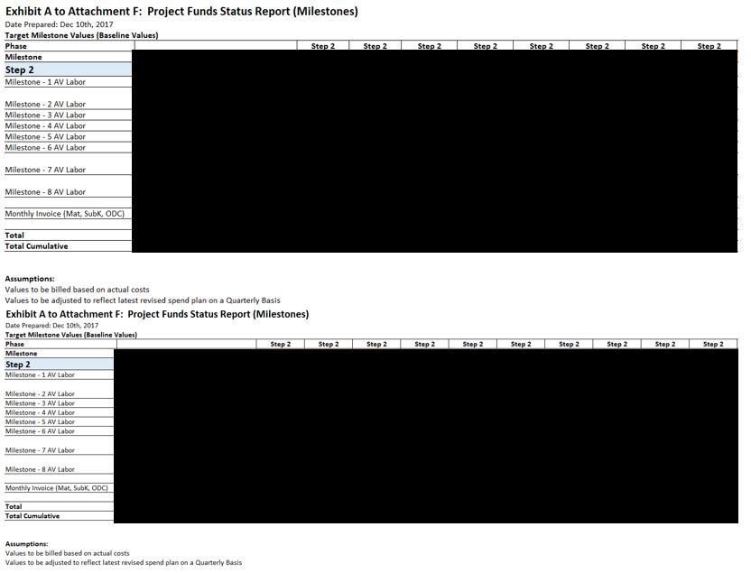

1

- Information has been omitted pursuant to Item 601(b)(2) of Regulation S-K. [___] = [***]

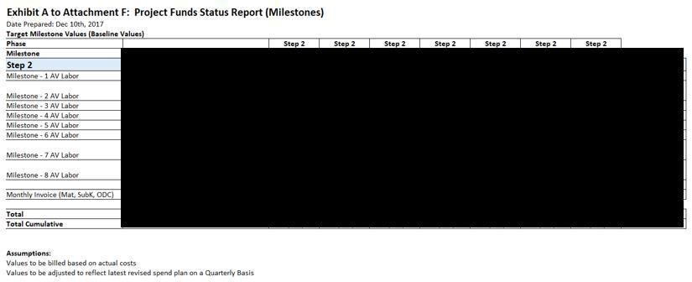

1

- Information has been omitted pursuant to Item 601(b)(2) of Regulation S-K. [___] = [***]

2. Estimate at Completion on Dec.10,2018
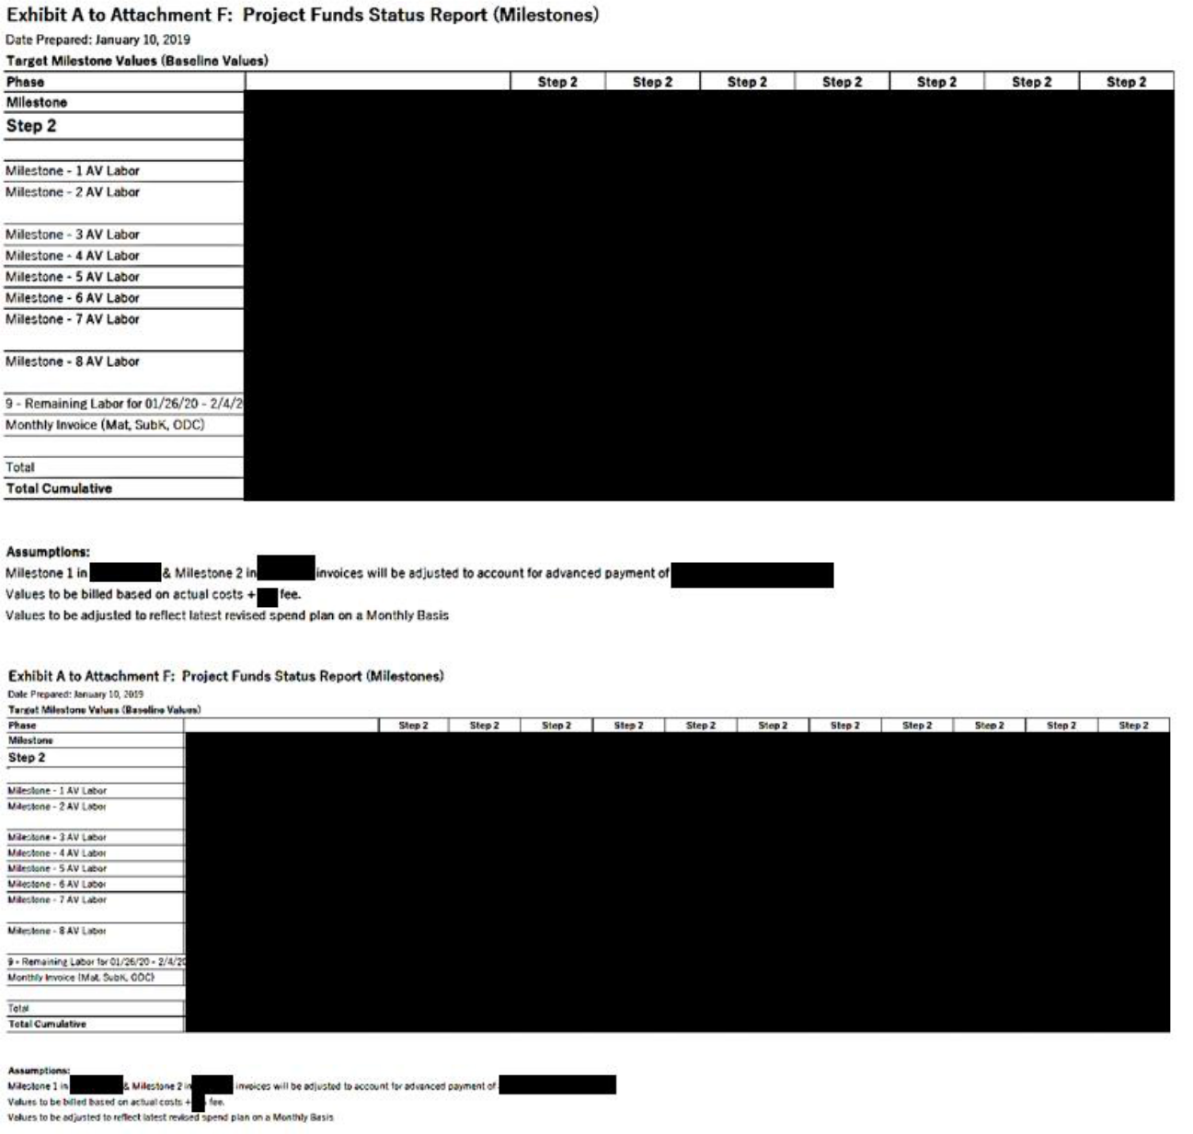

1

- Information has been omitted pursuant to Item 601(b)(2) of Regulation S-K. [___] = [***]

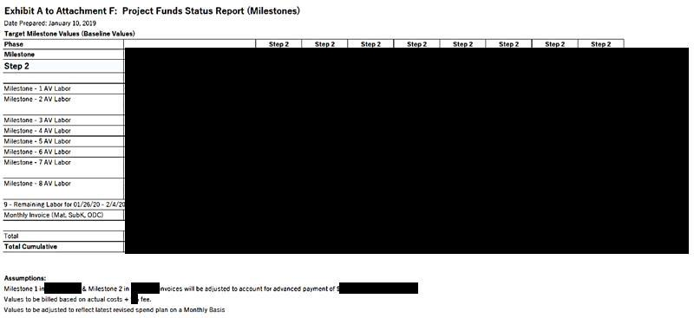

1

- Information has been omitted pursuant to Item 601(b)(2) of Regulation S-K. [___] = [***]

3. Estimate at Completion on March 4,2019
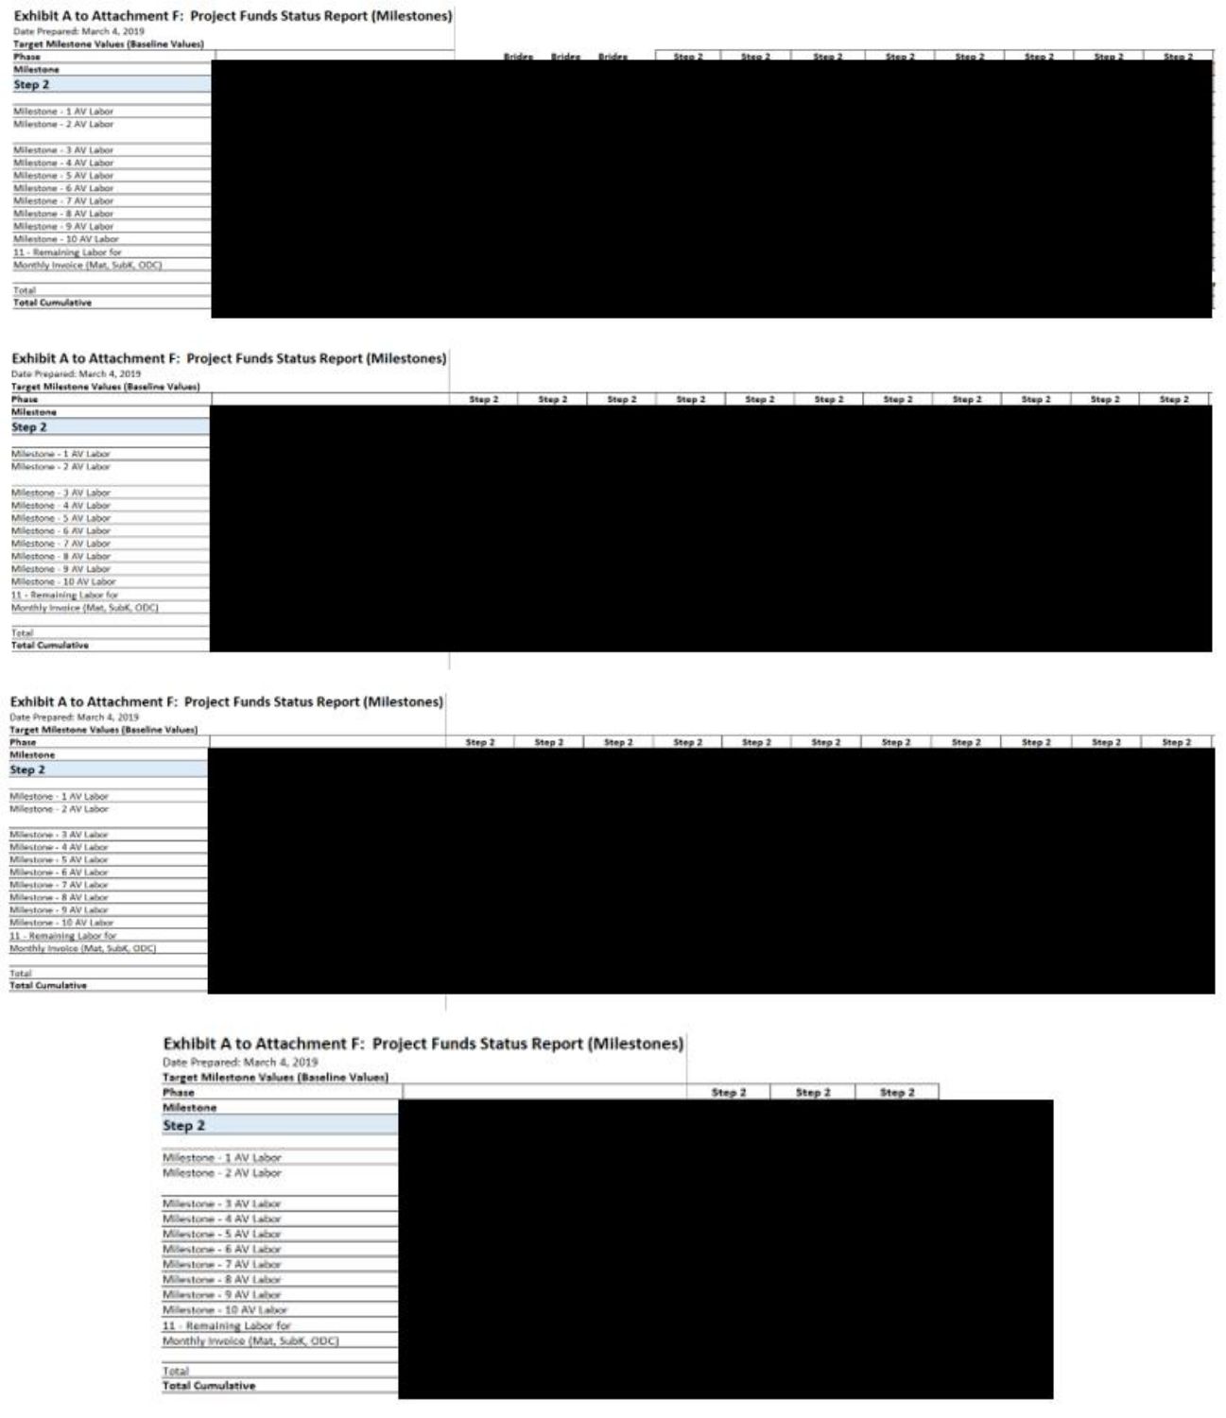

1

- Information has been omitted pursuant to Item 601(b)(2) of Regulation S-K. [___] = [***]

4. Estimate at Completion on September 2019
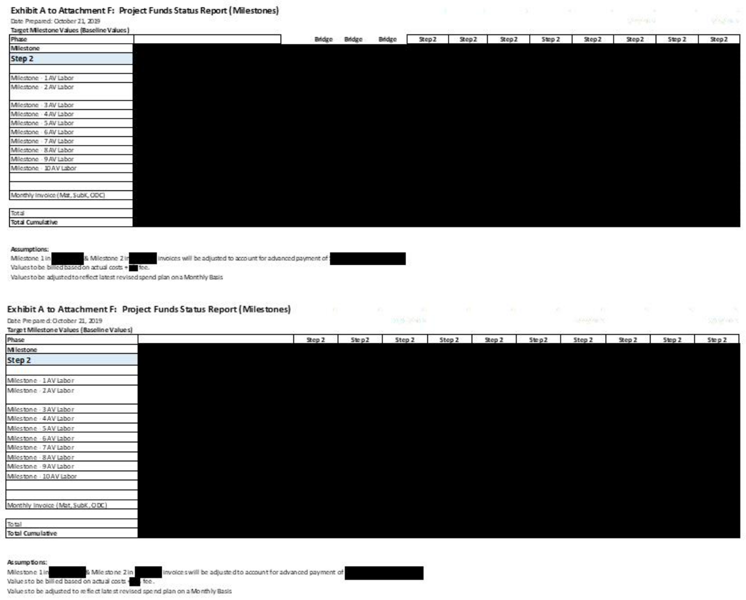

1

- Information has been omitted pursuant to Item 601(b)(2) of Regulation S-K. [___] = [***]

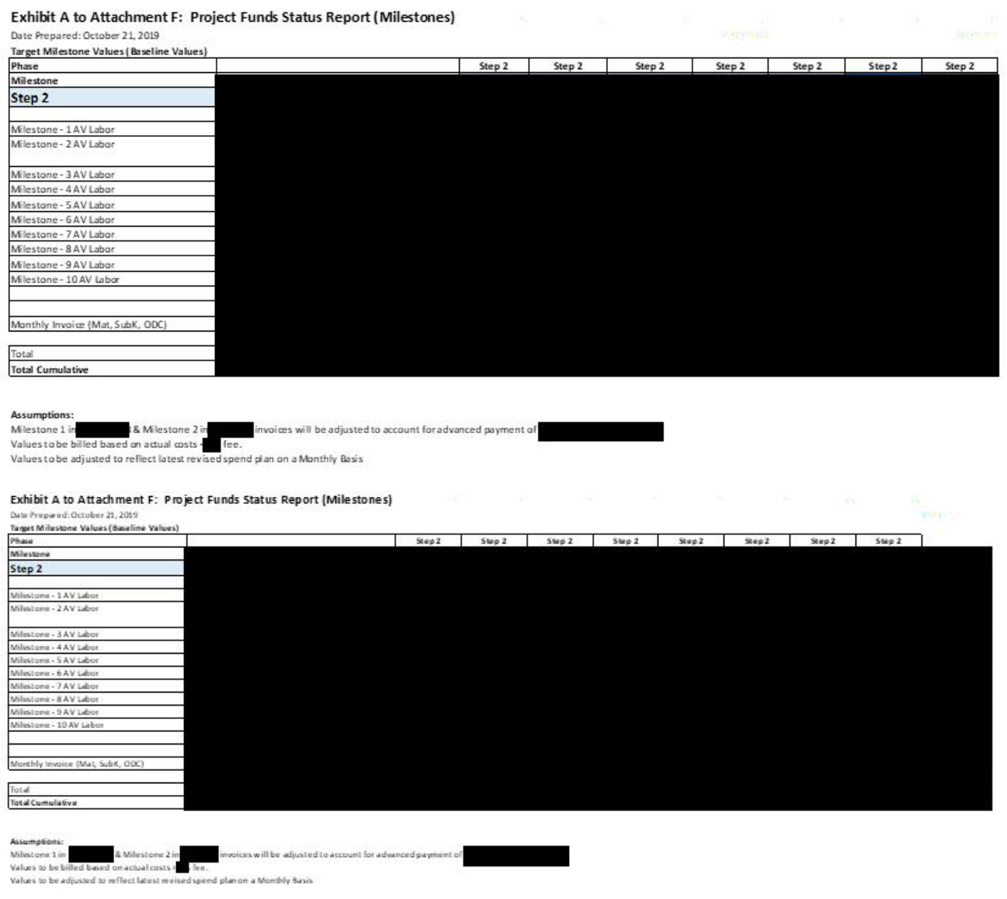

1

- Information has been omitted pursuant to Item 601(b)(2) of Regulation S-K. [___] = [***]

Exhibit B to Attachment F – Monthly Status Report (Example)


AeroVironment Inc.

980 Enchanted Way

Simi Valley, California 93065 – U.S.A.

Telephone 1(805) 581-2187 – FAX 1(805) 584-6922

2

[***] Information has been omitted pursuant to Item 601(b)(2) of Regulation S-K.

Approvals:

<Enter Name here> |  |  |  | Date
Originator
<Enter Name here> |  |  |  | Date
Project Manager
<Enter Name here> |  |  |  | Date
Program Manager
3
[***] Information has been omitted pursuant to Item 601(b)(2) of Regulation S-K.

REVISION HISTORY

REV | EDIT DATE | AUTHOR | DESCRIPTION
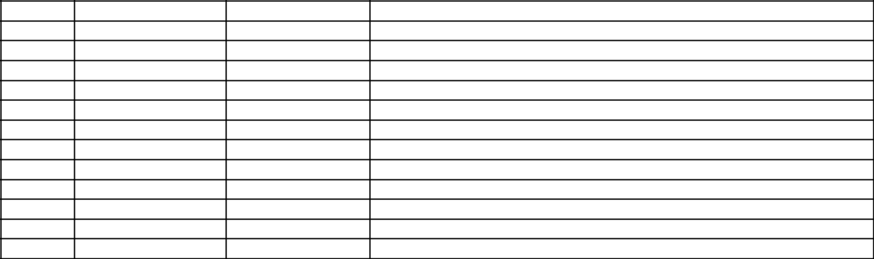
- MM/DD/YYYY

4

[***] Information has been omitted pursuant to Item 601(b)(2) of Regulation S-K.

TABLE OF CONTENTS
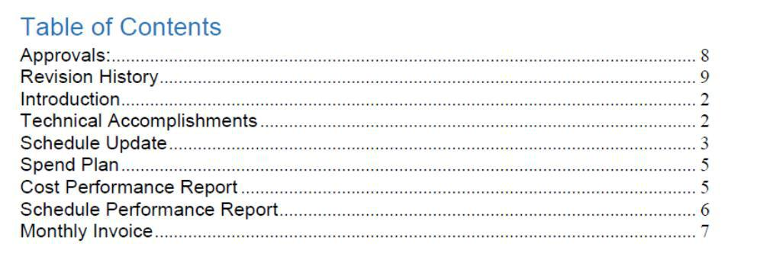

5

[***] Information has been omitted pursuant to Item 601(b)(2) of Regulation S-K.

INTRODUCTION

<<HIGH LEVEL PROGRAM OVERVIEW>>

<<STOPLIGHT CHART>>
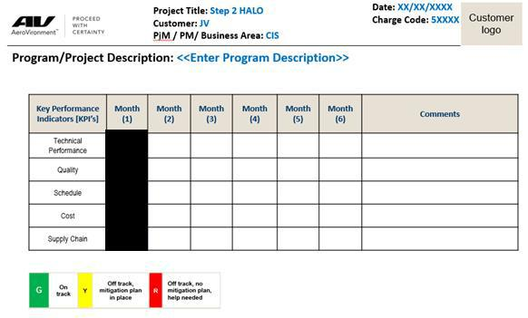

TECHNICAL ACCOMPLISHMENTS

What efforts were started this period?

<<Description of work started and performed during the reporting month>>

Task 5

Task 6

Task 7

Task …X

What efforts were completed this period?

<<Description of work completed and performed during the reporting month>>

Task 1

Task 2

Task 3

Task 4

6

- Information has been omitted pursuant to Item 601(b)(2) of Regulation S-K. [___] = [***]

Key Subcontract Status:

Subcontractor A:

Subcontractor B:

Subcontractor C:

SCHEDULE UPDATE

Integrated Master Schedule Update <<EXAMPLE>>


Milestone Status Update

7

- Information has been omitted pursuant to Item 601(b)(2) of Regulation S-K. [___] = [***]

REFERENCE TO ATTACHMENT H

SPEND PLAN

Spend Plan Update
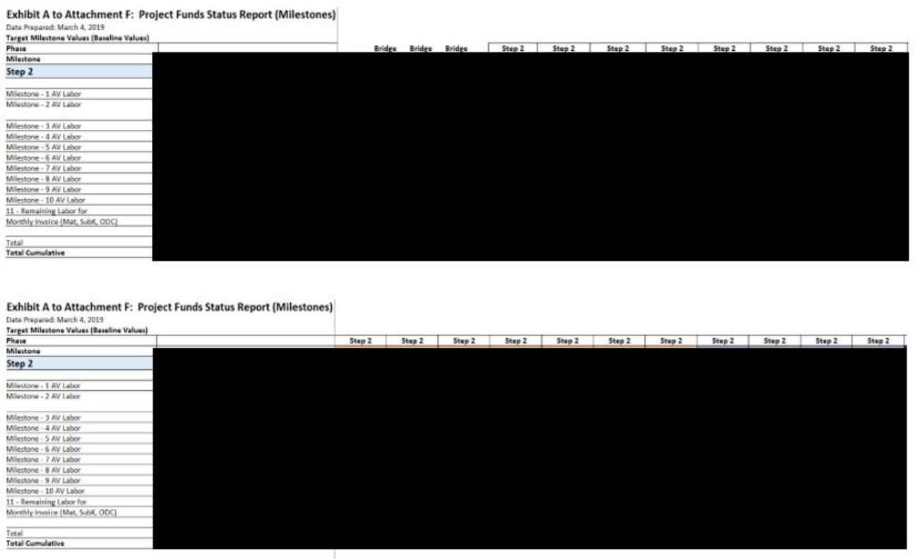

8

- Information has been omitted pursuant to Item 601(b)(2) of Regulation S-K. [___] = [***]

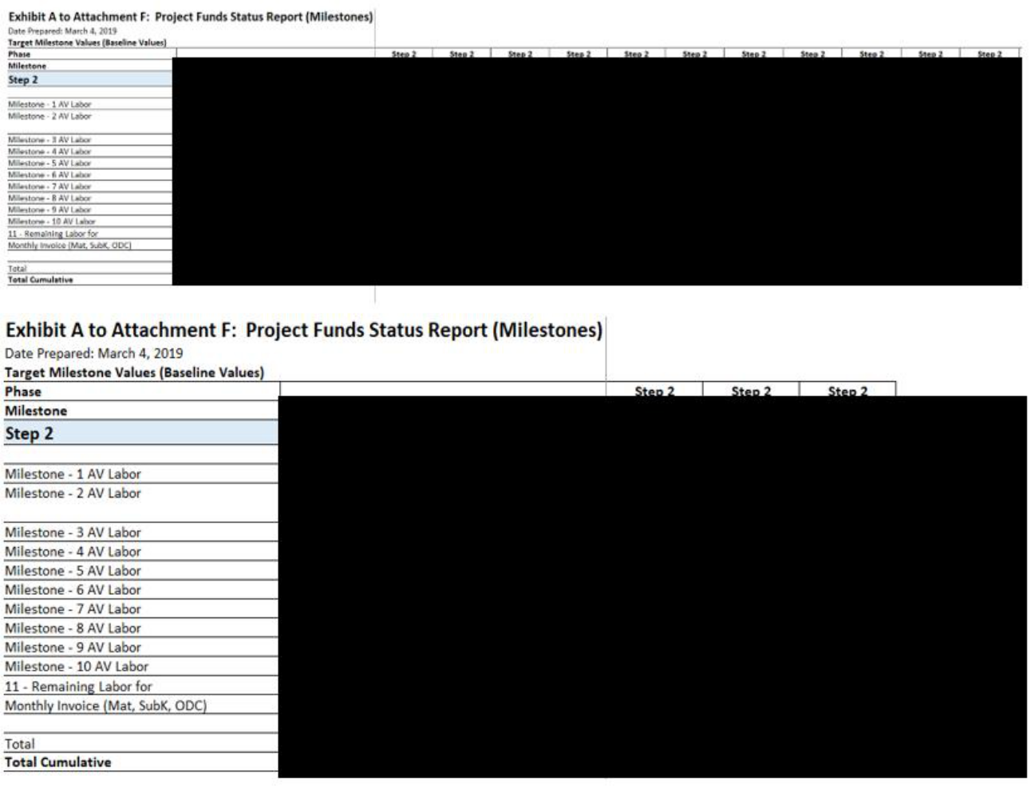

COST PERFORMANCE REPORT

Cost Performance Update

9

- Information has been omitted pursuant to Item 601(b)(2) of Regulation S-K. [___] = [***]

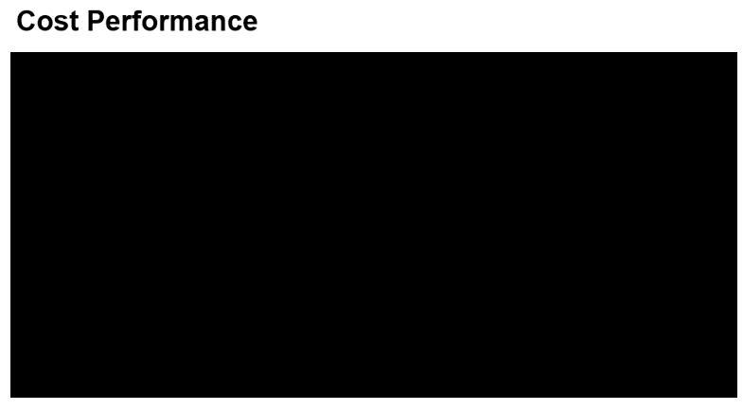

SCHEDULE PERFORMANCE REPORT

<<Schedule Performance Report>>

- Critical Path Analysis

- Schedule Performance Index (if applicable)

- Near term upcoming milestones (30 – 60 days )

- Milestone 1 =

- Milestone 2 =
- Milestone X =

10

- Information has been omitted pursuant to Item 601(b)(2) of Regulation S-K. [___] = [***]

MONTHLY INVOICE – (NON-LABOR)


11

- Information has been omitted pursuant to Item 601(b)(2) of Regulation S-K. [___] = [***]

Exhibit C to Attachment F

12

- Information has been omitted pursuant to Item 601(b)(2) of Regulation S-K. [___] = [***]

13

- Information has been omitted pursuant to Item 601(b)(2) of Regulation S-K. [___] = [***]

ATTACHMENT H

PROJECT MILESTONE

(This Attachment H is revised in its entirety by the Amendment No. 9 to the DDA)

# | Milestone | Criteria | Date
1 | [***] |  | [***]
 | [***]
 |  | [***].
 |  | [***].
 |  | [***].
 |  | [***].
 |  | [***].
 |  | [***].
 |  | [***]
 |  | [***].
 |  | [***]
 |  | [***].
 |  | [***].
 |  | [***].
 |  | [***].
 |  | [***].
2 | [***] |  | [***]
 | [***].
 | [***]:
 | [***].
 |  | [***]
 |  | [***].
 |  | [***].
 |  | [***].
 |  | [***].
 |  | [***].
3 | [***] |  | [***]
 | [***].
 | [***]:
 | [***].
 |  | [***].
 |  | [***].
 |  | [***].
 |  | [***]:
 |  | [***].
 |  | [***].
4 | [***] |  | [***]
 | [***].
 | [***]:
 | [***].
 |  | 14
[***] Information has been omitted pursuant to Item 601(b)(2) of Regulation S-K.

 |  | [***]
 |  | [***].
 |  | [***].
 |  | [***].
 |  | [***].
5 | [***] |  | [***]
 | [***].
 | [***]:
 | [***].
 |  | [***]
 |  | [***].
 |  | [***].
 |  | [***].
 |  | [***].
 |  | [***].
 |  | [***].
 |  | [***].
 |  | [***].
6 | [***] |  | [***]
 | [***].
 | [***]:
 | [***].
 |  | [***]:
 |  | [***].
 |  | [***].
 |  | [***].
 |  | [***].
 |  | [***].
7 | [***] |  | [***]
 | [***].
 | [***]:
 | [***].
 |  | [***]
 |  | [***].
8 | [***] |  | [***]
 | [***].
 | [***]:
 | [***].
 |  | [***]:
 |  | [***].
 |  | [***].
 |  | [***].
 |  | [***].
 |  | [***].
 |  | [***].
 |  | 15
[***] Information has been omitted pursuant to Item 601(b)(2) of Regulation S-K.

9 | [***] |  | [***]
 | [***].
 | [***]:
 | [***].
 |  | [***]:
 |  | [***].
 |  | [***].
 |  | [***].
 |  | [***]
 |  | [***].
10 | [***] |  | [***]
 | [***].
 | [***]:
 | [***].
 | [***].
 |  | [***]:
 |  | [***].
 |  | [***].
 |  | [***]
 |  | [***].
 |  | [***].
 |  | [***].

16

[***] Information has been omitted pursuant to Item 601(b)(2) of Regulation S-K.

Exhibit 10.2
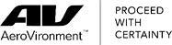

January 6, 2020

Kevin McDonnell

Dear Kevin,

Congratulations! We are pleased to offer you the position as Senior Vice President & Chief Financial Officer within AeroVironment, Inc.

located in Simi Valley, CA. This letter outlines the basic components of your offer.

Base Salary:

Your starting base weekly salary will be $7,692.31, which if annualized is $400,000 per year. You will be classified as an exempt-salaried, full-time employee.

Benefits:

You will be eligible to receive company benefits including medical, dental, vision, life insurance, 401k, paid holidays, paid vacation days and paid sick days in accordance with the eligibility terms and conditions of these programs.

Bonus:

You will be eligible to participate annually in our Section 16 Short Term Incentive Plan. Your annual bonus target will be $250,000. Additional details of the bonus plan will be provided separately after you start employment. All bonus compensation and participation is at the discretion of the company and your actual bonus payout will vary based upon company and business performance. FY20 began on May 1, 2019 and will end on April 30, 2020. Your bonus for FY20 plan year will be prorated and have a minimum payout of $75,000.

Equity Award Plan:

You will be eligible to participate in the AeroVironment 2006 Equity Incentive Plan. Your target annually will be initially set at $400,000 subject to annual review by the Compensation Committee of the Board of Directors. We will recommend that the Company’s Compensation Committee grant you the following equity awards for the FY2021 – 2023 Equity Award Plan:

- $260,000 of Performance Restricted Stock Units which will vest based upon the Company’s achievement of pre-established financial metrics over the cumulative three year FY2021-2023 period; and

- $140,000 of Restricted Stock Awards which will vest in three equal amounts over a three-year period, with the first vesting beginning approximately one year after the grant date of such awards (projected first vesting on July 11, 2021).

The number of shares subject to each award will be determined based on the Company’s share price on the date of grant.

Restricted Stock Award:

You will be eligible to participate in the AeroVironment 2006 Equity Incentive Plan. We will recommend that the Company’s Compensation Committee grant you the following equity awards at its next regularly scheduled meeting after your start date:

Page 1 of 3

- $250,000 of Restricted Stock Awards which will vest in five equal amounts over a five-year period, with the first vesting beginning approximately one year after the grant date of such awards.

The number of shares subject to each award will be determined based on the Company’s share price on the date of grant.

ITAR Notification:

AeroVironment is a government contractor which requires us to meet International Traffic in Arms Regulations (ITAR). These regulations prohibit foreign nationals from working on certain and possibly all of the Company’s products. You are required to provide documentation validating your U.S. person status no later than your start date as defined in the ITAR and Export Administration Regulations (EAR). In order to be a U.S. person for ITAR and EAR purposes, you must: (i) be a citizen or national of the United States; or (ii) be a lawful permanent resident (i.e. “green card holder”) of the United States; or (iii) have been admitted to the United States as a refugee, or have been granted asylum, provided that you have applied for naturalization within six months of the date you first became eligible, and if not yet accepted, you are actively pursuing naturalization after two years from the date of your application. Consequently, if you are unable to meet these ITAR requirements, your employment relationship with the Company will be affected to include separation from employment.

Conditions of Employment:

This offer and your employment at AeroVironment are contingent upon the following:

- Your providing satisfactory documentation to AeroVironment concerning your employment eligibility as required by Congress under the Immigration Reform and Control Act of 1986. You must complete and return the I-9 Employment Eligibility form with its supporting documentation to AeroVironment on your first day of employment.
- AeroVironment must verify that all new US employees are eligible to work in the US using the E-Verify System. The E-Verify process must be done in a non-discriminatory manner and, in the case of new employees, only after the individual has accepted an offer of employment and completed the Form I-9.

- Your completing all required employment documents that AeroVironment presents to you. This includes the Patent and Confidentiality Agreement which must be signed by your first day of employment.
- AeroVironment’s completion of a satisfactory investigation of your background. You agree to release AeroVironment, its employees and agents, and any individuals who may provide AeroVironment with information regarding your background from any liability in connection with this background check.

- Satisfactory completion of the drug screening. Failure to pass or take the drug test will result in a withdrawal of our offer of employment.

This offer packet constitutes the entire offer between you and AeroVironment. It supersedes all previous communications, representations and understandings, either oral or written.

By signing below you acknowledge your understanding that your employment with AeroVironment is at-will. As such the terms of this offer letter are not intended and shall not be deemed a contract of employment. Continued employment is based on performance and the needs of the business.

Page 2 of 3

To accept this offer, please sign this letter below and return it to the department of People and Culture. This offer will remain valid until January 8, 2020 and assumes that you will begin employment on February 3, 2020. If you have any questions, please contact me at
- 581-2198 ext.1904. Sincerely,

/s/ Alison Roelke

Alison Roelke

Vice President, People & Culture

I accept the offer and conditions described in this letter. My signature below acknowledges that I have given my prior permission to begin the pre-employment background check including References, Criminal History, Education, DMV, Drug Screening and credit check as it applies to my position.

/s/ Kevin McDonnell |  | 1-13-2020
Kevin McDonnell |  | Date

Page 3 of 3

Exhibit 31.1

Certification of Principal Executive Officer
Pursuant to Rule 13a-14(a)/15d-14(a) of the Securities Exchange Act of 1934

I, Wahid Nawabi, certify that:

- I have reviewed this quarterly report on Form 10-Q of AeroVironment, Inc.;

- Based on my knowledge, this report does not contain any untrue statement of a material fact or omit to state a material fact necessary to make the statements made, in light of the circumstances under which such statements were made, not misleading with respect to the period covered by this report;

- Based on my knowledge, the financial statements, and other financial information included in this report, fairly present in all material respects the financial condition, results of operations and cash flows of the registrant as of, and for, the periods presented in this report;

- The registrant’s other certifying officer and I are responsible for establishing and maintaining disclosure controls and procedures (as defined in Exchange Act Rules 13a-15(e) and 15d-15(e)) and internal control over financial reporting (as defined in Exchange Act Rules 13a-15(f) and 15d-15(f)) for the registrant and have:

  - Designed such disclosure controls and procedures, or caused such disclosure controls and procedures to be designed under our supervision, to ensure that material information relating to the registrant, including its consolidated subsidiaries, is made known to us by others within those entities, particularly during the period in which this report is being prepared;

  - Designed such internal control over financial reporting, or caused such internal control over financial reporting to be designed under our supervision, to provide reasonable assurance regarding the reliability of financial reporting and the preparation of financial statements for external purposes in accordance with generally accepted accounting principles;

  - Evaluated the effectiveness of the registrant’s disclosure controls and procedures and presented in this report our conclusions about the effectiveness of the disclosure controls and procedures, as of the end of the period covered by this report based on such evaluation; and

  - Disclosed in this report any change in the registrant’s internal control over financial reporting that occurred during the registrant’s most recent fiscal quarter (the registrant’s fourth fiscal quarter in the case of an annual report) that has materially affected, or is reasonably likely to materially affect, the registrant’s internal control over financial reporting; and

- The registrant’s other certifying officer and I have disclosed, based on our most recent evaluation of internal control over financial reporting, to the registrant’s auditors and the audit committee of the registrant’s board of directors (or persons performing the equivalent functions):

  - All significant deficiencies and material weaknesses in the design or operation of internal control over financial reporting which are reasonably likely to adversely affect the registrant’s ability to record, process, summarize and report financial information; and

  - Any fraud, whether or not material, that involves management or other employees who have a significant role in the registrant’s internal control over financial reporting.

Date: March 3, 2020

/s/ Wahid Nawabi
Wahid Nawabi
President and Chief Executive Officer

Exhibit 31.2

Certification of Principal Financial Officer
Pursuant to Rule 13a-14(a)/15d-14(a) of the Securities Exchange Act of 1934

I, Kevin P. McDonnell, certify that:

- I have reviewed this quarterly report on Form 10-Q of AeroVironment, Inc.;

- Based on my knowledge, this report does not contain any untrue statement of a material fact or omit to state a material fact necessary to make the statements made, in light of the circumstances under which such statements were made, not misleading with respect to the period covered by this report;

- Based on my knowledge, the financial statements, and other financial information included in this report, fairly present in all material respects the financial condition, results of operations and cash flows of the registrant as of, and for, the periods presented in this report;

- The registrant’s other certifying officer and I are responsible for establishing and maintaining disclosure controls and procedures (as defined in Exchange Act Rules 13a-15(e) and 15d-15(e)) and internal control over financial reporting (as defined in Exchange Act Rules 13a-15(f) and 15d-15(f)) for the registrant and have:

  - Designed such disclosure controls and procedures, or caused such disclosure controls and procedures to be designed under our supervision, to ensure that material information relating to the registrant, including its consolidated subsidiaries, is made known to us by others within those entities, particularly during the period in which this report is being prepared;

  - Designed such internal control over financial reporting, or caused such internal control over financial reporting to be designed under our supervision, to provide reasonable assurance regarding the reliability of financial reporting and the preparation of financial statements for external purposes in accordance with generally accepted accounting principles;

  - Evaluated the effectiveness of the registrant’s disclosure controls and procedures and presented in this report our conclusions about the effectiveness of the disclosure controls and procedures, as of the end of the period covered by this report based on such evaluation; and

  - Disclosed in this report any change in the registrant’s internal control over financial reporting that occurred during the registrant’s most recent fiscal quarter (the registrant’s fourth fiscal quarter in the case of an annual report) that has materially affected, or is reasonably likely to materially affect, the registrant’s internal control over financial reporting; and

- The registrant’s other certifying officer and I have disclosed, based on our most recent evaluation of internal control over financial reporting, to the registrant’s auditors and the audit committee of the registrant’s board of directors (or persons performing the equivalent functions):

  - All significant deficiencies and material weaknesses in the design or operation of internal control over financial reporting which are reasonably likely to adversely affect the registrant’s ability to record, process, summarize and report financial information; and

  - Any fraud, whether or not material, that involves management or other employees who have a significant role in the registrant’s internal control over financial reporting.

Date: March 3, 2020

/s/ Kevin P. McDonnell
Kevin P. McDonnell
Senior Vice President and Chief Financial Officer

Exhibit 32

Certification
Pursuant to Section 906 of the Sarbanes-Oxley Act of 2002
(Subsections (a) and (b) of Section 1350, Chapter 63 of Title 18, United States Code)

Pursuant to Section 906 of the Sarbanes-Oxley Act of 2002 (Subsections (a) and (b) of Section 1350, Chapter 63 of Title 18, United States Code) (the “Act”), each of the undersigned officers of AeroVironment, Inc., a Delaware corporation (the “Company”), does hereby certify, to each such officer’s knowledge, that:

The Quarterly Report on Form 10-Q for the quarter ended January 25, 2020 (the “Periodic Report”) of the Company fully complies with the requirements of Section 13(a) or 15(d) of the Securities Exchange Act of 1934 (15 U.S.C. 78m or 78o(d)) and information contained in the Periodic Report fairly presents, in all material respects, the financial condition and results of operations of the Company.

/s/ Wahid Nawabi
Wahid Nawabi
President and Chief Executive Officer

/s/ Kevin P. McDonnell
Kevin P. McDonnell
Senior Vice President and Chief Financial Officer

Dated: March 3, 2020

A signed original of this written statement required by Section 906 has been provided to the Company and will be retained by the Company and furnished to the Securities and Exchange Commission or its staff upon request.

1

